Pre-analysis Plan
Showing Life Opportunities: Take-up Interventions in the National Level (Highlands Regime)
July 19, 2020
Date of the latest version: 23rd of July 2020
Keywords: Online Education, Information Intervention, Take-Up, Experiment
JEL codes: I21, L26, O15
Study pre-registration:

Asanov, Igor and David McKenzie. 2020. "Scaling up virtual learning of online learning in high schools." AEA RCT Registry. June 10. https://doi.org/10.1257/rct.5982-1.0.

Introduction

The Covid-19 outbreak resulted in the closure of schools around the world (UNESCO, 2020). As a response, governments rolled-out remote-learning programs. The challenge, however, is to ensure continuity of learning activity when given remotely, by ensuring take-up of the programs from home. We aim to provide a series of experiments to learn iteratively how to improve the educational process. This pre-analysis plan focuses on a rapid analysis of inexpensive nimble interventions to improve take-up that we quickly introduced in Ecuador for the “Showing Life Opportunities” project during June 2020. It is intended to outline our analysis in a first pass through the data, with the purpose of helping inform the next phase of take-up experimentation.
Description of the National Level Program “Showing Life Opportunities”
As a rapid-fire response to the challenges of the COVID-19 outbreak we, in collaboration with the Ministry of Education of Ecuador, provide online courses in schools on the national level (highlands and coastal educational regimes) in Ecuador for the students of grade 12 (last year of school). We also assess the effect of the courses by randomizing 416 schools to one of the following four treatment groups:
1) Role Model videos and treatment courses (Personal initiative and Negotiations)
2) Placebo videos and treatment courses (Personal initiative and Negotiations)
3) Role Model videos and placebo courses (Spanish and Statistics)
4) Placebo videos and placebo courses (Spanish and Statistics)
The intervention started on the 18th of May in the Highlands region.
Interventions to increase take-up.
We provide interventions to increase take-up on two levels (1) Student level and (2) Teacher level.
- The Student level intervention includes the following four treatments implemented on the online learning platform:
- Control. No message.
- Encouragement (E). Students see encouragement message screens that are selected at random from a set of message screens. Messages aim to transmit the idea that students can finish the course despite hurdles e.g. “Graduating is a great achievement. Thank you for your impulse to make the world a better place. Source: UNICEF. You can finish all the lessons” (see appendix A for further details).
- Lottery (L). Students are reminded that they win an additional lottery ticket each time they finish lessons (see appendix A for further details).
- Plan and team-up (P). Students are asked to make plans on how they will study and share the plans with others (in the house). (see appendix A for further details).
The messages were introduced on the 1st of June 2020 on the platform and shown to students regularly from lesson 6 with increased frequency with their progress (in the first course only in two lessons, in each lesson during the second course). Thus, we targeted the students who are falling behind and increase the intensity of the messages to not lose pace. As we anticipate the risk of spillover effects from the treatment plan and team-up (P), we asked students in the second course (in lesson 3 and 9) assigned to this treatment with whom they team up to assess the spillover effect. The randomization is done automatically on the individual level on the platform when the student enters lesson 6 of the first course.
- The Teacher-level intervention includes the following three treatments:
- Control. No message.
- Monitoring SMS (M). We send a message that reminds teachers that their activity is monitored and they shall ensure take-up. “Remember, your Zone [Name] delegate and MINEDUC monitor your activity in the SLO project. Make sure your students finish until the end of the school year. SLO”. The wording in the message intentionally kept formal but cold to stimulate teachers.
- Encouragement (E). We send electronic letters where we aim to encourage teachers by asking them to watch the video of successful completion of the program in zone 2 and that we hope that they will finish the program successfully in time. The wording in the message intentionally kept formal but warm to encourage teachers. (see appendix A for further details).
The number of waves of messages we introduced since the 17th of June – one month after the start of the program – to stimulate completion of the program in time. Randomization was done on the teacher's level among 532 teachers. First, we formed 1 random strata of four teachers selecting at random four teachers among 76 inactive teachers, within this strata we randomly assigned 1 teacher to encouragement email(E), 1 teacher to monitoring SMS (M) and 2 teachers to control. We did this only for those four randomly selected teachers, so we could couple next strategy for the rest 528 teachers. We formed 88 strata of six of comparable teachers out of the rest (528) teachers and then randomly assigned two teachers to control, two to Monitoring SMS(M), two to Encouragement Email (E) within each strata. Specifically, we use the following variables to calculate the Mahalanobis distance between all pairs of teachers: Educational zone, cluster size (number of students on the platform), active teachers class (at least one student active), number of lessons completed, average time on the online platform, treatment status on the type of course that students receive under supervision of this teacher. We use the optimal greedy algorithm to form strata of six comparable teachers based on the calculated Mahalanobis distance between teachers, then we randomize within those strata. The information about the activity of students, classes, schools are based on the data collected through the platform approximately after one month (15th of June, 2020) since the beginning of main intervention (18th of 2020), right before the information intervention on teachers' level.

HYPOTHESES TO BE TESTED
We will test hypotheses in three next domains:
Domain 1: Main take-up measures.
Hypothesis: Treatment messages compared to no message leads to change in studying behavior.
- Time in minutes on the platform – timeinminutes
- Active days on the platform –activedays
- Main Take-up index – average standardized z-score of outcomes 1 and 2.
Domain 2: Secondary take-up measures
Hypothesis: Treatment messages compared to no message leads to change in the pattern of usage on the platform and to completion of a business project.
- Number of entries on the platform – entries
- Lessons completed per day - Lesson_Finished_day
- Business project submitted before the deadline (1st of July 2020) - project_completed_before_deadline
- Secondary Take-up index – average standardized z-score of outcomes from 1 to 3.
Domain 3: Performance in the knowledge test
Hypothesis: Treatment messages compared to no message improves performance on knowledge test.
We define it as the z-score of performance of student on subject specific tests:
- Personal initiative - z-score based on variables from endline knowledge test from 2_4_1_E to 2_4_9_E.
- Negotiations - z-score based on variables from endline knowledge test from 2_5_1_E to 2_5_11_E;
- Statistics and scientific thinking - z-score based on variables from endline knowledge test from 2_1_1_E to 2_1_20B_E;
- Spanish literacy - z-score based on variables from endline knowledge test from 2_2_1_E to 2_2_8f_E;
- Knowledge index - Average of standardized z-scores of outcomes 1 through 4.
We create an average z-score index, calculating the z-score of each variable by subtracting the control-group mean and dividing by the control group standard deviation, and averaging the z-scores of the outcomes for each family. These tests are given to students at end survey through the online platform. The information is collected for all groups treatments and control.

General Estimation Strategy
- Messages to Students
We will use the following specification for student i to estimate the impact of being offered the different messages relative to not getting the message using next ANCOVA specification:

$$Y_{i,1}= β_{0}+ β_{E}E_{i}{+β}_{E}L_{i}+β_{E}P_{i}+Y_{i,0}+controls_{i,j}+ε_{i}$$
In this specification $Y_{i,1}$ is the variable measures the outcome of interest for student i. The treatment variable $E$ is the dummy variable that equals 1 if the student receives encouragement message. The treatment variable $L$ is the dummy variable that equals 1 if the student receive lottery message. The treatment variable $P$ is the dummy variable that equals 1 if the student receives share plans message.$Y_{i,0}$is the outcome of interest at the baseline, before treatment (June 1, 2020). We will use the post-double-selection Lasso approach of Belloni et al. (2014) to select school, class and individual-level control variables from baseline information (see Appendix B). $ε_{i}$ is the error term. Since randomization is at the individual-level, standard errors will not be clustered, and Eicker-White robust standard errors will be used.
- Messages to Teachers
We will use the following specification for student i supervised by teacher j to estimate the impact of teachers being offered the different messages relative to not getting the message using the next ANCOVA specification:

$$Y_{i,1}= β_{0}+ β_{E}E_{J}{+β}_{M}M_{J}+Y_{i,0}+controls_{i,j}+Strat{a'}_{k,j} Θ+ε_{i,j}$$
In this specification $Y_{i,1}$ is the variable measures the outcome of interest for student i. The treatment variable $E$ is the dummy variable that equals 1 if the teacher receives an encouragement letter. The treatment variable $M$ is the dummy variable that equals 1 if teachers receive monitoring SMS messages.$Y_{i,0}$is the outcome of interest at the baseline, before treatment (June 15 2020). We will use the post-double-selection Lasso approach of Belloni et al. (2014) to school, class and individual-level control variables from baseline information (see Appendix B). $Strat{a'}_{k,j}$is a vector of randomization strata dummy variables, and $ε_{ij}$ is the error term, which we will cluster at the teacher level.
Capturing time-specific effects
As we anticipate the change in the effect of the intervention over time, we will assess the treatment effects in time with help of panel data analysis using weekly performance on outcomes from domain 1 and 2 for the period of message interventions for students (1st of June-1st of July) and daily for teachers (17th of June -1st of July).
Multiple Hypothesis Testing
We rely on two approaches to deal with multiple hypothesis testing. We define summary index measures, and can then consider a single summary measure per domain. Second, we will also calculate Romano-Wolf stepdown p-values to correct for multiple hypothesis testing.

Attrition.
To deal with the non-existence of the data in the endline survey for the knowledge tests. First, we will identify the overall attrition rate in the sample and the reasons for this attrition: (a) missing due to the drop-out from school/program and (b) failure to code the values due to the technical problems. Second, we will determine if the attrition in the treatments and comparison independent from the treatment.
If non-response rates are less than 5% and attrition is independent of treatment, we will assume data are missing-at-random and not carry out any imputation. If treatment status does have a statistically significant effect on survey attrition or attrition is higher than 5%, we will test the robustness of our results using Lee bounds (Lee, 2009) and provide estimation, with inputted data from baseline for variables present in the baseline. The use of the post-double selection lasso will also provide some robustness to an imbalance in treatment assignment on observables that arises from attrition.
Spillovers
As we anticipate the possibility of spillover effects from the student level treatment plan and team-up (P), we will use the information with whom students team-up to explore these spillovers. If students team-up with other students rather than siblings (mother, father, cousin etc.), and the other treated student is not from the plan and team-up (P) treatment, we will compare outcomes for indirectly treated students to other students in their treatment groups. Note that the selection of who to pair up with is an endogenous choice, and the students in other treatment groups who are chosen as pairs may differ systematically from those who are not chosen. As such, we will use double-selection lasso to control for observable baseline differences when exploring these spillovers, but acknowledge that we will not estimate the causal impact of being indirectly treated.
Estimating heterogeneous treatment effects
We will use two strategies to understand heterogeneous treatment effects. First, we want to assess heterogeneous treatment effects according to the following two baseline dimensions:
- The initial level of take-up
Hypothesis: The treatments have a different effect depending on the level of initial take-up.
- Gender: Male/ Female
Hypothesis: The treatments have a different effect on boys and girls.
Assessing the interaction between student-teacher treatments
We will explore the interaction effects between student-level treatments and teachers level treatments by assessing a fully-saturated model of interaction effects between those treatments.
References
Belloni, Alexandre, Victor Chernozhukov, and Christian Hansen (2014) “High-Dimensional Methods and Inference on Structural and Treatment Effects.” Journal of Economic Perspectives 28 (2): 29-50.
Lee, D. S. (2009). Training, wages, and sample selection: Estimating sharp bounds on treatment effects. Review of Economic Studies, 76(3), 1071–1102. https://doi.org/10.1111/j.1467-937X.2009.00536.x

Appendix A. Screenshots of the interventions.
Appendix A1. Student Level interventions.
Treatment 1 -Control  No message is shown. | Treatment 2 - Encouragement  Each time the next group of screens shown at random:  Message 2.1  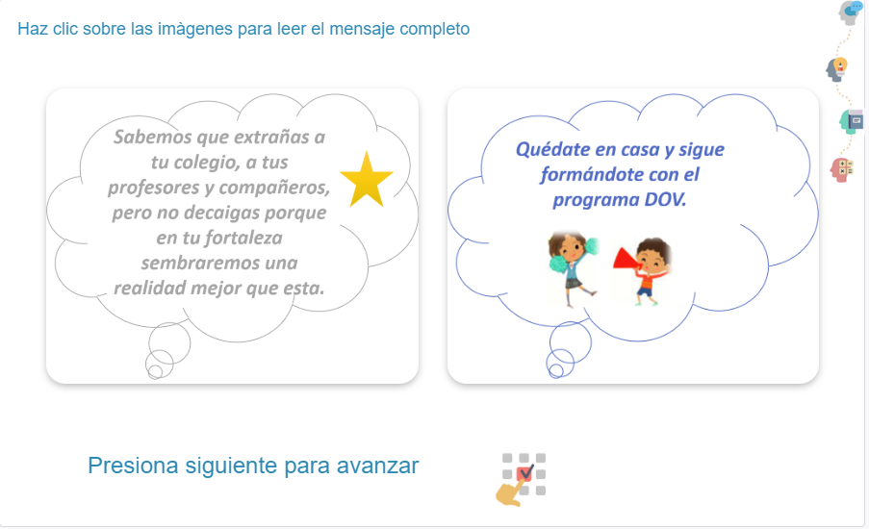  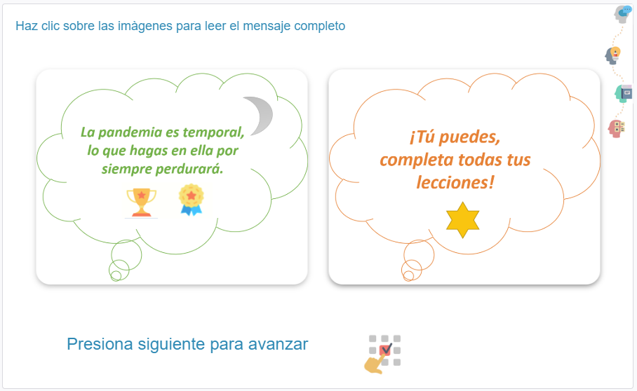  Message 2.2  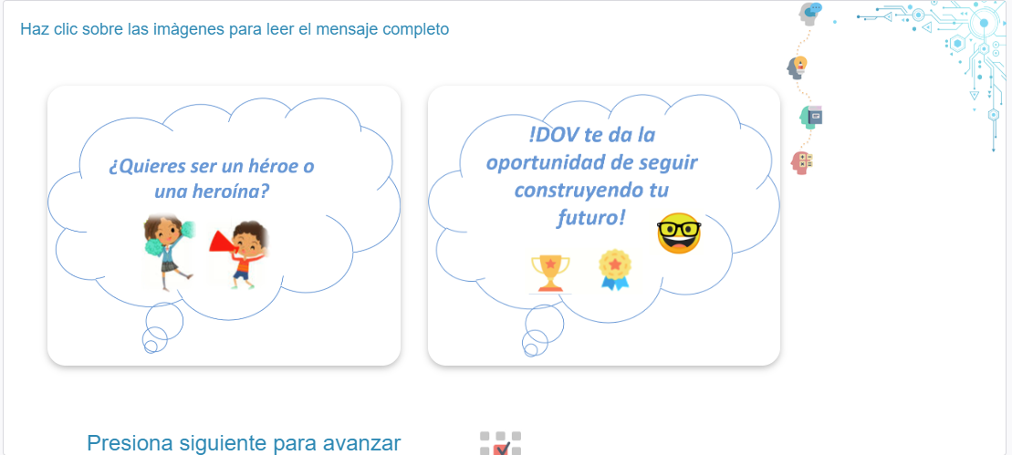  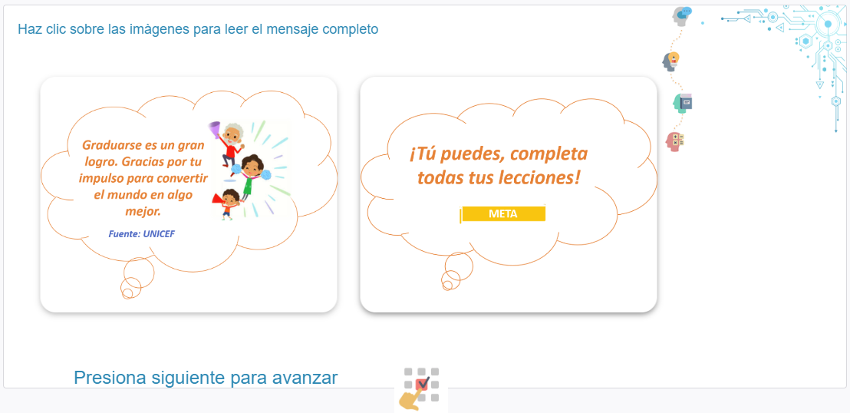  Message 2.3  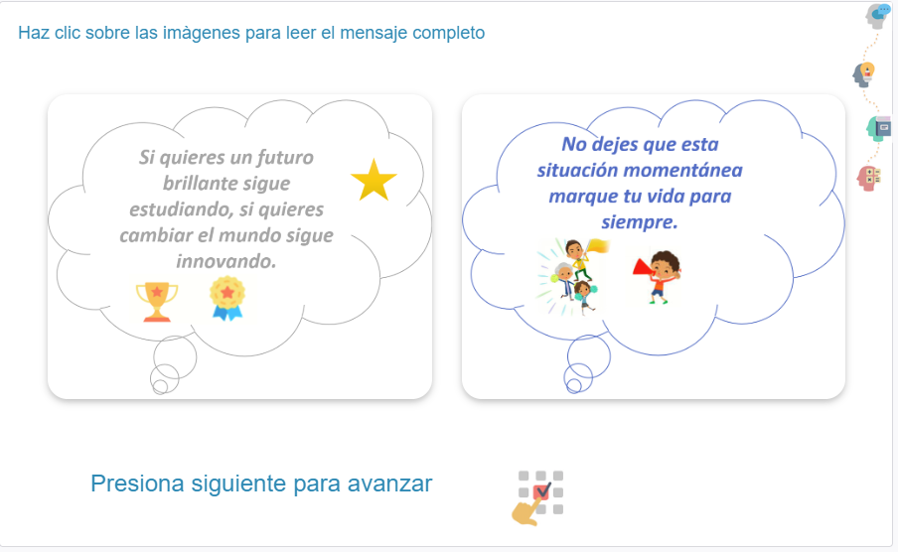  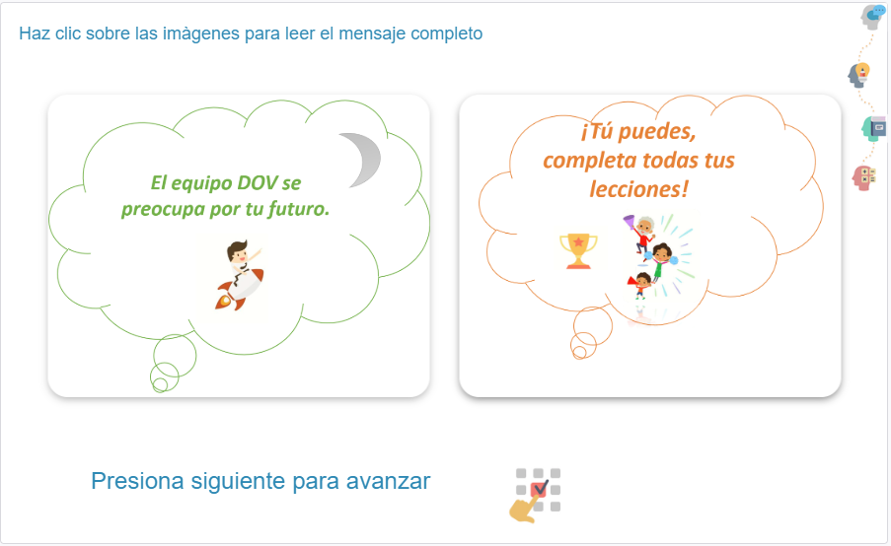  Message 2.4  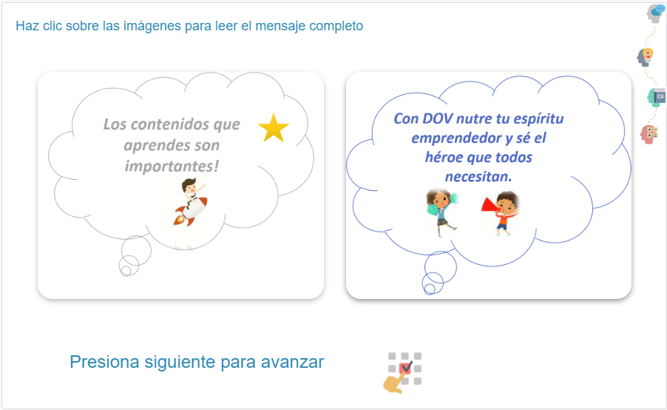  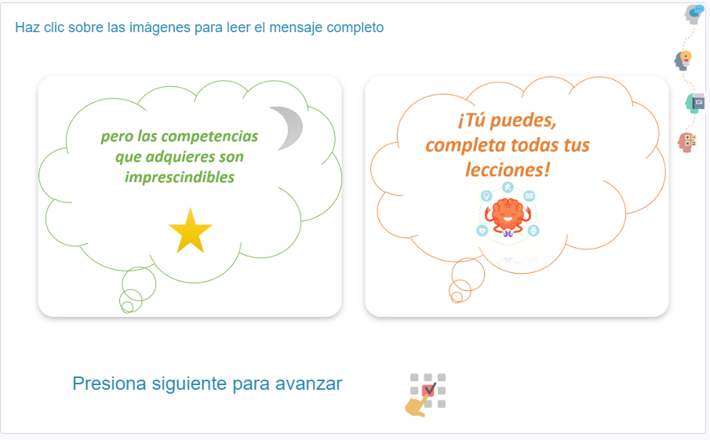  Message 2.5  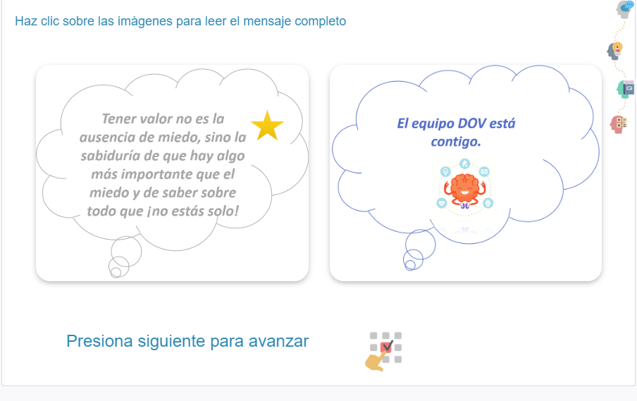  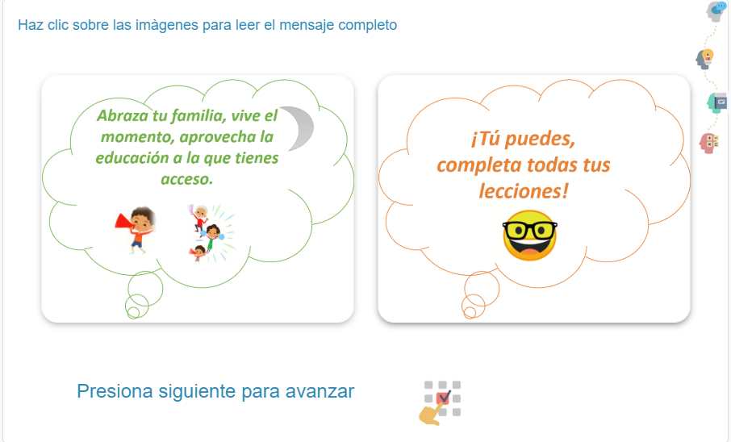
Treatment 3 - Lottery Ticket  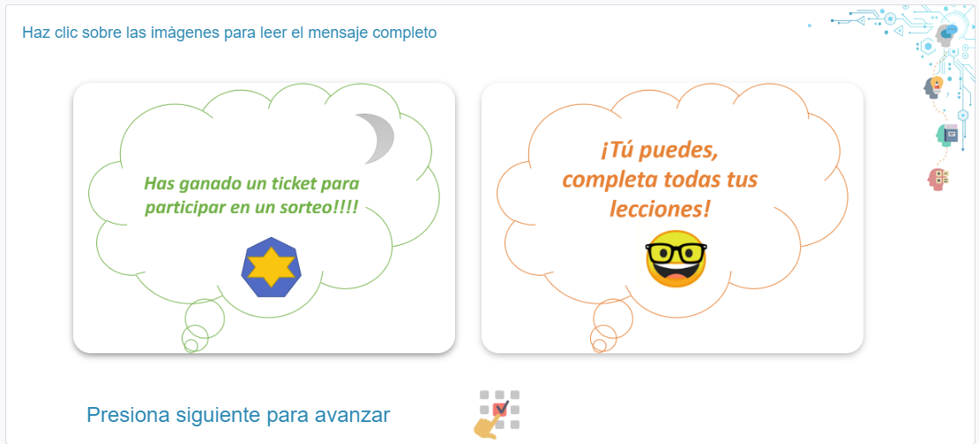  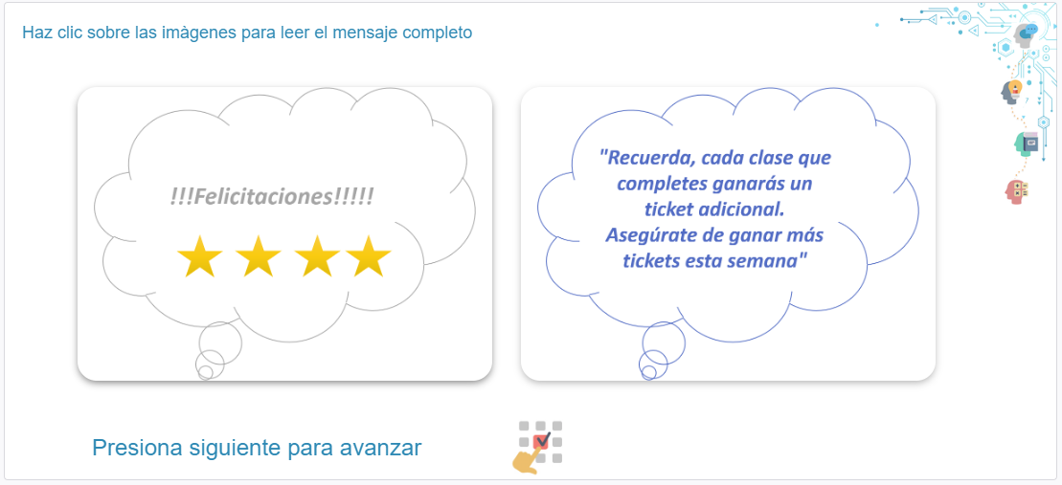 | Treatment 4 - Team-up and make plans  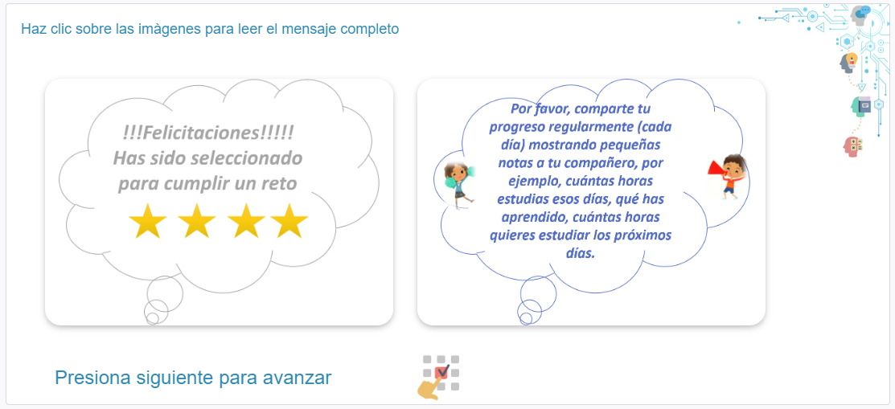  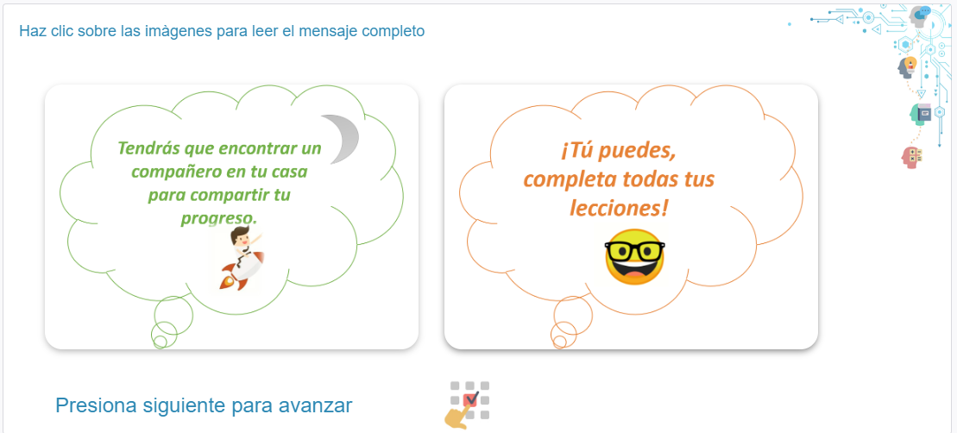

Appendix A2. Teachers level intervention
Treatment 1- Control  No message | Treatment 2 – Email with Video  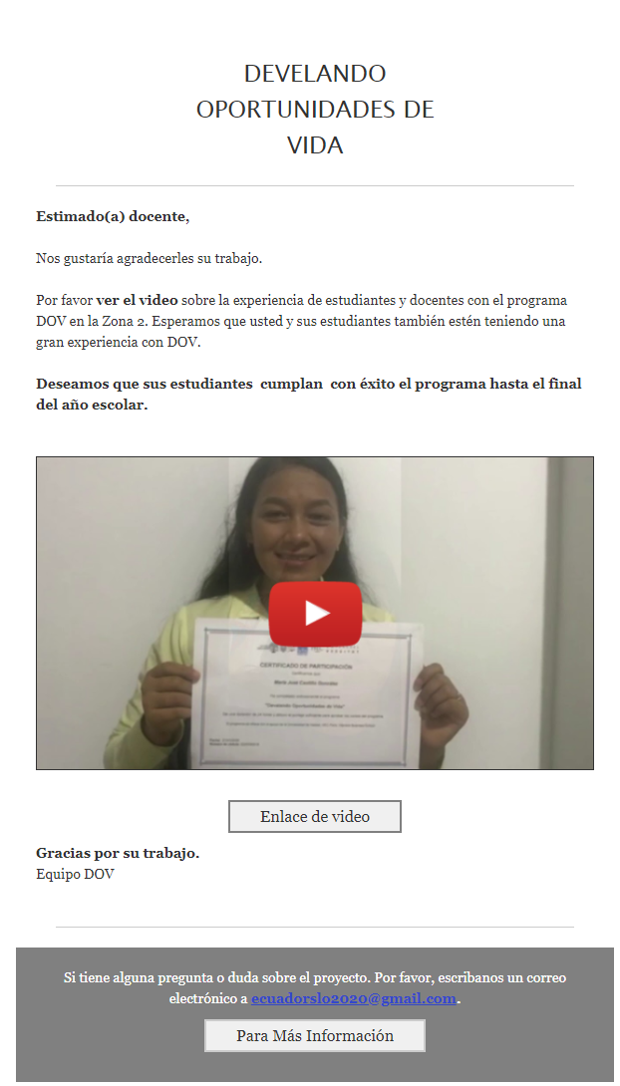
Treatment 3- SMS

Recuerde, su delegado de Zona [Nombre] y MINEDUC monitorean su actividad en el proyecto DOV. Asegure q sus alumnos acaben hasta el fin del ciclo escolar. DOV

Appendix B. List of control variables
Variables at class level
Code | Variables at class level | Definition
Class_size | Class size | Total number of active students on the platform, who have started at least one lesson.
Active_class | Active class | Classes that enroll more than 3 students on the platform and have started at least one lesson.
Variables Collected at the individual level
Code | Variables | Definition
I_Male | Gender | A dummy for gender
I_Age | Age | Student Age
I_Language | Language | Language (Only native language; native and Spanish language; Spanish; Spanish and foreign language; Native language and foreign language).
I_10_Income | Socioeconomic characteristics | Score of possession of a washing machine, air conditioner, car, number of bathrooms, number of bedrooms, etc. Principal component.
II_1A_Entr_Attitude | Entrepreneurship attitude | Average of standardized z-scores of students`s perception of entrepreneurship (worthless /worthwhile, fun /boring, negative/positive, need/opportunity).
II_1B_Entr_Intentions | Entrepreneurial intentions | Average of standardized z-scores of  student`s intention to become an entrepreneur (starting a business, have business ideas, become own boss).
II_2A_Stem_Attitude | STEM attitude | Average of standardized z-scores of student`s perception of professions in STEM (worthless/worthwhile, fun/boring, negative/positive)
II_2B_Stem_Intentions | STEM Intentions | Average of standardized z-scores of students`s intention to work in a STEM area (starting career in STEM, have ideas in STEM, become a professional in STEM).
II_Study_uni | Study at university | Dummy whether a student plans to go to university.
II_Option1,  II_Option2,  II_Option3 | 3 specializations/  options | Dummy whether a student plan to study STEM career or plan to study business (in any of 3 options).
III_Know_STEM | Know people in STEM areas | Average of standardized z-scores of whether a student knows adults who works in STEM areas: scientists, engineers, mathematicians, technologists.
III_Know_Ent | Know people in Entrepreneurship | Dummy whether a student knows adults who is Entrepreneur.
III_Expectations_5_ENT | Entrepreneurial  Occupation/profession expectations – 5 years | Dummy whether a student expect to be an entrepreneur in the next 5 years. Based on classification of written answers.
III_Expectations_10_ENT | Entrepreneurial  Occupation/profession expectations – 10 years | Dummy whether a student expect to be an entrepreneur in the next 10 years. Based on classification of written answers.
III_Expectations_5_STEM | STEM  Occupation/profession expectations – 5 years | Dummy whether a student expect to be in STEM career in the next 5 years. Based on classification of written answers.
III_Expectations_10_STEM | STEM  Occupation/profession expectations – 10 years | Dummy whether a student expect to be in STEM career in the next 10 years. Based on classification of written answers.
III_3_Entr_Success | Professional STEM/entrepreneur | Z-score of whether they can be successful as an entrepreneur.
III_3_Stem_Success | Professional STEM/entrepreneur | Z-score of whether a student believes they can be successful as a STEM professional.
III_3_Public_Success | Professional STEM/entrepreneur | Z-score of whether a student believes they can be successful as a public servant.
III_Earn_5_Years | Expectations for future earnings | How much a student expects to earn in 5 years.
III_Earn_10_Years | Expectations for future earnings | How much a student expects to earn in 10 years.
III_Salary_ecuador | Specific salary expectations | Knowledge of how much is the minimum wage per month in Ecuador.
III_Salary_ent | Specific salary expectations | Knowledge of how much an entrepreneur earn on average per month in Ecuador
III_Salary_stem | Specific salary expectations | Knowledge of how much a STEM professional (Science. Technologies, Engineering, Math) earn on average per month in Ecuador
IV_Mother_work | Parents background – mother | Dummy whether the mother is employed.
IV_Mother_profession_ENT | Parents background - mother | Dummy of profession of the mother (STEM areas)
IV_Mother_profession_STEM | Parents background - mother | Dummy of profession of the mother (entrepreneurship)
IV_Mother_edu | Parents background - mother | Education level of mother (Middle School or lower; Diploma; University Bachelors; Master degree; PhD).
IV_Mother_business | Parents background - mother | Dummy whether the mother has ever owned a business or been self-employed.
IV_Father_work | Parents background – Father | Dummy whether the Father is employed.
IV_Father_profession_ENT | Parents background - Father | Dummy of profession of the father (STEM areas).
IV_Father_profession_STEM | Parents background - Father | Dummy of profession of the father (entrepreneurship).
IV_Father_edu | Parents background - Father | Education level of father  (Middle School or lower; Diploma; University Bachelors; Master degree; PhD)
IV_Father_business | Parents background - Father | Dummy whether the father has ever owned a business or been self-employed.
IV_Siblings_work | Parents background – Siblings | Dummy whether the sibling(s) is employed.
IV_Siblings_profession_ENT | Parents background - Siblings | Dummy of profession of the siblings (STEM areas).
IV_Siblings_profession_STEM | Parents background - Siblings | Dummy of profession of the siblings (entrepreneurship).
IV_Siblings_edu | Parents background - Siblings | Education level of Siblings (Middle School or lower; Diploma; University Bachelors; Master degree; PhD).
IV_Siblings_business | Parents background - Siblings | Dummy whether the siblings has ever owned a business or been self-employed.
V_Work_Experience | Working experience | Dummy whether a student has worked in a paid job or in an unpaid job.
VI_1_Attitudes | Personal Initiative 1 | Average of standardized z-scores of student`s Personal Initiative I
VI_2_Attitudes | Personal Initiative 2 | Average of standardized z-scores of student`s Personal Initiative II
VI_3_Attitudes | Personal Initiative 3 | Average of standardized z-scores of student`s Personal Initiative III.
VII_1_Risk_Preference | Risk Preference | How willingly a student takes risk. Based on question from Global Preference Survey.
VII_2_Time_Preference | Time Preference | How willingly a student gives up something that is beneficial for them today in order to benefit more in the future.  Based on question from Global Preference Survey.
VII_2_Trust | Trust | Whether student assumes that people have only the best intentions.  Based on question from Global Preference Survey.
VII_3_BFI_Extraversion, | Personality traits | Average of extraversion items (reserved/sociable, coded in same direction).  BFI10
VII_3_BFI_Agreeableness, | Personality traits | Average of agreeableness items (confident/ tendency to find fault with others, coded in same direction)  BFI10
VII_3_BFI_Conscientiousness, | Personality traits | Average of conscientiousness items (thorough job/ tends to be weak, coded in same direction)  BFI10
VII_3_BFI_Neuroticism, | Personality traits | Average of neuroticism items (relax/ gets nervous easily, coded in same direction) BFI10
VII_3_BFI_Openness | Personality traits | Average of openness items (active imagination/ few artistic concerns, coded in same direction)  BFI10
Behavioral (Experimental) Games
IX_CRT | Cognitive Reflection Test | Measure of cognitive abilities: Average over three questions
IX_Unscramble_A  IX_Unscramble_B | Unscramble Task | Creativity Measure based on Unscramble task:  Points Earned  Originality Index
IX_Deception | Coin Task | Preferences for Honesty: Reported Correct predictions (aggregated on class level)
IX_Grit_A  IX_Grit_B  IX_GRIT_C | Grit: Triangle Task | Triangle Task:  Success in task (in points);  Choice of difficult task  Choice of difficult task after failure
IX_BRET | Bomb Risk Elicitation Task | Risk Preferences: Number of Boxes
IX_Dictator | Dictator game | Other-regarding preferences: Amount Given in Dictator Game
IX_PD | Prisoners Dilemma | Preferences for cooperation: If the person choose to cooperate
Psychological Measures
X0_2_Statistics_total, X0_2_Spanish_total, X0_2_English_total | Subject knowledge | Average of standardized z-scores of knowledge test in Statistics, English and Spanish.
X1_1_A_Personal_ Initiative  X1_1_B_Personal_ Initiative, | Subject knowledge - Personal Initiative | Average of standardized z-scores of Personal Initiative Attitude.
X1_2_A_Negotiations_Yielding, X1_2_B_Negotiations_Forcing, X1_2_C_Negotiations_Compromising, X1_2_D_Negotiations_Avoiding, X1_2_E_Negotiations_Problem_Solving | Subject knowledge - Negotiations | Average of standardized z-scores of  Negotiations Attitudes (in terms of yielding/Forcing/Compromising/Avoiding and Problem-Solving)
X2_1_ Self_Efficacy | General cognition measures | Average of standardized z-scores of Self-Efficacy measures
X2_2_Youth_Self_Efficacy | General cognition measures | Average of standardized z-scores of Youth Self-Efficacy (SEC-Q) measures
X2_3_Self_Efficacy_Scale | General cognition measures | Average of standardized z-scores of Perceived Affiliate Self-Efficacy Scale measures.
X2_4_Growth_Mentality | General cognition measures | Average of standardized z-scores of Growth Mentality measures.
X2_5_Self_Concept | General cognition measures | Average of standardized z-scores of Self-Concept Scale measures (Independent Self-Construal and Interdependent Self Construal)
X2_6_Self_Regulatory | General cognition measures | Average of standardized z-scores of Self-Regulatory Focus measures (Prevention Focus/ Promotion focus).
X2_7_ Grit_S | General cognition measures | Average of standardized z-scores of the Short Grit Scale (Grit-S) measures
X3_1_Bus_Self_Efficacy | Entrepreneurial cognitions (entrepreneurial mindset) | Average of standardized z-scores of Business Self-Efficacy measures
X3_2_Bus_Oport | Entrepreneurial cognitions (entrepreneurial mindset) | Average of numbers of opportunities that a student has identified in the last three months.
X3_3_Bus_Attitudes | Entrepreneurial cognitions (entrepreneurial mindset) | Average of standardized z-scores of Business Attitudes (Starting a business) measures.
X3_4_Social_Norms | Entrepreneurial cognitions (entrepreneurial mindset) | Average of standardized z-scores of Social Entrepreneurial Norms (in which extent parents/siblings, close friends, teachers will agree if a student decides to start a business).

We use R package blockTools to form strata of six (Moore, Ryan T. , 2016).

