AEA RCT Registration details

Title: Wage inequality and preferences for redistribution

Keywords: Inequality, Redistribution, Political Economy

JEL codes: D31, D63, D72, D83, P16

Abstract: Using new cross-country survey and experimental data, we investigate the nature of beliefs about wage inequality and the effect of these beliefs on people’s support for redistribution with over 9000 respondents across six high-income countries (Australia, France, Japan, Sweden, the United Kingdom and the United States). This study combines a flexible elicitation of beliefs about the distribution of full-time wages within each country and a randomized survey experiment where respondents are allocated into one of three groups, two of which receive different types of information about wage inequality.

Intervention(s): There are two treatment groups. One group receives information about the ratio of the average wage of a CEO of a publicly listed company relative to the average full-time worker and the other receives information about the P90/P10 ratio of full-time workers wages in their country. This data has been sourced from the OECD employment database and the Bloomberg Global CEO Pay Index.

Primary Outcomes: There are three main families of primary outcomes. The first is preferences for government led redistribution. The second is people’s beliefs about inequality and fairness in general. The third is real world actions people are willing to take to address wage inequality.

Secondary Outcomes: There are two families of secondary outcomes. The first is people’s perception of the distribution of wages in their country. The second is people’s preferred distribution of wages in their country. These outcomes are measured to illustrate whether the treatment impacts people’s priors.

Experimental Design: The impact of the information interventions outlined above will be evaluated via an online randomized survey experiment in 6 countries (Australia, France, Japan, Sweden, the United Kingdom and the United States) in mid 2021. In addition to the content of the treatment, respondents will also be randomly allocated to receive the treatment before or after they express their perception of and preferred level of wage inequality in their country (Sections B and C in the questionnaire). This will allow us to a) illustrate whether the treatment impacted people’s perceptions of and preferred levels of the wage distribution (when the treatment is provided prior to Sections B and C) and b) examine heterogenous treatment effects on the primary outcomes based on respondents prior perceptions of and preferences for the distribution of wages in their country (when the treatment is provided after Sections B and C). To conduct this analysis data will be pooled across countries and/or treatments. However we will also examine whether there are different treatment effects between countries.

Randomization Method: Qualtrics Stratified Randomization (by age and gender)

Sample size: 1500 respondents in each of the 6 countries (500 in each treatment and the control group)

Minimum detectable effect size for main outcomes: Power calculations have been conducted to estimate the sample size required based upon the average effect size in similar cross-country survey experiments on this topic (e.g. Alesina, Stantcheva and Teso 2018). The minimum detectable effect (MDE) is around 8 percentage points (with power 0.8 and alpha 0.05) for a specific outcome in each country. The MDE is substantially lower when the data is pooled across countries and/or treatments.

IRB Name: Monash University Human Research Ethics Committee

IRB Approval Date: 20/11/2020

IRB Approval Number: 26953

Pre-analysis plan (additional information beyond the AEA registration)

In this study, we investigate the accuracy of respondents’ perceptions of the distribution of full-time wages in their country and explore how misperceptions of wage inequality impact people’s support for redistribution.
Survey design
There are six sections of this survey that are discussion one by one below. The full questionnaire is available on the AEA RCT Registry website. Examples of questions are provided below, however please consult the full questionnaire for exact wording.
Section A
- Demographics (including age, gender, income level, location, education level, ethnicity/race, employment status, industry of employment, satisfaction with current income, voting preferences and reported experience of intergenerational mobility)
Section B
- Perception of the distribution of wages collected through a “distribution builder”
  - Participants perception of the full-time wage distribution in their country is elicited by using a novel interactive tool allowing them to draw a histogram via the online software interface quickly (see example below).
- Perception of the distribution of wages collected through questions from standardised international surveys (e.g. the International Social Survey Programme)
  - Participants were asked questions about their perception of the annual wages before tax of several types of workers: doctor, chairman of a large national corporation, shop assistant, unskilled worker, Government Minister for Defence, CEO of a firm listed on the national stock exchange, average full-time workers
Section C
- Preferences for the distribution of wages collected through a “distribution builder”
  - Participants preferences of the full-time wage distribution in their country is elicited by using a novel interactive tool allowing them to draw a histogram via the online software interface quickly.
- Preferences about the distribution of wages collected through questions from standardised international surveys (e.g. the International Social Survey Programme)
  - Participants were asked questions about their preferences for the annual wages before tax of several types of workers: doctor, chairman of a large national corporation, shop assistant, unskilled worker, Government Minister for Defence, CEO of a firm listed on the stock exchange, average full-time workers
Section D
- Preferences for government led redistribution. Examples of the questions asked include:
  - Do you think the government should concern itself with making the opportunities for children from poor and rich families less unequal?
  - To reduce the inequality of opportunities between children born in poor and rich families, the government has the ability and the tools to do (scale 1 – 7)
  - What do you think would do more to make the opportunities for children from poor and rich families less unequal? (Tax rises on the rich or tax cuts for the rich)
  - Do you think income taxes on the rich should be increased, stay the same or decreased?
  - An inheritance tax is a tax imposed on the transfer of wealth from very rich people who have deceased to their heirs. To what extent do you agree that this sort of tax should exist?
  - Do you think the taxes on the top 10% of full-time workers are too high?
  - What share of their income should people pay in taxes (top 1%/next 9%/next10%/next 40%/next 50%)
  - Indicate your preferred allocation of the national government budget across different spending categories (defence, infrastructure, education…)
Section E
- Beliefs about inequality and fairness in general. Examples of the questions asked include:
  - Why is a person poor (lack of effort or circumstances)?
  - Why is a person rich (worked hard or advantages)?
  - What is more important to succeed: hard work or luck?
  - If children from poor and rich backgrounds have unequal opportunities in life, do you think this is (not a problem or very serious problem)
  - Do you agree with the statement “everybody has a chance to make it”

Section F
- Real world actions that participants are willing to take to address wage inequality. Examples of the questions asked include:
  - If you are enrolled in a lottery to win $1000, how much of your potential gains would you give to a charitable organisation (focused on domestic poverty)?
  - Would you be willing to write to your member of parliament to influence policy on the income level of corporate executives or on the level of the minimum wage?
  - Would you be willing to sign a petition in favour of reducing income inequality?
  - Would you consider joining a union?

Treatments
Examples of the two information treatments that are provided in the US are shown below.
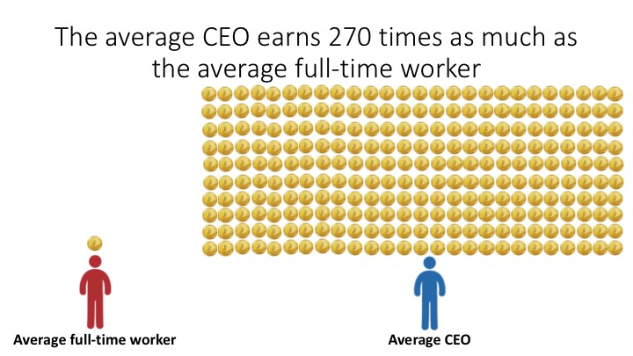

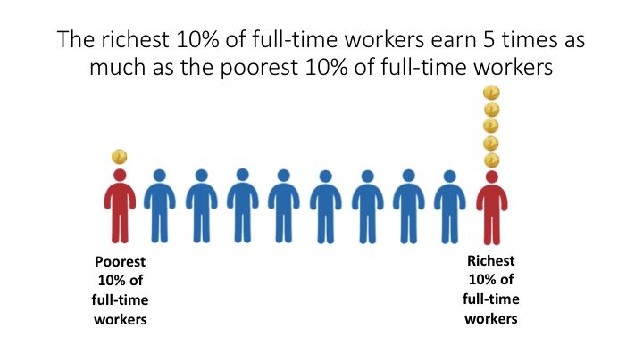
The information treatments will be given randomly allocated to occur at one of two different times in the survey. Either before the elicitation of perceptions and preferences for wage inequality (Sections B and C) or afterwards. These variations in the timing of the treatment will allow us to elicit both the perceptions of and preferences for wage inequality prior to some respondents receiving accurate information and the effect of this accurate information on some respondents’ perceptions of and preferences for wage inequality. If providing accurate information on the level of wage inequality influences the respondents’ attitudes towards redistribution, we will be able to see whether the effect is associated with a change in beliefs.

Hypotheses
Our study is motivated by the investigation of the roots of attitudes towards wage inequality and preferences for redistribution. From past research, we make two primary hypotheses about the mechanisms underlying people’s attitudes towards redistribution.
Primary Hypotheses
Hypothesis 1a: The larger the difference between people’s perceived and preferred level of inequality, the greater their support for redistribution (based on responses to Section D)
Hypothesis 1b: The larger the difference between people’s perceived and preferred level of inequality, the greater their belief that the economic system is unfair (based on responses to Section D and E)
Hypothesis 1c: The larger the difference between people’s perceived and preferred level of inequality, the greater the likelihood they will intend to take real world actions to address wage inequality (based on responses to Section F)
Hypothesis 1 is founded on the logic that the larger the gap between people’s perceptions and preferences the more likely their beliefs and preferences will indicate a desire for change. This is based on the ideas behind a series of seminal theoretical models about preferences for redistribution (e.g. Alesina and Giuliano 2011, Fehr and Schmidt 1999) and recent empirical findings that show perceptions drive people’s preferences more than what is actually the case (e.g. Gimpelson and Treisman 2018; Hauser and Norton 2017).

Hypothesis 2a: Respondents that receive a treatment are more likely to support redistribution (based on responses to Section D)
Hypothesis 2b: Respondents that receive a treatment are more likely to hold a belief that the economic system is unfair (based on responses to Section D and E)
Hypothesis 2c: Respondents that receive a treatment are more likely they will intend to take real world actions to address wage inequality (based on responses to Section F)
Hypothesis 2 is based on how beliefs and preferences are expected to change once respondents are provided with accurate information, given that prior studies have shown on average people tend to underestimate actual levels of inequality (e.g. Gimpelson and Treisman 2018; Hauser and Norton 2017). This idea has been the motivation for a series of survey experiments that provide information about the level of income inequality (e.g. Kuziemko et al. 2015), the degree of mobility (e.g. Alesina, Stantcheva and Teso 2018) and a respondents position in the distribution (e.g. Hoy and Mager 2021). However the evidence has been mixed about the effect of these types of treatments and there is yet to be a large-scale cross-country study on this topic that provides information about wage inequality. There have been a series of localised randomised experiments that suggest people do respond quite strongly to information about wage inequality (e.g. Card et al. 2012).

Analysis
General overview
We will use standard linear regression techniques to assess whether correlations in our data are compatible or not with existing theories explaining attitudes towards redistribution.
We will use our experimental informational treatment to assess the causal effect of providing specific information on the level of inequality on beliefs about inequality and attitudes towards redistribution using Sections D, E and F of the survey.
We will complement our analyses with discrete choice models such as ordered probit to ensure that our results are robust to different specifications.
Pooled samples and split samples
To ensure adequate statistical power, we will pool some of our main analyses across treatments (e.g. information before/after, information about P90/P10 income ratio and CEO vs average full-time worker) and across countries. These pooled analyses will help us assess whether providing accurate information about wage inequality influence attitudes towards redistribution, in general. We will use our large sample, to run analyses country by country to study country-specific effects. And we will run analyses treatment by treatment to study the effects of different type of information delivery.

Heterogenous treatment effects
We will investigate heterogenous treatment effects based the characteristics of respondents (collected in Section A) as well as respondents perceptions of and preferences for wage inequality when the treatment was provided after section B and C. Prior studies would suggest that heterogenous treatment effects are likely to occur based on respondents political preferences (e.g. left- or right-wing), actual income levels and satisfaction with their income (e.g. Alesina, Stantcheva and Teso 2018). Given the focus of this study on wage inequality, there is reason to believe heterogenous treatment effects may also occur in terms of respondents’ employment status, industry of employment and reported experience of intergenerational mobility (in terms of job status).

Robustness checks
Our survey includes several features that are in line with best practise to maximise data quality, including:
- A description at the start of the survey that outlines the non-partisan purpose of the study and the need for respondents to provide their full attention throughout (or risk missing out on compensation).
- Attention checks throughout the survey that remind respondents that they must provide their full attention and in some cases incorrect answers to these attention checks result in automatic disqualification from the survey.
- The ordering of questions within each section of the survey are randomized so that responses should not be disproportionally driven by respondent fatigue.
- There are logic checks throughout the survey, such as the zip/postal code respondents provide must actually exist in their country.
- Respondents must view the treatments for a minimum of 5 seconds before they are able to advance to the next stage of the survey.
Despite our best efforts to maximise data quality, there may still be reason to believe that robustness checks are required. Some examples of these robustness checks that we will conduct include:
- We will exclude the top/bottom 1%, 2%, 5% and 10% of respondents who complete the survey the fastest or slowest.
- We will winzorise and/or trim free text responses about wage levels (sections B and C), government spending allocations (section D) and charitable donations (section F) at the 1%, 2%, 5% and 10% levels.
- We will reweight the sample treatment effects to match the general population based on respondents characteristics such as age, gender and location.

References
Alesina, Alberto, and Paola Giuliano. 2011. “Preferences for Redistribution." In Handbook of Social Economics, edited by Benhabib, J. Bisin, A. and Jackson, M. 93-131. North Holland: Elsevier.
Alesina, Alberto, Stefanie Stantcheva, and Edoardo Teso. 2018. “Intergenerational Mobility and Preferences for Redistribution." American Economic Review. 108:2: 521-554.
Card, David, Alexandre Mas, Enrico Moretti, and Emmanuel Saez. 2012. “Inequality at Work: The Effect of Peer Salaries on Job Satisfaction." American Economic Review. 102:6: 2981-3003.
Fehr, Ernst, and Klaus Schmidt. 1999. “A Theory of Fairness, Competition and Cooperation." Quarterly Journal of Economics. 114:3: 817-868.
Gimpelson, Vladimir, and Daniel Treisman. 2018. “Misperceiving Inequality." Economics and Politics. 30:1: 27-54.
Hauser, Oliver, and Michael I. Norton. 2017. “(Mis)perceptions of Inequality." Current Opinion in Psychology. 18:21-25.
Hoy, Christopher, and Franziska Mager. 2021 “Why Are Relatively Poor People Not More Supportive of Redistribution? Evidence from a Randomized Survey Experiment Across 10 Countries." American Economic Journal: Economic Policy. (Forthcoming)
Kuziemko, Ilyana, Michael I. Norton, Emmanuel Saez, and Stefanie Stantcheva. 2015. “How Elastic are Preferences for Redistribution: Evidence from Randomised Survey Experiments." American Economic Review. 105:4: 1478-1508.

