Strategic Ignorance in the Presence of Bystanders

1. Introduction

A growing body of research, pioneered by Dana et al. (2007), has confirmed the prevalence of strategic ignorance (e.g., Matthey and Regner 2011; Grossman 2014; van der Weele 2014; Feiler 2014; Exley 2016; Grossman and van der Weele 2017; Momsen and Ohndorf 2020; Serra-Garcia and Szech 2021): if acting in one’s own interest might harm the interest of someone else, many individuals prefer not to know whether interests conflict or align; moreover, if given the option to stay ignorant, subjects tend to behave more selfishly.
In particular, Dana et al. (2007) found that in a binary version of the dictator game, only 26% of subjects chose the selfish alternative when payoffs were known. However, when dictators had to click a button to reveal whether there was a conflict of interest between themselves and the recipient, many abstained from revealing this information, and as much as 63% of those who actually faced conflicting interest now chose the selfish option.
Although willful ignorance may be caused by confusion or lack of interest, individuals may also avoid information in order to keep a good self-image or social image while behaving selfishly (Nyborg 2011, Grossman and van der Weele 2017, Exley and Kessler 2021). If an individual – below, the dictator – stays ignorant for such self-image reasons, however, and someone else imposes the avoided information on them anyway, this could trigger negative social reactions. Also, if the dictator knows that a bystander is likely to impose the information, this may deter the dictator from choosing ignorance in the first place. The present project aims to explore, in a context of strategic ignorance, the interplay between dictators and bystanders who may choose to impose information on the dictator.
With the exception of two studies, Lind et al. (2019) and Shalvi et al. (2019), we are not aware of previous research exploring the role of third parties in a strategic ignorance context. Our study is most closely related to, and largely inspired by, Lind et al. (2019). They used a design very similar to that of Dana et al. (2007), although with a charity rather than individual student subjects as the recipient. In additional treatments, they explored how dictators’ information choices and generosity changed with the introduction of a bystander. Lind et al. (2019) found that willful ignorance almost completely vanished when a bystander was known to be present – provided that the bystander did have the option to actually impose information: in these treatments, 94 percent of dictators chose to reveal information themselves.
Nevertheless, in spite of the close similarity to the design of Dana et al. (2007), strategic ignorance was barely present even before adding the bystander: in Lind et al.’s Hidden Payoff treatment, in which no bystander was present, as much as 78 percent of dictators revealed information themselves, and the share choosing the selfish option did not differ significantly between the Baseline and Hidden Payoff treatments. This prevented a further exploration of the interaction between the dictator and the bystander in their study: if the information is not unwelcome at the very outset, one can hardly explore the role of a bystander able to impose unwelcome information.
The present study aims to explore the interaction between information-averse dictators and bystanders with an option to provide the unwanted information. As described in more detail below, we have taken several steps to prevent the problems of low initial ignorance rates faced by Lind et al. (2019).
Our first question in the present project is whether the presence of a bystander affects the share of selfish choices by dictators. If so, is this caused by the mere presence of the bystander – through giving the dictator a feeling of being watched, for example – or is it caused by the bystander’s actual provision of information?
If the dictator would really have preferred to stay ignorant, i.e., the information is in fact unwelcome, a bystander choosing to provide information might trigger negative emotions on the dictator’s part. Our second question is thus whether bystanders’ provision of information is deterred when the dictator has an option to sanction the bystander.
Third, what determines whether dictators use the option (if available) to sanction bystanders? Are sanctions mainly used by dictators who prefer to stay ignorant? If so, do they mainly sanction bystanders who provide information? If the bystander provides information, does it matter whether the news is good (aligned interests) or bad (conflicting interests)?
Fourth, does the knowledge that a bystander is present reduce dictators’ propensity to stay ignorant, as in the study by Lind et al. (2019)?
A few recent studies (Momsen and Ohndorf 2020; Lind et al. 2019; Felgendreher 2018; Thunström et al., 2016) might indicate that the phenomenon of strategic ignorance is sensitive to context and not as robust as one may expect based on the earlier literature. Grossman (2014) found that ignorance rates vary substantially according to whether being informed is the default choice. Our own preliminary pilot studies, moreover, provide strong indications that the exact wording and/or design of the computer interface can substantially affect ignorance choices, causing ignorance rates to vary from almost negligible to a majority.
Based on this, we have taken several steps to prevent suppressing strategic ignorance that may be present at the outset, since our main research questions can only be explored in a context in which strategic ignorance prevails. First, in terms of wording, layout and default choices, we have avoided framing the information decision as an active or default choice; we have also avoid highlighting the information choice more than absolutely necessary. Second, instructions are constructed to be clear enough to understand, but brief enough to require a slight cognitive effort on subjects’ part, making it easier to ‘close one’s eyes’ for those who may want to do so. Third, except in the Known Bystander Presence treatment, the dictators are not informed about the presence of the bystanders until dictators have already made their information/ignorance choice. We do not consider this deception since, although some information is not provided initially, no erroneous or directly misleading information is provided either.
Still, since our research questions can only be explored in a context where strategic ignorance does prevail, our study will proceed in two stages.
First, we will explore in Stage 1 whether there is indeed strategic ignorance in our context, using the treatments without bystanders, the Baseline and Hidden Information treatments. These treatments correspond to the Baseline and Hidden Information treatments in Dana et al. (2007). For strategic ignorance to be considered present, some dictators must not reveal information in Hidden Information, and a significantly larger share of dictators must choose the selfish option in Hidden Information with conflicting interests than in the Baseline.
If strategic ignorance turns out to be sufficiently prevalent to allow exploration of our primary research questions, i.e., if Hypotheses 0a and 0b below are supported, we will then proceed to Stage 2; if not, the design will be modified and tested again, aiming to trigger strategic ignorance, before we proceed to Stage 2.
In Stage 2, we will add the treatments involving bystanders: the Hypothetical Messenger, No Punishment, Punishment, and Known Bystander Presence treatments.

2. Design

In the Baseline of their original study, Dana, Weber and Kuang (2007) (DWK) ran a binary dictator game experiment with student participants in which dictators had to choose between two alternatives, A and B. In alternative A, the dictator would earn 6 and the recipient 1; in alternative B, each would earn 5. About three quarters chose the fair alternative B. In DWK’s Hidden payoff treatment, however, dictators did not initially know the payoffs of the recipient in each alternative: they knew that dictators themselves would get 6 in A and 5 in B, but the payoffs to the recipient was either, with equal probabilities, 1 in A and 5 in B (non-aligned), or 5 in A and 1 in B (aligned). This uncertainty, however, could be costlessly resolved by the dictators simply by clicking a button on the screen. About half of dictators did not click the button, thus remaining ignorant about the recipient’s payoffs – and among those who were actually in the state of conflicting interests, all chose the selfish option A. Thus, the option to stay ignorant substantially reduced the resulting generosity.

 | Non-aligned |  |  | Aligned
 | Dictator | Recipient |  | Dictator | Recipient
A | 6 | 1 |  | 6 | 5
B | 5 | 5 |  | 5 | 1

Table 1. Payoffs in DKW’s Hidden Information treatment.

Our Baseline treatment replicates the incentives and main design of DWK’s baseline treatment. Some changes were made in the wording and screen interfaces (see below) to enable us to introduce the bystander in other treatments without making our treatments differ unnecessarily. In particular, this required splitting the dictator’s choices of information and allocation between two screens. All instructions are given on-screen. After an initial explanation (see Figure 1) and a simple comprehension check, dictators make their choice between options A and B.

Figure 1. First instruction screen to all participants in Baseline and Hidden Information, and to Dictators (Person 1) and Recipients (Person 2) in all treatments. (Bystanders (Person 3) get a different first screen in the Hypothetical Messenger, No Punishment and Punishment treatments.)
Our alternative treatments are Hidden Information; Hypothetical Messenger; No Punishment; and Punishment.
The Hidden Information treatment is close to the Hidden Information treatment of DWK, except for the same minor interface design adjustments as in our Baseline treatment.

Dictators are faced with the following two screens:
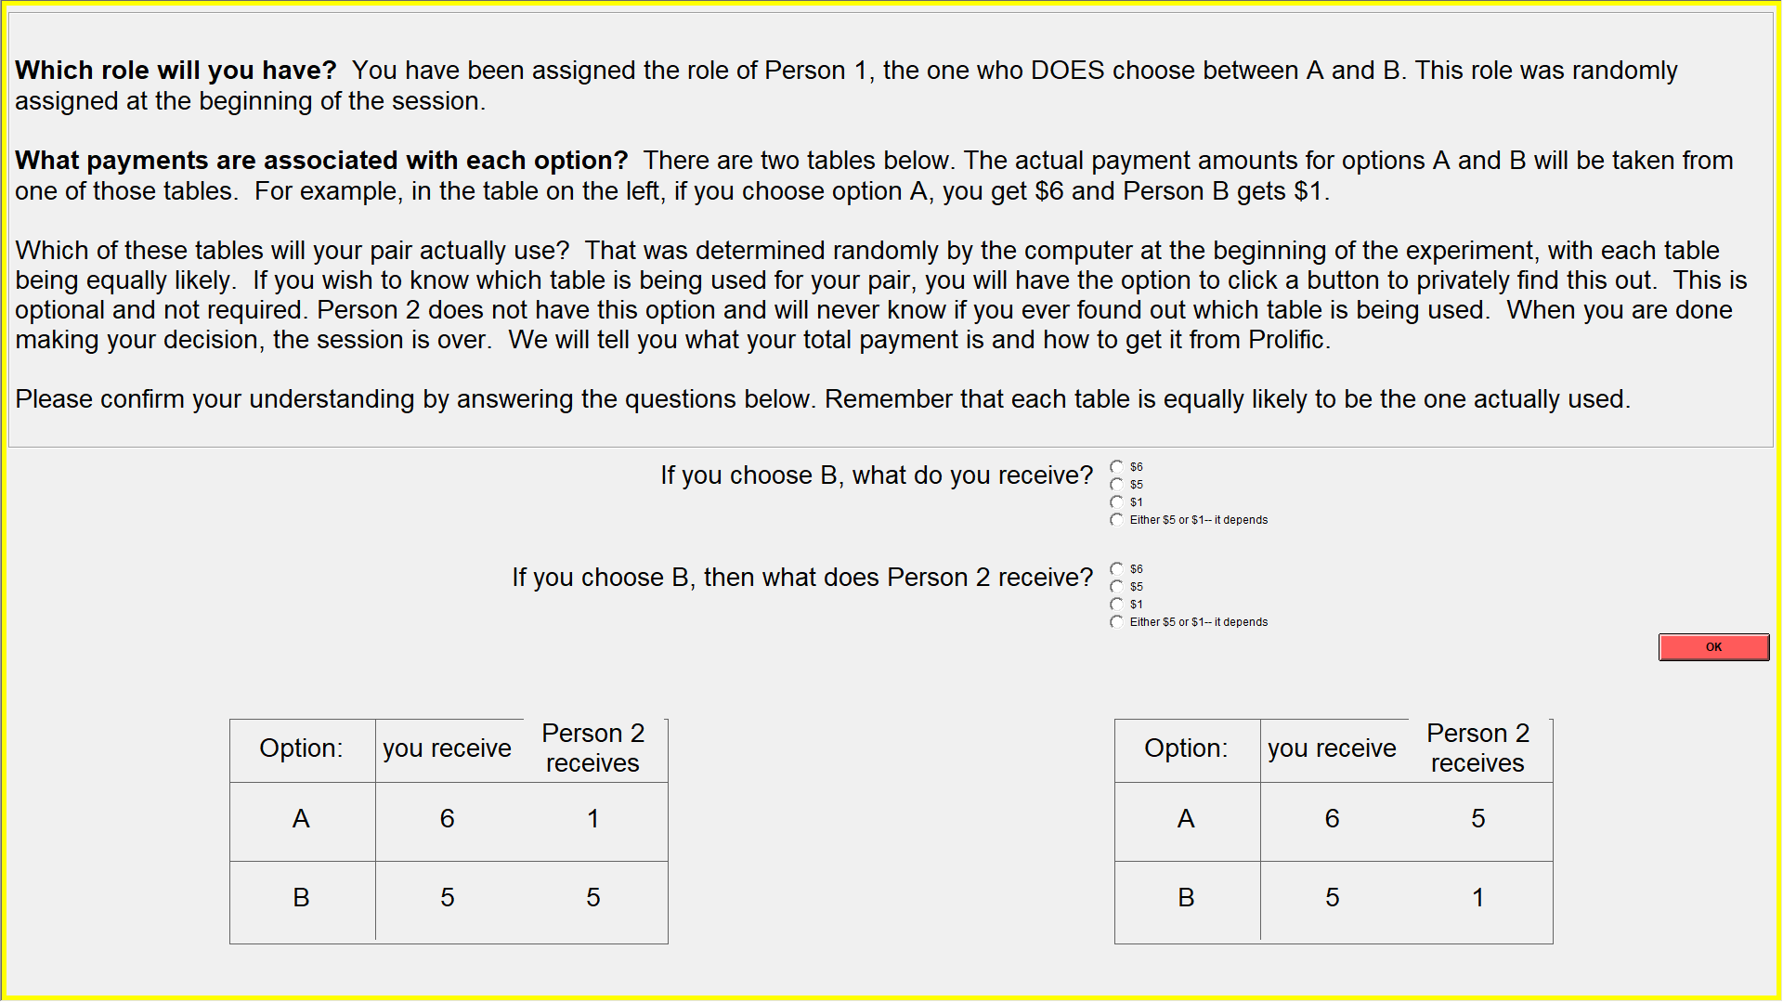
Figure 2. Dictators’ second screen, Hidden Information.

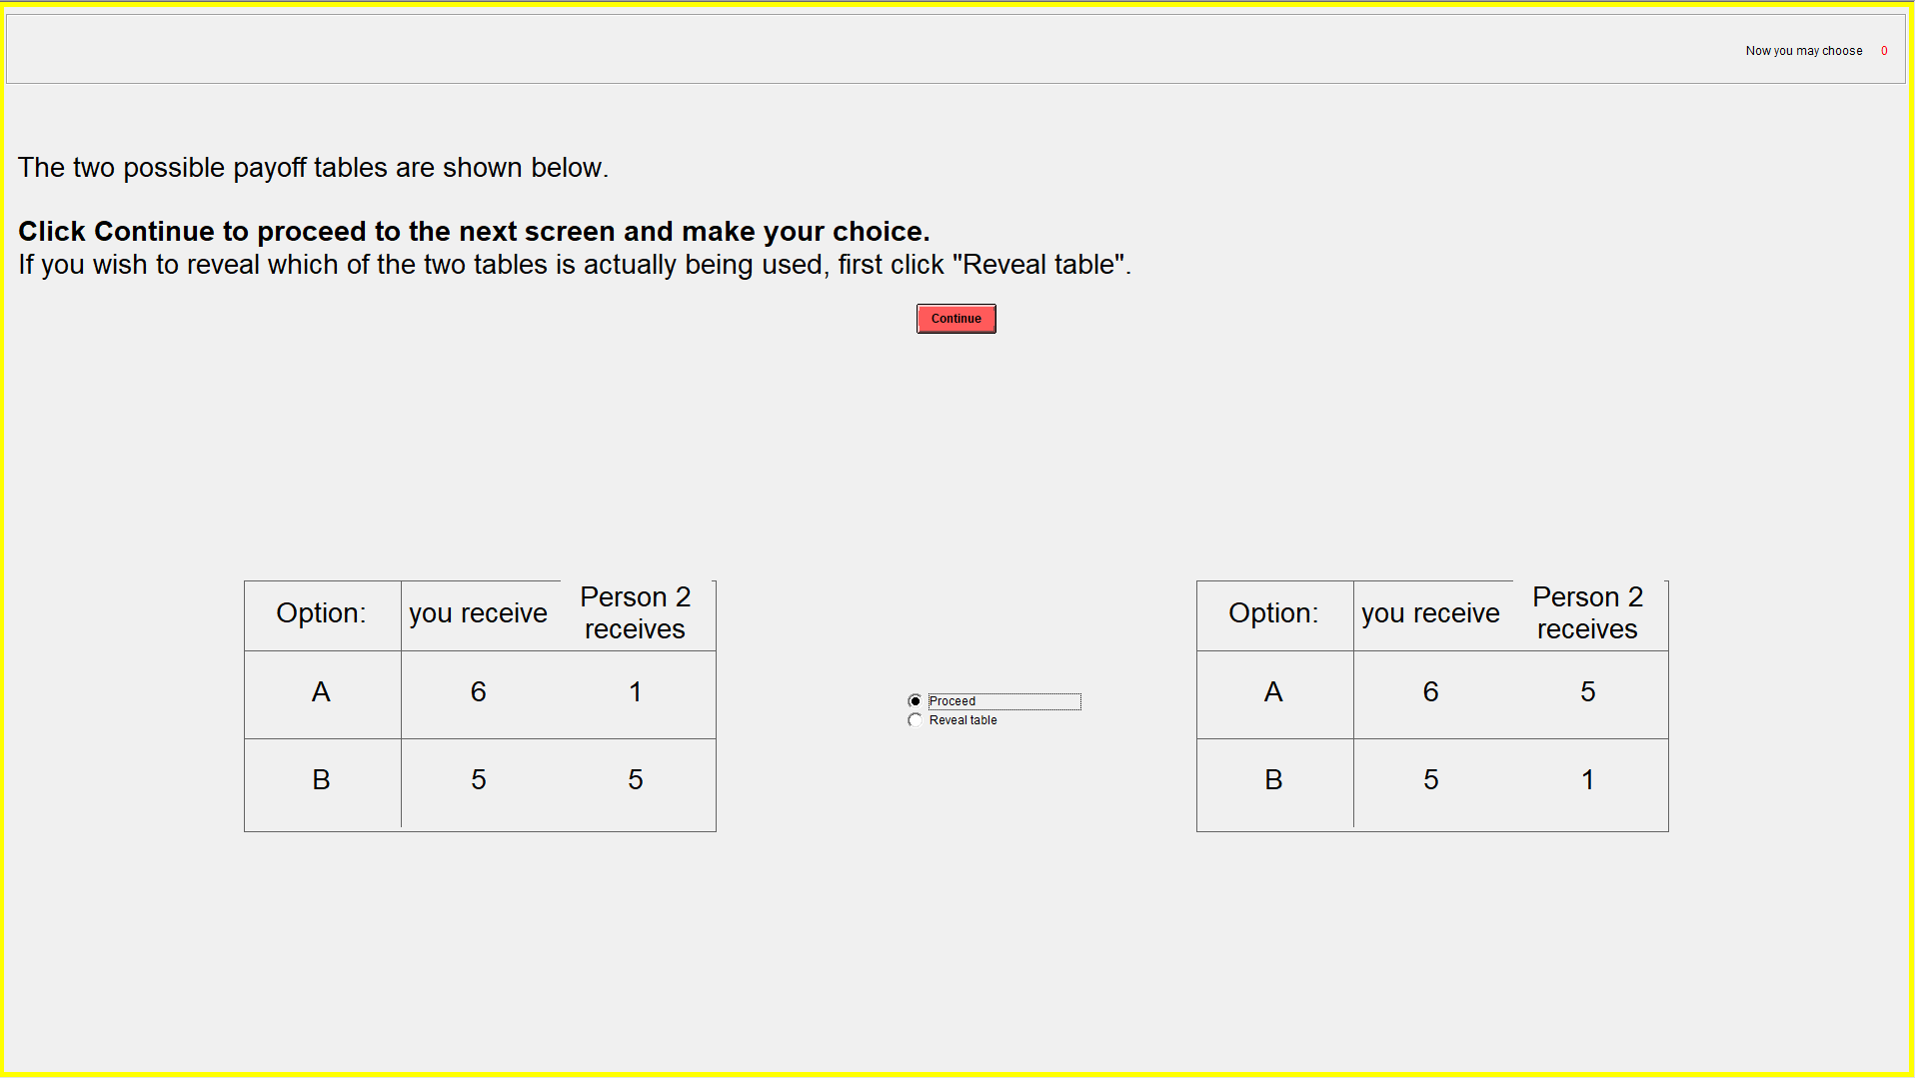
Figure 3. Dictators’ third screen, Hidden Information.
When pressing “continue” again, dictators are sent to the decision screen (after first being shown the correct table, if choosing to reveal information):
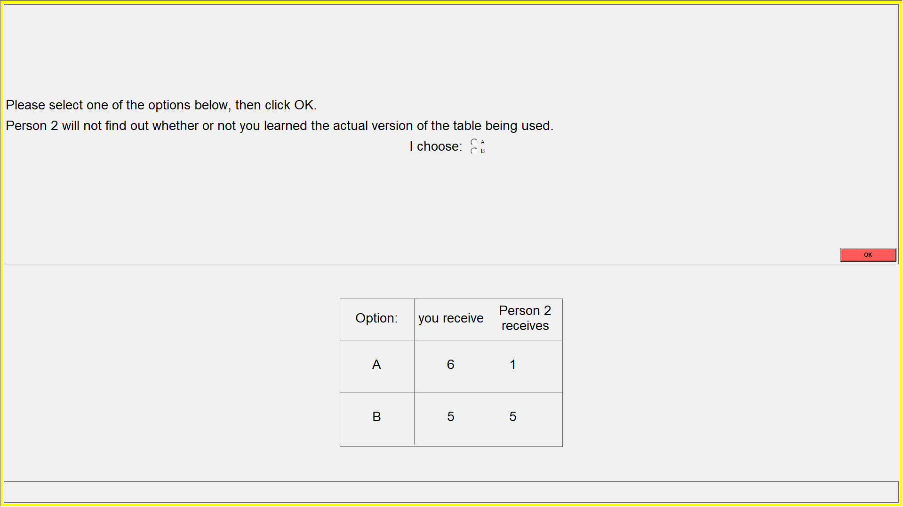
Figure 4. Dictators’ fourth screen, Hidden Information.

For Dictators (and Recipients), the Hypothetical Messenger treatment is identical to Hidden Information until and including the screen shown in Figure 3. However, before facing the option choice screen shown in Figure 4 (and before getting to see the correct table, if choosing to reveal information), dictators get to see an additional screen with the following instructions.
“You requested [did not request] information about which table is being used for your pair.
A third participant, Person 3, has been matched with your pair. Before you make your choice, we will ask Person 3 the following question: “If Person 1 did not reveal which table is being used for their pair, would you prefer to provide this information to Person 1?” The question is a purely hypothetical one, however; Person 3 will not know which table is being used, and is not able to provide any information to you. Thus, you will get to know which table is used only if you requested this information yourself.”
After the bystander makes her (hypothetical) choice, the dictator is informed about the bystander’s decision and also, if the dictator has chosen to reveal information, about the correct table. The dictator then makes his allocation decision and the game ends.

The No Punishment treatment is similar to the Hypothetical Messenger treatment except that the bystander can choose to actually impose information on a dictator. The text appearing after dictators’ information choice screen is now:
“You requested [did not request] information about which table is being used for your pair.
A third participant, Person 3, has been matched with your pair. Before you make your choice, we will ask Person 3 the following question: “If Person 1 did not reveal which table is being used for their pair, would you prefer to provide this information to Person 1?” If Person 3 responds affirmatively, you will get to know which table is being used, regardless of whether you chose yourself to reveal this information. If Person 3 responds negatively, you will get to know which table is used only if you requested this information yourself. Person 3’s payoff is independent of their choice.
We will then tell you the response of Person 3. If you and/or Person 3 asked that you are informed about the correct table, you will get this information. You will then make your choice between option A and option B.”
The bystander then makes their choice; dictators are being informed about this choice, get information about the correct table if they themselves and/or the bystander chose to reveal it, and then make their final choice between options A and B.

The Punishment treatment is similar to No Punishment, except that the dictator now has a third choice to make (i. information, ii. allocation, iii. punishment): After getting to know whether the bystander chose to impose information on him or not, he can now choose to reduce the bystander’s payoff by 2 payoff units (dollars). The dictator will not himself get these money; they are lost to participants.
The text appearing after the information choice screen is now:
“You requested [did not request] information about which table is being used for your pair.
A third participant, Person 3, has been matched with your pair. Before you make your choice, we will ask Person 3 the following question: “If Person 1 did not reveal which table is being used for their pair, would you prefer to provide this information to Person 1?” If Person 3 responds affirmatively, you will get to know which table is being used, regardless of whether you chose yourself to reveal this information. If Person 3 responds negatively, you will get to know which table is used only if you requested this information yourself. Person 3’s payoff is independent of their choice.
We will then tell you the response of Person 3. If you and/or Person 3 asked that you are informed about the correct table, you will get this information. You will then make your choice between option A and option B.
Based on what Person 3 did, you can choose whether you want to reduce Person 3’s payoff by 2 payoff units. If you use this option, you will not yourself get these money; they are lost to participants.”
Bystanders get a similar instruction screen providing them with the same information.
Bystanders make their choice, before dictators are informed about this choice and, if the bystander and/or the dictator requested this, the correct table. Dictators are then sent to their decision screen (choice between options A and B). After this, they face a new screen, where they are reminded of their own and the bystander’s information choices, and are asked whether they prefer to reduce Person 3’s payoff by 2 dollars. It is specified that Person 1’s own payoff is not affected by whether they use this option or not. When the bystander and the dictator have made their choices, the dictator is asked for their reasons to reduce Person 3’s payoff or not (open-ended question), before the game ends.

The Known Bystander Presence treatment is identical to the No Punishment treatment except that the screen informing dictators about the presence of the bystanders is shown before the screen with the information/ignorance choice. The screen informing dictators about the bystanders is identical to the screen used in No Punishment, except that the first sentence (“You requested [did not request] information about which table is being used for your pair”) is omitted.

3. Hypotheses/Results
The experimental set-up described above provides the following data:
- Dictators:
  - Information choice (yes/no)
  - Choice of alternative (A/B)
  - Punishment in Punishment treatment (yes/no)
  - Justification for punishment in Punishment treatment (open answer)
- Bystanders:
  - Choice of information provision (yes/no)
- Questionnaire
  - Demographics
  - Explanation for choices made
  - Party sympathies: Democrat/Republican/Independent
  - “How worried are you about global warming?” (Very, rather, slightly, not at all)
  - In “August 2020, how worried were you about the Covid-19 pandemic?” (Very, rather, slightly, not at all)
For cases of aligned interests, we expect a majority of dictators to choose option A.
Below, we specify our hypotheses and how they will be explored. Except for Hypotheses 0a, II, and IV, all hypotheses relate only to cases of conflicting interests.

Is there strategic ignorance?
Hypothesis 0a: There is ignorance in in Hidden Information.
Hypothesis 0b: The share of dictators choosing B in the Baseline is higher than in Hidden Information among dictators facing conflicting interests.

Does the presence of a bystander affect selfish choices?
Hypothesis Ia: The share of selfish choices is similar in Hidden Information and Hypothetical Messenger.
Hypothesis Ib: Dictators in the No Punishment and Punishment treatments who did not reveal information themselves, but on whom the bystander chose to impose information, are less likely to make selfish choices than dictators who did not reveal information themselves in Hidden Information and Hypothetical Messenger treatments.
Hypothesis Ic: Dictators in the No Punishment and Punishment treatments on whom the bystander did not choose to impose information, are equally likely to make selfish choices as dictators in Hidden Information and Hypothetical Messenger treatments.

Are bystanders deterred by punishment?
Hypothesis II: Bystanders are more likely to (want to) provide information in No Punishment than in Punishment.

What determines dictators’ punishment choice?
Hypothesis IIIa: In the Punishment treatment, dictators are more likely to take 2 dollars from the bystander if the bystander chose to impose information and the dictator chose ignorance than in the other cases (dictator chose information, or neither dictator nor bystander reveals).
Hypothesis IIIb: Dictators who chose to get information are less likely to punish bystanders imposing information than dictators who chose ignorance.
Hypothesis IIIc: Dictators who chose ignorance are less likely to punish bystanders imposing information if interests are aligned than if interests are conflicting.

Knowledge of messenger’s presence
Hypothesis IV: In Known Bystander Presence, the share of dictators choosing ignorance is lower than in No Punishment.

4. Experimental procedures

The experiments will be run online, recruiting English speaking US subjects above the age of 18 on the recruitment/payment platform Prolific, and is programmed using zTree unleashed (Fischbacher 2007, Duch et al. 2020).

5. Methods
The main tests of the hypotheses are described below, and Stata code to undertake the tests can be found in the appendix. We will also test the hypotheses using regression analysis allowing us to control for confounding variables collected through the questionnaire.
Hypothesis 0a: Check whether there are dictators in Hidden Information choosing not to get information.
Hypothesis 0b: Test the share of dictators choosing B in the Baseline treatment vs. the share in Hidden Information with conflicting interests using a proportions test and Fisher’s exact test.
Hypothesis Ia: Test the share of dictators choosing B in the Hidden Information treatment vs. the Hypothetical Messenger treatment, both with conflicting interests, using a proportion test and the Fisher exact text.
Hypothesis Ib: Pool dictators in the No Punishment and Punishment treatments with information imposed as well as the dictators in Hidden Information and Hypothetical Messenger, all with conflicting interests. Test the share of dictators playing B in the first group with the second group using a proportion test and the exact Fisher test.
Hypothesis Ic: Pool dictators in the No Punishment and Punishment treatments without information imposed as well as the dictators in Hidden Information and Hypothetical Messenger, all with conflicting interests. Test the share of dictators playing B in the first group with the second group using a proportion test and the exact Fisher test.
Hypothesis II: Compare the share providing information in No Punishment with the share in Punishment using a proportions test and the exact Fisher test.
Before testing the hypotheses regarding punishment behavior, we will undertake a descriptive analysis of the punishment behavior in all relevant cases.
Hypothesis IIIa: Compare the share punishing in the Punishment treatment between (dictator chooses ignorance and bystander imposes information) and (dictator chooses information, or both dictator and bystander choose not to reveal) using a proportions test and the exact Fisher test.
Hypothesis IIIb: Compare share punishing in the Punishment treatment between (dictator chooses ignorance and bystander imposes information) and (dictator chooses information and bystander imposes information) using a proportions test and the exact Fisher test.
Hypothesis IIIc: : When bystander imposes information and dictator chooses ignorance, compare share punishing in the Punishment treatment between conflict of interest and aligned interest using a proportions test and the exact Fisher test.
Hypothesis IV: Compare share of dictators choosing information in No Punishment and Known Bystander Presence using a proportions test and the exact Fisher test.

6. Sample size and power
Consistent with Dana et al. (2007), we design experiments to attempt to be able to discern differences of about 0.2. Considering the worst case scenario of comparing proportions of 0.4 and 0.6, we obtain the following power relationship:
To obtain a power of 80 % we should expect to need a sample of 97 subjects.

References
Dana, J., Weber, R., Kuang, J., 2007. Exploiting moral wiggle room: experiments demonstrating an illusory preference for fairness. Economic Theory 33 (1), 67–80.
Duch, M. L., Grossmann, M. R. P. and Lauer, T. (2020). “z-Tree unleashed: A novel client-integrating architecture for conducting z-Tree experiments over the Internet”. Journal of Behavioral and Experimental Finance 28, Article 100400.
Exley, C.L., 2016. Excusing selfishness in charitable giving: the role of risk. Review of Economic Studies 83 (2), 587–628.
Exley, C.L, and J. Kessler (2021): Information Avoidance and Image Concerns, NBER Working Paper 28376.
Feiler, L., 2014. Testing models of information avoidance with binary choice dictator games. J. Econ. Psychol. 45, 253–267.
Felgendreher, S. (2018): Do consumers choose to stay ignorant? The role of information in the purchase of ethically certified products. Working Paper in Economics No. 717, University of Gothenburg.
Fischbacher, U. (2007): z-Tree: Zurich toolbox for ready-made economic experiments. Experimental Economics 10, 171–178.
Grossman, Z., 2014. Strategic ignorance and the robustness of social preferences. Manag. Sci. 60 (11), 2659–2665.
Grossman, Z., van der Weele, J., 2017. Self-image and willful ignorance in social decisions. J. Eur. Econ. Assoc. 15 (1), 173–217.
Lind, Jo Thori, Karine Nyborg, and Anna Pauls. Save the planet or close your eyes? Testing strategic ignorance in a charity context. Ecological Economics 161 (2019): 9-19.
Matthey, A., Regner, T., 2011. Do I really want to know? A cognitive dissonance-based explanation of other-regarding behavior. Games 2 (1), 114–135.
Momsen, K., and M. Ohndorf (2020): When do people exploit moral wiggle room? An experimental analysis of information avoidance in a market setup, Ecological Economics 169, 106479.
Serra-Garcia, M., and N. Szech (2021): The (In)Elasticity of Moral Ignorance, Management Science, published online Nov. 21.
Shalvi, S., Sorrapera, I., Van der Weele, J., Villeval, M.C. (2019). Shooting the Messenger? Supply and Demand in Markets for Willful Ignorance. Tinbergen Institute Discussion Paper 2019-071/I.
Thunström, L., Cherry, T.L., McEvoy, D.M., Shogren, J.F. (2016): Endogenous context in a dictator game. Journal of Behavioral and Experimental Economics 65, 117–120.
van der Weele, J.J., Kulisa, J., Kosfeld, M., Friebel, G., 2014. Resisting moral wiggle room: how robust is reciprocal behavior? American Economic Journal: Microeconomics 6 (3), 256–264.

Appendix: Stata code
**** Hypothesis 0a: Any dictators in Hidden Information stay ignorant
use hidden_info, clear
tab info

**** Hypothesis 0b: The share of dictators choosing B in the Baseline is higher
* than in Hidden Information
use hidden_info, clear
keep if aligned==0
append using baseline
prtest choice, by(treatment)
tab choice treatment, exact

**** Hypothesis Ia: The share of selfish choices is similar in Hidden Information * and Hypothetical Messenger
use hypothetical_messenger, clear
keep if role==1 // Only dictators
append using hidden_info
keep if aligned
prtest choice, by(treatment)
tab choice treatment, exact

**** Hypothesis Ib: Dictators in the No Punishment and Punishment treatments on
* whom the bystander chose to impose information, are less
* likely to make selfish choices than dictators in Hidden
* Information and Hypothetical Messenger treatments
use no_punishment, clear
append using punishment
gen tid=treatment*1000+id // Id that varies between sessions
sort tid role
replace bystander_informs=bystander_informs[_n+1] if tid==tid[_n+1]
keep if bystander_informs
gen imposed_info=1
append using hidden_info
append using hypothetical_messenger
replace imposed_info=0 if mi(imposed_info)
drop if role==2

prtest choice, by(imposed_info)
tab choice imposed_info, exact

**** Hypothesis Ic: Dictators in the No Punishment and Punishment treatments on
* whom the bystander did not choose to impose information, are
* equally likely to make selfish choices as dictators in
* Hidden Information and Hypothetical Messenger treatments
use no_punishment, clear
append using punishment
gen tid=treatment*1000+id // Id that varies between sessions
sort tid role
replace bystander_informs=bystander_informs[_n+1] if tid==tid[_n+1]
keep if !bystander_informs
gen imposed_info=1
append using hidden_info
append using hypothetical_messenger
replace imposed_info=0 if mi(imposed_info)
drop if role==2

prtest choice, by(imposed_info)
tab choice imposed_info, exact

**** Hypothesis II: Bystanders are more likely to (want to) provide information in
* Hypothetical Messenger and No Punishment than in Punishment
use no_punishment, clear
append using punishment
keep if role==2
gen punishment=treatment==5

prtest bystander_informs, by(punishment)
tab bystander_informs punishment, exact

**** Hypothesis IIIa: In the Punishment treatment, dictators are more likely
* to take 2 dollars from the bystander if the bystander
* chose to impose information and the dictator chose
* ignorance
use punishment, clear
sort id role
replace bystander_informs=bystander_informs[_n+1] if id==id[_n+1]
drop if role==2
gen involuntary_info = 1 if bystander_informs & !info
replace involuntary_info = 0 if info

prtest punish, by(involuntary_info)
tab punish involuntary_info, exact

**** Hypothesis IIIb: Dictators who chose to get information are less likely
* to punish bystanders imposing information than dictators
* who chose ignorance
use punishment, clear
sort id role
replace bystander_informs=bystander_informs[_n+1] if id==id[_n+1]
drop if role==2
keep if bystander_informs

prtest punish, by(info)
tab punish info, exact

**** Hypothesis IIIc: Dicators who chose ignorance are less likely to punish
* bystanders imposing information if interests are aligned
use punishment, clear
sort id role
replace bystander_informs=bystander_informs[_n+1] if id==id[_n+1]
drop if role==2
keep if !info & bystander_informs

prtest punish, by(aligned)
tab punish aligned, exact

**** Hypothesis IV: In Known Bystander Presence, the share of dictators
* choosing ignorance is lower than in No Punishment
use no_punishment, clear
append using known_bystander_presence
drop if role==2

prtest info, by(treatment)
tab info treatment, exact

Shalvi et al. (2019) construct a competitive market in which advisers equipped with ethically relevant information offer their services to decision makers. The authors find that information averse decision makers (about 25% of all decision makers) seek advisers suppressing information. As a consequence, a competitive market for information does not substantially affect the ignorance and reduced generosity arising from endogenous information choice in a non-market context.
See also van der Weele 2014, Momsen and Ohndorf 2020, Feiler 2014, for studies of how the context and/or parameter values affect strategic ignorance.

