Baseline survey of students
Written by Jimmy Lee, Northwestern University
Note:
This survey is for students who are in treatment schools, and are selected for the household-level interventions.
---------------------------------------------------------------------------------------------------------------------
Module 0: Identifying information
Q1. Who in this student’s household is invited to the video session?
Choice (select one):
- Male elder
- Female elder
Q2. What is the relation of the invited person to the student?
Choice (select one):
- Father
- Mother
- Grandfather
- Grandmother
- Uncle
- Aunt
- Older brother
- Older sister
- Brother in law
- Sister in law
- Other relatives: please specify
---------------------------------------------------------------------------------------------------------------------
Module 1: Demographics (20 min)
Questions:
Q1. How old are you?
Numeric answer: range = 12-20
Q2. [Enumerator records] What is the gender of the student?
Choice (select one): Male/Female
Q3. What grade are you in?
Choice (select one): Grade 4 / Grade 5 / Grade 7 / Grade 8
Q4. How long have you been farming outside schools? Please answer in terms of years.
Numeric answer: range = 0-20
Q5a. Have you ever taken care of a farm on your own, without the guidance of an older person?
Choice (select one): Yes/No
Q5b. At what age did you first take care of a farm on your own, without the guidance of an older person? (Applicable if response to Q5a is yes.)
Numeric answer: 0-20
Q6a. Have you ever taken part in a Kuu labor group?
Choice (select one): Yes/No
Q6b. At what age did you first take part in a Kuu labor group? (Applicable if response to Q6a is yes.)
Numeric answer: 0-20
Q7a. Have you ever worked in the school garden?
Choice (select one): Yes/No
Q7b. How long have you been working in the school garden? Please answer in terms of months. (Applicable if response to Q7a is yes.)
Enumerator instructions: If the subject has been working in the school garden for less than 1 month, record “0”.
Numeric answer (number of months): range = 0-18
Q8a. At the moment, are you a member of the 4-H Club?
Choice (select one): Yes/No
Q8b. How long have you been in the 4-H Club? Please answer in terms of months. (Applicable if response to Q8a is yes.)
Enumerator instructions: If the subject has joined the 4-H Club for less than 1 month, record “0”.
Numeric answer (number of months): range = 0-18
Q8c. Do you hold any special positions in the 4-H Club? (Applicable if response to Q8a is yes.)
Enumerator note: special positions include Club president, vice-president, treasurer, secretary and chaplain.
Choice (select one): Yes/No
Q9a. In this rainy season, will you farm together with [response to Module 0 Q2]?
Choice (select one): Yes/No
Q9b. Which farming tasks will you perform when you are working with [response to Module 0 Q2]?
Choice (select multiple, read options to subjects):
- Land clearing
- Planting crops
- Scratching
- Weeding
- Fertilizing
- Fencing
- Harvesting
- Preparing storage of crops
- Taking farm produce to the market
- Other: please specify
Q9c. Have you ever tried teaching [response to Module 0 Q2] any new farming practices?
Choice (select one): Yes/No
Q9d. Has [response to Module 0 Q3] tried using any new farming practices that you taught? (Applicable if response to Q9c is yes.)
Choice (select one): Yes/No
Q10. How many hours per week do you spend on each of the following activities?
- Studying
(This does not include time spent at school during official school hours)
- Doing household chores other than farming
- Farming
Numeric answer: 0-168
Enumerator instructions: Ask the subject to revise responses to Q10a-Q10c if the responses to Q10a-Q10c add up to more than 168 hours.
Q11. Are you a member of a susu [i.e. a rotating savings group]?
Select one: Yes/No

---------------------------------------------------------------------------------------------------------------------
Module 2: Perceptions and intended farming decisions (20 min)
Questions:
Q1. When it comes to teaching older people in my family about farming practices:
Enumerator instructions: Ask the subject to choose the position that best represents his/her views according to a 5-point semantic differential scale.
Select one
- It is very easy because they know that I am learning in school.
- It is easy because they know that I am learning in school.
- It is neither easy nor hard.
- It is hard because they think I have less experience with farming.
- It is very hard because they think I have less experience with farming.
Q2. When it comes to ideas about farming practices:
Enumerator instructions: Ask the subject to choose the position that best represents his/her views according to a 5-point semantic differential scale.
Select one
- I always need to follow what older people in my family tell me to do, even if I disagree.
- I often need to follow what older people in my family tell me to do, even if I disagree.
- It depends on the situation.
- Older people in my family and I are often free to learn from each other.
- Older people in my family and I are always free to learn from each other.

Q3. How likely would the following situations happen to you? (7-point Likert scale)
- If I teach older people in my family new farming practices, they will say I am showing disrespect.
- If I teach older people in my family new farming practices, they will not try because the work is too hard for them.
- If I teach older people in my family new farming practices, they will blame me if the crops don’t grow well.
- If I don’t follow what older people in my family ask me to do in the field, I will not be given land in the future.
Choices:
It can never happen/It won’t happen/Maybe it won’t happen/Not sure what will happen/Maybe it will happen/It will happen/It will surely happen
Q4. Do you want to look after a farm on your own in this rainy season?
Enumerator note: With “on your own”, we mean not under the guidance of any older person. Remind the subject that this is about intention to farm on his/her own. It is okay if he/she does not have land at his/her disposal yet.
Select one: Yes/No
Q5. Do the following statements apply to you when you are planning how to farm? (Applicable if response to Q4 is yes.)
- It is hard for me to get farmland in my community.
- It takes too many steps to get farmland in my community.
- It is hard for me to get people to work on my farms.
- I don’t have enough money to buy seeds.
- I don’t have enough time to look after my farms.
- I don’t have a good enough relationship with the town chief and the respected old people in the community to get help on farm(s).
Select one: Yes/No
Q6a. Do you have land ready to start your farm? (Applicable if response to Q4 is yes.)
Enumerator note: with ready, we mean available/at their disposal.
Select one: Yes/No
Q6b. How did you get the land? (Applicable if response to Q6a is yes.)
Enumerator note: the difference between renting and borrowing is that a respondent pays for the land whilst renting but does not pay whilst borrowing.
Select multiple (read out options to the subject):
- Backyard garden
- Obtain farmland from older people in family
- Obtain farmland from older people in lineage
- Obtain community land
- Buy farmland
- Rent from others in the community
- Borrow from others in the community
- Other: please specify
Q6c. How will you get the land? (Applicable if response to Q6a is no.)
Enumerator note: the difference between renting and borrowing is that a respondent pays for the land whilst renting but does not pay whilst borrowing.
Select multiple (read out options to the subject):
- Backyard garden
- Obtain farmland from older people in family
- Obtain farmland from older people in lineage
- Obtain community land
- Buy farmland
- Rent from others in the community
- Borrow from others in the community
- Other: please specify
---------------------------------------------------------------------------------------------------------------------
Module 3: Farm management knowledge test (10 min)
Task:
Enumerators will ask students a set of 10 questions on farm management knowledge: 4 multiple-choice questions with 4 choices each, and 6 true-or-false questions. Select all that apply.
- Which of the following is a reason why sandy soil should be avoided for crop production?
[Enumerator instructions: Read out options (a)-(c), ask yes/no. After reading (a)-(c), record the choice.]
  - Because it does not hold water
  - Because it does not have enough nutrients
  - Because it does not provide stable ground for crop growth
  - None of the above

- It is important to loosen the soil before planting. Which of the following is a reason for that? Choose only one answer.
[Enumerator instructions: Read out options (a)-(c), ask yes/no. After reading (a)-(c), record the choice.]
  - It allows roots to develop more quickly in the soil.
  - It makes it easier for the plant to take in nutrients.
  - It makes planting and water absorption easier.
  - All of the above.

- When should a farmer start weeding for cassava? Choose only one answer.
[Enumerator instructions: Read out every option. After reading all options, ask subjects to choose one option. Record the choice.]
  - 1-2 weeks after planting
  - 3-4 weeks after planting
  - 5-6 weeks after planting
  - 7-8 weeks after planting

- Which of the following is true about cassava stem cuttings [sticks]? Select all that apply.
[Enumerator instructions: Read out options (a)-(c), ask yes/no. After reading (a)-(c), record the choice.]
  - Older parts of a cassava stem are better than younger parts.
  - Thicker cassava stems are better than thinner cassava stems.
  - Cassava sticks with less nodes are better than sticks with more nodes.
  - All of the above.
True or false questions

- When finding a site for planting cassava, it is good to find a place where water pools (sits down) when it rains.
[Enumerator instructions: Ask if the statement is true or false, and record the choice.]
Select one: True / False
- How deep a cassava plant reaches into the soil depends on the angle the farmer puts the cassava sticks into the ground.
[Enumerator instructions: Ask if the statement is true or false, and record the choice.]
Select one: True / False
- If you plant your cassava cuttings [sticks] closer to each other, you can get more produce because you have more crops for a given piece of land.
[Enumerator instructions: Ask if the statement is true or false, and record the choice.]
Select one: True / False
- When choosing a farm site, one sign of fertile soil is that there are a large number of different plants in the field.
[Enumerator instructions: Ask if the statement is true or false, and record the choice.]
Select one: True / False
- Weeding should always be done AFTER using fertilizer.
[Enumerator instructions: Ask if the statement is true or false, and record the choice.]
Select one: True / False
- If brown spots show on the tips of cassava leaves, it is a sign that the soil lacks nitrogen [i.e. a kind of nutrient].
[Enumerator instructions: Ask if the statement is true or false, and record the choice.]
Select one: True / False

---------------------------------------------------------------------------------------------------------------------
Module 4: Beliefs about scores in the farm management test (5 min)
Introduction to module:
Just now I gave you a test about how to look after a farm. Now I would like to ask you a few questions about your views on the test.
Questions:
Q1. There were ten questions in the test. How many questions do you think you have answered correctly?
Numeric answer: range = 0-10
Present Q2a - Q2b on the same page in the survey
Q2a. You think you have answered [answer to Q1] questions correctly in the test. How many questions would [response to Module 0 Q3] think you can answer correctly? (on a scale of 0-10)
Numeric answer: range = 0-10
Q2b. How many questions would the town chief think you can answer correctly? (on a scale of 0-10)
Numeric answer: range = 0-10
Present Q3a - Q3b on the same page in the survey
Q3a. Questions in the test were about how to look after a farm on your own. Would [response to Module 0 Q2] believe that you can correctly use the knowledge and practices in real life? (7-point Likert scale)
(Hint: Try to break down the Likert scale for the respondent by first getting from them whether they think {response to Module 0 Q2} would believe, not believe or don’t know. If the respondent’s first response is don’t know, simply select “don’t know” and move on to the next question. If the respondent’s first response is Believe, further ask how strongly they think this belief would be. (eg. Maybe believe, Believe or Surely believe). The same goes for Not believe.
Choices:
Never believe/Not believe/Maybe not believe/Don't know what he/she will think/Maybe believe/Believe/Surely believe
Q3b. Would the town chief believe that you can correctly use the knowledge and practices in real life? (7-point Likert scale)
Choices:
Never believe/Not believe/Maybe not believe/Don't know what he/she will think/Maybe believe/Believe/Surely believe
---------------------------------------------------------------------------------------------------------------------
Module 5: Agricultural innovations test (10 min)
Task:
Enumerators will ask subjects a set of 10 short questions on the promoted agricultural innovations. These 10 questions are about the following promoted innovations:
- Composting
- Making mounds or ridges for roots and tubers
- Making vegetable gardens using the dig-dig method
- Direct seeding and transplanting
- Seed germination test

Questions:
For Q1, show the following pictures of compost piles and pits.
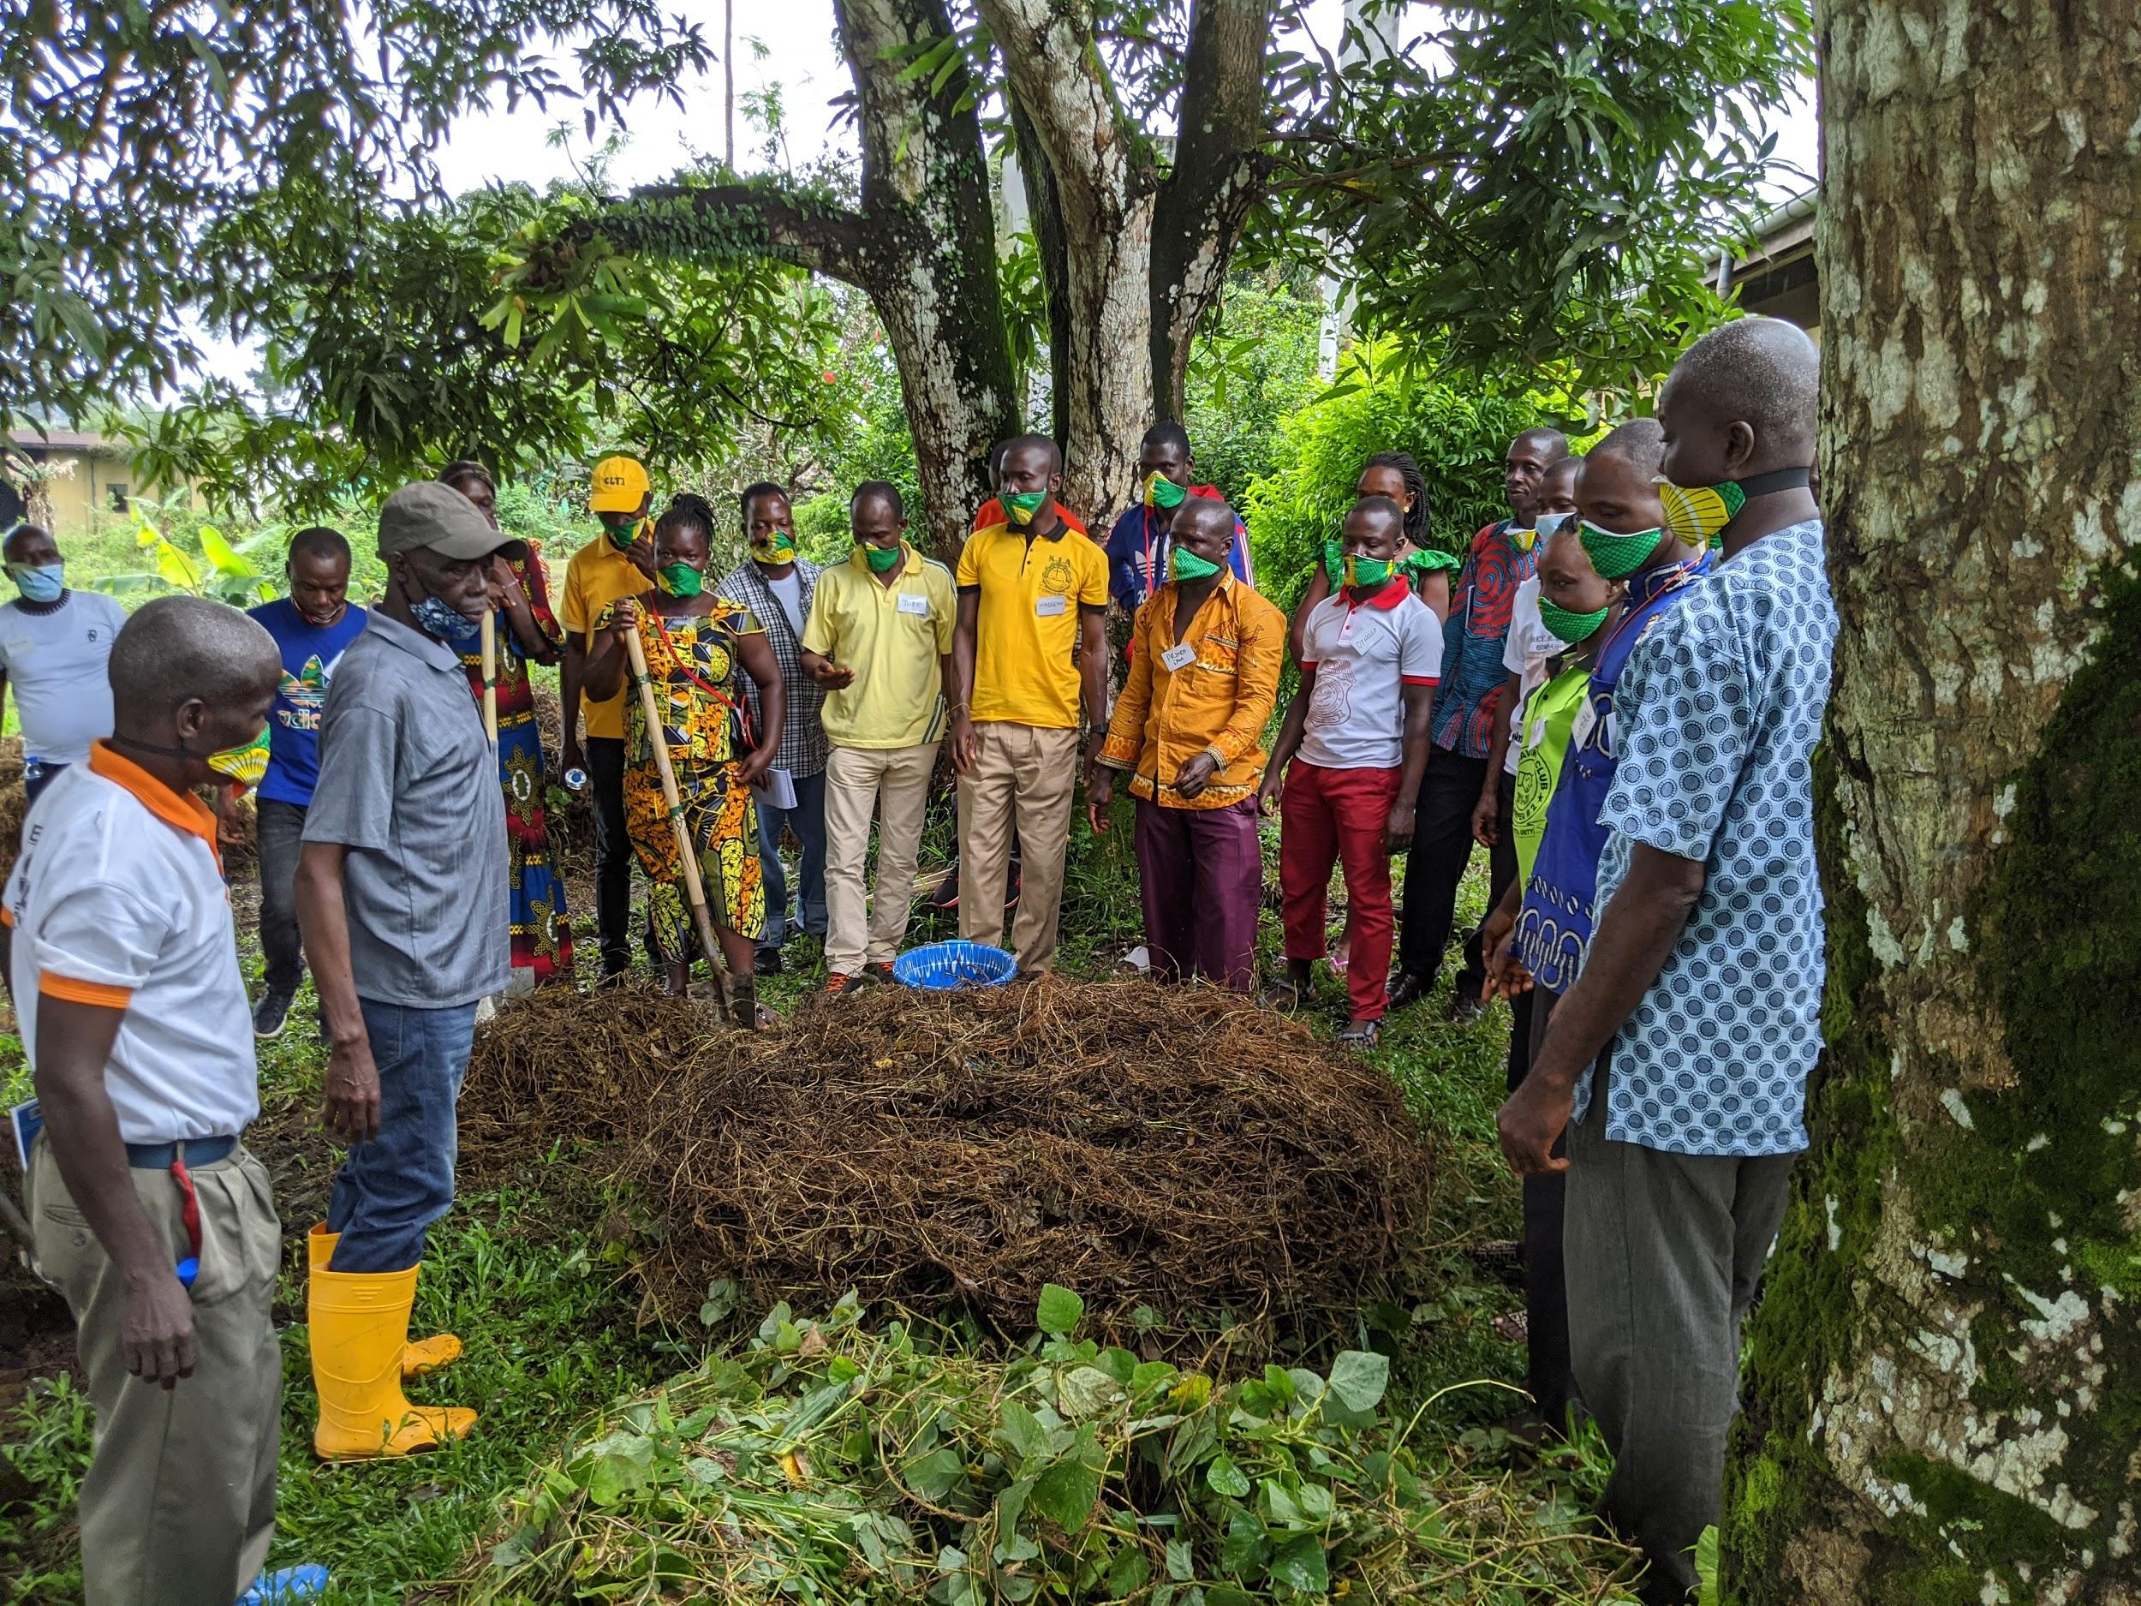
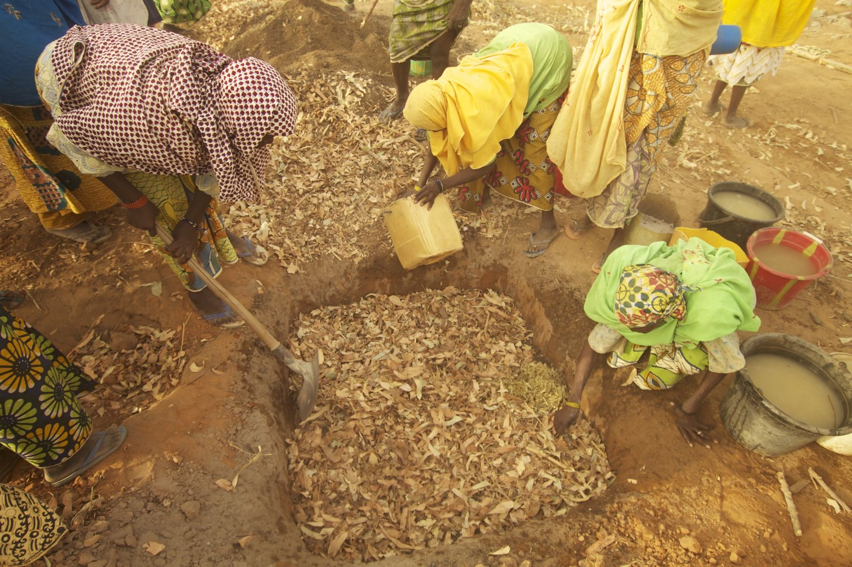

(Read to subjects) Explanation:
Composting is a practice of making natural fertilizer. This means the fertilizer does not use any chemical material, it is only natural. Farmers can use things like animal waste or poo, cassava dirt, and leaves. It can either be made above the ground, in piles (enumerator, show the picture).
You can also make a hole in the ground, and put the materials in there. These are called pits (enumerator, show the picture).

Q1a. Have you ever made compost fertilizer piles or pits?
Select one: Yes / No
Q1b. A compost [fertilizer] pile, which is above the ground, should be turned after how many weeks?
Numeric answer: range = 0-10
Q1c. True-or-false: During the rainy season, it is better to use pits than piles to make a compost [fertilizer].
[Enumerator instructions: Ask if the statement is true or false, and record the choice.]
Select one: True / False
For Q2, show the following pictures of mounds and ridges.
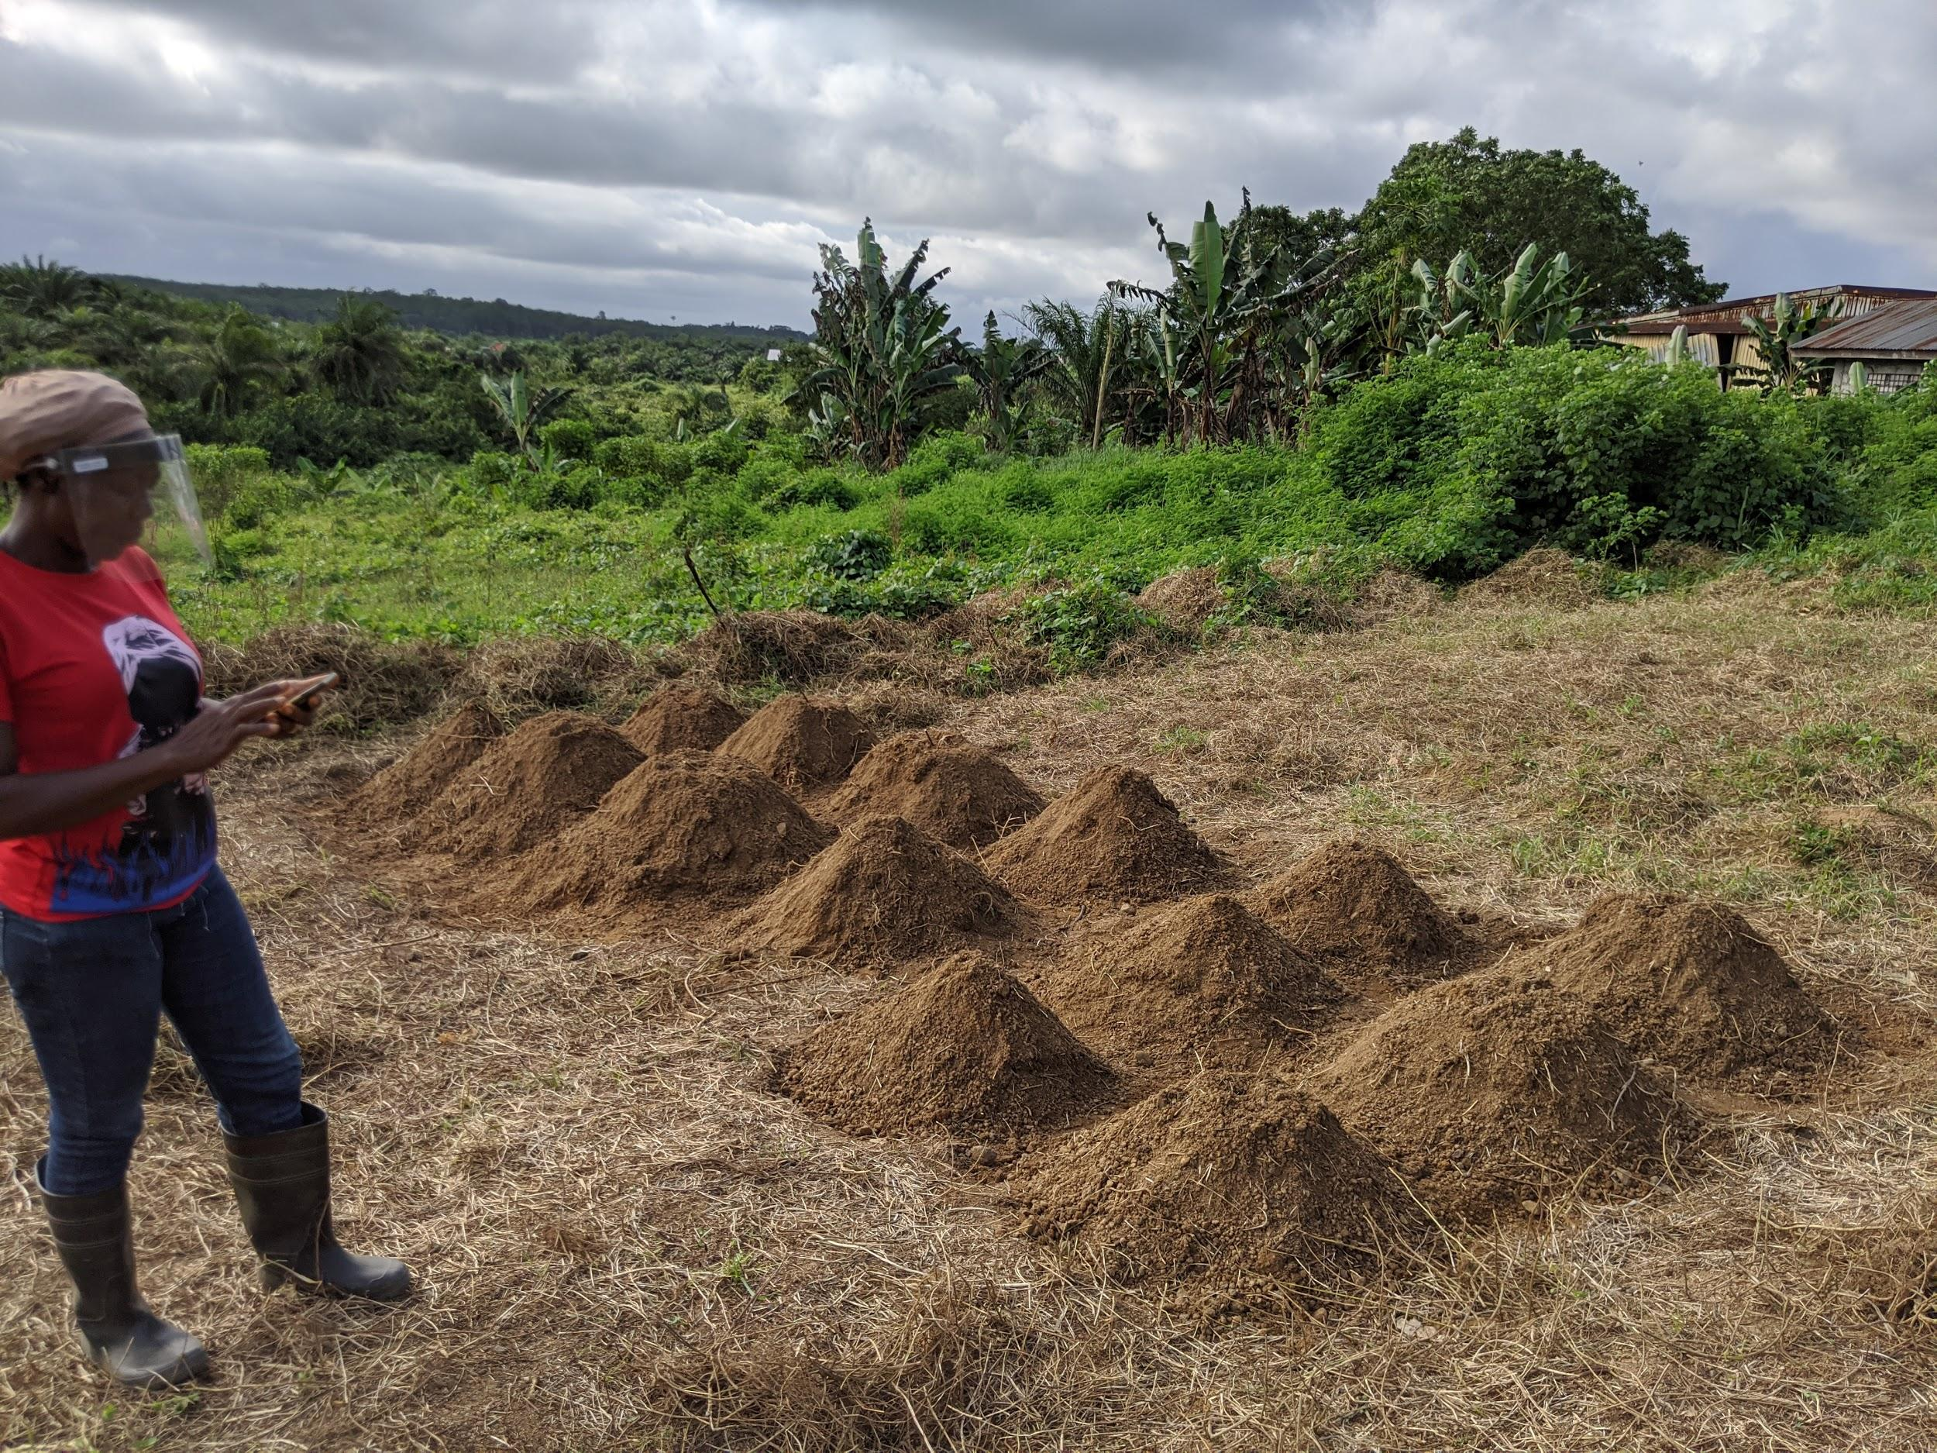
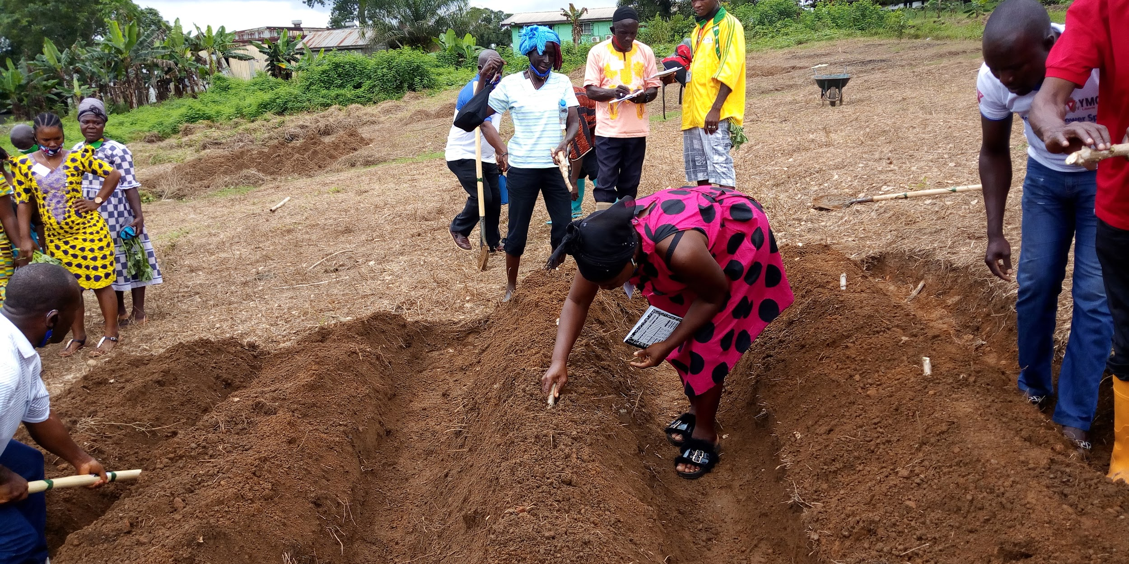
(Read to subjects) Explanation:
These are raised beds. This means the farmer does not farm on flat land. There are two types. One is like a hill, and is called mounds. They look like this (enumerator, show the picture).
One is called ridges, and looks like this (enumerator, show the picture).

Q2a. Have you ever made mounds or ridges for growing roots and tuber crops [e.g. cassava and sweet potatoes]?
Select one: Yes / No
Q2b. Which of the following is a benefit of using mounds and ridges to grow cassava?
Enumerator instructions: Read out options (a)-(c), ask yes/no. After reading (a)-(c), record the choice.
- It prevents the crop from taking in too much water when it rains.
- It allows plants to reach deeper into the soil and grow bigger.
- It makes harvesting easier.
- All of the above.

Q2c. True-or-false: On steep slopes, it is always better to grow cassava using ridges than mounds.
Enumerator instructions: Ask if the statement is true or false, and record the choice.
For Q3, show the following picture of a vegetable garden made using the double-dig method.
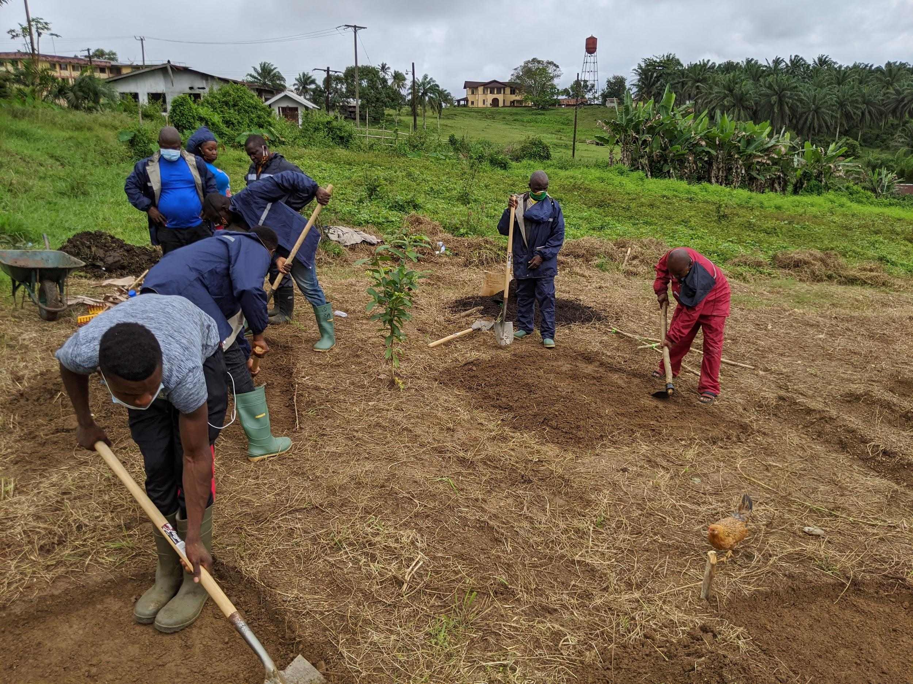
(Read to subjects) Explanation:
This is a garden using the dig-dig method. The topsoil is first removed.
You take other soil that is rich in nutrients and you replace the topsoil with it.

Q3a. Have you ever made a vegetable garden using the dig-dig method?
Select one: Yes / No
Q3b. True-or-false: After using the dig-dig method, you should step in the garden bed to water the plants.
[Enumerator instructions: Ask if the statement is true or false, and record the choice.]
Select one: True / False
Q3c. Select one: After using the dig-dig method, what should you use to water the plants?
[Enumerator instructions: Read out options (a) and (b). After reading (a) and (b), ask the subject to choose one. Record the choice.]
- Watering can
- Water bucket
Select one: (a) / (b)
For Q4, show the following picture of a nursery.
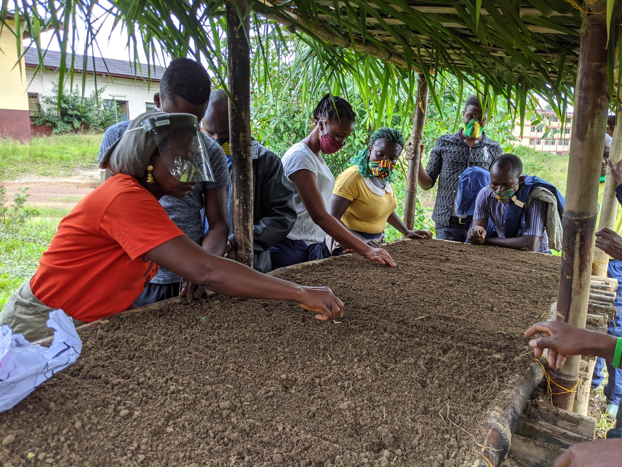
(Read to subjects) Explanation:
This is a nursery. The practice of transplanting means to plant seeds first in the nursery, and then taking seeds to the field.
Q4a. Have you ever moved seeds from the nursery to the field?
Select one: Yes / No
Q4b. After how many weeks can you move pepper seeds from the nursery to the field?
Enumerator instructions: Ask the subject to give a number, and record the number.
Numeric answer: range = 0-10
Q4c. Multiple choice: For which of the following crops, it is better to sow seeds directly into the soil than to start in the nursery?
Enumerator instructions: Read out every option. After reading all options, ask the subject to choose one. Record the choice.
- Collard greens
- Eggplant
- Okra
- Bitterballs
Select one: (a) / (b) / (c) / (d)
For Q5, show the following picture of a seed germination test.
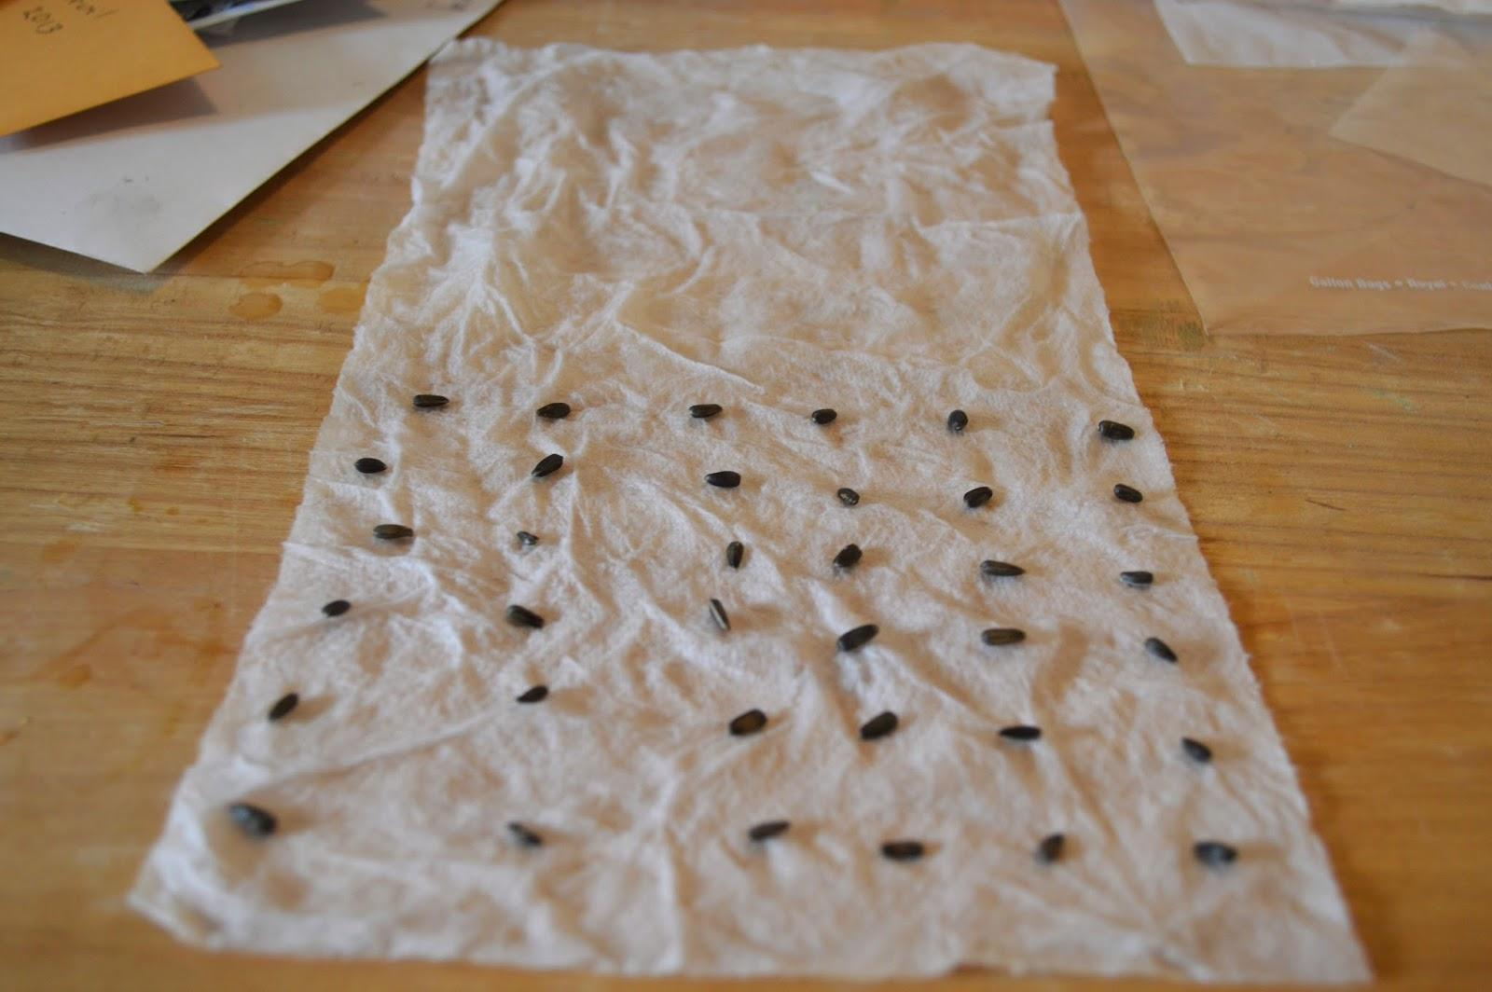
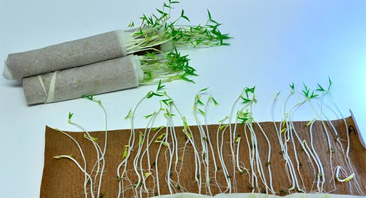
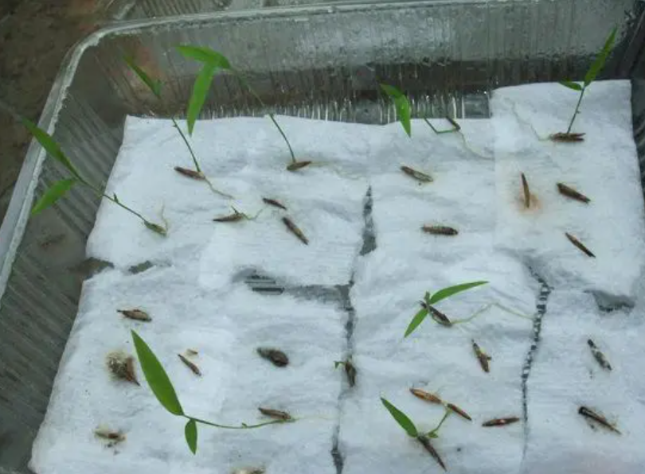

(Read to subjects) Explanation:
The purpose of a seed test is to see if seeds are usable for planting. Some people also call it a seed germination test. It can either be done on a nursery or in a rolled cloth (enumerator, show this picture and the picture on the next page). Show the picture and explain to the respondent this is also the rolled cloth method. You can also put the seeds in a bucket of water to do a seed germination test (enumerator, show the picture).

Q5a. Have you ever done a seed germination test before planting?
Select one: Yes / No
Q5b. After placing seeds in a rolled cloth, how many days do you have to wait to see the results of a seed germination test?
Enumerator instructions: Ask the subject to give a number, and record the number.
Numeric answer: range = 0-10
Q5c. Select one: Imagine you put 10 seeds to a seed germination test. In which situation do you need to get more seeds for planting?
Enumerator instructions: Read out options (a) and (b). After reading (a) and (b), ask the subject to choose one. Record the choice.
- If 4 seeds germinate
- If 6 seeds germinate
Correct answer: (a)
Select one: (a) / (b)

Introduction to Q6-Q8:
Just now I gave you a test about new farming practices. Now I would like to ask you a few questions about your views on the test.
Questions:
Q6. There were ten knowledge questions in the test. How many questions do you think you have answered correctly?
Numeric answer: range = 0-10
Present Q7a - Q7b on the same page in the survey
Q7a. You think you have answered [answer to Q6] questions correctly in the test. How many questions would [response to Module 0 Q3] think you can answer correctly? (on a scale of 0-10)
Numeric answer: range = 0-10
Q7b. How many questions would the town chief think you can answer correctly? (on a scale of 0-10)
Numeric answer: range = 0-10
Present Q8a - Q8b on the same page in the survey
Q8a. Questions in the test were about how to use new farming practices. Would [response to Module 0 Q2] believe that you can correctly use the new practices in this rainy season? (7-point Likert scale)
Choices:
Never believe/Not believe/Maybe not believe/Don't know what he/she will think/Maybe believe/Believe/Surely believe
Q8b. Would the town chief believe that you can correctly use the new practices in this rainy season? (7-point Likert scale)
Choices:
Never believe/Not believe/Maybe not believe/Don't know what he/she will think/Maybe believe/Believe/Surely believe
---------------------------------------------------------------------------------------------------------------------
Module 6: Beliefs about yields (5 min)
Questions:
Q1. Have you ever seen older people in your community harvest cassava?
Enumerator instructions: Emphasize to the subject that this is about the harvesting process, not the planting process.
Choice: yes/no
Q2a. Imagine an older person in your community grows cassava for 9-10 months. What do you think is the highest number of cassava tubers that can be harvested from 1 plant?
Enumerator instruction: Remind the subject that this adult farmer is not from the subject’s family.
Numeric answer: range = 0-15 (Do not show subjects the range. If the subject gives a response outside this range, ask him/her to revise and show visual aid again.)
Include visual aids

Q2b. Now imagine that person has 4 cassava plants. Some of these plants might do well, some of these plants might not do well. How many cassava tubers do you think the person could harvest from 4 plants?
Enumerator note: If the subject reports a number that is different from 4 times the amount reported in Q2a, this does not mean the answer is wrong.
Numeric answer: range = 0-60 (Do not show subjects the range. If the subject gives a response outside this range, ask him/her to revise and show visual aid again.)
Include visual aids

Q3a. Now imagine that you plant cassava on your own for 9-10 months. What do you think is the highest number of tubers that you can harvest from 1 plant?
Numeric answer: range = 0-15 (Do not show subjects the range. If the subject gives a response outside this range, ask him/her to revise and show visual aid again.)
Include visual aids
Q3b. Now imagine you have 4 cassava plants. Some of these plants might do well, some of these plants might not do well. How many cassava tubers do you think you could harvest from 4 plants?
Enumerator note: If the subject reports a number that is different from 4 times the amount reported in Q3a, this does not mean the answer is wrong.
Numeric answer: range = 0-60 (Do not show subjects the range. If the subject gives a response outside this range, ask him/her to revise and show visual aid again.)
Include visual aids
Q4a. Based on your answers to previous questions, you think that you can harvest [more/the same number of/less] cassava tubers [than/as/than] an adult farmer in your community. Is that correct?
Select one: Yes/No
[Enumerator instruction: If the subject answers no in Q4a, show Q2b and Q3b again on the same screen. Allow the subject to revise his/her answers to Q2b and Q3b. Then ask Q4a again.]
Q4b. You think that you can harvest [more/the same number of/less] cassava tubers [than/as/than] an adult farmer in your community. Would {response to Module 0 Q2} agree with you? (7-point Likert scale)
Choices:
Disagree badwy/ Disagree / Disagree small/ Neutral(No opinion) / Agree small/ Agree / Agree badwy
Q4c. You think that you can harvest [more/the same number of/less] cassava tubers [than/as/than] an adult farmer in your community. Would the town chief agree with you?
Choices:
Disagree badwy/ Disagree / Disagree small/ Neutral(No opinion) / Agree small/ Agree / Agree badwy

---------------------------------------------------------------------------------------------------------------------
END OF SURVEY

