The effect of voicebots on lying behavior for financial gain

- Variables
  - conditions: reporting channels(AI_condition: text, chatbot, AIbot,human), voicegender(feminine, masculine)
  - key outcome var: # of heads reported
    - # of heads reported of 7 times coin tosses: (0-7)
  - elicitation of subjects’ belief on the credibility of emotion detection of chatbot
    - can detect emotion: yes, no, don’t know (0,1)
    - how accurate was the chatbot detecting emotion (0-10)
  - experience/attitudes about chatbots: likert scale strongly disagree to strongly agree (0-10)
    - frequency of usage of chatbots: I use chatbots very often.
    - understanding of chatbots: I believe chatbots understand me well
    - capability of chatbot in solving problems: I feel chatbots can solve my problems
    - frustration in interacting with chatbots: I feel frustrated when I am interacting with chatbots
    - prefer to interact with a chatbot than a person: I rather interact with a chatbot than a person
  - perception of AI: likert scale strongly disagree to strongly agree (0-10)
    - I am familiar with AI
    - I trust AI
    - I fear AI
    - AI will destroy humankind
    - AI will benefit humankind
    - AI will cause many job losses
  - perception of female and male AI voice: likert scale (0-10)
    - Attractiveness
    - Authoritativeness
    - Confidence
    - Familiarity
    - Likeability
    - Trustworthiness
    - Warmth
  - trustiness of others: likert scale strongly disagree to strongly agree (0-10)
    - Most people can be trusted
    - Most people are helpful
    - Most people are fair
  - trustiness of yourself: likert scale strongly disagree to strongly agree (0-10)
    - I am trustworthy
    - I am fair
    - I never tell lies to family and close friends
    - I never tell lies to my partner or spouse
    - I never tell lies to acquaintances
    - I never tell lies to strangers
  - gender (m, f, other)
  - age (18-22, 23-27, 28-35, 36-45, 46-55, 56 or over)
  - race/ethnicity (white, black or african American, American Indian or alska native, Asian, native Hawaiian or pacific islander, other, dwtanswer)
  - education level: less than high school degree, high school graduate, some college but no degree, associate degree in college 2-year, associate degree in college 4-year, master’s degree, doctoral degree, professional degree

- Constructed Variables
  - credibility of emotion detection of chatbot
  - chatbots attitude
    - chatbot_attitude: add all questions on chatbots, reverse code one question and standardize.
  - AI attitude
    - ai_attitude: add all questions on AT attitudes, reverse code two questions, and standardize.
  - voice perception
    - authoritativeness
  - trust of others
  - truth of self

- Simple Hypotheses: humanity of observer, levels of sophistication of chatbots
- H1a (Voicebot compared to human increases # of heads)
  - show CDFs
  - KS test (differences in distribution)
  - t-test
  - proportions test
- H1b (AI compared to human increases/decreases # of heads)
  - Analogous analysis as part (a)
- H1c (AI compared to chatbot decreases # of heads)
  - Analogous analysis as part (a)
- H2 (voice gender difference: feminine AI/person/increases # of heads)
  - Analogous analysis as part (a)
- H3 (acoustic features/pitch increases as # of heads increases)
  - Between subjects comparison
  - Within subjects comparison

4. Regression Hypotheses
- H4 (outcome: # of heads, acoustic features/pitch: how the reporting channels and the gender of voice affect the outcomes )
  - # of heads =
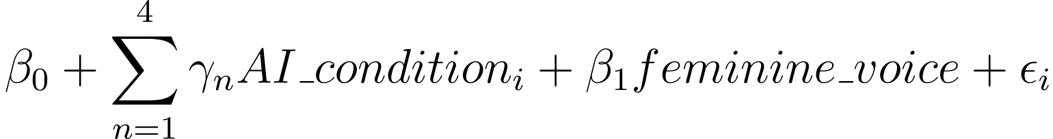

Outcomes: # of heads(logit), acoustic features
- H6 (Mediation Analysis: how the effects of levels of sophistication of voicebots mediated by credibility of emotion detection, voice perception)
  - Details depend on results found above.
- H5(Heterogeneous treatment effects on # of heads (Moderation analysis: how the effects of levels of sophistication of chatbots moderated by AI attitudes, chatbot attitudes, trust of others, trust of self, gender, age, race, educational level))
# of heads_{i} =
Moderators: AI attitudes, chatbot attitudes, trust of others, trust of self, gender, age, race, educational level

