Improving Teacher Uptake of Effective FLN Instructions using Behavioural Principles

Abstract
Foundation Literacy and numeracy (FLN) is critical for a child's education. India’s National Education Policy (NEP) recommends a set of basic literacy and numeracy skills to be acquired by Grade 3. These requirements are not met in many districts in India for various reasons. Here, in a field experiment, we plan to test interventions targeted at improving teacher uptake of effective FLN instructions. As part of the interventions, bite-sized videos on effective teaching practices will be shared with the teachers, or summaries of daily lesson plans from the teacher guides will be made accessible through a WhatsApp Chatbot.

Introduction
Foundational literacy and numeracy (FLN) levels in India are low and have declined further. The National Education Policy (2020) proposes a National Mission on Foundational Literacy and Numeracy (FLN) - prioritising an area that evidence suggests is critical for overall education outcomes. Studying global trends of learning outcomes and trajectories across years shows that learning shortfalls start early. Students who exit grade 3 without having acquired basic literacy and numeracy skills do not pick up these skills even by the end of primary school. The learning gap continues to widen from that point, as the texts in the language textbooks and mathematical concepts become more complex and abstract in later primary grades.

The foundational learning (FLN) crisis faced by our country today, cannot be solved through top-down policy approaches or business-as-usual increments in national education expenditure alone. Solutions to this crisis preclude recognising that bottom-up approaches involving all stakeholders in the education ecosystem are necessary. Key amongst all these stakeholders are teachers. In order to truly improve FLN outcomes at scale, we must facilitate teachers’ adoption of effective pedagogical practices envisioned in India’s FLN mission, NIPUN Bharat. The program lays strong emphasis on building teacher capacity through the provision of high quality training and providing teachers with teaching and learning materials to make classroom teaching more effective. Despite efforts at training, and providing requisite information and materials, teacher adoption of effective practices remains low.

Existing literature highlights that a behavioural lens is needed in education because various obstacles to change may exist within the system. Teachers’ adoption of effective pedagogical practices may also be influenced by lack of motivation, lack of the ability to translate their intent into action, and other behavioural biases affecting their perception of choices and options available to them.

Our diagnostic findings based on qualitative research across three districts of Uttar Pradesh also corroborate these claims:

- Teachers are adopting parts of the program that are aligned to their previously held beliefs. There is evidence of status quo bias with an unwillingness to invest in new techniques and complete adoption being perceived as difficult.
- Teachers experience cognitive overload from juggling multiple teaching and non-teaching responsibilities and limited user-friendliness of teacher guides.
- Teachers believe that low learning outcomes are outside the teacher's locus of control and exhibit low ownership by shifting the blame towards irregular student attendance, low parental engagement and mental ability of students.
- Teachers’ agency is affected by the focus on complying with trackable aspects of the program, and they may feel micromanaged.
- Teachers believe that learning happens by default i.e., if they teach, students will learn regardless of the teaching methods used, and do not give much importance to lesson planning.
- Teachers have limited understanding of evidence-based pedagogical techniques such as gradual release of responsibility, or the link between the activities in teacher guides and learning outcomes, this suggests limited technical know-how due to inadequate training.

This project aims to test behaviour change strategies to improve foundational learning outcomes in Uttar Pradesh. The insights from these research experiments will aid in developing public goods by CSBC (Centre for Social and Behaviour Change) and CSF (Central Square Foundation) for States designing their foundational learning programs. The interventions designed and tested in this project will aim to improve behavioural outcomes for teachers. Based on the insights from the diagnostic, we intend to focus on the below areas:

- Teachers use Teacher guides for planning and teaching
- Teachers use targeted questioning (using student engagement strategies)
  - Teacher asks specific questions (close/open ended) to individual students
  - Teacher asks questions to most students and not just a selected few.
  - Teachers can identify which students are struggling.
  - Teacher adjusts instruction based on student response
- Teachers undertake Balanced -literacy approach with skills focussed on decoding
  - Shares target Varna/Matra (letter/accent) sounds with the students and makes them repeat (I-do)
  - Makes children identify the target varna/maatra sound first and then its symbol (We do)
  - Teaches get children to write the varna/maatra
  - Teachers get the children to blend the varna/maatra to form words

- Teachers undertake Gradual Release of Responsibility (GRR)
  - Models and explains the concept on the board (I do)
  - Performs an activity with the children using concrete objects or pictures to explain the concept (We Do)
  - Makes children practise the concept or procedure multiple times (you do)
- Teachers give students dedicated time for student practice with feedback.

Based on our qualitative diagnosis, we designed interventions that we hypothesised would increase the adoption of effective teaching practices. Our main objectives for the interventions are:
- Demystify desired teaching behaviours by breaking them down into smaller practices with clear actionable steps to help teachers integrate these key practices into their teaching.
- Make the instructional material and information therein easier and more accessible to increase the likelihood of teachers its adoption and application
- Use various behavioural nudges such as reminders, motivational and social-proof messages, non-monetary rewards etc. to make teachers adopt the desired practices and processes.

This document outlines a proposed experiment using the randomised controlled methodology to assess the effectiveness of the proposed interventions in increasing the teacher uptake of evidence-based and effective teaching practices.

Methods

Experimental Design Overview
Our design is a randomised control experiment. The study population will be Grade 3 teachers in government schools of Sitapur and Hardoi districts of Uttar Pradesh. Sampled schools will be randomly assigned to control or either of the two treatment arms. The recruitment criteria and the treatment arms are explained in the following sections.
Recruitment will be followed by one in-person baseline survey that includes treatment initiation and a questionnaire to measure adoption, value perception, confidence, knowledge, attitudes, past behaviour, and standard demographics. The treatment period will last 6 months, followed by an endline survey.

Sample Identification
The study will be conducted in the districts of Sitapur and Hardoi of Uttar Pradesh. The districts have been chosen based on size, accessibility, performance proximity to state averages on various development indicators, and likelihood of other interventions/programs overlapping with our interventions.

Sitapur has approximately 2408 primary schools (Grades 1-5) and 611 composite schools (Grades 1-8) spread across its 23 blocks. In Hardoi, there are approximately 2423 primary schools and 408 composite schools spread across 25 blocks. Thus, schools will be sampled from roughly 5850 schools. Grade 3 teachers will be selected for the study from the sampled schools.

Grade 3 teachers from the selected schools of the two districts will be invited for the baseline survey at the block-level office and only those who provide consent will be selected to participate in the study. A screening test will also be conducted to check for whether teachers have WhatsApp accounts. The recruitment exercise will be carried out in support and consultation with the district and block education administration. Reserve/back-up schools (~ 5-10%) will be selected in each block in case the target sample is not reached.

Eligibility Criteria
- Teachers of grade 3 at a hindi-medium government school in the sampled geographies.
- Must have access to Smartphone
- Must have access to internet connection
- Must have access to WhatsApp

Treatment Components

Treatment arm 1: The first treatment arm intends to increase adoption of TGs by making accessible to teachers simplified summaries of daily lesson plans in the form of bite-sized texts or audio-notes through a WhatsApp Chatbot. A series of clicks and simple entries will enable teachers to get acquainted with the content of daily lesson plans for literacy and numeracy in a few seconds. This will be supplemented by friendly nudges and positive messaging and an in-built reward mechanism to aid habit formation. Figure below summarises the basic conversational flow of the bot.

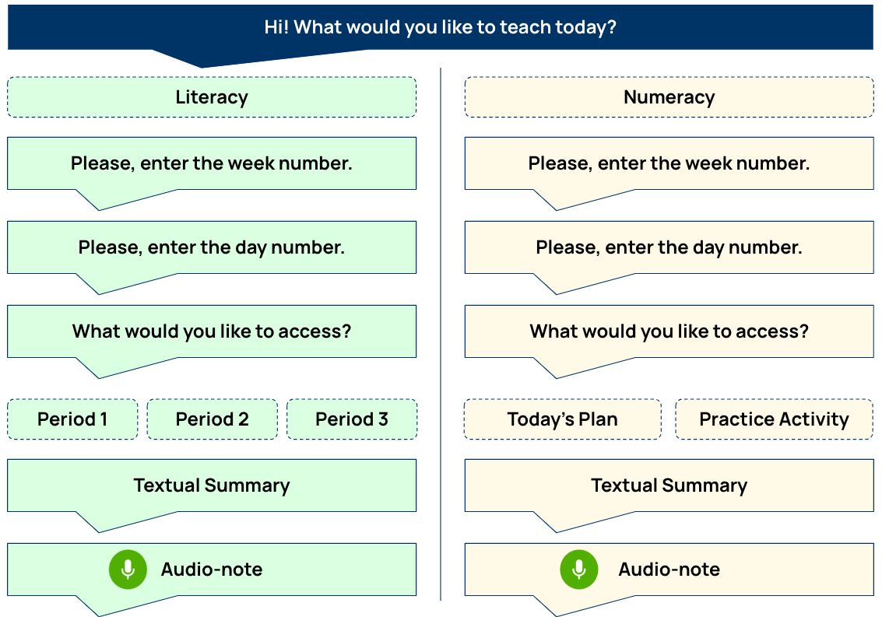

Certain design elements will be embedded into the chatbot to make the lesson plan information comprehensible and visually appealing for the user.
- Concise - Textual summaries will be properly spaced and limited to 5-7 lines (of prompts) on the screen to avoid cognitive overload. Audio notes will be 2 minutes long on average.
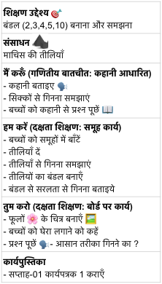
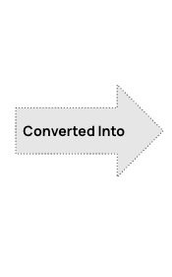
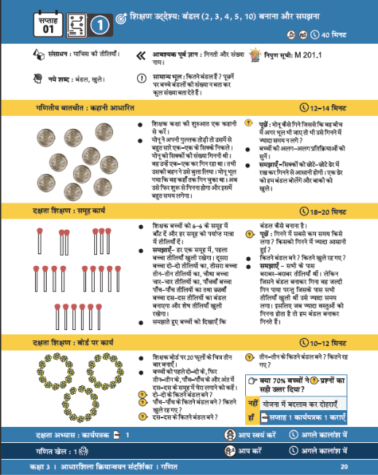

- Searchable - Minimal effort will be required from the user and they will be able to get the desired response from typing in a few letters/numbers, after 2-3 clicks/inputs.
- Attractive - Emojis/Icons will be included in the text messages to make the interface visually appealing for the users and reduce the amount of text. Similar iconography as in the TG will be used so that the user can easily (and subconsciously) connect the information in the chatbot to that in the TG.
- Relatability - Voice in the audio-note will be relatable and contextual
The chatbot will have the following additional components:
- User Demonstration Request: Users will be encouraged to share videos of themselves implementing the plan and activities from the TG in the classroom.
- Weakly Streak: The streak would be used for a weekly reward system where a rewarding message in the form of stickers will be shared with the users appreciating and recognising them for continuously engaging with the chatbot and maintaining their streak. Additionally, inactive or irregular users will be reminded of their broken streak and will be nudged to resume their engagement.
- Monthly Report Card: Teachers will be given a monthly report card as a visual summary of their engagement with the chatbot. It will summarize information on frequency of engagement and their performance vis-à-vis other teachers and include an encouraging message to appreciate their effort or nudge them to use the chatbot more often. The purpose of the monthly report card is to appreciate their effort, and at the same time use peer effects/social comparison to encourage engagement.
Treatment arm 2: The second treatment arm intends to increase adoption of key pedagogical practices. The treatment is centred around bite-sized videos on pedagogical practices derived from the target behaviours.

- To ensure that the pedagogical practice videos are easy to consume for teachers, each target behaviour (that is, each practice) has been broken down into three learning objectives, where each objective represents one micro-practice.
- The four target behaviours are thus translated into a total of twelve micro-practice videos of 3-4 minutes each.
- Each video will clearly lay out the steps involved in adoption of the practice, and the entire series will be based on a relatable teacher-character presenting these practices as solutions to common classroom challenges.
- The same set of teacher-actor and students have been shown throughout the 12 videos to build a narrative of the journey of a classroom.
- Videos will be shared to the teachers through WhatsApp Groups

Target Behaviour | Learning Objective
Phase I
Teachers take student responses effectively. | Video 1: Teachers ask questions to individual students and provide time to get responses.
Teachers take student responses effectively. | Video 2: Teachers ask questions to all students and provide time to get responses.
Teachers take student responses effectively. | Video 3: Teachers respond to student answers and push their thinking.
Teachers give students dedicated time for student practice - individually and in groups - with feedback. | Video 4: Teachers give students practice time effectively everyday.
Phase II
Teachers teach all domains of Balanced Literacy - with a focus on decoding. | Video 5: Teachers use a literacy lesson plan with the 4-block approach.
 | Video 6: Teachers teach letter sound identification and letter symbol recognition.
 | Video 7: Teachers teach segmenting words into sounds of letters and blending letter sounds into words.
Teachers give students dedicated time for student practice - individually and in groups - with feedback. | Video 8: Teachers provide support during everyday student practice.
Phase III
Teachers follow all steps of Gradual Release of Responsibility in the correct order to teach a new concept in Numeracy. | Video 9: Teachers use the 'I do-We do-You do' structure for numeracy.
 | Video 10: Teachers conduct an effective 'I do' activity.
 | Video 11: Teachers conduct an effective 'We do' activity.
Teachers give students dedicated time for student practice - individually and in groups - with feedback. | Video 12: Teachers conduct weekly assessments and remediation using the lesson plans.

Still from a Micro-practice Video

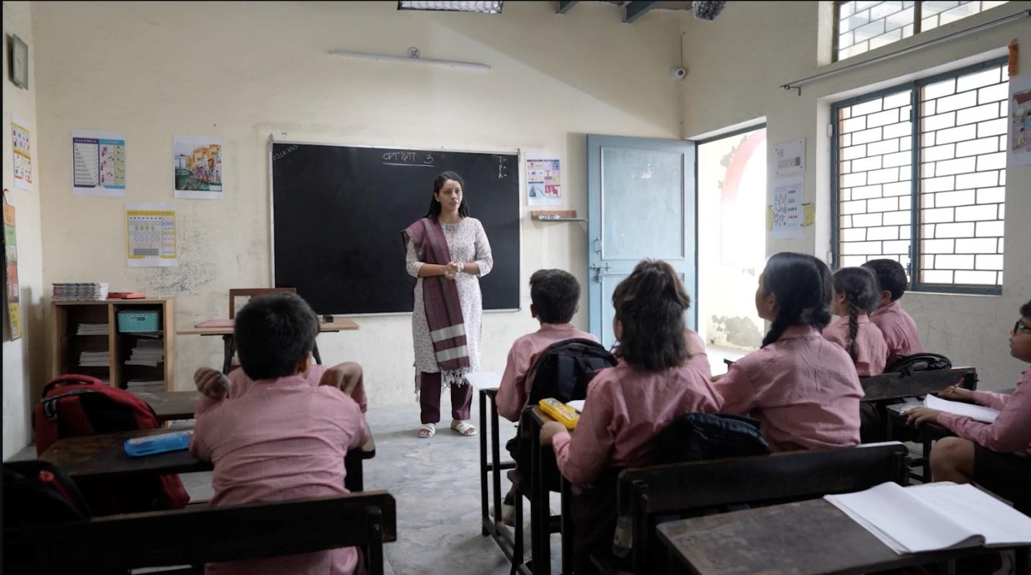
In addition to the micro-practice videos, following supplementary content will also be shared with teachers to ensure consistent engagement:

- For each micro-practice video a teacher testimonial video will be shared (in the following week) with the users. The video will be a one-minute testimonial that will show an experienced teacher sharing their experience of implementing a particular micro-practice.
- To encourage engagement with the content shared, different types of reminders will be sent to the teachers.

- Infographic - An infographic will be shared after each micro-practice video. The infographic will summarize the information given in the video regarding the practice.
- Whatsapp Poll - Basic check-for-understanding will be done through Whatsapp polls for each video and to get feedback on practice implementation from the users.
- Social Proof Message - Messages with engagement numbers will be shared to encourage the inactive users to participate leveraging norms.
- User Demonstration Request - Users will be encouraged to share videos of themselves using a given micro-practice in their classroom. This will leverage peer effects to boost engagement.
- Reward: Teachers will also be rewarded once in every two months, where they will be recognised for having mastered a particular target behavior (pedagogical practice). Teachers’ cumulative engagement data over each micro-practice cycle, and the videos sent in by teachers where they showcase the micropractice in class will be used to assess mastery.

Experimental/ Survey Design
The BL and EL surveys will be conducted via an in-person setup and will be self-administered under the supervision/guidance of on-ground enumerators. Introduction to the intervention - including trailer of Micro-Practice Video series/Demo of the WhatsApp Chatbot, discussion of intervention, addition to WhatsApp group/Registration of numbers for Chatbot will happen in-person on the day of the baseline. The rest of the intervention will be administered to the treatment groups via WhatsApp Chatbot for treatment arm 1 and WhatsApp Groups for treatment arm 2. All participants will be compensated in kind with a set of pen and diary worth Rs. 100 each for both baseline and endline surveys. The survey and intervention will be administered in Hindi.

This evaluation will have the following components:
- Baseline: This will via an in-person setup and will be self-administered under the supervision/guidance of on-ground enumerators
- DIET Assessment: Analysis of standardised test of math and Hindi conducted by the State (secondary resource)
- Treatment
  - Treatment 1: Given access to WhatsApp chat to access summaries of daily numeracy and literacy lesson plans from the teacher guides
  - Treatment 2: Videos on micro-practices will shared every 2 weeks along with supplementary materials and reminder via WhatsApp groups
  - Control: Will not receive any treatment
- Endline: This will be conducted in the same format as the baseline.
- Student Outcomes: Experienced enumerators administer standardised tests of math and Hindi to students of grade 3 in the selected schools.
- Classroom Observations: This will be conducted at both baseline and endline with a small (non-representative) subset of the sample to measure students responsiveness and engagement level to assess how effective the instruction was

Randomisation
We use a clustered randomisation method. The study will be conducted in 36 blocks (18 blocks per district). We select 6 clusters which have more than 10 schools from each block i.e., a total of 216 clusters. We randomly select 12 schools per cluster i.e. 72 schools per block. The teachers in the school could refuse to participate due to election duty load, lack of bandwidth, etc. Other schools will replace them. We randomise clusters into control clusters and the 2 treatment arms. We have 72 clusters (Nyay Panchayat) per arm.

Data Collection
Enumerators from the NYAS agency were hired to administer the in-person baseline survey on licensed software, SurveyCTO on their offline Collect app. Teachers are invited to participate in the study by the Block-Education Officers. They are asked to gather at the block-level office on a specific day. Teachers fill the surveys in-person and type the answers into the app (on their tablets) under the supervision and guidance of trained enumerators. The duration of the survey is around 45-60 mins. They will be compensated for their time in kind—a set of pen and diary worth Rs. One hundred will be given, along with refreshments. Only complete surveys will be used for analysis, and no participants with partial surveys are recontacted to resume the survey. While the enumerators are familiar with the broad outline of the study, they are not made aware of the details of the treatment groups to reduce potential bias. The enumerators introducing the intervention aspects are different from those administering the baseline survey. The survey and interventions are in Hindi. The endline survey will happen in the same manner.

Experimental Flow
Step 1: Hindi-medium government schools are selected based randomly in a given cluster of a block. Grade 3 teachers of these schools are invited to participate in a survey by the block-education officer. If they refuse to participate, they will be replaced with other schools.
Step 2: Selected clusters are randomised to control and treatment arms.
Step3: Block Education Officers help contact grade 3 teachers of selected schools and ensure the attendance of teachers at baseline and endline surveys by inviting them to the school premises on specific days.
Step 4: Baseline through in-person surveys: Enumerators hired through an external agency will guide and supervise self-administered surveys on SurveyCTO offline app on tablets. The same standard consent question is asked to all participants during this process.
Step 5: Deployment of treatment – Chatbot Outlook in case of treatment arm 1 and Trailer Video in case of treatment arm 2 are shown immediately to the teachers after the baseline survey. These are not shown to control.
Step 6: Deployment of treatment (1) – Daily access to lesson plans of TG through the Whatsapp Chatbot along with behaviourally informed reminder and rewarding messages
Step 7: Deployment of treatment (2) – Videos on micro-practices, teacher testimonials, summary infographics, behaviourally informed reminder, rewards through WhatsApp groups
Step 8: Student evaluation. These evaluation sheets will be collected during the endline and wil be conducted by an external agency.
Step 9: Endline through in-person surveys: Enumerators hired through an external agency will guide and supervise self-administered surveys on SurveyCTO offline app on tablets. The same standard consent question is asked to all participants during this process.

Backcheck
15% of the participants will be chosen for an additional short survey across treatment and control groups and blocks. A week after the primary data collection, these surveys will be conducted by a separate set of enumerators via a phone call. It will include a few questions about the previous survey length and comfort rating, a few knowledge, and demographics questions.

Sample Size Determination
Based on the literature and experimental work conducted with similar research goals and study population, the sample size for the current study was determined by conducting the following power calculations:

Power | 0.80
Alpha | 0.05
 | Case 1 | Case 2 | Case 3
Benchmark study used | Randomised evaluations of in Delhi and Uttar Pradesh (U.P.) of a program that seeks to improve teacher motivation and classroom practice by organising teachers into local  networks.  Impact of STIR’s programming on teacher  motivation and student learning, StiR and IDinsight | RCT to test cost-effective and scalable model’s ability to improve literacy  and numeracy among Class 1 and 2 pupils in Kenya. The design has the following elements:  1. Inexpensive books  2. Simple instructional aids, including an  A3-sized pocket chart and a set of letter and numeral flashcards.  3. Self-contained teachers’ guides:  4. Modest teacher training:  5. TAC tutors and instructional coaches to visit schools and observe  Classrooms.  Piper,B. et al, 2014 | RCT to test the impact of written diagnostic feedback to teachers on their students' performance (both absolute and relative) at the beginning of the school year, along with suggestions on ways to improve learning levels of students in low achievement areas.  Muralidharan, K., & Sundararaman, V. (2010)
Effect Size | Outcome:  - Teacher Motivation; 0.13 SD (p<0.01) increase in an overall index measuring teacher motivation in treatment arm in Delhi  - Math learning outcome: 0.1 standard deviations (p-value: 0.02) increase in combined treatment arms | Outcome  - English language Outcomes - Average effect size of 0.46 SD  - Math Outcomes - Average effect size of 0.2 SD  - Kishwahili language outcomes - Average effect size of 0.35 SD | Outcome: Teacher activity index (an average of 15 measures of teacher activities such as giving tests, asking questions, writing on board, encouraging student participation etc.) - Teachers in treatment schools showed a 0.11 SD higher  level of activity.
Estimated required sample size | Total: ~180 schools (with 2 treatment arms and 1 control) | 311 schools in treatment arms spread across two cohorts; 101 schools in the control arm. | 100 treatment Schools; 300 control schools

Based on the power analyses above and other studies, we selected a sample size of 72 clusters (720 teachers) per arm, a total sample size of 2160 across 3 arms (two treatment arms and one pure control arm). With ~ 9 teachers per cluster, a 0.8 power, with an ICC of 0.33 we can detect an effect size of ~ 3 with a SD of 10. Accounting for an attrition of 20% at the endline, we will sample 864 schools per arm and a total of ~ 2592 schools at baseline.

Monitoring

Treatment arm 1: The project team will continuously monitor the engagement data at the backend through a monitoring dashboard. Additionally, classroom observations and phone surveys will also be conducted as part of the monitoring process to track engagement. User activity data will be used to track streaks and send reward/loss-aversion messages accordingly. The table below provides an indicative list of parameters that will be tracked at the backend to monitor engagement.
Table 14: Monitoring Details for Treatment Arm 1 (Chatbot)
Chatbot
Indicator | Parameters | Data source
Level of Engagement with the Intervention | - No. of teachers engaging with the bot in a day  - Date & time teachers access the bot  - No. of clicks in a day by a teacher/How far teachers go in the bot flow  - Weekly report of inactive users  - No. of teachers sending videos of themselves implementing activities in classroom | Whatsapp Bot Dashboard
Level of Engagement with TG | No. of teachers that report using the chatbot as well as TG | Phone Surveys
Level of Engagement with TG | No. of teachers observed to be using the chatbot as well as TG | Classroom Observation

Treatment arm 2: The WhatsApp group moderators will be trained to collect and record engagement data which will be verified and checked by the project team regularly. This data will allow the project team to gauge engagement level, implement course-correction strategies if feasible, and keep track of attrition. This will be supplemented by qualitative insights from data collected through classroom observations and phone-surveys on adoption of practices and engagement with the videos. The table below provides an indicative list of parameters that will be tracked to monitor engagement and adoption levels.
Table 15: Monitoring Details for Treatment Arm 2 (Micro-Practice Videos)
Micro-practice Videos
Indicator | Parameters | Data source
Level of Engagement with the Intervention | - No. of teachers received/seen/reacted/replied to the videos  - No. of teachers received/seen/reacted/replied to the reminder and other messages  - No. of teachers responding to the Whatsapp polls on engagement, such as:  -> Did you try the strategy shown in the video? [Yes/No/Haven't seen the video yet/Wasn't feasible, tried but too much chaos]  -> What was the key message of the video?  -> What was the name of the student who answered the question correctly in the video?  - No. of teachers sending queries, feedback, photos related to the intervention  - Type of content shared by the teachers  - No. of teachers leaving group, and reason for leaving  - No. of teachers who agree to join back and get re-added to the group | Whatsapp group backend data to be tracked by moderators
Level of Engagement with the Intervention | No. of teachers that report watching videos | Phone Surveys
Level of Adoption of Micro Practices | - No. of teachers sending videos showcasing adoption of practices  - Type of videos being shared by the teachers | Whatsapp Group
Level of Adoption of Micro Practices | No. of teachers observed adopting the practices | Classroom Observations

Given the field team size of three members and a six-month deployment period, the team arrived at an approximate sample size for classroom observations and phone surveys across the two arms. The sample size is outlined in the table below.

Outcome Variables
We primarily want to test:
  - Does breaking down evidence-based pedagogical practices into smaller actions/ relatable video demonstrations and communicating them to teachers in a staggered approach increase adoption and knowledge of these practices and improve the effectiveness of classroom instruction?
  - Does easier access to classroom instruction plans and learning materials for a given day/learning objective increase adoption and knowledge of these materials and improve the effectiveness of classroom instruction?

To do this we will be using classroom observations where enumerators will observe about 120 classrooms evenly distributed across arms during baseline, 240 during the intervention and about 120 at Endline. Some key indicators noted down by enumerators are as follows:

Teacher Action | Student Action
Literacy
Teacher gives clear instructions and demonstration for the activities | Students listen to each other share
Teacher corrects students doing the activity incorrectly | Students feel comfortable and safe in asking questions
Teacher asks individual students questions related to the topic
Teacher observes the work of students by moving around
Numeracy
Teacher explains a new concept on the board or through an activity | Students share real life examples related to the concept
Teacher gives real life examples to explain the concept | Students answer questions related to the concept when asked
Teacher asks individual students questions related to the concept she is teaching | Students feel comfortable sharing if they do not know the answer to the question
Teachers questioning is only focused on selected few students
Teacher uses TLM to teach a new concept

Additionally, we investigate whether we increase salience of effective teaching practices, motivation to use these practices, and whether the effect of treatment changes is a function of the amount of hyperbolic discounting exhibited by the teachers at baseline.
Description of all outcomes in the study
Outcome Variable | Description | Outcome Measure
Teachers’ knowledge of effective pedagogical practices use of Teacher Guides. | Direct Questions to assess teachers’ knowledge level on  - Effective pedagogical practices  - Use of Literacy and Numeracy Teacher | The number of correct responses across four questions.  Variable type: Numerical (0-4)
Valuation/Salience of Evidence based Pedagogical Practices by teachers: To estimate the importance teachers given to effective teaching practices and use of Teacher Guides. | - Ranking question to assess how important teachers feel are effective pedagogical practices in achieving certain goals such as student learning outcomes over external factors like student attendance, parents engagement etc | Rank from 1-6  Variable Type: Ordinal (1-6)
 | - A revealed preference question to assess at what level of monetary compensation would teacher prefer to choose TG or a training session on effective teaching practices. Here teachers will have to make a series of choices always between "spending some time on a good teacher training session" or “receiving a teaching toolkit” or receiving an endowment y, where the endowment amount gradually reduces from Rs. 500 to Rs. 1. To reduce social-desirability bias and make it a realistic choice we will tie this game to a lottery where teachers will actually receive an option of their choice - cash reward or training video or teaching toolkit. We have pegged the probability of winning the lottery at 0.01% | 6 Steps (INR 500, 400, 300, 200, 100, 1)  Variable type: Numerical (0-500)
Intention/Ability to use of effective practices/TG | Self-reported measures using Likert scale rating of likelihood (1-5): Rate your intention to use teaching practices like I do, We you. You do method | Number of responses with Likert-scale of 3 or above  Variable Type: Numerical (0-3)
Adoption of practice/ TG | 6 Scenarios/vignettes of a teacher teaching and asking about the their next step followed by a question to assess teacher’s. Additionally in each case, participants answer and state how confident they are of that answer using the Likert scale rating of likelihood (1-5). | The number of correct responses across six questions.  Variable type: Numerical (1-4)
Motivation: Estimate how motivated teachers feel about their work. | Self-reported measures: rate agreement with the statement on a scale of 1 to 5, where 1 is “I don’t agree at all” and 5 is “I completely agree”. This set of statements includes a combination of intrinsic and extrinsic motivation. E.g., “When I work hard, students perform up to my expectations” | Number of responses with Likert-scale of 3 or greater  Variable Type: Numerical (0-14)
Locus of Control: To estimate perception about the underlying main causes of events in life | Observe teachers' perception on the extent to which they can affect outcomes by their own actions by asking them to rate their agreement on a Likert Scale of 1-5. | Number of responses with Likert-scale of 3 or greater  Variable Type: Numerical (0-3)
Hyperbolic discounting: To estimate the amount of discounting bias the teachers exhibit. We will further examine if the treatment effect is higher for those with higher discounting at baseline. | A standard discounting question is asked using a convex budget task. Participants answer a question where choosing a payout later ensures an overall greater payout.  Which of the following would you choose?  -Rs.350 this week & Rs. 0 in 3 weeks  -Rs. 300 this week & Rs. 100 in 3 weeks  -Rs.100 this week & Rs. 350 in 3 weeks  -Rs.0 this week & Rs. 500 in 3 weeks  To ensure the teachers play realistically, they are entered in a lottery. If they win the lottery, they are given the option they choose. | Number with 4 choices  Variable Type: Numerical (1,2,3,4)
Belief and Attitude: Understanding beliefs and perceived social norms regarding their role/ accepted teacher practices, | Vignettes describing a scenario and asking teachers what is acceptable; and what is acceptable to most teachers (to elicit norms) | Number with 3 choices  Variable Type: Categorical (1,2,3)
Time-Use: to assess how time availability play a role in teachers’ engagement with the program | Self-reported measures of how teachers "spend" or allocate their time over a day on various activities such as teaching, commuting planning, household work etc. | Number with 6 options:  - Less than an hour  - 1-2 hrs  - 2-4 hrs  - 4-6 hrs  - more than 6 hrs  - Spend no time on this activity.  Ordinal variable (1-6).
Student Outcomes: Hindi and English test scores | DIET Student Assessment (UP State Government)  Using standardised tests conducted by the government to measure student outcomes for Hindi and Mathematics at baseline and endline | An index of child’s performance combined across the two tests – Continuous variable
Demographics: | Age and Gender of the teacher. Highest education level of the teacher. Salary, household income, number of people in the house, years of teaching experience, type of teacher, staff strength, religion and caste. | Age – Continuous numeric variable.  Gender – Binary Variable.  Education – Ordinal variable (1-6)  Salary: Categorical variable (1-6)  Household Income: Categorical (1-6)  Years of Experience: Continuous numeric variable  Religion and Caste combined – Variable Type: Categorical variable (1-9)  HH size: Continuous numeric variable.  Staff strength: Continuous numeric variable.  Type of teacher: Categorical (1-4)

Model Specifications
Ordered Logistic Regression will be used for ordinal outcomes and logit regression for the categorical variables.
Ordinary Least Squares will be used for discrete and continuous numerical variables (Knowledge, Adoption, Salience, Intention, Valuation, Belief and Attitude, Student test outcome, Motivation).
We will use one model controlling for demographic information and measuring the increase from baseline measures (M1) for every outcome measure. M1 is repeated for each of the three treatment groups.
Ordinary Least Squares will be used for the discrete numerical variable of specific discounting, modelled without baseline measure (M2).

We will use multiple hypothesis testing adjustments with pFDR and the q-value.
M1: Y ~ treatment_assignment + demographic_covariates + baseline_measures + error
M2: Y ~ treatment_assignment + demographic_covariates + error
Y = outcome measures
treatment_assignment = dummy variable, 1 for treatment and 0 for control.

Further, we will split the sample into high discounting and low discounting groups based on the median discounting value. We will estimate if the treatment effect differs for the high and low discounting groups in each of the three groups using a T-Test. We will also use multiple hypothesis testing adjustments with pFDR and the q-value.

All analysis, including randomisation and data checks, will be conducted using custom-made MATLAB (The MathWorks, Inc) scripts in R (R Core Team, 2014).

Randomisation Check
Treatment status is the only difference between the treatment and control groups in a randomised control study. On average, all other characteristics of treatment and control group members, including demographics, should be balanced. Treatment effect estimates could be biassed if there is an imbalance across the groups despite the randomisation process. We will check for balance between treatment and control groups for baseline measures.

M3: X ~ treatment_assignment + error
X is the different Outcome measures of interest at baseline.

Attrition Check
The biggest concern with attrition is the possibility of bias. If the types of treatment group teachers who are attritted are systematically different from the control teachers in a manner related to our outcomes, results are likely biassed. For example, if older teachers leave one treatment group more than the control group, and age correlates with study outcomes, results are likely skewed. We would analyse by regressing a binary variable that equals one if a teacher attrition treatment status,

M4: A ~ treatment_assignment + X_{i} + treatment_assignment* X_{i} + error

A is a binary variable of attrited or not.
X_{i} is the different Outcome measures of interest at baseline.

Bibliography
  - Abraham, R., Shirrell, S., Downs-Tepper, H., & Chakravarthy, V. (2015). Quantitative Assessment of Teacher Motivation, Classroom Practices and Student Learning. IDinsight. Idinsight. Org/insights/stir/STIR% 20Baseline% 20Report% 20Final% 20Clean. Pdf (accessed 26 October 2017).
  - The Primary Math and Reading (PRIMR) Initiative Endline Impact Evaluation. USAID Kenya. 2014
  - Muralidharan, K., & Sundararaman, V. (2010). The impact of diagnostic feedback to teachers on student learning: Experimental evidence from India. The Economic Journal, 120(546), F187-F203.
  - 4. Storey, JD. (2002). A direct approach to false discovery rates. Journal of the Royal Statistical Society: Series B (Statistical Methodology). 64 (3): 479–498. https://doi.org/10.1111%2F1467-9868.00346.
  - R Core Team (2014). R: A language and environment for statistical computing. R Foundation for Statistical Computing, Vienna, Austria. URL http://www.R-project.org/

Teacher guides are designed for teachers with a focus on structured pedagogy with daily learning objectives and corresponding scripted lesson plans for 22 teaching weeks with activities, checks for understanding questions to be asked to the students in between, and specified TLMs (such as manipulatives, storybooks, concrete objectives, workbooks etc.) to be used.
Please refer to the survey instrument for further details on all outcome measures across tables - https://docs.google.com/document/d/1a7-nyvUBls7HEV1qn05T3RkY0ewkWi2mxInpkNDc29k/edit

