Improving Participation in College Savings Accounts:
Evidence from Illinois
Analysis Plan – Update 11/03/23

Abstract

This study addresses accessibility gaps in higher education by examining the effectiveness of financial incentives to increase participation into 529 college savings plans. The research employs a randomized trial to analyze the impact of different incentive amounts compared to an information-only group. The study’s findings will provide novel evidence on whether upfronting financial benefits can improve participation into available programs that increase social mobility, especially among lower income households, and will also offer insights for policymakers seeking to enhance economic equity through savings interventions.

- Introduction

Higher education is widely recognized as a critical tool for creating equity and achieving economic security, especially for children in lower-income households. Due to the rapidly increasing cost of college and cuts to public funding for state universities, this goal of achieving higher education is increasingly out of reach for many middle- and low-income families. College Savings Accounts, also known as 529 plans, are a useful tool for bridging this gap. Such accounts are offered by 49 states and the District of Columbia, and provide families with a low-cost, tax-advantaged vehicle for saving. Despite the potential impact and broad availability of these plans, relatively little is publicly known about their take up and usage. Few studies exist of 529 take-up and use. The few national studies that have been conducted imply that a relatively low percentage of US families save in 529 plans and those who do tend to be wealthier than others. Moreover, trends in 529 take up reflect wider trends in inequality related to ownership of retirement and other savings accounts.
In Illinois, the Illinois State Treasurer’s Office (ILSTO) administers the state’s two 529 College Savings Plans – Bright Start and Bright Directions. Since 2015, the Illinois State Treasurer’s Office has worked to expand the number and diversity of Illinois families saving for college. Over recent years, the State Treasurer’s Office has reduced barriers to entry to the plans, for example by making the 529 program available in Spanish, investing in multicultural and multilingual marketing and outreach, enabling ITIN holders to open accounts, and greatly reducing the costs for families to participate. However, analysis on take-up rates of 529 across zipcodes in Illinois based on ILSTO’s administrative data suggests that income and racial disparities in take-up have persisted over the past two decades. In a survey conducted in 2021 on a sample of 1,013 households with children aged 17 or less in Illinois, we found that most families hope their children will pursue post-secondary education, and a majority have begun saving to cover educational expenses across income groups. However, saving mostly consisted in setting money aside in a bank account, and 529 awareness was relatively low and correlated with income: less than 50 percent of families with a household income below $60,000 had heard of 529 plans compared to more than 80 percent of families with an income above $125,001. Once the program was briefly explained to survey respondents who never heard of 529 plans, almost all expressed interest in opening an account, regardless of income.
Income disparities in 529 ownership are not unique to the state of Illinois, and several states have launched initiatives, including offering financial incentives, to encourage more families, especially from under-represented communities, to open and start saving into a 529 plan. For example, the state of California matches 529 contributions dollar for dollar, up to $200; plus, an additional $25 when enrolled in an automatic contribution plan; Colorado matches contributions up to $500 each year for up to 5 years. Similarly, many states offer seeding incentives: Connecticut provides 529 plan accounts with $100, Massachusetts offers a $50 seeding deposit, and from January 2023 Illinois also introduced a $50 initial deposit for any newly opened 529 plan. Little is known about the effectiveness of these initiatives, and whether financial incentives can contribute to closing the representation gap in 529 opening rates as well as subsequent contributions. This paper aims to fill this gap by means of a Randomized Control Trial (RCT), testing the effects of offering different amounts of financial incentives, compared to an information only group, on 529 plans' sign-up rates and contributions.
Existing research predominantly examines how individuals change their savings behavior and benefit take-up in response to nudges. Many large-scale field experiments have observed a positive relationship between messaging and participation in savings plans, particularly through informative emails and reminder text messages (Clark, et al., 2017; Goldin, et al., 2017; Rodríguez and Saavedra, 2019). Similar studies have explored the impact of informational nudges on tax-filing behavior, suggesting that they can lead to less delinquency and more benefit take-up (Cranor, 2020; Goldin, et al., 2022). However, further research has revealed that nudging efforts can offer mixed outcomes. Linos et al. (2022) ran six large-scale field experiments surrounding EITC take-up due to various forms of messaging; they did not observe any increase in low-income household take-up in response to nudges.
Research regarding the impact of financial incentives on savings outcomes tends to offer similarly mixed results. Studies which examine retirement savings contributions as they relate to matching and tax incentives suggest modest or negligible effects, although results were not consistent across income groups (Engelhardt, 2007; Duflo 2007). Mason et al. (2010) utilized data from a Child Development Account initiative to examine the relationship between financial incentives and saving outcomes in programs specifically for low- and middle-income children. Their analyses suggest that varying types of financial incentives had different associations across savings outcomes, and further flagged the possibly regressive nature of the plans. In a pilot study ran in partnership with the pediatrician’s offices of the Boston Medical Center, new parents were helped by the birth registry staff to open a 529 account; the study found that only 6% of parents ended up opening an account (Tummula et al. 2022). Thus, currently there seems to be not enough evidence to determine the causal impact of financial incentives on 529 take-up and contributions among under-represented communities.
- Research Questions and Hypotheses

We are interested in studying the effectiveness of financial incentives, compared to information only, on two key outcomes: (a) sign-up rates to 529 plans and (b) contributions into newly opened 529 plans.

Looking at the first outcome - sign up rates - our first research question is whether financial incentives increase 529 plans’ sign-up rates. It is possible that, once limited awareness is no longer a barrier, households will react positively to the presence of financial incentives as they may help overcome the perceived costs of going through the administrative burden to open an account (Herd and Moynihan, 2019). On the other hand, it is also possible that an information only campaign, without any seeding offer, is equally effective at increasing sign-up rates, thus making the introduction of costly financial incentives unnecessary. Thus, our first hypothesis is as follows:

H1a: Financial incentives significantly increases the sign-up rate of 529 plans

Our second question is whether households are sensitive to the amount of the financial incentives being offered. Thus, our second hypothesis is:

H2a: Higher amounts of financial incentives increase the probability of signing up for a 529 plan

Our third research question is that financial incentives may have a different effect depending on the household’s income. On the one hand, it is possible that a small financial incentive is sufficient at closing the sign-up rate gap among different income groups; this would allow the government to implement a larger scale financial incentive campaign on the same available budget. On the other hand, lower income households may be more responsive to larger seeding amounts, suggesting that any scaled-up intervention would need to rely on a larger budget to attract households from under-represented communities. Thus, our third hypothesis is as follows:

H3a: The effectiveness of the financial incentive amounts depends on the household’s income

As explained better in the next section, since we will not have access to a household's income, we will rely on the median household income at the zipcode level.

The next main outcome we’re interested in tracking is contributions. It is possible that introducing seeding offers increases sign-up rates to 529 plans, but this may not necessarily translate into regular subsequent contributions, thus not generating any return on investment from the seeding money that will sit idle on people’s accounts. For this outcome, as explained in the rest of this analysis plan, we will track total net contributions at months 1, 6, and 12 since opening an account. Thus, our hypothesis is:

H1b: Financial incentives significantly increases the contributions into 529 plans

As per our second research question, we are also interested in understanding whether households respond differently to larger seeding amounts by contributing more during the first year of their account lifespan:

H2b: Higher amounts of financial incentives increase net contribution amounts into 529 plans

Lastly, we will study the effects of financial incentive amounts on contributions along the income gradient:

H3B: Higher amounts of financial incentives increase net contribution amounts into 529 plans especially among lower income households.

In the next section, we will discuss the experimental design and implementation plan.

- Experimental Design

We will partner with ILSTO to implement a 4-arm RCT to test the effectiveness of financial incentives in increasing 529 plans’ sign-up and contribution rates. We will receive from ILSTO a database of approximately 730,000 email recipients who reside in Illinois, have interacted with ILSTO’s ePay system before, and have agreed to receive regular electronic communications from the department. Email recipients will be randomly assigned to one of the following groups:

- Control, which will receive an information email with no financial incentives
- Treatment 1, which will receive an email almost identical to the control group and will be offered a seed of $10 upon completion of the sign-up process
- Treatment 2, which will receive an email identical to T1 group, but with a $50 seed offer
- Treatment 3, which will receive an email identical to T1 and T2 groups, but with a $100 seed offer

Each email respondent will receive two emails: an initial email and a follow-up reminder a week later. Treatment group respondents will receive a unique promo code in their emails which they will be asked to insert at the time of signing up for a 529 account. This will ensure that individuals can’t share their seeding offers with other people.

In order to meet ILSTO budget constraints, we will recruit participants via a staggered batches approach. First, we will randomly select 7,500 email recipients who will be randomized into one of the four groups. We will then use sign-up rates after this first batch to run power analysis and choose a sample size for a second batch to ensure that ILSTO will have the financial resources to seed enough accounts in a timely manner. If necessary, we will repeat this approach with subsequent batches until the budget cap of $150,000 is met.

The process will look as follows:

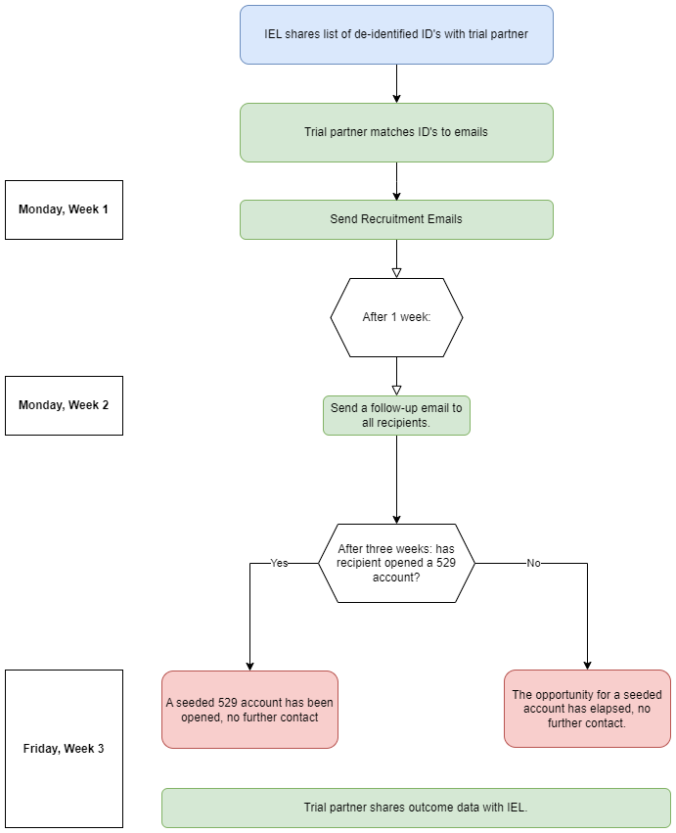

- Outcome Measures and Analysis

Outcome | Measure/Unit | Analysis
Primary
Sign up rates | Binary outcome equal to 1 if the email recipient opened an account and 0 otherwise | OLS linear probability regression with an independent categorical variable that indicates which treatment group individuals were assigned to. We will cluster standard errors at the zipcode level.
Sign up rate by income group | Binary outcome equal to 1 if the email recipient opened an account and 0 otherwise | OLS linear probability regression with an independent categorical variable that indicates which treatment group individuals were assigned to, interacted with income quartile (with income being equal to the median household income in the recipient’s zipcode). We will cluster standard errors at the zipcode level.
Cumulative contributions at months 1, 6, and 12 (net of seeding) | Continuous outcome equal to the sum of contributions made into newly opened 529 plans. This outcome will exclude the seeded amount but won’t take into account withdrawals. | OLS linear probability regression with an independent categorical variable that indicates which treatment group individuals were assigned to. We will cluster standard errors at the zipcode level.
Cumulative contributions at months 1, 6, and 12 (net of seeding) by income group. | Continuous outcome equal to the sum of contributions made into newly opened 529 plans. This outcome will exclude the seeded amount but won’t take into account withdrawals. | OLS linear probability regression with an independent categorical variable that indicates which treatment group individuals were assigned to, interacted with income quartile (with income being equal to the median household income in the recipient’s zipcode). We will cluster standard errors at the zipcode level.
Secondary
Number of accounts opened | Continuous variable equal to the number of accounts opened | Poisson regression with an independent categorical variable that indicates which treatment group individuals were assigned to. We will cluster standard errors at the zipcode level.
Email opening rate | Binary outcome equal to 1 if the email recipient opened the email or not | OLS linear probability regression with an independent categorical variable that indicates which treatment group individuals were assigned to. We will cluster standard errors at the zipcode level.
Email click-through rate | Binary outcome equal to 1 if the email recipient opened the email or not | OLS linear probability regression with an independent categorical variable that indicates which treatment group individuals were assigned to. We will cluster standard errors at the zipcode level.
Balance differences at months 1, 6, and 12 | Continuous outcome equal to the total balance into newly opened 529 plans (i.e., this will include contributions plus any accrued interest, plus seeded amounts, minus withdrawals). | OLS linear probability regression with an independent categorical variable that indicates which treatment group individuals were assigned to, interacted with income quartile (with income being equal to the median household income in the recipient’s zipcode). We will cluster standard errors at the zipcode level.
Net cumulative contributions at months 1, 6, and 12 (net of seeding). | Continuous outcome equal to the net (i.e., contributions minus withdrawals) contributions into newly opened 529 plans. This outcome will exclude the seeded amount. | Instrumental Variable with an independent categorical variable that indicates which treatment group individuals were assigned to. We will instrument random assignment on whether respondents signed up for an account. We will cluster standard errors at the zipcode level.
Sign up rates conditional on claiming the incentive | Binary outcome equal to 1 if the email recipient opened an account and 0 otherwise | OLS linear probability regression with an independent categorical variable that indicates which treatment group individuals were assigned to. We will cluster standard errors at the zipcode level.

Covariates: We will replicate the above econometric analysis including available covariates. When comparing control and treatment groups, we will use zip code level census data as controls, specifically: median household income, the share of residents who are Black and Hispanic, the share of residents who are aged less than 18, and the share of residents who hold at least a bachelor’s degree. Among the participants who sign-up, we will include additional controls based on the information they provide in the sign-up process for their newly created 529 accounts.

Robustness checks: We anticipate replicating the analysis dropping observations of accounts that were closed at any point in time before reaching the milestone of the outcome of interest (thus, including accounts that may have a negative balance).

Staggered roll-out: Since the trial will be implemented following a staggered roll-out approach, we will upload updated power analysis for the subsequent trial batches. In the final analysis, we also expect to run robustness checks, including adding dummies for batches as covariates.

- Power Analysis

In this section we provide a copy of the code that we will use to run power analysis to estimate the necessary sample size of the batches. However, we expect to add an amendment to the pre-registered protocol with the exact sample size after obtaining the results from the first batch.
Because we have multiple treatment arms, we can look at pairwise comparisons between different combinations of the treatments and control. Being powered for the smallest minimum detectable effect size (MDES) among the comparisons would ensure power among all pairwise possibilities but since we have equal allocation between the four groups, each of the six calculations will look the same in this pre-trial iteration.

Although the entire batch 1 size is 7,500 people, because each of the four arms will contain an equal allocation of 1,875 people, the combined sample size for each pairwise comparison will be 3,750. We intend to use a two-sided hypothesis test with a standard power level of 0.8. While our α is a standard 0.05, we make a Bonferroni correction to account for the multiple pairwise comparisons that will be made. Essentially because we will be using the same data to look at multiple comparisons, the probability that at least one of the comparison tests comes back significant is higher overall by virtue of us looking multiple times. As to not inflate the overall false-positive rate, we divide our alpha value by the number of comparisons we’ll be making, which is the Bonferroni correction factor.

Informed by existing research of Tummula et al. (2022), we assume a control group base rate of success of 6%. Our primary outcome of interest is the take-up rate of 529 accounts, which can be expressed as a binary per person. As binary variables follow a Bernoulli distribution, knowing the probability of success (s) means the outcome variance can be estimated as s(1-s).

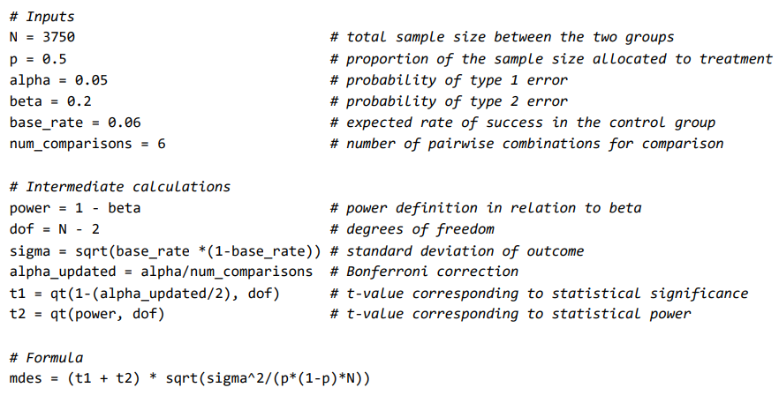

As a result, we estimate that the effect observed needs to be 2.7 percentage points higher in the treatment group for us to detect it with a probability of 0.8 (the power level). Assuming the control group has a base rate of success at 6%, this would mean needing to observe a 8.70% take-up rate in the treatment group.

After the list of ePay users was refined to those who live in an Illinois zip code with an American Community Survey (ACS) population estimate but are not already current or past 529 account owners, a simple random sample of size 7,500 is drawn from the remaining 715,649 sampleable pool of people. Then complete random assignment is done to place exactly 1,875 of these people into each of the four arms.

Utilizing the ACS data, we look at the shares of people in each arm that live in a zip code that is majority-Black or majority-Hispanic and below $50,000 or above $72,000 in median household income and then complete pairwise 2-sample tests for equality of proportions for each.

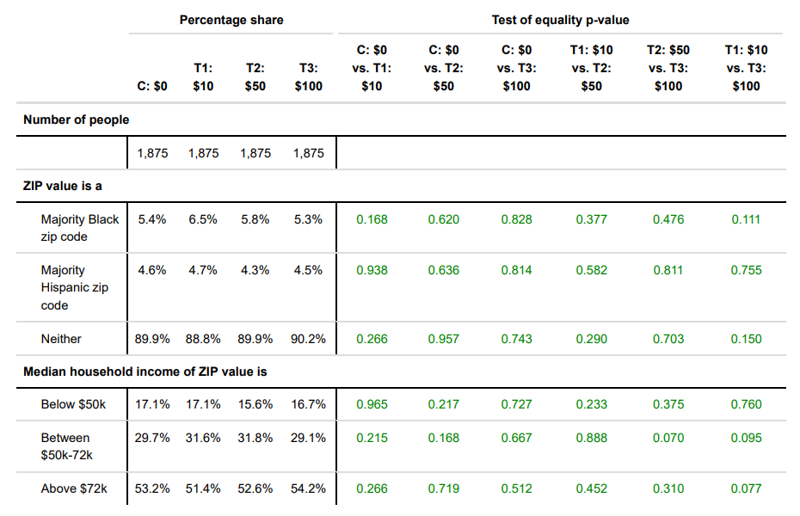

After data from batch 1 is collected a few weeks after launch, we will have a better estimation of the expected effect size and outcome variance for our context, and the calculation below will be completed to determine the sample size expected to be needed for batch 2. The process of extracting a sample of that size from the remaining 708,149 people and performing an equal allocation randomization of each person into one of the arms will follow the process in which these were done for batch 1.

$$N={(t_{1-\frac{α}{2}}+t_{1-β})}^{2}×\frac{1}{p(1-p)}×\frac{σ^{2}}{{effect_size}^{2}}$$

- Post-Pilot Analysis

As specified in this pre-analysis plan and as of the end of October, we have successfully implemented the pilot with n = 7,500 email recipients. The results show a relatively high email engagement rate (~40%) across the control and treatment groups, but only 4 email recipients opened an account (1 in the control group, 2 in the $10 incentive group, and 1 in the $100 incentive group). Despite the null and insignificant take-up rate, we will launch a larger batch to ensure that the pilot did not miss out on potential new account owners due to a lack of important observable characteristics, such as whether the email recipient is a parent.

The table below summarizes the necessary number of account signups per group to detect an effect assuming different baseline take-up rates.

Number of Account Signups Needed Per Group (Total N = 150,000)
Base Rate | 0.1% | 0.2% | 0.5% | 1.0%
Control ($0) | 38 | 75 | 188 | 375
Each treatment | 62 | 110 | 242 | 452

With a batch size of 150,000 email recipients split equally among the four groups ($0, $10, $50, and $100 incentive) and a control group base take-up rate of 0.1% (38 account signups among the 37,500 email recipients with the $0 incentive), we will need to observe 62 signups per treatment group for us to detect an effect with a probability of 0.8 (the power level). For control group base rates of 0.2%, 0.5%, and 1.0%, the required number of seeded account signups per group for us to detect an effect would be 110, 242, and 452, respectively.

Based on the results of this next batch and potential budget constraints, we will update the analysis plan again should we decide to send emails to another batch of a similar or larger size.

- Appendices
  - Recruitment email

No incentive recruitment email:
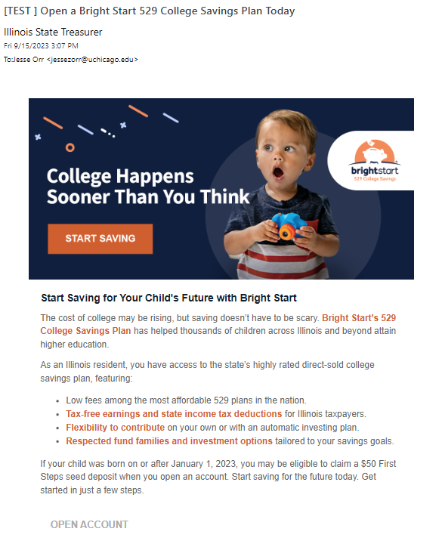

$10 incentive recruitment email:

The $50 and $100 incentive recruitment emails are identical to the $10 incentive recruitment email with every instance of “$10” being replaced with the corresponding amount for each treatment group.

  - Reminder email

No incentive reminder email:
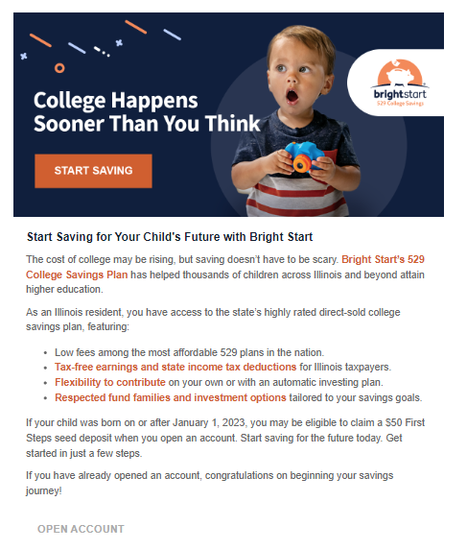

$10 incentive reminder email:

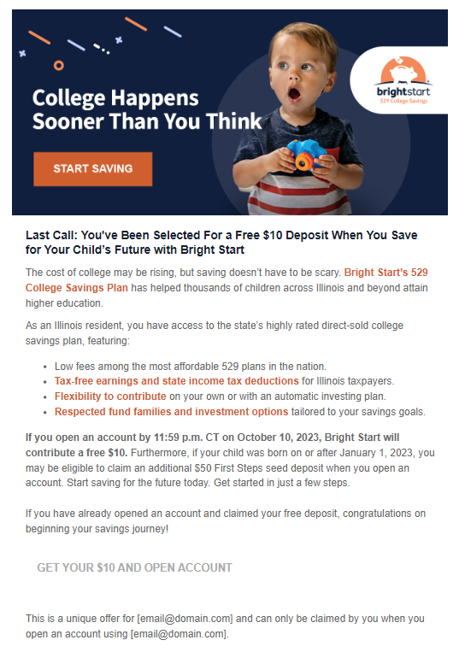
The $50 and $100 incentive reminder emails are identical to the $10 incentive reminder email with every instance of “$10” being replaced with the corresponding amount for each treatment group.
  - Webpage to claim the promo code

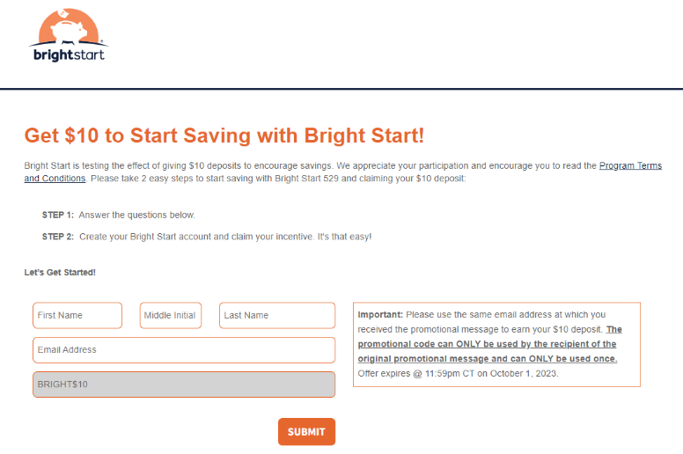

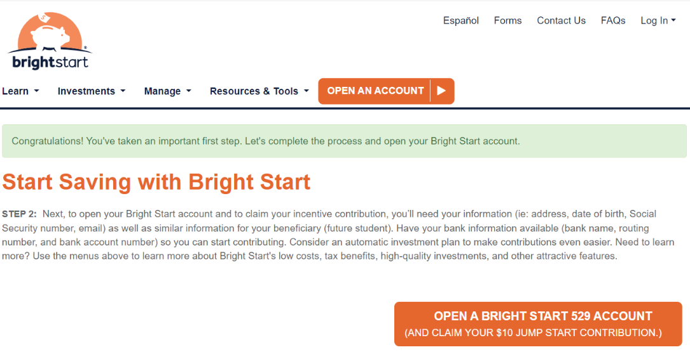

The $50 and $100 incentive webpages are identical to the $10 incentive webpage with every instance of “$10” being replaced with the corresponding amount for each treatment group.
- References

- Briscese, G., Liu, S., & Orr, J. (2023). The Promise of 529 Plans: Increasing college savings for all Illinois Families (p. 11) [Policy Brief]. University of Chicago Inclusive Economy Lab. https://urbanlabs.uchicago.edu/attachments/4454e1001fbb05f928db77ac2700ab6b259854e3/store/70119b5c0f47dd4d38b68c63db8e746e00c3fdf3037943dbb0c8e57c05d3/UC-529-Policy-Brief-Final%5B5%5D.pdf
- Clark, R. L., Hammond, R. G., Sandler Morrill, M., & Khalaf, C. (2017). Nudging Retirement Savings: A Field Experiment on Supplemental Plans (Working Paper 23679). National Bureau of Economic Research. https://www.nber.org/papers/w23679
- Cranor, T., Goldin, J., Homonoff, T., & Moore, L. (2020). Communicating tax penalties to delinquent taxpayers: Evidence from a field experiment. National Tax Journal, 73(2), 331–360. https://doi.org/10.17310/ntj.2020.2.02
- Duflo, E., Gale, W., Liebman, J., Orszag, P., & Saez, E. (2007). Savings Incentives for Low- and Moderate-Income Families in the United States: Why is the saver’s credit not more effective? Journal of the European Economic Association, 5(2–3), 647–661. https://eml.berkeley.edu/~saez/duflo-gale-liebman-orszag-saezJEEA07savercredit.pdf
- Engelhardt, G. V., & Kumar, A. (2007). Employer matching and 401(K) saving: Evidence from the health and retirement study. Journal of Public Economics, 91(10), 1920–1943. https://doi.org/10.1016/j.jpubeco.2007.02.009
- Herd, Pamela, and Donald P. Moynihan. Administrative burden: Policymaking by other means. Russell Sage Foundation, 2019.
- Hoffman, M. G., Klee, M. A., & Sullivan, B. (2022, August 31). New data reveal inequality in retirement account ownership. America Counts: Stories. https://www.census.gov/library/stories/2022/08/who-has-retirement-accounts.html
- Goldin, J., Homonoff, T., Javaid, R., & Schafer, B. (2022). Tax filing and take-up: Experimental evidence on tax preparation outreach and benefit claiming. Journal of Public Economics, 206, 104550. https://doi.org/10.1016/j.jpubeco.2021.104550
- Goldin, J., Homonoff, T., & Will, T.-R. (2017). Retirement Contribution Rate Nudges and Plan Participation: Evidence from a Field Experiment. The American Economic Review, 107(5), 456–461. https://www.jstor.org/stable/44250440
- How America Pays for College. (2021). Sallie Mae. https://www.salliemae.com/content/dam/slm/writtencontent/Research/HowAmericaPaysforCollege2021.pdf
- Linos, E., Prohofsky, A., Ramesh, A., Rothstein, J., & Unrath, M. (2022). Can nudges increase take-up of the EITC? Evidence from multiple field experiments. American Economic Journal: Economic Policy, 14(4), 432–452. https://doi.org/10.1257/pol.20200603
- Mason, L. R., Nam, Y., Clancy, M., Kim, Y., & Loke, V. (2010). Child Development Accounts and saving for children’s future: Do financial incentives matter? Children and Youth Services Review, 32(11), 1570–1576. https://doi.org/10.1016/j.childyouth.2010.04.007
- Nebraska State Treasurer’s Office. (2019, May 29). New Study Finds 57% of Americans Unfamiliar with 529 Plans. https://treasurer.nebraska.gov/news/default.aspx?story=511
- Rodríguez, C., & Saavedra, J. E. (2019). The persistent effects of youth savings reminders: Experimental evidence from text-message campaigns in Colombia. Journal of Development Economics, 139, 135–156. https://doi.org/10.1016/j.jdeveco.2019.03.001
- Tummala, Swetha, Wayne Zhong, and Lucy E. Marcil. "Embedding 529 College Savings Accounts in Pediatric Care: A Pilot Innovation." Academic Pediatrics 22, no. 3 (2022): 501-502.

How America Pays for College, 2021
Nebraska State Treasurer’s Office, 2019
Hoffman et al., 2022
See Briscese et al., 2023

