

FOUNDATION UNIVERSITY SCHOOL OF SCIENCE AND TECHNOLOGY

TOPIC:
The effect of MDCT cognitive training on Cognitive impairment and Dementia in Blinds

Supervisor:
Mr. Muhammad Aqeel

Group Member:
Yusra Habib
Rafia Perveen
Ayesha Mehmood

The effect of MDCT cognitive training on Cognitive impairment and Dementia in Blinds

Introduction
Globally, around 55 million people are currently living with dementia or cognitive impairment and this number may increase to 152 million by 2050 according to proper estimation (Livingston et al.,2017;Zhou et al.,2023).Several long-term studies cognitive skills severe enough to reduce a person's ability to perform everyday activitieshave been conducted to assess the impact of visual impairment on cognitive function. Zhou et al., 2023 findings revealed that vision and hearing impairments were independently as well as together linked to worse cognitive performance over time. About 110 full-text research and cognitive decline in older persons, of which 53 were cross-sectional papers were chosen for data extraction in a systematic evaluation of vision impairment studies, 43 were longitudinal, and 14 were case-control studies. Participants' ages ranged from 50 to 93.1 years old on average. 91 (83%) of this research claimed to have shown a connection between VI and cognitive decline (Davies‐Kershaw et al., 2018 ; Hajek et al., 2016 ; Hamedani et al., 2019 Lin et al., 2004 ; Luo et al., 2018 ; Nagarajan et al., 2022). but some studies conclude that VI was not significantly associated with dementia and cognitive decline, a combination of both visual and hearing impairments was significantly associated with the risk of dementia (Brenowitz et al., 2018 ; Ihle et al., 2015 ; Michalowsky et al., 2019 ; Swenor et al., 2018).Although some earlier research has shown a link between visual impairment and cognitive decline, the majority of these investigations have been carried out in western populations
Dementia describes an overall decline in memory and other. It is characterized by the progressive and persistent deterioration of cognitive function. Affected patients often have memory loss and a partial or significant lack of insight into their deficits. (Emmady & Tadi, 2022). Dementia has no known cure or medical treatment, and there is no known way to restore function to those who have it. Researchers have recently started to concentrate on preventing or slowing the onset of dementia in its preclinical phases (Livingston et al., 2017).
It is crucial to understand how sensory loss affects older adults' performance on measures of cognition and how the evaluation of sensory impairments could inform the interpretation of cognitive test results and clinicians' recommendations for case management. This is because there is a high prevalence of age-related sensory loss, a strong link between sensory and cognitive functioning and a higher risk for dementia associated with sensory loss, (Dupuis et al, 2014).
Loss of vision can have a significant impact on both your physical and emotional health. It can increase your risk of falling and lower your quality of life. Loneliness, social isolation, and thoughts of concern, anxiety, and dread have all been connected to vision loss. People with vision loss frequently experience depression. One in four persons with vision loss reported experiencing anxiety or sadness in a recent CDC survey. In comparison to those 65 and older, younger adults with visual loss had a nearly 5-fold increased chance of experiencing severe anxiety or depression, probably as a result of a lack of good coping or self-management abilities. Untreated anxiety can increase the risk of developing depression. Depression and anxiety should be examined in those with vision loss. Their quality of life will improve as rapidly as these issues are addressed (CDC, 2021). Furthermore, vision impairment has a significant impact on people and the world, according to a systematic review by (Demmin & Silverstein, 2020). They discovered that the prevalence of depression and anxiety is rising among those who are visually impaired. Additionally, data from community samples indicates that people with low vision and/or blindness are 1.6–2.8-times more likely to develop depression compared to those without vision impairment (Mayro et al., 2020;Zhang et al., 2013).
There haven't been any experimental studies up to now that have been explicitly concerned with employing cognitive tests to evaluate cognitive performance in people with visual impairment. The implementation of scales like the Mini-Mental State Examination (MMSE) and the Short Portable Mental Status Questionnaire (SPMSQ) has been an essential component of previous research in this field. It is important that no psychometric tests have been employed to assess cognitive impairment in this cohort. This gap in the literature highlights the need for additional research on the cognitive abilities and limitations encountered by people with visual impairment, using a wider variety of assessment techniques to acquire a more through picture of their cognitive functioning. The development and implementation of a psychometric test intended to evaluate blind people's cognitive ability forms the foundation of our theoretical framework. In the present study distinct scales are used to assess dementia, depression and cognitive impairment. After the initial assessment, an intervention is started. The test is then retaken and the remaining half of its items are used this time. This post-intervention phase attempts to look into how the intervention might affect dementia, depression, and cognitive impairment.
The main goal of this study is to determine whether implementing this intervention results in any appreciable improvements in the levels of dementia, depression, and cognitive impairment that have been measured. With the aid of this research methodology, the present study examines the relationship that may exist between cognitive functioning, and the onset of dementia in blind people, providing insight into the success of the intervention in enhancing their overall cognitive function.

Methodology

Objective
- To examine the effect of visual impairment, blindness and cognitive decline in a Pakistani population.
- To examine whether the implementation of intervention yields any significant changes in the measured levels of cognitive impairment, depression, and dementia.
- To study the effect of psychometric properties of the Cognitive test
- To examine the effect of blindness on cognitive function, depression and dementia

Study Design and Participants
This study was a within-group, simple random 2-block design to investigate the effect of the cognitive intervention on cognitive performance in blind patients. Thirty blind patients who expressed an interest in participation in the study were recruited from government school of blind in Shamsabaad between November 2023 and December 2023. They then undergo a standardized psychological assessment and were scheduled to undergo Cognitive test that are specially design for the blind. All participants met preserved general cognitive function (mini-mental state examination (MMSE) score of >24/30), and do not meet the diagnosis of dementia (according to the 10th International Statistical Classification of Diseases and Related) Health Problems (ICD-10).Other inclusion criteria were as follows: males and females with an average age of 30 years (range:18 to 60).In order to be included in the study, the participants had to be diagnosis of visual impairment and blind as evaluated by an eye specialist, primary school education (≥5 years), a Dementia severity rating scale (DSRS) = 2, and Beck depression Inventory. Exclusion criteria were that participant not be normal and younger than 18 years or older than 60, not have psychiatric disorders listed in the Diagnostic and Statistical Manual of Mental Disorders 5th edition (DSM-v), current pharmaceutical regiment, including cognitive enhancers or antidepressants, and any physical condition that could preclude regular attendance and full participation in the intervention program. The present study was approved by the ethics committee of Foundation University School of Science and Technology, Islamabad, Pakistan. All participants were fully informed regarding the study protocol and provided written informed consent.


Research
Paradigm

Cognitive

test for
blind

Dement

B
eck
D
epression
I
nventory

Intervention

D
igit
S
pan test

T
actile
P
uzzle

Tactile
T
exture

Cognitive

test for
blind

C
linical
D
e
mentia
R
ating
S
cale

B
eck
D
epression
I
nventory

Interventions
As mentioned, the intervention covered a broad range of cognitive domains with tasks that involved reasoning, memory, visuospatial skills, and attention. The cognitive training program was developed by the Foundation University School of Science and Technology. The intervention was carried out at the Government Institute. The whole intervention comprised of a training session delivered once. The session included tasks that focused on cognitive domains. The cognitive training program covered the domains of memory (e.g., memorizing pictures and words, adapted from the word learning test and digit span test). Each task contained 3–5 different levels of difficulty, with 4 trials in each difficulty level. If a participant answered correctly in four or more trials, the difficulty level would be increased; conversely, if a participant answered incorrectly in more than two trials, the difficulty level in the next trial would be decreased. We modulated the task difficulty to maintain the degree of challenge and maximize participant performance. During the study, all participants did not receive cognitive enhancers.

Cognitive assessment
The study assessed cognition both at the baseline and after the intervention. Based on a survey of neuropsychological assessment, this study designed a cognitive test that examined memory, reasoning, visuospatial ability, attention, processing speed, and executive functioning. The individual tests are listed below. Global cognition was assessed via the MMSE (Folstein et al., 1975) and Cognitive test. The Cognitive test is further divided into 5 task such as Block design, Object assembly, pattern recognition, Labyrinth, Card arrangement.

MMSE
The Mini Mental State Examination (MMSE) is a tool that is used to systematically and thoroughly assess mental status. It is an 11-question measure that tests five areas of cognitive function: orientation, registration, attention, calculation, recall, and language. The maximum score is 30. (Kurlowicz & Wallace, 1999)

Scale Development
The initial version of the scale administered to the participant in the present study is consist of 5 task , the whole test contain 72 item which is shown in the table. We started to identifying the key properties of Semantic memory by reviewing the literature and categorizing the characteristics typically measured for individual memories.
The Blind Cognitive Intelligence Test : Instructions, Item and Component Categories.
Instructions:
People vary a lot as to how they do the task. The following task item are about how you perform a task. Please consider each item and experimenter indicate on a scoring sheet from 0 to 2 how much the individual score in task
Component 1: Block design 1
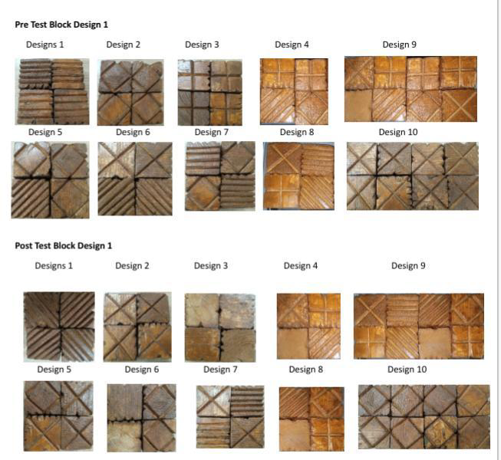
Task items
Component 1: Block design 2 Task items
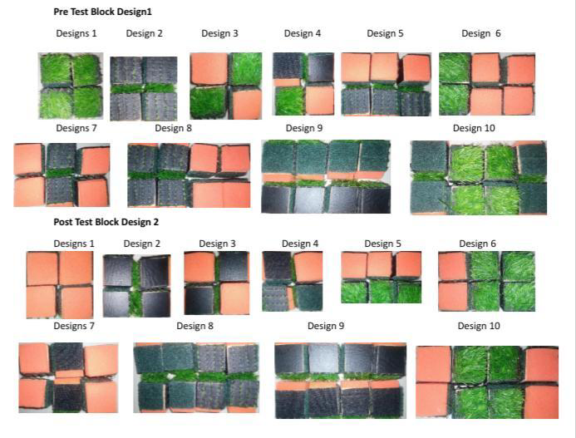
Component 2: Pattern Recognitions Task item
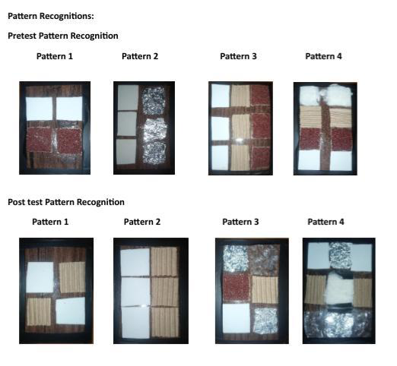
Component 3: Card Arrangement
Task items
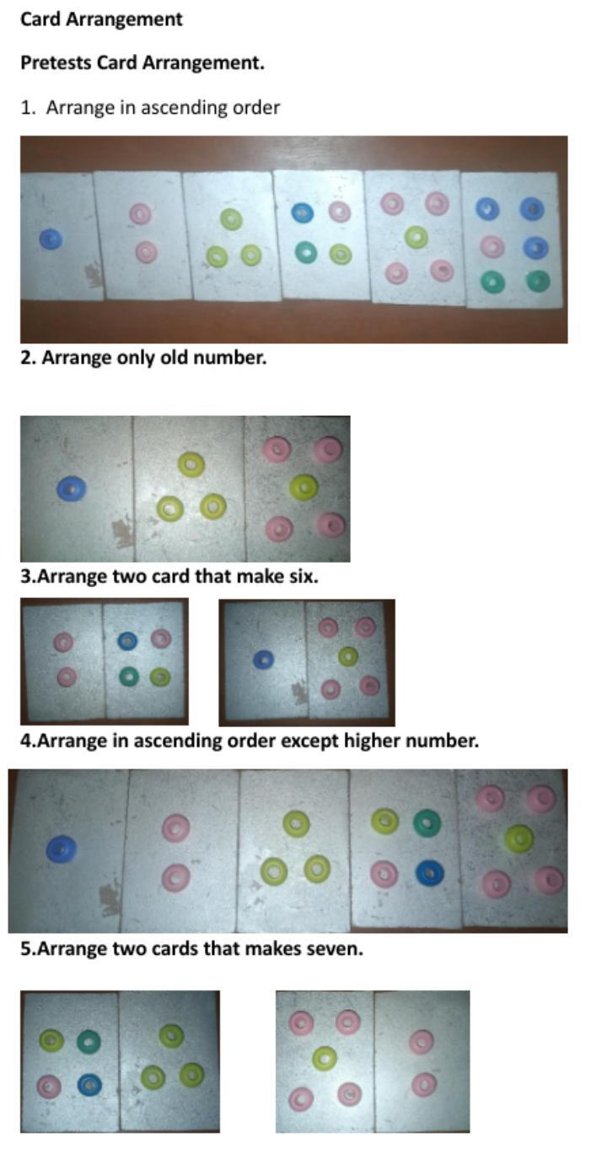
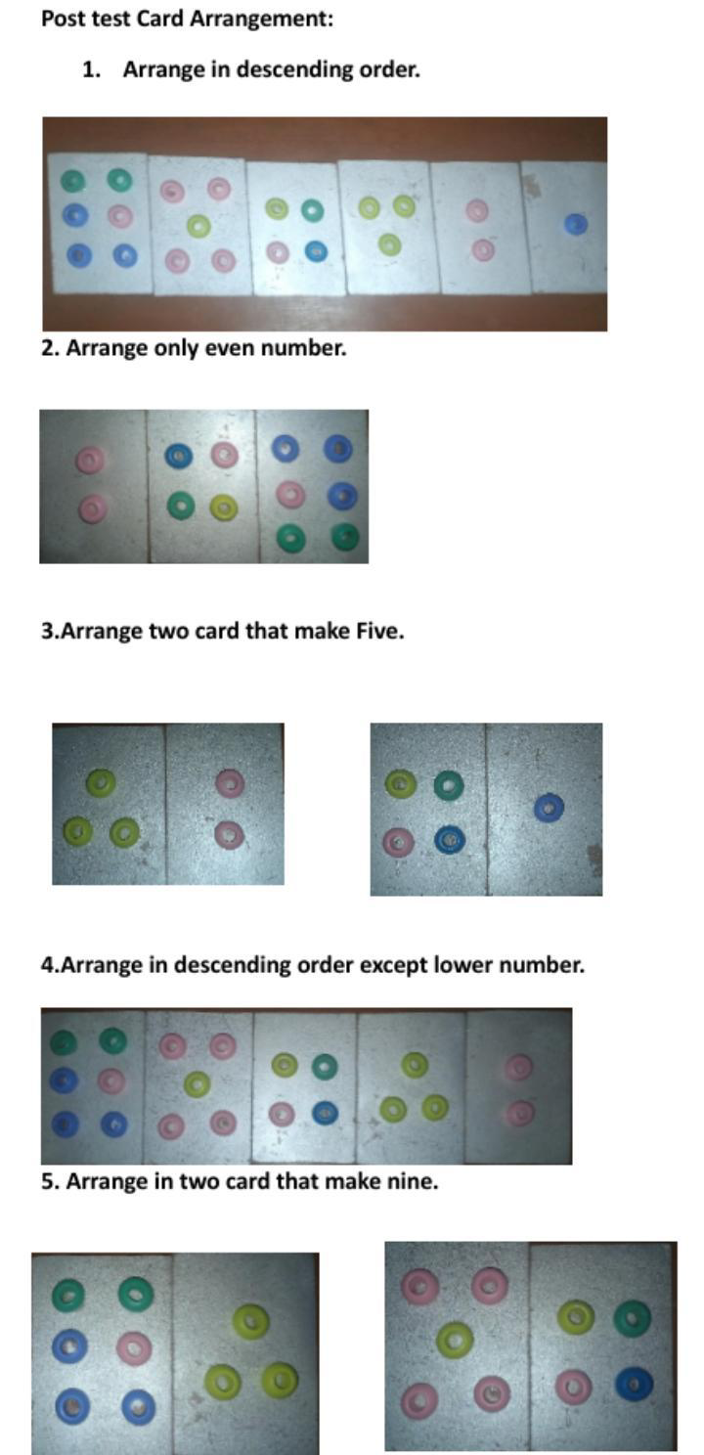

Component 4: Object Assembly
Task items
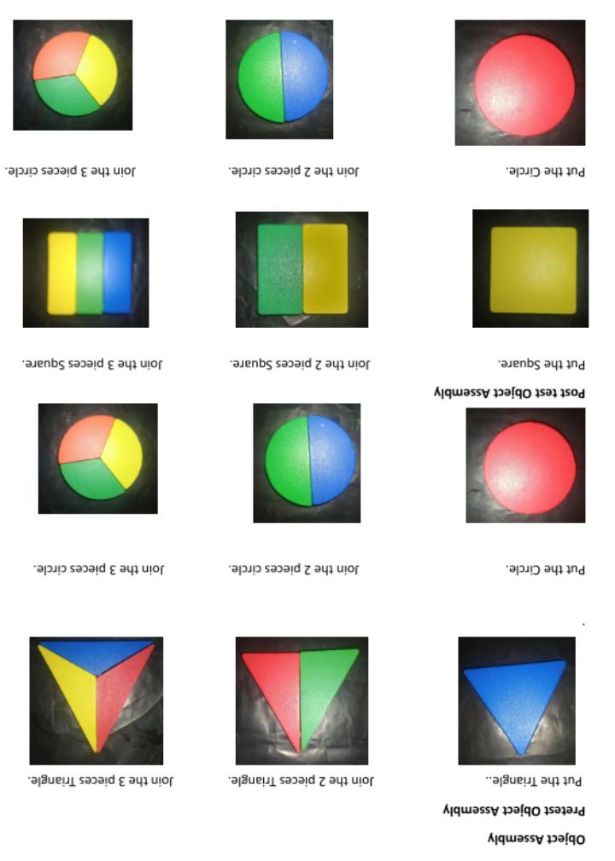

Component 5: Maze
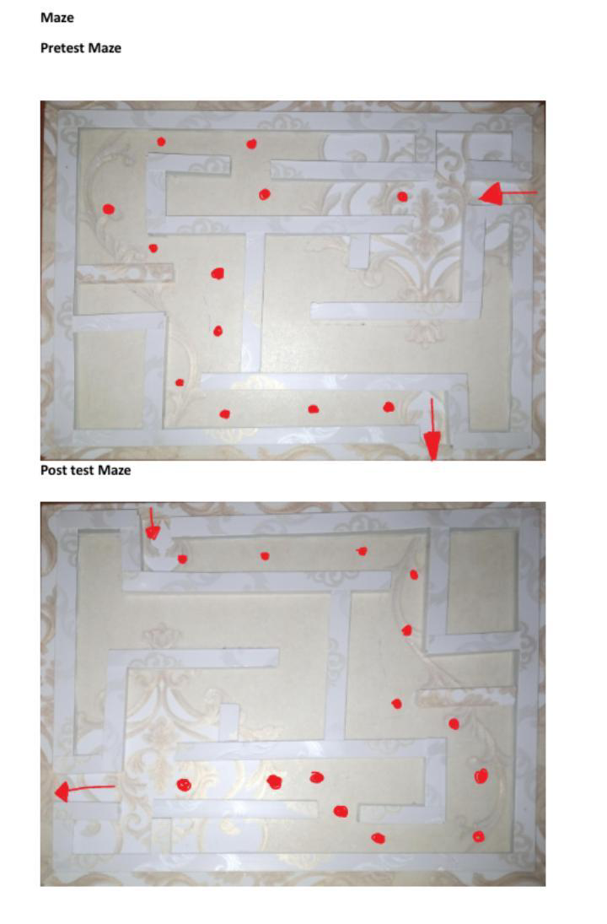
Task items
The theoretical model of a blind cognitive test was covered in this review.In a clinical environment, as well as during orientation and rehabilitation, the use of test instruments measuring intellectual functioning is crucial for providing appropriate assessment and management. The Weschler Scales, which include a Verbal part and a Performance part for abilities unrelated to culture, are the most widely used cognitive assessments. Unfortunately, there isn't a Weschler Scales version specifically for those with visual impairments. Vander Kolk (1977) employed verbal subtests of the Weschler Adult Intelligence Scale to measure cognitive performance in the blind. Additionally, Tobin and colleagues (2010) gave verbal intelligence tests only to a group of 85 adults and children with retinoblastoma. While nonverbal cognitive abilities are completely ignored, this strategy has been found insufficient. Other non-vision-required performance skill assessments, like the Ravens Tactual Progressive Matrices (Rich, Anderson, 1965) and D48 (Pichot, 1968), are no longer in use. The Cognitive Test for the Blind was standardized by Nelson, Dias, and Joyce (2002) and evaluates both verbal and nonverbal domains.Children under the age of fourteen are not eligible to use CBT; only those who are fourteen years of age and up eligible. The Blind Learning Aptitude Test was created by Newland (1979) for children who are visually impaired. It has a good level of validity and reliability when standardized on 961 youngsters who are educationally blind. But the data are too outdated to administer this test in modern times. Finally it became clear that tests were not and could no become widely available without further support for research and development.
This study identified five components that are frequently studied and have robust effects in research on individual semantic memory: though Block design: orientation, ability to reproduce an haptic pattern, mental operations; analyzing, combining, comparing, deliberating, completing, discriminating, judging, criticizing and deciding, through Object assembly: spatial visualization and analysis, simultaneous processing, visual- motor coordination, dexterity and nonverbal concept formation, through Card arrangement: reasoning ability, and performance relates to the ability to understand the precursors and consequences of events, measures working memory, concentration, and planning abilities evaluating sense of direction the space, through Maze: the ability to make spatial cognitive maps, and planning, through Pattern recognition: assess the ability to identify and understand visual patterns will be measures. We then develop the 20, 20 items of block design 1 & 2, 8 items of pattern Recognition, 10 item of card arrangement, 12 item of object assembly, and 2 items of maze. The 72 items were adapted from, or inspired by, concrete task used in studies addressing cognitive level of individual who are blind , such as the block design firstly develop by (Kohs, 1920),(Hutt, 1932), (David Wexler, 1939), research on card arrangement by (Alida Bolwer, 1917), (David Wexler, 1939),( Sylvain Tompkins and Daniel Horn, 1942), the object assembly firstly develop by (David Wexler, 1939), (Carolina Cassar and Franco Lucchese, 2016), Ikeuchi and suehiro , Bader and Aehnelt, Richardson et al. (2004) and Carolina Cassar and Franco Lucchese (2016), studies on Maze (e.g Tolman and Charles Honzik, 1930), (David Wexler, 1939), (Carolina Cassar and Franco Lucchese, 2016) and pattern recognition (Theodoridis & Koutroumbas, 2009) then we develop a task .
Goal of this is to generate items reflecting the conceptual breadth of each of the five components. The final version of the BCIT is presented below.

Procedure

The 72 item BCIT was administered by performing each task in a lab . Each participant was first asked to fill in a consent form and answer demographic questions before preceding to answering the BCIT. The BCIT was the first of a series of task to be perform by the participants. The remaining half item of task were always presented after the Multi domain cognitive training.
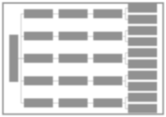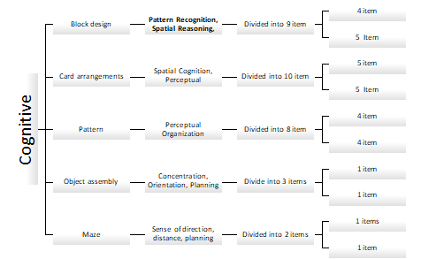

Dementia Severity Rating Scale

The Dementia Severity Rating Scale is a 5-point scale used to characterize six domains of cognitive and functional performance applicable to Alzheimer disease and related dementias: Memory, Orientation, Judgment & Problem Solving, Community Affairs, Home & Hobbies, and Personal Care. The necessary information to make each rating is obtained through a semi structured interview of the patient and a reliable informant or collateral source.

Beck Depression Inventory:
The Beck Depression Inventory (BDI, BDI-II), created by Dr. Aaron T. Beck, it’s a 21-question multiple-choice self-report inventory, one of the most widely used instruments for measuring the severity of depression. Its development marked a shift among health care professionals, who had until then viewed depression from a psychodynamic perspective, instead of it being rooted in the patient’s own thoughts.

References

Zhou, Y., Jin, W., Sun, Q., Liu, H., Liu, Y., Luo, J., & Zhou, M. (2023). Do Sensory Impairments Portend Cognitive Decline in Older Chinese Adults? Longitudinal Evidence from a Nationally Representative Survey, 2011–2018. Journal of Clinical Medicine, 12(2), 430–430. https://doi.org/10.3390/jcm12020430
‌Livingston, G., Sommerlad, A., Orgeta, V., Costafreda, S. G., Huntley, J., Ames, D., Ballard, C., Banerjee, S., Burns, A., Cohen-Mansfield, J., Cooper, C., Fox, N., Gitlin, L. N., Howard, R., Kales, H. C., Larson, E. B., Ritchie, K., Rockwood, K., Sampson, E. L., & Samus, Q. (2017). Dementia prevention, intervention, and Care. The Lancet, 390(10113), 2673–2734.
Zhou, Y., Jin, W., Sun, Q., Liu, H., Liu, Y., Luo, J., & Zhou, M. (2023). Do Sensory Impairments Portend Cognitive Decline in Older Chinese Adults? Longitudinal
Evidence from a Nationally Representative Survey, 2011–2018. Journal of Clinical Medicine, 12(2), 430–430. https://doi.org/10.3390/jcm12020430
Nagarajan, N., Assi, L., Varadaraj, V., Motaghi, M., Sun, Y., Couser, E., Ehrlich, J. R., Whitson, H., & Swenor, B. K. (2022). Vision impairment and cognitive decline among older adults: a systematic review. BMJ Open, 12(1), e047929.
https://doi.org/10.1136/bmjopen-2020-047929
Lin, M., Gutierrez, P. R., Stone, K. L., Yaffe, K., Ensrud, K. E., Fink, H. A., Sarkisian, C. A., Coleman, A. L., & Mangione, C. M. (2004). Vision impairment and combined vision and hearing impairment predict cognitive and functional decline in older women. Journal of the American Geriatrics Society, 52(12), 1996–2002. https://doi.org/10.1111/j.1532-5415.2004.52554.x
Luo, Y., He, P., Guo, C., Chen, G., & Li, N. (2018). Association Between Sensory Impairment and Dementia in Older Adults: Evidence from China. Journal of the American Geriatrics Society, 66(3), 480–486. https://doi.org/10.1111/jgs.15202
Hajek, A., Brettschneider, C., Lühmann, D., Eisele, M., Mamone, S., Wiese, B., Weyerer, S., Werle, J., Pentzek, M., Fuchs, Â., Riedel‐Heller, S. G., Luck, T., Bickel, H., Weeg, D., Koppara, A., Wagner, M., Scherer, M., Maier, W., & König, H. (2016). Effect of visual impairment on physical and cognitive function in old Age: Findings of a Population-Based Prospective Cohort study in Germany. Journal of the American Geriatrics Society, 64(11), 2311–2316. https://doi.org/10.1111/jgs.14458
Davies‐Kershaw, H., Hackett, R. A., Cadar, D., Herbert, A., Orrell, M., & Steptoe, A. (2018). Vision Impairment and Risk of Dementia: Findings from the English Longitudinal Study of Ageing. Journal of the American Geriatrics Society, 66(9), 1823–1829. https://doi.org/10.1111/jgs.15456
Hamedani, A. G., VanderBeek, B. L., & Willis, A. W. (2019). Blindness and Visual Impairment in the Medicare Population: Disparities and Association with Hip Fracture and Neuropsychiatric Outcomes. Ophthalmic Epidemiology, 26(4), 279–285. https://doi.org/10.1080/09286586.2019.1611879
Ihle, A., Oris, M., Fagot, D., & Kliegel, M. (2015). No cross-sectional evidence for an increased relation of cognitive and sensory abilities in old age. Aging & Mental Health, 21(4), 409–415. https://doi.org/10.1080/13607863.2015.1109055
Brenowitz, W. D., Kaup, A. R., Lin, F. R., & Yaffe, K. (2018). Multiple Sensory Impairment Is Associated With Increased Risk of Dementia Among Black and White Older Adults. The Journals of Gerontology: Series A, 74(6), 890–896. https://doi.org/10.1093/gerona/gly264
Swenor, B. K., Wang, J., Varadaraj, V., Rosano, C., Yaffe, K., Albert, M., & Simonsick, E. M. (2018). Vision Impairment and Cognitive Outcomes in Older Adults: The Health ABC Study. The Journals of Gerontology: Series A, 74(9), 1454–1460. https://doi.org/10.1093/gerona/gly244
Michalowsky, B., Hoffmann, W., & Kostev, K. (2019). Association Between Hearing and Vision Impairment and Risk of Dementia: Results of a Case-Control Study Based on Secondary Data. Frontiers in Aging Neuroscience, 11. https://doi.org/10.3389/fnagi.2019.00363
Emmady, P. D., & Tadi, P. (2022, May 8). Major Neurocognitive Disorder (Dementia). PubMed; StatPearls Publishing. https://www.ncbi.nlm.nih.gov/books/NBK557444/
Livingston, G., Sommerlad, A., Orgeta, V., Costafreda, S. G., Huntley, J., Ames, D.,
Ballard, C., Banerjee, S., Burns, A., Cohen-Mansfield, J., Cooper, C., Fox, N., Gitlin, L. N., Howard, R., Kales, H. C., Larson, E. B., Ritchie, K., Rockwood, K., Sampson, E. L., & Samus, Q. (2017). Dementia prevention, intervention, and Care. The Lancet, 390(10113), 2673–2734Dupuis, K., Pichora-Fuller, M. K., Chasteen, A. L., Marchuk, V., Singh, G., & Smith, S. L. (2014). Effects of hearing and vision impairments on the Montreal Cognitive Assessment. Aging, Neuropsychology, and Cognition, 22(4), 413–437. https://doi.org/10.1080/13825585.2014.968084
CDC. (2021, September 27). Protect Your Vision. Centers for Disease Control and Prevention:https://www.cdc.gov/visionhealth/resources/features/vision-lossmentalhealth.html#:~:text=Vision%20loss%20can%20affect%20your%20physica l%20health%20by%20increasing%20your
Demmin, D. L., & Silverstein, S. M. (2020). Visual Impairment and Mental Health: Unmet Needs and Treatment Options. Clinical Ophthalmology (Auckland, N.Z.), 14, 4229–4251.https://doi.org/10.2147/OPTH.S258783
Mayro, E. L., Murchison, A. P., Hark, L. A., Silverstein, M., Wang, O. Y., Gilligan, J. P., Leiby, B. E., Pizzi, L. T., Casten, R. J., Rovner, B. W., & Haller, J. A. (2020). Prevalence of depressive symptoms and associated factors in an urban, ophthalmic population. European Journal of Ophthalmology, 112067212090170. https://doi.org/10.1177/1120672120901701
Zhang, X., Bullard, K. M., Cotch, M. F., Wilson, M. R., Rovner, B. W., McGwin, G., Owsley, C., Barker, L., Crews, J. E., & Saaddine, J. B. (2013). Association Between Depression and Functional Vision Loss in Persons 20 Years of Age or Older in the United States, NHANES 2005-2008. JAMA Ophthalmology, 131(5), 573. https://doi.org/10.1001/jamaophthalmol.2013.2597
World Health Organization. International Statistical Classification of Diseases and
Related Health Problems, 10th revision. Geneva: World Health Organization (1993)
American Psychiatric Association. Diagnostic and Statistical Manual of Mental Disorders, 4th edn. Washington, DC: American Psychiatric Association
Publishing (1994).
Folstein, M. F., Folstein, S. E., & McHugh, P. R. (1975). “Mini-mental state”. A practical method for grading the cognitive state of patients for the clinician. Journal of Psychiatric Research, 12(3), 189–198. https://doi.org/10.1016/00223956(75)90026-6
Cassar, C., & Lucchese, F. (2016). Psychometric Test for Blind Adults and Children, Critical Issues and Perspectives. International Journal of Developmental and Educational Psychology, 2(1), 109–116. https://www.redalyc.org/journal/3498/349851777046/html/
Dunn, A., Qiao, A., & Johnson, M. (n.d.). Measuring More to Learn More From the Block Design Test: A Literature Review. https://doi.org/10.6084/m9.figshare.14560593.v1
Richardson, M., Jones, G. A., Torrance, M., & Baguley, T. (2006). Identifying the task variables that predict object assembly difficulty. Human Factors, 48(3), 511–525.
Theodoridis, S., & Koutroumbas, K. (2009, January 1). Chapter 8 - Template Matching (S. Theodoridis & K. Koutroumbas, Eds.). ScienceDirect; Academic.Press. https://www.sciencedirect.com/science/article/abs/pii/B9781597492720500104

‌

