Strategic Ignorance with Third-Party Information Provision
  - Version 2, supplementing previous preregistered research plan
Main modifications as compared to initial preplan: Added co-author, simplified instructions, and new attempt to replicate previous findings in the literature concerning strategic ignorance (Stage 1). This involves i) presenting the information and allocation option choices in one screen (as opposed to two different screens); introduction of attention checks; and a change of programming tool (Lioness instead of z-tree Unleashed).

1. Introduction

A growing body of research, pioneered by Dana et al. (2007), has documented the prevalence of strategic ignorance in social decisions (e.g., Matthey and Regner 2011; Grossman 2014; van der Weele 2014; Feiler 2014; Exley 2016; Grossman and van der Weele 2017; Momsen and Ohndorf 2020, 2023; Serra-Garcia and Szech 2022): although people frequently incur a private cost to bring about some social benefit under conditions of full information, when the social benefit is uncertain, a surprisingly large number of people avoid easy opportunities to resolve this uncertainty and revert to selfish behavior.
Although ignorance may stem from confusion or lack of interest, some individuals avoid information for strategic reasons, such as maintaining positive self - or social image (Nyborg 2011, Grossman 2014, Grossman and van der Weele 2017, Exley and Kessler 2021). Our social interactions frequently unfold in situations much richer than the simple two-person decision environment modeled in the basic moral-wiggle-room game introduced by Dana et al. (2007)—henceforth DWK. For example, other people with whom we interact might be able to either supply the information which we wish to avoid or at the very least point out our attempts to avoid it. Someone dining with an aspiring vegetarian could say, “you know that soup is made with chicken stock, right?” or “aren’t you going to ask what’s in that soup?”. Avoiding clicking on articles with headlines like, “Fast fashion: how clothes are linked to climate change,” doesn’t stop people from discussing such articles in your presence. If some people strictly prefer ignorance (as opposed to merely being indifferent to information), then externally imposing information on them might harm them.
The present study aims to explore how third parties with the option to inform dictators of the potential consequences of their choices affect the behavior of dictators, particularly those who would otherwise wish to avoid that information. We will use the moral-wiggle-room game of DWK as the fundamental decision because of its simplicity and to maintain comparability with other studies. In particular, we will look at whether the presence of such third parties affects dictators’ information and allocation choices, whether the dictator is willing to reward the behavior of the informer, and whether such potential reward deters bystanders from providing information. The goal is to shed further light on the strategic nature of information avoidance, the conditions under which it may manifest as an image-management strategy, and how social outcomes are determined in environments with richer social interactions.
However, various secondary aspects of the environment may encourage or discourage information avoidance. To best be able to examine our primary questions, we first must identify an environment in which this information avoidance is prevalent at the outset. Thus, before embarking on our primary experimental data collection, we must first conduct a preliminary experiment replicating the original DWK study in our decision environment to establish whether the environment is suitable (Stage 1). If we fail to find sufficiently high levels of information avoidance, we will not continue with the rest of the experiment. While we will have failed at this attempt to answer our main questions, will have learned something about the conditions under which information avoidance does or does not manifest.
However, conditional on finding sufficient levels of information avoidance in the preliminary experiment (see Hypotheses 0a-0c below), we will conduct the main experiment (Stage 2) to answer our main questions, both of which concern the dictator’s behavior. First, how does the presence of a third party affect ignorance rates and allocation choices? If allocation choices are affected, is this caused by the mere presence of the bystander – through giving the dictator a feeling of being watched, for example – or is it caused by the bystander’s actual provision of information?
Second, what behaviors or characteristics are correlated with the dictator’s behavior when it comes to rewarding the third party informer? Is the third party rewarded less when they impose information on a dictator who wanted to remain ignorant? Do dictators who try to avoid information reward less than those that seek it? If the informer provides information, does it matter whether the news is good (aligned interests) or bad (conflicting interests)?
Our third main question concerns the third party’s behavior. If the dictator would really have preferred to stay ignorant, i.e., the information is in fact unwelcome, a bystander choosing to provide information might trigger negative emotions on the dictator’s part. Our third question is thus whether informers’ provision of information is deterred when the dictator has an option to reward the informer’s behavior.
Preliminary work: finding a suitable experimental environment
Except for two studies, Lind et al. (2019) and Sorrapera et al. (2023), we are not aware of previous research exploring the role of third parties in a strategic ignorance context. Our study is most closely related to, and largely inspired by, Lind et al. (2019). They used a design very similar to that of DWK, although with a charity rather than individual subjects as the recipient. In additional treatments, they explored how dictators’ information choices and generosity changed with the introduction of a third party. Lind et al. (2019) found that willful ignorance almost completely vanished when another person, who may choose to impose information anyway, was known to be present: in these treatments, 94 percent of dictators chose to reveal information themselves.
Nevertheless, despite the close similarity to DWK’s design, information avoidance was barely present even before adding the third party: in Lind et al.’s Hidden Payoff treatment, in which no third party was present, as much as 78 percent of dictators revealed information themselves, and the share choosing the selfish option did not differ significantly between the Baseline and Hidden Payoff treatments. This is not entirely surprising, as many aspects of the experimental environment may affect ignorance rates, which already are known to be quite sensitive to the choice architecture (Grossman, 2014). However, this prevented a further exploration of the interaction between the dictator and the third party in their study: if the information is not avoided at the very outset, one can hardly explore the impact of another person on information avoidance.
Several studies (Momsen and Ohndorf 2020; Lind et al. 2019; Felgendreher 2018; Thunström et al., 2016; Grossman 2014) indicate that the phenomenon of strategic ignorance is sensitive to context and not as robust as one may expect based on the earliest literature on the topic. In particular, Grossman (2014) found that ignorance rates vary substantially according to whether being informed is the default choice, indicating that strategic ignorance is considerably less prevalent when the information choice is an active one. Our own preliminary pilot studies, moreover, provide strong indications that the exact wording and/or design of the computer interface can substantially affect ignorance choices, causing ignorance rates to vary from almost negligible to a majority.
Based on this, we have taken several steps to prevent suppressing strategic ignorance that may be present at the outset, since our main research questions can only be explored in a context in which strategic ignorance prevails. First, in terms of wording, layout and default choices, we have avoided presenting the information decision as an active choice; we have also avoided highlighting the information choice more than absolutely necessary. Second, instructions are constructed to be clear enough to understand, but brief enough to require a slight cognitive effort on subjects’ part, making it easier to ‘close one’s eyes’ for those who may want to do so. Third, in most of our treatments the dictators are not informed about the presence of the informers until dictators have already made their information/ignorance choice. We do not consider this deception since, although some information is not provided initially, no erroneous or directly misleading information is provided either.
We initially preregistered our study in April 2022 (see https://www.socialscienceregistry.org/versions/141944/docs/version/document). In that initial plan, we pointed out that since our research questions can only be explored in a context where strategic ignorance does prevail, our study would proceed in two stages: First, we would explore in Stage 1 whether there is indeed strategic ignorance in our context, using the treatments without informers, the Baseline and Hidden Information treatments. These treatments correspond to the Baseline and Hidden Information treatments in Dana et al. (2007). For strategic ignorance to be considered present, some dictators must not reveal information in Hidden Information, and a significantly larger share of dictators must choose the selfish option in Hidden Information with conflicting interests than in the Baseline. If strategic ignorance turned out to be sufficiently prevalent to allow exploration of our primary research questions, i.e., if Hypotheses 0a and 0b below were supported, we would then proceed to Stage 2; if not, the design would be modified and tested again, aiming to trigger strategic ignorance, before we would proceed to Stage 2.
In the spring and summer of 2022, we collected Stage 1 data according to the previous preregistered plan (https://www.socialscienceregistry.org/versions/141944/docs/version/document). The experiments were programmed using zTree unleashed (Fischbacher 2007, Duch et al. 2020) and were run using the recruitment/payment platform Prolific. Using a total sample of 232 subjects and hence 116 pairs (55 in Baseline and 61 in Hidden Information), we found that although some dictators did choose not to reveal information in the Hidden Information treatment, and a larger share of dictators chose the selfish option in Hidden Information with conflicting interests than in Baseline, the latter difference was not statistically significant (p=.148; see Appendix I for details). Consequently, according to our initial plan, we have now revised our Stage 1 design and procedures, aiming to create an environment in which previous findings of strategic ignorance are replicated. If it turns out that we are unable to do so, there is little point in proceeding to Stage 2.
In our new Stage 1 attempts, four main changes will be implemented as compared to the previous preregistered plan.
First, we will introduce attention checks and timers to reduce noise from inattentive subjects (possibly also bots).
Second, the experimental design itself is adjusted in that for several treatments, the information choice and allocation option choices will now be made in the same screen (as in, for example, Dana et al. 2007). In the previous Stage 1 attempt, the information choice was made before the allocation option choice, on a separate screen; thus, to stay ignorant the dictator had to actively choose to proceed without asking for information (a feature copied from Lind et al. 2019). The reason was that in the later Informer treatments, a bystander wanting to provide information to ignorant dictators would need to be able to do so before dictators’ allocation choice. However, a separate screen for the information choice may well affect its salience, and previous research as well as our own pilot studies indicate that this may influence the prevalence of strategic ignorance.
We now solve the above problem as follows. To study the effect of known bystander presence on ignorance rates, it is necessary to separate the dictator’s information and allocation choices: if information imposed by the third party is to have any potential effect at all, it must be imposed after the dictator has decided to stay ignorant but before the dictator has made their allocation choice. Thus, in our Informer – Separate Screens treatment, these decisions are made in separate screens, making it possible for a third party to provide information after the dictator has chosen ignorance, but before the dictator’s allocation choice. As a control for this treatment, we use our Hidden Information—Separate Screens treatment. Acknowledging the fact that the mere presence of a third party may affect the dictator’s information choice, we also include a Hypothetical Informer—Separate Screens treatment, in which the third party’s presence and role is announced, but their decision to inform is not implemented.
The separate decision screens, however, may increase the salience of the information choice, potentially yielding low ignorance rates (Grossman 2014, Lind et al. 2019). To keep as closely to the original DWK design as possible, we return to the single-screen design for the treatments exploring dictators’ reactions to imposed information. Our Hidden Information treatment is like the corresponding treatments in Dana et al. (2007) and Grossman (2014), with the information and allocation choices made on the same screen. This treatment is used as a control for our Hypothetical Informer, Informer and Informer—Bonus treatments. In these treatments, the presence of the third party is introduced to dictators after their information/ignorance choice. If the informer imposed information on a dictator who avoided it, the dictator subsequently is allowed to reconsider her allocation choice.
Third, we will change our choice of programming tool. Combining subject interaction in z-Tree Unleashed and the Prolific platform turned out to be more complicated than expected, introducing impractical experimental routines and long time lags between recruitment and experiment. This may have contributed to a major attrition problem – losing about 50 percent of subjects between the recruitment stage and the experiment itself. Since attrition might not be random with respect to our main variables of interest, the high attrition rate could be one reason for the apparently low or missing prevalence of strategic ignorance. Instead, we will be using Lioness (Giamattei et al. 2020) instead of z-tree Unleashed (Fischbacher 2007, Duch et al. 2020), which will essentially eliminate the practical problems and time lags mentioned above. This allows us to collect a sizable dataset with (hopefully) less attrition.
Fourth, instead of exploring the effects of Dicators’ option to punish Informers (reducing the Informer’s payoff by 2 dollars) we now explore the effects of Dictators’ option to reward Informers by a bonus of 0.50 dollars. This is due to our belief that the previous sanction opportunity may have been too harsh, possibly causing Dictators not to use it at all. (No Informer treatments were performed in Stage 1, so this design change was not motivated by empirical results in Stage 1.)
Since procedures are not fully comparable, we will include only the new Stage 1 data in our analysis, to be collected in the Spring of 2023, omitting the data from the Spring 2022 sessions. If the new Stage 1 data confirms that strategic ignorance is present, as specified in Hypotheses 0a - 0c below, we will then proceed to Stage 2.
In Stage 2, we will add the three separate-screens treatments (Hidden Info—Separate Screens, Hypothetical Informer—Separate Screens, and Informer—Separate Screens) as well as the three single-screen treatments (Hypothetical Informer, Informer, and Informer—Bonus).

2. Treatments
We will conduct eight treatments, numbered according to the corresponding subsections below.

2.1 Baseline
In the Baseline of their original study, Dana, Weber and Kuang (2007) (DWK) ran a binary dictator game experiment with student participants in which dictators had to choose between two alternatives, A and B. In alternative A, the dictator would earn 6 and the recipient 1; in alternative B, each would earn 5. About three quarters chose the fair alternative B. In DWK’s Hidden information treatment, however, dictators did not initially know the payoffs of the recipient in each alternative: they knew that dictators themselves would get 6 in A and 5 in B, but the payoffs to the recipient was either, with equal probabilities, 1 in A and 5 in B (conflicting), or 5 in A and 1 in B (aligned). This uncertainty, however, could be costlessly resolved by the dictators simply by clicking a button on the screen. About half of dictators did not click the button, thus remaining ignorant about the recipient’s payoffs – and among those who were actually in the state of conflicting interests, all chose the selfish option A. Thus, the option to stay ignorant substantially reduced the resulting generosity.

 | Conflicting |  |  | Aligned
 | Dictator | Recipient |  | Dictator | Recipient
A | 6 | 1 |  | 6 | 5
B | 5 | 5 |  | 5 | 1

Table 1. Payoffs in DKW’s Hidden Information treatment.

Our Baseline treatment replicates the incentives and main design of DWK’s baseline treatment. All instructions are given on-screen. After an initial explanation (see Figure 1) and a simple comprehension check, dictators make their choice between options A and B.

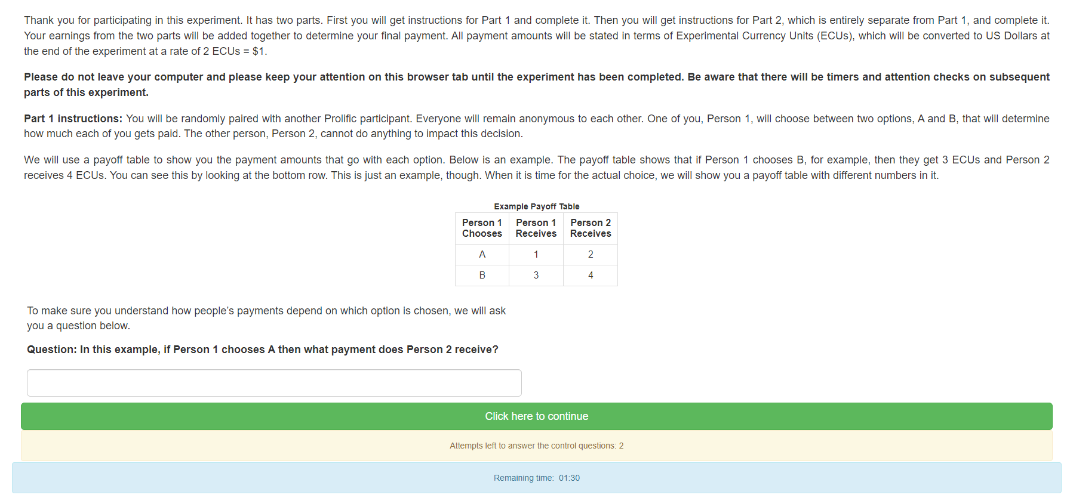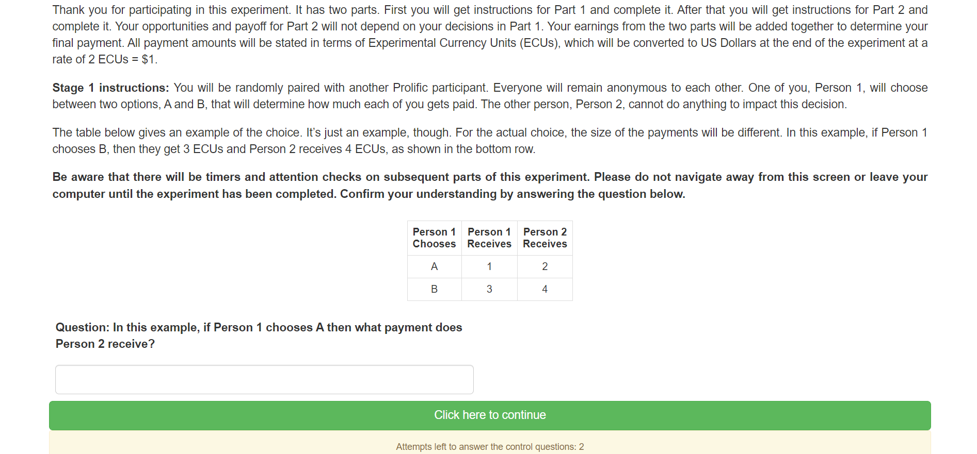
Figure 1. First instruction screen to Dictators (Person 1) and Recipients (Person 2) in all treatments

After a quick attention check (entering a given number, time limit of 45 seconds), dictators are faced with the following screen:
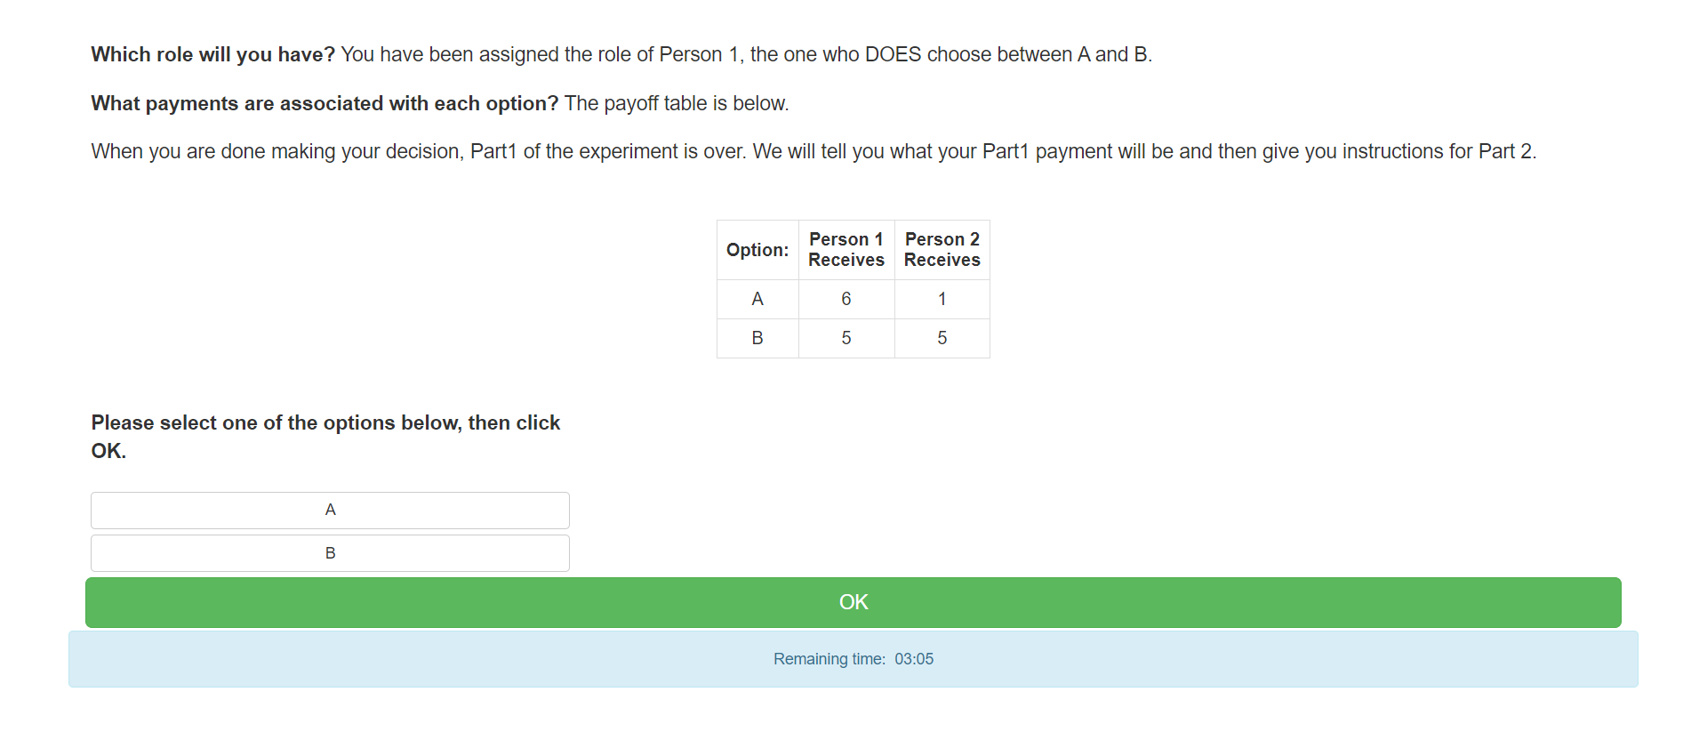
Figure 2. Second screen, dictators, Baseline.
Our alternative treatments are Hidden Information; Hypothetical Informer; Informer; Informer—Punishment; Hidden Information—Separate Screens; Hypothetical Informer—Separate Screens; Informer—Separate Screens.

2.2 Hidden Information
The Hidden Information treatment is like the Hidden Information treatment of DWK.

The first screen is identical to that in Baseline. The second screen, identical for Dictators and Recipients, looks like this:
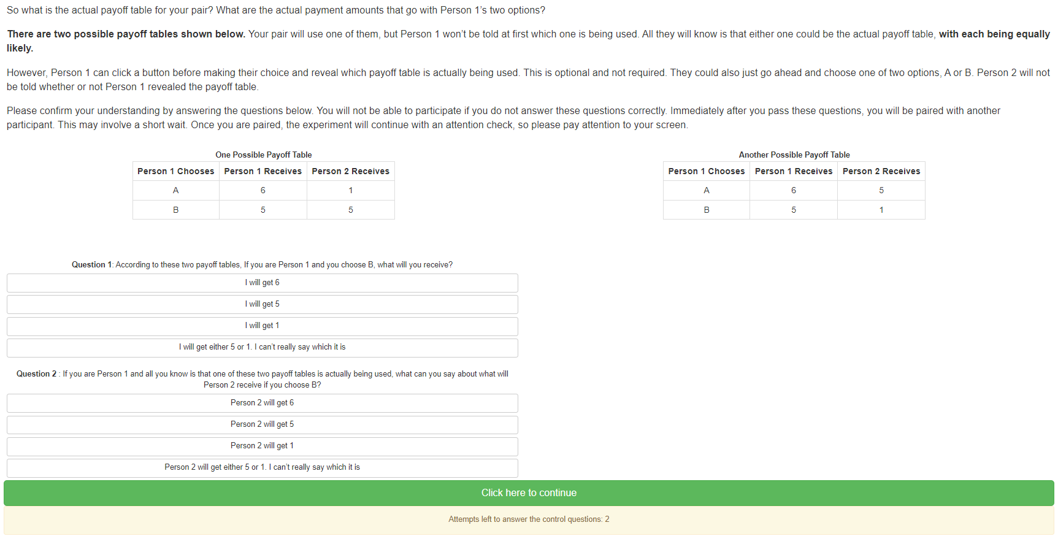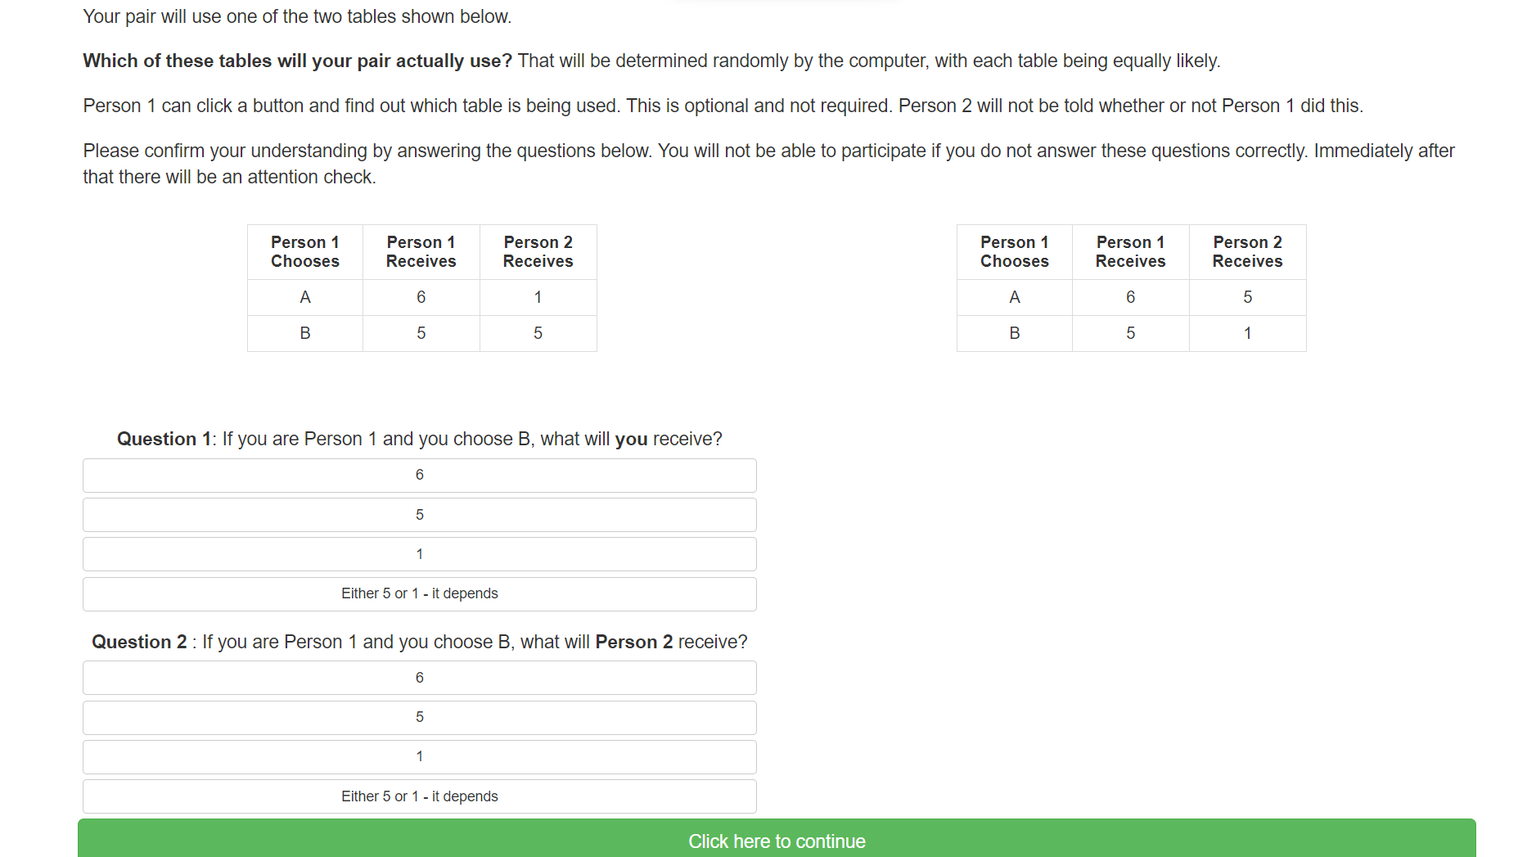
Figure 3. Second screen, all subjects, Hidden Information.

When pressing “continue”, dictators are sent to a decision screen where they are asked to choose either A, B, or revealing information about which table applies:
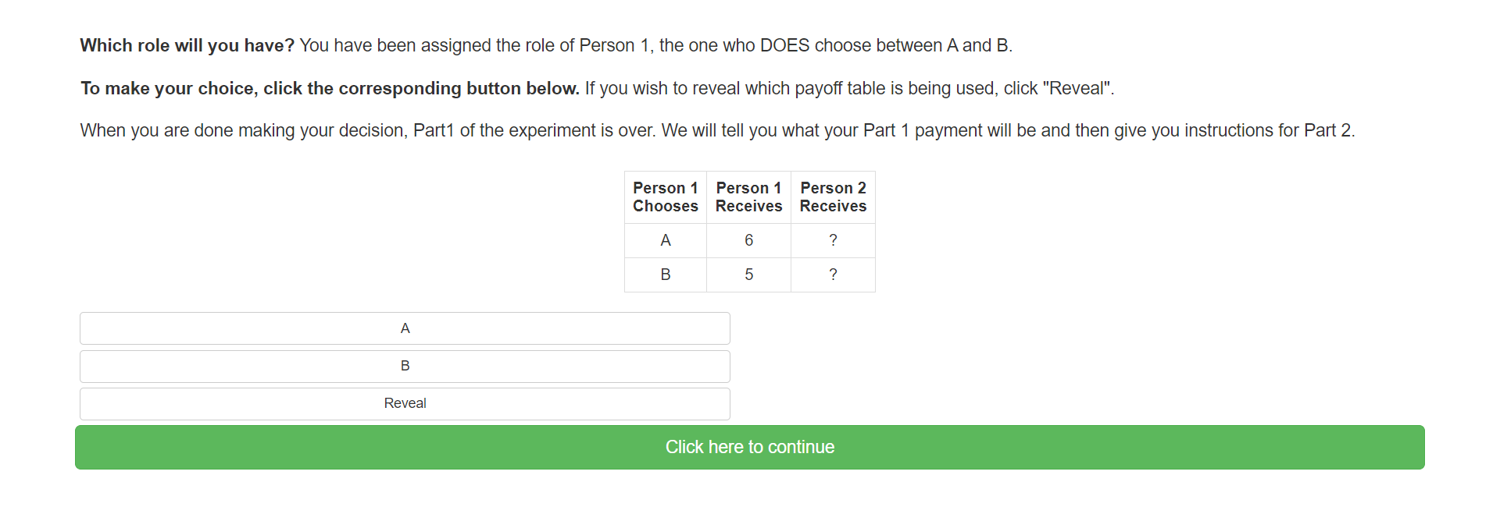
Figure 4. Dictators’ initial choice screen, Hidden Information.
If the Dictator chooses either A or B, the game is over and the payoffs are realized. However, if the dictator instead chooses `Reveal’, then she is directed to the allocation decision screen with the payoffs shown, as in Figure 5.
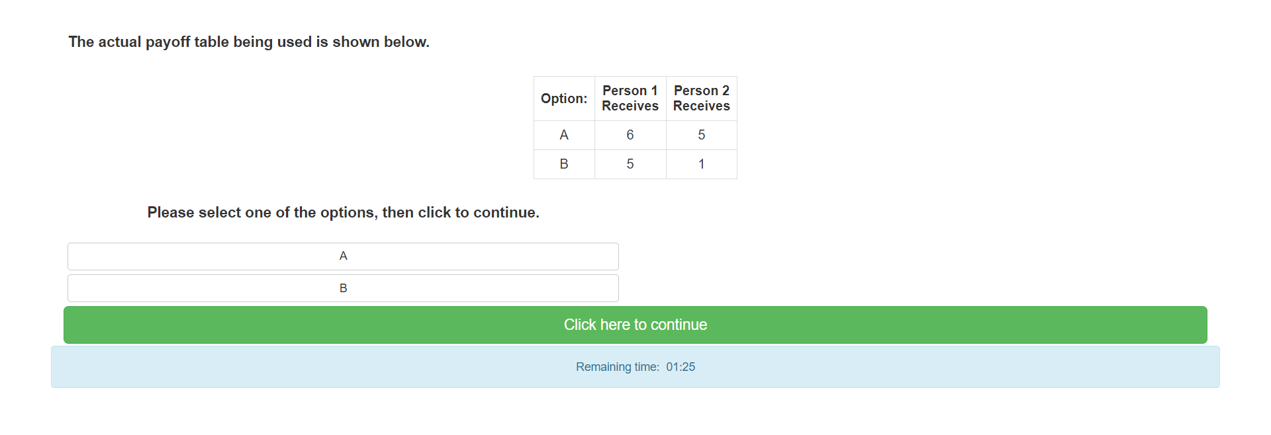
Figure 5. Dictators’ allocation choice after revealing payoffs, Hidden Information. The aligned-interests payoffs are shown in this screen shot.

2.3 Hypothetical Informer
For Dictators, the Hypothetical Informer treatment is identical to Hidden Information until and including the screen shown in Figure 4. However, after the screen shown in Figure 4 (and before getting to see the correct table, if choosing to reveal information), dictators get to see an additional screen with the following instructions:
“You chose [option A/option B/to reveal information about which table is being used for your pair].
A third participant, Person 3, has been matched with your pair. Person 3 will answer the following question: “In the case that Person 1 did not reveal which payoff table is being used for their pair, would you prefer to overturn their decision, providing this information to Person 1?” The question is a purely hypothetical one, however; Person 3 is not able to provide any information to you. Thus, you will get to know which table is used only if you requested this information yourself. Person 3’s payoff is independent of their choice.
On the next screen, you will be informed about Person 3’s decision. You will also be shown the correct payoff table if you requested it. You are then asked to make your choice between options A and B.
Note that we will ask you to choose between options A and B even if you already did so on the previous decision screen. Your previous choice will then be filled out by default, and you can confirm it by pressing the “OK” button. If you wish to change your choice at this point, however, you are free to do so. Payoffs to both you and Person 2 will be based on your final choices on the next screen.”
After this, the dictator is informed about the informer’s decision and also, if the dictator has chosen to reveal information, about the correct table. On the same screen, the dictator makes their final allocation decision and the game ends.

2.4 Informer
The Informer treatment is like the Hypothetical Informer treatment except that the Informer’s choice is actually implemented. The text appearing after Dictators’ information-choice screen is now:
“You chose [option A/option B/to reveal information about which table is being used for your pair].
A third participant, Person 3, has been matched with your pair. Person 3 will answer the following question: “In the case that Person 1 did not reveal which table is being used for their pair, would you prefer to overturn their decision, providing this information to Person 1?” If Person 3 answers yes, we will show you which table is being used, regardless of whether you chose yourself to reveal this information. If Person 3 answers no, we will show you which table is used only if you requested this information yourself. Person 3’s payoff is independent of their choice.
On the next screen, you will be informed about Person 3’s decision and then make your choice between options A and B.
Note that we will ask you to choose between options A and B even if you already did so on the previous decision screen. Your previous choice will then be filled out by default, and you can confirm it by pressing the “OK” button. If you wish to change your choice at this point, however, you are free to do so. Payoffs to both you and Person 2 will be based on your final choices on the next screen.”
The Informer then makes their choice; Dictators are informed about this choice, get information about the correct table if either party chose to reveal it, and make their final choice between options A and B.

2.5 Informer—Bonus
The Informer—Bonus treatment is similar to Informer, except that the Dictator now has a third choice to make (i. information, ii. allocation, iii. bonus): After getting to know whether the Informer chose to impose information on him or not, the Dictator can now choose to increase the Informer’s payoff by 1 ECU, covered by the experimenters.
The text appearing after the information choice screen is now:
“You chose [option A/option B/to reveal information about which table is being used for your pair].
A third participant, Person 3, has been matched with your pair. Person 3 answers the following question: “In the case that Person 1 did not reveal which payoff table is being used for their pair, would you prefer to overturn their decision, making sure that they actually have this information when they make their choice between A and B?” If Person 3 answers yes, we will show you which table is being used, regardless of whether you chose yourself to reveal this information. If Person 3 answers no, we will show you which table is used only if you requested this information yourself. Person 3’s payoff is independent of their choice.
On the next screen, you will be informed about Person 3’s decision and then make your choice between options A and B.
Note that we will ask you to choose between options A and B even if you already did so in the previous decision screen. Your previous choice will then be filled out by default, and you can confirm it by pressing the “OK” button. If you wish to change your choice at this point, however, you are free to do so. Payoffs to both you and Person 2 will be based on your final choices on the next screen.
Finally, we will ask you whether you want to increase Person 3’s payoff by 1 ECU. If you use this option, the extra payoff to Person 3 is covered by the experimenters, not by yourself.”
Informers get a similar instruction screen providing them with the same information.
After Dictators make their final A/B choice, they face a new screen, where they are reminded of their own and the Informer’s information choices, and are asked whether they prefer to increase Person 3’s payoff by 1 ECU. It is specified that Person 1’s own payoff is not affected by this choice. When both have made their choices, the Dictator is asked for their reasons to increase Person 3’s payoff or not (open-ended question), before the game ends.

2.6 Hidden Information—Separate Screens
To examine whether the very knowledge that others may impose information cause dictators to seek information themselves, we include the three separate-screens treatments.
The Hidden Information—Separate Screens treatment is like Hidden Information, except that the information and allocation decisions are in separate screens.
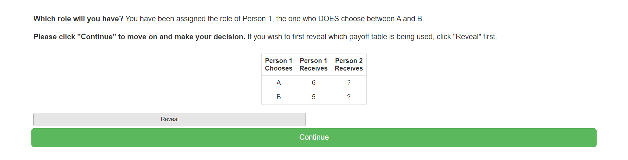
Figure 6. Dictators’ information-choice screen, Hidden Information—Separate Screens
Figure 6 shows the information-choice screen. After this screen, the dictator is directed to the allocation decision screen (Figure 7). If the dictator chose information, the payoffs are displayed. Otherwise, the unknown payoffs are represented by a `?’.
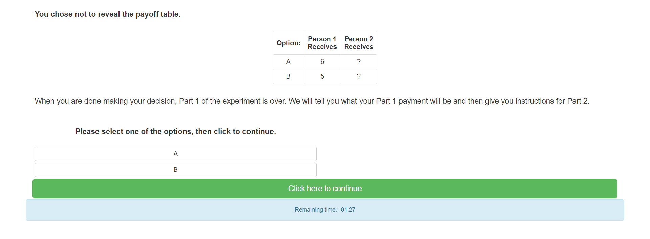
Figure 7. Dictators’ allocation-choice screen, Hidden Information—Separate Screens, with payoff state not revealed. If payoff state is instead revealed, the both instances of `?’ are instead replaced with the appropriate number.

2.7 Hypothetical Informer—Separate Screens
The Hypothetical Informer—Separate Screens treatment uses the same set-up as Hidden Information--Separate Screens. However, after the instructions shown in Figs. 1 and 3 above, but before any choices are made, Dictators are informed about the presence of a potential informer. The text reads:
“A third participant, Person 3, has been matched with your pair. Person 3 answers the following question: “In the case that Person 1 did not reveal which payoff table is being used for their pair, would you prefer to overturn their decision, providing this information to Person 1?” The question is a purely hypothetical one, however; Person 3 is not able to provide any information to you. Thus, you will get to know which table is used only if you requested this information yourself. Person 3’s payoff is independent of their choice.”

2.8 Informer—Separate Screens
The Informer—Separate Screens treatment uses the same set-up as Hidden Information--Separate Screens. However, after the instructions shown in Figs. 1 and 3 above, but before any choices are made, Dictators are informed about the presence of a potential informer. The text reads:
“A third participant, Person 3, has been matched with your pair. Person 3 answers the following question: “In the case that Person 1 did not reveal which payoff table is being used for their pair, would you prefer to overturn their decision, providing this information to Person 1?” If Person 3 answers yes, we will show you which table is being used, regardless of whether you chose yourself to reveal this information. If Person 3 answers no, we will show you which table is used only if you requested this information yourself. Person 3’s payoff is independent of their choice.”

3. Hypotheses/Results

3.1 Data
The experimental set-up described above provides the following data:
- Dictators:
  - Information choice yes/no (all but Baseline)
  - Initial choice of allocation A/B (all treatments)
  - Final choice of alternative (A/B) (Hypothetical Informer, Informer, Informer—Bonus)
  - Bonus yes/no (Informer—Punishment)
  - Justification for Bonus– open answer (Informer—Punishment)
- Informers:
  - Choice of information provision yes/no (Hypothetical Informer—Separate Screens, Informer—Separate Screens, Hypothetical Informer, Informer, Informer—Punishment)
- Questionnaire
  - Demographics
  - Explanation for choices made
  - Party sympathies: Democrat/Republican/Independent
  - “How worried are you about global warming?” (Very, rather, slightly, not at all)
  - In “August 2020, how worried were you about the Covid-19 pandemic?” (Very, rather, slightly, not at all)
For cases of aligned interests, we expect most dictators to choose option A.
In the table below, we specify our hypotheses and how they will be explored.
Table 2. Hypotheses and tests.
 | Hypothesis | Test
Hypothesis 0 (confirming previous findings): People avoid info in the moral-wiggle-room game.
0a | A non-zero fraction of Dictators remain ignorant in the Hidden Information treatment. | Check whether there are Dictators in Hidden Information choosing not to get information.
0b | The fraction choosing ignorance in the Hidden Information treatment is greater than the fraction choosing selfishly in the Baseline treatment. | Test the share of Dictators choosing A in the Baseline treatment vs. the share choosing ignorance in Hidden Information using a proportions test and Fisher’s exact test.
0c | The share of dictators choosing B in the Baseline is higher than in Hidden Information. | Test the share of dictators choosing B in the Baseline treatment vs. the share in Hidden Information with conflicting interests using a proportions test and Fisher’s exact test.
Hypothesis I (the information choice): The actual threat of being unwillingly informed deters information avoidance, but the mere presence/thought of an informer does not.
Ia | Fewer Dictators will choose ignorance in Informer—Separate Screens than in Hidden Information—Separate Screens. | Compare the share choosing information in Informer – Separate Screens with the share in Hidden Information—Separate Screens using a proportions test and the exact Fisher test.
Ib | Equally many Dictators will choose ignorance in Hypothetical Informer—Separate Screens as in Hidden Information—Separate Screens. | Compare the share choosing information in Hypothetical Informer—Separate Screens with the share in Hidden Information—Separate Screens using a proportions test and the exact Fisher test.
Hypothesis II (the final outcome choice): The threat of being informed leads to more pro-social outcomes, but this effect is limited when the dictator can sanction the informer.
IIa | The share of selfish final choices does not vary between the Hidden Information and the Hypothetical Informer, but the share varies between the Hidden Information, Informer and Informer—Bonus treatments. | Compare the share of dictators choosing A in the Hidden Information, Hypothetical Informer, Hidden Information, Informer and Informer—Bonus treatments all with conflicting interests. We undertake pairwise comparisons using a proportions test and Fisher’s exact test and grouped comparisons using a $χ^{2}$ test.
IIb | Imposing information increases prosocial behavior. Dictators in the Informer and Informer—Bonus treatments who did not reveal information themselves, but on whom the Informer chose to impose information, are less likely to make selfish choices than dictators who did not reveal information themselves in Hidden Information and Hypothetical Informer treatments. | Pool dictators in the Informer and Informer — Bonus treatments with information imposed as well as the dictators in Hidden Information and Hypothetical Messenger, all with conflicting interests. Test the share of dictators playing A in the first group versus the second group using a proportion test and the exact Fisher test.
IIc | Dictators in the Informer and Informer—Bonus treatments upon whom the Informer did not choose to impose information, are equally likely to make selfish choices as dictators in the Hidden Information and Hypothetical Informer treatments. | Pool dictators in the Informer and Informer — Bonus treatments without information imposed as well as the dictators in Hidden Information and Hypothetical Messenger, all with conflicting interests. Test the share of dictators playing A in the first group versus the second group using a proportion test and the exact Fisher test.
Hypothesis III (revision of the allocation choice): More reflection and scrutiny of one's choices will lead to more prosocial choices.
III | Dictators are more likely to choose selfishly in the initial than the final decision in the Hypothetical Informer, Informer, and Informer—Bonus treatments. | Compare the share of dictators with conflicting interests playing the selfish choice A in the Hypothetical Informer, Informer, and Informer—Bonus treatments using a proportion test and the exact Fisher test.
Hypothesis IV (the bonus choice of the dictator): People who want to use ignorance strategically don't like having information imposed on them.
IVa | In the Informer—Bonus treatment, Dictators are less likely to give the Informer a bonus if the Informer chose to impose information on a Dictator who did not choose it for herself compared to the other cases (Dictator willingly chose information or remained ignorant). | Compare the share punishing in the Informer—Bonus treatment between (dictator chooses ignorance and informer imposes information) and (dictator chooses information, or both dictator and informer choose not to reveal) using a proportions test and the exact Fisher test.
IVb | Dictators who chose to get information are more likely to give a bonus to Informers imposing information than are Dictators who chose ignorance in the Informer—Bonus treatment. | Compare the share giving a bonus in the Bonus treatment between (dictator chooses ignorance and bystander imposes information) and (dictator chooses information and bystander imposes information) using a proportions test and the exact Fisher test.
IVc | Dictators who chose ignorance are more likely to give a bonus to Informers imposing information if interests are aligned than if interests are conflicting in the Informer—Bonus treatment. | When the bystander imposes information and the dictator chooses ignorance, compare the share giving a bonus in the Informer—Bonus treatment between conflict of interest and aligned interest using a proportions test and the exact Fisher test.
Hypothesis V (the informers’ choice of providing information): Informers are deterred by the possibility of losing the bonus.
V | Informers are more likely to choose to provide information in Informer than in Informer—Bonus. | Compare the share providing information in Informer with the share in Informer—Bonus using a proportions test and the exact Fisher test.

4. Experimental procedures
The experiments will be run online, recruiting English speaking US subjects above the age of 18 on the recruitment/payment platform Prolific. Subjects are then forwarded to the real experiment on the Lioness platform. For the Baseline treatment, we need subjects to be divided between Dictators and Recipients. To accomplish this, we randomize subjects into different roles as they complete the instructions and comprehension checks. At that point they enter a lobby and are placed into a group with a randomly assigned role as soon as there are enough participants to form the group. Everyone receives the same instructions, but only Dictators make a choice. Both types of subjects will also answer a questionnaire (demographics; explanation for choices made; political sympathies; concerns for global warming; covid concerns) at the end of the experiment.
The procedure for the Hidden information and Hidden Information-Separate Screens treatments is similar to the one outlined above. In these treatments, however, Dictators are first given the possibility to acquire information (see Figure 4). The payoff state is randomly determined when the group is formed and the realized payoff table is displayed if and only if the Dictator chooses to reveal it.
The procedure for the Informer treatments, Hypothetical Informer—Separate Screens, Informer—Separate Screens, Hypothetical Informer, Informer, and Informer—Bonus will also be based on this approach. The Informer chooses conditionally and is not informed of the dictator’s actual choice before she makes her own. In the Informer—Bonus treatment the dictator learns of the Informer’s choice, either is given the payoff information or not, makes a final allocation choice, and is subsequently asked whether or not to punish the Informer.

5. Methods, sample size and power
The main tests of the hypotheses are described in Table 2 above. Stata code to undertake the tests can be found in the appendix. We will also test the hypotheses using regression analysis allowing us to control for confounding variables collected through the questionnaire.
Consistent with Dana et al. (2007), we design experiments to attempt to be able to discern differences of about 0.2. Considering the worst-case scenario of comparing proportions of 0.4 and 0.6, we obtain the following power relationship:
To obtain a power of 80 % we should expect to need a sample of 97 subjects per treatment. To simplify, we aim for 100 subjects in each group in each comparison.
In some of the treatments, however, we focus on the 50% of subjects with non-aligned interests, requiring twice the sample. Moreover, the treatments with informers also require an informer, doubling the number of participants.
The required number of subjects is summarized below:
Treatment | Number of subjects
- Baseline | 100 subjects
- Hidden information | 100 subjects
- Hypothetical informer | 100 subjects
- Informer | 200 pairs in each group (*)
- Informer - Bonus | 100 pairs in each group (**)
- Hypothetical informer – separate screens | 100 subjects
- Informer – separate screens | 100 subjects
- Hidden information – separate screens | 100 subjects
(*) In the Informer treatment, we need 100 subjects both in the group with conflicting interests and 100 subjects jointly in Informer and Informer – Bonus with conflicting interests and information imposed by the informer.
(**) In the Informer – Bonus treatment, we need 100 subjects in each of the groups dictator chooses ignorance and informer imposes information; dictator chooses information, or both dictator and informer choose not to reveal; dictator chooses information and bystander imposes information; bystander imposes information, the dictator chooses ignorance, aligned; and bystander imposes information, the dictator chooses ignorance, non-aligned.
Recruitment to these groups is based on subjects’ decision. Hence we aim to recruit until we reach the target of 100 subjects in each group.

References
Dana, J., Weber, R., Kuang, J., 2007. Exploiting moral wiggle room: experiments demonstrating an illusory preference for fairness. Economic Theory 33 (1), 67–80.
Duch, M. L., Grossmann, M. R. P. and Lauer, T. (2020). “z-Tree unleashed: A novel client-integrating architecture for conducting z-Tree experiments over the Internet”. Journal of Behavioral and Experimental Finance 28, Article 100400.
Exley, C.L., 2016. Excusing selfishness in charitable giving: the role of risk. Review of Economic Studies 83 (2), 587–628.
Exley, C.L, and J. Kessler (2021): Information Avoidance and Image Concerns, NBER Working Paper 28376.
Feiler, L., 2014. Testing models of information avoidance with binary choice dictator games. J. Econ. Psychol. 45, 253–267.
Felgendreher, S. (2018): Do consumers choose to stay ignorant? The role of information in the purchase of ethically certified products. Working Paper in Economics No. 717, University of Gothenburg.
Fischbacher, U. (2007): z-Tree: Zurich toolbox for ready-made economic experiments. Experimental Economics 10, 171–178.
Giamattei, M., Yahosseini, K. S., Gächter, S. and Molleman, L. (2020): LIONESS Lab: a Free Web-Based Platform for Conducting Interactive Experiments Online. Journal of the Economic Science Association 6: 95-111.
Grossman, Z., 2014. Strategic ignorance and the robustness of social preferences. Manag. Sci. 60 (11), 2659–2665.
Grossman, Z., van der Weele, J., 2017. Self-image and willful ignorance in social decisions. J. Eur. Econ. Assoc. 15 (1), 173–217.
Lind, Jo Thori, Karine Nyborg, and Anna Pauls. Save the planet or close your eyes? Testing strategic ignorance in a charity context. Ecological Economics 161 (2019): 9-19.
Matthey, A., Regner, T., 2011. Do I really want to know? A cognitive dissonance-based explanation of other-regarding behavior. Games 2 (1), 114–135.
Momsen, K., and M. Ohndorf (2020): When do people exploit moral wiggle room? An experimental analysis of information avoidance in a market setup, Ecological Economics 169, 106479.
Momsen, K., and M. Ohndorf (2023): Expressive voting versus information avoidance: experimental evidence in the context of climate change mitigation, Public Choice 194, 45–74.
Moyal, A., and A. Schurr (2022): The effect of deliberate ignorance and choice procedure on pro-environmental decisions, Ecological Economics 200, 107512.
Serra-Garcia, M., and N. Szech (2022): The (In)Elasticity of Moral Ignorance, Management Science, 68(7), 4755-5555.
Sorrapera, I., van der Weele, J., Villeval, M.C., Shalvi, S. (2023): The Social Construction of Ignorance: Experimental Evidence, Games and Economic Behavior 138, 197-213.
Thunström, L., Cherry, T.L., McEvoy, D.M., Shogren, J.F. (2016): Endogenous context in a dictator game. Journal of Behavioral and Experimental Economics 65, 117–120.
van der Weele, J.J., Kulisa, J., Kosfeld, M., Friebel, G., 2014. Resisting moral wiggle room: how robust is reciprocal behavior? American Economic Journal: Microeconomics 6 (3), 256–264.

Appendix I: Preliminary findings
Between April 21 and August 2, 2022, we conducted 12 successful sessions. A total of 116 pairs were studied.
session | Freq. Percent Cum.
------------+-----------------------------------
220421_1934 | 1 0.86 0.86
220505_1926 | 6 5.17 6.03
220509_1851 | 13 11.21 17.24
220509_1948 | 11 9.48 26.72
220510_1921 | 7 6.03 32.76
220510_1947 | 10 8.62 41.38
220512_1901 | 11 9.48 50.86
220512_1945 | 9 7.76 58.62
220801_1950 | 12 10.34 68.97
220802_1512 | 13 11.21 80.17
220802_1544 | 12 10.34 90.52
220802_1610 | 11 9.48 100.00
------------+-----------------------------------
Total | 116 100.00

Of the 12 sessions, 6 sessions used the Baseline treatment collecting data from 55 pairs. All has a conflicting structure of the payoff matrix. Dictator behavior was as follows:
choice | Freq. Percent Cum.
------------+-----------------------------------
A | 14 25.45 25.45
B | 41 74.55 100.00
------------+-----------------------------------
Total | 55 100.00

The remaining 6 sessions with a total of 61 pairs of subjects, used the Hidden information treatment.

 |  | Conflicted |  |  |  | Aligned |  |  |  | Total
 |  | Don't reveal | Reveal | Total |  | Don't reveal | Reveal | Total |  | Don't reveal | Reveal | Total
Choice | A | 11 | 2 | 13 |  | 6 | 16 | 22 |  | 17 | 18 | 35
Choice | B | 0 | 18 | 18 |  | 6 | 2 | 8 |  | 6 | 20 | 26
Total |  | 11 | 20 | 31 |  | 12 | 18 | 30 |  | 23 | 38 | 61

We see that 23 (38 %) subject choose to not reveal the true payoff matrix. A 95 % confidence interval for this proportion is [.26; .51].
If we focus on subjects with the conflicted payoff matrix, 13 (42 %) choose the selfish choice A. In the baseline, the corresponding number is 14 (25 %), a difference that is not significant at conventional levels of significance using Fisher’s exact test (p=.148).
Another approach is to define the strategically ignorant as subjects who would have chosen B in the Baseline treatment, but prefers to stay ignorant in the Hidden information treatment. As 25 % of subjects choose A in Baseline and 38 5 choose ignorance in HI, we have an estimated 13 % strategically ignorant subjects. The difference between the two shares is not statistically significant using a Fisher exact test, though (p=.169).

Appendix II: Stata code
**** Hypothesis 0a: A non-zero fraction of dictators remain ignorant in the Hidden
* Information treatment
use hidden_info, clear

tab info

**** Hypothesis 0b: The fraction choosing ignorance in the Hidden Information
* treatment is greater than the fraction choosing selfishly
* in the Baseline treatment
use hidden_info, clear
append using baseline
gen selfish = choice
replace selfish = info if treatment==2

prtest selfish, by(treatment)
tab selfish treatment, exact

**** Hypothesis 0c: The share of dictators choosing B in the Baseline is higher
* than in Hidden Information
use hidden_info, clear
keep if aligned==0
append using baseline

prtest choice, by(treatment)
tab choice treatment, exact

**** Hypothesis Ia: Fewer Dictators will choose ignorance in Informer—Separate
* Screens than in Hidden Information—Separate Screens
use hidden_info_ss, clear
append using informer_ss

prtest info, by(treatment)
tab info treatment, exact

**** Hypothesis Ib: Equally many Dictators will choose ignorance in
* Hypothetical Informer—Separate Screens as in
* Hidden Information—Separate Screens
use hidden_info_ss, clear
append using hypothetical_informer_ss

prtest info, by(treatment)
tab info treatment, exact

**** Hypothesis IIa: The share of selfish final choices does not vary between
* the Hidden Information and the Hypothetical Informer,
* but the share varies between the Hidden Information,
* Informer and Informer—Bonus treatments
use hypothetical_informer, clear
append using informer
append using informer_bonus
rename final_choice choice // Study final choice for Hyp Msg
append using hidden_info
keep if !aligned

prtest choice if (treatment==2 | treatment==3), by(treatment)
prtest choice if (treatment==2 | treatment==4), by(treatment)
prtest choice if (treatment==2 | treatment==5), by(treatment)
prtest choice if (treatment==3 | treatment==4), by(treatment)
prtest choice if (treatment==3 | treatment==5), by(treatment)
prtest choice if (treatment==4 | treatment==5), by(treatment)

tab choice treatment if (treatment==2 | treatment==3), exact
tab choice treatment if (treatment==2 | treatment==4), exact
tab choice treatment if (treatment==2 | treatment==5), exact
tab choice treatment if (treatment==3 | treatment==4), exact
tab choice treatment if (treatment==3 | treatment==5), exact
tab choice treatment if (treatment==4 | treatment==5), exact

tab choice treatment, chi2 exact

**** Hypothesis IIb: Dictators in the Informer and Informer - Bonus
* treatments who
* did not reveal information themselves, but on whom the
* bystander chose to impose information, are less likely to
* make selfish choices than dictators in Hidden
* Information and Hypothetical Messenger treatments
use informer, clear
append using informer_bonus
gen tid=treatment*1000+id // Id that varies between sessions
sort tid role
replace bystander_informs=bystander_informs[_n+1] if tid==tid[_n+1]
keep if bystander_informs
gen imposed_info=1
append using hypothetical_informer
rename final_choice choice // Study final choice
append using hidden_info
replace imposed_info=0 if mi(imposed_info)
drop if role==2

prtest choice, by(imposed_info)
tab choice imposed_info, exact

**** Hypothesis IIc: Dictators in the Informer and Informer - Bonus treatments
* on whom the bystander did not choose to impose information,
* are equally likely to make selfish choices as dictators in
* the Hidden Information and Hypothetical Messenger treatments
use informer, clear
append using informer_bonus
gen tid=treatment*1000+id // Id that varies between sessions
sort tid role
replace bystander_informs=bystander_informs[_n+1] if tid==tid[_n+1]
keep if !bystander_informs
gen imposed_info=1
append using hypothetical_informer
rename final_choice choice // Study final choice
append using hidden_info
replace imposed_info=0 if mi(imposed_info)
drop if role==2

prtest choice, by(imposed_info)
tab choice imposed_info, exact

**** Hypothesis III: Dictators are more likely to choose selfish choices in the
* preliminary than the final decision in Hypothetical
* Informer, Informer and Informer - Bonus treatments
use informer, clear
append using informer_bonus
append using hypothetical_informer
drop if role==2
keep if info==0 // Did not choose info

prtest prelim_choice==final_choice
tab prelim_choice final_choice, exact

**** Hypothesis IVa: In the Informer - Bonus treatment, Dictators are less
* likely to give the Informer a bonus if the Informer
* chose to impose information on a Dictator who did not
* choose it for herself compared to the other cases
* (Dictator willingly chose information or
* remained ignorant)
use informer_bonus, clear
sort id role
replace bystander_informs=bystander_informs[_n+1] if id==id[_n+1]
drop if role==2
gen involuntary_info = 1 if bystander_informs & !info
replace involuntary_info = 0 if info

prtest bonus, by(involuntary_info)
tab bonus involuntary_info, exact

**** Hypothesis IVb: Dictators who chose to get information are more likely
* to give a bonus to Informers imposing information
* than are Dictators who chose ignorance in the
* Informer - Bonus treatment
use informer_bonus, clear
sort id role
replace bystander_informs=bystander_informs[_n+1] if id==id[_n+1]
drop if role==2
keep if bystander_informs

prtest bonus, by(info)
tab bonus info, exact

**** Hypothesis IVc: Dictators who chose ignorance are more likely to give
* a bonus to Informers imposing information if interests
* are aligned than if interests are conflicting in the
* Informer—Bonus treatment
use informer_bonus, clear
sort id role
replace bystander_informs=bystander_informs[_n+1] if id==id[_n+1]
drop if role==2
keep if !info & bystander_informs

prtest bonus, by(aligned)
tab bonus aligned, exact

**** Hypothesis V: Informers are more likely to choose to provide information
* in Informer than in Informer - Bonus
use informer, clear
append using informer_bonus
keep if role==2

prtest bystander_informs, by(treatment)
tab bystander_informs treatment, exact

Sorrapera et al. (2023) construct a competitive market in which advisers equipped with ethically relevant information offer their services to decision makers. The authors find that information-averse decision makers (about 25% of all decision makers) seek advisers suppressing information. As a consequence, a competitive market for information does not substantially affect the ignorance and reduced generosity arising from endogenous information choice in a non-market context.
See also van der Weele 2014, Momsen and Ohndorf 2020, Feiler 2014, Moyal and Schurr 2022, for studies of how the context and/or parameter values affect strategic ignorance.

