World Bicycle Relief Randomized Controlled Trial: Pre-Analysis Plan
22 March 2024

Summary
IDinsight prepared this pre-analysis plan in collaboration with World Bicycle Relief (WBR) to describe how the research team will analyze the data in the randomized controlled trial (RCT) of the Mobilized Communities program. This version has been prepared after random assignment of groups, bicycle distribution, and early monitoring by WBR, and after baseline data collection, but before 1-year follow-up data collection. We provide background on World Bicycle Relief, a description of the evaluation, a list of our main outcomes, our chosen analytical model, potential limitations & corresponding mitigation strategies, and summary statistics from the baseline data.

Background on WBR and the MC program
World Bicycle Relief (WBR) is a 501(c)3 not-for-profit that owns 100% of Buffalo Bicycle Limited, a for-profit social enterprise with a retail network in Colombia, Kenya, Malawi, Zambia, and Zimbabwe. WBR partners with people in rural communities to expand access to education, markets, health facilities, and vital services by providing bicycles. WBR provides Buffalo Bicycles to students, health workers, and entrepreneurs in low-income regions.
WBR has operated in Zambia since 2007. With 40+ full-time staff, a Lusaka-based warehouse and distribution center, and 16 social enterprise locations throughout the country, WBR has distributed 210,535 bicycles and trained 1,188 mechanics. In addition, WBR’s social enterprise retail shop in Mumbwa has operated for three years and distributed bicycles to USAID, UNICEF, and other bilateral and multilateral-supported programs, and collaborated with local and international partners in Zambia, including PATH, Churches Health Association of Zambia (CHAZ), and Zambia’s Ministry of Health.
WBR started implementing the five-year Mobilized Communities (MC) program in Mumbwa District, Zambia, in 2021. The MC program is designed to support communities in sustainably increasing access to education, healthcare, and livelihoods. The MC program aims to provide Buffalo Bicycles to approximately 14,000 households over five years. The program has a particular focus on women and girls and building a sustainable bicycle ecosystem to support long-term community impact.
In past programs, WBR has usually targeted schoolchildren to increase school attendance. The MC program is a new program being piloted by WBR, in which they identify all types of individuals who may face mobility challenges (including school children, but also other groups such as small business owners and community health workers), provide bicycles to those individuals, and build a local bicycle ecosystem such that the community can manage the program, monitor program recipients, and provide trained repair services.

The Evaluation
WBR and IDinsight are partnering to conduct an RCT to estimate the causal impact of the MC program on mobility, and economic outcomes, including household consumption, asset value, income, savings, improved productivity, and empowerment measures.

Research Questions
Our research questions are:
- What is the causal impact of the MC program on household welfare and the well-being of program recipients?
- What is the causal impact of the MC program on household access to services and livelihood-enhancing activities?
- What is the causal impact of the MC program on social norms and women’s empowerment, including gender norms, locus of control, and self-esteem?
- How do treatment effects of the MC program vary by subgroups of interest, such as gender, being a livelihoods group member or community service worker, or age?
Our household survey elicits detailed measures for household consumption, asset, and mobility patterns to answer these research questions. We also include questions measuring common inputs and outputs for livelihoods group members, community service workers, and households involved in microenterprises.

Randomization and Sampling Procedure
Our evaluation will focus on the MC program's impact on adults eligible to receive bicycles in WBR’s 2023 distribution in the Mumbwa district of Central Province, Zambia. In consultation with WBR, we identified livelihoods groups (including savings groups, cooperatives groups, women's groups, and other types of village livelihood groups) and individual community service workers as the most viable units of treatment assignment.
This evaluation is being carried out in rural areas of Mumbwa district, specifically within the following 19 communities: Chibuluma, Chibusa, Chiwena, Kabalwa, Kabwanga, Kantengwa, Kanwanzhiba, Kapepe, Kawena, Lukanga, Maimwene, Mituntu, Moomba, Muyoba, Mwamba Nzovu, Nakabu, Nakasaka, Nangoma, Nkolola. Within these 19 communities, WBR identified 185 eligible livelihoods groups covering 2,827 members and 324 community service workers (CSW).
We calculated that we needed 120 livelihoods groups and approximately 10 members per livelihoods group to participate in the baseline and endline survey in order to detect effect sizes of 0.20 to 0.30 standard deviations, which are moderate effect sizes for economic outcomes (our CSW sample, though smaller, is randomized at the individual level, and thus has similar statistical power as the livelihoods group sample). Our power calculations are described further in Appendix A.
Based on these power calculations, we selected 120 of the 185 eligible livelihoods groups, removing groups from the sampling frame that were very small (fewer than 10 eligible participants) or very large (more than 30 eligible participants) to reduce the likelihood of differently-sized treatment and control groups and to facilitate survey and program logistics. Following WBR’s guidance, we removed ineligible members from this list, including members who were over 75 years old, members who were also in our CSW sample, members who were part of the bicycle supervisory committee (BSC), members who were listed under multiple names, and households that were listed in multiple livelihoods groups. We sampled up to 12 members per livelihoods group from the remaining list to participate in the baseline survey. If a livelihoods group had fewer than 12 eligible members, we sampled them all. We designated any remaining members as replacements and randomized the order in which they should be used to replace sampled respondents. We included the full list of 324 CSWs in our baseline sample.
During baseline data collection, we identified additional ineligible participants, including households relocated from the study area and households with BSCs not identified in the original sampling frame. Our final survey sample includes 1,297 Livelihoods group members (LGM) from 120 livelihoods groups and 273 CSWs, or 1,570 total respondents.
After baseline data collection, we randomized survey respondents into treatment and control arms. We randomized 120 livelihoods groups into 60 treatment livelihoods groups (comprising 640 members surveyed at baseline) and 60 control livelihoods groups (comprising 657 members surveyed at baseline), stratifying on livelihoods group type (savings, women/gender, cooperative & multipurpose, and youth groups) and average reported distance that members had to travel to the group. We separately randomized the 273 surveyed CSWs into 137 treatment CSWs and 136 control CSWs, stratifying on the sector (health, livelihoods, and environment) and gender. Figure 1 summarizes the sampling and randomization process for LGMs and CSWs, while Figure 2 shows the location of sampled households within the study region.

Figure 1: Sampling & randomization flowcharts
Livelihoods groups members  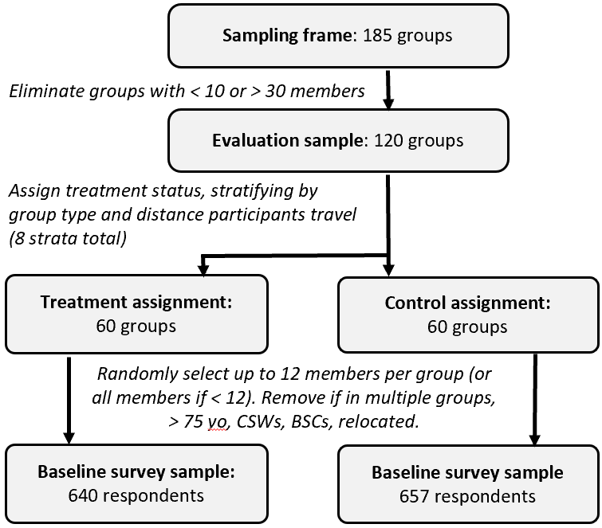 | Community service workers  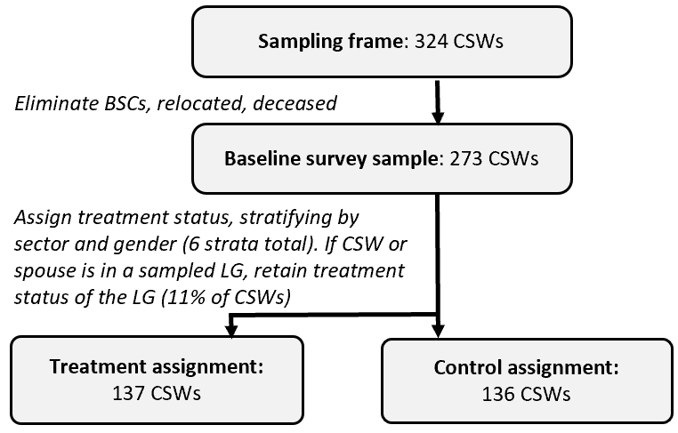

Figure 2: Map of study region, with T & C HHs pinpointed in different colors
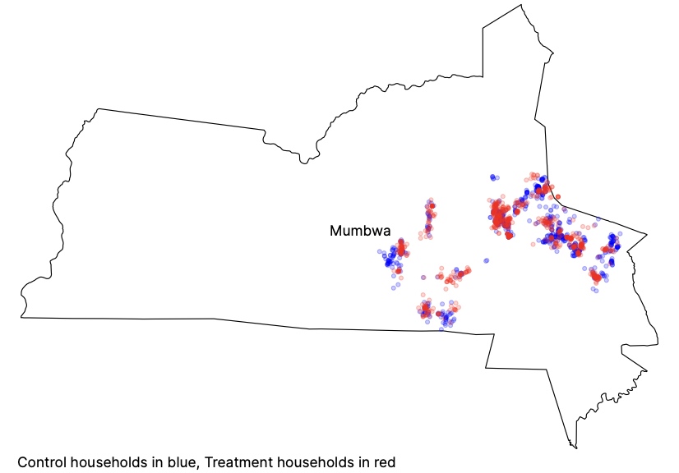

Outcomes
This evaluation will seek to measure the effect of the Mobilized Communities program on the following outcomes:
i. Household welfare & wellbeing.
ii. Individual and household productivity.
iii. Access to health services, and other livelihood-enhancing activities.
iv. Empowerment and social capital of girls and women

Table 1 defines our key outcomes. We present results from our baseline data collection for all of these outcomes in the appendix
Table 1: Key variables at baseline
Outcome category | Survey module name | Description
Household welfare & wellbeing | Income (monthly) | The total monthly household income. This includes income for all individuals in the households, including from employment, farm activities, social transfers, and enterprises among others.
Household welfare & wellbeing | Income Diversity | The number of sources of income in the households
Household welfare & wellbeing | Business Activity | Household involvement in a business and its corresponding output (recipients reached, revenue)
Household welfare & wellbeing | Total household consumption (monthly) | This is the sum of all spending on food and non-food items incurred by the household.
Household welfare & wellbeing | Total household asset value | The sum of valuation of a set of common durable and agricultural assets owned by the household
Household welfare & wellbeing | Total transportation expenditure | Total amount of money spent by household on transportation per month.
Household welfare & wellbeing | Savings and Loans | % of households that saved income in the last 30 days and amount spent on loans annually.
Individual and household productivity | Time traveled to places of interest | Time spent traveling to places of interest over a 7-day period. Places of interest include markets, public transport station, church, community meeting center, farming field, school, health center, place of voluntary work, place of work, and bank/mobile money agent.
Individual and household productivity | Distance traveled to places of interest | Average distance traveled to places of interest over a 7-day period.
Access to health services, and other livelihood-enhancing activities | Service recipients | The total number of households that health volunteers report servicing per month
 | Improved access to health services | % of households reporting improved access to health services
 | Travel for business purposes | Time and costs to access markets (customers) for business purposes  Time and costs to source supplies for business purposes
Empowerment and social capital of women | Decision-making | % of females who are able to make decisions about general financial administration in the house  % of females who are able to voice out their opinions in community meetings  % of females who are consulted by their partner when making household decisions
Empowerment and social capital of women | Self-esteem | % of females who value and perceive themselves highly
Empowerment and social capital of women | Locus of control | % of females who feel they have control over their lives
Empowerment and social capital of women | Gender norms | How respondents perceive gender norms such as “A wife should obey her husband, even if she disagrees”, “It is better to be a man than to be a woman” etc.

Analytical Model
The primary question of this study looks at changes in households' livelihood economic outcomes. The effect of the MC program on household mobility, consumption, income, savings, improved productivity, and empowerment measures will be estimated using the following Ordinary Least Squares model:
Y_{ij}= β₁T_{j} + X’_{ij}γ + α’_{s} + ε_{ij}
Where:
- Y_{ij} denotes the outcome variable (household consumption, income, savings, improved productivity, and empowerment measures) for household i in livelihood group j
- T_{j} denotes the treatment status of livelihood group j (1 for treatment group; 0 for control group)
- β₁ is the estimated treatment effect of MC compared to control
- X’_{ij} is a vector of household-level covariates, including baseline values of the outcome variable
- γ is a vector of coefficients for the included covariates
- α’_{s} is a vector of categorical factors corresponding to the LG or CSW stratum that the household is found in
- ε_{ij} denotes the household error term i, clustered at the LG-level or CSW-level j to reflect the randomization process
We will conduct this analysis for the pooled sample and separatelyfor the LG and CSW subsamples.
We will estimate intention-to-treat (ITT) effects, comparing households that were randomized to receive a bicycle in the treatment group versus the control group. We will also attempt to estimate treatment-on-the-treated effects (TOT) based on bicycle usage by treatment households and potential contamination of control households (such as treatment households sharing bicycles with control households), subject to the availability of data on bicycle usage.
Missing values in our data may occur in our dataset, particularly in the consumption and asset modules, when the respondent says that their household consumed or owns an item but does not know its cost, quantity, or total value. Although enumerators will encourage respondents to give their best estimate when they are unsure of a value, some respondents may not reasonably estimate some survey items, and the value will be coded as missing.
We will replace the missing observation values with zero for missing questions outside the consumption or asset module. However, for missing quantities or ZMW values in the consumption and asset survey items, we will replace missing quantities or total values with the median reported by other households in the sample (in the baseline dataset, this occurred in 1% of observations). We will do this because households with missing values reported consuming or owning the item in question but were unsure of the value.

Limitations & Mitigation Strategies
The livelihood group-level randomization risks spillover effects from the treatment group sharing the bicycles with the control group and difficulty managing dynamics in the community when some receive the bicycles and others do not. Sharing bicycles or tension between households may most likely occur if treatment and control households are near each other. Since livelihoods group members tend to live near each other, we believe that livelihoods group-level randomization will mitigate this risk somewhat. Moreover, WBR will emphasize to treatment households that bicycles are intended for household use and should not be shared outside of the household. However, spillovers may still occur. In order to mitigate the risk of spillovers on estimation, we will ask both treatment and control households about bicycle sharing and usage at the endline and apply treatment-on-the-treated adjustments to account for spillovers.
Another risk to the evaluation is the attrition of study households between baseline and endline. In order to maintain a high response rate and minimize attrition at the endline, we have collected ample contact information from the participant, such as their phone number. Actions will be taken to address attrition depending on the levels of attrition initially observed during data collection. No action will be taken if attrition is lower than 10% and not statistically significantly different across treatment and control arms. We will utilize baseline data to predict attrition likelihood if attrition is higher or unbalanced (i.e., statistically significantly different at the 5% level). These estimates will then serve as inverse probability weights in our analysis, functioning as a robustness check.

Appendix A: Power Calculations
We conducted power calculations to determine the appropriate sample size for the MC Program evaluation under various conditions. Our estimates of intracluster correlation (0.2) and autocorrelation of economic outcomes (0.2) come from a prior IDinsight RCT of a livelihoods program, and we assume 80% power to detect significant effects at the 5% level. Figure 3 shows power calculation results for the cluster-level RCT design, highlighting the tradeoff between more communities per treatment arm and the minimum detectable effect size (MDES) in terms of standard deviations of economic outcomes. In order to detect effect sizes of 0.2 SD (moderate effects among livelihood programs), our evaluation would require 60 treatment groups and 60 control communities. In these calculations, we assume a sample of 12 members per group, though results are not sensitive to this number (+/- 10 members per group would have a minor effect on precision).
Figure A1 shows the power calculations and how the number of clusters affects MDES.

Figure A1: Power Calculations

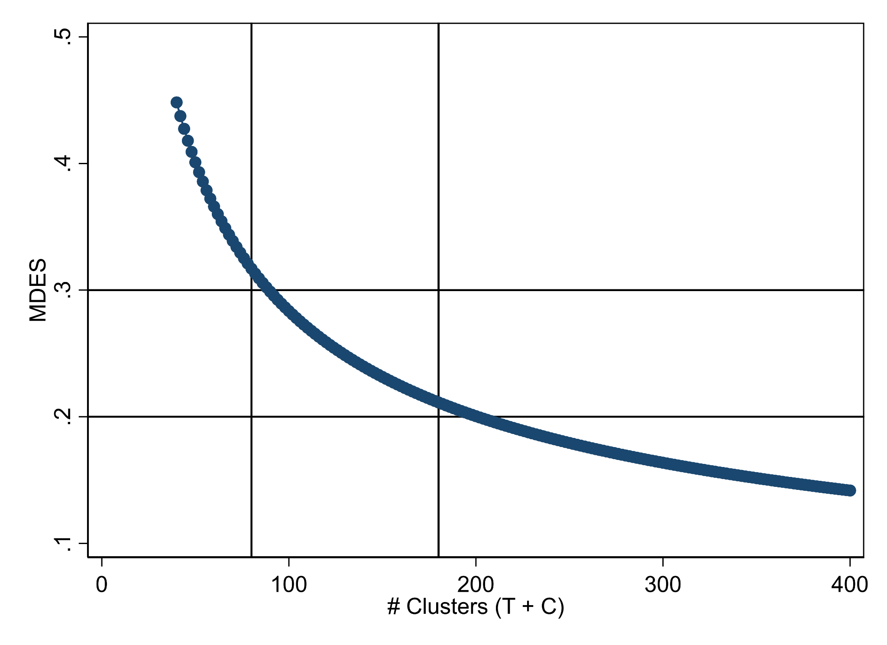

Appendix B: Baseline Balance
The following tables show balance among the our outcomes of interest in treatment and control groups at baseline.

Table B1: Description of study population characteristics
Variable | Mean LGM (N=1297) | T/C Diff. LGM | Mean CSW (N=273) | T/C Diff. CSW | T/C Diff. Pooled
Respondent age | 40.962 | -1.947 * | 41.817 | -1.595 | -1.886 *
Female | 70.2% | -3.0% | 48.7% | -3.7% | -3.1%
Household size | 6.985 | -0.400 * | 7.348 | -0.338 | -0.389 **
No. school-going children 6-17 yrs | 2.835 | -0.11 | 2.927 | -0.056 | -0.101
Employment status (not mutually exclusive)
Self-employed | 75.4% | -5.1% | 60.8% | -10.3% * | -6.0% *
Volunteer for NGO/government | 0.8% | -0.5% | 55.3% | -4.2% | -1.1%
Unemployed: not looking for work | 19.7% | 7.1% * | 16.1% | -1.7% | 5.5% *
All other employment types | 10.6% | -0.026 | 13.9% | -0.4% | -2.2%
Work nature (not mutually exclusive)
Crop farmer | 76.2% | -2.3% | 78.8% | -7.3% | -3.2%
Livestock farmer | 13.4% | -0.2% | 19.4% | -5.3% | -1.1%
Community-based volunteer | 0.4% | 0.1% | 49.5% | -0.9% | 0.0%
Petty trader | 19.6% | 1.6% | 9.2% | 5.2% | 2.3%
Gardener | 10.6% | -2.0% | 8.4% | -8.1% ** | -3.0%
All other work natures | 21.7% | 5.9% * | 22.0% | -6.0% | 3.8%
Main income source
Subsistence farming | 63.4% | -4.4% | 73.6% | -1.3% | -3.8%
Commercial farming | 3.5% | -0.5% | 4.0% | 5.1% ** | 0.5%
Petty trading | 19.7% | -1.6% | 8.1% | 1.5% | -1.1%
All others | 13.4% | 6.5% *** | 14.3% | -5.2% | 4.5% **
Monthly earnings from work nature mentioned (ZMW) (respondent only) | 1225.569 | -8.342 | 1212.269 | -81.044 | -22.485
Est. total monthly HH income (ZMW) | 1584.276 | -150.734 | 1748.853 | -526.260 * | -215.921
HH saved income in last 30 days | 66.1% | -0.2% | 58.6% | -3.4% | -0.8%
Has formal financial Services | 8.6% | 0.5% | 11.0% | -1.7% | -0.1%
Education level: Respondent
No education level attained | 0.5% | -0.3% | 0.0% | 0.0% | -0.3%
Pre-primary completed | 1.4% | 0.7% | 0.4% | 0.7% | 0.7%
Less than primary completed | 34.5% | -5.3% * | 16.5% | 3.6% | -3.7%
Primary completed | 24.4% | -1.2% | 20.5% | -0.2% | -1.1%
Less than secondary completed | 25.2% | 4.0% | 45.1% | -2.7% | 2.9%
Secondary completed | 8.2% | 1.0% | 14.3% | -3.6% | 0.2%
Less than secondary completed | 1.1% | 0.3% | 1.5% | -0.1% | 0.2%
Bachelor's degree and above | 0.3% | 0.0% | 0.7% | 1.5% | 0.3%
Education level: Any household member
No education level attained | 2.9% | 0.0% | 2.9% | 0.0% | 0.0%
Pre-primary completed | 0.5% | 0.3% | 0.0% | 0.0% | 0.3%
Less than primary completed | 9.6% | -2.1% | 4.4% | -0.1% | -1.8%
Primary completed | 15.5% | -2.3% | 11.0% | 2.8% | -1.4%
Less than secondary completed | 38.0% | 3.0% | 38.5% | -1.2% | 2.2%
Secondary completed | 29.0% | 0.8% | 34.8% | -2.2% | 0.3%
Less than secondary completed | 3.2% | 0.9% | 6.2% | -0.8% | 0.6%
Bachelor's degree and above | 1.2% | -0.1% | 2.2% | 1.5% | 0.2%
Poverty likelihood % (from PPI) | 62.5% | -2.2% | 57.3% | -3.1% | -2.4%
Note: The p-value symbols in the table are as follows: '***' for p ≤ 0.01, '**' for 0.01 < p ≤ 0.05, and '*' for 0.05 < p ≤ 0.10. No symbol denotes p > 0.10.

Table B2: Participation in livelihoods group
Variable | Mean LGM (N=1297) | T/C Diff. LGM
Livelihood group size | 20.673 | 0.037
Nature of group (not mutually exclusive)
Members of VSLAs | 28.0% | 1.1%
Co-operative members | 37.5% | 1.4%
Women's clubs | 34.3% | -1.1%
Youth clubs | 7.3% | -1.3%
Tot. value of LG monetary contribution (ZMW) | 240.881 | 194.681 **
LG transport costs last 30 days (ZMW) | 110.918 | -7.303
Receives dividends | 41.7% | 0.6%
Avg. value of dividends received (ZMW) | 814.789 | 362.769 **
Better transport access would impact LG activity | 99.6% | 0.1%
How better access to transportation would impact activities (not mutually exclusive)
Can be able to attend meetings frequently | 41.4% | 1.0%
Ease movements (including business-related activities) | 83.5% | -1.0%
Ease costs (including the cost of doing business) | 38.5% | 0.9%
General livelihood improvement | 41.3% | 0.5%
Ease mobilization | 42.4% | 1.4%
More efficiency in carrying out different tasks | 34.2% | 1.0%
Note: The p-value symbols in the table are as follows: '***' for p ≤ 0.01, '**' for 0.01 < p ≤ 0.05, and '*' for 0.05 < p ≤ 0.10. No symbol denotes p > 0.10.
Table B3: Description of mobility patterns to social and economic places of interest
Variable | Mean LGM  (N=1297) | T/C Diff. LGM | Mean CSW (N=273) | T/C Diff. CSW | T/C Diff Pooled
Total distance (km) traveled daily | 24.763 | -0.072 | 24.814 | 2.358 | 0.351
Total distance (km) traveled weekly | 173.339 | -0.505 | 173.695 | 16.509 | 2.454
Total distance (km) to places of interest | 47.707 | -0.535 | 50.242 | 5.436 | 0.504
Daily time (min) spent traveling to places of interest | 231.889 | -1.120 | 233.98 | 20.302 | 2.606
Weekly time (min) spent traveling to places of interest | 1623.22 | -7.842 | 1637.6341 | 142.112 | 18.239
Total monthly visits | 99.794 | 1.004 | 104.015 | -0.873 | 0.677
Note: The p-value symbols in the table are as follows: '***' for p ≤ 0.01, '**' for 0.01 < p ≤ 0.05, and '*' for 0.05 < p ≤ 0.10. No symbol denotes p > 0.10.
Table B4: Access to transportation
Variable | Mean LGM (N=1297) | T/C Diff LGM | Mean CSW (N=273) | T/C Diff CSW | T/C Diff Pooled
Able to ride a bicycle | 98.6% | 0.3% | 99.6% | -0.7% | 0.1%
HH owns bicycle | 16.8% | 2.2% | 33.0% | 1.1% | 2.0%
HH number of bicycles, if household owns bicycles | 1.037 | 0.031 | 1.144 | -0.073 | 0.001
HH access to bicycle when needed | 14.6% | 2.1% | 29.3% | -1.9% | 1.4%
Bicycle use is daily to weekly | 35.8% | 7.9% ** | 45.8% | -4.1% | 5.8% **
Bicycle use is several times a month to monthly | 31.2% | -3.9% | 28.6% | -3.1% | -3.8%
Bicycle use is rare or never | 44.7% | -5.1% | 36.3% | 3.6% | -3.6%
Bicycle shared outside household | 13.6% | 4.4% ** | 29.7% | 0.3% | 3.7% *
More bicycle access for males, if HH owns bicycles | 66.5% | 2.2% | 63.3% | 19.8% * | 7.3%
More bicycle access for females, if HH owns bicycles | 15.6% | 1.8% | 10.0% | 0.4% | 1.4%
Equal bicycle access for males/females, if HH owns bicycles | 17.9% | -4.0% | 26.7% | -20.2% ** | -8.7% *
Other transport owned: None | 83.0% | 3.0% | 80.6% | 2.3% | 2.9%
Owns vehicle or cart | 16.7% | -2.6% | 17.9% | -0.8% | -2.3%
Est. HH transport expenditure in past 30 days (ZMW) | 369.387 | -39.598 | 492.674 | 140.632 | -8.231
Note: The p-value symbols in the table are as follows: '***' for p ≤ 0.01, '**' for 0.01 < p ≤ 0.05, and '*' for 0.05 < p ≤ 0.10. No symbol denotes p > 0.10.
Table B5: Description of sources of income/business/economic activities
Variable | Mean LGM (N=1297) | T/C Diff LGM | Mean CSW (N=273) | T/C Diff CSW | T/C Diff Pooled
Number of businesses 0-2 | 1.434 | 0.015 | 0.905 | -0.056 | 0.002
Sector of HH business (not mutually exclusive)
HH business agriculture | 65.9% | -3.2% | 51.6% | -5.6% | -3.6%
HH business trade | 27.6% | 4.5% | 16.8% | 0.3% | 3.7%
HH business skills/all other | 8.8% | 1.1% | 8.8% | 2.9% | 1.4%
HH business is stationary | 40.9% | 3.8% | 36.3% | -1.0% | 2.9%
HH business is mobile | 47.1% | -2.6% | 30.0% | 1.3% | -1.9%
HH business sources supplies elsewhere | 52.0% | 2.7% | 38.1% | 0.0% | 2.2%
HH distance (km) to business | 14.174 | -1.458 | 16.073 | 2.021 | -0.91
HH time (min) to travel to business | 95.567 | -15.14 | 110.513 | -5.665 | -13.618
HH mob. business distance (km) traveled | 20.885 | -0.96 | 25.329 | 18.389 | 1.28
HH business distance (km) to supply source | 33.721 | 4.973 | 40.311 | 18.993 * | 6.8
HH business time (min) to supply source | 134.594 | 0.47 | 136.931 | 31.283 | 4.48
HH business revenue (ZMW) | 2272.952 | -50.058 | 2166.077 | 352.67 | 4.892
Sector of group business (not mutually exclusive)
Group business agriculture | 49.1% | 2.2% | 18.3% | -0.2% | 1.8%
Group business trade | 3.2% | -0.2% | 1.5% | 0.1% | -0.2%
Group business skill/all other | 4.1% | -1.9% | 5.1% | -5.8% ** | -2.5% **
Belongs to a social, economic, political, or religious group | 86.4% | -0.5% | 84.6% | 0.2% | -0.4%
# of group meetings per Year | 53.329 | -6.872 ** | 58.433 | 4.597 | -4.911 *
Group meetings attend last 3 months | 7.742 | -0.945 * | 9.913 | 0.762 | -0.653
Note: The p-value symbols in the table are as follows: '***' for p ≤ 0.01, '**' for 0.01 < p ≤ 0.05, and '*' for 0.05 < p ≤ 0.10. No symbol denotes p > 0.10.
Table B6: Summary of household consumption patterns and asset ownership
Variable | Mean LGM (N=1297) | T/C Diff LGM | Mean CSW (N=273) | T/C Diff CSW | T/C Diff Pooled
Monthly consumption (ZMW) | 4054.26 | 24.007 | 4651.735 | 112.915 | 39.471
Weekly consumption - food (ZMW) | 627.358 | 25.584 | 697.34 | 14.229 | 23.609
Total asset value (ZMW) | 60261.193 | -10783.962 ** | 76416.442 | -2611.258 | -9362.503 **
Durable asset value (ZMW) | 7045.707 | -1128.300 | 9717.863 | 243.855 | -889.644
Agricultural asset value (ZMW) | 52180.349 | -8115.361 * | 64811.315 | -2608.257 | -7157.524 *
Note: The p-value symbols in the table are as follows: '***' for p ≤ 0.01, '**' for 0.01 < p ≤ 0.05, and '*' for 0.05 < p ≤ 0.10. No symbol denotes p > 0.10.
Table B7: Description of community service work delivery
Variable | Mean CSW (N=273) | T/C Diff CSW
Service nature
Health | 83.9% | -1.6%
Agriculture | 6.0% | 1.8%
Environment | 7.1% | -0.5%
Lead Farming | 3.0% | 0.3%
Where service is provided from
Home | 2.2% | 0.1%
Stationary place | 24.7% | -1.2%
Mobile | 73.0% | 1.2%
Stationary CSW
Weekly reached (recipients) | 30.861 | -1.028
Required days per week | 1.736 | -0.174
Actual days per week | 1.486 | 0.208
Distance (km) to place | 7.972 | -5.925
Time (min) to place | 71.167 | 7.898
Mobile CSW
Weekly target (recipients) | 33.138 | -8.107
Weekly reached (recipients) | 32.826 | -10.492
Required days per week | 2.692 | -0.057
Actual days per week | 2.754 | -0.211
Distance (km) per week for service | 124.638 | -1.345
Time spent traveling per week for service (min) | 1875.964 | 2.855
Transport costs (ZMW) | 101.795 | -7.785
Main transport for service provision
Walking | 82.1% | -4.8%
Own bicycle | 4.4% | 1.4%
Paid bicycle | 6.2% | 3.5%
All others | 7.3% | -0.2%
Challenges for service provision (not mutually exclusive)
Long distance | 72.3% | 4.0%
Lack of transportation | 86.7% | -3.5%
Cost of transportation | 20.5% | -1.2%
Physical fatigue | 26.2% | 1.6%
Lack of compensation | 20.5% | 1.2%
Other challenges aside from distance, lack of transport, cost of transport, fatigue | 24.9% | 5.8%
Solutions to the challenges (not mutually exclusive)
Money | 34.9% | 2.5%
Transportation | 97.9% | 0.4%
Incentives | 22.6% | -0.3%
Solutions other than money, transport, incentives | 17.2% | -2.2%
Note: The p-value symbols in the table are as follows: '***' for p ≤ 0.01, '**' for 0.01 < p ≤ 0.05, and '*' for 0.05 < p ≤ 0.10. No symbol denotes p > 0.10.
Table B8: Decision-making, locus of control and self-esteem
Variable | Mean LGM (N=1297) | T/C Diff LGM | Mean CSW (N=273) | T/C Diff CSW | T/C Diff Pooled
Finance decisions
Me primarily | 32.2% | 3.7% | 24.2% | -11.9% ** | 1.0%
Me and consult spouse | 43.5% | -0.7% | 55.3% | 6.1% | 0.5%
Me and consult someone | 3.7% | 0.7% | 2.2% | -1.5% | 0.3%
Me, consult spouse and someone | 1.2% | -0.3% | 4.0% | 0.6% | -0.1%
Consult spouse primarily | 16.0% | -4.0% | 12.1% | 5.2% | -2.4%
Consult someone | 3.4% | 0.7% | 2.2% | 1.5% | 0.8%
Consulted by partner
Never | 1.5% | -1.0% * | 1.1% | 0.7% | -0.7%
Sometimes | 19.2% | -0.3% | 14.7% | 11.5% *** | 1.7%
Often | 22.4% | -1.6% | 28.9% | -6.6% | -2.4%
Always | 30.1% | 1.2% | 39.2% | 6.3% | 2.1%
N/A, no spouse | 26.8% | 1.7% | 16.1% | -11.9% *** | -0.6%
Voice Opinion in Community Meetings
Never | 6.6% | -2.6% * | 2.9% | -2.9% | -2.7% **
Sometimes | 45.7% | 4.6% | 32.2% | 8.7% | 5.4% *
Often | 21.9% | -2.1% | 29.7% | -2.3% | -2.2%
Always | 23.3% | 1.6% | 32.6% | 0.2% | 1.3%
Don't attend community meetings | 2.5% | -1.5% | 2.6% | -3.7% * | -1.9% **
Locus of control (Likert Scale 1-5)
I think I am satisfied with my life in general | 2.964 | 0.063 | 3.081 | 0.049 | 0.06
I feel I have control over the direction my life is taking | 3.643 | 0.037 | 3.692 | -0.105 | 0.013
I feel there is always a solution to any problem when you make effort | 4.191 | 0.073 | 4.077 | -0.039 | 0.054
Whatever happens to me is because of my own doing | 3.073 | -0.046 | 3.223 | -0.027 | -0.043
Self-esteem (Likert Scale 1-5)
I feel that I have a number of good qualities | 4.189 | 0.081 * | 4.275 | -0.084 | 0.052
I am able to do things as well as most other people | 4.161 | 0.043 | 4.179 | -0.071 | 0.023
I feel that my life will improve in the future | 4.453 | 0.028 | 4.451 | 0.015 | 0.026
I expect good things to happen to me in the future. | 4.557 | -0.001 | 4.582 | -0.102 | -0.018
I feel I can provide for my family and meet my family’s needs. | 4.023 | 0.039 | 3.989 | -0.18 | 0.001
Gender norms (Likert Scale 1-5)
Boys should be allowed to get more opportunities for education than girls | 2.392 | -0.078 | 2.194 | 0.085 | -0.05
It is better to be a man than to be a woman | 2.7 | 0.037 | 2.766 | -0.027 | 0.026
A wife should obey her husband, even if she disagrees | 3.187 | 0.043 | 3.26 | 0.182 | 0.067
It is the job of men to be leaders, not women | 2.992 | -0.022 | 2.872 | 0.375 ** | 0.047
Note: The p-value symbols in the table are as follows: '***' for p ≤ 0.01, '**' for 0.01 < p ≤ 0.05, and '*' for 0.05 < p ≤ 0.10. No symbol denotes p > 0.10.

For the consumption modules, we utilized the most commonly purchased goods from the Living Conditions Monitoring Survey from the Central Statistical Office of Zambia in 2015, to find a list of items that accounted for 87.4% of total consumption in the district of Mumbwa. This process resulted in cutting 217 items down to 50. During analysis, we multiplied the consumption value in each country by (1/0.87.4) to estimate total consumption and then winsorized the total values at the 2.5 and 97.5 percentiles.
10 respondents initially categorized as LGMs reported not being group members when asked by the enumerator at the beginning of this section. As a result, the sample size for questions regarding the nature of service, contributions, and dividends was 1,297-10 = 1,287.
Values from this point up to “Belongs to a social, economic, political or religious group” are conditional on the respondent operating the particular type of business mentioned
1 USD using the average exchange rate for the data collection period May 30, 2023 through June 23, 2023 is equivalent to 19.10 Zambian Kwacha (https://www.exchange-rates.org/)
Six respondents initially listed as CSWs reported they were not service workers. Therefore, their data is not included in the analysis pertaining to the nature of service and service provision location.

