Perceptions on Intergenerational Mobility and Preferences for Redistribution in Spain
Survey Plan and Key Questions
27 Jun 2024
Rui Fukuda and Dan Sasaki

- National statistics of the target country
Figure 1: Demographics distribution of Spanish residents in percentage (n=28,111,460)
Source: Spanish Statistical Office, Continuous Register Statistics (as of 01/01/2022).
Note: Foreigners are excluded due to two reasons. One is because our research topic is connected with voting behaviours, and the other is because only around 3% among the survey panels of the professional survey company (Bilendi&respondi) we recruit participants are those non-Spanish residing in Spain.

Figure 2: Decile annual income distribution of Spanish residents in percentage
Source: Spanish Statistical Office, EU Statistics on Income and Living Conditions, 2022.
Notes: Obtained as tailor-made statistics from the Spanish Statistical Office. Foreigners are included in the data, and the fraction of them is approximately 9.6% (n=59,799).

- Survey schedule, sampling, and randomisation
Figure 3: Plan of survey schedule and target respondents’ numbers (February 2024 -)
Figure 4: Question order difference and randomisation groups by waves

Notes: (1) Two animations will be shown only for respondents of waves B and C. (2) Government questions are: (i) trust in government; (ii) beliefs on government's ability to reduce unequal opportunities for children from poor and rich families; (iii) thoughts on whether the unequal opportunities is a problem. (3) ‘Effort and mobility’ refers to the intergenerational mobility perceptions of very hard-working children from poor families, and ‘Talent and mobility’ refers to the perceptions on mobility of very talented children from poor families. (4) Although the wave C was planned to contain two animations, the wave C was converted to control group, and the animation was not shown. This is simply due to a technical problem of the form.
Figure 5: Treatment animations for the Spanish survey
A. Low mobility of the poor | B. Low mobility of the wealthy
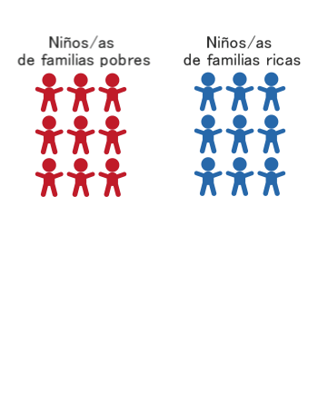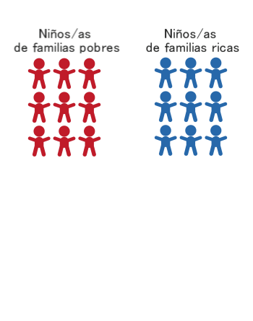
Note: Both of the two animations are shown to treatment group respondents.
Figure 6: Quotas for age, gender, and income groups by waves
Note: Quotas are based on nationally representative distribution of age, gender, and household income.

- Key questions
The main questions for our analyses are the followings.
(1) Perceptions on respondents’ own income position in the country and on intergenerational mobility
(2) Policy preferences

Ⅲ-1. Perceptions

(A) Perceptions on relative positions of their own income in the country
We ask respondents questions on last year’s personal and household income, of which the categories are based on actual income decile distribution (Source: EU Statistics on Income and Living Conditions 2022,). We also ask a question on their perceptions on relative positions of their own income in the country. Combining those questions, see Figure 7, which were not included in preceding research in the way we built up, we show stylised facts on Spanish respondents’ misperceptions on income positions in the country, which is related to over- and under-confidence topics.

Figure 7: Actual income distribution-based questions and relative income position perception question in the Spanish survey
Personal income  €0 - €4978  €4979 - €7117  €7118 - €9043  €9044 - €10882  €10883 - €13031  €13032 - €15432  €15433 - €18498  €18499 - €22730  €22731 - €30301  €30302 + | Household income  €0 - €10628  €10629 - €15737  €15738 - €20841  €20842 - €26276  €26277 - €32016  €32017 - €38283  €38284 - €46136  €46137 - €57309  €57310 - €77008  €77009 + | Perceived relative income positions in the country

(B) Perceptions on intergenerational mobility (main part)
To elicit respondents’ beliefs on intergenerational upward mobility, we introduce an image of ladders to the question, in the same way as preceding research. Hypothesising 500 families that represent the country's population, we ask the perceived probability of upward mobility of the children coming from poorest families. Specifically, using an image of ladders as is in Figure 8, we ask respondents how many children coming from the poorest 100 families will belong to different income groups, once they grow up (respondents need to fill out empty fields to indicate their views). We then redo the same question of upward mobility conditional on children’s effort and talent.

Using mobility perceptions and actual mobility data, we can calculate the extent of misperceptions. However, notice that we cannot precisely measure misperceptions on this topic, in the same manner as preceding research, due to measurement issue. For the measurement of actual upward mobility, we need data coming from tax records on parents’ and children’s household income but Soria-Espín (2022, Table A5), the only study showing the mobility matrix using Spanish tax records, uses parents' household income and children's personal income for the matrix. Note that we will calculate mobility misperceptions using this actual mobility data, which is different from other countries’ measures.
Figure 8: Intergenerational mobility perception question of the Spanish survey
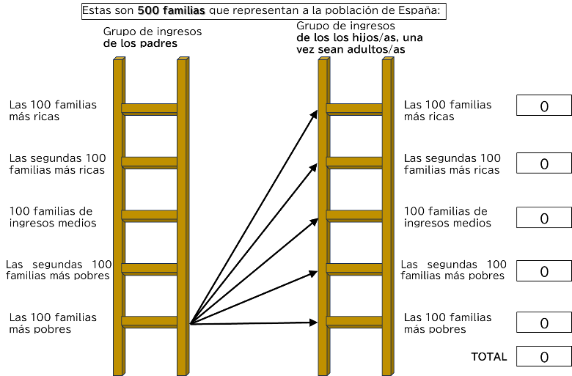

Ⅲ-2. Policy preferences
To clarify policy preferences, we split diverse questions to cover multiple dimensions of the preferences. Hereinafter, the main questions, that are planned to be utilised as outcome variables for regression analyses, will be described.

(A) Preferred government budget allocation
We show respondents diverse policy categories to divide the national budget as is in Figure 9, in which the total percentile of the budget must sum to 100.

Notice that in our Spanish survey, we augmented the policy categories from 6 to 7, because we preferred to divide the category of education into two subcategories, considering different roles of them in society. Namely, we divided the education category into, (i) spending on early childhood, primary, and secondary education, and (ii) spending on tertiary education. Therefore, the categories for the budget in the Spanish survey are i) Defense and National Security, ⅱ) Infrastructure, ⅲ) Education (early childhood, primary and secondary education), ⅳ) Education (tertiary education), ⅴ) Old age and disability pensions, ⅵ) Social Insurance and Public Assistance, and ⅶ) Health.

Figure 9: Government budget allocation question of the US survey form
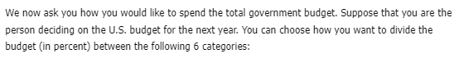
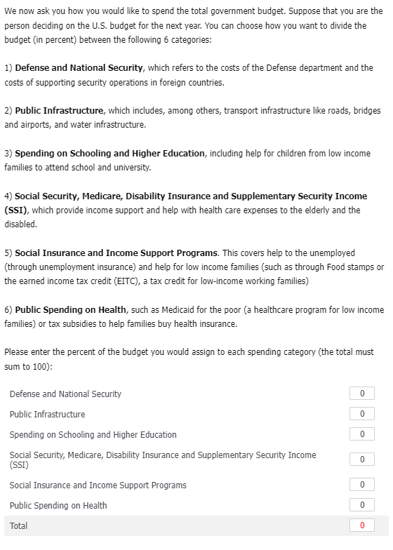

Source: US Questionnaire form of Alesina et al. (2018).

(B) Preferred income tax rates by income groups
To elicit income tax preferences, we ask respondents to move taxation sliders, as is in Figure 10, which correspond to preferred income tax rates on each income group, in a way that they view fair. Income groups are the top 1%, the next 9%, the next 40%, and the bottom 50% of the national income distribution.

Figure 10: Income tax rate preference question of the US survey form
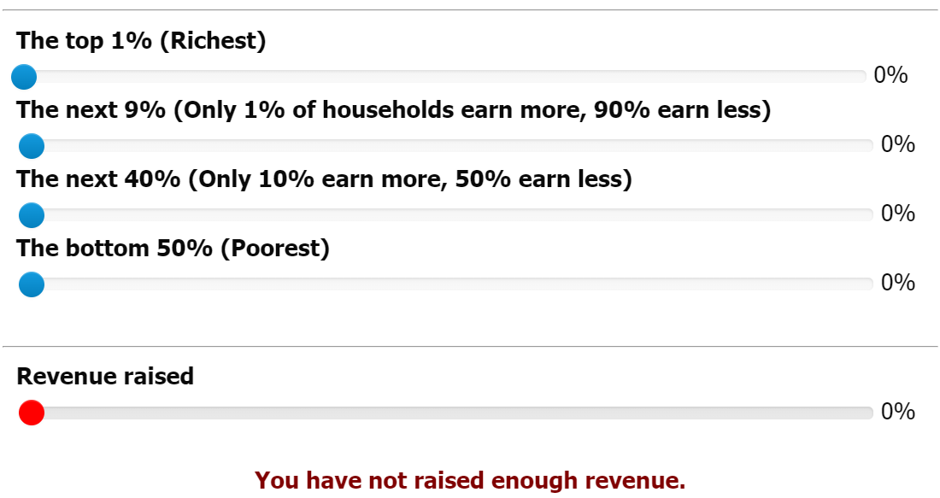
Source: US Questionnaire form of Alesina et al. (2018).

Once respondents move the sliders of tax rates for each income group, then accordingly, automatically, the total revenue raised listed in the bottom slider moves. Respondents have to satisfy the target revenue (must have the 95-104% of the target revenue), otherwise they cannot advance to the next question.

Notice that respondents are constrained to current level of revenue in their country, and to build up this constraint, actual statistics, such as GNI and income tax revenue statistics, are utilised behind the question. Although the respondents only see the sliders on tax rates and revenue raised, the researchers must have the actual statistics on income distribution and tax revenue through income taxes of the country, to build up the sliders (respondents do not see the data behind but only the sliders).

Figure 11 shows the actual statistics used for the question of the Spanish survey. The statistics are Gross National Income (GNI), distribution of GNI by income groups in percentiles, and tax revenue through personal income taxes of the year 2022. Utilising this information, the movement of the sliders were built up. For instance, if the respondent’s preferred income tax rates to the richest income group is 10%, and for the rest of the groups is 0%, then the government raises 13,798.274 million euros of revenue, and the bottom slider in Figure 10 automatically moves to 11.29%. This is because 13,798.274 million euros, which is the 10% of the total income the richest group has (13,7982.74 million euros), correspond to 11.29% of the target revenue 122,214 million euros (calculated as 13,798.274/122,214*100). Thereafter, the respondent needs to satisfy the remaining target revenue, through taxation to the remaining three groups, otherwise will not be allowed to advance to the next question.

Figure 11: Actual national income and tax statistics behind taxation question in the Spanish survey (annual data of 2022)

Source: Spanish Statistical Office, Spanish Tax Administration Agency, and OECD Tax Revenue Statistics.

- Newly added questions
The main goal of our analysis is to detect the causal effect of the treatment animations on the preferences for redistribution. However, as sub-part of our study, we attempt to find out several correlation-based stylised facts which might be useful for the succeeding research. In this section, we briefly depict questions for the correlation analyses, of which the information was included in our questionnaire (but not in the preceding questionnaire).

(A) Views on intra-generational upward mobility
Preceding research show the importance of both present and future income as determinants of preferences for redistribution (Alesina and Giuliano, 2011). As such, we collect both present actual income and future prospect income information. As for the present actual income, we collar both personal and household income information, in a decile category form as is shown in Figure 2. We do also collect perceptions on respondents’ relative income positions in the country, in a decile category form as is described in Ⅲ-1(A). With regard to the future income prospect, which will be measured in order to test the so-called prospect of upward mobility (POUM) hypothesis, which indicate peoples’ views on higher upward mobility in the future may demand lower levels of redistribution considering their cost/benefit from the policy, we collar different information as is in below.
Perceived present relative income positions | Prospects of relative income positions in five years

We attempt to test the POUM hypothesis from two different dimensions; namely (i) inter-generational; and (ii) intra-generational mobility perspectives.

Views on (i) inter-generational mobility are measured using the questions of social ladders, as is explained in Ⅲ-1(B), which is the core part of our survey.

As for views on (ii) intra-generational mobility, we collar the information using the gap between perceived relative income positions in the country at the present time and in the future, which are listed in the left figure (both for the personal and household income, the relative position questions are asked in the questionnaire). Using this information, we can distinguish people who have the prospect of upward- and downward-mobility within their own generation.

(B) Voting behaviours
Since the general election was held on 23 July 2023 in Spain, we collar the voting information (whether the respondents went to voting and the parties they voted if they went to vote). Having this information allows us to approach revealed policy preferences, more than just stated ones (although we are aware of the measurement error problem which questionnaire surveys basically contain). We will clarify the consistency between policy preferences, which are measured using questions described in Ⅲ-2, and the voting behaviour.

(C) Heritages
We do also ask questions on inheritance, expectations for heritages for those who have not inherited anything yet, of real- and financial-assets. We collect this information because heritages, and expectations for this, might affect their policy preferences, since inheritance affects the cost/benefit from the redistribution.

(D) Others
Some other questions are modified or replaced from the original questionnaire (such as, duration of employment contract, living place (province) at age of 15, and the relationship between the respondent and cohabitants).

References
Alesina Alberto and Giuliano Paola. 2011. “Preferences for Redistribution.” In eds. Benhabib J., Jackson M. O. and Bisin A. Handbook of Social Economics, 1A, pp.93-131.
Alesina Alberto, Stantcheva Stefani, and Teso Edoardo. 2018. “Intergenerational Mobility and Preferences for Redistribution.” American Economic Reviw, 108 (2), pp. 521-554.
Soria-Espín Javier. 2022. “Intergenerational Mobility, Gender Differences and the Role of Out-Migration: New Evidence from Spain.” DP.

