1. Welcome screen
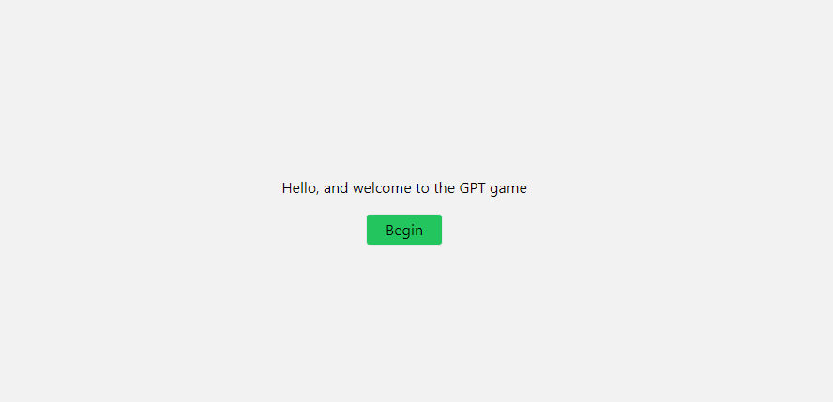

2. Consent form
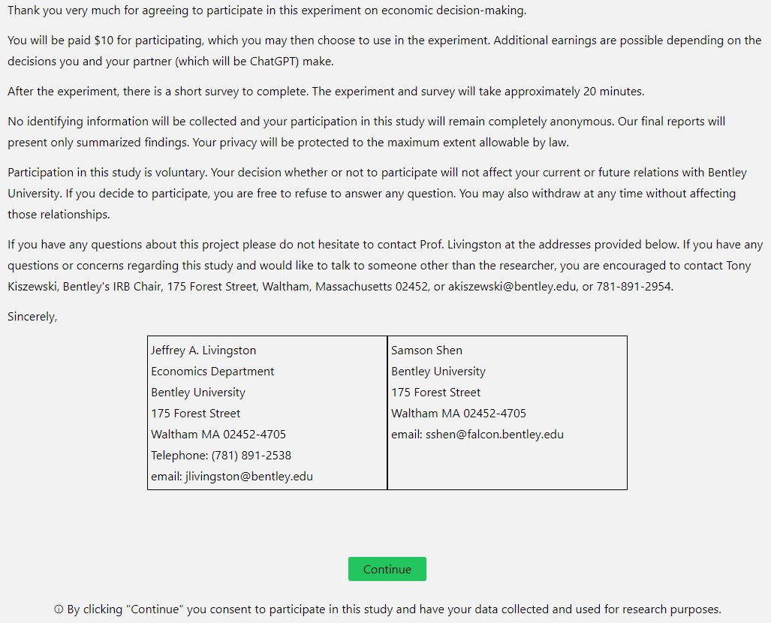

3. Main instructions screen 1 (seen in all treatments)
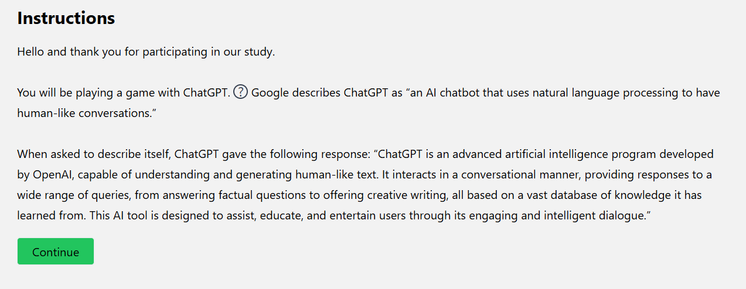

When hovered over, the question mark box displays the following:
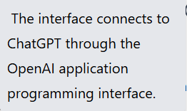
4. Main instructions screen 2 (seen in all treatments)
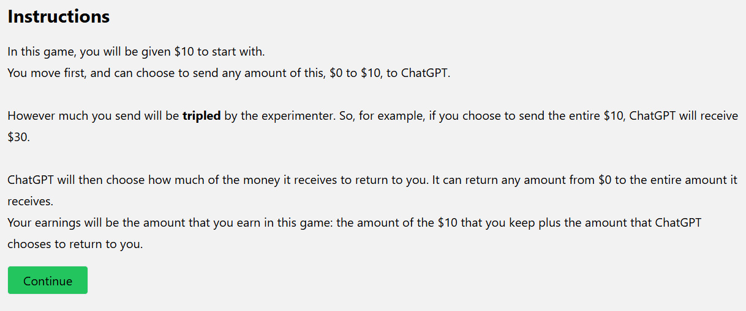

5. Main instructions screen 3 (seen in all treatments)
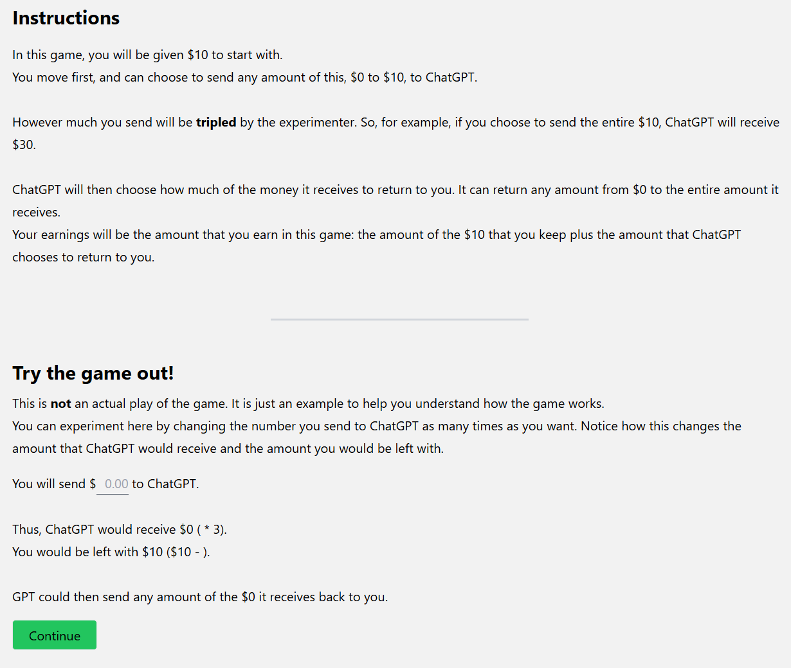

6. Main instructions screen 4 (seen in all treatments)
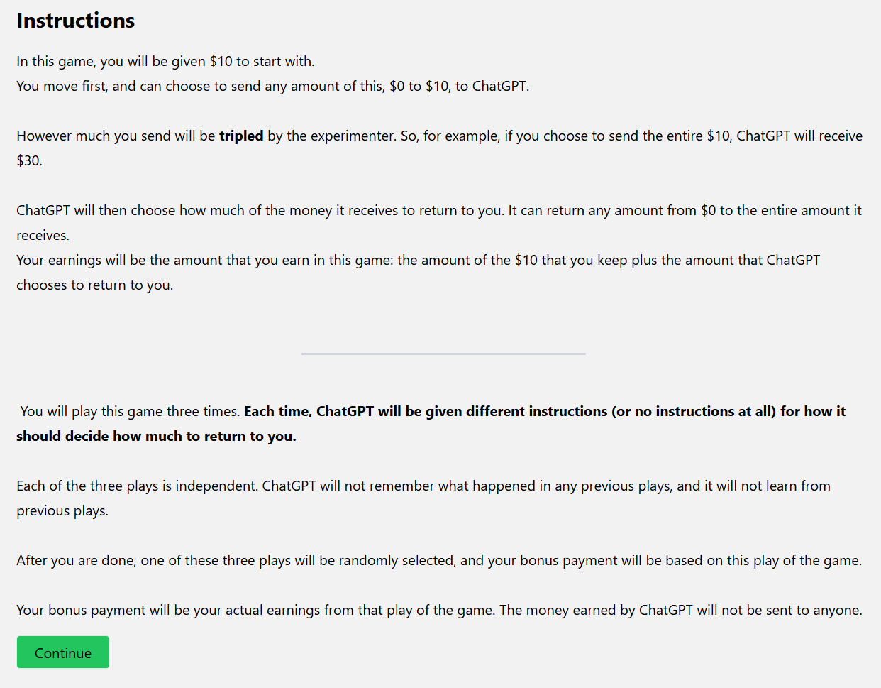

7. Treatment No Prompt instructions
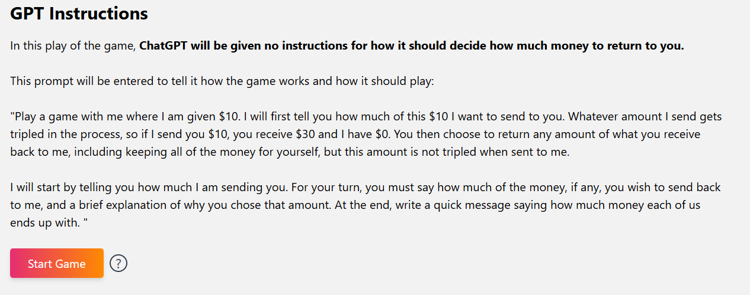

When hovered over, the question mark box displays the following:
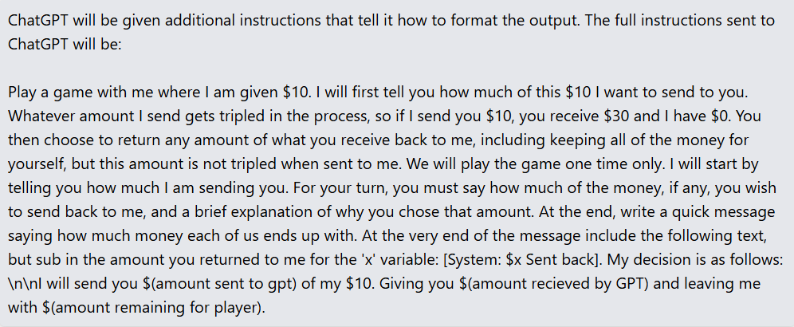

8. ChatGPT interface screen, Treatment No Prompt
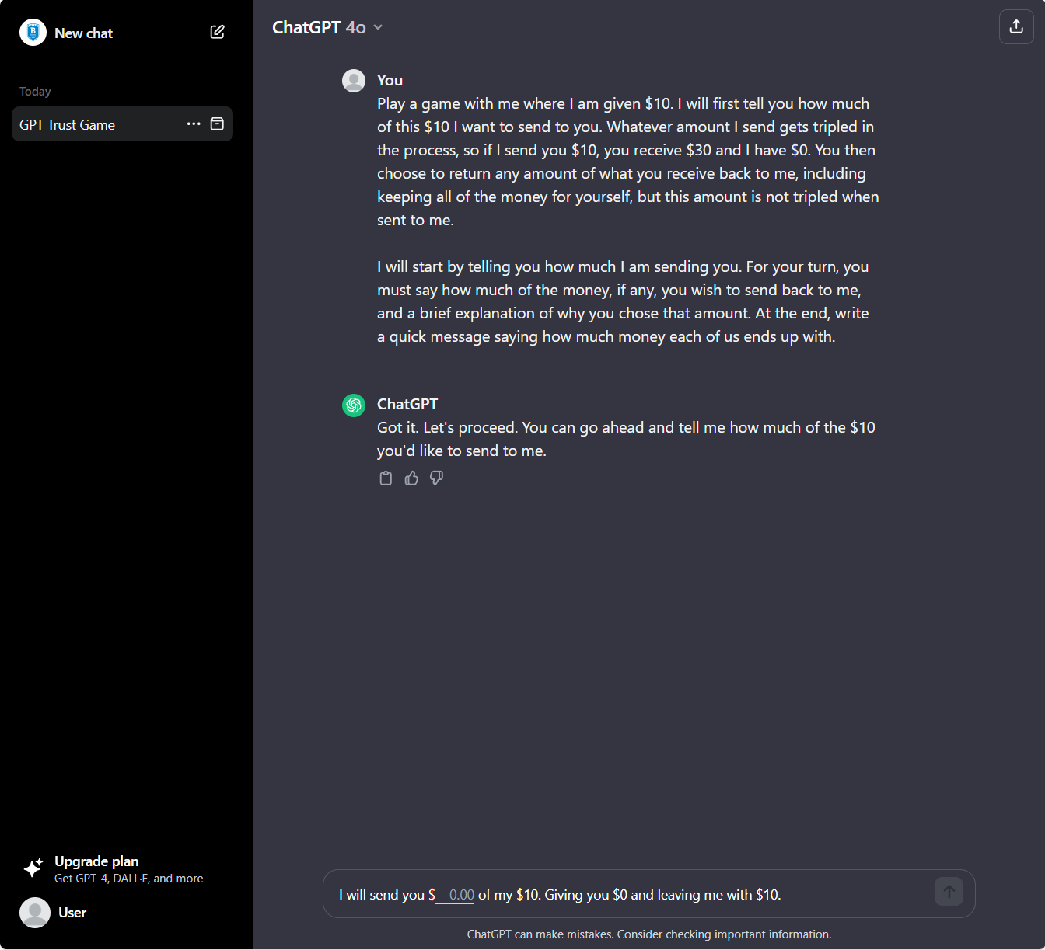

9. Treatment Fairness instructions
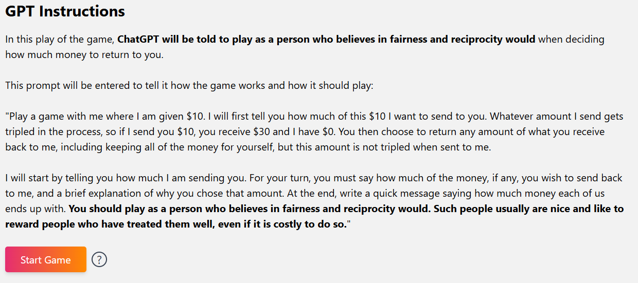

When hovered over, the question mark box displays the following:
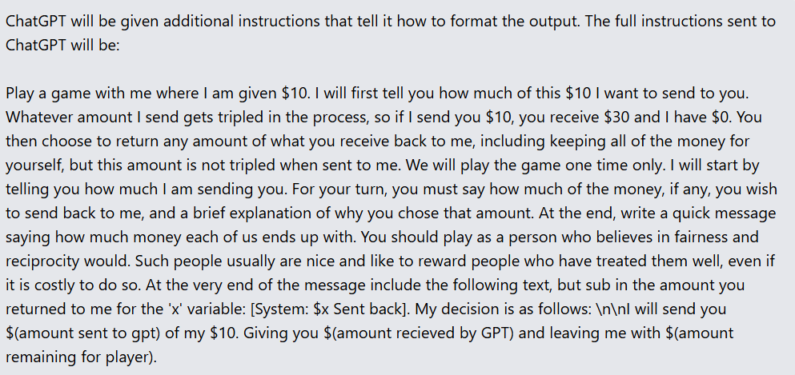

10. ChatGPT interface screen, Treatment Fairness
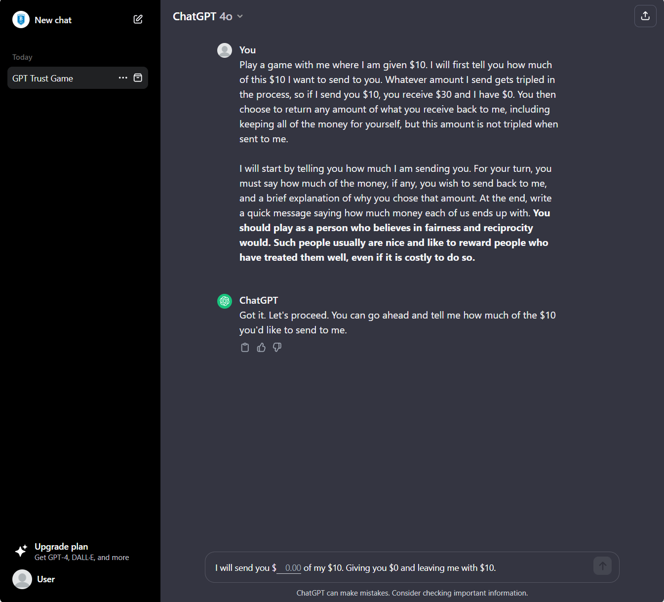

11. Treatment Self-Interest instructions
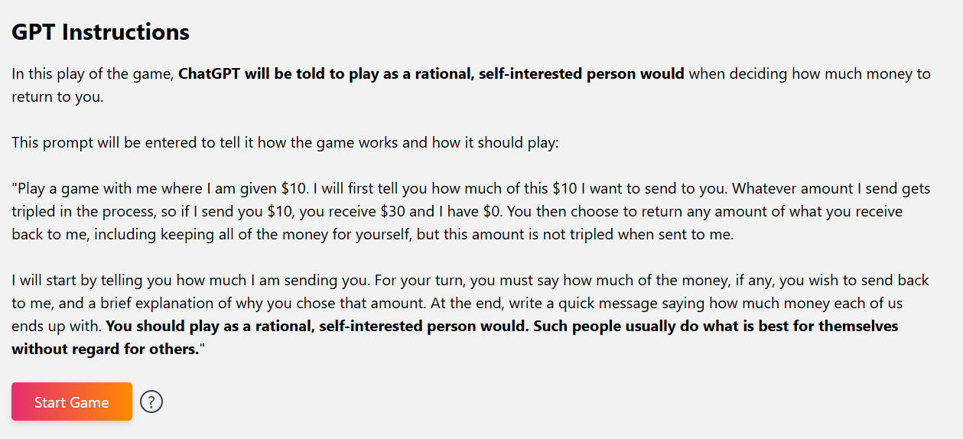

When hovered over, the question mark box displays the following:
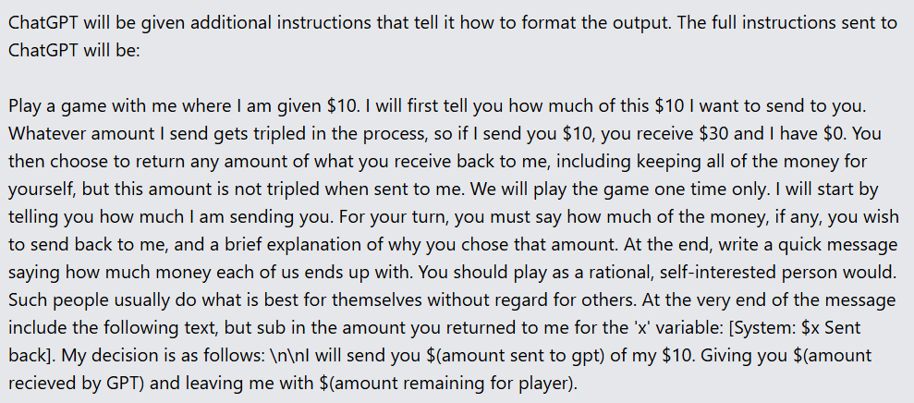
12. ChatGPT interface screen, Treatment Self-Interest
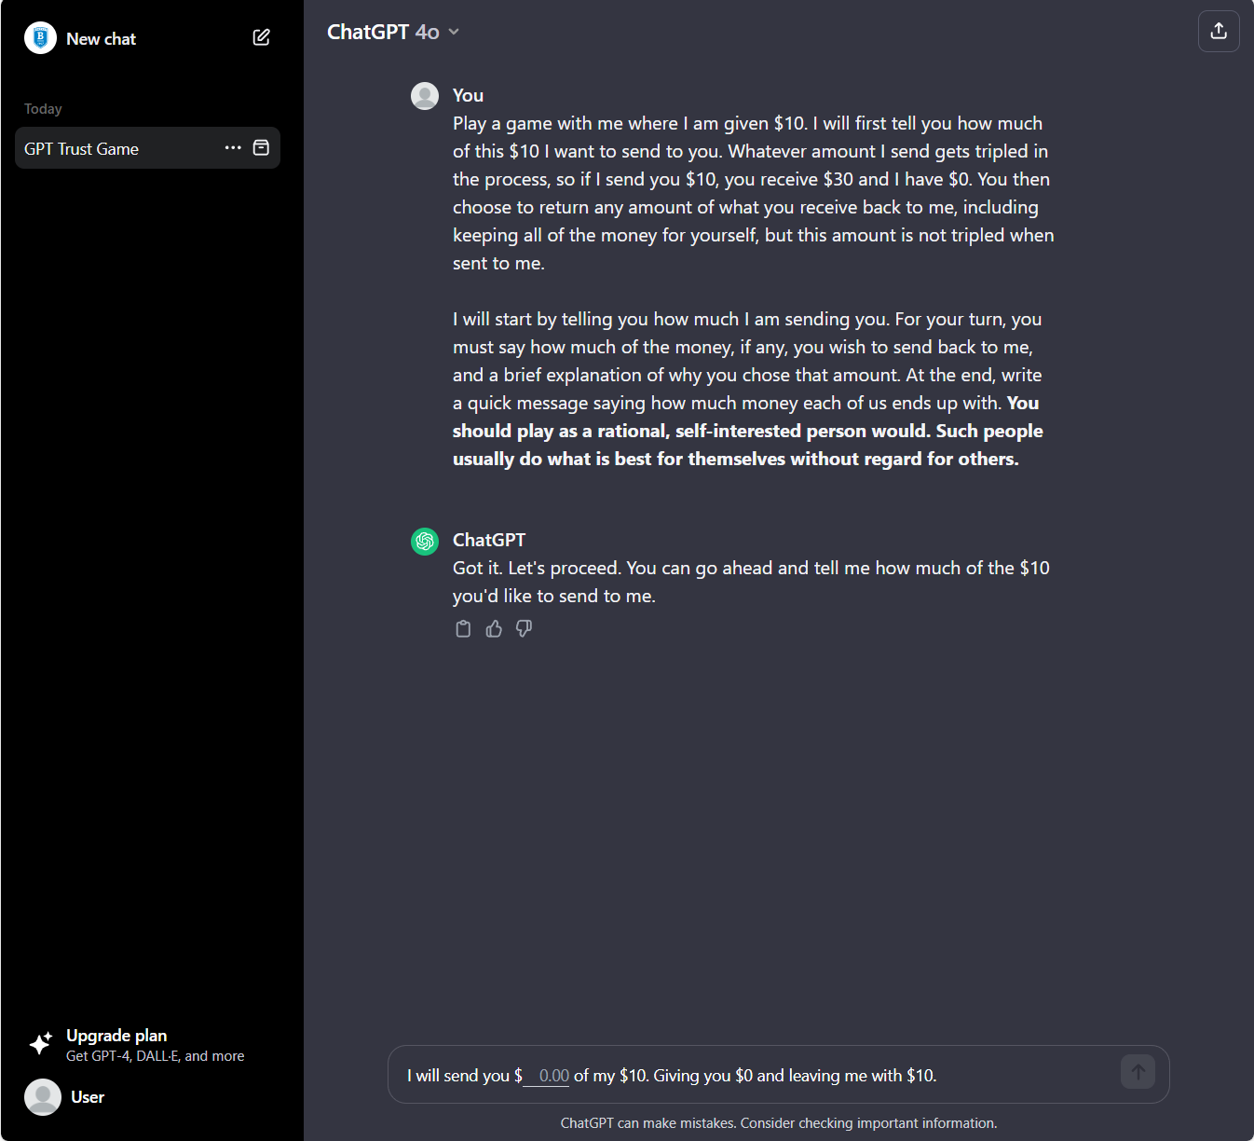

13. Payment announcement example
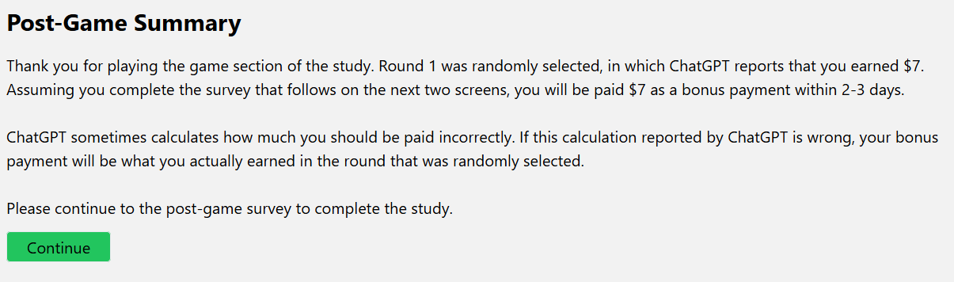

14. Survey, Page 1
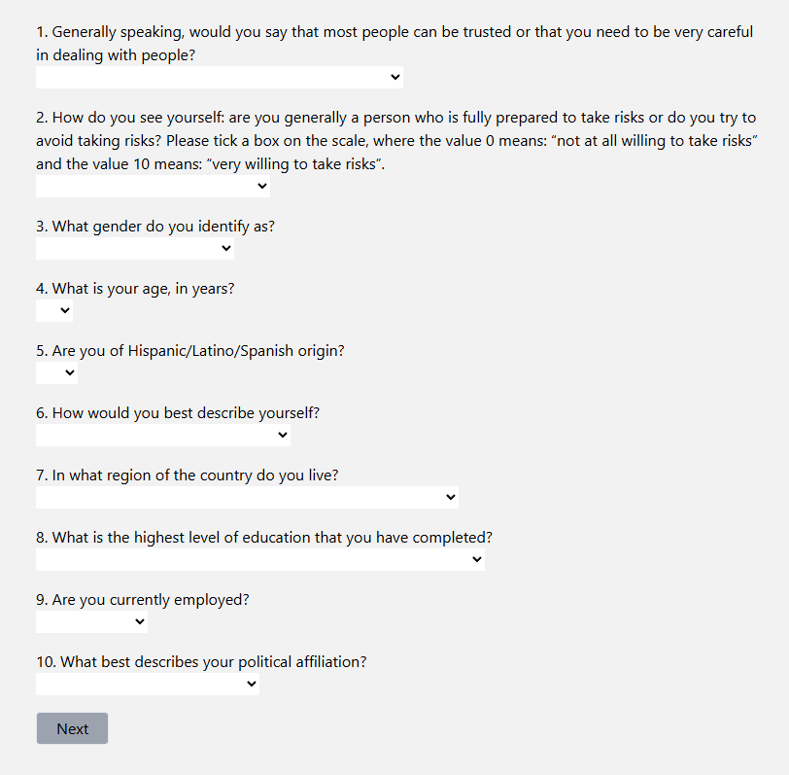

15. Survey, Page 2


