Instructions
The game that you all will play on your computers involves 3 players for each group. Player 1 acts as a firm and will be given an initial endowment of 60 points. Player 2 acts as a public official and gets 30 points to start with. Player 3 acts as a citizen and they will get either 40 points or 80 points depending on the treatment given to you.
Before the game is played, you all will be asked to fill out a demographic information survey on the computer. Once completed and everyone in your group has finished it, you will proceed to the game.
This is how the game will play. Player 1 can choose to offer a bribe or not offer a bribe to Player 2. If Player 1 offers a bribe, Player 1 will lose 2 points because of a “transfer fee”.
Next, Player 2 can either accept or reject the bribe. If the bribe is rejected, the game is instantly over. But, if the bribe is accepted, three times the amount of the bribe will be added to Players 1 and 2’s earnings. In addition, that bribe amount will be deducted from the earnings of Player 3.
Finally, Player 3 will have the opportunity to punish or not punish Players 1 and 2. If Player 3 chooses to punish them, they will be able to choose the punishment amount. But this punishment amount will be deducted from Player 3 and three times the punish amount will be deducted from Players 1 and 2. If Player 3 chooses to not punish them, the game will be over.
After either choice, you all will fill out another survey explaining your decision behind the choices you made. After this survey is completed, you will come up to collect your earnings from the game thus concluding the experiment.
The diagram below details payoffs for each player and the game layout. The specific values may vary depending on the treatment and will be detailed once you start the game.
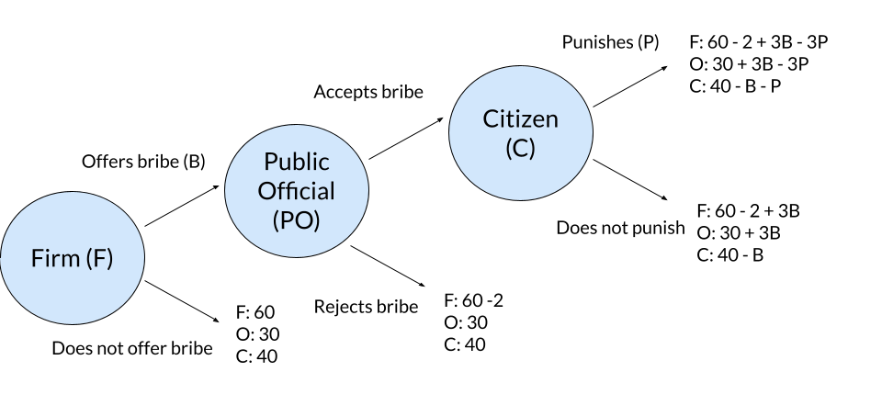

Screenshots:


