Annex: RCT Registry
Impact Evaluation Project Title: Uptake of Best Management Practices by Rice Farmers in Nigeria: The Effectiveness of Bundling Women’s Empowerment Training, Digital Extension, and In-Person Extension
Investigators: Aminou Arouna (AfricaRice), Andrew Dillon (Northwestern University), Edouard Mensah, Mare Sarr, Leland Glenna (Penn State University)
Project Summary: The proposed cluster randomized controlled trial investigates whether bundling women’s empowerment training, digital extension, and in-person extension to tackle gender and extension constraints in rice production can increase the adoption of improved cultural practices and use of mechanization in rice-based farming systems in Nigeria --- while ultimately enhancing the productivity and profitability of rice farming. To evaluate the effectiveness of the bundle/package of women’s empowerment training, digital extension, and in-person extension on the uptake of best management practices and the performance of rice production, the experiment will build upon the following arms: “Provision of wives-only training about women’s empowerment and RiceAdvice Lite recommendations supplemented with bi-weekly visits of female extension agents in the rice cropping season” (T1), “Provision of wives-only training about women’s empowerment and RiceAdvice Lite recommendations supplemented with bi-weekly visits of male extension agents in the rice cropping season” (T2), “Provision of couples’ training about women’s empowerment and RiceAdvice Lite recommendations supplemented with bi-weekly visits of female extension agents in the rice cropping season” (T3), “Provision of couples’ training about women’s empowerment and RiceAdvice Lite recommendations supplemented with bi-weekly visits of male extension agents in the rice cropping season” (T4), and “No training about women’s empowerment, no RiceAdvice Lite recommendations, and no supplementary bi-weekly visits of extension agents of any gender in the rice cropping season” (C).
Problem Statement: Digital innovations in agricultural extension have the potential to improve the sustainable production and economic performance of agriculture (Aker, 2011; Fabregas et al, 2019; Finger, 2023; Jones et al, 2022; Singh et al., 2022). In Nigeria, digitized extension services, such as RiceAdvice Lite, which gives proven pre-season recommendations on fertilizer and other management practices for rice cultivation and other rotational crops in rice-based systems for various locations, based on a very minimum amount of information (location, crop, and environment) to be provided by the farmer have the potentially to increase the uptake of best management practices in rice-based farming systems. Prior impact studies showed that using RiceAdvice increases rice yields by 7 to 20%, profits by 10 to 23%, and nutrient use efficiency (Arouna et al. 2021; Zossou et al. 2020). However, large-scale use of digital extension for the sustainable economic development of the rice sector requires addressing several challenges, including the needs for supplementary in-person or public extension services due to limited farmer’s literacy as well as gender-differentiated extension services (Caine et al., 2015) and the use of a gender-transformative rather than gender-accommodating approach (Interagency Gender Working Group, 2017; Cole et al. 2020; Lambrecht et al., 2023). The study aims to address the barriers inhibiting women’s adoption of innovations, digital technologies, and access to agricultural advice, by testing the effectiveness of a “bundling” or “multi-faceted” program delivering women’s empowerment training, digital extension, and in-person extension to rice farmers in married households in Nigeria. The study’s main research question is the following: Does bundling “women’s empowerment training, digital extension, and in-person extension” increase the adoption of improved cultural practices and use of mechanization in rice-based farming systems in Nigeria?
Specifically, the study answers the following questions:
- (RQ1) What is the effect of increasing women’s empowerment with digital extension and either female or male extension agents on the adoption of improved cultural practices and use of agricultural machinery?
- (RQ2) Are there differences in treatment response by gender of the spouse?
RQ1 simply focuses on testing the effectiveness of bundling interventions ---regardless of the components of the bundle --- on the main outcomes of interest. RQ2 investigates intra-household gender differences in the main outcomes of interest within “wives-only training” clusters, within “couples training” clusters, and within “female extension agent” clusters.
Target population: The study will take place in two North-Western states (Jigawa and Kaduna) and two North-Central states (Nasarawa and Benue) of Nigeria. The Northern region faces gender barriers more than the Southern region due to religious and cultural differences. For the same reasons, North-Central states are also more gender-progressive than North-Western states.
Farmer’s Gender Dynamics: The study targets farmers/spouses by gender within married households growing rice in the villages. Village census data at baseline informs about the composition and marital status of the population of rice-growing households in the villages of the four study states. In the sub-component “wives-only” of the bundle component “women’s empowerment training”, within the household, female farmers are treated while male farmers are not. In the sub-component “couples” of the bundle component “women’s empowerment training”, within the household, both female and male farmers are treated; however, farmer’s gender differences in the take-up of best management practices may be observed due to differences between female and male farmers in access to resources, intra-household decision-making, as well as individual and plot characteristics (Udry, 1996; Dillon and Mensah, 2024).
Extension Agent’s Gender Dynamics: Although the bundle component “digital extension supplemented with in-person extension” is allocated at the village level, extension agent’s gender differences in the take-up of best management practices across villages may be observed due to heterogeneous abilities of agricultural advice delivery. Besides, the interaction between the farmer’s gender and the extension agent’s gender introduces additional dynamics to be observed since female extension agents may relate well with the female farmers and deliver them agricultural advice in a better way than male extension agents do due to the gender norms in Northern Nigeria. Thus, the “female extension agent” assignment may contribute to gender-transformative intra-household changes as opposed to gender-accommodating intra-household changes.
Intervention and Evaluation Design: The study will test variations of two interventions (women’s empowerment training and digital extension supplemented with in-person extension) leading to 5 experimental groups (Table 1).
- “Provision of wives-only training about women’s empowerment and RiceAdvice Lite recommendations supplemented with bi-weekly visits of female extension agents in the rice cropping season” (T1),
- “Provision of wives-only training about women’s empowerment and RiceAdvice Lite recommendations supplemented with bi-weekly visits of male extension agents in the rice cropping season” (T2),
- “Provision of couples’ training about women’s empowerment and RiceAdvice Lite recommendations supplemented with bi-weekly visits of female extension agents in the rice cropping season” (T3),
- “Provision of couples’ training about women’s empowerment and RiceAdvice Lite recommendations supplemented with bi-weekly visits of male extension agents in the rice cropping season” (T4), and
- “No training about women’s empowerment, no RiceAdvice Lite recommendations, and no supplementary bi-weekly visits of extension agents of any gender in the rice cropping season” (C).
The proposed evaluation design is a multi-site (state), cluster (village) randomized trial with treatment at the village level. The interventions start with the women’s empowerment training workshops in October 2024 (Figure 1). There are 8 one-day training workshops: 2 per state, including 1 only for wives and 1 for both wives and husbands. In polygamous households, only the wife growing rice and managing their own plots is selected; if there are many such wives, one of them is randomly selected. Wives of households in the villages allocated to the “wives-only” training receive a one-day training about women’s empowerment implemented by an experienced local NGO in Nigeria. The training curriculum is administered to address five empowerment domains (production, resources, income, leadership, and time) and increase the Abbreviated Women’s Empowerment in Agriculture Index (A-WEAI). Wives and husbands and of households in the villages allocated to the “couples” training receive the same one-day training about women’s empowerment implemented by the same experienced local NGO in Nigeria. Although treated couples receive the same training curriculum as treated wives, differences in outcomes may be observed between the two bundle sub-components because the “couples” training contributes to gender-transformative intra-household changes as opposed to gender-accommodating intra-household changes.
Table 1: Experimental groups
Bundle component “Training about Women’s Empowerment” | Bundle component “Digital Extension supplemented with In-Person Extension”
Bundle component “Training about Women’s Empowerment” | RiceAdvice Lite + Female Extension Agents | RiceAdvice Lite + Male Extension Agents | No RiceAdvice Lite and No Supplementary Extension Agents
Wives-only Training | Group 1 (T1):  “Provision of wives-only training about women’s empowerment and RiceAdvice Lite recommendations supplemented with bi-weekly visits of female extension agents in the rice cropping season” | Group 2 (T2):  “Provision of wives-only training about women’s empowerment and RiceAdvice Lite recommendations supplemented with bi-weekly visits of male extension agents in the rice cropping season”
Couples Training | Group 3 (T3):  “Provision of couples’ training about women’s empowerment and RiceAdvice Lite recommendations supplemented with bi-weekly visits of female extension agents in the rice cropping season” | Group 4 (T4):  “Provision of couples’ training about women’s empowerment and RiceAdvice Lite recommendations supplemented with bi-weekly visits of male extension agents in the rice cropping season”
No training |  |  | Group 5 (C):  “No training about women’s empowerment, no RiceAdvice Lite recommendations, and no supplementary bi-weekly visits of extension agents of any gender in the rice cropping season”
Wives-only Training
Group 1: RiceAdvice Lite
+ Female Extension Agents
Group 2: RiceAdvice Lite
+ Male Extension Agents
Couples’ Training
Group 3: RiceAdvice Lite
+ Female Extension Agents
Group 4: RiceAdvice Lite
+ Male Extension Agents
May 2024
Baseline data
collection
Oct. 2024
Women’s
Empowerment
Trainings
collection
Group 5:
No Women’s Empowerment Training,
No RiceAdvice Lite,
No Supplementary Extension Agents
Sept.-Oct. 2024
Planting season
Oct.-Nov. 2024
RAL recommendations and Extension Agent Visits
December 2024
Harvest season and Endline data collection

Figure 1: Timeline of the intervention and data collection

In addition to the women’s empowerment training, households in treatment villages will receive RAL recommendations and bi-weekly visits of extension agents in October and November 2024 (Figure 1). The extension agent is female in T1 and T3 while male in T2 and T4. Extension agents facilitate the use of RAL app on the plots and give any additional agricultural advice that the households may need on rice cropping practices and use of agricultural machinery. Extension agents are local extension professionals from two NGOs, ATAFI and Green Sahel.
The control group is composed of households in villages allocated to no women’s empowerment training and which do not receive RAL recommendations and bi-weekly visits of extension agents either. Since control households do not receive any part of the intervention in October and November, they only participate in the study at baseline (May 2024) and endline (December 2024). The baseline data collection occurs before the planting season which precedes the entire intervention. The endline data collection occurs after harvest. Thus, the outcomes from the intervention refer to one full rice cropping season (Figure 1).

Power calculations:
The trial focuses on outcomes at two levels: farmer level (i.e., spouse level) and farmer-plot level.
Main outcomes of interest: binary and continuous outcomes
-Binary adoption of key improved cultural practice (smart-valley)
-Binary use of key agricultural machinery (tractor)
-Count of agricultural machinery used (tractor, power tiller, mechanized transplanter, mechanized seeder, mechanized weeder, net (for bird scaring), mini combine harvester, ASI/ATA thresher, GEM parboiler, Striga management video)
-Count of improved cultural practices adopted and agricultural machinery used (mulching, smart-valley, mechanical leveling, row-sowing, row-transplanting, improved steamed parboiling, tractor, power tiller, mechanized transplanter, mechanized seeder, mechanized weeder, net (for bird scaring), mini combine harvester, ASI/ATA thresher, GEM parboiler, Striga management video)
-Abbreviated Women’s Empowerment in Agriculture Index (A-WEAI)
Secondary outcomes: binary and continuous outcomes
-Binary use of non-labor inputs (improved rice varieties, inorganic fertilizer, pesticides/insecticides/herbicides), on-farm labor, and off-farm labor.
-Quantity and monetary value of non-labor inputs (seeds, inorganic fertilizer, organic fertilizer, pesticides/insecticides/herbicides)
-Quantity and monetary value of on-farm labor and off-farm labor
-Yield and value of rice output
-% output sold and value of sales
-Profit from rice farming
Summary of power calculations for RQ1 (based on pilot data)
Using a sample size of 40 village clusters, 400 households, 800 farmers, and 1,600 farmer-plots, the study will have at least 82% statistical power to detect a 12% minimum difference in take-up rates of smart-valley practice between bundling and control groups, 76% statistical power to detect a 24.6% minimum difference in take-up rates of tractor use between bundling and control groups, 92% statistical power to detect a minimum difference in the number of agricultural machinery used of 0.783 between bundling and control groups, and 98% statistical power to detect a minimum difference in the number of agricultural practices adopted and machinery used of 1.195 between bundling and control groups (See Figure 2 and Excel file “Final Power Calcs”).
Summary of power calculations for RQ2 (based on pilot data)
Using a sample size of 40 village clusters, 400 households, 800 farmers, and 1,600 farmer-plots, the study will have at least 70% statistical power to detect a minimum difference in the number of agricultural machinery used of 0.660 between wives and husbands within villages receiving “RiceAdvice Lite recommendations supplemented with female extension agents” (Group 1 and Group 3). It will take a sample size of 44 village clusters, 440 households, 880 farmers, and 1,760 farmer-plots to have at least 79% study’s power to detect the same difference (See Figure 3 and Excel file “Final Power Calcs”).
Given the above and our budget constraint, the study plans a sample size of 40 village clusters, 440 households (i.e. 11 households per village cluster), and 880 farmers (i.e. 2 spouses per household). Applying the rate of non-compliance with the treatment in Arouna et al. (2021), which is about 3%, we still have at least 853 farmers (thus, more than 800 farmers in the final sample). Besides non-compliance issues, attrition due to farmers not growing rice in the period of October-November 2024 would underpower the study. To guard against attrition, a light phone survey outreaching baseline households is conducted in September 2024 to assess the feasibility of a planned sample size of 880 farmers based on 11 married households each in 40 villages and 2 farmers/spouses per household.
We proceed as follows for the sampling. Using local expert knowledge, we identify 3 Local Government Areas (LGAs) within each state of the corridor Jigawa-Kano-Kaduna-Nasarawa-Benue. Although there are only four study states for this trial, a pilot survey includes the state of Kano where a previous impact study (Arouna et al. 2021) was conducted. Each of the 3 LGAs has at least 4 villages with a minimum of 20 households within the village growing rice under irrigated ecology in uplands or lowlands. This yields a sample frame of 48 villages for the study (4 states * 3 LGAs per state * 4 villages per LGA).
As the villages are identified using expert knowledge, the study confirms and updates the information using local enumerator’s knowledge during the training of enumerators for the baseline data collection. In each of the 48 villages, a list of rice-growing households is obtained from the village head; the households are classified into “households mostly with male-managed rice plots” versus “households mostly with female-managed rice plots.” From this household list for the village, 20 rice-growing households are initially selected to ensure the household sample is representative of the classification into mainly male- or female-managed rice-growing households. After a baseline survey conducted in May 2024, and following the rice cropping plans of the households in September 2024, we retain 40 villages having each at least 11 households with 2 farmers/spouses per household planning to grow rice in the period of October-November 2024.
We will select and randomize the 40 villages into bundling treatment and control groups. In October 2024, 20 villages will be allocated to the control group (C) receiving “no training about women’s empowerment, no RiceAdvice Lite recommendations, and no supplementary bi-weekly visits of extension agents of any gender in the rice cropping season”; 5 villages will be allocated to the treatment group (T1) receiving “wives-only training about women’s empowerment and RiceAdvice Lite recommendations supplemented with bi-weekly visits of female extension agents in the rice cropping season”; 5 villages will be allocated to the treatment group (T2) receiving “wives-only training about women’s empowerment and RiceAdvice Lite recommendations supplemented with bi-weekly visits of male extension agents in the rice cropping season”; 5 villages will be allocated to the treatment group (T3) receiving “couples’ training about women’s empowerment and RiceAdvice Lite recommendations supplemented with bi-weekly visits of female extension agents in the rice cropping season”; and 5 villages will be allocated to the treatment group (T4) receiving “couples’ training about women’s empowerment and RiceAdvice Lite recommendations supplemented with bi-weekly visits of male extension agents in the rice cropping season.” Within each village assigned to the bundling treatment, the 11 married households all receive the same treatment assigned to the village.

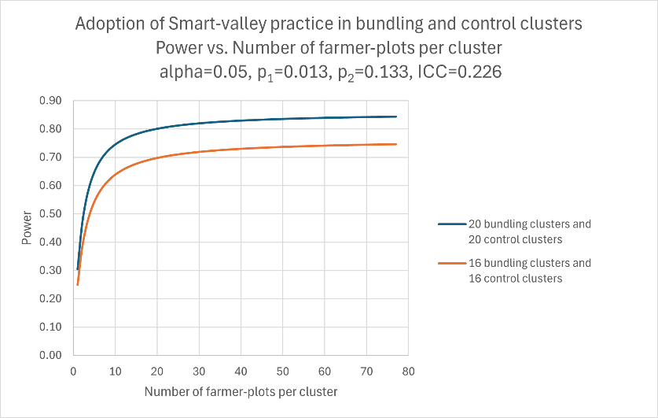 | 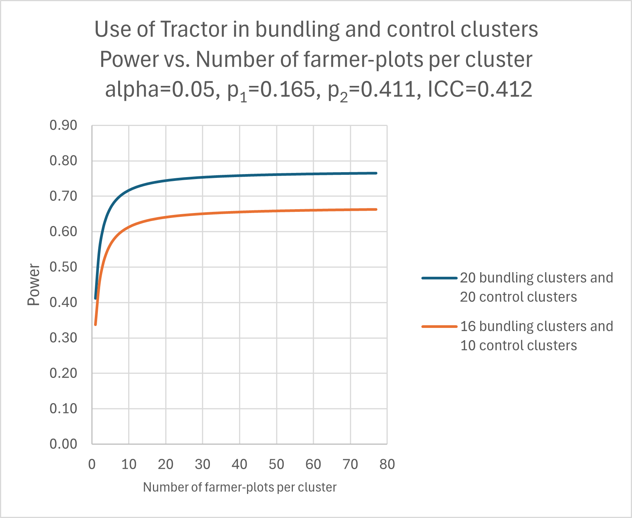
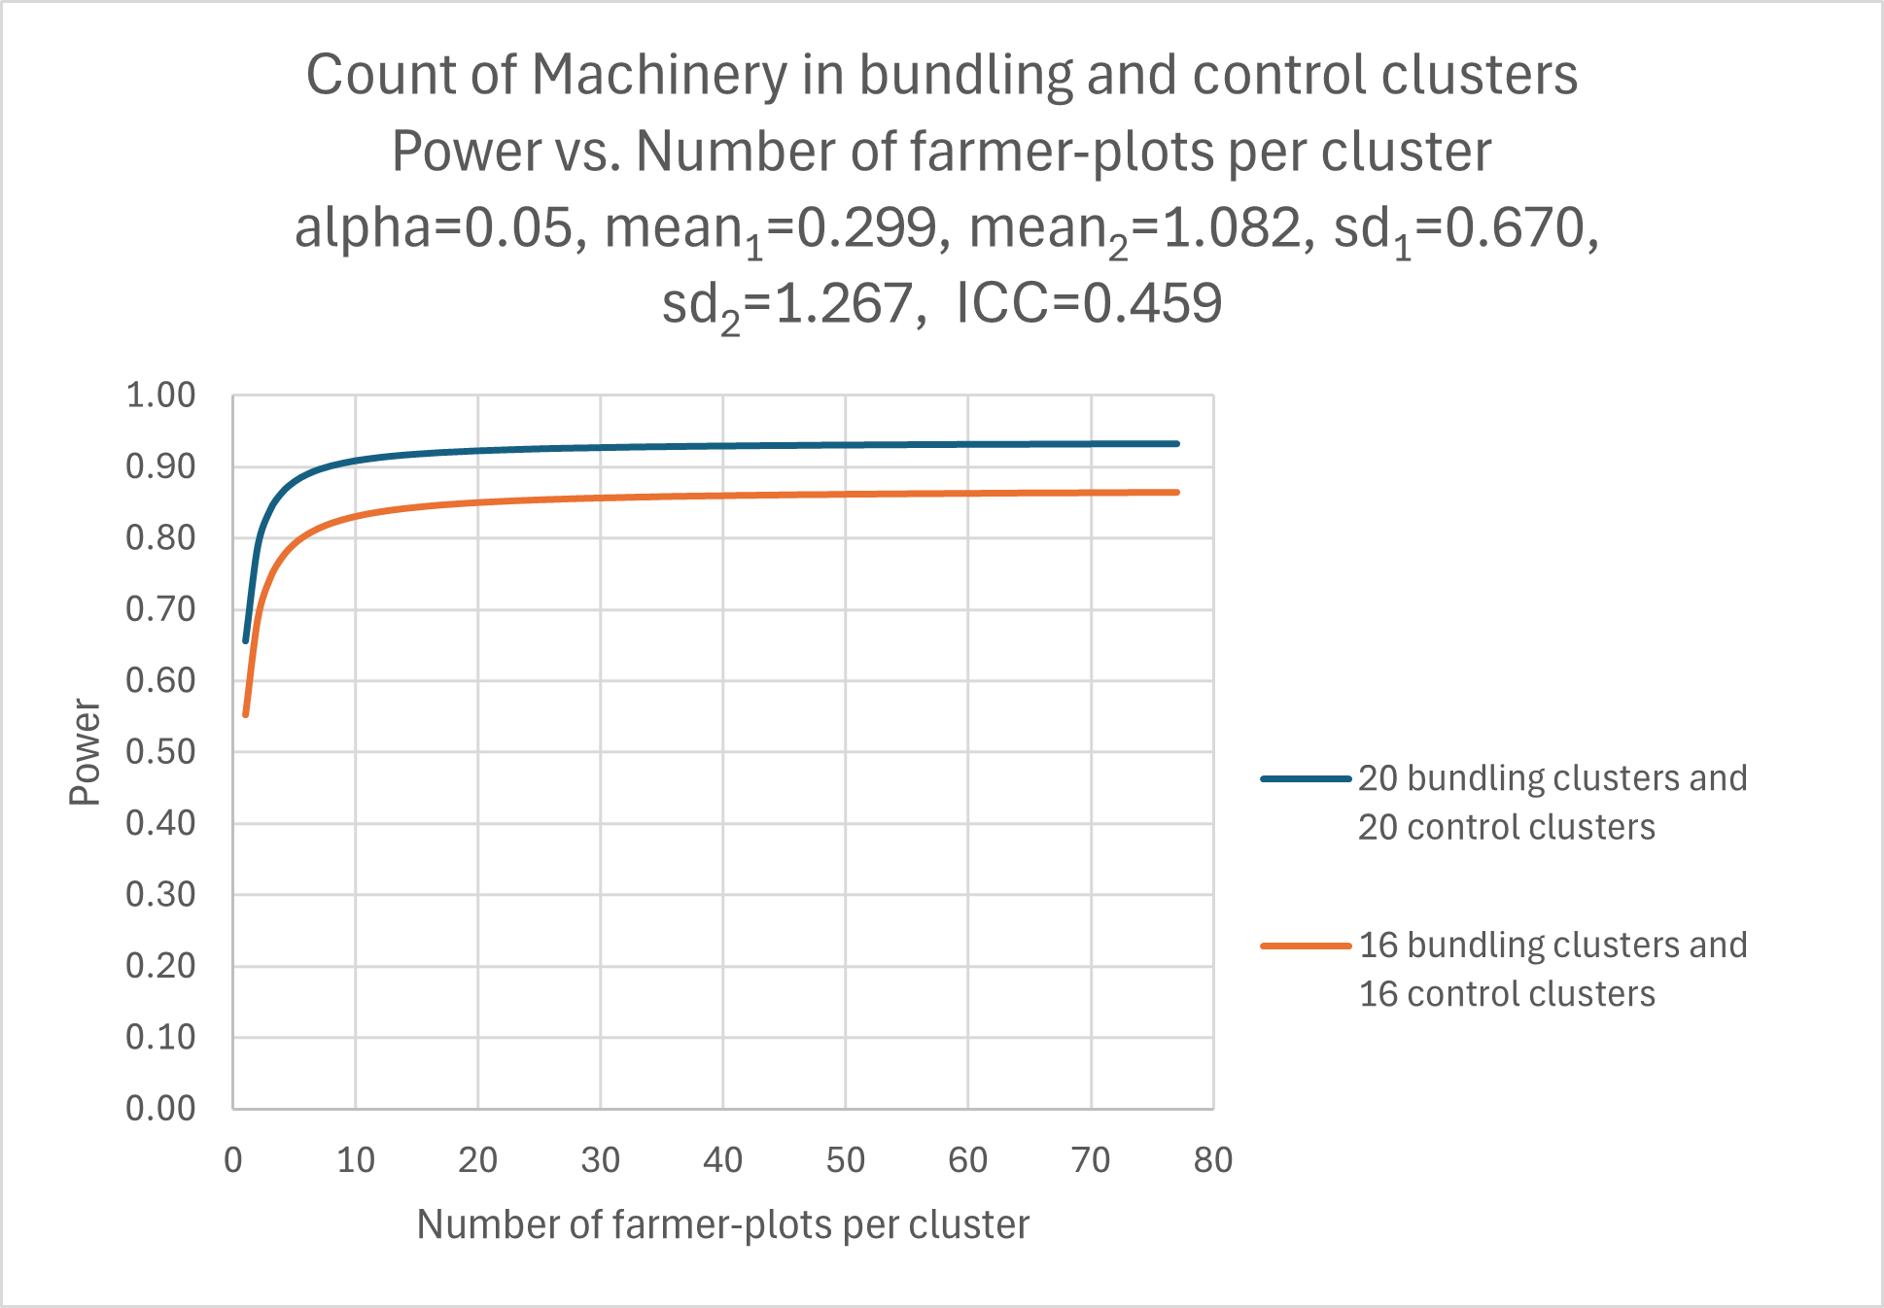 | 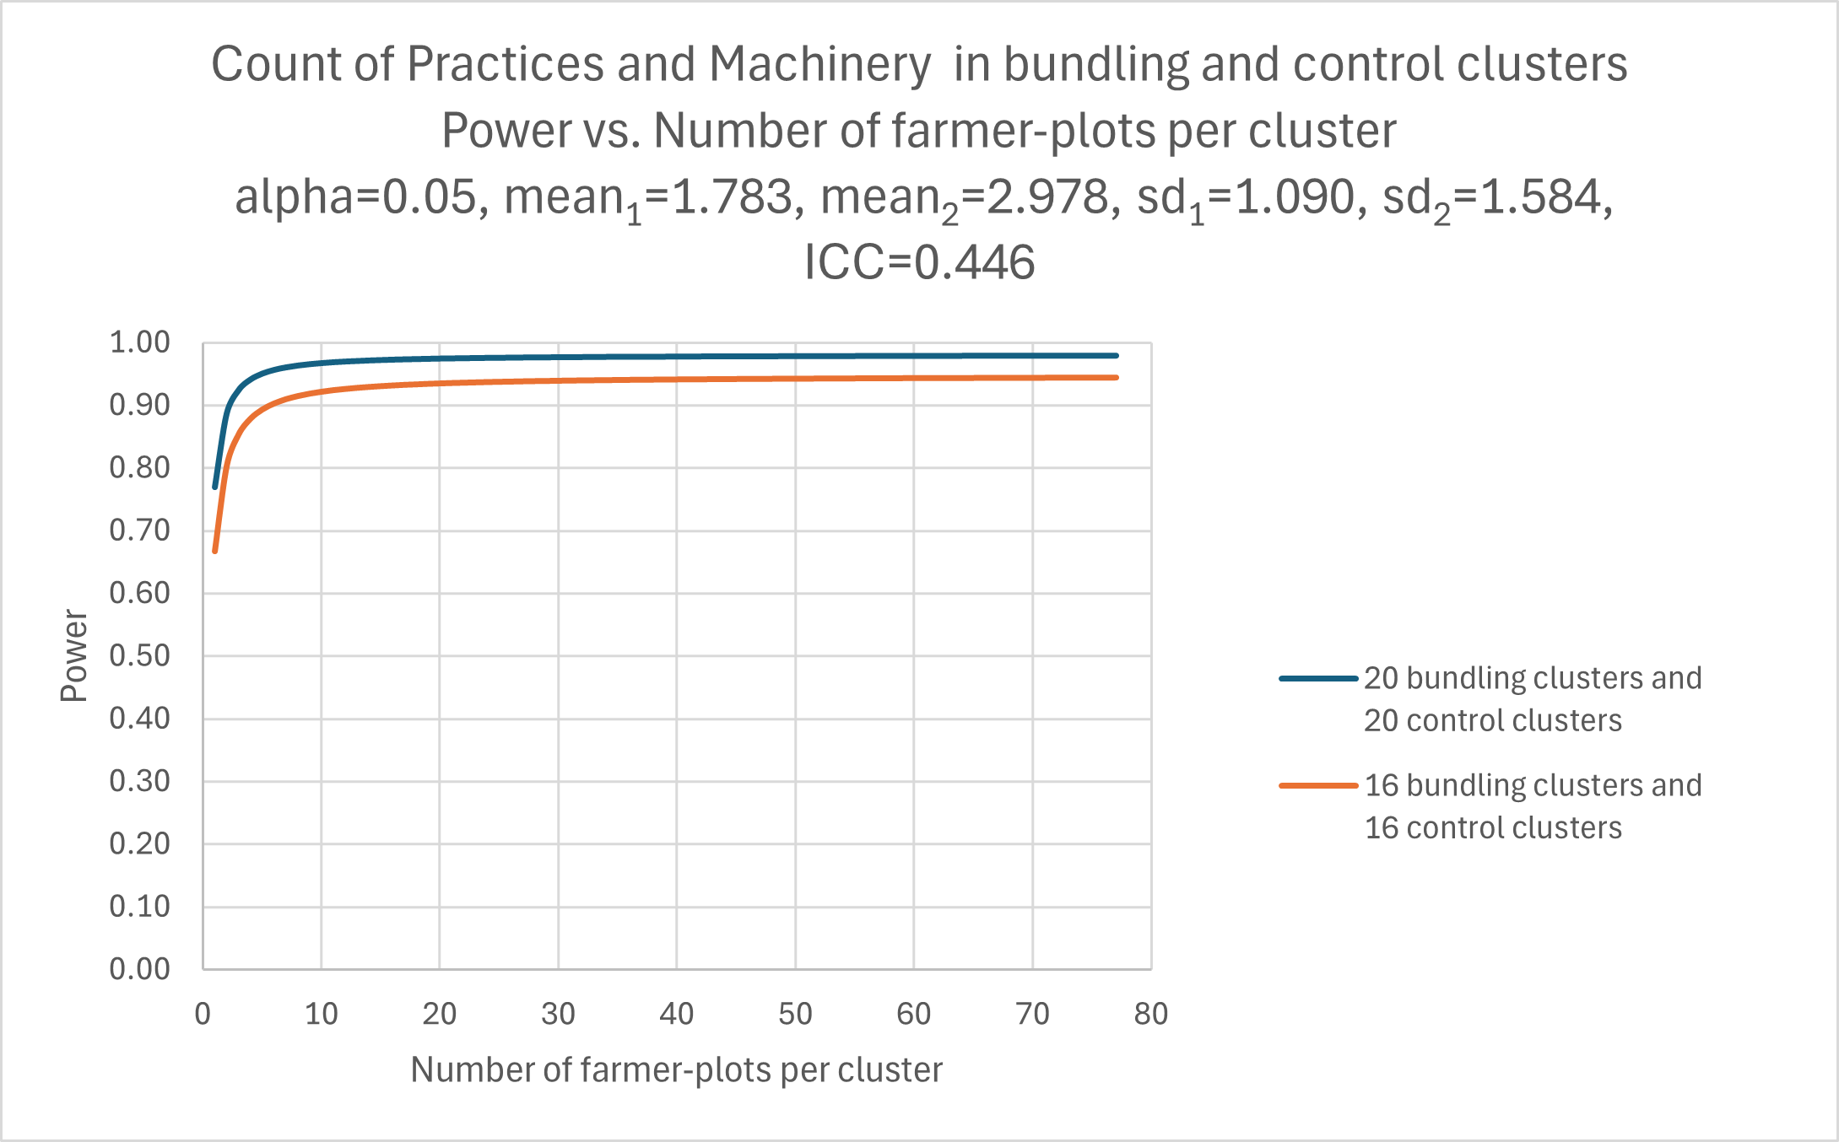
Figure 2: Power calculations for research question 1 comparing bundling and control groups
Note: By allocating 20 villages to Group 5 (C) and 5 villages to each of the four treatment groups (T1, T2, T3, and T4) and surveying 10 households in each of the 40 villages with 2 farmers/spouses in the household, one spouse having 3 plots and the other having 1 plot, i.e., the number of farmer-plots in each village is 40, the study will have at least 82% statistical power to detect a 12% minimum difference in take-up rates of smart-valley practice between bundling and control groups, 76% statistical power to detect a 24.6% minimum difference in take-up rates of tractor use between bundling and control groups, 92% statistical power to detect a minimum difference in the number of agricultural machinery used of 0.783 between bundling and control groups, and 98% statistical power to detect a minimum difference in the number of agricultural practices adopted and machinery used of 1.195 between bundling and control groups.

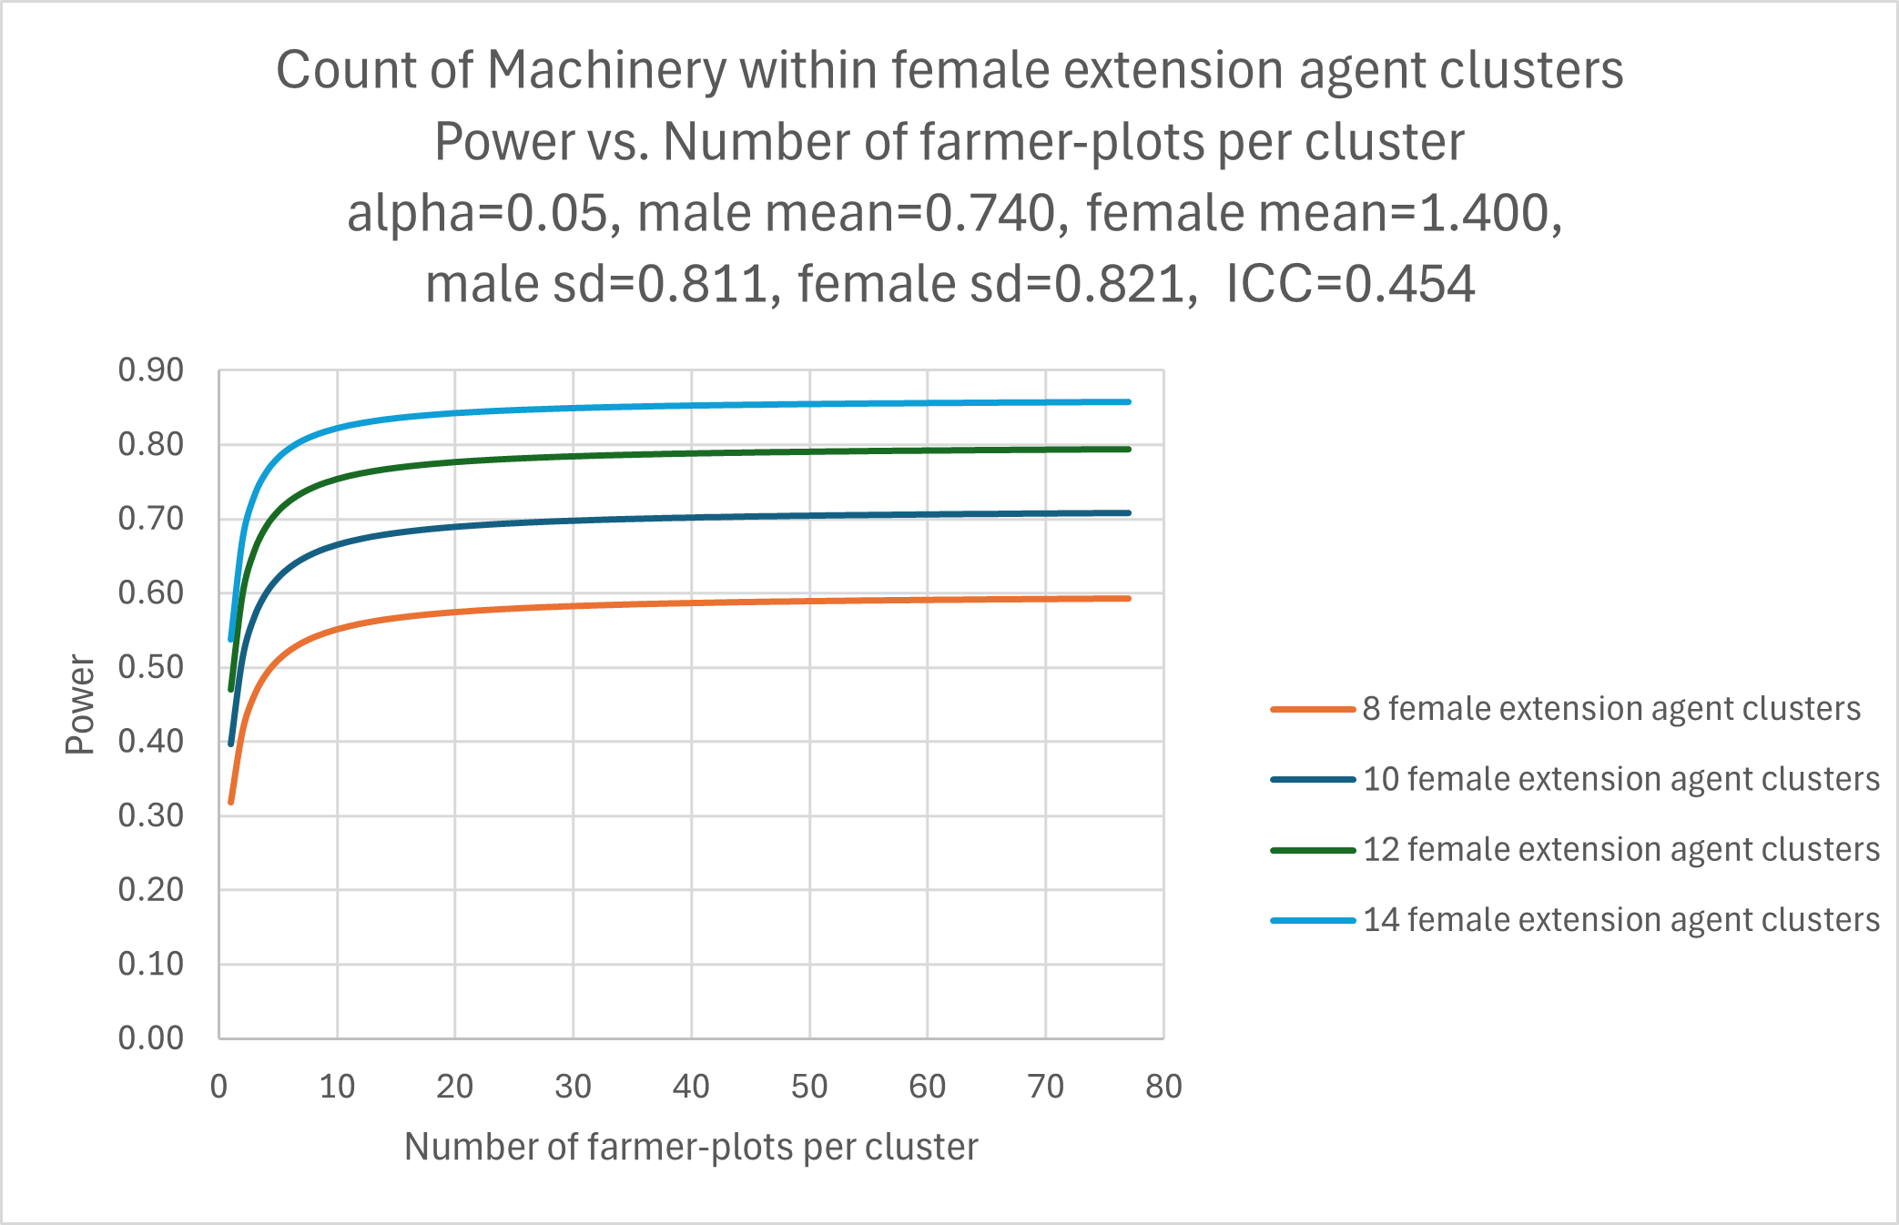
Figure 3: Power calculations for research question 2 comparing spouses within villages receiving “RiceAdvice Lite recommendations supplemented with female extension agents” (Group 1 and Group 3)
Note: Using 16 bundling villages (including 8 villages allocated to female extension agent clusters, i.e., 4 villages to each of the two treatment groups T1 and T3) and surveying 10 households in each of these 8 villages with 2 farmers/spouses in the household, one spouse having 3 plots and the other having 1 plot, i.e., the number of farmer-plots in each village is 40, the study will have at least 59% statistical power to detect a minimum difference in the number of agricultural machinery used of 0.660 between wives and husbands. Using 20 bundling villages (including 10 villages allocated to female extension agent clusters with 40 farmer-plots in each village), the study’s power would be 70% to detect the same difference. Using 24 bundling villages (including 12 villages allocated to female extension agent clusters with 40 farmer-plots in each village), the study’s power would be 79% to detect the same difference. Using 28 bundling villages (including 14 villages allocated to female extension agent clusters with 40 farmer-plots in each village), the study’s power would be 85% to detect the same difference.

The sample size of 440 households and 880 farmers or spouses is distributed across the treatment arms as follows:
-Control group (C): 220 households and 440 farmers or spouses;
-Treatment group (T1): 55 households and 110 farmers or spouses;
-Treatment group (T2): 55 households and 110 farmers or spouses;
-Treatment group (T3): 55 households and 110 farmers or spouses;
-Treatment group (T4): 55 households and 110 farmers or spouses.

Econometric specifications:
Let denote the subscripts $i$ for the farmer/spouse, $h$ for the household, $v$ for the village, $s$ for the state, and $t$ for time.
For farmer-specific outcomes $Y_{ihvs,t}$, we will use the baseline data $Y_{hvs,t-1}$ at the household level and the endline data at the spouse level to estimate Equation (1) using Ancova specification.
$Y_{ihvs,t}=α+β_{0}Y_{hvs,t-1}+ β_{1}TWEwives_{v}+β_{2}TWEcouples_{v}+β_{3}RALEAfemale_{v}$
$+β_{4}(TWEwives_{v}*RALEAfemale_{v})+β_{5}(TWEcouples_{v}*RALEAfemale_{v})$ $+η^{'}X_{h,t}+θ_{s}+θ_{vs}+ϵ_{ihvs,t}$ (1),
where $X_{h,t}$ are household covariates, $θ_{s}$ are state-fixed effects, and $θ_{vs}$ are state-village fixed effects.
To answer RQ1, the study will test the null hypothesis $β_{4}+β_{5}=0$ against the alternative $β_{4}+β_{5}>0$
To answer RQ2, the study will estimate Equation (2) and test the two-sided null hypotheses $γ_{1}+γ_{4}=0$ for no difference in wives-only treatment response by gender of the spouse, $γ_{2}+γ_{5}=0$ for no difference in couples’ treatment response by gender of the spouse, and $γ_{3}+γ_{4}+γ_{5}=0$ for no difference in the response for digital extension supplemented with female extension agents by gender of the spouse.
$Y_{ihvs,t}=α+β_{0}Y_{hvs,t-1}+ β_{1}TWEwives_{v}+β_{2}TWEcouples_{v}+β_{3}RALEAfemale_{v}$
$+β_{4}(TWEwives_{v}*RALEAfemale_{v})+β_{5}(TWEcouples_{v}*RALEAfemale_{v})$
$+ γ_{1}(TWEwives_{v}*Farmerfemale_{i})+ γ_{2}(TWEcouples_{v}*Farmerfemale_{i})$
$+ γ_{3}(RALEAfemale_{v}*Farmerfemale_{i}){+ γ}_{4}(TWEwives_{v}*RALEAfemale_{v}*Farmerfemale_{i})$
${+ γ}_{5}(TWEcouples_{v}*RALEAfemale_{v}*Farmerfemale_{i})$ $+η^{'}X_{h,t}+θ_{s}+θ_{vs}+ϵ_{ihvs,t}$ (2)

We denote the subscript $p$ for the rice plot. For farmer-plot-specific outcomes $Y_{pihvs,t}$, we will estimate the Ancova specification in Equation (3) to conduct the same tests above relating to RQ1.
$Y_{pihvs,t}=α+β_{0}Y_{hvs,t-1}+ β_{1}TWEwives_{v}+β_{2}TWEcouples_{v}+β_{3}RALEAfemale_{v}$
$+β_{4}(TWEwives_{v}*RALEAfemale_{v})+β_{5}(TWEcouples_{v}*RALEAfemale_{v})+ψ^{'}X_{ph,t}+θ_{s}+θ_{vs}+ϵ_{pihvs,t}$(3),
where $X_{ph,t}$ are household-plot covariates.
We will estimate the Ancova specification in Equation (4) to conduct the same tests above relating to RQ2.
$Y_{pihvs,t}=α+β_{0}Y_{hvs,t-1}+ β_{1}TWEwives_{v}+β_{2}TWEcouples_{v}+β_{3}RALEAfemale_{v}$
$+β_{4}(TWEwives_{v}*RALEAfemale_{v})+β_{5}(TWEcouples_{v}*RALEAfemale_{v})$
$+ γ_{1}(TWEwives_{v}*Farmerfemale_{i})+ γ_{2}(TWEcouples_{v}*Farmerfemale_{i})$
$+ γ_{3}(RALEAfemale_{v}*Farmerfemale_{i}){+ γ}_{4}(TWEwives_{v}*RALEAfemale_{v}*Farmerfemale_{i})$
${+ γ}_{5}(TWEcouples_{v}*RALEAfemale_{v}*Farmerfemale_{i})$ $+ψ^{'}X_{ph,t}+θ_{s}+θ_{vs}+ϵ_{pihvs,t}$ (4)

References
Aker, J. C. (2011). Dial “A” for agriculture: a review of information and communication technologies for agricultural extension in developing countries. Agricultural Economics, 42 (6), 631-647.
Arouna, A., Michler, J.D., Yergo, W.G., & Saito, K. (2021). One Size Fits All? Experimental Evidence on the Digital Delivery of Personalized Extension Advice in Nigeria. American Journal of Agricultural Economics, 103 (2), 596–619.
Caine, A., Dorward, P., Clarkson, G., Evans, N., Canales, C. S., Stern, D., & Stern, R. (2015). Review of mobile applications that involve the use of weather and climate information: Their use and potential for smallholder farmers. CCAFS Working Paper no.150. CGIAR Research Program on Climate Change, Agriculture and Food Security (CCAFS). Copenhagen, Denmark. Available online at: https://cgspace.cgiar.org/server/api/core/bitstreams/dd5459cf-42a5-4c25-a0d6-a75f771a18b2/content.
Cole, S.M., Kaminski, A.M., McDougall, C., Kefi, A.S., Marinda, P.A., Maliko, M., & Mtonga, J. (2020). Gender accommodative versus transformative approaches: a comparative assessment within a post-harvest fish loss reduction intervention. Gender, Technology and Development, 24 (1), 48-65.
Dillon, A., & Mensah, E. (2024). Respondent biases in agricultural household surveys. Journal of Development Economics, 166, 103198.
Fabregas, R., Kremer, M., Lowes, M., On, R., & Zane, G. (2019). SMS-extension and farmer behavior: lessons from six RCTs in East Africa. Available online at: https://www.atai-research.org/wp-content/uploads/2020/05/textfarmers1.pdf .
Finger, R. (2023). Digital innovations for sustainable and resilient agricultural systems. European Review of Agricultural Economics, 50 (4), 1277-1309.
Interagency Gender Working Group (IGWG) (2017). The gender integration continuum: training session user’s guide. Washington D.C.: Population Reference Bureau, United States Agency for International Development (USAID).
Jones, E. O., Tham-Agyekum, E. K., Ankuyi, F., Ankrah, D. A., Akaba, S., Shafiwu, A. B., & Richard, F. N. (2023). Mobile agricultural extension delivery and climate-smart agricultural practices in a time of a pandemic: Evidence from southern Ghana. Environmental and Sustainability Indicators, 19, 100274.
Lambrecht, I., Ma, N., Ragasa, C., Cole, S., Kreye, C., Peter, H., & Sasakawa Africa Association. (2023). Designing gender- and youth-responsive agronomic solutions. Study Report: Sasakawa Africa Association Nigeria Use Case. Nairobi, Kenya: Excellence in Agronomy. Available online at: https://hdl.handle.net/10568/137502.
Singh, R., Slotznick, W., & Stein, D. (2023). Digital tools for rural agriculture extension: Impacts of mobile‐based advisories on agricultural practices in Southern India. Journal of the Agricultural and Applied Economics Association, 2 (1), 4-19.
Udry, C. (1996). Gender, agricultural production, and the theory of the household. Journal of Political Economy, 104(5), 1010-1046.
Zossou, E., Saito, K., Assouma-Imorou, A., Ahouanton, K., & Tarfa, B.D. (2020). Participatory diagnostic for scaling a decision support tool for rice crop management in northern Nigeria. Development in Practice, 31(1), 11–26.

