Pre-analysis plan: banking prompts trial

Policy problem
The Treasury is advising the government on its responses to the ACCC’s Retail Deposits Inquiry and Home Loan Price Inquiry. Despite the financial benefits that can result from switching products, the reports found a lack of consumer engagement in these markets. For both markets the ACCC recommended that prompts be considered encouraging consumers to see if they could benefit from switching to alternative products that might better suit their needs.
BETA is working with the Treasury to: (1) identify the relevant behavioural factors in consumer financial decision-making; (2) understand the utility of prompts; (3) determine the optimal design for the prompts proposed in the ACCC reports; and (4) understand the barriers and enablers consumers experience when switching or repricing to identify additional interventions which may complement, or be an alternative to, the use of prompts.
BETA is conducting a suite of research activities to support this work, including a field trial (‘trial’) in partnership with a large retail bank.This trial will specifically test a single prompt designed to encourage disengaged customers to engage with their bank to negotiate a better deal on their home loan. This will provide evidence informing the effectiveness of prompts to encourage engagement in a relatively disengaged cohort.

Trial Aims
The aim of the trial is to test the effectiveness of a prompt to encourage disengaged customers to call the bank to see if they are eligible to receive a lower interest rate on their loan.

Trial design
This project will be a 2-arm cluster randomised controlled field trial. Clusters will be defined in the administrative data as people who share loans, defined through inter-related person-loan pairs. This is because the intervention will be delivered to individuals, and the outcomes will relate to both people (e.g. calling the bank) and loans (e.g. rate reductions).
Participants in the trial will receive a prompt in their banking app if they are in the intervention arm. Control participants will not see the prompt. We will use bank administrative data to measure the primary and secondary outcomes.

Sample selection
The eligible customers will be customers of the partner bank who have a home loan and meet the following inclusion and exclusion criteria.
Inclusion criteria:
- Loan is on a variable rate
- Loan was funded more than 3 years ago and has not been repriced in the last 3 years
- Are eligible for a discount under the bank’s risk management framework
- Person/loan not in hardship, arrears or delinquency
- Uses the mobile application
Exclusion criteria:
- Currently applying for a new product
- Has more than 50% of loan balance in offset
- Has opted out of marketing or is otherwise quarantined
There will be a fixed sample size of 11,922 clusters, 18,769 person-loan pairs with a mean cluster size of 1.28 (SD = 0.21). This comprises 15,211 people with 14,767 loans.
- CONSORT diagram
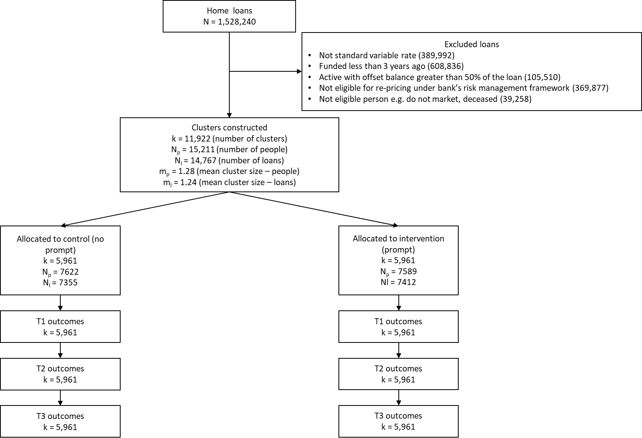

Estimand
Treatment condition: Prompt available in banking mobile app.
Population: Customers with variable rate loans who are eligible for marketing messages and potential reductions in their interest rate who have not repriced or refinanced their loan in at least 3 years.
Endpoint: A call to the bank on the bank’s standard line or home loan line within 13 days of deployment of the prompt.
Population-level summary:
- Cluster-level: Proportion of clusters in the group where at least one individual called the bank.
- Individual-level: Proportion of individuals in the group who made at least one call.
Intercurrent events (ICEs): Did not open the app, did not receive the prompt, did not see the prompt, did not open the prompt, refinanced internally, closed account/s, no longer eligible, new home loan, commenced a top-up application on home loan, becomes delinquent / in arrears/ in hardship, cannot read the notification, participants requests a reminder. Truncating ICEs include customer death or otherwise leaving the bank ecosystem.
Management of intercurrent events: Treatment policy and hypothetical (for truncating ICEs).
Estimand: The effect of making a prompt available on the calling behaviour of eligible decision-making groups who have not engaged with their home loan for at least 3 years, assuming people never leave the bank ecosystem.

Intervention
There are 2 treatment arms in this trial: a no-intervention control and one intervention arm. The control group will not receive any communication. For the treatment group, participants will be shown a prompt consisting of an image and text. The image displays a woman holding a mobile phone to her ear. Below the image, the prompt features text that reads “Interested in reducing your mortgage payment? Check whether you can get a lower interest rate on your home loan.” Below this message are two response options: a prominent Call now button that serves as the main call-to-action, and a smaller, less conspicuous “Hide” option that allowed users to dismiss the prompt. If users selected “Hide” they could then choose to be reminded via an inbox notification.

Intervention timeline
The intervention will be delivered via the bank’s mobile application. The initial prompt will be surfaced in the app on Tuesday, 03 December (12am) and will disappear from the app on Tuesday, 10 December (12am).
The study will track all customer-initiated contacts (both CTA-driven and direct calls) for a period of 14 days from the study start date with the measurement window closing on Tuesday, 14 December (12am). This measurement window captures the initial 7-day prompt period and an additional 7 days to allow customers enough time to follow up on the prompt.

Outcome measures
Outcomes will be measured at three time points. Timepoint 1 (T1) will be 14 days after the close of the prompt in the mobile application (17 December 2024). Timepoint 2 (T2) will be 3 months post T1. Timepoint 3 (T3) will be 3 months post T2. T3 outcomes will explore longer-term effects of the intervention on financial wellbeing of participants. T2 outcomes will be exploratory.

Primary
Cluster-level customer contact rate
The primary outcome variable is a binary indicator at the cluster level, taking the value of 1 if at least one customer telephoned the bank on their general contact line or their specialist home loan line in the trial period, and 0 otherwise. This definition captures cluster-level engagement with the intervention, recognising that for shared loans, one borrower making contact is sufficient. The variable will be constructed from administrative data measuring the count of calls made to the bank in the trial period. This will be averaged within the treatment and control groups to give the proportion of clusters in which at least one person made contact with the bank in each arm. The outcome will be measured at T1.
The cluster-level analysis is consistent with a model of joint decision-making by people within each group. This model assumes perfect coordination. Under this model all members of a group collaborate on decisions and therefore action taken by one member represents a coordinated action.
This assumption is likely to be true of many clusters, especially as most clusters have only one person. However, other clusters represent more disparate groups that may be less coordinated. These include clusters where not all people are borrowers on all loans in the cluster. As re-pricing does not require any application nor consent of all parties, a call from more than one person in these clusters is possible and represents separate decision-making. The likely level of cooperation or influence within these clusters is unknown.

Secondary
Individual customer contact rate
This analysis is an upper bound analysis. Here each individual is treated as an independent actor and assumes that there is coordination among individuals in the cluster, but that it is imperfect. That is, we will use cluster-robust standard errors to account for correlations between individuals within each cluster while measuring each person’s separate action.
At an individual level the outcome will be a binary indicator, flagging whether a customer telephoned the bank on their general contact line or their specialist home loan line in the trial period (0 = did not make contact, 1 = made contact). The variable will be constructed from administrative data measuring the count of calls made to the bank in the trial period. This will be averaged within treatment and control group to give the proportion of customers who made contact with the bank by arm. This outcome will be measured at T1.
Interest rate
A variable at the cluster level, the interest rate outcome will be a continuous variable representing the mean interest rate of all loans in a cluster expressed as a percentage. This will be averaged within treatment groups to give the mean interest rate by arm. This outcome will be measured at T1.
Re-pricing
A binary variable at the cluster level of whether at least one loan in a cluster was repriced during the intervention period. This will be constructed from administrative data, with 1 indicating at least one loan was re-priced and 0 if it was not. For shared loans, the outcome captures whether the shared loan was re-priced regardless of which borrower initiated the change. This will be averaged within treatment and control groups to give the proportion of clusters with reduced rates by arm. This outcome will be measured at T1.
Financial stress
A binary indicator at the cluster level of whether at least one person in a cluster has experienced financial stress (0 = no financial stress, 1 = financial stress). This will be any of:
- Hardship support requests, OR
- Late payment fees for any of their loans, OR
- Arrears on any of their loans
This will be averaged within treatment groups to give the proportion of clusters in financial stress by arm. This outcome will be measured at T2 and T3.
Financial wellbeing
At the cluster level we will measure the total balance of available accounts such as deposit accounts, investment accounts, and shares held by each individual in the cluster at T2 and T3. The construction of this variable will depend on account information that is shared by the bank partner. This will be averaged within treatment groups to give the mean balance in each arm.

Hypotheses
H1: The proportion of clusters with at least one person who contacted the bank will be higher in the treatment group than the control group at T1 (treatment > control)
H2: The proportion of customers who called the bank will be higher in the treatment group than the control group at T1 (treatment > control)
H3: The mean interest rate will be lower in the treatment group than the control group at T1 (treatment < control)
H4: The proportion of clusters with at least one loan re-priced will be higher in the treatment group than the control group at T1 (treatment > control)
H5: The proportion of clusters experiencing financial stress will be lower in the treatment group than the control group at T3 (treatment < control)
H6: The mean balance in customer accounts will be higher in the treatment group than the control group at T3 (treatment > control)

Randomisation
Randomisation will be at the cluster level. Clusters of connected customers will be randomly assigned to treatment and control groups in a 1:1 ratio. The clusters are flexible structures able to manage a multitude of individual arrangements (Table 1) and the many-to-many relationship between people and loans.
After initial treatment assignment, 10% of customers from the treatment group will be randomly selected to not receive the intervention as part of the stakeholder’s automatic program implementation. The random selection will occur at the individual customer level, not the cluster level. For single-customer clusters (Cluster A), the entire network will not receive the intervention if selected. For multi-customer clusters (Cluster B-D), only the selected customers will not receive the intervention. All people and clusters will be analysed as initially allocated to maintain the integrity of clusters post-randomisation.
- Example cluster composition
Cluster | Person | Loan
A single borrower with a single loan will constitute a cluster with one element
Cluster A | Person 1 | Loan Z
A couple with a single loan will constitute a cluster with two elements
Cluster B | Person 2 | Loan Y
Cluster B | Person 3 | Loan Y
A couple with two loans will constitute a cluster with four elements
Cluster C | Person 4 | Loan X
Cluster C | Person 5 | Loan X
Cluster C | Person 4 | Loan W
Cluster C | Person 5 | Loan W
Other complex structures can be accommodated such as where a couple share a loan and also have separate loans, or share loans with others such as children.
Cluster D | Person 6 | Loan V
Cluster D | Person 7 | Loan V
Cluster D | Person 6 | Loan U
Cluster D | Person 8 | Loan U
Cluster D | Person 7 | Loan T
Clustering will ensure that each person, all their loans and all the people they share loans with will receive the intervention or not. This will prevent spillovers, where people on the same loan are randomised to the intervention and to control, and prevent people being randomised more than once.

Sample size and power calculations
This study has a fixed sample size and will analyse 11,922 loan clusters. Using a joint decision framework at the cluster level and accounting for the 10% of individuals that will be randomly removed from receiving the intervention, our estimation approach (which treats a loan cluster as treated if at least one individual remains in the treatment group) indicates we will have a minimum detectable effect of 0.78 percentage points. Historical click-through rates for interventions using this type of prompt are approximately 1%. Therefore, with our sample size, we will be able to detect an increase from 1% to 1.78%, representing a 78.2% relative increase. This trial will be adequately powered to detect these differences using a one-sided test with a conventional alpha level of 5% and 90% power.

Method of analysis
The analysis of the cluster-level effect of the intervention will consist of a covariate-adjusted comparison of our primary outcome. This estimate, confidence intervals and p-values will be derived from an ordinary least squares (OLS) model using robust (HC2) standard errors with the following specification:
$$Y_{j}=β_{0}+ β_{1}Z_{j}+ β_{2}X_{j}+ β_{3}{Z_{j}X}_{j}+ ϵ_{j}$$
Where $j$ is an index for a cluster, $Y$ is the cluster-level outcome measured as 0 or 1, $β_{0}$ is the intercept, $Z$ is a treatment assignment indicator, $β_{1}$ is coefficient representing the average treatment effect for the intervention relative to control, $X$ is a vector of mean centred covariates (see Covariates section below), $ZX$ is the interaction of the treatment indicator with the mean centred covariate indicator vector, and $ϵ$ is the cluster error term. This model will also be used for the secondary outcomes.
We will use cluster-level analysis with a mixed model for all analyses that include multiple post-randomisation time points for a single variable e.g. financial wellbeing at T3. We will also conduct a logistic model for our primary outcome as sensitivity analysis.
The analysis of the individual-level effect of the intervention will consist of a covariate-adjusted comparison of the individual customer contact rate outcome measure. This estimate, confidence intervals and p-values will be derived from an ordinary least squares (OLS) model using cluster-robust (CR2) standard errors with the following specification:
$$Y_{ij}=β_{0}+ β_{1}Z_{ij}+ β_{2}X_{ij}+ β_{3}{Z_{j}X}_{ij}+ ω_{j}+ϵ_{ij}$$
Where $i$ is an index for an individual in cluster $j$, $Y$ is the individual-level outcome measured as 0 or 1, $β_{0}$ is the intercept, $Z$ is a treatment assignment indicator, $β_{1}$ is coefficient representing the average treatment effect for the intervention relative to control, $X$ is a vector of mean centred covariates (see Covariates section below), $ZX$ is the interaction of the treatment indicator with the mean centred covariate indicator vector, $ω$ is the cluster-level error term and $ϵ$ is the individual error term.
We will use one-sided test for all directional hypotheses.

Baseline covariates
- Number of times the customer called the bank in the last 3 years (individual, or mean for the cluster)
- The number of person-loan pairs in the cluster (all outcomes)
- Mean interest rate by cluster
- Mean maturity of loan by cluster
- Flag for any loan in a cluster with loan-to-value ratio (LVR) or less than 80% at origination
- Over 60 (older person) flag either at the individual or at the cluster level (1 if any person in the cluster have the flag, 0 if no one in the cluster have the flag)
- Flag for any loan in a cluster with a balance over $600,000
Additional covariates in T3 analyses:
- Had a reduction in interest at T1
- Was in financial stress at T2

Exploratory analyses
We may explore the effects of the intervention of a range of subgroups such as: investor loans vs owner-occupier loans, removal of the 10% holdout sample, differences in loan maturity, loan balance, customer age, and the number of products held with the bank. We will also explore the effect of treatment on the treated – that is those who saw an impression of the intervention in the trial period. We may use causal machine learning techniques and traditional analyses to explore heterogeneous effects.
We will also explore other measures of financial wellbeing measured at T2 and T3. These may include opening new accounts, increasing investment, extra payments on their mortgage and reducing credit card balances.
We will also explore measures of switching between institutions by comparing the rate of mortgage closure at T1, T2 and T3.

Trial threats
As we will be using administrative data, information will only be missing if the participant leaves the bank ecosystem either through death or changing banks entirely. Neither of these is likely to be related to the intervention and therefore we will remove records with missing data.
While this is a field trial and therefore a pragmatic test of the intervention, the sample is specifically selected to be those eligible for re-pricing on their loan, due to a lack of engagement over at least 3 years. Therefore, while this is a different cohort to a wider audience that would likely be the target of future policy, it is likely that the current trial will represent a conservative estimate of the efficacy of prompts for home loan customers.
There could be media or other events during the trial period that affect uptake of the intervention. For example, strong media speculation about interest rates could act as a reminder or reinforcer of the intervention, increasing or decreasing engagement. Thus, the final point estimate in the trial may not be directly replicable in future field trials, or through delivery at scale.

Interpretation and reporting
For our primary hypotheses, we will use null hypothesis statistical testing to decide whether to interpret an effect as real. However, we will also make use of non-significant primary analyses – and secondary and exploratory analyses – to provide context to and highlight interesting avenues for further research. We will clearly delineate these analyses when communicating findings.
For reporting, all group proportions will be transformed to percentages. Treatment effects, standard errors, and confidence intervals will be presented as percentage point differences. Absolute p-values will be reported. We will provide these outputs for all primary hypotheses and any pre-specified secondary analyses.
To enhance interpretation of the RCT findings, we will incorporate insights from qualitative interviews (de-identified) that will be independently conducted by the bank with mortgage holders from various financial institutions. While these interviews will be conducted with a separate population, they might help contextualise our treatment effects by providing deeper insights into how mortgage holders think about and respond to similar interventions.

Pre-analysis plan commitments
No trial data have been received prior to the completion of this pre-analysis plan.
We will be transparent about, and provide justification for, any deviations (additions or omissions) from this plan.

Appendix: Results tables
- Primary outcome table
Condition | Means (per cent) | Estimate (pp) | Standard error (pp) | 95% Confidence Interval (pp) | p-value
Control |  | - | - | - | -
Treatment
- Secondary outcomes table
Condition | Means (per cent) | Estimate (pp) | Standard error (pp) | 95% Confidence Interval (pp) | p-value
Control |  | - | - | - | -
Treatment
- Sample descriptives
Variable | Value | Total sample | Control | Treatment
Overall | Number of people
Overall | Number of loans
Overall | Number of clusters
Age | Younger (<60)
Age | Older (60+)
Mean number of calls in last 3 years | -
Mean number of products with the bank | -
First home buyer loan | -
Proportion of broker-originated loan | -
Mean interest rate | -
Proportion of late payments in the last year | -
Mean maturity | -
Proportion of interest-only loans at T0 | -
LVR at origination | <60
LVR at origination | 60-70
LVR at origination | 70-80
LVR at origination | 80-90
LVR at origination | 90+
Loan balance | Under $300,000
Loan balance | $300,000 to $600,000
Loan balance | Over $600,000

Retail deposits inquiry 2023 | ACCC
Home loan price inquiry - final report.pdf (accc.gov.au)

