Power Analysis, Target Effect Size, and Required Sample Size
Our study primarily investigates how treatment information—covering aspects such as cell-cultivated salmon production, nutrition, ingredients, and safety—affects participants’ willingness to pay. To determine the sample size needed to detect a statistically significant treatment effect, we first conducted a pilot study to estimate the relevant parameters to calculate the required sample size.
In our clock-proxy auction, we auctioned 1 Salmon Crudo (“dish1”), 1 Salmon Nigiri (“dish2”), 1 Salmon Saku (“dish3”), and 3 exclusive invitations (“vouchers”) in each session. Each participant could bid for at most one unit of each item. To be considered as a potential winner, a participant had to bid for a package that included a voucher (bidding for the voucher alone was also allowed).
Bids submitted for packages containing the voucher in the pilot study are used for detecting effect size and sample size calculations.
Package bids refer to those submitted for combinations that include the voucher and one or more dishes. These combinations include [voucher], [dish1, voucher], [dish2, voucher], [dish3, voucher], [dish1, dish2, voucher], [dish1, dish3, voucher], [dish2, dish3, voucher], and [dish1, dish2, dish3, voucher]. The package bids considered are the most recently updated ones, which ultimately enter the allocation process that determines both item allocation and corresponding payments. These bids are subject to revealed preference activity rules imposed during both the clock and proxy phases.
Table A-1. Means, standard deviations (SD), and number of observations (n) for bid types from our pilot study
Type | Treatment group |  |  | Control group |  |  | Mean Difference | Target Effect Size
Type | Mean | SD | n | Mean | SD | n | $ | $
voucher | 36 | 18 | 7 | 34 | 5 | 4 | 2 | 10
dish1, voucher | 54 | 30 | 9 | 30 | 11 | 6 | 24 | 15
dish2, voucher | 44 | 21 | 6 | 26 | 10 | 6 | 18 | 15
dish3, voucher | 50 | 25 | 7 | 23 | 12 | 3 | 27 | 15
dish1, dish2, voucher | 63 | 36 | 8 | 32 | 13 | 5 | 32 | 20
dish1, dish3, voucher | 68 | 36 | 8 | 40 | 8 | 2 | 28 | 20
dish2, dish3, voucher | 56 | 34 | 6 | 31 | 1 | 2 | 25 | 20
dish1, dish2, dish3, voucher | 88 | 43 | 8 | 31 | 16 | 3 | 57 | 25
Note: Our pilot study includes one treatment group with 12 participants and one control group with 11 participants.
While Canavari et al. (2019) provide guidance on conducting power analysis and calculating sample sizes in experimental auction design assuming equal sample size and variances, Ahles et al. (2024) have presented a formula that accommodates unequal variances. Table A-1 indicates that unequal variances need to be considered. To familiarize readers with the derivation, we provide the following details.
It implicitly assumes that two samples with known standard deviations are independent, and that each sample mean has its own variability:
$\overline{X_{1}}\sim N(μ_{1}, \frac{σ_{1}^{2}}{n_{1}})$, $\overline{X_{2}}\sim N(μ_{2}, \frac{σ_{2}^{2}}{n_{2}})$.
where $σ_{1}^{2}$ and $σ_{2}^{2}$ are known population variances (inferred from our pilot study), $μ_{1}$ and $μ_{2}$ are unknown population means, $n_{1}$ and $n_{2}$ are the observations required under treatment and control conditions in the full study.
The variance of mean difference is the sum of the variance:
$$Var\left(\overline{X_{1}}-\overline{X_{2}}\right)=\frac{σ_{1}^{2}}{n_{1}}+\frac{σ_{2}^{2}}{n_{2}}$$
To detect the true effect size $∆=μ_{1}-μ_{2}$ with 80% power, we start with
$$P\left(\overline{X_{1}}-\overline{X_{2}}>Z_{\frac{α}{2}}\sqrt{\frac{σ_{1}^{2}}{n_{1}}+\frac{σ_{2}^{2}}{n_{2}}} | μ_{1}-μ_{2}=∆\right)=0.8$$
Assume $α=0.05$ (Type I error), $Z_{\frac{α}{2}}=∅^{-1}\left(1-\frac{0.05}{2}\right)=1.96$, representing $Z$ critical value for a two-tailed test with significance level $α=0.05$. Then,
$$P\left(\overline{X_{1}}-\overline{X_{2}}-∆>Z_{\frac{α}{2}}\sqrt{\frac{σ_{1}^{2}}{n_{1}}+\frac{σ_{2}^{2}}{n_{2}}}-∆ | μ_{1}-μ_{2}=∆\right)=0.8$$
Dividing through by $\sqrt{\frac{σ_{1}^{2}}{n_{1}}+\frac{σ_{2}^{2}}{n_{2}}}$, under the assumption of normality, produces,
$$1-∅\left(Z_{\frac{α}{2}}-\frac{∆}{\sqrt{{σ_{1}^{2}}/{n_{1}}+{σ_{2}^{2}}/{n_{2}}}}\right)=0.8$$

$$∅\left(Z_{\frac{α}{2}}-\frac{∆}{\sqrt{{σ_{1}^{2}}/{n_{1}}+{σ_{2}^{2}}/{n_{2}}}}\right)=0.2$$
Assuming in the full study, we have the same size of observations under treatment and control conditions, i.e., $n=n_{1}=n_{2}$, then
$$Z_{\frac{α}{2}}-\frac{∆}{{\left(σ_{1}^{2}+σ_{2}^{2}\right)}/n}=-Z_{β}$$
Assume $β=0.2$ (Type II error), $Z_{β}=∅^{-1}\left(1-β\right)=0.84$, meaning the test has an 80% power of detecting a true effect size if it exists.
Solving this last equation gives
$$n=\frac{\left(σ_{1}^{2}+σ_{2}^{2}\right){(Z_{\frac{α}{2}}+Z_{β})}^{2}}{∆^{2}}$$

Although Table A-1 displays the mean difference in Willingness-to-Pay (WTP) between the treatment and control groups in the pilot study (Table A-1, Column 7 “Mean Difference”), using this directly as the target effect size for calculating the required sample size in the full study may be problematic. On the one hand, specifying a mean difference of $2 in WTP for the voucher alone as the target effect size—especially if applied across all bid types—would result in an unnecessarily large required sample size, potentially in the thousands. This level of precision is not needed, given that our primary focus is on bids involving combinations of the voucher and one or more dishes. Overly precise estimates may lead to inefficient use of resources. On the other hand, assuming a large effect size based on pilot data may lead to an underestimation of the required sample size for the full study. This, in turn, could result in statistically insignificant findings for most bid types if the true effect size in the population is smaller than assumed.
Therefore, a more appropriate and reliable approach is to assume a tiered target effect size, specified according to the number of items included in the package, when calculating the sample size. If the true effect size exceeds the assumed target and is statistically significant, the study will still be well-powered to detect the target effect size with confidence.
For bids submitted on packages containing the voucher, the target effect size, i.e., the minimal detectable effect (MDE)—is set at $10 for the voucher alone, $15 for two-item packages, $20 for three-item packages, and $25 for four-item packages (Table A-1, Column “Target Effect Size”).

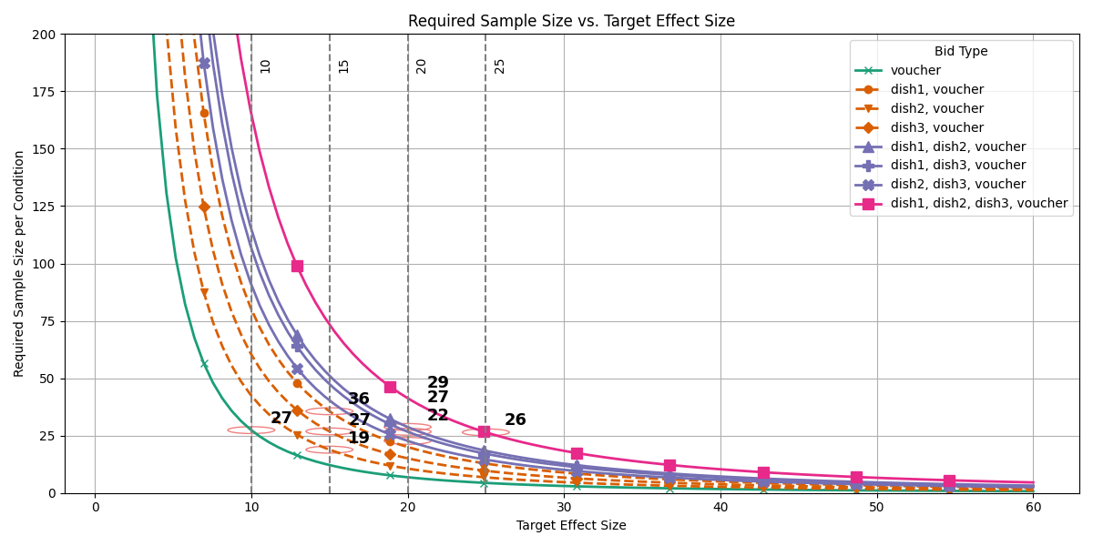
Figure A-1. Relationship Between Required Sample Size and Target Effect Size

We need to recruit more participants per condition to ensure that the number of observations for each bid type exceeds the required sample size shown in the graph (Figure A-1). In the full study, we recruited 55 participants assigned to five treatment groups and 55 participants assigned to five control groups.

Ahles, A., Palma, M.A., Drichoutis, A.C., 2024. Testing the effectiveness of lottery incentives in online experiments. Am. J. Agric. Econ. 106, 1435–1453. https://doi.org/10.1111/ajae.12460
Canavari, M., Drichoutis, A.C., Lusk, J.L., Nayga, R.M., 2019. How to run an experimental auction: a review of recent advances. Eur Rev Agric Econ 46, 862–922. https://doi.org/10.1093/erae/jbz038

As shown in Table A-1, the sample size 𝑛 in the pilot study can differ between treatment and control groups for each bid type, even if the overall number of participants is similar. This occurs because participants do not bid on all packages. Nevertheless, as long as the sample size in each condition of the full study exceeds the required number, the study is sufficiently powered to detect the intended effect.

