Authors
Ezgi Kurt, Bentley University
Jeff Livingston, Bentley University
Laura Young, Bentley University

(1) Have any data been collected for this study already?
Yes, but in the spirit of pre-analysis plans, we intend to re-run the experiments starting today (April 3rd, 2025). The experiments and the hypotheses they test are not central to the study, however, so it may be appropriate to include the already-collected data.

(2) What’s the main question being asked or hypothesis being tested?
Following replications of an experiment, how can Bayes Factor Functions be used to update our beliefs about a) whether an effect exists and b) the magnitude of the effect? How does this compare to Butera et al. (2020), who show how to use a method introduced by Maniadis et al. (2015) to calculate Post-Study Probabilities that an effect exists, following a new replication of an experiment?

As an example, we conduct several replications of the seminal Kahneman, Knetsch, and Thaler (1990) experiment that was used to show the existence of the endowment effect.

(3) Key dependent variables and how measured
Willingness to pay (WTP) (for subjects who are not initially endowed with a coffee mug)
Willingness to accept (WTA) (for subject who are initially endowed with a coffee mug)

(4) Conditions and Interventions

We replicate the Kahneman, Knetsch, and Thaler (1990) experiment. The instructions are based on a replication and extension conducted by Gächter et al. (2022).

In the experiment, subjects are randomized (via random number generation by computer) into a role as a seller of a coffee mug or a buyer of a coffee mug.

Sellers are given a coffee mug. Each mug was purchased from the Bentley University Bookstore at a cost of $12.98 per mug. They are allowed to keep the mug with them. The experiment begins approximately 20 minutes later.

In the experiment, subjects first play two rounds for hypothetical payments. In these initial rounds:
Sellers are told they own a token. The value of the token to them is induced. The value is randomly selected from prices between $0.00 and $12.50 in 50 cent increments. They are then told that the price of the token will be randomly selected from this range. They are asked if they would be willing to sell the token at each of these prices. Their earnings are determined by whichever price is randomly selected and what they said they would do at that price. IF they do not sell their token at the randomly-chosen price, their payoff is the value of the token. If they do sell their token at the randomly chosen price, their payoff is the price. This is repeated twice, with new induced values and prices selected in each round.

In these initial rounds, buyers are told they can purchase a token if they wish. The value of the token to them is induced. The value is randomly selected from prices between $0.00 and $12.50 in 50 cent increments. They are then told that the price of the token will be randomly selected from this range. They are asked if they would be willing to buy a token at each of these prices. Their earnings are determined by whichever price is randomly selected and what they said they would do at that price. If they do not buy a token at the randomly chosen price, their payoff is $0. If they do buy a token at the randomly chosen price, their payoff is their value for the token minus the price. This is repeated twice, with new induced values and prices selected in each round.

Finally, the third round involves the purchase or sale of the mug. between $0.00 and $12.50 in 50 cent increments. Sellers are told that the price of the mug will be randomly selected from the range of $0.00 and $12.50. They are asked if they would be willing to sell their mug at each of these prices. The price is then randomly selected. If they said they would want to sell their mug at the randomly chosen price, they return the mug to us and are paid the price. If they said they would not want to sell their mug at the randomly chosen price, they keep their mug.

Buyers are told that the price of the mug will be randomly selected from the range of $0.00 and $12.50. They are asked if they would be willing to buy a mug at each of these prices. The price is then randomly selected. If they said they would want to buy a mug at the randomly chosen price, they are given a mug and pay us the randomly selected price. If they said they would not want to buy a mug at the randomly chosen price, they do not purchase a mug and no transaction occurs.

The prices chosen in each round and values induced in rounds 1 and 2 are drawn separately for each subject.

Thus far the experiment has been replicated six times.

We plan on repeating this endeavor, conducting another five replications.

(5) Primary Analysis

Analysis of experiment results: t-tests of the difference between WTA and WTP. The experiment is between-subject.

Synthesis of results:

We will first update prior beliefs about whether there is a difference between WTA and WTP by calculating the Post-Study-Probabilities following the method described in Butera et al. (2020). This method allows one to calculate updated beliefs about whether the endowment effect exists or not, but not its magnitude.

The main contribution of the paper is to accumulate evidence on the magnitude of the effect, not just whether the effect exists. We do so using Bayes Factor Functions for a variety of priors (as we do with the Butera et al. method). The result gives us evidence on the probability that the magnitude of the true effect is of various sizes. For example, using the data we have collected so far from 5 replications, our method produces the following estimates:

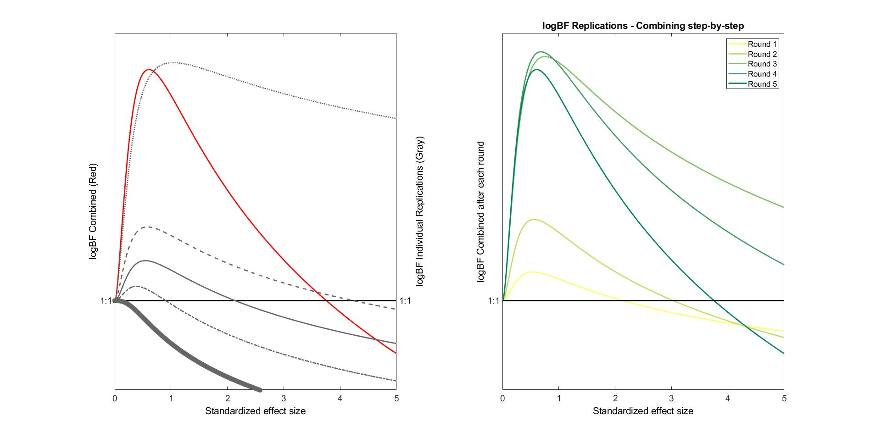

The evidence gives strongest support for the existence of an endowment effect of about 0.61 sd.

Our analysis will then compare what we learn from the Butera et al. method to what we learn from our method following the same set of replications.

Secondary analysis: none

(6) Aimed for sample size and power

Each replication of the experiment will be conducted in a separate class at Bentley University. They range in students from around 20 to 34. Each is treated as if it is a separate replication of a version of the original Kahneman, Knetsch, and Thaler (1990) experiment.

They are intentionally underpowered because we are interested in studying how evidence from underpowered but repeated replications of the same experiment should be synthesized. The power achieved by simple t-tests of the difference between WTA and WTP will vary with the number of subjects who participate in each replication, but we aim for each to have only around 20% power to detect a reasonable MDE.

References:

Butera, Luigi, Philip J. Grossman, Daniel Houser, John A. List, and Marie-Claire Villeval. A new mechanism to alleviate the crises of confidence in science-with an application to the public goods game. No. w26801. National Bureau of Economic Research, 2020.

Gächter, Simon, Eric J. Johnson, and Andreas Herrmann. "Individual-level loss aversion in riskless and risky choices." Theory and Decision 92, no. 3 (2022): 599-624.

Kahneman, Daniel, Jack L. Knetsch, and Richard H. Thaler. "Experimental tests of the endowment effect and the Coase theorem." Journal of Political Economy 98, no. 6 (1990): 1325-1348.

Maniadis, Zacharias, Fabio Tufano, and John A. List. "How to make experimental economics research more reproducible: Lessons from other disciplines and a new proposal." In Replication in experimental economics, pp. 215-230. Emerald Group Publishing Limited, 2015.

