General information
Title:
Bringing Democracy to Finance: A Field Experiment on Pension Fund Members' Preferences for Impact Investing

Initial registration date:
2025/05/03

Country:
Netherlands

Primary Investigator:
Paul Smeets

Other Primary Investigator(s)
Rob Bauer
Emmeline Cooper
Bram van der Kroft

Additional Trial Information
Status: Not yet completed
Start date: 2025/05/01 - 2025/07/01
Keywords: Sustainable investments, field experiment, deliberative forum, experimental economics
JEL codes: C93 (Field Experiments), G11 (Portfolio Choice - Investment Decisions), D72 (Political Processes: Rent-Seeking, Lobbying, Elections, Legislatures, and Voting Behavior)
Abstract:
We investigate the democratization of financial decision-making through a large-scale field experiment in which pension fund participants face a binding vote on their fund's investment strategy. Their vote can substantially increase impact investments (by a factor of five), potentially lowering their fund’s returns and increasing risk while positively impacting society. Prior to voting, we conducted a deliberative forum where a representative sample of pension participants recommended increasing impact investments after having engaged in three days of structured discussions with expert guidance on sustainable investment strategies. Our field experiment studies whether participants follow deliberative forum recommendations on impact investing when making binding decisions, controlling for peer effects. This is the first instance in the financial sector where a deliberative forum is followed by a binding vote with real investment strategy consequences based on its recommendations. The study contributes to understanding democratic governance in financial institutions and the role of information provision in shaping collective decisions that weigh financial returns against societal impact.

Sponsors & partners:
This project is in collaboration (but without financial support from) Pensioenfonds Detailhandel.
Bram van der Kroft received funding from the Dutch Science Foundation (NWO) Rubicon Grant under grant number 2023-3.
Paul Smeets received funding from the Dutch Science Foundation (NWO) Vidi Grant under grant number VI.Vidi.221E.011.

Experimental Details:
Experiment setup:
In this field experiment, we want to assess whether participants desire to expand impact investing in a democratic setting and whether recommendations from a deliberative forum help shape their decisions. To this end, we first inform participants about impact investing and assess their priors regarding (sustainable) investing knowledge, return expectations, risk perception, impact beliefs, and preferences for sustainable investing. Subsequently, we treat them with two different forms of information and ensure they understand the information or assign them to a control group without information (see below). Next, we ask participants whether to expand, keep unchanged, or reduce impact investing in their pension fund with a binding vote. We also ask participants to vote with commitment on the topics and location of impact investing. Last, we assess participants’ trust in their pension funds, the provided information, and commitment. We also collect demographic information and ask a control question to determine whether they understood the definition of impact investing.

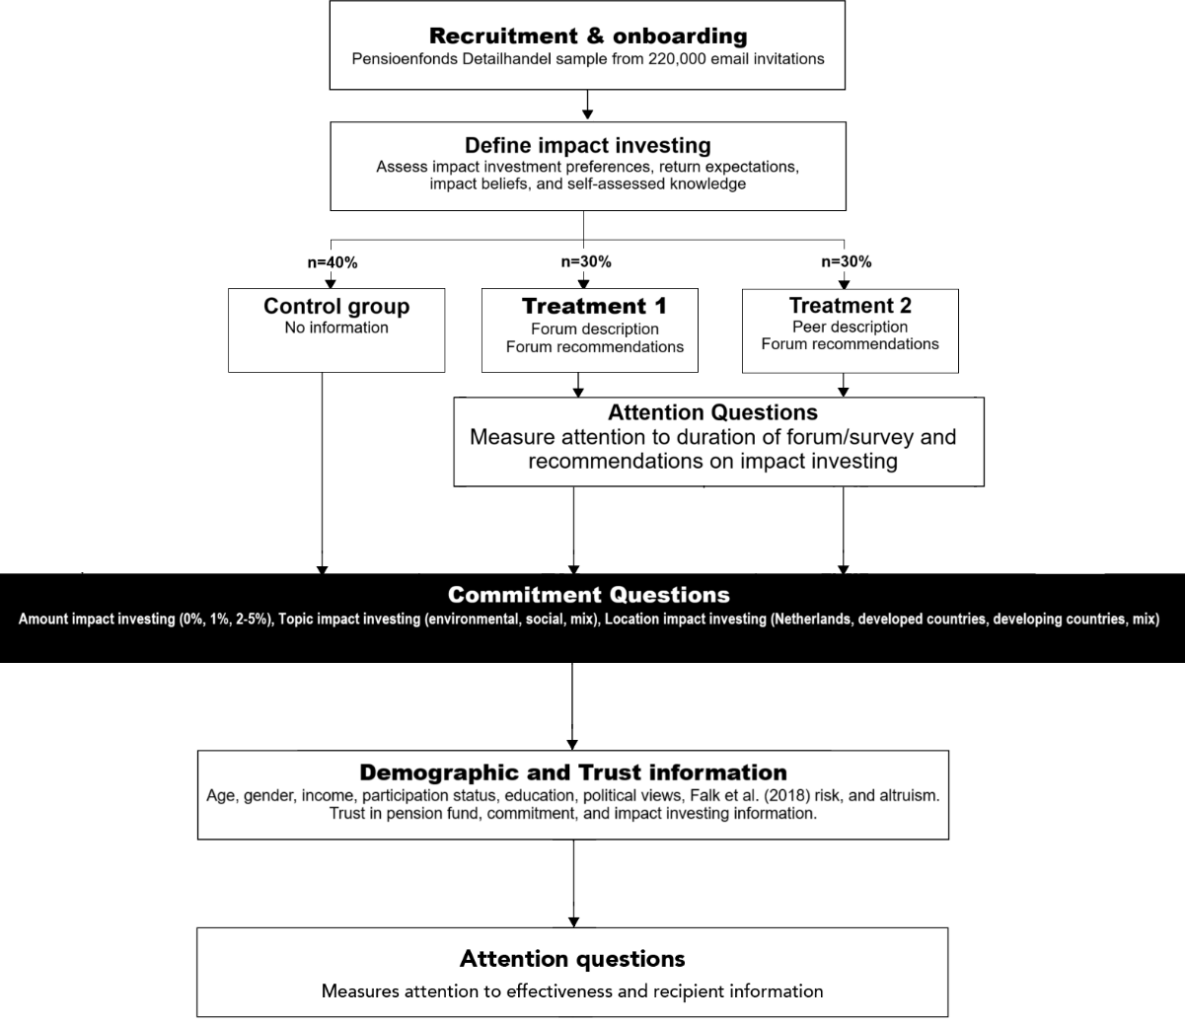
Interventions:
Alongside participants’ general tendencies to vote for expanding impact investing, we study whether they follow impact investing recommendations from a deliberative forum when provided with this information. This allows us to test the generalizability of forum outcomes in representing the general population. To this end, we introduce a forum information treatment covering a random sample of 30% of participants.
The key information participants receive in this treatment is the share of forum participants who want to expand impact investing, keep impact investing unchanged, or reduce impact investing; their expectations about the effect of impact investing on returns; and their beliefs regarding the environmental and social consequences of impact investing. We communicated that this information was collected during a deliberative forum involving 43 participants from Pensioenfonds Detailhandel. We elaborated on the forum's expert-led informational sessions, deliberative nature, and collective recommendation-building aspects. Further, we emphasize that these recommendations were diligently made as they result from a three-day intervention, for which participants traveled throughout the entire country. Last, we convince participants that participants like them make these recommendations, as the forum was representative of the average Pensioenfonds Detailhandel demographics. We provide the exact treatment information at the end of this pre-registration form.
One concern with the above setting is that our results might be driven by peer effects rather than being specific to our deliberative forum. We address this concern by introducing an additional peer effects treatment covering 30% of the sample. To adequately and truthfully measure this, we provide participants with identical information from the forum on participants’ willingness to expand impact investing, return expectations, and impact beliefs. We explain that this information was collected through a 15-minute survey (the method of collecting data during the deliberative forum). As with the forum treatment, we emphasize the representativeness of respondents. The sole difference in treatments is the knowledge that these recommendations stemmed from a deliberative forum. The remainder of the participants (40%) serve as a control group and provide no additional information.

Survey outcomes:
Primary outcome:
- Participants’ vote on impact investing (expanding, keeping unchanged, or stopping)
Supplementary outcomes:
- Participants’ vote on the topic and location of impact investing
- Impact investing knowledge, preferences, return and risk expectations, and impact beliefs

Hypotheses:
Primary Hypotheses:
H1: Participants collectively choose to expand impact investing when asked democratically.
H2: Participants treated with forum recommendations more frequently vote for expanding impact investing than those treated with peer information or the control group.
Secondary Hypotheses:
H3: Participants with lower levels of trust will show a stronger effect of the forum over peer information in their decision to vote for expanding impact investing.
H4: Participants with more negative prior impact beliefs will show a greater treatment effect.
H5: Participants with more negative prior return expectations will show a greater treatment effect.

Analyses & Tests
Hypothesis 1:
For the first Hypothesis, we count the number of votes for expanding impact investing (2% to 5%) compared to the votes for keeping impact investing unchanged (1%) and stopping with impact investing (0%). The hypothesis holds if the number of votes for expansion is higher than for other choices.
As mentioned in the survey to participants, we reweigh votes based on pension participation status (active contributor, past contributor, or retiree), income, age, and gender to ensure participant representativeness. We employ fitted votes to assess final voting outcomes, as we have proportionally more email addresses for active members than retirees in our samples compared to the population. We first fit a model testing the extent, if any, to which demographic information such as age, gender, and participation status affects how participants voted. Subsequently, we compute the distance in the sample means of these demographics from the Pensioenfonds Detailhandel population means. We fit the vote for expansion and voted for keeping the impact investing unchanged dummies by adding the sum of the estimated coefficient times this distance in demographics to the original voting dummy.
Hypothesis 2:
We test Hypothesis 2 through a regression framework. The dependent variable Expand_{i} captures whether participants voted to expand impact investing (value = 1) or not (value = 0). The independent variable Forum_{i} captures whether participants were treated by forum information (value = 1) or by peer information or in the control group (value = 0). The independent variable Peer_{i} captures whether participants were treated by peer information (value = 1) or are in the forum treatment or control group (value = 0). For Hypothesis 2 to hold, β₁ should be larger than β₂ and statistically significantly different using a Wald test at the 5% level. We also test whether forum and peer treatment positively affect voting for the expansion of impact investing beyond the control group by interpreting the coefficients β₁ and β₂ at the 5% level.
We employ standard errors clustered at the participation status level (active contributors, past contributors, and retirees) in all regressions. As treatments are randomly allocated, we first run a specification without controls. Subsequently, we estimate the effect using a set of control variables (Controls_{i} ) identical to those used in Bauer et al. (2021). Specifically, we control for financial expectations by introducing dummies for participants who expected impact investing to reduce returns or increase returns, with expectations unchanged as the reference category. For demographic controls, we introduce a female dummy, age in years, and a dummy variable for whether participants are highly educated (variable equal to one if the participant reports having a university degree or a degree from a university of applied sciences). We also include participants’ financial background with a dummy for after-tax income of 2,500 euros a month and a dummy for above 4,000 euros per month. Last, we include information on Falk (2018) altruism/social preferences. For every demographic question, we include a “I prefer not to say” dummy reflecting participants who preferred not to answer this question.
Bauer, R., Ruof, T., & Smeets, P. (2021). Get real! Individuals prefer more sustainable investments. The Review of Financial Studies, 34(8), 3976-4043.
Falk, A., Becker, A., Dohmen, T., Enke, B., Huffman, D., & Sunde, U. (2018). Global evidence on economic preferences. The quarterly journal of economics, 133(4), 1645-1692.

Hypothesis 3:
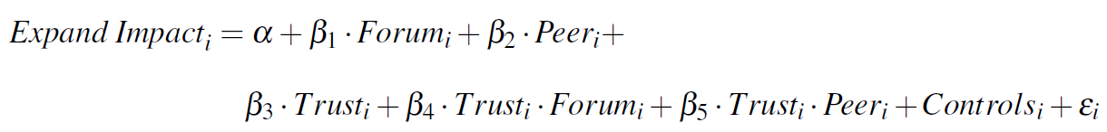

We test Hypothesis 3 through a regression framework using similar variables as in Hypothesis 2. However, to test the 3rd hypothesis, we introduce a Trust_{i} indicator and interact it with the previously introduced dummy variables. Trust_{i} represents participants’ answers to the extent to which they trust their pension fund, measured on a 1 (least trust) to 10 (most trust) scale following the World Value Survey. For hypothesis 3 to be true, β₄ should be negative and statistically significantly smaller than β₅ at the 5% level using a t-test. In other words, the effect of forum information over peer effects shrinks with higher trust, as one key benefit of performing a deliberative forum is the trust it signals to participants. When participants are already trusting, this benefit should disappear.
Hypothesis 4:
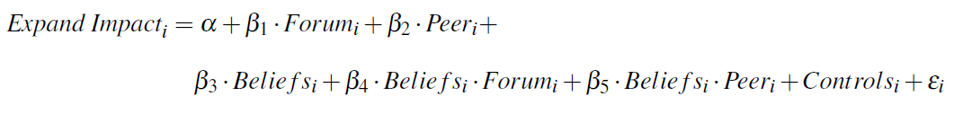
We test Hypothesis 4 through a regression framework using similar variables as in Hypothesis 2. Here, we introduce Beliefs_{i} and interact it with the previously introduced dummy variables. Beliefs_{i} represents participants’ answers to the environmental and social consequences of impact investing using a 5-point Likert scale from 1 (very negative effect) to 5 (very positive effect). After asking this question, we provided them with information on the expectations of forum participants regarding environmental and social consequences, which were relatively positive. Therefore, participants with lower priors on impact beliefs, i.e., those who were positively surprised, will react more strongly to the treatment information, leading us to expect a negative relationship. For hypothesis 4 to be true, β₄ and β₅ should be negative and statistically significantly different from zero at the 5% level.
Hypothesis 5:

We test Hypothesis 5 through a regression framework using similar variables as in Hypothesis 2. Here, we introduce E(Returns)_{I} and interact it with the previously introduced dummy variables. E(Returns)_{I} represents participants’ expectations of the financial return of impact investing on pension payments at retirement using a 5-point Likert scale from 1 (very negative effect) to 5 (very positive effect). After asking this question, we provided them with information on the expectations of forum participants regarding expected pension payments, which were relatively neutral. Therefore, participants with lower priors on return expectations, i.e., those who were positively surprised, will react more strongly to the treatment information, leading us to expect a negative relationship. For hypothesis 5 to be true, β₄ and β₅ should be negative and statistically significantly different from zero at the 5% level.

Correction for multiple hypothesis testing
For testing hypotheses 3-5 on our supplementary anlyses, we apply the false discovery rate (FDR) procedure, commonly used to ensure the share of Type I errors remains no more than the desired target rate (e.g., 5%; see Benjamini and Hochberg, 1995).
Benjamini, Y., & Hochberg, Y. (1995). Controlling the false discovery rate: a practical and powerful approach to multiple testing. Journal of the Royal statistical society: series B (Methodological), 57(1), 289-300.
Exploratory analysis
Topic and Location of Impact Investing
Pensioenfonds Detailhandel has committed to letting participants decide not only how much to invest but also in which topics and areas with a commitment question. Specifically, participants can choose to pursue impact investing mostly from an environmental perspective, a social perspective, or a mix between the two. Additionally, they can choose to impact invest mostly in the Netherlands, in developed countries (excluding the Netherlands), in developing countries, or a mix of the three. We are interested in participants’ choices among these dimensions, but do not have any expectations of what they will choose.
Forum participants
Alongside new participants, we also ask forum participants separately to answer the survey so that we can trace whether the knowledge they gained is persistent and whether they vote similarly with real incentives as during the forum. We test the latter by regressing a dummy variable indicating whether participants who partook in the initial deliberative forum voted for expanding impact investing more strongly than participants who did not participate in the forum. We expect a positive effect. However, with access to 42 email addresses of participants who participated in the forum and an optimistic response rate of 50% to the survey, we anticipate our test to be severely underpowered and the likelihood of observing any effect to be slim.

Experimental Design
Experimental Design: Experimental Design details: Across subjects: Field experiment; Survey
Randomization method: Software
Randomization unit: Individual
Was the treatment clustered? No

Experiment Characteristics
Sample size: planned number of clusters:
We send emails to 220k participants. Bauer et al. (2021) found that the same pension fund's response rates were 6.3% to 6.7%. We take a conservative lower-bound response rate of 3% and expect 3%* 222k = 6,660 participants.
Bauer, R., Ruof, T., & Smeets, P. (2021). Get real! Individuals prefer more sustainable investments. The Review of Financial Studies, 34(8), 3976-4043.
Sample size: planned number of observations:
We send emails to 220k participants. Bauer et al. (2021) found that the same pension fund's response rates were 6.3% to 6.7%. We take a conservative lower-bound response rate of 3% and expect 3%* 222k = 6,660 participants.

Sample size (or number of clusters) by treatment arms
We expect 6,660 participants. We assign 40% of them to the control group (2,664), 30% to the deliberative forum treatment (1,998), and 30% to the peer effects treatment (1,998).

Minimum detectable effect size for primary outcomes (accounting for sample design and clustering)
- For the first main question, we assess the share of participants voting for impact investing. Since it is a fraction rather than a difference in effect sizes, power calculations are not needed.
- For the second main question, whether the effectiveness of forum information is higher than peer effects, we compare the share of participants voting to expand impact investing across treatments, each with an N of 4,158. Assuming a power of 80% and a significance level of 5%, we can detect effect sizes of 0.063 standard deviations.

Institutional Review Board
IRB name:
MIT Committee on the Use of Humans as Experimental Subjects
IRB Approval Date:
2025/Feb/01
IRB Approval Number:
E-6389 - ESG preferences (impact investing) of retail investors with information treatment
Additional Document: Exact treatment text for the Forum information treatment:
Page 1:
Participant Dialogue
• After this, we will ask you how you want Pensioenfonds Detailhandel to approach impact investing.
• In 2024, Pensioenfonds Detailhandel conducted a participant dialogue involving 43 randomly selected participants and pensioners from Pensioenfonds Detailhandel. We asked them for their opinions on sustainable investing by Pensioenfonds Detailhandel.
• A participant dialogue is a democratic method where participants become well-informed on a topic through extensive discussion and listening to experts’ viewpoints. This is similar to a citizens' assembly. Such a dialogue aims to formulate recommendations for the pension fund board.
• The dialogue lasted three full days and took place in Utrecht.
• During the dialogue, ten experts provided extensive information on sustainable investing. Participants had ample opportunities to deliberate and form a collective opinion on how Pensioenfonds Detailhandel should handle sustainability. Everyone was encouraged to share their opinion, and professional facilitators safeguarded this.
• Following the dialogue, participants submitted recommendations to Pensioenfonds Detailhandel. An important recommendation was to expand impact investing.
• Participants were randomly selected to take part and are representative of other Pensioenfonds Detailhandel participants in terms of age, gender, and whether they are retired. Participants also represent the average Dutch person in terms of where they live, their place of birth, and their preferences regarding economic growth and the environment.
• At the end of the participant dialogue, we asked participants whether the pension fund should increase, decrease, or maintain the current level of impact investing. We also asked about the perceived effects of impact investing on environmental and social aspects, and pension payouts. You will see these responses on the next page.

Page 2:

Responses from the 3-Day Participant Dialogue
To help you make a better-informed choice, we have illustrated the participants’ responses from this 3-day participant dialogue using the pictograph below. The pictograms (of a person) are red if the participants chose less, orange if they chose the same, and green if they chose more. For example, 85% of participants chose to increase impact investing (in green) and 15% to keep it the same (in orange). The more pictograms have a specific color, the more frequently participants from Pensioenfonds Detailhandel chose this opinion.
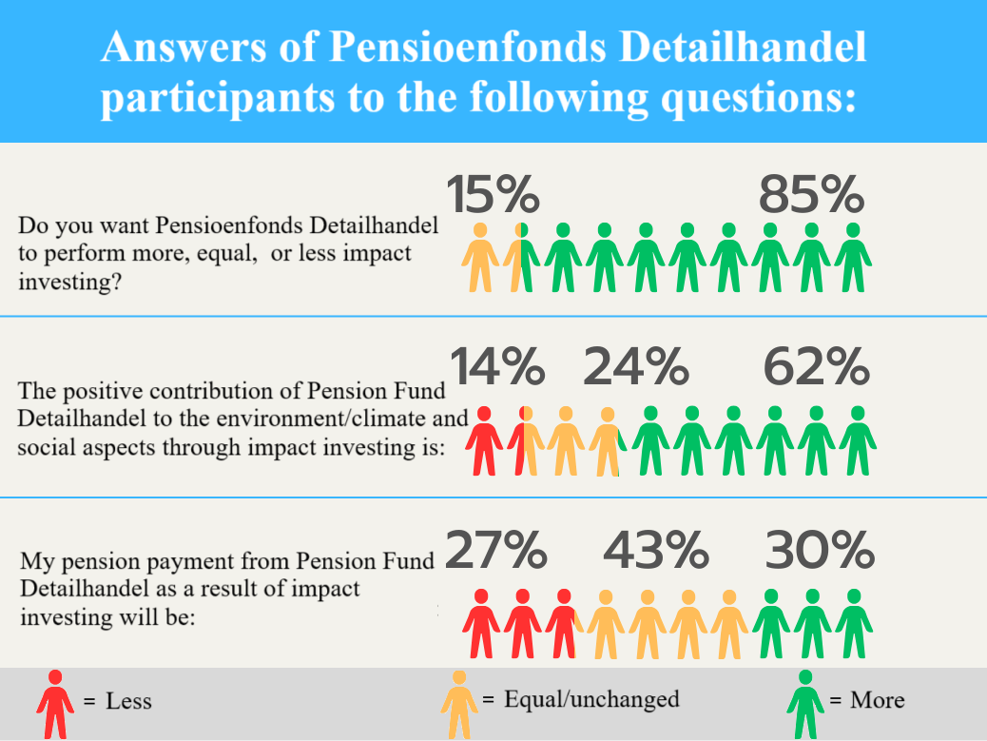

Peer information treatment
Page 1:
The opinion of other participants and retirees of Pensioenfonds Detailhandel
• The following questions concern how you want Pensioenfonds Detailhandel to invest with impact.
• To help you make a better-informed choice, we sent out an extensive questionnaire in 2024 to 43 participants and retirees of Pensioenfonds Detailhandel. We asked them whether the pension fund should increase, decrease, or keep impact investing unchanged, and what the effect of impact investing is on environmental and social aspects and pension payments. In this questionnaire, participants were informed about impact investing.
• Participants took, on average, 15 minutes to complete this questionnaire and answered carefully.
• Participants were randomly selected to participate and are comparable to other participants of Pensioenfonds Detailhandel in, among other things, age, gender, and whether they are retired. They also represent the average Dutch person in terms of where they live, where they were born, and their preferences regarding economic growth and the environment.
• You will see their answers on the next page.

Page 2:

Answers from the 15-minute questionnaire
In the pictograph below, you see the answers from participants in the 15-minute questionnaire. The pictograms (of a person) are red if the participants chose less, orange if they chose the same, and green if they chose more. For example, 85% of participants chose to increase impact investing (in green) and 15% to keep it the same (in orange). The more pictograms have a specific color, the more frequently participants from Pensioenfonds Detailhandel chose this opinion.
We included the same pictograph as with the deliberative forum treatment depicted above.

