Consent
Please read the following, then tick the statements that apply afterwards. This study has been approved through the ethics process of the School of Social Sciences at Birkbeck College.
This survey involves completing a questionnaire. It should require no more than 10 minutes of your time. Your participation will contribute to research to help us understand what makes data tools acceptable to UK residents in the context of children’s social care. Your responses will play a crucial role in shaping the future of research in this vital area. Thank you for your time and participation.
If you find the subject matter distressing, please see NHS services here: https://www.nhs.uk/every-mind-matters/mental-wellbeing-tips/self-help-cbt-techniques
Please note that this study includes attention checks in order to ensure the quality of the data.
If you consent, please tick all that apply:
I have read the information above and understand I can email the researcher, Daniel Bogiatzis-Gibbons at d.gibbons@bbk.ac.uk with any questions about the survey, including to remove my consent to participate by September 1, 2025. After that date, the data will be anonymised and this will not be possible.
I understand that my anonymised information will be used for academic research.
I understand that all personal information will remain confidential and that my data gathered in this study will be stored anonymously and securely. It will not be possible to identify me in any publications.
I understand that my anonymised research data may be shared with, and used by, others for future research (no one will be able to identify you when these data are shared).
I understand that I am free to withdraw from the study without penalty if I so wish, simply by closing my browser.
I consent to take part in the study.

Next

Instructions
Children's services often receive reports, for example, from schoolteachers, about a child who might be at risk of abuse or neglect. The local council wants to use a computer program that learns from past cases to help social workers. This program helps predict if the child might be harmed if no action is taken.
Now, imagine you are a council worker tasked with choosing which program to pick. On the following pages, please indicate which of the two programs shown you would personally prefer to see used by the council.
You will see seven pairs of programs, please choose one from each pair.

Next
EXAMPLE TASK BELOW (7 SCREENS)
Before the introduction of the program, social workers made correct decisions about 80 children out of every 100 children referred to them.
They made two kinds of mistakes:
- "False negatives": 10 children from every 100 referred children were at risk of harm, but were missed by social workers, and their cases were closed.
- "False positives": 10 children from every 100 referred children were not at risk of harm, but were incorrectly progressed to further investigation.
Below are descriptions of two programs that could help social workers with screening referrals. Please read the descriptions and indicate which of the two programs shown you would personally prefer to see used by the council.
 | Option 1 | Option 2
How many fewer safe children had their cases incorrectly progressed | 10 fewer safe children from every 100 had their cases incorrectly progressed | 6 fewer safe children from every 100 had their cases incorrectly progressed
For each specific child, information about how the program made a prediction is: | Available to the social worker and parents or guardians | Available to the social worker only
Information about the program is: | Easy to understand and publicly available | Not publicly available
How many fewer at-risk children had their cases incorrectly closed | 2 fewer at-risk children from every 100 had their cases incorrectly closed | 10 fewer at-risk children from every 100 had their cases incorrectly closed
How the program is used by social workers in decisions made about children | The program only makes a recommendation to the social worker | The program makes a preliminary decision that the social worker must override to change

Next

What is the highest educational level that you have achieved?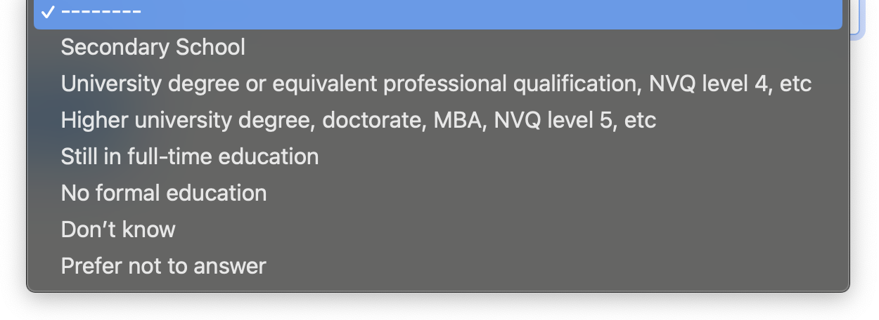

This is an attention check. Please ignore the question and select bbc.co.uk and Google News as your two answers.
Based on the text you read above, what two websites have you been asked to select?
The Telegraph
bbc.co.uk
Google News
CNN.com
Guardian
Sky News
Another site, namely:

Next
BELOW, THE CORRECT ANSWER IS C.

Which of the following questions was included in the table in the scenarios relating to the data tool used by social workers that you read about today?
- Was the program made by Microsoft or Google?
- Did the program include input from ChatGPT or not?
- How many fewer at-risk children had their cases incorrectly closed?
- Could police access the program?

Next
On a scale of 0 to 10, where 0 is no trust and 10 is complete trust, how much do you personally trust to carry out their work:

The legal system of the United Kingdom
--------0 (no trust)12345678910 (complete trust)
Children’s social workers in the United Kingdom
--------0 (no trust)12345678910 (complete trust)
Local councils, when using resident data
--------0 (no trust)12345678910 (complete trust)

Next

This is an attention check. Please ignore the question and click ChatGPT.
What is your favourite AI tool?
Microsoft Copilot
Replika
ChatGPT
Mistral Le Chat
None of the above

Next

On a scale of 0 to 10, where 0 is not at all and 10 is completely:

Do children's social workers in the United Kingdom have the competence to carry out their work?
--------0 (not at all)12345678910 (completely)
Do children's social workers in the United Kingdom have the motivation to carry out their work?
--------0 (not at all)12345678910 (completely)
Do children's social workers in the United Kingdom have the opportunity to carry out their work? In other words, do they have adequate resources, and are they supported to do their work without too much red tape?
--------0 (not at all)12345678910 (completely)

Next

Thank you for taking part in this survey, your answers will help contribute to academic research into AI tools used in child protection.

Click here to complete the survey and return to Prolific

