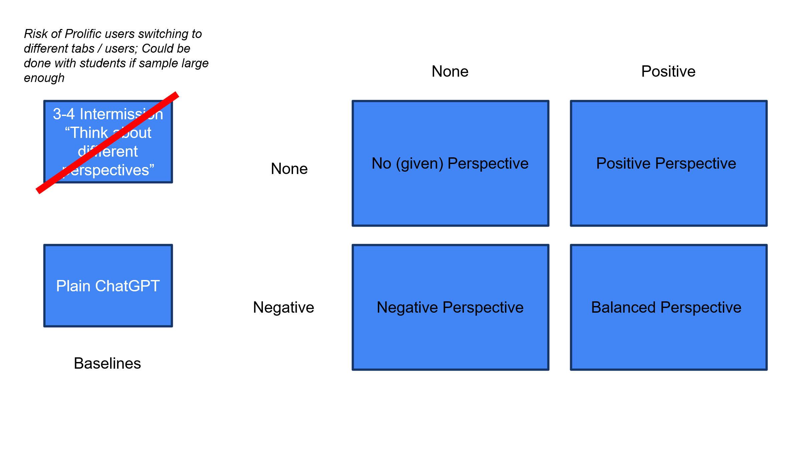 Option 1: No perspective AI conversation as control/reference
Option 2: Plain ChatGPT (almost no customization) AI conversation as control/reference
Assessment Change Story: (individual level) (MAYBE LESS IMPORTANT? SPECIFIC HYPOTHESES NECESSARY?)
H1a: Negative AI conversations lead to stronger changes in assessment, compared to no perspective/plain ones.
H1b: When before-AI idea scores are low (< 3 out of 7 or < first quantile or continuous, negative AI conversations lead to less stronger changes in assessment, compared to no perspective/plain ones. (OBVIOUS HYPOTHESIS NECESSARY?) (maybe no implications if before AI score was extremely low, e.g., <2)
H2a: Positive AI conversations lead to stronger changes in assessment, compared to no perspective/plain ones.
H2b: When before-AI idea scores are high (> 5 out of 7 or > third quantile or continuous), positive AI conversations lead to less stronger changes in assessment, compared to no perspective/plain ones. (OBVIOUS HYPOTHESIS NECESSARY?) (maybe no implications if before AI score was extremely high, e.g., > 6)
H3: Balanced AI conversations lead to stronger changes in assessment, compared to no perspective/plain ones.
Assessment Quality Story: (individual level) (PROBABALY MOST IMPORTANT)
H4: AI conversations lead to assessments closer to the average before-AI quality benchmarks, compared to before-AI assessments.
H5: Balanced AI conversations lead to assessments closer to the average before-AI quality benchmarks, compared to no perspective/plain ones.
H6: Positive AI conversations lead to assessments closer to the average before-AI quality benchmarks, only if the before-AI score was low (< 3 out of 7 or < first quantile or continuous or below the average before-AI quality benchmarks), compared to no perspective/plain ones. (maybe no implications if before AI score was extremely low, e.g., <2)
H7: Negative AI conversations lead to assessments closer to the average before-AI quality benchmark, only if the before-AI score was high (> 5 out of 7 or > third quantile or continuous or below the average before-AI quality benchmarks), compared to no perspective/plain ones. (maybe no implications if before AI score was extremely high, e.g., > 6)
H8: Impacts of AI conversations on the detailed idea assessment score are stronger than on the holistic assessment score. (AS A HYPTHESIS OR AS A POST-HOC?)
Convergence Story: (overall condition group level) (BETTER AS POST-HOC?)
H9: AI conversations lead to convergence in idea assessment, compared to before-AI assessments.
H10: Convergence is stronger for positive AI conversations and negative AI conversations, and lower for balanced (positive and negative together) AI conversations, compared to no perspective ones.
Personality and AI perception – as post-hoc analyses to learn more about mechanism?
Detailed quality dimensions – as post-hoc analysis?

