Pre-Analysis plan

Main research questions
As previously outlined, this aspect of the research aims to address one primary research question, and three additional, secondary research questions:
- RQ1.1: Does a standing charge-based price signal reduce peak electricity consumption, and by how much?
- RQ1.2: How does the effect of a standing charge-based price signal differ across subgroups (geographical location, PSR marker)?
- RQ1.3: What is the effect of a standing charge-based price signal on total electricity use, and off-peak electricity use?
- RQ1.4: How is the effect of a standing charge-based price signal impacted by a) incentive received, and b) communications and messaging?
In this section, we outline the approach planned to answer these questions.

Outcomes of interest
- Energy consumption (total, peak, off-peak)
- Email click-through rates
- Bill amount (total bill)
  - Also how much customer would have spent with the old standing charge
- Attrition

Analyses

Descriptive statistics and Balance tables
The first step is to present summary statistics on the groups in the trial, to summarise the demographic profile of participants, and whether these variables are significantly different from each other. Variables are presented in table 1.

Table 1: Descriptive characteristics of the sample
Variable name | Variable type | Availability | Test for balance check
Consumption of previous month | Continuous | Pre-trial | Kruskal-Wallis, Wilcoxon test
Estimated Annual Consumption | Continuous | Pre-trial | Kruskal-Wallis, Wilcoxon test
Electricity only customer | Binary | Pre-trial | Chi2 test
PSR | Binary | Pre-trial | Chi2 test
Type of tariff | Categorical | Pre-trial | Chi2 test
Standing charge paid | Continuous | After trial | Kruskal-Wallis, Wilcoxon test

Graphical analysis, and Parallel Trend analysis
The next step is to prepare a graphical representation of the data. This step presents two main analyses
Parallel trends Analysis, plotting the trends in the pre-trial period, to see if treatment and control groups present different trends prior to the intervention (Figure 1). We will also formally test for the parallel trend assumption using the "honest DID" test of Rambachan and Roth (see HonestParallelTrends_Main.pdf), to obtain an event-study plot (Figure 2); and/or a placebo trend test (see Difference-in-Differences. Learn another method to determine… | by Figarri Keisha | Bukalapak Data | Medium).
- We will explore the distribution of both standing charge paid and on-peak electricity consumption to determine whether there is evidence of bunching in proximity of the thresholds (as in Figure 3), a reflection of consumers moving towards the threshold with the ambition of earning the reward.

Figure 1: Sample representation of consumption trends, by experimental group
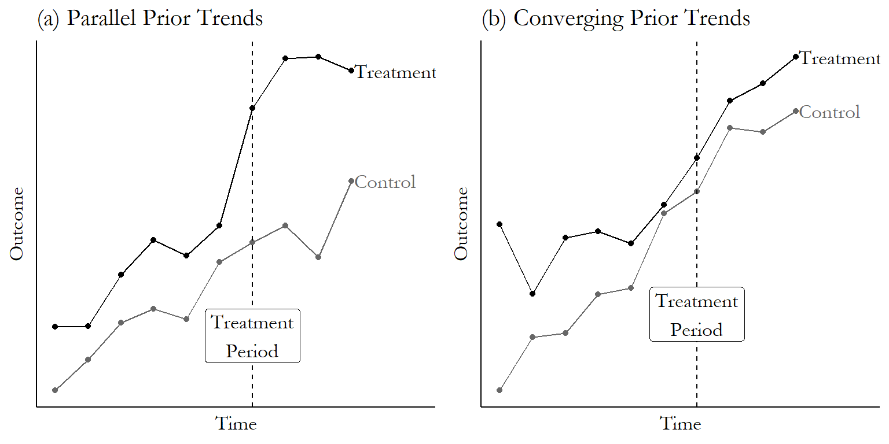

Figure2: Sample event-study plot
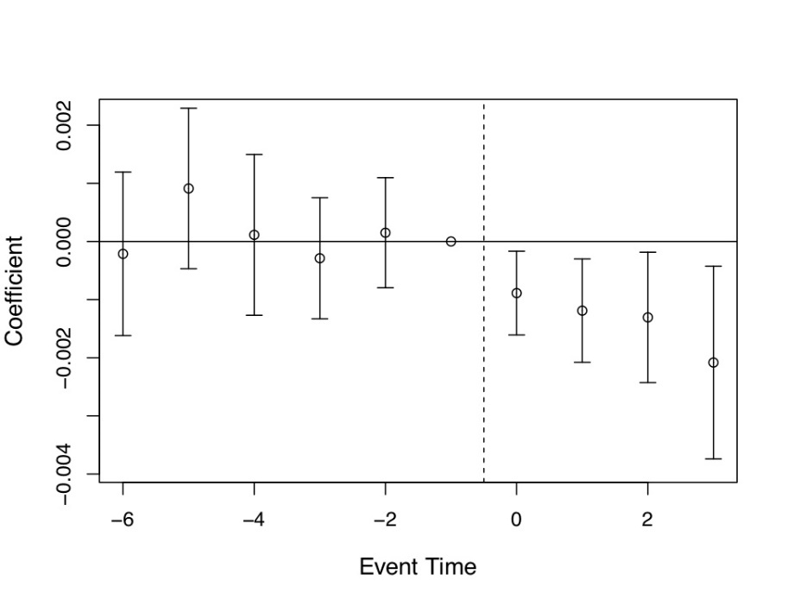

Figure 3: Visual representation of bunching
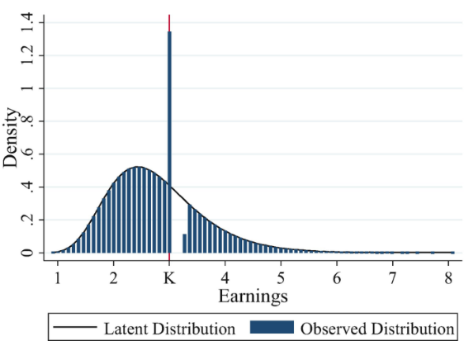

Data quality checks
A final initial step is to run some sensitivity analysis help us assess the quality of the data. This step will be run concurrently with steps 1.3.1 and 1.3.2, rather than sequentially.
- Outlier analysis: We will explore the presence of extreme consumption values (e.g., top 1% and bottom 1% in the month prior to the start of the experiment), using scatter diagrams and box plots.
- Missing data analysis: We will explore the extent of the occurrence of missing data, which will cause us to employ different approaches (method will depend on the type of issues we encounter, if any).

Regression analyses – energy consumption
The statistical approach that will be taken to address these research questions will be a Difference-in-Difference (DID) linear regression design. This is a technique commonly used in experimental and quasi-experimental design that compares the change in outcomes (in this case, electricity use) over time in a treatment group to the change in the same outcome for a control group. By removing the change in outcome in the control group, this approach eliminates unobservable factors that may have influence electricity consumption in both groups. The resulting effect is causal as long as, absent the treatment, the average change in the outcome for the treated group would have followed the same trajectory as the control group, the so-called Parallel Trends Assumption. By differencing twice (first across time, then across groups) the method controls for both time-invariant group differences and common time shocks, isolating the effect attributable to the treatment.
More specifically, this design allows us to compare changes in electricity use over time between groups, controlling for baseline differences and time trends. Even though randomisation makes baseline differences unlikely, using a DiD approach still improves the precision of our estimates and reduces error, and protects against pre-existing differences occurring by chance.
The basic model will also adjust for fixed consumer effects, time-fixed effects, and other variables of relevance. As needed, we will also look at the pre-trial and the trial period separately, to gain as much knowledge of the data as possible.

The effect of the change in standing charge (ATE)
In order to answer the research questions “Does a standing charge-based price signal reduce peak electricity consumption, and by how much?” (RQ1), the following hypotheses will be tested:
- H₁: Participants that receive a standing charge-based price signal will significantly reduce their peak electricity consumption during the intervention period compared to participants that do not receive the price signal.
- H₂: Participants that receive a standing charge-based price signal will significantly increase their off-peak electricity consumption during the intervention period compared to participants that do not receive the price signal.
- H₃: Participants that receive a standing charge-based price signal will significantly decrease overall electricity consumption during the intervention period compared to participants that do not receive the price signal.
As outlined above, these will be tested using a DiD estimator (the Average Treatment Effect, or ATE), with the model specified as follows:
$Y_{it}=α_{i}+β_{1}G_{i}+β_{2}{\text{T}}_{t}+β_{3}(G_{i}×{\text{T}}_{t})+γX_{it}+ε_{it}$ (1)
Where:
- $Y_{it}$= electricity used for participant i on day t; this can be peak, off-peak, and total consumption;
- $α_{i}$= consumer fixed effects, time-invariant consumer characteristics that capture individual-level heterogeneity (e.g. PSR status, payment type, geographical area);
- ${\text{G}}_{i}$= treatment group (1 = intervention, 0 = control), which is also a fixed effect;
- ${\text{T}}_{t}$= dummy equal 1 if the trial has started, 0 otherwise;
- $G_{i}×{\text{T}}_{t}$= interaction term, the DID estimator;
- $X_{it}$= time-varying covariates (e.g., weather in the area of consumer i at time t; electricity price paid by consumer i at time t);
- $δ_{t}$= day fixed effects (to control for time trends);
- $ε_{it}$= residual error (which we cluster at the level of the consumer).
The parameters in equation (1) are as follows:
- $β_{1}$ = baseline difference in peak energy use between treatment and control groups
- $β_{2}$ = Time-related consumption trends in the control group
- $β_{3}$ = DID estimator – the change in electricity use attributable to the intervention
- $γ$ = influence of time-varying characteristics on electricity consumption

When Y refers to peak electricity consumption, $β_{3}$ answers RQ1.1; while the same model using off-peak and total electricity consumption as Y answers RQ1.2. We will use a Romano-Wolf test to determine the validity of the p-value with multiple dependent variables.
All assumptions required for the statistical analyses will also be tested, and model diagnostics run to ensure the taken approach is valid, appropriate and robust. Specifically we will:
- Check for parallel trends (see section 1.3.2), plotting the trends in the pre-trial period, to see if treatment and control groups present different trends prior to the intervention. Non-parallel trend will be resolved using either propensity scores, or – if suitable instruments are found – using IV methods.
- Assess model fit through interrogation of residuals, and random effects
- Compare nested models to ensure the final model identifies meaningful effects without overfitting.
- Check for independence of residuals by examining autocorrelation using ACF plots and Durbin-Watson tests.
- Check for multicollinearity by examining variation inflation factors (VIFs).
- Assess normality of residuals and random effects using visual inspections and formal normality tests.

Effect heterogeneity (CATE)
To answer RQ1.3, we augment equation (1) to interact the DID estimator with selected personal characteristics to estimate a Conditional ATE (CATE), as
$Y_{it}=α_{i}+β_{1}G_{i}+β_{2}{\text{T}}_{t}+β_{3}\left(G_{i}×{\text{T}}_{t}\right)+β_{4}(G_{i}×{\text{T}}_{t})×D_{i}+γX_{it}+ε_{it}$ (2)
where $D_{i}$ are personal characteristics (e.g. PSR status, payment type, geographical area). In this case, $β_{4}$ estimates the effect of the treatment across different demographics.

Exploring the role of incentives in driving change
The final research questions for this part of analysis are “How is the effect of a standing charge-based price signal impacted by a) incentive received, and b) communications and messaging?” (RQ1.3). To explore these, we will test two hypotheses:
- H₄: Participants with a higher average price signal exposure (a higher mean incentive band) will show greater reductions in peak electricity use than participants with lower average exposure or no exposure (control group).
- H₅: Participants that engage with feedback messages will show a greater reduction in peak electricity use compared to participants that do not engage with the messages

Price incentives
The aim of testing H₄ is to determine whether the reward band has an impact on peak electricity use beyond that of the intervention. To test this hypothesis, we explicitly model whether the inventive band achieved by consumer i at time t-1 influences consumption at time t. The model would be specified as follows:
$Y_{it}=α_{i}+β_{1}G_{i}+β_{2}{\text{T}}_{t}+β_{3}\left(G_{i}×{\text{T}}_{t}\right)+β_{4}(G_{i}×{\text{T}}_{t})×D_{i}+β_{5}​B_{i,t-1}+ β_{6}(B_{i,t-1} × G_{i}) +γX_{it}+ε_{it}$ (3)
Where $B_{i,t-1}$ is the band achieved in the previous period (depending on suppliers), irrespective of whether the consumer is in the control or the trial.
We will estimate equation (3) using daily electricity consumption data. However, because daily monitoring is imperfect, this approach may underestimate the actual impact of the band, as individuals will not know what band they were in any previous day. Because they will receive feedback every two weeks, we will also re-run the analyses aggregating the data over a two-week period, which is information that consumers will have access to.
Note that the lagged model will also capture flexibility costs, that is how easy is for a person to consume within a certain band: consumers who conduct a lifestyle that allows (does not allow) flexibility will be always staying in the top (bottom), with a positive $β_{6}$.

Engagement
To test whether engaging with the monthly emails (i.e. opening the monthly email recap) reduced peak electricity use by a greater degree is to re-estimate the original DID model, splitting the treatment group into two groups
  - An active treatment group who opened the monthly email; and
  - A passive treatment group who did not open the monthly email.
The control group will remain unchanged. We then replicate the analyses in section 1.3.3.1 to explore whether the pattern of behaviour differs when only including engaged participants compared to the full sample, testing H₅. Note, however, this approach will not identify the causal effect of engagement.
Alternatively, lagged engagement can be added as a predictor in the DID regression, to determine whether having read an email influences peak electricity, relative to the control group. In this case, equation 1) can be modified as (note the control receives no notifications at all):
$Y_{it}=α_{i}+β_{1}G_{i}+β_{2}{\text{T}}_{t}+β_{3}\left(G_{i}×{\text{T}}_{t}\right)+β_{4}(G_{i}×{\text{T}}_{t})×D_{i}+ β₅(E_{i,t-1} × G_{i}) +γX_{it}+ε_{it}$ (4)
Where $E_{i,t}$ equals 1 if the consumer read the email, 0 otherwise. The parameter $β_{5}$ will indicate whether engagement influences the subsequent month’s peak electricity use.

Regression analyses – Customer perceptions
The research question being answered by this part of the research is “what is the customer perception of a standing charge-based price signal in terms of understanding, fairness and engagement?”. There are three sets of variables:
- understanding of standing charges (as they are in trial for those in the treatment group, and as they are outside of the trial for the control group),
- perceived fairness of standing charges (as before),
- engagement with electricity conservation behaviours.
- perceived control over bills,
- understanding of bills,
- motivation to engage with energy bills, and
- satisfaction with energy supplier.
The survey presented an opportunity to also include questions relating to the predicted theory of change underpinning the intervention, and therefore these will be included in comparisons between the control and treatment groups. Open ended questions included in the version of the survey sent to the treatment group will also allow further exploration of the experiences of the intervention. There will therefore be two strands of analysis for this question, quantitative and qualitative responses.

MANOVA
To test whether the treatment influenced these variables, we will use a Multivariate Analysis of Variance (MANOVA) on the key dependent variables, using treatment group as the independent variable. This will allow the treatment group and the control group to be compared on all three dependent variables in an efficient and parsimonious manner, without the need for additional corrections for multiple comparisons to identify any main effect. Although the questionnaire items are single-item Likert scale responses, they will be treated as approximately continuous for the purposes of multivariate analysis, as linear model provide consistent (albeit inefficient) estimates in the presence of ordinal variables.
To ensure interpretability and consistency across questionnaire items, all items will be aligned so that higher scores reflect more positive outcomes, with responses reverse coded where necessary. Assumptions of multivariate normality and homogeneity of covariance matrices will be tested, and if violated, alternative nonparametric methods (e.g., PERMANOVA) will be considered. Similarly, as we cannot control the response rate for either the intervention or the control, if the sample sizes for each treatment group end up being unequal, we will conduct a MANOVA using Pillai’s Trace (rather than Wilks’ Lambda), which is more robust to unequal sample sizes.
The MANOVA will produce an omnibus statistic indicating whether the groups differ significantly on the dependent variables. We will also perform ANOVA/pairwise comparison tests with multiple comparison corrections to identify what variables are underpinning any significant differences, ensuring we also report effect sizes in addition to statistical significance to maintain a focus on practical value of each variable.

Structural Equation Model (SEM)
In the next step, we will use a SEM approach to link attitudes to behaviour, to further establish the psychological pathway underpinning changes in behaviour. The dependent variable is expected to be the total peak electricity use – or the average monthly peak electricity use – of consumer i during the trial. This dependent variable was chosen to be the most straightforward and easy to interpret, because the coefficient will measure the change of the treatment relative to the control. The key independent variables would be treatment group (intervention, control), and the self-report variables such as: understanding of standing charges (as they are in trial for those in the treatment group, and as they are outside of the trial for the control group), perceived fairness of standing charges (as before), engagement with energy use, perceived control over bills, understanding of bills, motivation to engage with energy bills, and satisfaction with energy supplier.
The model will be specified once the variables that will be collected. A sample SEM regression would be as follows:
$\begin{aligned}Y_{i}=β_{0}+β_{1}X_{i}+β_{2}M_{i}+β_{3}G_{i}+e_{i} \\ M_{i}=α_{0}+α_{1}X_{i}+α_{2}C_{i}+β_{3}G_{i}+u_{i} \\ C_{i}=γ_{0}+γ_{1}X_{i}+β_{3}G_{i}+ε_{i}\end{aligned}$ (5)
Where:
- $Y_{i}​$ = total/monthly peak electricity use for participant $i$ during the trial
- $X_{i}$ = demographic characteristics of participant $i$
- $G_{i}$ = treatment group (0 = control, 1 = intervention)
- $M_{i}$ = behavioural variable 1
- $C_{i}$ = behavioural variable 1
- $ϵ_{i}$= error
This model enables understanding not only how the trial impacted consumption, but also how the treatment changed the underlying beliefs of the consumer. Crucially, the approach allows separating now much of the change in behaviour is due to the change in underlying beliefs, as opposed to other beliefs-unrelated stimuli.

