Below is a document we published.
The key is that we declared the primary metric (called OEC in industry) as follows:
The OEC (Overall Evaluation Criterion) is the per user conversion from the product page to add-to-cart (Boolean per user). The buttons are either square or rounded.

Details

While the Coop experiment was running, we published the following Throwdown (competition) on LinkedIn at https://www.linkedin.com/posts/ronnyk_abthrowdown-experimentguide-roundedcorners-activity-7275249620413304833-jghz
-----
Join the A/B Testing Throwdown!
We (Jakub Linowski, Lukas Vermeer, and Ron Kohavi) have two exciting live experiments, and we’re inviting YOU to predict their outcomes.
Do certain patterns lead to predictable treatment effects? Explore the screenshots, test them live, and submit your predictions!
What’s at stake? Eternal bragging rights AND a $1,000 donation to the experimentation-related charity chosen by the winners!
Visit https://bit.ly/ABThrowdown to read the details and enter your predictions!
1/1/2025: Results from the first throwdown (rounded vs. square corners) are in: https://lnkd.in/g5uGV8_v. Vote on pattern #2
Tag a friend or colleague who loves A/B testing—let’s see who is closer!
-----------
Below is the document https://bit.ly/ABThrowdown, restored from 12/17/2024 when it was shared.
A/B Testing Throwdown:
Can You Predict the Outcome of Actual Live Experiments?
Ron Kohavi, Jakub Linowski, Lukas Vermeer Updated 12/17/2024
A few months ago, we started the A/B Patterns Reproducibility project
( https://bit.ly/trustworthyABPatterns ), calling for public replications of five patterns, and volunteering our time to help design and execute the experiments.
We now have two live experiments on two patterns, and we want to challenge the community to predict the treatment effect to study the prediction distribution, and to provide feedback to the experimenters.
To highlight the community goals and encourage some time investment by the participants, for each of the two experiments below, if the treatment effect is statistically significant (p-value <0.05), then the person whose prediction is the closest will get to name a charity related to experimentation that will be awarded $1,000 (see Appendix A).
The two websites on which each experiment is running are part of Coop, Norway’s 15 ^{th} biggest company, with the descriptions provided by the experiment owner:
- Obs ( https://www.obs.no ), Norway’s largest hypermarket with 31 physical stores throughout the whole of Norway that sells groceries and non-food and a webshop that sells non-food items. The product range varies from PlayStation consoles to gardening tools, sporting equipment and LEGO®. More or less everything you would ever need.
- Obs BYGG ( https://www.obsbygg.no ), one of Norway’s largest B2C DIY (do it yourself) chains with 59 stores throughout the whole of Norway that sells everything you need for your home improvement project, your garden or for your garage. The product range varies from a broad selection of tools, paint, flooring, windows doors and equipment and furniture for your garden.
The two patterns being tested are described briefly below. More detailed are available in Appendix B and C, including how to see the variants:
- Rounded/square corners. A paper published in a peer-reviewed journal claimed a result that we suspect is highly exaggerated, making it a classic for polling the community and replicating. Details at
https://www.linkedin.com/posts/ronnyk_do-elements-with-rounded-shapes-enhance-click-thro ugh-activity-7183554027773734914--ugr
The OEC (Overall Evaluation Criterion) is the per user conversion from the product page to add-to-cart (Boolean per user). The buttons are either square or rounded.
To enter your prediction, visit https://bit.ly/ABThrowdown1
- The second pattern is the elimination of the coupon code field.
The company currently has a few coupons available, but they are rarely used except in specific events. During such a four-day event in December, the experiment will be suspended, but otherwise, the field will be removed.
A description of the motivation for this pattern is in https://experimentguide.com Chapter 2, and in Session 2 of the online course: https://bit.ly/ABClassRKLI . A lift of 2.8% is mentioned in these.
To enter your prediction, visit https://bit.ly/ABThrowdown2
Happy predicting!

Appendix A – Determining the Winning Predictions and Charities
Here are details of how we intend to name the winners and charities:
- Each person, identified by LinkedIn URL, can predict one relative treatment effect (e.g., X.X%). If multiple people make the same closest prediction, multiple charities will be named, and the amount will be split approximately equally.
- The charity chosen by the winner(s) can be any of the following:
  - Center for Open Science: https://www.cos.io/support-cos (research )
  - J-PAL: https://www.povertyactionlab.org/support-us (part of MIT)
  - Test & Learn Community: https://testandlearn.community/donate ( research )
  - A charity related to experimentation that is approved by Ron Kohavi. It must be recognized as a 501(c)(3) in the US in Fidelity Charitable. See prior discussions .
- Kohavi, Linowski, and Vermeer, will publish an initial summary after the experiments end, solicit community input for any questions, and then publish the “official” treatment effect for the throwdown. If the experiment is deemed not trustworthy, or the result is not statistically significant, there will be no winner(s) named.
- The vendor used is Kameleoon, and our plan is to turn on CUPED for the analysis.
- A person can update their vote multiple times. The last one will count.
- No-one associated with the experiment can participate (e.g., from the company experimenting, from vendor used)

Appendix B - Rounded/square Corners Experiment Details
The experiment is now running on the two sites mentioned above (each on web and mobile) in Norway.
The OEC (Overall Evaluation Criterion) is the per user conversion from the product page to add-to-cart (Boolean per user).
There are actually three variants running (a third “slightly round” variation is a treatment that we will eventually report on, but this variation is ignored for the purposes of this throwdown). The experiment is run with 80% power to detect a 2% effect, much lower than the 17% to 55% mentioned in the paper.
Because the experiment is running on two websites, we will do a weighted average of the two lifts, where the weight will be determined by the square-root of the number of users in each.
The two variants of interest show different buttons are as follows:
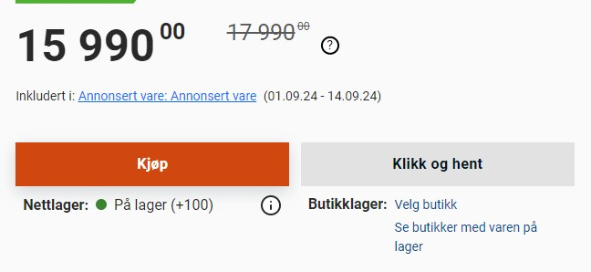
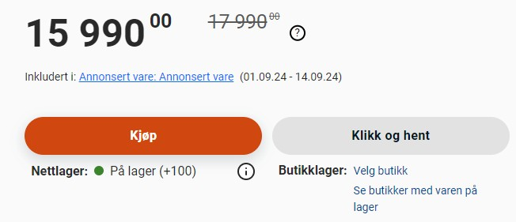
The two buttons indicate either buy, which adds to cart, or Click-and-collect, where you can pick it up in a store. Either click counts as a conversion for the purpose of this experiment.
Zoomed out, it looks like this:
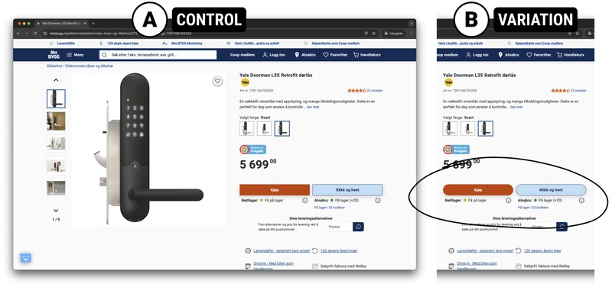
To enter your prediction, visit https://bit.ly/ABThrowdown1

Appendix C – Coupon Code Removal
A description of the motivation for this pattern is in https://experimentguide.com Chapter 2, and in Session 2 of the online course: https://bit.ly/ABClassRKLI .
The OEC is conversion rate from initiating checkout to purchase (Boolean per user), again a weighted average of the two sites. Only users who start checkout and could see the coupon code, so only they are triggered.
The following table shows prior results, which could help the prediction.
Source | Lift | Comments
Trustworthy Online Controlled  Experiments : A Practical  Guide to A/B Testing  ( https://experimentguide.com )  Chapter 2, and  https://bit.ly/ABClassRKLI | 2.8% lift to revenue/user
GoodUI pattern #1  Only the last one removed the gift card & coupon code; others made the coupon code less visible (e.g., clickable element, not field)  ( https://goodui.org/patterns/1 ) | -1.6% to sales  3.3% to sales 2.6% to sales 0.8% to sales  2.4% to sales  24% to revenue | 33K visits, p-value 0.07  20K visits, p-value 0.29  15.5K visits. p-value 0.01  3.8K visits, p-value 0.61  4.1K visits, p-value 0.21  No details on number of p-value
Evidoo pattern 136 changed  coupon to text (lower attraction) for mobile  ( https://www.evidoo.io/best-pr actices/136 ) | +4.0% | 63K visitors: There were five A/B tests from electronics, B2C gaming with 40% win ratio, 40% loss ratio
The two variants of interest are as follows:
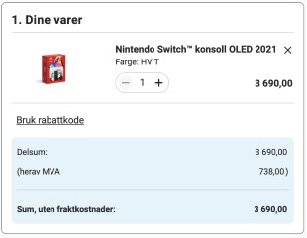
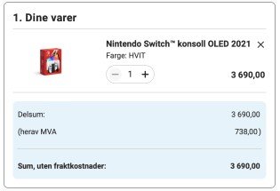
Note that the “Bruk rabattkode,” which means use discount code, is missing in the second.
We will also point out that this is not the “in your face” discount code where there is a field that takes up space and attracts the eye.
To enter your prediction, visit https://bit.ly/ABThrowdown2

