Enhanced Salience of Nonlinear Pricing and Energy Conservation

Chi Taª, Teevrat Garg^{b}, and Minkyong Koª

Abstract

Demand management has become an important strategy for utilities to address electricity production shortfalls and intermittent issues resulting from the transition to renewable energy. Many utilities apply increasing block tariffs to prevent pricing low-income households out of basic electricity access, while simultaneously discouraging wasteful overconsumption by high-income households. However, consumers' limited understanding of or attention to such complex pricing systems can result in private and socially sub-optimal behavior, rendering nonlinear pricing ineffective for energy conservation. This project aims to determine whether enhancing the understanding of energy use and nonlinear electricity pricing can help households respond to marginal pricing, thereby increasing energy conservation. We are conducting a large-scale experiment covering 45,000 users of a recently launched mobile app from a state-owned electric utility company in Vietnam. The treatment groups receive either a real-time app display of their estimated daily marginal prices or their total estimated bills to date, for a minimum of six months. To assess and compare the persistent effects of providing high-frequency nonlinear price and total cost information on consumer behavior, we will gather electricity billing data from the participants for one year before and after the experiment.

JEL: Q41, D03, D12

*Authors' name appears in random order and senior authorship is equally shared, ª Department of Agricultural and Applied Economics, Virginia Tech, ^{b} School of Global Policy and Strategy, the University of California - San Diego.

Introduction
The energy sector in low- and middle-income countries (LMICs) faces two pressing challenges: accommodating the increasing energy demand for economic growth and limiting carbon emissions from primarily coal-based electricity generation. To curb air pollution levels and enhance electricity reliability, utilities have been prompting households and businesses to lower their electricity usage. Demand management has progressively become a crucial strategy for utilities to address shortcomings in electricity production and intermittency issues from the transition to renewable energy. Many utilities employ nonlinear pricing or escalating block tariffs to prevent pricing low-income households out of basic electricity access while simultaneously discouraging wasteful overconsumption by high-income households. However, growing evidence suggests that households respond to average prices rather than marginal prices due to their misunderstanding of or lack of attention to complex nonlinear pricing (Ito, 2014). In some cases, households may mistakenly perceive the marginal price as the price they must pay for all consumption units, resulting in underconsumption and significant welfare losses (Shaffer, 2020). Therefore, the energy conservation benefits of nonlinear pricing are not well-realized. Consequently, the design of nonlinear pricing systems and efforts to enhance consumers’ comprehension of such pricing structures are crucial in realizing their potential benefits.
In this project, we have partnered with EVN Hanoi, a state-owned electric utility company in Vietnam that is the sole provider of electricity in the city of Hanoi, the second-largest city in Vietnam. We leverage its newly launched app for a large-scale randomized experiment. This experiment provides real-time price and total cost information via the app's display to a sample of residential customers in Hanoi. We aim to study whether an enhanced understanding of energy use and nonlinear electricity pricing can prompt households to respond to marginal pricing and consequently save more electricity. Specifically, we examine three questions: (1) Does frequent information about electricity prices help households respond more effectively to marginal prices and alter their electricity consumption? (2) Which type of information has a stronger impact on consumer behavior - marginal electricity prices or total electricity bills? (3) How do households' responses to daily information about prices and bills evolve over time?
The project contributes to the existing literature in several ways. First, inattention and imperfect information are acknowledged as contributors to excessive resource usage, and many studies suggest that nudges -- for example. regular updates on pricing and usage -- could foster energy conservation (Allcott and Mullainathan, 2010; Gilbert and Graff Zivin, 2014; Tiefenbeck et al., 2018). Our study enhances this concept by integrating these nudges into a nonlinear pricing context, to discern whether frequent updates on electricity usage and its corresponding nonlinear pricing can induce a more effective response to marginal prices, thereby reducing overall electricity consumption. Stojanovski et al. (2020) align with our study's goal, demonstrating that a one-time, in-person information provision can motivate households to decrease their electricity usage under a nonlinear pricing schedule. Unlike their approach, we provide households with frequent updates on electricity usage and prices over a prolonged period. Conversely, Jessoe and Rapson (2014) found that price salience did not affect electricity conservation, even with regular information updates. Our study delves deeper by offering information about a nonlinear pricing structure and probing how such detailed pricing salience impacts customers' energy consumption behaviors.
Second, this project involves the use of digital tools, such as a mobile app and smart meter data, to provide real-time energy, price, and billing information. The digitalization of our everyday lives simplifies access to information and can help individuals overcome bias and align their actions more closely with their preferences (Tiefenbeck et al., 2018). Our intervention employs this technology, addressing the information cost issues associated with nonlinear pricing. With the recently launched app, communication with customers has become much easier and cheaper. Moreover, many customers now have smart meters, enabling utility companies to share frequent consumption data with them. This data provides immediate feedback that assists customers in their conservation efforts. Therefore, this study benefits from the availability and practicality of digital data, contributing to a more comprehensive examination of both the intervention and energy consumption patterns.
Third, this project examines the effects of price salience over varied durations. Gilbert and Graff Zivin (2014) discovered that consumers are most responsive to electricity prices immediately after receiving their bills. However, this responsiveness diminishes over time as the information becomes less prominent. This 'recency effect' of information provision is also highlighted by Allcott and Todd (2014). Therefore, it is crucial to evaluate both the short-term and long-term impacts of interventions, as well as how these impacts differ over diverse durations. Assuming the price is dependent on the total electricity use in a billing cycle and not on the day of use, we are keen to observe i) whether households "temporarily" reduce consumption during the last few days of the billing cycle when the in-app displayed electricity price is at its peak and ii) whether households balance their consumption over a billing cycle after "permanently" comprehending the price structure.
Fourth, further research into energy consumption behavior, especially in the context of developing countries, is urgently needed to address the dual issues of providing sufficient energy to promote economic development while limiting emissions from the energy sector. This is especially true for research employing technology such as smart meters almost exclusively focused on high-income countries with little understanding of such information and technology in low- and middle-income countries where these investments are nonetheless being pursued. Our project seeks to bridge this gap by centering our study on Hanoi, a city experiencing rapid economic growth, rising middle-class prosperity, and an increasing demand for electricity-intensive appliances. The city's issues with high per capita electricity consumption and energy constraints, resulting in frequent blackouts, make it representative of urban areas in developing countries expected to experience a surge in energy use. With Hanoi's context embodying the energy issues faced by many developing countries, the insights gained from this study have the potential to inform and shape sustainable growth policies beyond Vietnam.
EVN Hanoi serves the entire city of Hanoi, encompassing 2.8 million customers, the majority of whom are equipped with smart meters that record and transmit consumption data to the company's database daily. Among the 2.8 million smart meter users, 30% have installed the app, offering us a substantial sample size. We randomly select a sample of 45,000 households and split them equally into one control group and two treatment groups. Every household, including those in the control group, receives information about their past and present daily electricity usage via the electric utility company's app. The first treatment group is given daily updates about the estimated electricity prices for their last unit of consumption in each billing cycle, through the app's interactive display. The second treatment group receives information about their projected up-to-date electricity bill, also through the app's interactive display. By randomizing the groups, we are able to estimate the average treatment effect of an enhanced understanding of nonlinear pricing on consumers' energy consumption.
The remainder of this pre-analysis plan is structured as follows. Section 1 provides background information about the research setting; Chapter 3 outlines our experimental design. In Chapter 4, we detail the data collection process. Our planned analysis is presented in Chapter 5, and finally, the timeline and concluding remarks.
- Research setting
  - Background of Vietnam’s energy use
Vietnam is experiencing a surge in energy consumption due to various influential factors. The country's significant economic growth has led to an increase in household incomes, which in turn is contributing to the emergence of a middle class with changing lifestyle preferences. This economic shift has led to a marked increase in the ownership and use of electronic devices, including computers, smartphones, and televisions. The hot and humid weather that is characteristic of Vietnam further drives the demand for cooling appliances such as air conditioners, particularly during the wet seasons. The humid conditions also lead to the use of dehumidifiers and other appliances aimed at improving indoor comfort, further adding to energy consumption. As energy consumption continues to rise, Vietnam faces the twin challenges of meeting the growing energy demands and coping with energy constraints, which manifest into rolling blackouts and intermittent electricity access, a scenario common in many developing countries.
Vietnam has implemented a nonlinear pricing structure that comprises six price tiers determined by consumption quantity as shown in Table 1. This pricing structure is universal across the country and is operated by the state-owned Vietnam Electricity (EVN) group and its subsidiaries. Its purpose is to incentivize consumers to manage their electricity use wisely, thereby allowing lower-income households to access electricity at more affordable rates while placing the burden of higher prices on excessive consumption. This approach has the potential to be an effective instrument in addressing the aforementioned challenges in terms of assigning higher prices to higher consumption levels. However, understanding this structure can be challenging for customers, as noted by Ito (2014). EVN frequently faces customer complaints since they do not understand why their bills are so high. Given the difficulty and lengthy process of changing tariffs politically, improving customer understanding of multi-tiered pricing systems becomes crucial.
Our sample population will be households in Hanoi, the capital and second-largest city of Vietnam. With its expanding economy, a diverse population ranging from low-income to wealthy individuals, and energy challenges that reflect broader national issues, Hanoi serves as a relevant and informative representative sample. A subsidiary of the EVN, EVN Hanoi, serves the city, providing approximately 2.8 million customers. Notably, 90% of these customers are equipped with smart meters, which send consumption data to the company's database daily, and 30% have adopted the utility's app, facilitating direct communication between the company and its users. This tech-inclined segment who already installed the app forms our study's sample.
Given these attributes, our dataset from Hanoi is indicative of urban areas where energy consumption is expected to address the grid balancing problem, reduce power outages, and achieve a reduction in emissions. Thus, this project will address the sustainable growth policy challenges faced by Vietnam and by other developing countries that might follow suit.

Table 1. Nonlinear Pricing Structure Implemented by EVN Hanoi, Vietnam
Tier | Electricity usage (kWh) | Marginal electricity cost (Dong/kWh)
1 | 0-50 | 1,728
2 | 51-100 | 1,786
3 | 101-200 | 2,074
4 | 201-300 | 2,612
5 | 301-400 | 2,919
6 | 401- | 3,015

  - Sampling
We obtain monthly consumption data for 700,000 households from the EVN Hanoi utility company, covering the period from August 2022 to July 2023. These households represent all app users of EVN Hanoi. To ensure data quality, we exclude households with more than 15% missing daily data from May 2023 to July 2023. We also exclude households that had participated in other experiments, reducing our dataset to about 400,000 households.
Our study focuses on evaluating the impact of marginal price salience on energy consumption. In our experimental context, the highest price tier applies when monthly energy use exceeds 400 kWh. Conversely, the lowest price tier is applicable when consumption is at or below 50 kWh. As such, households consuming significantly more than 400 kWh/month or significantly less than 50 kWh/month will not be affected by our marginal price intervention. To enhance the statistical power of our study, we limit our sample to households with monthly energy usage ranging from 10 to 1000 kWh. Please note that less than 1% of all 700,000 app users consume less than 10 kWh monthly, and only 2% consume 1,000 kWh or more. We have also excluded households with missing data for any month over a twelve-month span. As illustrated in Figure 1, a comparison of the histograms of all 700,000 app users to those of the 400,000 users after exclusion shows a strong similarity. This suggests that, despite the removals, the data sample remains representative.

Figure 1. Distribution of Monthly Electricity Use among App Users
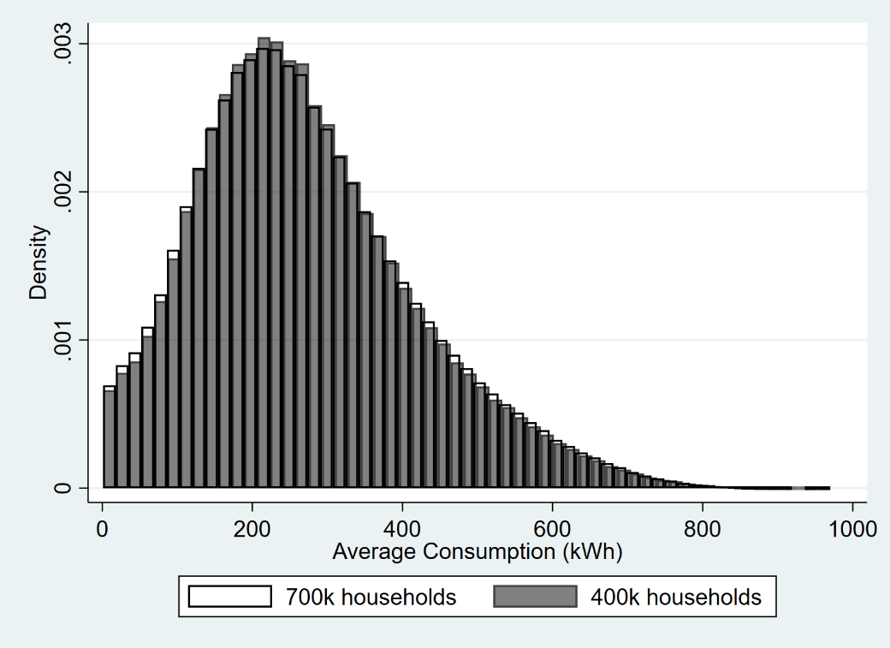

Hence, our study's final sample comprises 45,000 households, which are randomly distributed into three equal-sized groups. The first group serves as a control, not receiving any specific information about the nonlinear pricing of electricity. The other two groups are our treatment subjects, receiving information about their projected electricity pricing during the six-month treatment periods: one group receives real-time pricing information and the other receives real-time billing information. In terms of potential attrition, we anticipate minimal withdrawal given that there is no cost for households to remain in the study. Reminder notifications can be turned off and households can simply choose to stop exerting effort to conserve energy rather than leave the study. However, reductions in effort are not attrition and indeed the outcome we want to study.
To choose the sample size of our study, we use data from our pilot study from December 2022 to May 2023. We then use the following equation to calculate the appropriate sample size for our study:
$$J=\frac{{\left(t_{1-κ}+t_{\frac{α}{2}}\right)}^{2}}{P\left(1-P\right)}\frac{σ^{2}}{MDE^{2}} \left(ρ+\frac{1-ρ}{T}\right)$$
where
- $J$ is the sample size
- $κ$ is the probability of correctly rejecting a false null or the power
- $α$ is the probability of a type I error
- $t_{\frac{α}{2}}$ and $t_{1-κ}$are the critical values of $t$distributions
- $MDE$ or the mean detectable effect is the smallest effect size where an effect can still be detected if there is one

- $P$ is the proportion of the sample that is treated
- $σ^{2 }$is the variance of the treatment effect estimator
- $ρ$ is the intracluster correlation coefficient
- $T$ is the length of the experiment in days

We set $κ$ to 0.80, or 80%, and $α$ to 0.05, or 5%, values typically used for these calculations. The proportion of the sample that is treated is 50%. We use the pilot data to calculate the variance of the outcome variable and intraclass correlation coefficient $ρ$= 0.566. For sensitivity, we vary $σ$ from 0.05 to 0.5. For the low variance $σ^{2}$ = 0.05, to detect $MDE=1\%,$ the required sample size of each treatment and control group is 6,011. For the high variance $σ^{2}=0.5,$to detect $MDE=2.5\%$, the required sample size of each treatment and control group is 9,617.

- Experiment Design
The experiment will be conducted on a subset of EVN Hanoi's customers, who have installed the utility's app. The app displays each household’s daily consumption, and it compares customers’ current and past consumption levels. We collaborate with I-Com, EVN Hanoi’s app developer, to develop functionality on the mobile app to assign treatments to different groups and to provide households with our designed and customized messages and information. Specifically, we will take the universe of households who have installed the app as our population interest and randomly select and assign 45,000 households into a control and two treatment groups. The first and second treatment groups will receive real-time pricing and real-time billing information, respectively. The intervention strategies applied to each group are summarized in Table 2.
Control Group: This group will receive push notifications about their daily consumption twice a week for one month. For instance, the push notification will display the following message: "Your current electricity consumption is 345 kWh". However, they will not be provided with any interactive display for daily electricity prices and up-to-date bills. Figure 2A shows the app interface of the control group.
Real-time Price Treatment: During the six-month treatment period from September 29, 2023, to February 28, 2024, households will receive information regarding their estimated electricity prices for each unit of consumption in their current billing cycle via the app's interactive display. Households will also receive a push notification twice a week for one month (Sep 29, 2023 – Oct 29, 2023). Figure 2B presents an example of the redesigned interactive display, visually representing the nonlinear pricing system, as compared to the original interface shown in Figure 2A. The graph in Figure 2B highlights the primary intervention, allowing customers to visualize their current energy consumption along with the corresponding marginal price on a real-time six-tier graph. The design's objective is to help participants better understand this pricing structure. An example of a push notification would say: "Your current electricity price at level 3 is 2,834 VND/kwh. If you exceed an additional 28 kwh, your electricity price will increase to level 4, which is 2,927 VND/kwh."
Real-time Bill Treatment: In this treatment, similar to the price proficiency treatment, households will receive information regarding their estimated, up-to-date electricity usage and bill each day of their current billing cycle through the app's interactive display, as well as through push notifications twice a week. The push notifications will be sent over one month, while the app's interactive display will remain active for six months. Figure 2C showcases the interactive interface for this treatment. Unlike Treatment Group 1, this treatment provides users with a simple daily display of total energy costs. Households in this group can view a semicircular gauge on their app, visually representing energy consumption. As energy usage escalates over time, the gauge fills up, transitioning its color from blue (signifying low consumption) to red (signifying high consumption). An example of a push notification would read: "Your current electricity consumption is 190 kWh and your bill to date is 380,000 VND."

Figure 2. App Interface Variations: Control Group vs. Treatment Groups
A. Control B. Treatment 1 C. Treatment 2
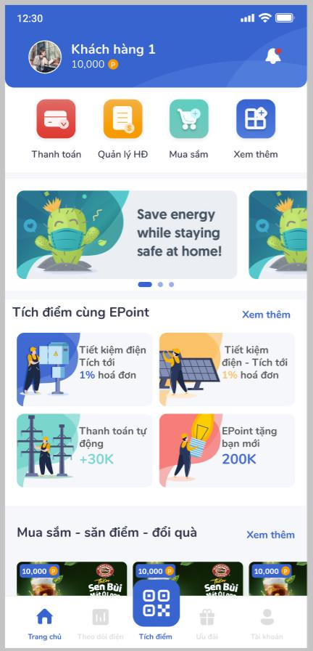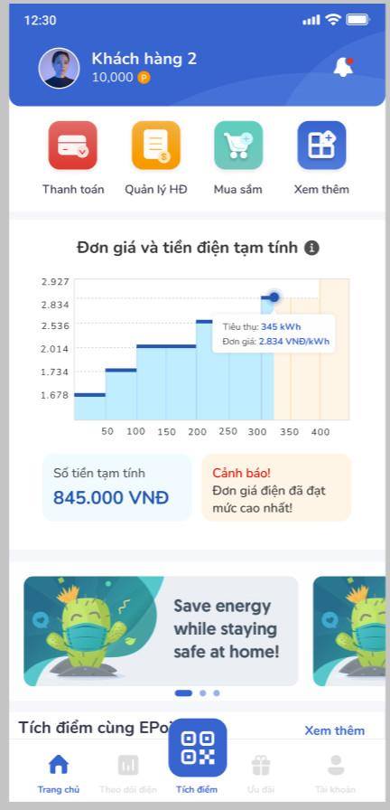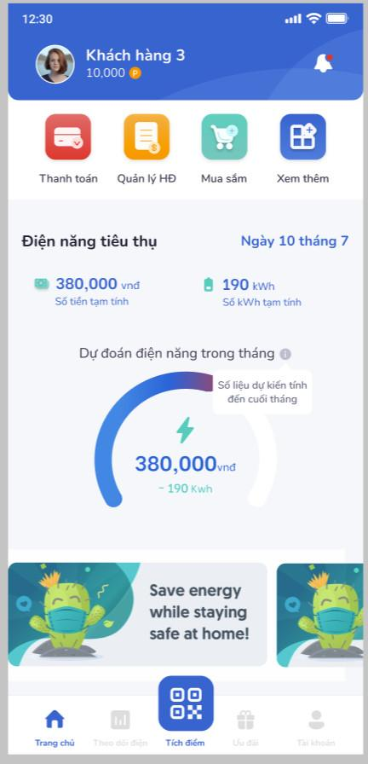

Note: The control group (Panel A) does not have access to price or usage information on the app's main page. In contrast, the interface for Treatment Group 1 (Panel B) has been redesigned for a more visually intuitive understanding of the nonlinear pricing system. The app display for Treatment Group 2 (Panel C) offers users a vivid day-by-day visual of their accumulating energy costs.

Table 2. Intervention Strategies by Groups
Note: An "X" in a cell indicates treatment received, and a dash ("-") indicates no treatment. In this experiment, all groups, including the control group receive information on daily energy consumption and bill-to-date in numeric form.

 | Intervention
Group | Participants are to be provided marginal price info on their app display for 6 months | Participants are to be sent push notifications for 1 month | Participants provided total cost info on their app display for 6 months
Control  (15K households) |  | X | -
Treatment 1  (15K households) | X | X | -
Treatment 2  (15K households) | - | X | X

2.1 Randomization Process
We determine that a sample size of 45,000 households is ideal, based on our power calculation results and budget. We randomly select this group of 45,000 households and check the balance with the remaining households to ensure the representativeness of the sample. Following the confirmation of the balance check (Tables 3 and 4), the 45,000 households are evenly divided into three separate groups: one control group and two treatment groups with 15,000 households each. A final balance check is performed on these groups. If any group shows signs of imbalance, re-randomization is conducted. Once the balance is confirmed (Tables 5 and 6), the randomized assignment is finalized for the experiment. Table 7 shows the distribution of consumption in tiers.

Table 3: Balance analysis: mean comparisons between 45K and the rest of the sample
Month | Rest of Sample  Mean | 45K  Coeff. | 45K  P-value
Aug22 | 348.213 | .521 | .6
Sep22 | 322.361 | .229 | .803
Oct22 | 274.245 | -.211 | .789
Nov22 | 235.904 | .091 | .892
Dec22 | 236.328 | -.298 | .654
Jan23 | 251.303 | .139 | .854
Feb23 | 257.33 | .308 | .683
Mar23 | 219.841 | -.194 | .759
Apr23 | 246.716 | -.021 | .976
May23 | 258.163 | .029 | .968
Jun23 | 361.664 | -.717 | .474
Jul23 | 349.073 | -.316 | .747
Average | 280.095 | -.037 | .959
Note: An observation is a household. All variables are defined at the household level. The last two columns report the coefficients and p-values from OLS regression on indicators for the 45K group.

Table 4: Kolmogorov-Smirnov tests between 45K and the rest of the sample
Month | Control vs Treatment1
Aug22 | .708
Sep22 | .242
Oct22 | .747
Nov22 | .553
Dec22 | .944
Jan23 | .916
Feb23 | .91
Mar23 | .65
Apr23 | .953
May23 | .728
Jun23 | .461
Jul23 | .515
Average | .868
Note: An observation is a household. All variables are defined at the household level. The second column reports the combined corrected p-values of a Kolmogorov-Smirnov equality-of-distributions test.

Table 5: Balance analysis: mean comparisons across control and treatment groups
Month | Control  Mean | Treatment1  Coeff. | Treatment1  P-value | Treatment2  Coeff. | Treatment2  P-value | F-test  P-value
Aug22 | 348.713 | -0.901 | 0.691 | 0.963 | 0.671 | 0.713
Sep22 | 323.2 | -1.718 | 0.411 | -0.115 | 0.956 | 0.656
Oct22 | 274.544 | -1.109 | 0.537 | -0.422 | 0.814 | 0.823
Nov22 | 236.5 | -1.313 | 0.383 | -0.203 | 0.893 | 0.644
Dec22 | 236.601 | -1.2 | 0.427 | -0.512 | 0.735 | 0.728
Jan23 | 251.501 | -0.6 | 0.727 | 0.42 | 0.807 | 0.837
Feb23 | 257.5 | -0.334 | 0.847 | 0.748 | 0.665 | 0.814
Mar23 | 220.253 | -1.636 | 0.256 | -0.184 | 0.898 | 0.462
Apr23 | 247.173 | -1.103 | 0.484 | -0.33 | 0.834 | 0.773
May23 | 258.912 | -1.456 | 0.37 | -0.705 | 0.664 | 0.668
Jun23 | 361.402 | -1.019 | 0.654 | -0.347 | 0.879 | 0.902
Jul23 | 348.72 | -0.619 | 0.782 | 0.728 | 0.744 | 0.833
Average | 280.418 | -1.084 | 0.51 | 0.003 | 0.998 | 0.748
Note: An observation is a household. All variables are defined at the household level. Columns 3-6 report the coefficients and p-values from OLS regression on indicators for treatment groups 1 and 2. Column 7 reports the p-value from a joint test of the statistical significance of two indicators.

Table 6: Kolmogorov-Smirnov tests across control and treatment groups
Month | Control vs Treatment1 | Control vs Treatment2
Aug22 | 0.708 | 0.775
Sep22 | 0.242 | 0.452
Oct22 | 0.747 | 0.916
Nov22 | 0.553 | 0.793
Dec22 | 0.944 | 0.998
Jan23 | 0.916 | 0.737
Feb23 | 0.91 | 0.62
Mar23 | 0.65 | 0.64
Apr23 | 0.953 | 0.852
May23 | 0.728 | 0.876
Jun23 | 0.461 | 0.728
Jul23 | 0.515 | 0.63
Average | 0.868 | 0.765
Note: An observation is a household. All variables are defined at the household level. Columns 2 and 3 report the combined corrected p-values of a Kolmogorov-Smirnov equality-of-distributions test.

Table 7: Distribution of Consumption in Tiers
Tier | Energy usage (kWh) | Control |  | Treatment1 |  | Treatment2 |  | Total
Tier | Energy usage (kWh) | Obs. | % | Obs. | % | Obs. | % | Obs. | %
1 | 0-50 | 276 | 1.84 | 308 | 2.05 | 297 | 1.98 | 881 | 1.96
2 | 51-100 | 861 | 5.74 | 866 | 5.77 | 840 | 5.60 | 2,567 | 5.70
3 | 101-200 | 3,639 | 24.26 | 3,690 | 24.60 | 3,710 | 24.73 | 11,039 | 24.53
4 | 201-300 | 4,504 | 30.03 | 4,393 | 29.29 | 4,424 | 29.49 | 13,321 | 29.60
5 | 301-400 | 2,912 | 19.41 | 2,969 | 19.79 | 2,891 | 19.27 | 8,772 | 19.49
6 | 401-600 | 2,355 | 15.70 | 2,339 | 15.59 | 2,402 | 16.01 | 7,096 | 15.77
Above 6 | 601-801 | 437 | 2.91 | 419 | 2.79 | 425 | 2.83 | 1,281 | 2.85
Above 6 | 801- | 16 | 0.11 | 16 | 0.11 | 11 | 0.07 | 43 | 0.10
Total |  | 15,000 | 100.00 | 15,000 | 100.00 | 15,000 | 100.00 | 45,000 | 100
Note: Table 7 displays the distribution of consumption across tiers after the randomization, showing the number of observations and their respective percentage share within each tier and group. The electricity utility in Vietnam (EVN) officially operates on a six-tier pricing system; any usage beyond this is categorized as "above 6".

2.2 Timeline
Figure 3 outlines our experiment's timeline, scheduled to occur from end-September 2023. The experiment will start on September 29th for all groups simultaneously. Treatment groups 1 and 2 will get a push notification paired with a redesigned app interface that visualizes either daily estimated marginal information or total cost information, respectively. Meanwhile, the control group will receive a push notification revealing their usage amounts and will interact with the traditional app interface, which lacks further pricing information. The intervention period for all groups will involve sending push notifications for one month and providing differentiated app interfaces anticipated to last between six months and one year.
Figure 3: Experimental Timeline

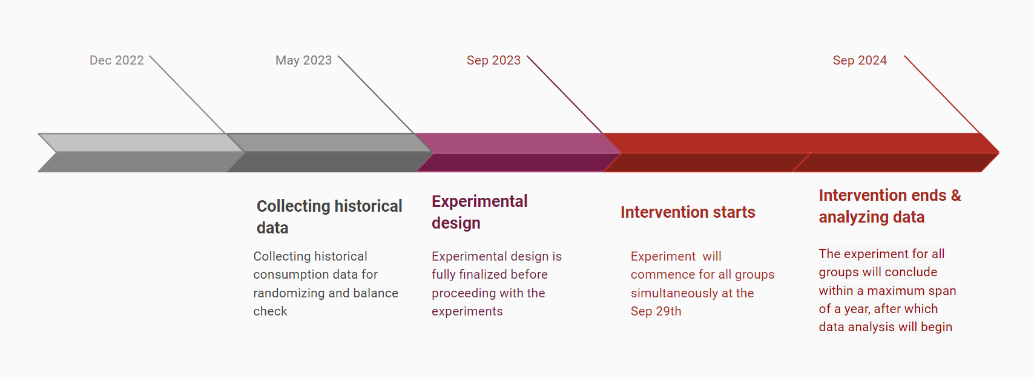

- Data
The data for this study is collected through a partnership with EVN Hanoi, a state-owned electric utility company in Vietnam, and I-Com, the app developer of EVN Hanoi. Specifically, we construct a household panel dataset by combining the following data sources to conduct our empirical analysis. Our data spans considerable periods. We use historical consumption data dating back 12 months prior to the intervention and will continue to track electricity consumption. This monitoring period is anticipated to last approximately a year. This lengthy observational period strengthens the validity of our study by capturing the potential long-term effects of the intervention.
The main outcome variable is electricity consumption at the household level. The smart meters provide an accurate measurement of energy usage and are capable of recording consumption data at regular intervals (e.g., monthly or daily). The dataset is obtained from EVN Hanoi, and includes historical data prior to the intervention, as well as consumption data throughout and after the treatment period.
Next, in collaboration with I-Com, we collect data on the usage of the mobile app by the participating households. This includes information on the frequency and duration of app usage, as well as the push notification receipt. This data allows us to analyze the engagement levels of the households with the app and assess the effectiveness of the app in improving the households' understanding of their energy consumption and nonlinear pricing. We will also obtain billing data from EVN Hanoi for the participating households, which includes information on the billed electricity consumption, the corresponding charges, and payment records for each household. Using this information, we can analyze the impacts of the intervention on on-time bill payments and delinquency rates, as well as validate consumption data obtained from smart meters.
In addition to the primary datasets, further information will be gathered on weather data and street-level characteristics (i.e., local housing prices) for heterogeneity analysis and to improve the statistical power of our study. Factors such as temperature or precipitation inevitably affect electricity consumption as households adjust their use of air conditioners or heaters. Moreover, given the lack of direct data on individual household characteristics, street-level housing prices will be used as a proxy for the socioeconomic status of the neighborhood, which may correlate with electricity consumption patterns.
- Empirical Analysis
4.1 Balance Check
Before implementing our intervention, we performed the balance check by comparing the pre-treatment characteristics of the households in the treatment and control groups. Specifically, we will leverage historical electricity usage data and household size for this purpose. Our analysis includes around 45,000 households in Hanoi, a sizable sample that lends itself well to robust randomization. To this end, we employ computer-generated random numbers to evenly distribute households among the control, treatment group 1, and treatment group 2.
We then verify the balance of our assignment using the following regression:

$$y_{i}=β_{0}+\sum_{k∈\left\{1,2\right\}}{}1\left\{treatment_{i}=k\right\}β_{k}+ε_{i},$$

where $y_{i}$ denotes the household $i$'s pre-intervention characteristics, such as historical electricity consumption and household size; $treatment_{i}$ is a binary variable that represents whether household $i$ is assigned to treatment 1 or treatment 2, and $ε_{i}$ signifies the error term. Note that this regression excludes indicators for the control group. In our balance analysis, we report estimates for the coefficients of $β_{k}$, their standard errors, and the p-value from a joint test of the statistical significance of all coefficients on the treatment indicators. Additionally, we apply the Kolmogorov-Smirnov test to continuous variables, such as electricity consumption, to compare distributions between each treatment group and the control group. The null hypothesis in these tests will be that the distributions are identical.
4.2 Treatment Effects
In this experiment, we will estimate the average treatment effect of two distinct interventions. Treatment group 1 is exposed to the salience of nonlinear pricing, while treatment group 2 receives emphasis on daily energy costs. All of our participants have already downloaded the app and have been randomly allocated to one of the three groups. This random allocation ensures that each group is statistically comparable in every aspect, except for the distinct treatment they receive. To measure these treatment effects, we will run the following regression:

$$y_{i}=β_{0}+\sum_{k∈\left\{1,2\right\}}{}1\left\{treatment_{i}=k\right\}β_{k}+X_{i}'γ+ε_{i},$$

where $y_{i}$ is the natural logarithm of the electricity consumption of household $i$ during the study period. A dummy variable $treatment_{i}$ indicates the assignment of household $i$ to treatment group $k$. $X_{i}$ is a vector of control variables that captures other factors influencing electricity consumption, such as weather; $ε_{i}$ is the error term clustered at the household level.
In this specification, the parameters $β_{k}$ capture the average effect of the respective treatments on electricity consumption. For example, $β_{1}$ would measure the average change in electricity consumption for households in treatment group 1 relative to the control group, while $β_{2}$ would capture the corresponding effect for treatment group 2.
Note that our key dependent variable is logged electricity energy use. Taking the log in our study offers several advantages. Given the likely wide variations and skewness in household energy use, the log transformation aids in normalizing this distribution and minimizing the impact of extreme values. Furthermore, it allows for an interpretation of the coefficients as percentage changes, providing more intuitive insights into the effects of our interventions. Another advantage is the reduction of outcome variance. This reduction enhances the statistical power of our analysis, enabling us to detect smaller effects and increasing the likelihood of identifying meaningful relationships between the independent variables and energy use. However, there are potential concerns with this approach, particularly the issue of zero consumption. Since the logarithm of zero is undefined, households with zero electricity consumption could create issues in the analysis. One way to address this issue is to apply an inverse hyperbolic transformation, which has similar properties to the log transformation but accommodates zero values. For robustness checks, we will also consider using this transformation. In addition, we will also examine energy consumption in its raw form - levels, not logarithms. However, this approach may be more sensitive to extreme values and may not manage non-linearity as effectively as logarithmic transformations.
4.3 Heterogeneous Treatment Effects
Furthermore, we extend the basic model to study the heterogeneous treatment effects such as the number of days after billing payment or reminders, the frequency of app usage during the treatment period, and seasonal or holiday effects. These elements could influence the households' responsiveness to the intervention.
This involves incorporating interaction terms between the treatment indicators and time variables such as the day of the billing cycle and the month of the billing cycle. The inclusion of these interaction terms allows us to understand whether and how the treatment effect varies over different timescales. For instance, the time elapsed since the bill payment and last reminder might significantly affect a household's energy usage. We expect immediate responses might be more potent compared to later responses, where the effect of the reminder might diminish.
To capture these heterogeneous treatment effects, we will add interaction terms to our regression model for each of these variables:

$$y_{i,t}=β_{0}+\sum_{k∈\left\{1,2\right\}}{}\sum_{τ=0}^{\underline{t}-1}{}1\left\{treatment_{i}=k\right\}⋅1\left\{{billingcycles}_{t}=τ\right\}β_{k,τ}+X_{i}'γ+ε_{i,t},$$

$$y_{i,t}=β_{0}+\sum_{k∈\left\{1,2\right\}}{}\sum_{τ=0}^{\underline{t}-1}{}1\left\{treatment_{i}=k\right\}⋅1\left\{{billingcycles}_{t}=τ\right\}β_{k,τ}+X_{i}'γ+ε_{i,t},$$

where${ y}_{i, t}$ is a log of daily electricity consumption at the household level during the treatment period, and $\underline{t}$is the number of days between billing cycles (or reminders). Here, $τ$ refers to days since the last bill payment (or reminders).
Similarly, we will also consider the holiday periods or seasons as well as the number of times the household opens the app during the treatment period as these factors may also influence consumers’ response. Frequent app users might be more responsive to price information and, consequently, adjust their electricity consumption more effectively.
- Conclusion
In this project, we investigate whether real-time price information improves consumers' responses to nonlinear pricing systems and promotes efficient energy use. We focus on three research questions that address the effects of frequent electricity price information, which information has a greater effect on consumers between marginal prices, total bills, or average prices, and how these household responses shift over time.
In collaboration with EVN Hanoi, Vietnam's state-owned electric utility company, we will conduct a large-scale randomized controlled trial. Our experimental design includes a control group and two treatment groups. The first treatment group will receive daily interactive app updates on the estimated prices for their most recent unit of consumption. Meanwhile, the second group will get updates on their cumulative up-to-date electricity bill through the same app interface.
We intend to contribute to the existing body of research by integrating behavioral nudges with nonlinear pricing strategies and utilizing digital tools for real-time price information.
Furthermore, we aim to examine the temporal effects of these interventions within the setting of a rapidly developing country facing increasing energy demands. By providing households with a clear understanding of their consumption costs, we expect to promote more sustainable energy usage patterns in consumers and policy development in the sector.

Reference

Allcott, H., & Mullainathan, S. (2010). Energy. Behavior and energy policy. Science, 327(5970), 1204-1205.

Allcott, H., & Rogers, T. (2014). The Short-Run and Long-Run Effects of Behavioral Interventions: Experimental Evidence from Energy Conservation. American Economic Review, 104(10), 3003-3037.

Allcott, H., & Kessler, J. B. (2019). The Welfare Effects of Nudges: A Case Study of Energy Use Social Comparisons. American Economic Journal: Applied Economics, 11(1), 236-276.

Andor, M. A., Gerster, A., Peters, J., & Schmidt, C. M. (2020). Social Norms and Energy Conservation Beyond the US. Journal of Environmental Economics and Management, 103, 102351.

Brent, D. A., & Ward, M. B. (2019). Price perceptions in water demand. Journal of Environmental Economics and Management, 98, 102266.

Gilbert, B., & Graff Zivin, J. (2014). Dynamic salience with intermittent billing: Evidence from smart electricity meters. Journal of Economic Behavior &amp; Organization, 107, 176-190.

Gillingham, K., & Tsvetanov, T. (2018). Nudging energy efficiency audits: Evidence from a field experiment. Journal of Environmental Economics and Management, 90, 303-316.

Grubb, M. D., & Osborne, M. (2015). Cellular Service Demand: Biased Beliefs, Learning, and Bill Shock. American Economic Review, 105(1), 234-271.

Henry, M. L., Ferraro, P. J., & Kontoleon, A. (2019). The behavioural effect of electronic home energy reports: Evidence from a randomised field trial in the United States. Energy Policy, 132, 1256-1261.

Ito, K. (2014). Do Consumers Respond to Marginal or Average Price? Evidence from Nonlinear Electricity Pricing. American Economic Review, 104(2), 537-563.

Jessoe, K., & Rapson, D. (2014). Knowledge is (Less) Power: Experimental Evidence from Residential Energy Use. American Economic Review, 104(4), 1417-1438.

Kahn, M. A. W., Frank. (2013). Using Information to Improve the Effectiveness of Nonlinear Pricing: Evidence from a Field Experiment. Working Paper.

Knittel, C. R., & Stolper, S. (2021). Machine Learning about Treatment Effect Heterogeneity: The Case of Household Energy Use. AEA Papers and Proceedings, 111, 440-444.

Shaffer, B. (2020). Misunderstanding Nonlinear Prices: Evidence from a Natural Experiment on Residential Electricity Demand. American Economic Journal: Economic Policy, 12(3), 433-461.

Stojanovski, O., Leslie, G. W., Wolak, F. A., Huerta Wong, J. E., & Thurber, M. C. (2020). Increasing the energy cognizance of electricity consumers in Mexico: Results from a field experiment. Journal of Environmental Economics and Management, 102, 102323.

Tiefenbeck, V., Goette, L., Degen, K., Tasic, V., Fleisch, E., Lalive, R. et al. (2018). Overcoming Salience Bias: How Real-Time Feedback Fosters Resource Conservation. Management Science, 64(3), 1458-1476.

Wichman, C. J. (2017). Information provision and consumer behavior: A natural experiment in billing frequency. Journal of Public Economics, 152, 13-33.

Nauze, A. L., & Myers, E. (2023). Do Consumers Acquire Information Optimally? Experimental Evidence from Energy Efficiency. Working Paper.

Ito (2014) said that the information cost of understanding the marginal price of electricity is likely to be substantial in terms of i) monthly utility bills do not provide relevant information on the nonlinear structure of the pricing, and ii) difficulties in monitoring cumulative consumption during a billing month.
The trends in energy consumption put the city at the top of the nation in terms of electricity consumption per person.
The absence of daily data is primarily due to temporary technical issues, which include meter failures, errors during data transfer, storage, and backups. This could also be attributed to households discontinuing services, taking long-term vacations, or the fact that the homes are rental or vacation units.

