Survey A - Prebunking for democracy

Start of Block: Consent

consent Take part in a digital training session on spotting mis/disinformation

You are invited to attend a short training session called “Fact or Fake? Empower Yourself and Others Against Misinformation”, delivered by XXX, a multi-award-winning organisation specialising in media and political literacy. This training is part of a research project, led by researchers from the University of XXX, XXX University, and XXX. We are studying how people recognise and check information online.

Before the training, we ask you to complete a short survey about yourself and your views on misinformation and online information checking. The survey takes up to 15 minutes, and the training session lasts up to 1 hour.

Your data and privacy
Your answers are completely confidential. Only the research team will see your individual responses. Any data shared with other researchers will be fully anonymized. Your information will not be shared with third parties.

Risks and approval
There are no risks associated with taking part. This research has been approved by the University of XXX Research Ethics Committee.

Your rights
Taking part is entirely voluntary. You can stop the survey at any time without giving a reason. You can also choose not to take part at all.

Prize draw
If you complete the survey and attend the training session, you will enter a prize draw to win a £300 Amazon voucher.

Contact: If you have any questions, please contact XXX at XXX .
Do you agree to take part in this study, which includes a digital training session?
- No (1)
- Yes (2)

Page Break

End of Block: Consent

Start of Block: Workshop_interest

hear_survey. How did you first hear about this training session? (Select all that apply)
- Social media (e.g. Facebook, LinkedIn) (1)
- Direct message/ email (e.g. WhatsApp, Telegram, email, newsletter) (2)
- Barnet Council communications (e.g. Barnet Homes, At-Home Magazine, Barnet First, Barnet Post, internal communications) (3)
- Community channels (e.g. resident panels, engagement panels, community newsletter, link workers, community groups) (4)
- In-person outreach/event (e.g. poster/flyer, community event/workshop) (5)
- Employment/training networks (e.g. BOOST, Barnet Get Online Network) (6)
- Other (please specify): (7) __________________________________________________

Page Break

Workshop interest. Thank you for your interest in the “Fact or Fake?” training. Before continuing, please confirm that you are willing to take part in a session of up to 1 hour, held in person or online.
- No (1)
- Yes (2)

End of Block: Workshop interest

Start of Block: Demographics

age How old are you?
Please select (1)
▼ 17 (1) ... 99 (83)

gender What is your gender?
- Woman (1)
- Man (2)
- Other (3)
- Prefer not to say (-1)

education What is the highest education level that you have completed or about to complete?
- No qualifications / Primary (1)
- Secondary school., e.g. GCSE, Nationals (2)
- A-Levels / Highers (or equivalent) (3)
- Apprenticeship / Vocational / College (4)
- Undergraduate degree (5)
- Postgraduate (Master’s/PhD) (6)
- Prefer not to say (-1)

Page Break

ethnic background. Ethnic background
- White (1)
- Mixed / Multiple ethnic groups (2)
- Asian / Asian British (3)
- Black / African / Caribbean / Black British (4)
- Other (5)
- Prefer not to say (6)

postcode Postcode area (first part only, e.g., EN4):
________________________________________________________________

Page Break

employment status. Employment status
- Employed full-time (1)
- Employed part-time (2)
- Self-employed (3)
- Student (4)
- Unemployed (5)
- Other (6)
- Prefer not to say (-1)

household income. Annual gross household income (before taxes, including all benefits)
- <£20k (1)
- £20–39k (2)
- £40–59k (3)
- £60–79k (4)
- £80–99k (6)
- £100k+ (7)
- Prefer not to say (-1)

Page Break

vote intention. If a UK General Election were held tomorrow, which party would you vote for?
- Labour Party (1)
- Conservative Party (2)
- Reform UK (3)
- Liberal Democrats (4)
- Green Party (5)
- Another party (please specify) (6) __________________________________________________
- I would not vote (7)
- Don’t know / not sure (8)
- Prefer not to say (-1)

Page Break

Platforms use. Which platforms do you use regularly? (Select all that you use)
- Facebook (1)
- X/Twitter (2)
- Instagram (3)
- TikTok (4)
- YouTube (5)
- WhatsApp (6)
- Telegram (7)
- LinkedIn (8)
- Other: (9) __________________________________________________
- None (10)

Page Break

freq_media_engage. How often do you engage with news stories on social media (for example, by liking, sharing, or commenting)?
- Never (1)
- Less than once a month (2)
- A few times a month (3)
- A few times a week (4)
- Daily or almost daily (5)

Page Break

End of Block: Demographics

Start of Block: pre-treatment media literacy

Feeling_misinfo. How do you feel about the amount of false information online?
 | Not at all concerned | Extremely concerned

 | 0 | 1 | 2 | 3 | 4 | 5 | 6 | 7 | 8 | 9 | 10

Please click on the scale to answer the question () | 

Page Break

misleading_content. How confident are you in identifying misleading or false news?
 | Not at all confident | Extremely confident

 | 0 | 1 | 2 | 3 | 4 | 5 | 6 | 7 | 8 | 9 | 10

Click on the scale to answer the question ()

Page Break

End of Block: pre-treatment media literacy

Start of Block: Email and phone incentive

E-mail. Please provide your email address and mobile number so we can contact you if you win the £300 Amazon voucher and share training details if you are invited to attend. Your contact details will only be used for these purposes. Please enter your email here.
________________________________________________________________

Phone. Please enter a valid UK phone number, e.g., 0XX XXXX XXXX or 0XXX XX XXXX.
________________________________________________________________

Page Break

End of Block: Email and phone incentive

Start of Block: Treatment: T1 (SHORT VIDEO)

short_video. Watch a short video on spotting misinformation (“Fact or Fake”) by XXX. Next, we’ll show you a short video designed to help you feel more confident judging what you see online.
What to expect: A short video with real-world examples and a few simple tips for checking whether something is fact or fake. No prior knowledge needed.
How long: Just 1 minute.
How it works: To start, click the centre of the video. After you finish watching, we’ll ask you a few quick questions about what you’ve just seen.
Prize raffle reminder: You will only be eligible for the £300 Amazon voucher prize raffle if you complete the full questionnaire.

watch_shortvideo

Q206 Timing
First Click (1)
Last Click (2)
Page Submit (3)
Click Count (4)

Page Break

Thankyou. Thank you very much for watching the video. Now we will ask you a series of questions about it.

Page Break

End of Block: Treatment: T1 (SHORT VIDEO)

Start of Block: Treatment: T2 (IN-PERSON)

invite_inperson. Join us for an IN-PERSON digital training session on spotting misinformation (“Fact or Fake”) by XXX. We’d love to invite you to a relaxed, in-person session on mis/disinformation - and how to deal with it confidently in everyday online life.
What to expect: A friendly, interactive discussion with practical, hands-on tips to help you recognise misleading or false content online. No prior knowledge needed. The training will be provided by XXX.
How long: Around 1h
Where: XXX
When: XXX
Prize raffle reminder: To be eligible for the £300 prize raffle, please make sure to attend the digital training session.

consent_time. The training session will be offered at the following times on XXX. Which time works best for you?
- Morning, at 10:30am (1)
- Afternoon, at 3 pm (2)
- Neither time works for me (3)

Display this question:
If The training session will be offered at the following times on XXX. Which time... = Neither time works for me

pref_day. If the proposed times don’t work for you, please let us know which day(s) or time(s) generally suit you. Preferred day(s) of the week
- Mondays (1)
- Tuesdays (2)
- Wednesdays (3)
- Thursdays (4)
- Fridays (5)
- Saturdays (6)
- Sundays (7)

Display this question:
If The training session will be offered at the following times on XXX. Which time... = Neither time works for me

pref_time. Preferred time(s) of the day
- Mornings, between 9 am-noon (1)
- Lunch time, between noon-2 pm (2)
- Afternoons, 2-5pm (3)
- Early evenings, 5-7 pm (4)

Page Break

End of Block: Treatment: T2 (IN-PERSON)

Start of Block: Treatment: T3 (WEBINAR)

invite_webinar. Join us for a live, interactive online digital training session (WEBINAR) on spotting misinformation (“Fact or Fake”). We’d love to invite you to a live online webinar on mis/disinformation - designed to help you feel more confident navigating information online. What to expect: An interactive session with real-world examples, practical tools for checking information, and time for questions and discussion. No prior knowledge needed. The training will be provided by XXX.
How long: Around 1h
When: XXX
Where: Online via Zoom. We will email the link to join the session.
Prize raffle reminder: To be eligible for the £300 prize raffle, please make sure you attend the training session.

time_consent. The training session will be offered at the following times on XXX. Which time works best for you?
- Morning, at 10:30am (1)
- Afternoon, at 3 pm (2)
- Neither time works for me (3)

Display this question:
If The training session will be offered at the following times on XXX. Which tim... = Neither time works for me

pref_webday. If the proposed times don’t work for you, please let us know which day(s) or time(s) generally suit you. Preferred day(s) of the week
- Mondays (1)
- Tuesdays (2)
- Wednesdays (3)
- Thursdays (4)
- Fridays (5)
- Saturdays (6)
- Sundays (7)

Display this question:
If The training session will be offered at the following times on XXX. Which tim... = Neither time works for me
pref_webtime. Preferred time(s) of the day
- Mornings, between 9-noon (1)
- Lunch time, between noon-2pm (2)
- Afternoons, 2-5pm (3)
- Early evenings, 5-7pm (4)

Page Break

End of Block: Treatment: T3 (WEBINAR)

Start of Block: Treatment: T4 (PASSIVE VIDEO)

video_passive Watch a 20-minute digital training session on spotting misinformation (“Fact or Fake”) by XXX. Next, we’ll show you a 20-minute-long video designed to help you feel more confident judging what you see online.
What to expect: A 20-minute-long video with real-world examples and a few simple tips for checking whether something is fact or fake. No prior knowledge needed.
How it works: To start, click the centre of the video. After you finish watching, we’ll ask you a few quick questions about what you’ve just seen.
Prize raffle reminder: You will only be eligible for the £300 Amazon voucher prize raffle if you complete the training and related questions.

Watch_long_passive

Q207 Timing
First Click (1)
Last Click (2)
Page Submit (3)
Click Count (4)

Page Break

Q105 Thank you very much for watching the video. Now we will ask you a series of questions about it.

Page Break
End of Block: Treatment: T4 (PASSIVE VIDEO)

Start of Block: Session questions

video_info. How informative did you find this digital training session?
 | Not at all informative | Very informative

 | 0 | 1 | 2 | 3 | 4 | 5 | 6 | 7 | 8 | 9 | 10

Please click on the scale to answer the question ()

Page Break

Helpful_pilot. To what extent did the content help you feel able to identify mis/disinformation online?
 | 0 | 1 | 2 | 3 | 4 | 5 | 6 | 7 | 8 | 9 | 10

Click on the scale to answer the question ()

Page Break

interest_misinfo. How interested are you in learning more about how to spot mis/disinformation online?
 | Not interested at all | Very much interested

 | 0 | 1 | 2 | 3 | 4 | 5 | 6 | 7 | 8 | 9 | 10

Click on the scale to answer the question ()

Page Break

attention_check. Can you please tell us which of the images below is taken from the video/training you have just watched/attended?
- Image: False (1)
- Image:True (2)
- Image: False (3)
- Image: False (4)

Page Break

End of Block: Session questions

Start of Block: Media literacy (Awareness)

aware_literacy. To what extent do you agree or disagree with the following statements? Please choose the option that best reflects your view.
 | Strongly disagree (1) | Disagree (2) | Neither agree nor disagree (3) | Agree (4) | Strongly agree (5)
False or misleading information is common on social media
Misleading information online can have serious consequences for society

Page Break
End of Block: Media literacy (Awareness)

Start of Block: Engagement with secret ballot false content

ballot_accur_false. Please read the online post below carefully.
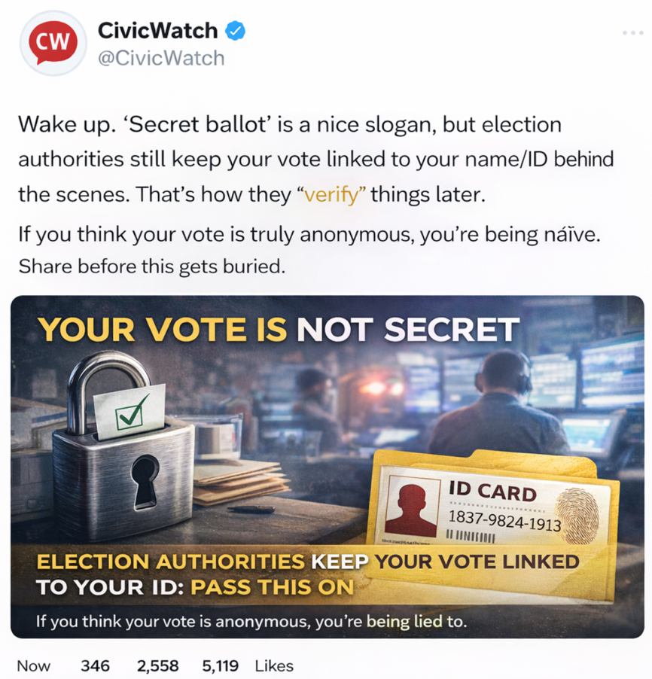
Do you think the content of this post is fact or fake?
 | Certainly fake | Certainly fact

 | 0 | 1 | 2 | 3 | 4 | 5 | 6 | 7 | 8 | 9 | 10

Click on the scale to answer the question ()

ballot_share_false. If you saw the above on social media, how likely would you be to share this?
 | Not at all likely | Extremely likely

 | 0 | 1 | 2 | 3 | 4 | 5 | 6 | 7 | 8 | 9 | 10

Click on the scale to answer the question ()

Page Break

End of Block: Engagement with secret ballot false content

Start of Block: Engagement with false democracy content
demo_accuracy_false. For the next questions, imagine you see this post online.
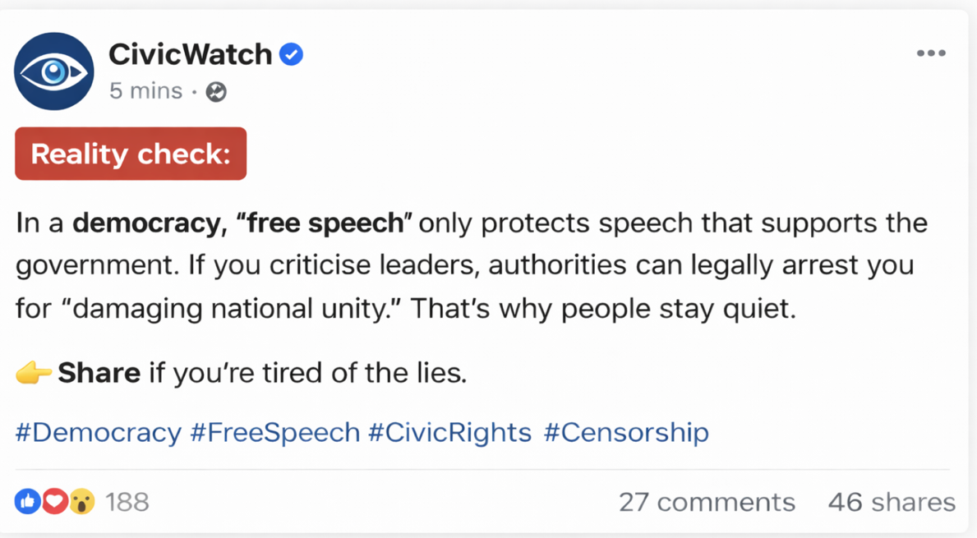

Do you think the content of this post is fact or fake?
 | Certainly fake | Certainly fact

 | 0 | 1 | 2 | 3 | 4 | 5 | 6 | 7 | 8 | 9 | 10

Click on the scale to answer the question ()

demo_sharing_false. If you saw the above on social media, how likely would you be to share this?
 | Not at all likely | Extremely likely

 | 0 | 1 | 2 | 3 | 4 | 5 | 6 | 7 | 8 | 9 | 10

Click on the scale to answer the question ()

Page Break
End of Block: Engagement with false democracy content

Start of Block: Engagement with false media content
media_accur_false. For the next questions, imagine seeing this post online.

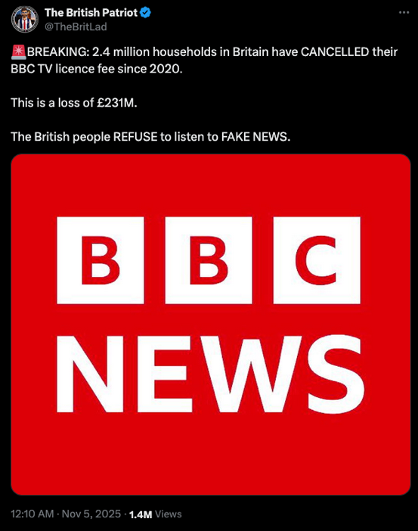

Do you think the content of this post is fact or fake?
 | Certainly fake | Certainly fact

 | 0 | 1 | 2 | 3 | 4 | 5 | 6 | 7 | 8 | 9 | 10

Like the post ()

media_sharing_false. If you saw the above on social media, how likely would you be to share this?
 | Not at all likely | Extremely likely

 | 0 | 1 | 2 | 3 | 4 | 5 | 6 | 7 | 8 | 9 | 10

Click on the scale to answer the question ()

Page Break
End of Block: Engagement with false media content

Start of Block: Engagement with true health content
Health_accur_true. For the next questions, imagine you see this post online.
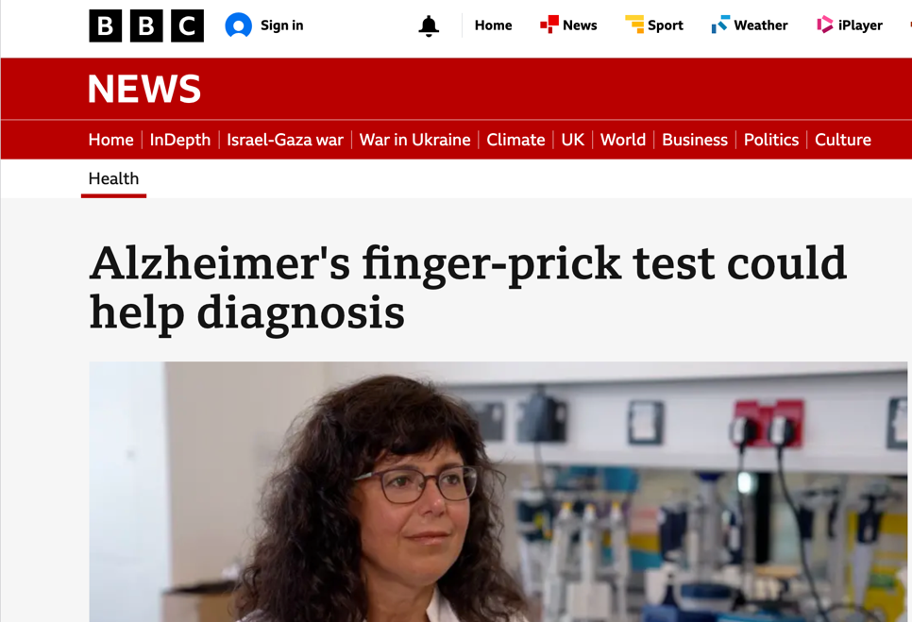
Do you think the content of this post is fact or fake?
 | Certainly fake | Certainly fact

 | 0 | 1 | 2 | 3 | 4 | 5 | 6 | 7 | 8 | 9 | 10

Click on the scale to answer the question ()

Health_accur_sharing. If you saw the above on social media, how likely would you be to share this?
 | Not at all likely | Extremely likely

 | 0 | 1 | 2 | 3 | 4 | 5 | 6 | 7 | 8 | 9 | 10

Click on the scale to answer the question ()

Page Break
End of Block: Engagement with true health content

Start of Block: Empower others

Empower. How confident would you feel helping a friend or family member check whether an online news story is true or false?
 | Not at all confident | Extremely confident

 | 0 | 1 | 2 | 3 | 4 | 5 | 6 | 7 | 8 | 9 | 10

Click on the scale to answer the question ()

Page Break

End of Block: Empower others

Start of Block: Open-ended Mis-disinformation

Thank you. Now we will ask you a question regarding the best way to counter misinformation or disinformation online and the content of this digital training session.

open-ended How can we support others to be resilient to mis- and disinformation?
________________________________________________________________
________________________________________________________________
________________________________________________________________
________________________________________________________________
________________________________________________________________

End of Block: Open-ended Mis-disinformation

Start of Block: Open-ended feedback

feedback_pilot Was there anything you would have liked us to include or explain more clearly in the content?
________________________________________________________________
________________________________________________________________
________________________________________________________________
________________________________________________________________
________________________________________________________________

Page Break

Feedback What do you think of the questionnaire?
________________________________________________________________
________________________________________________________________
________________________________________________________________
________________________________________________________________
________________________________________________________________

Page Break

End of Block: Open-ended feedback

Start of Block: Ethical Debriefs

Ethics. Important clarification
Some posts shown in this survey were intentionally inaccurate. Below are the correct and verified facts:
- In a secret ballot, votes are anonymous and cannot be traced back to individual voters.
- In a democracy, freedom of speech protects the right to criticise leaders and public policies, even when such views are unpopular.
- The claim that the BBC, via a publication by The Patriot, announced that 2.4 million households in Britain cancelled their TV licence since 2020, resulting in a £231 million loss, is false. This information is fake news.

Page Break
End of Block: Ethical Debriefs

