Pre-Analysis Plan (PAP)
DNA Notification at Release in Pennsylvania State Prisons
Site visit: SCI Phoenix (largest PA DOC facility) on March 3, 2026
Principal investigators:
Research partners:
Funding / supporting organizations:
Planned registration: AEA RCT Registry (https://www.socialscienceregistry.org/)

1. Introduction and project summary
This project tests whether clearer information at release about an inmate’s inclusion in DNA databases changes post-release behavior. Some people leaving prison may not fully understand that a qualifying conviction places their DNA profile in CODIS, how DNA evidence can be used to identify them in future investigations, or they may not recall that their DNA was collected. The intervention, therefore, provides standardized notification at release that, if the individual was convicted of a felony or another qualifying offense that requires DNA submission under Pennsylvania law, their DNA profile has been entered into CODIS, a law-enforcement DNA database.
The design is motivated by prior evidence that DNA databases deter crime at both the individual and aggregate levels. Doleac (2017) shows that U.S. DNA database expansions deter crime by profiled offenders and reduce crime rates, while Anker, Doleac, and Landersø (2021) find that DNA registration in Denmark reduced next-year recidivism by up to 42 percent. If a release-time reminder produces additional deterrence in this setting, that would imply that at least some offenders are imperfectly informed about either their own presence in DNA databases or the investigative salience of DNA evidence. Under that interpretation, existing population-wide estimates of the deterrent effect of DNA databases may be lower bounds on the effect that would obtain under fuller information.
The trial, therefore, includes two active treatment arms. T1 provides a basic reminder and a tightly limited FAQ that answers only a narrow set of eligibility and release-process questions. T2 provides a richer spoken explanation of how DNA is used in investigations and a broader FAQ that answers the most common follow-up questions. This structure lets us test not only whether reminders matter, but whether more complete information produces larger effects while keeping staff responses standardized.
Design and implementation details reflect a site visit to SCI Phoenix (the largest PA DOC facility) on March 3, 2026, during which the research team observed the release (exit interview) process and discussed staffing, document flow, signature practices, and contamination risks with facility staff. They also reflect the finalized March 2026 script/FAQ packet that will govern field implementation. This pre-analysis plan follows the outline suggested in Arnold Ventures' Pre-Analysis Plan Guidance (July 2025) and is informed by J-PAL resources on pre-analysis plans. Items marked [TBD] indicate parameters that will be finalized before registration or before outcome data are analyzed.

2. Research questions and hypotheses
Conceptually, the intervention distinguishes between two possible information margins. A T1 effect would suggest that some people are not fully aware that qualifying convictions place them in a searchable DNA database, or do not recall that information. An additional T2 effect would suggest that broader knowledge about how DNA is used in investigations also matters for behavior. That distinction is one of the central motivations for the two treatment arms. The same logic implies that effects may vary with the amount of time that has elapsed since DNA collection, including time served in the current incarceration spell.
Primary hypotheses (confirmatory):
- H1 (T1 vs Control): Assignment to the low-information DNA notification reduces post-release recidivism by the primary follow-up horizon (T* months; defined in Section 6).
- H2 (T2 vs Control): Assignment to the high-information DNA notification package reduces post-release recidivism by the primary follow-up horizon (T* months; defined in Section 6).
- H3 (T2 vs T1): Assignment to the high-information notification package (T2) reduces post-release recidivism by the primary follow-up horizon (T* months; defined in Section 6) relative to the low-information notification (T1).
Secondary hypotheses (pre-specified heterogeneity):
- Effects are larger for individuals with limited prior incarceration / fewer prior releases (higher attention / novelty of message).
- Effects differ by time served / length of current incarceration spell, with larger effects expected for individuals who have served longer sentences and may be less likely to remember the original DNA collection event.
- Effects differ by proximity of DNA collection to release (e.g., DNA collected recently vs long ago), if date/indicator is available.
- Effects differ by whether DNA collection occurred at or prior to prison entry or during the period of incapacitation (law change added a prior conviction to DNA eligibility)
- Effects differ by offense type in post-release events (DNA-relevant vs DNA-irrelevant offenses).
- Effects differ by geography of return (e.g., urban vs rural; county-level), subject to data availability.
- Effects differ by elapsed time between DNA notification and physical release, if exact timing data are available.
Secondary spillover analyses using in-prison housing-location data are described in Section 7.8. They are not part of the confirmatory hypothesis set, but they will exploit randomized peer assignment conditional on observed pre-release opportunity sets and are motivated by recent work showing that brief jail interactions and early peer exposure can shape later recidivism (Diaz, Naddeo, and Sukhatme 2025).

3. Study design
The trial is an individual-level randomized controlled trial embedded in the PA DOC release process. The unit of randomization is the individual release event.
Arms:
- Control: Business-as-usual exit interview / release process; no DNA notification script and no arm-specific FAQ materials.
- Treatment 1 (T1) - Low information: A brief spoken notification that, if the individual has been convicted of a felony (or another qualifying offense requiring DNA submission under Pennsylvania law), their DNA profile has been entered into CODIS, plus a short arm-specific FAQ. The T1 FAQ is intentionally narrow: it answers only why the notice is being given, whether it affects release today, and what to do if the individual believes the notice does not apply. All other substantive questions are redirected to the parole agent or to public Pennsylvania State Police / FBI resources.
- Treatment 2 (T2) - High information: A longer spoken notification that repeats the core CODIS notice and adds salient information about how DNA is used in investigations, including use in some property crimes, common sources of crime-scene DNA, evidence that DNA testing in property crimes can substantially increase suspect identification and arrest, and the fact that DNA tools can now be used more quickly than in the past. T2 is accompanied by a broader arm-specific FAQ that answers common follow-up questions about CODIS, qualifying offenses, where DNA comes from, why the person is being told this now, the speed of DNA tools, whether CODIS is the only DNA database, and whether the notice affects release today.
The T2 vs T1 contrast identifies the incremental effect of a richer information package - more detailed verbal content and a broader set of approved follow-up answers. It does not separately identify whether any added effect comes from the richer spoken script or from the broader approved FAQ answers.
The existing exit interview process is interactive, and individuals commonly sign and date after each module/item read to them. We will integrate the DNA notification as a standalone module with its own acknowledgment section and arm-specific FAQ materials, consistent with that workflow.

3.1 Random assignment procedure
Assignment is determined by the second-to-last digit of the incarcerated person's PA DOC identification number. The site visit suggested that the last digit of the ID number may be used operationally by staff to allocate which reentry agent prepares exit interview paperwork, so the study uses the second-to-last digit to reduce the risk of confounding treatment assignment with staff-specific effects.
Planned allocation is 40% control, 30% T1, and 30% T2 using the following mapping:
Second-to-last digit | Assignment | Share
0–3 / 4–6 / 7–9 | Control / T1 / T2 | 40% / 30% / 30%
Deterministic mapping (using the selected digit d ∈ {0,…,9}): d ∈ {0,1,2,3} → Control; d ∈ {4,5,6} → T1; d ∈ {7,8,9} → T2.

3.2 Spillovers and contamination
Site visit observations indicated that exit interviews are sometimes conducted with multiple individuals at once. This creates one potential spillover channel if individuals hear scripts intended for other arms or observe different FAQ materials during the interview. A second potential spillover channel arises if an individual receives the DNA module, returns to a housing block or cell area, and then interacts with others before physical release. Recent work on peer effects in jail emphasizes that even brief, overlap-based exposure can affect later outcomes and that early exposure can matter disproportionately (Diaz, Naddeo, and Sukhatme 2025). That intuition motivates our attention to both timing and pre-release peer exposure in this setting.
We will record whether anyone else was in the room when the DNA module was delivered. The primary analysis will follow intention-to-treat (ITT) regardless of setting; we will conduct a pre-specified sensitivity analysis that is restricted to deliveries recorded as one-on-one. If exact DNA-module timing and exact release timing can be recovered, we will also construct the elapsed time between notification and release. Longer elapsed times may matter both because they give the treated individual more time to process the message and because they increase the opportunity for peer-to-peer diffusion prior to release.
Subject to sufficient timing resolution and successful linkage, we will merge housing-location data with notification timing and release timing to construct pre-release exposure measures. Because the study arm is randomly assigned, the treatment mix among peers in a given observed opportunity set (same location and overlapping time after notification but before release) varies randomly, conditional on that opportunity set. The opportunity set itself—housing placement, number of peers, and time remaining until release—is not randomized, so spillover analyses will condition on these features as feasible and will be described as secondary/exploratory rather than confirmatory.

3.3 Question handling and FAQs
To preserve separation between treatment arms, staff will use only the approved answers in the finalized script/FAQ packet after the assigned script is read. T1 is intentionally narrow: staff may answer only why the notice is being given, whether it affects release today, and what to do if the individual thinks it does not apply. All broader questions are redirected to the parole agent or to public Pennsylvania State Police / FBI resources.
T2 includes the CODIS / eligibility answer used in T1, plus approved answers on whether DNA is only used in violent crimes, where DNA can come from, why the notice is being given at release, how quickly DNA can now be used, whether CODIS is the only DNA database, and whether the notice affects release today or the release date. Training materials will emphasize that staff should stay within the assigned script and approved answers. Delivery forms will record whether the individual had questions that went beyond the assigned script/FAQ so the research team can track potential contamination.

4. Sample selection and timeline
The target sample is all individuals released from participating PA state correctional institutions (SCIs) during the intervention period who complete an exit interview and are eligible for the standard release process, in which the notification can be delivered. Based on PA DOC's 2025 release counts, a one-year rollout would yield approximately 10,331 release events before study-specific exclusions. Planned coverage includes all participating facilities with standard exit interviews.
Planned exclusions (implementation-based):
- Individuals released from programs that do not follow the standard exit interview workflow or for which the delivery logistics differ materially (e.g., SDTP releases, boot camp releases, Swift, Predictable, and Brief (SPB) releases).
- Release events that occur without an exit interview and without feasible alternate delivery (expected to be rare). Such cases will be tracked and reported as non-deliveries.

5. Data sources and measurement
Primary data sources (administrative):
- PA DOC administrative data on incarceration history, facility, sentence, time served, individual demographics, release date, release address/county, supervision conditions, prison movement, and cell/bed assignment.
- Recidivism outcomes (rearrest and/or reconviction) from administrative records. Primary source is expected to be state criminal justice administrative data accessible to PA DOC/NORC.
- Delivery/compliance records from exit interview forms, including assigned study group, date, inmate ID, second-to-last digit used for assignment, whether others were in the room, staff role and staff name / ID, delivery status (Control / T1 delivered / T2 delivered / Not delivered), acknowledgment method (initials, verbal confirmation, or declined), whether the individual had questions that went beyond the assigned script/FAQ, and module signature/date. Under the current workflow, the completed acknowledgment form is returned to designated DOC staff for scanning to NORC.
- PA DOC has confirmed the availability of prison movement and cell/bed assignment data. Subject to sufficient timing detail and successful linkage, these data will be used together with delivery timing and exact release timing to study notification-to-release elapsed time and pre-release spillovers.
Linkage: Because names may be incorrect in some paperwork (site visit observation), the evaluation will rely on PA DOC identification numbers (and other stable identifiers such as date of birth when available) for linkage between delivery records and administrative outcomes.

6. Outcomes
6.1 Primary outcome
Primary outcome is an indicator for any rearrest within T* months of release, where T* is selected using a pre-specified 'elbow' procedure applied to historical (pre-intervention) administrative recidivism data. If a sufficiently comparable pre-intervention cohort is not available, we will apply the same elbow procedure using the study's control group only, finalizing T* before estimating any treatment effects. Specifically, using a historical cohort of releases prior to study launch [TBD: years], we will compute the cumulative probability of rearrest by month m = 1,...,24. Let ΔP(m) denote the month-to-month increase in cumulative rearrest probability. Define the plateau threshold τ = 0.10 × max_m ΔP(m). We will define the elbow month T* as the smallest month m such that ΔP(m) ≤ τ for three consecutive months (m, m+1, m+2). If no such m exists up to 24 months, we set T* = 24. T* will be finalized and documented before estimating treatment effects. We will report treatment effects on rearrest at T* months as the primary confirmatory endpoint, and also report effects at regular intervals (3, 6, 9, 12 months, and every 3 months thereafter up to T*) to distinguish 'quick' vs 'long' recidivism patterns. PA DOC's Recidivism Report 2022 indicates that among those who recidivate within three years of release, 75% recidivate within the first 16 months (median 8 months; Bucklen et al., 2022). This motivates reporting outcomes at earlier horizons and suggests the elbow point may occur within the first 12-24 months, although we select T* empirically using the procedure above.
6.2 Secondary outcomes
- Any rearrest within 3 months of release.
- Any rearrest within 6 months of release.
- Any rearrest within 9 months of release.
- Any rearrest within 12 months of release.
- Any reconviction (if available) within the same horizons (3, 6, 9, 12, and T* months).
- Return to incarceration / technical violation outcomes (if available), within the same horizons.
- Time-to-first rearrest from release, analyzed with Kaplan-Meier curves and Cox proportional hazards models as a secondary timing outcome and robustness check to the fixed-horizon framework.
6.3 Crime-type classification (secondary / exploratory)
PA DOC has provided a statewide offense classification table with both main category and subcategory fields. We will use the main category for the primary crime-type outcome families and, where sample size permits, use the subcategory for more granular exploratory analyses. If either level is too fine-grained for statistical power or interpretability, we will coarsen it into a smaller set of mutually exclusive categories (e.g., violent, property, drug, public order/other) prior to outcome analysis. The final categorization and any coarsening rules will be documented in an appendix to this PAP before accessing outcome data.

7. Analysis plan
7.1 Estimands
The primary estimand is the intention-to-treat (ITT) effect of assignment to T1 or T2 on the primary recidivism outcome. Secondary estimands include the ITT effect of T2 vs T1 and exploratory complier average causal effects if delivery noncompliance is non-trivial and can be measured reliably.
7.2 Primary regression specification
For individual i released from facility f in period t, we will estimate:
$$Y_{ift}= α + β_{1}·T1_{ift}+ β_{2}·T2_{ift}+ X_{ift}^{'}γ + δ_{f}+τ_{t}+ ε_{if}$$
where $Y_{ift}$ is the outcome (e.g., any rearrest within T* months), $T1_{ift}$ and $T2_{ift}$ are treatment indicators (control is omitted), $X_{ift}$ is a vector of pre-specified baseline covariates, $δ_{f}$ are facility fixed effects, and $τ_{t}$ are release time fixed effects (depending on variation we will use month or quarter of release). Because there are approximately 21 facilities, we will not rely solely on asymptotic cluster-robust standard errors. Our primary inference will use facility-level clustering with small-sample-robust methods (wild cluster bootstrap p-values and/or bias-reduced cluster-robust variance estimation with Satterthwaite degrees of freedom). As an additional robustness check, we will compute randomization-inference (permutation) p-values using the study’s assignment mechanism within facilities.
7.3 Covariates
We will include a pre-specified set of baseline covariates to improve precision. Candidate covariates include: age at release, sex, race/ethnicity, sentence length, time served, offense type, indicators for prior incarceration/releases, zip code of release residence, individual demographics, and facility/program indicators. Final covariate list will be locked after confirming data availability and before outcome analysis.
7.4 Multiple comparisons and outcome families
We will define outcome families and adjust for multiple hypothesis testing within each family using the Benjamini–Hochberg false discovery rate (FDR) procedure. The primary confirmatory endpoint (rearrest within T* months) is a single outcome; FDR adjustment will therefore be applied to secondary families, including (i) rearrest at the intermediate horizons (3, 6, 9, 12, … up to T* months), (ii) alternative recidivism measures (e.g., reconviction, return to incarceration), and (iii) crime-type-specific outcomes. Implementation will use standard software (e.g., statsmodels.stats.multitest.fdrcorrection). Time-to-event analyses (Kaplan-Meier / Cox) will be interpreted as part of the secondary rearrest-timing family; the fixed-horizon T* rearrest outcome remains the single primary confirmatory endpoint.
7.5 Missing data and attrition
Outcomes are expected to be measured via administrative records; missingness is expected to be low. We will document the extent of missing outcome data by arm and test for differential missingness. If missingness is non-trivial, we will use bounds or imputation strategies appropriate for administrative outcomes and report sensitivity analyses. [TBD]
7.6 Heterogeneity analyses (pre-specified)
- Prior releases / criminal history (e.g., first-time vs repeat release).
- Time served / length of current incarceration spell.
- Facility/program context (facility fixed effects are included in all models; heterogeneity by facility/program will be exploratory).
- Proximity of DNA collection to release (if a DNA collection date/indicator is available).
- Elapsed time between notification and physical release, if exact timing data are available.
- Delivery setting, measured by whether others were in the room, as an implementation sensitivity check.
7.7 Survival and timing analyses (secondary / robustness)
As a secondary analysis of arrest timing and a robustness check to the main fixed-horizon framework, we will report Kaplan-Meier survival curves by study arm for time from release to first rearrest. We will also estimate Cox proportional hazards models for time to first rearrest using treatment indicators and the same baseline covariates used in the main regression framework.
The release date will define time zero, and individuals without an observed rearrest by the end of follow-up will be right-censored at the end of the observation window. The default Cox specification will stratify the baseline hazard by facility and include treatment indicators and baseline covariates. These survival analyses are intended to summarize whether treatment effects are concentrated earlier or later in the post-release period; the fixed-horizon ITT framework remains primary.
7.8 Exploratory spillover analyses
Using the prison movement and cell/bed assignment data, we will estimate secondary spillover models that use location information together with notification timing and release timing to measure pre-release exposure to peers assigned to T1 or T2. The core idea is that a control individual may be indirectly exposed to treated peers after those peers receive the DNA notification and before the control individual's own release.
Because assignment to Control, T1, and T2 is randomized, peer-assignment exposure varies randomly conditional on the observed set of overlapping peers (the pre-release opportunity set). This creates design-based variation in indirect exposure even though the opportunity set itself - housing placement, overlap counts, and time remaining until release - is not randomized. Following the intuition of Diaz, Naddeo, and Sukhatme (2025), we will construct overlap-based exposure measures that emphasize both intensity and timing of peer exposure.
Candidate exposure measures include: (i) indicators for any overlapping peer assigned to T1 and any overlapping peer assigned to T2; (ii) counts or shares of overlapping peers assigned to T1 and T2; (iii) overlap-time-weighted measures such as T1 peer-hours and T2 peer-hours before release; and, if timing granularity permits, (iv) indicators for whether the first observed treated-peer exposure before release was to T1 or T2. If delivered-arm compliance data permit, we may also report descriptive versions based on realized delivery, but assigned-arm exposure will be the primary spillover definition.
Preferred spillover regressions will focus on control-group individuals, for whom peer-assignment exposure provides randomized variation in indirect treatment while own direct treatment is fixed at zero. Specifications will condition on facility fixed effects and, if available, more granular housing-unit fixed effects, release cohort or calendar-time controls, the number of overlapping peers, the individual's own notification-to-release interval (when applicable), and baseline covariates. We will also report balance/randomization checks assessing whether measured exposure variables are predicted by pre-treatment individual characteristics once the relevant housing/time structure is conditioned on. These analyses are secondary/exploratory because they depend on data availability and on how precisely opportunity sets can be measured. Evidence of spillovers would imply partial treatment of the control group and would therefore tend to bias the direct ITT contrasts toward zero.

8. Implementation, compliance, and fidelity measurement
Delivery records will be collected as part of the exit interview paperwork. Consistent with observed practice and the finalized implementation packet, the incarcerated person will either initial each acknowledgment line or verbally confirm understanding while staff checks the box, and staff will complete the structured administrative and fidelity fields on the form. Staff will not determine legal eligibility for DNA collection during the exit interview; instead, they will follow the assigned study group and use only the approved script/FAQ packet. Because the exit interview is interactive, preserving treatment separation requires explicit question-handling rules: T1 staff may give only the narrow approved answer set, while T2 staff may use the broader approved answer set.
- Assigned study group, date, inmate ID, and second-to-last digit used for assignment recorded.
- Delivery status recorded: Control / T1 delivered / T2 delivered / Not delivered.
- Whether others were in the room at delivery - yes/no
- Recipient initials or verbal confirmation recorded, or declined.
- Whether the individual had questions that went beyond the assigned script/FAQ - yes/no
- Staff role and staff name / ID recorded.
- Optional notes field completed when needed.
Training: A standardized training package will be developed for reentry specialists, unit managers, case agents, counselors, parole agents, and other staff who may deliver exit interviews (including for max-out releases). The package will include the final script/FAQ packet, the implementation / acknowledgment form, and a short scripted video tutorial housed in the mandatory training modules in PA DOC's digital training library. Training will cover the second-to-last-digit assignment rule, how to use the correct study-group script and approved answers, how to avoid turning T1 into T2 through off-script discussion, and how to document delivery and any contamination risks consistently.

9. Power analysis
Power calculations use an exact two-sample difference-in-proportions framework for a binary recidivism outcome, assuming α = 0.05 (two-sided) and 80% power. Following McConnell and Vera-Hernández (2025), Section 5, Equation (17), the required total pairwise sample size to detect an absolute reduction δ with treatment share π is:
$$N_{req}=\left({\left(z_{\left(1-α/2\right)}+z_{\left(1-β\right)}\right)}^{2}/δ^{2}\right)*\left[p_{1}\left(1-p_{1}\right)/pi+p_{0}\left(1-p_{0}\right)/\left(1-π\right)\right]$$

We implement this calculation in Python (see project power notebook) and produce contour plots of required pairwise sample size across plausible baseline rates p0 and absolute treatment reductions δ = p0 - p1.
Using PA DOC's 2025 facility release table as the planning benchmark, a one-year rollout would yield approximately N = 10,331 release events before study-specific exclusions. Under the planned 40/30/30 allocation, the expected group sizes are about 4,132 control, 3,099 T1, and 3,099 T2. The implied pairwise sample sizes are therefore about 7,232 for each treatment-vs-control comparison and 6,199 for the T1 vs T2 comparison. Because T1 vs C and T2 vs C have the same pairwise sample size and treatment share, they have the same analytical MDE under the exact difference-in-proportions calculation.
Table 1. Illustrative exact MDEs for key contrasts (α = 0.05; power = 0.80; treatment-vs-control contrasts are identical analytically).
Assumed baseline rearrest rate (control) | MDE: T1/T2 vs Control (100% delivery) | MDE: T1 vs T2 (100% delivery) | MDE under 75% delivery
0.25 | 2.8 pp | 3.0 pp | 3.7-4.0 pp
0.35 | 3.1 pp | 3.4 pp | 4.2-4.4 pp
0.45 | 3.3 pp | 3.5 pp | 4.4-4.7 pp
Compliance adjustment: If only a fraction c of assigned individuals receive the notification as intended, the ITT effect size scales approximately by c relative to the treatment-on-the-treated effect, and required sample size scales approximately by 1/c². We therefore report exact analytical MDEs under full compliance (c = 1.0) and a conservative compliance scenario (c = 0.75). As additional threshold sensitivities retained in the project power notebook, moving from two-sided to one-sided testing lowers analytical MDEs by about 11 percent, while applying a worst-case Benjamini-Hochberg threshold for a three-comparison family raises analytical MDEs by about 15 percent. The preregistered primary analysis, however, remains two-sided with α = 0.05, and BH adjustments apply to secondary outcome families rather than to the single primary confirmatory endpoint.

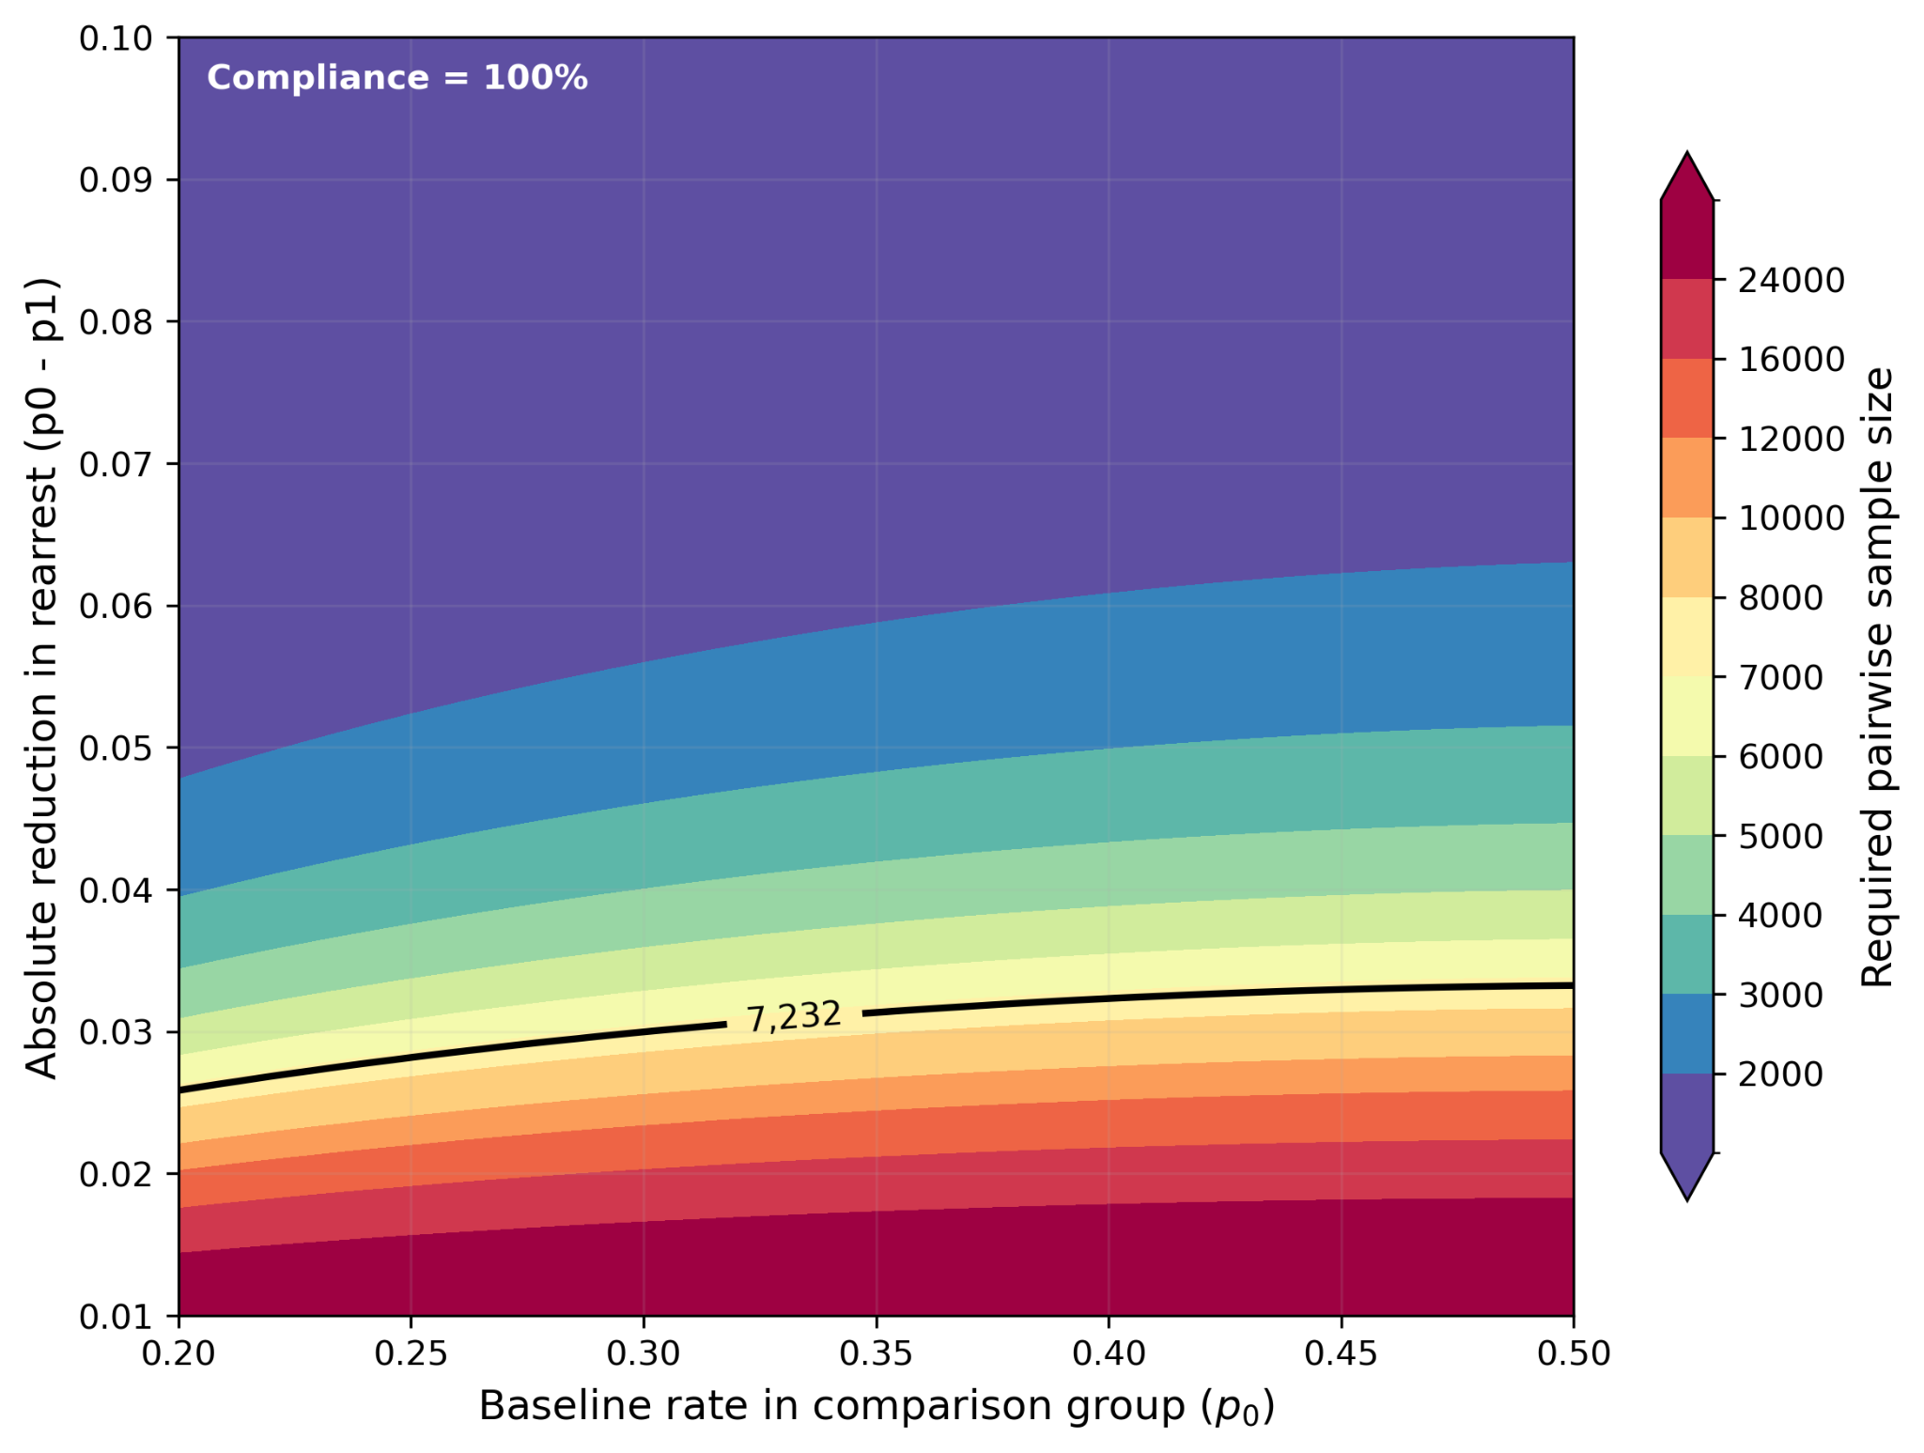
Figure 1a. Required pairwise N for T1/T2 vs Control (compliance = 1.0).

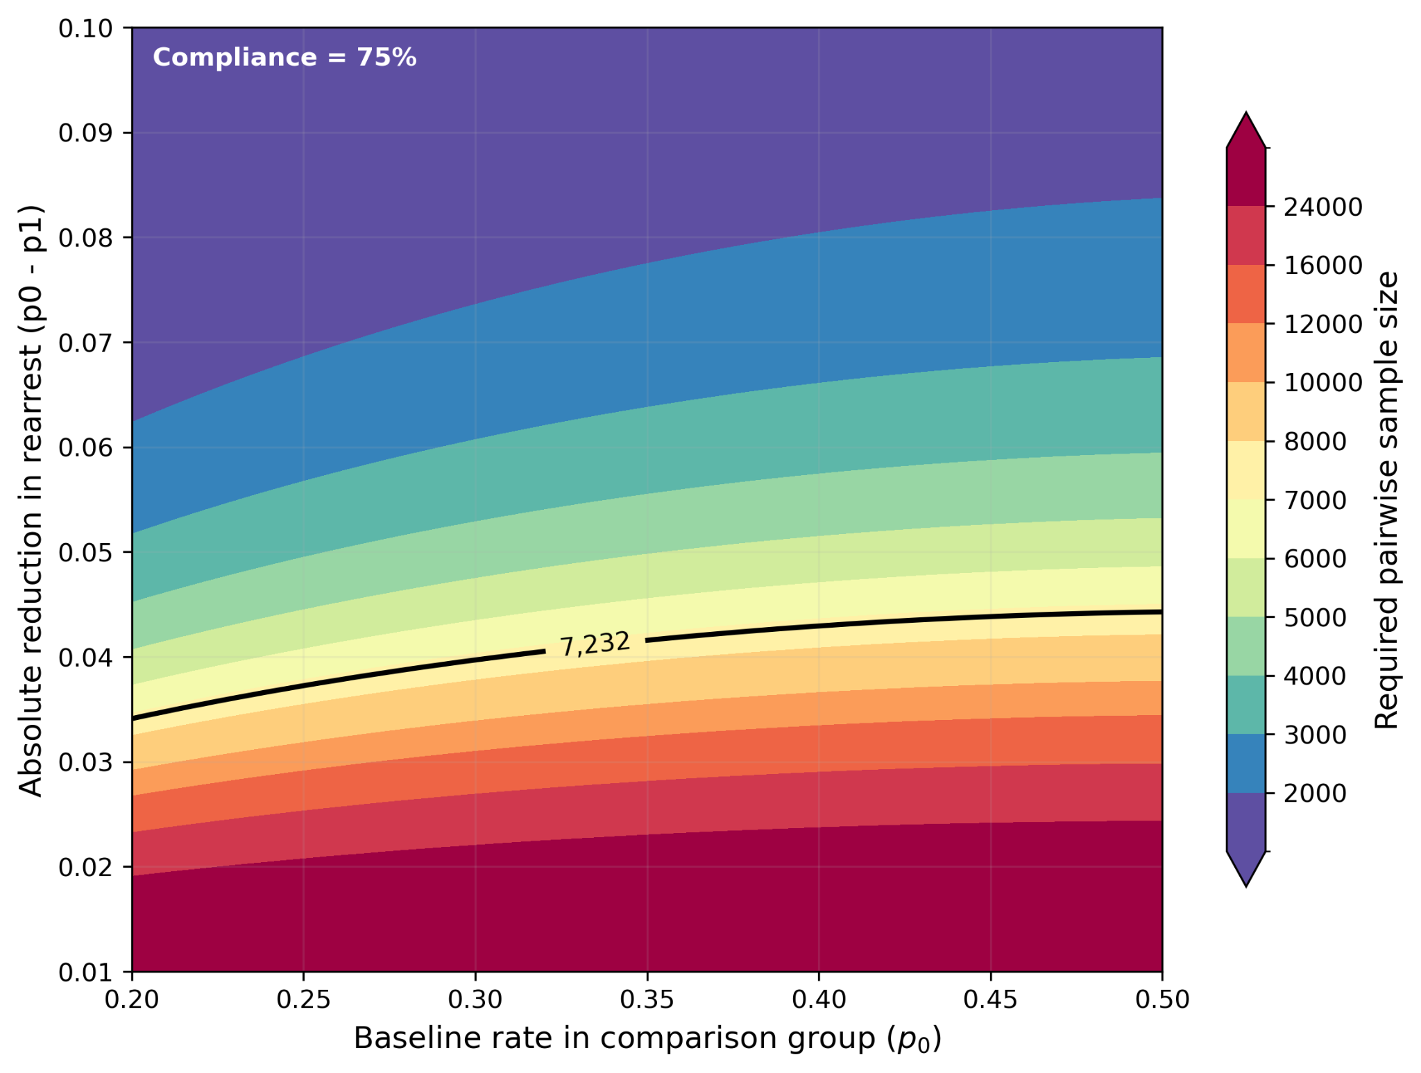
Figure 1b. Required pairwise N for T1/T2 vs Control (compliance = 0.75).

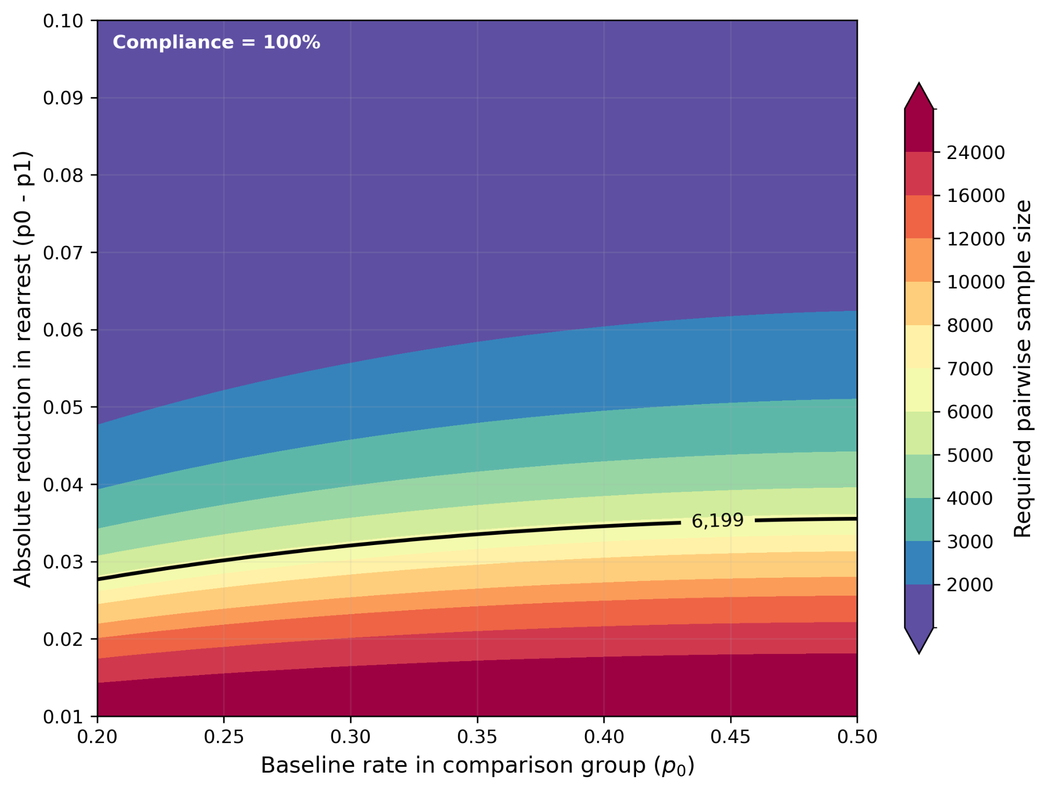
Figure 2a. Required pairwise N for T1 vs T2 (compliance = 1.0).
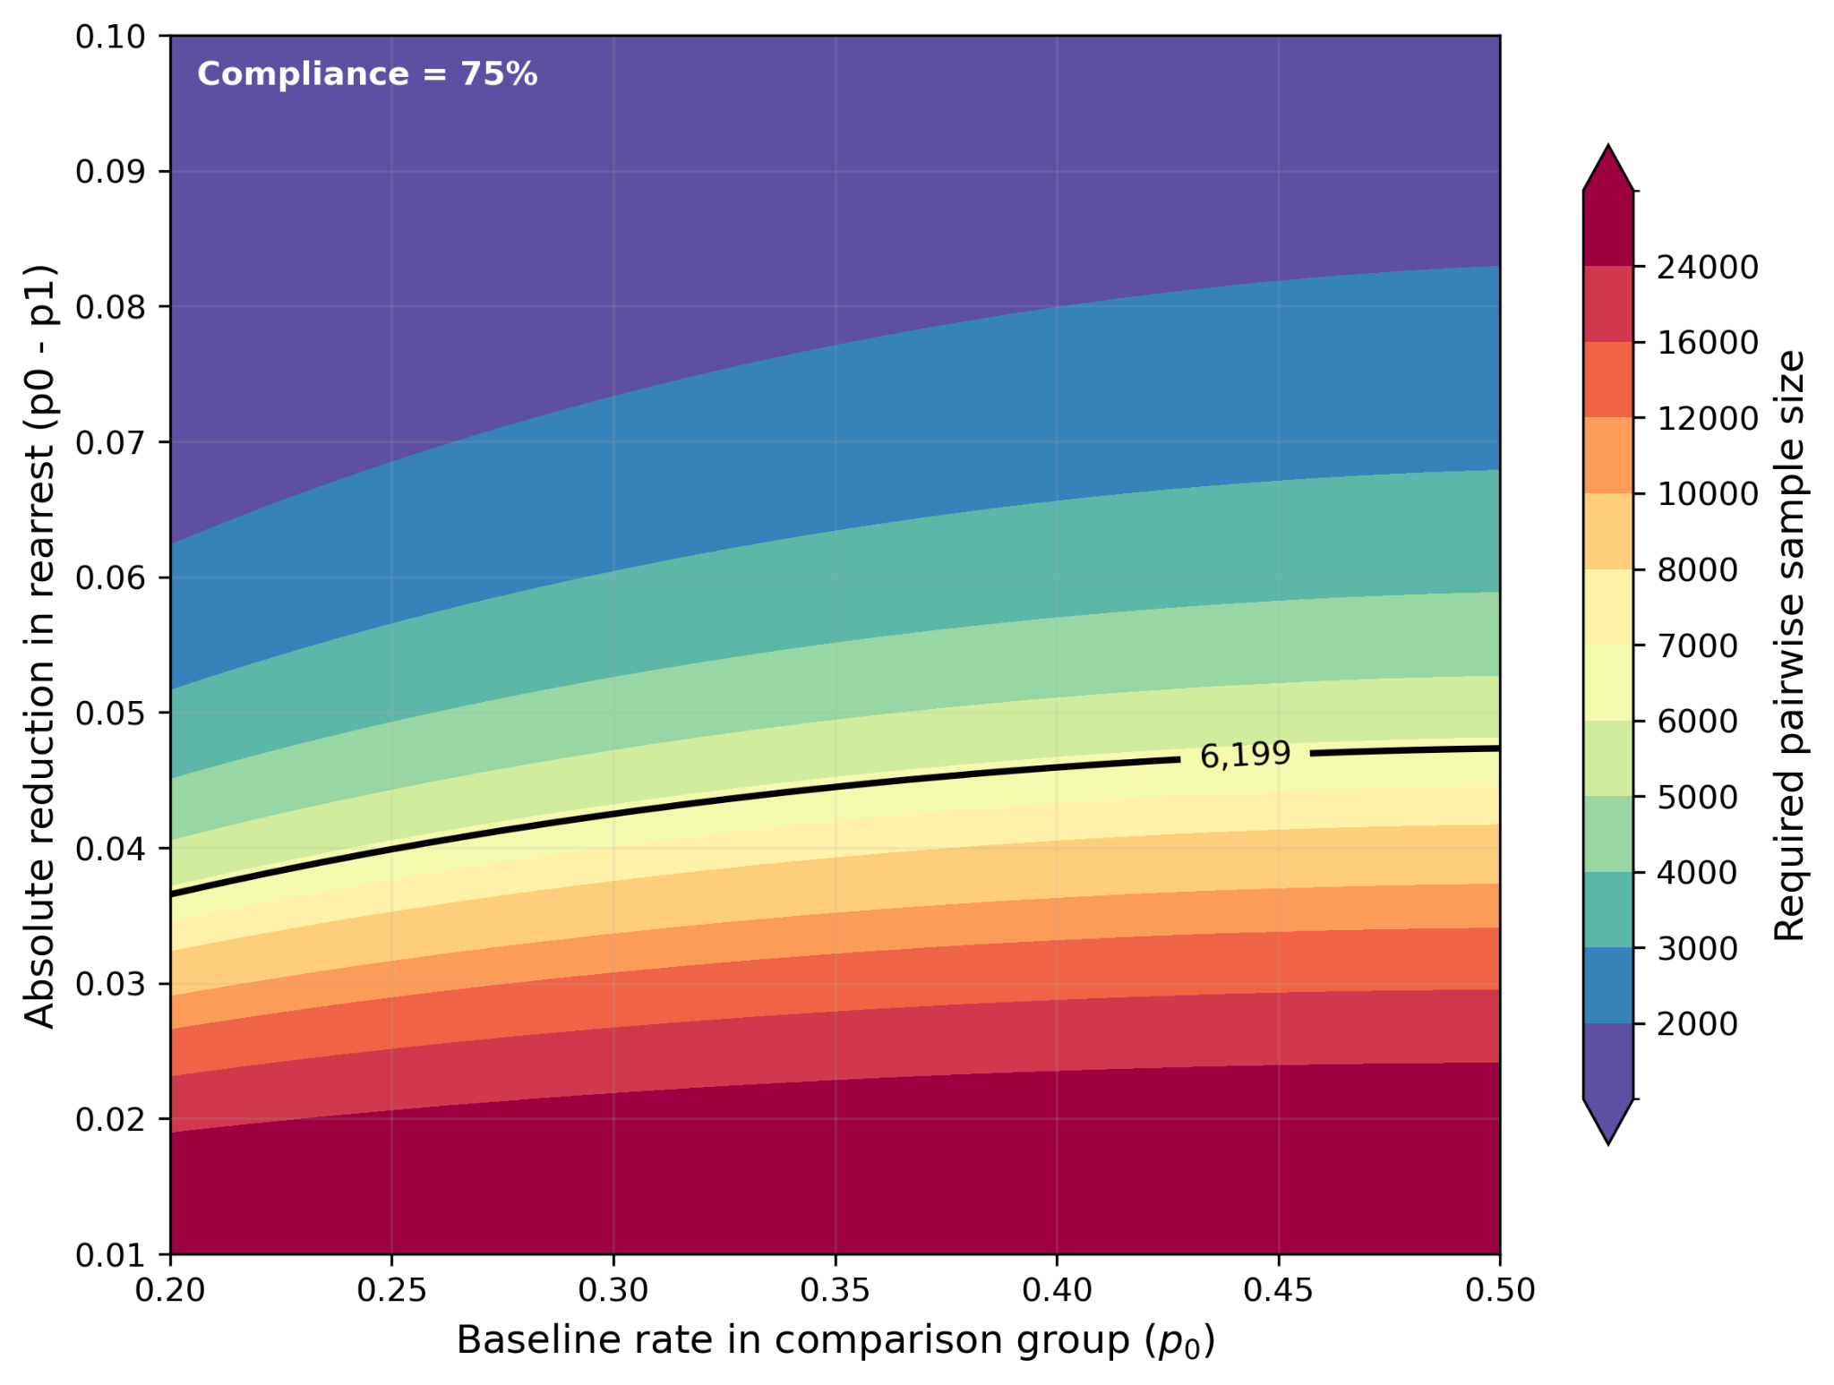
Figure 2b. Required pairwise N for T1 vs T2 (compliance = 0.75).

9.1 Conservative clustering benchmark and simulation-based power
The exact analytical calculations above assume independent observations. To illustrate the potential importance of within-facility correlation, we first report a conservative design-effect benchmark based only on 2025 facility release counts and assumed ICC values. Because treatment is randomized at the individual level within facility and the planned analysis includes facility fixed effects, this benchmark likely overstates clustering penalties relative to the actual estimator and should be interpreted as an upper-bound sensitivity rather than as the main power model. We then complement it with simulation-based power calculations that more closely match the actual design: individual randomization within facility at a 40/30/30 split, facility heterogeneity calibrated to assumed ICC values, facility fixed effects in the analysis model, and facility-clustered inference. Under p0 = 0.35, the conservative benchmark rises sharply with ICC, while the simulation-based MDE remains close to about 3.3 percentage points for T1/T2 vs control and about 3.5 percentage points for T1 vs T2 even at ICC = 0.01. This pattern is consistent with the logic of individual randomization within facility: common facility-level shocks are largely differenced out once assignment occurs within facility and facility fixed effects are included.

Table 2: Conservative DEFF benchmark vs simulation-based MDE at p0 = 0.35 (2,000 Monte Carlo replications per design point).
Comparison | Assumed ICC | Conservative benchmark MDE | Simulation-based MDE
T1 vs C | 0.000 | 3.1 pp | 3.3 pp
T1 vs C | 0.001 | 3.6 pp | 3.3 pp
T1 vs C | 0.005 | 5.1 pp | 3.3 pp
T1 vs C | 0.010 | 6.4 pp | 3.3 pp
T2 vs C | 0.000 | 3.1 pp | 3.3 pp
T2 vs C | 0.001 | 3.6 pp | 3.3 pp
T2 vs C | 0.005 | 5.1 pp | 3.3 pp
T2 vs C | 0.010 | 6.4 pp | 3.3 pp
T1 vs T2 | 0.000 | 3.4 pp | 3.5 pp
T1 vs T2 | 0.001 | 3.8 pp | 3.5 pp
T1 vs T2 | 0.005 | 5.2 pp | 3.5 pp
T1 vs T2 | 0.010 | 6.5 pp | 3.5 pp
The conservative DEFF benchmark increases rapidly with assumed ICC because it treats within-facility correlation as a direct design-effect penalty. The simulation-based MDE is much flatter because treatment is assigned within facility and the analysis model includes facility fixed effects. We therefore use the exact analytical calculations as the main planning benchmark and treat the DEFF table as a conservative upper-bound sensitivity.

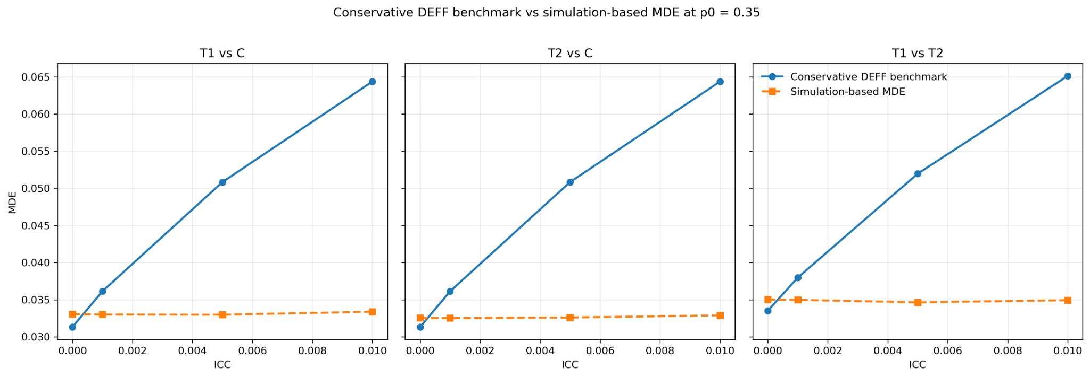
Figure 3. Conservative DEFF benchmark vs simulation-based MDE at p0 = 0.35.

10. Reporting, transparency, and deviations
The study will be registered on the AEA RCT Registry and will upload this PAP prior to accessing outcome data for analysis. Any deviations from the pre-specified analyses will be documented with an amendment note that explains the rationale, the timing, and the potential implications for interpretation.

11. Items to confirm before finalizing / registering the PAP
- Confirm actual intervention start/end dates and final participating-facility list. The planning assumption for power uses roughly one full year of releases.
- Confirm which release types will be excluded (SDTP, boot camp, SPB) and how they are flagged in PA DOC data; estimate counts of excluded releases.
- Confirm availability of rearrest timing (monthly or exact event date), exact release date/time, DNA-module date/time, prison movement, and cell/bed assignment data; obtain a historical pre-intervention release cohort to compute the elbow month T*; finalize and document T* before estimating treatment effects.
- Finalize any coarsening rules for the PA DOC main-category and subcategory crime classification and include the final categorization in an appendix to the PAP prior to outcome analysis.
- Confirm availability of (a) prior release / criminal history measures, (b) facility program participation indicators, (c) any indicator/date of DNA collection near release for heterogeneity analysis, and (d) exact timing fields needed to construct elapsed time between notification and release.
- Confirm enough timing detail within the prison movement and cell/bed assignment data to construct pre-release opportunity sets and spillover exposure measures based on peers' assigned study arm; if feasible, prepare balance tests for these exposure measures.

References (selected)
- Arnold Ventures. 2025. "Pre-Analysis Plan Guidance for RCTs and QEDs." July 2025. https://assets.arnoldventures.org/uploads/PDFs/AV_Pre-Analysis_Plan_Guidance_202507.pdf
- J-PAL (Abdul Latif Jameel Poverty Action Lab). "Pre-analysis plans." https://www.povertyactionlab.org/resource/pre-analysis-plans (accessed March 2026).
- McConnell, Brendon, and Marcos Vera-Hernández. 2025. "Going Beyond Simple Sample Size Calculations: a Practitioner’s Guide." July 30, 2025.
- Benjamini, Yoav, and Yosef Hochberg. 1995. "Controlling the False Discovery Rate: A Practical and Powerful Approach to Multiple Testing." Journal of the Royal Statistical Society: Series B 57(1): 289–300.
- Kaplan, Edward L., and Paul Meier. 1958. "Nonparametric Estimation from Incomplete Observations." Journal of the American Statistical Association 53(282): 457–481.
- Cox, D. R. 1972. "Regression Models and Life-Tables." Journal of the Royal Statistical Society: Series B 34(2): 187–220.
- Cameron, A. Colin, Jonah B. Gelbach, and Douglas L. Miller. 2008. "Bootstrap-Based Improvements for Inference with Clustered Errors." Review of Economics and Statistics 90(3): 414–427.
- Becker, Gary S. 1968. "Crime and Punishment: An Economic Approach." Journal of Political Economy 76(2): 169–217.
- Doleac, Jennifer L. 2017. "The Effects of DNA Databases on Crime." American Economic Journal: Applied Economics 9(1): 165–201.
- Anker, Anne Sofie T., Jennifer L. Doleac, and Rasmus Landersø. 2021. "The Effects of DNA Databases on the Deterrence and Detection of Offenders." American Economic Journal: Applied Economics 13(4): 194–225.
- Diaz, Angelo, J.J. Naddeo, and Neel U. Sukhatme. 2025. "The First and the Worst: Evidence of Peer Effects in a Large U.S. Jail." Working paper.
- Pennsylvania Department of Corrections. 2022. "Recidivism Report 2022." Bureau of Planning, Research and Statistics. (Released 2023).
- Pennsylvania Department of Corrections. 2024–2025. "Monthly Population Reports" (Monthly Population v. Capacity tables by facility).

