Russian Disinformation in Kenya
Pre-Analysis Plan
August 2026
Anastasiia Arbuzova  Stockholm Institute of Transition Economics  Kiel Institute | Anders Olofsgård  Stockholm Institute of Transition Economics  Stockholm School of Economics | Maria Perrotta Berlin  Stockholm Institute of Transition Economics  Stockholm School of Economics

Abstract
This pre-analysis plan specifies the hypotheses, research design, and analysis strategy for a large-scale survey experiment examining susceptibility to Russian disinformation among young urban Kenyans. The study fields a cross-sectional survey with an embedded experiment among approximately 5,000 individuals aged 18–40 in Nairobi and other urban centres across Kenya. Respondents are asked to read two social media posts, one questioning the motive behind western companies selling gene-modified crops in Kenya, and the second mimicking the language used in posts trying to attract Kenyans to sign up for work in the Russian military. To encourage respondents to read the messages carefully they are asked to rate the posts based on spelling and grammar. Respondents are then randomized into a control group and eight treatment arms receiving variations of disinformation-debunking warnings. Warnings differ across three dimensions: the source of the disinformation warning (European Union vs. a local independent fact-checking organization), whether the spread of disinformation is attributed explicitly to Russia or to a generic foreign power, and the medium of the message (radio ad versus a social media post). The key outcome variable is social media sharing intention, but we also look at perceived message credibility, and opinions on global powers. The study addresses a critical gap in the literature by providing the first randomized experimental evidence on disinformation resistance in East Africa against Russian influence campaigns and war recruitment.
This plan will be registered in the AEA RCT Registry (socialscienceregistry.org) before data collection is completed and before any data are delivered to or accessed by the research team, following J-PAL and AEA trial registration guidance. Ethics review pending. The study was submitted to the Swedish Ethical Review Authority (Etikprövningsmyndigheten) on 29 July 2026 (Grundansökan, application no. 86318).

1. Introduction
Political disinformation has emerged as one of the central challenges to democratic governance globally. A growing body of experimental evidence demonstrates that exposure to false narratives distorts factual beliefs, reduces institutional trust, and can influence political behavior (Nyhan et al., 2020; Pennycook et al., 2020; Clayton et al., 2020). This literature has also shown that corrective interventions, fact-checking warnings, pre-bunking inoculations, source-credibility signals, can partially counter these effects, though their efficacy varies substantially by context, audience, and the specific design of the intervention (Roozenbeek & van der Linden, 2019; Walter et al., 2020; Kozyreva et al., 2024). In a recent contribution, Guriev et al. (forthcoming), combine a two-wave randomized experiment on Twitter/X during the 2022 and 2024 U.S. elections with a structurally estimated model of the sharing decision. Through the model they decompose treatment effects into different channels, emphasizing the role of updating of beliefs about a post's veracity, and the salience of reputational concerns relative to partisan motives. These channels both point to the importance of the credibility and perceived partisanship of the initial source of the information, as well as the credibility of the medium of transition. This is directly relevant to the design of our warnings where we vary these dimensions in a 2×2×2 design.
Almost all of the existing experimental evidence is drawn from the United States and Europe, where trust in domestic and Western multilateral institutions, while contested, differs qualitatively from trust in much of the Global South. Sub-Saharan Africa, and East Africa in particular, represent a critical but largely unstudied context for disinformation research. Russia has mounted extensive and well-documented influence campaigns across the continent, promoting pro-Russian narratives about the Ukraine war, framing Western institutions as neo-colonial actors, and, most recently, conducting deceptive recruitment operations targeting African nationals for military service (Frederiksen, 2023; Africa Center for Strategic Studies, 2024). Kenya is a particularly important case: it is one of the most digitally connected countries in East Africa, has a large and youthful urban population with high social media engagement, and has been specifically targeted by Russian recruitment campaigns that have been documented by Kenyan authorities and investigative journalists.
Despite this, no experimental evidence exists on how young Kenyans respond to Russian disinformation or on what counter-messaging strategies are effective in this context. The present study fills this gap. It deploys a 2×2×2 factorial experimental design embedded in a large cross-sectional survey, varying (i) the source of a disinformation warning, EU versus a local independent organization, (ii) whether the attributed source of the false message is identified explicitly as Russia or left as a generic foreign power, and (iii) the medium of the disinformation warning, a radio advertisement versus a social media post. This design allows us to isolate, for the first time in an East African context, the causal effects of debunking interventions and their dependence on source credibility, actor attribution (which may be perceived as partisan), and the medium through which a warning is delivered.
The study makes primarily four contributions. First, it provides experimental estimates of disinformation susceptibility and debunking efficacy in a non-Western, post-colonial context where trust in Western institutions is more contested than in the European or American settings that make up nearly all of the existing evidence base. Second, it varies the identity and credibility of the corrective source, the European Union versus a local independent fact-checker, a dimension that is held fixed in prior experimental work (e.g., PolitiFact throughout Guriev et al.'s experiment), allowing a direct test of source-credibility theory in a setting where the messenger's own geopolitical affiliation is contested. Third, it tests whether explicitly naming Russia as the source of disinformation increases or decreases warning effectiveness, as it may be perceived as partisan, in particular if the source of the message is the EU. This is a question with direct policy relevance for international counter-disinformation actors operating in Africa. Fourth, we pair sharing-intention outcomes with a post-level suspicion rating of the debunking message which can tell us something about the mechanisms behind potential variation in effectiveness. The study further explores heterogeneous treatment effects across theoretically motivated subgroups defined by anti-Western attitudes, news consumption patterns, economic precarity, and colonial historical experience, providing evidence on which populations are most and least susceptible to Russian disinformation and to corrective interventions.

2. Research Questions
This study addresses the following primary research questions:
- Do disinformation warnings reduce Kenyan respondents' willingness to share social media posts containing false narratives?
- Do warnings reduce the strength of belief in false statements related to Russia, the war against Ukraine, China, and Western institutions?
- Does the source of the warning (EU vs. local independent organization) affect warning effectiveness?
- Does explicitly attributing the disinformation to Russia (vs. a generic foreign power) affect warning effectiveness? Does this effect vary depending on the source of the warning (EU vs. local independent organization)?
- Does the medium of the warning, radio versus social media post, affect its effectiveness?
- Are treatment effects heterogeneous across respondents defined by attitudes toward Western institutions, news consumption patterns, economic precarity, and regional/ethnic background?

3. Research Design

3.1 Sampling and Study Population
The study targets the young urban population of Kenya, defined as individuals aged 18–40 residing in urban areas. This population is the primary audience for social media-delivered disinformation and the primary target of Russian recruitment campaigns in Kenya. The target sample is approximately 5,000 respondents, recruited through a commercial survey panel provider (GeoPoll) with stratification by age (18–30 and 31–40), education, gender, and adm1 region.
Respondents are recruited via mobile phone and complete the survey on their own devices, reflecting the primary medium through which disinformation circulates in urban Kenya. All instruments are available in English and Swahili. The survey is programmed to assign respondents randomly to treatment arms at the point of recruitment, prior to the start of the questionnaire.

3.2 Experimental Design and Randomization
The study uses a 2×2×2 factorial design, crossing three binary treatment dimensions, plus a control group, yielding nine experimental arms. The three treatment dimensions are:
- Warning source: European Union (EU) vs. local independent fact-checking organization (hereafter 'Local NGO')
- Actor attribution: the false message is attributed explicitly to Russia vs. attributed to a generic unspecified foreign power
- Warning medium: the warning is delivered as a social media post or a radio add.

The nine groups are:
Group | Label | Warning source | Actor attribution | Warning medium
G1 | Control | No warning | — | —
G2 | EU × Foreign Power × SM post | European Union | Generic foreign power | SM post
G3 | EU × Russia × SM post | European Union | Russia named explicitly | SM post
G4 | Local NGO × Foreign Power × SM post | Local NGO | Generic foreign power | SM post
G5 | Local NGO × Russia × SM post | Local NGO | Russia named explicitly | SM post
G6 | EU × Foreign Power × Radio | European Union | Generic foreign power | Radio
G7 | EU × Russia × Radio | European Union | Russia named explicitly | Radio
G8 | Local NGO × Foreign Power × Radio | Local NGO | Generic foreign power | Radio
G9 | Local NGO × Russia × Radio | Local NGO | Russia named explicitly | Radio
Table 1: Experimental Arms
Randomization is implemented at the survey programming level, with 1,000 respondents assigned to the control group and 500 with equal probability to one of the eight treatment groups. Randomization is stratified by age group, education, admin1-region, and gender to ensure balance on these dimensions across arms. Treatment assignment is recorded automatically by the survey platform.

3.3 Survey Structure and Flow
All respondents complete the following sections in order:
- Section A: Consent and introduction
- Section B: Demographics (gender, age, education, employment, income, urban/rural, region)
- Section C: Media consumption (frequency of use for TV, radio, Facebook, WhatsApp/Telegram, TikTok, YouTube, online news, print, friends/family; primary news source)
- Section D: Trust battery (trust in people in general, neighbours, national government, courts, police, civil society, media, United States, Russia, China, European Union, United Nations; scale 1–5)
- Section E: Messages and evaluation task (all respondents read two social media posts and evaluate them on writing quality, see Section 3.4)
- Section F: Warning treatment (treatment groups G2–G9 receive a warning message attributed to the relevant source, relevant actor attribution, and using the assigned medium whereas the control group (G1) receives no warning)
- Section G: Primary outcome measures (sharing intention and offline discussion intention for each message)
- Section H: Secondary outcome measures (agreement with international affairs statements (belief battery); suspicion ratings for each message; warning credibility rating)

The order of the two messages in Section E is randomized across respondents. The order of items in the international affairs battery (Section H) is also randomized.

3.4 Disinformation Stimuli
All respondents are exposed to two disinformation messages, presented as social media posts, in Section E. The messages represent two distinct categories of Russian disinformation that are relevant to the Kenyan context, see below.

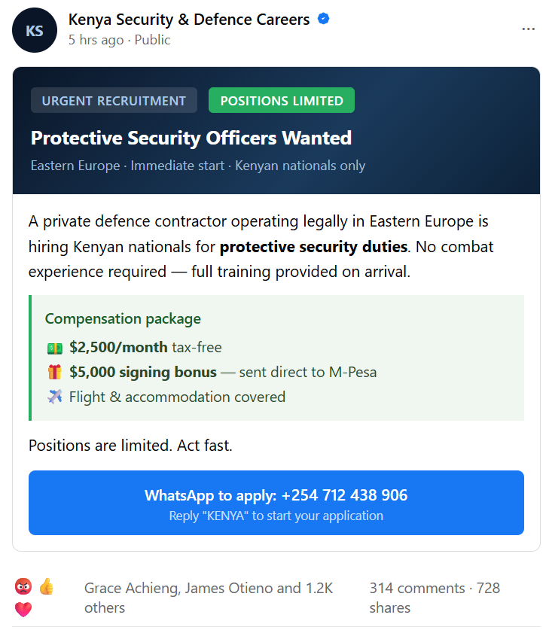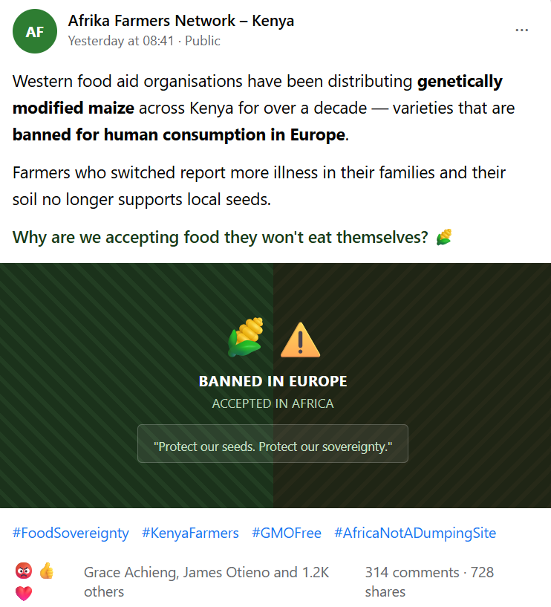

These stimuli were selected following a piloting exercise designed to identify messages that avoid floor and ceiling effects in believability and sharing intention. The general message targets anti-Western sentiment around food sovereignty and GMO concerns; the recruitment message targets the documented deceptive recruitment operations in Kenya in which criminal syndicates posing as legitimate work-abroad recruiters directed job seekers toward Russian military service.
To ensure that respondents read each message carefully before outcome questions are asked, the task is framed as a writing quality evaluation: respondents are asked to rate each message on a 1–7 scale for how professionally written it is. This provides a plausible cover task that requires careful reading without the dual-task interference of orthographic correction tasks and generates a behavioral engagement covariate (response time and quality rating) that can be used to identify inattentive respondents.

3.5 Warning Treatments
Respondents in treatment arms G2–G9 receive a warning message in Section F, after completing the message evaluation task in Section E. The warning is presented as a social media post for groups G2–G5, and as a radio announcement for groups G6–G9 in alternative medium conditions. The warning content varies by arm:
- EU × Foreign Power (G2 and G6): A warning from the European Union indicating that unspecified foreign powers are spreading disinformation on social media indicating that the preceding posts may contain false information
- EU × Russia (G3 and G7): Identical to G2 but with Russia named explicitly as the source of the disinformation
- Local NGO × Foreign Power (G4 and G8): Identical warning content to G2 but attributed to a named local independent fact-checking organization
- Local NGO × Russia (G5 and G9): Identical to G4 but with Russia named explicitly

Control respondents (G1) proceed directly from Section E to Section G with no intervening warning.

4. Hypotheses
The study tests five pre-registered hypotheses, organized around the three treatment dimensions - warning source, actor attribution, and medium - and their interactions. Since our warnings name a specific claim and a specific source rather than offering a content-neutral reminder of the existence of disinformation, they most closely resemble the source-attributed fact-check treatment in Guriev et al (forthcoming). This allows us to learn about the role of the credibility of the source, and perceived partisanship, in sharing intention.

H1: Main effect of debunking warnings
We expect the warnings to reduce sharing intention at least in part by updating respondents' beliefs about the veracity of each post, rather than through a purely generic reluctance to engage. We will use the post-level suspicion rating (Section 5.2) as a secondary, descriptive check on whether warnings shift perceived veracity and not only stated sharing intentions. We expect negative effects (i.e., reduced sharing) across both message types, and we anticipate larger effects for the recruitment message (Message 1), where the warning content more directly contradicts the stimulus and where sharing misleading information may be considered more risky for personal reputation, consistent with the role reputational concerns play in sharing decisions more generally (Guriev et al., forthcoming).

H2: Source credibility effect
This hypothesis is grounded in source-credibility theory and in the specific context of Kenya, where the EU may be perceived as a self-interested actor with a political stake in the Ukraine conflict. Much of prior experimental work on debunking interventions holds the identity of the fact-checking source fixed and so cannot speak to this dimension. We test it directly by crossing warning source with the other two treatment arms. Prior work in European contexts finds mixed results on the domestic vs. supranational source dimension. We expect the domestic-source advantage to be larger in Kenya given the salience of anti-colonial and pan-African identity framings.

H3: Actor attribution effect
This hypothesis departs from a simple directional prediction because the effect of naming Russia is theoretically ambiguous: it may increase warning effectiveness for respondents who are already sceptical of Russia but may trigger reactance or disbelief among respondents who hold favorable views of Russia as a geopolitical actor. We therefore frame this as an interaction hypothesis, tested through heterogeneity analysis by respondents' baseline relative trust in Russia versus Western institutions (Section 8), rather than through a directional main-effect prediction.

H4: Interaction of source and attribution
This hypothesis captures the possibility that the source and attribution dimensions interact: an EU warning that also names Russia may be read as political messaging rather than neutral fact-checking, amplifying the source-credibility disadvantage of EU attribution documented under H2. We test this interaction directly within each warning source (see Table 2).

H5: Medium effect
This hypothesis captures the possibility that debunking messages carry different credibility, and impose different demands on attention, depending on the medium through which they are delivered. Radio remains a widely trusted source of news in Kenya, distinct from its entertainment function, and a radio advertisement heard in the course of normal listening may impose a different engagement cost than a social media post that must be actively read and dismissed, in the language of the cost-of-engagement channel identified by Guriev et al. (forthcoming; see also Ershov & Morales, 2024, on sharing frictions on Twitter/X). We hypothesize that radio warnings will be perceived as more credible than social-media warnings, though the net effect on sharing intention is, a priori, ambiguous given this offsetting cost channel.

5. Outcome Measures

5.1 Primary Outcomes

The study has two primary outcomes, both measuring intention to share content on social media:

Sharing intention for Message 1

Sharing intention for Message 2

For each message, the outcome is a binary indicator equal to one if the respondent indicates that they would share the post on their social media feed, and zero otherwise. The two outcomes will be analyzed separately.

5.2 Secondary Outcomes
Secondary outcomes include intention to discuss the messages with friends, family, or colleagues. Discussion intention will be measured separately for each of the two posts. For each post, the outcome is a binary indicator equal to one if the respondent indicates that they would discuss the post with friends, family, or colleagues, and zero otherwise.
We will also analyze whether the treatments affect respondents’ views of major global powers. We are primarily interested in attitudes toward Russia and the European Union, while China is included as a reference case because it is not mentioned in either the experimental messages or the debunking warnings.
Respondents will be asked to indicate their agreement with three statements, presented in random order, using a five-point scale ranging from Strongly agree (1) to Strongly disagree (5). “Don’t know” responses will be retained as a distinct response category rather than coded as missing or treated as equivalent to the scale midpoint. For analyses using the five-point agreement scale, “Don’t know” responses will be excluded, and we will separately test whether treatment assignment affects the probability of responding “Don’t know.” Each statement will be analyzed as a separate outcome.

1. China gave Kenya huge loans to build the railway between Mombasa and Nairobi, knowing the country might struggle to repay them, so that China could eventually gain control over Mombasa port and other strategic assets.

2. NATO began the Ukraine war by promising Ukraine membership and placing weapons on Russia's border. Russia had no choice but to defend itself.

3. European countries grew wealthy by colonizing and exploiting Africa for centuries, and the aid and trade deals they offer African countries today are really just a new way to keep control over Africa's resources and economy.

We will additionally measure perceived suspiciousness of each experimental message on a five-point scale, with higher values indicating greater perceived suspiciousness. Among respondents assigned to a treatment condition, we will also measure perceived credibility of the debunking warning on a five-point scale, with higher values indicating greater credibility.

6. Empirical Strategy

6.1 Average Treatment Effects
We estimate average treatment effects (ATEs) using OLS regressions with robust standard errors. Let Y_{i} denote the outcome of interest for respondent i. For the primary outcome, Y_{i} is the binary indicator of sharing intention defined in Section 5.1.
Our primary specification is a fully saturated treatment-arm specification, in which each of the eight treatment groups is represented by a separate indicator variable:
$$Y_{i}=α+\sum_{g=2}^{9}{β_{g}G_{ig}}​​+X_{i}'​γ+δ_{c}+ε_{i},$$
where $G_{ig}$ is an indicator equal to one if respondent i is assigned to treatment group g, for g=2,…9. The control group ($G_{1}$) is the omitted reference category. Thus, each coefficient $β_{g}$ captures the average treatment effect of assignment to treatment arm $G_{g}$ relative to the control group, without imposing any restrictions on how the effects vary across warning source, attribution, or message medium.
$X_{i}$ is a vector of pre-treatment covariates including age, gender, education, income decile, and primary news source. All regressions also include urban-centre fixed effects, $δ_{c}$. The base specification is a linear probability model for the binary sharing-intention outcomes. We will also report logit/probit average marginal effects as a robustness check.
Because the specification includes a separate indicator for every treatment arm, it is fully flexible with respect to treatment assignment: no assumptions of additivity or common effects across the experimental dimensions are imposed. Comparisons corresponding to the study's hypotheses will be estimated as linear contrasts of the treatment-arm coefficients, see next section.

6.2 Specification of Pre-Registered Contrasts
The following contrasts are pre-specified and will be tested.

Contrast | Groups compared | Contrast in β coefficients | Hypothesis
Any warning vs. Control | G2–G9 vs. G1 | (β2+β3+β4+β5+β6+β7+β8+β9)/8 | H1
EU vs. Local NGO | G2, G3, G6, G7 vs. G4, G5, G8, G9 | (β2+β3+β6+β7)/4-(β4+β5+β8+β9)/4 | H2
Russia attribution vs. Generic | G3, G5, G7, G9 vs. G2, G4, G6, G8 | (β3+β5+β7+β9)/4-(β2+β4+β6+β8)/4 | H3
Source × Attribution | Difference in Russia-attribution effect between EU and NGO warnings | [(β3-β2)+(β7-β6)]/2 - [(β5-β4)+(β9-β8)]/2 | H4
Radio vs. SM post | G6–G9 vs. G2–G5 | (β6+β7+β8+β9)/4-(β2+β3+β4+β5)/4 | H5
Table 2: Pre-Specified Contrasts

6.3 Multiple Hypothesis Testing

The primary family consists of ten prespecified tests: the five hypotheses H1–H5 are tested separately for each of the two primary outcomes, corresponding to sharing intention for Message 1 and Message 2. The treatment effects are tested using the prespecified linear contrasts of the treatment-arm coefficients reported in Table 2. All tests are two-sided. The ten primary tests are adjusted jointly using the Romano–Wolf step-down procedure. Because the two message-specific sharing outcomes are expected to be positively correlated, the resampling procedure will account for the dependence across test statistics, yielding a less conservative adjustment than methods such as Bonferroni that do not exploit this correlation structure.We will report Bonferroni-adjusted p-values alongside as a simpler benchmark.

7. Statistical Power
Power calculations assume two-sided tests at α = 0.05 and 80% power (zα/2 = 1.96, z_power = 0.84, sum = 2.80). For simple differences in proportions with baseline probability Pr(Y=1), the MDE is:
MDE_binary = 2.80 × √[Pr(Y=1)(1 − Pr(Y=1)) × (1/n₁ + 1/n₂)]
For the source × attribution interaction, which is estimated as a difference-in-differences contrast across four source-by-attribution cells, we calculate the MDE using the variance of the corresponding linear contrast. Table 3 reports nominal, unadjusted MDEs under the control-group sharing probability of 0.60 in the pilot.
Contrast | n₁ | n₂ | MDE (pp) | MDE (SD)
Any warning vs. Control [H1] | 4,000 | 1,000 | 0.049 | 0.099
Local NGO vs. EU [H2] | 2,000 | 2,000 | 0.043 | 0.089
Russia attribution vs. Generic attribution [H3] | 2,000 | 2,000 | 0.043 | 0.089
Radio vs. Social Media [H5] | 2,000 | 2,000 | 0.043 | 0.089
Russia vs. Generic within EU source [H4] | 1,000 | 1,000 | 0.061 | 0.125
Russia vs. Generic within Local NGO source [H4] | 1,000 | 1,000 | 0.061 | 0.125
Source × Attribution interaction [H4] | Difference of two 1,000-vs.-1,000 contrasts | — | 0.087 | 0.177
Table 3: Minimum Detectable Effects by Contrast (N = 5,000)

Prior experimental studies in comparable contexts report standardized effect sizes for debunking interventions of approximately 0.15–0.30 SD (Walter et al., 2020; Nyhan et al., 2020). Our power calculations yield MDEs ranging from approximately 0.089 to 0.177 in SD terms, depending on the contrast. At MDEs of 0.089 SD (H2, H3, H5) and 0.125 SD (H4, within-source contrasts), the design can detect moderate differences between warning designs but not the small ones. The Source × Attribution interaction has an MDE of 0.177 SD, meaning it is detectable only if the interaction is as large as the main debunking effects documented in prior work.

8. Heterogeneous Treatment Effects
A central aim of this study is to examine whether treatment effects vary across theoretically motivated subgroups. The following moderators are pre-specified and will be examined using interaction terms in the empirical models developed above.
- Ethnicity
- Income
- Media environment
- EU vs. Russia trust-gap, defined as TrustRussia_i – TrustEU_i, both on a 1-5 scale. This gives a scale from -4 to +4: -4 = much more trust in the EU than in Russia; 0 = equal trust in Russia and the EU; +4 = much more trust in Russia than in the EU
- Perceived suspiciousness of the message (1–5 scale)

9. Data Cleaning and Quality Control
All data cleaning procedures are specified in advance and will be implemented prior to any outcome analysis. The following exclusion criteria will be applied:
- Incomplete interviews: respondents who do not reach Section G (primary outcome questions) will be excluded.
- Duplicate respondent identifiers: duplicate IDs will be investigated and resolved; confirmed duplicates will be excluded.
- Inattentive respondents: respondents who complete the survey too quickly will be flagged and excluded from the primary analysis. Results will be reported with and without this exclusion.
- Non-consent: respondents who do not affirm consent (Q1) will be automatically terminated by the survey platform and will not appear in the dataset.
- Message evaluation task quality: respondents who provide a writing quality rating per message too quickly (Section E) will be flagged as likely non-readers and excluded from primary analysis as a robustness check.

Treatment assignment will be verified against the platform-recorded randomization codes. Any discrepancies will be investigated before analysis. Analysis will be conducted on the full analytic sample and replicated on a restricted sample excluding all flagged respondents.

References
Africa Center for Strategic Studies (2024). Mapping Russian disinformation campaigns in Africa. Washington, DC: Africa Center for Strategic Studies.
Clayton, K., Blair, S., Busam, J. A., et al. (2020). Real solutions for fake news? Measuring the effectiveness of general warnings and fact-check tags in reducing belief in false stories on social media. Political Behavior, 42(4), 1073–1095.
Frederiksen, M. (2023). Russia’s disinformation campaigns in Africa: Strategies, narratives, and impact. Copenhagen: Danish Institute for International Studies.
Ershov, D., & Morales, J. S. (2024). Sharing news left and right: Frictions and misinformation on Twitter. The Economic Journal, 134(662), 2391–2417.
Guess, A. M., Lerner, M., Lyons, B., Montgomery, J. M., Nyhan, B., Reifler, J., & Sircar, N. (2020). A digital media literacy intervention increases discernment between mainstream and false news in the United States and India. Proceedings of the National Academy of Sciences, 117(27), 15536–15545.
Guriev, S., Henry, E., Marquis, T., & Zhuravskaya, E. (forthcoming). Curtailing false news, amplifying truth. Econometrica.
Imai, K., Keele, L., Tingley, D., & Yamamoto, T. (2011). Unpacking the black box of causality: Learning about causal mechanisms from experimental and observational studies. American Political Science Review, 105(4), 765–789.
Kozyreva, A., Lorenz-Spreen, P., Herzog, S. M., Ecker, U. K. H., Lewandowsky, S., Hertwig, R., et al. (2024). Toolbox of individual-level interventions against online misinformation. Nature Human Behaviour, 8(6), 1044–1052.
Nyhan, B., Porter, E., Reifler, J., & Wood, T. J. (2020). Taking fact-checks literally but not seriously? The effects of journalistic fact-checking on factual beliefs and candidate favorability. Political Behavior, 42(3), 939–960.
Pennycook, G., McPhetres, J., Zhang, Y., Lu, J. G., & Rand, D. G. (2020). Fighting COVID-19 misinformation on social media: Experimental evidence for a scalable accuracy-nudge intervention. Psychological Science, 31(7), 770–780.
Pennycook, G., Bear, A., Collins, E. T., & Rand, D. G. (2020). The implied truth effect: Attaching warnings to a subset of fake news headlines increases perceived accuracy of headlines without warnings. Management Science, 66(11), 4944–4957.
Pennycook, G., & Rand, D. G. (2022). Accuracy prompts are a replicable and generalizable approach for reducing the spread of misinformation. Nature Communications, 13, 2333.
Roozenbeek, J., & van der Linden, S. (2019). Fake news game confers psychological resistance against online misinformation. Palgrave Communications, 5(1), 1–10.
Walter, N., Cohen, J., Holbert, R. L., & Morag, Y. (2020). Fact-checking: A meta-analysis of what works and for whom. Political Communication, 37(3), 350–375.

The effective detectable effects after multiple-testing adjustment will generally be somewhat larger.

