Research Task

Research Question
Among ethnically Hispanic-Mexican Mexican-born people living in the United States, what was the causal impact of eligibility for the Deferred Action for Childhood Arrivals (DACA) program (treatment) on the probability that the eligible person is employed full-time (outcome), defined as usually working 35 hours per week or more?
Proceed on this question by assuming that eligible people who were ages 26-30 at the time when the policy went into place comprise the treated group. Estimate the effect of the policy by comparing these individuals to an untreated group made up of people who were ages 31-35 at the time the policy went into place, but otherwise would have been eligible if not for their age. Estimate the effect of treatment by seeing how the 26-30 group changed from before treatment to after relative to how the 31-35 group changed (keeping in mind this is not panel data, so it’s not actually the same people before and after). You may also, but are not required to, use data to account for differing trends, or use covariates to improve comparability or account for other predictors of full-time employment. Attempt to estimate the effect for all eligible individuals aged 26-30 at the time, and do not limit your estimate, for example, only to one subgroup, like only men or only women.
(Note that this further specification of the research question does not imply that other approaches are or were incorrect or inferior. However, at this stage we must all work from the same research design, and so a single design must be chosen).
DACA was implemented in 2012. Examine the effects on full-time employment in the years 2013-2016.

Background
DACA is a program enacted in the United States on June 15, 2012. The program, enacted by the US federal government, allowed a selected set of undocumented immigrants, who had arrived unlawfully in the US, to apply for and obtain authorization to work legally for two years without fear of deportation. Because the program offers legal work authorization, and also allows recipients to apply for drivers’ licenses or other identification in some states, we might expect that the program would increase employment rates among those eligible.
People were eligible for the program if they:
- Arrived unlawfully in the US before their 16th birthday
- Had not yet had their 31st birthday as of June 15, 2012
- Lived continuously in the US since June 15, 2007
- Completed at least high school (12th grade) or are a veteran of the military
- Were present in the US on June 15, 2012 and did not have lawful status (citizenship or legal residency) at that time
Additional background notes:
- Applications for the program started to be received on August 15, 2012, and in the first four years nearly 900,000 initial applications were received, about 90% of which were approved.
- After the initial two years of work authorization and deportation relief, people could reapply for an additional two years, which many did.
- While the program was not specific to immigrants from any origin country, because of the structure of undocumented immigration to the United States, the great majority of eligible people were from Mexico.

Data
Data for analysis will come from the American Community Survey (ACS) as provided by IPUMS USA (see the “data extract system” link at the bottom), in addition to a provided supplemental file of state demographic and policy information.
Use the provided data file to perform your analysis. This file includes ACS data from 2008 through 2016, omitting all data from 2012, since it cannot be determined whether someone in 2012 is observed before or after treatment. This entire file constitutes the intended analytic sample for your analysis; do not further limit the sample by dropping individuals on the basis of their characteristics.
The provided data contains a new variable ELIGIBLE that is equal to 1 for all observations considered eligible for DACA, and 0 for the comparison group (note that observations from before DACA went into place are also be considered ELIGIBLE if they satisfy the criteria, although they are not actually treated at the time). Use this variable to identify individuals in the treated and comparison groups, and do not create your own eligibility variable. Individuals who are neither treated nor in the comparison group have been omitted from the data. There is a variable FT that is equal to 1 for anyone in full-time work, and 0 for anyone not in full-time work. Those not in the labor force are included, usually as 0 values; keep these individuals in your analysis. There is also a variable AFTER that is equal to 1 in the years 2013-2016, and 0 in the years 2008-2011, to indicate years in which DACA was in effect.
The data includes a long list of other variables from ACS and the state-level policy file you previously had access to. Descriptions of each variable can be found on the same IPUMS data selection portal you originally used, or in the data documentation. Please do not attempt to add in any other information aside from what is in the data, and do not return to the original ACS files. Also note that the inclusion of a long list of other variables does not imply that you must use these other variables. However, they are available in case anyone does want to use them. Some of these variables have been simplified into variables marked _RECODE, for example EDUC_RECODE takes the original EDUC variable from ACS and simplifies its categories into just “Less than High School”, “High School Degree”, “Some College”, “Two-Year Degree”, and “BA+”.
Two versions of the data are available, based on your preference: “prepared_data_numeric_version.csv” includes all variables as their numeric codes. For example, “SEX” takes the values 1 and 2 instead of “Male” and “Female.” Coding is available in the documentation file. “prepared_data_labelled_version.csv”, on the other hand, includes value labels where appropriate, for example using “Male” and “Female” instead of 1 and 2.
Be aware, if using the numeric version of the data, that binary variables that come directly from IPUMS tend to be coded with 1 = No and 2 = Yes. This has been left in place to be consistent with IPUMS documentation. Binary variables added afterwards, including FT, AFTER, ELIGIBLE, and all of the state policy variables, are instead coded with 0 = No and 1 = Yes. Refer to the data documentation for details on coding of each variable.
A data dictionary is provided, with value labels and variable descriptions. The code used to generate this file is also provided, written in the R coding language (with comments describing the code for anyone not familiar with R; note that reviewing this code is not necessary).
- Keep in mind: ACS is a repeated cross-section, not a year-to-year panel data set.
- You will be asked later to describe your analytic choices using original IPUMS variable names. This may be easier to do if you refrain from renaming your variables in your code. When responding to these questions in this round, please refer to provided variable names in your explanation. However, you do not need to fully describe the choices we made in preparing this file – for example, the provided file already drops all citizens from the data. You do not need to say that you dropped citizens in your survey response, since it was already done for you.
Files can be downloaded on GitHub. You should be able to download files without creating an account. The link to the labelled version is here, and the numeric version is here. Click the “Download Raw Data” button to download the CSV, circled below. Please let us know if you are having difficulty downloading the files:
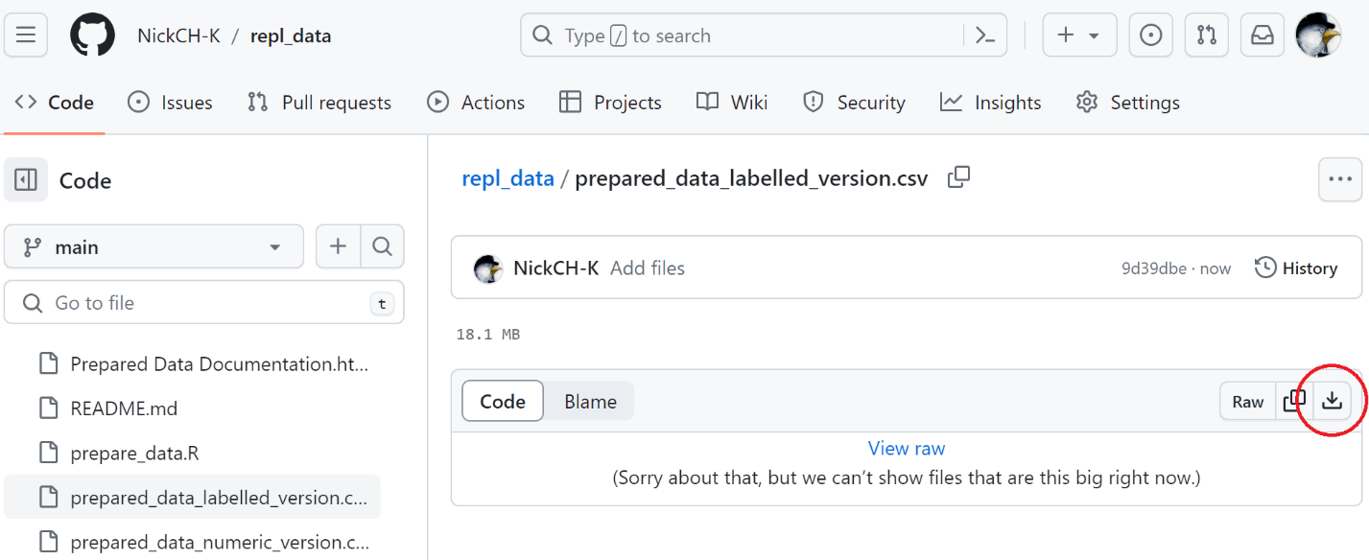

Reminders:
- You may use any statistics package you like. Coding languages are preferred (like Stata, R, Python, Matlab, etc.). Point-and-click statistics packages can be acceptable if they allow your analysis to be automatically replicated from start to finish, with all decisions you’ve made being fully visible (i.e. your results cannot just be a set of results tables, an Excel sheet with all the analysis already pre-performed so the analysis choices can’t be seen, or a set of written instructions for point-and-click software of the form “1. Load the data, 2. In the Analysis menu select Regression…”)
- If you would typically use graduate students for a given task (data cleaning, coding, etc.) we encourage you to use them for that task in this project as well.
- Unless necessary, we ask that you try not to ask for clarification on how the analysis should be done, as the analysis should be independent. Similarly, do not try to guess how other researchers will approach this task in order to match (or avoid matching) their approach. The idea is that we want to see how you would estimate this effect, if you’d had this question, this idea for identification, and had chosen this particular sample.
- You may want to review the post-analysis survey form (found here) before starting. These are questions you will be asked after you are done, and it may be easier if you prepare to answer them as you work.
- There are already published studies that use various methods to look at the effect of DACA or other immigration reforms on different outcomes, including employment. Some of these studies use ACS data as well. You may, if you like, seek out existing literature for background. However, do not assume that these published studies are “the right answer” and attempt to directly copy them just because they are published. This research task is not designed as a replication of any particular study, so there is no “right answer” study to emulate. The idea is that we want to see how you would estimate this effect, if you’d had this question, this idea for identification, and had chosen this particular sample. At most this would be informed by prior research, but not directed by it, as you might be informed by a literature review when writing a paper.

Turn in When Done
For each round of analysis, when you are finished:
- Make sure that your code and files contain no mention of your own name or the names of any assistants. This includes places where your name might appear in filenames (myname_code.do), in code itself (use “C:/Files/myname/mydata.csv”), or in your written justifications (Sincerely, Myname).
- Move all your code and data to the same folder, and double-check that your code runs properly from a clean session in that folder.
- Make sure you’ve held on to the IPUMS .dat.gz file provided by the IPUMS website. Upload the compressed .dat.gz version, not the extracted .dat version, even if your code relies on the .dat version. There is no need to upload a data file in this round.
- Have your participant ID handy.
- From your preferred estimate, have your effect size, sample size, and standard error/confidence interval handy. Space will be available to submit nonstandard effect estimates as well. Please select a single “preferred estimate” rather than several estimates produced under differing assumptions (robustness tests). What’s the estimate you’d mention in the abstract or intro of this paper if you were publishing it? Use that one.
Then, head to your personal Microsoft Sharepoint link, which was emailed to you, locate the folder for your participant ID, and upload:
- A Word, PDF, or HTML document that contains both a short (1-2 paragraph) description and interpretation of your results, as you might find in the “Results” section of a paper, as well as a demonstration of your results (for example, a table of regression coefficients).
- Your compressed (.gz, typically) IPUMS extract file There is no need to upload a data file in this round.
- Any code files used. Code files should begin from a clean slate by loading the IPUMS compressed or uncompressed data file
- If there is more than one code file that needs to be run, then there should be a clear indication (such as numbered scripts) as to the order they should be run in.
Finally, head to the Qualtrics survey: here. You will be asked to fill in:
- Your participant ID
- Your preferred estimate’s effect size, sample size, and standard error, among other questions.
- An explanation of what decisions you made in your analysis, and why you made those decisions.
After everyone is finished, you will hear back with further details on peer review and additional rounds of revision. Note that your uploaded Word/PDF/HTML document describing your results, as well as your responses to the Qualtrics survey may be shared with a peer reviewer.

