Big Push for the Rural Economy

Pre-Analysis Plan - I

Asim Khwaja, Muhammad Farooq Naseer, Joshua Gill, Jacob Shapiro
November 20, 2018

Abstract
The Big Push for the Rural Economy (BPRE) program provides vocational skills training in the agriculture and livestock sectors in four high-poverty districts of South Punjab. By infusing frontier skills and practices simultaneously at multiple nodes of the value chains, BPRE presents an opportunity to rigorously evaluate the impact of “big push” intervention on village-level GDP, productivity, household income and the extent of spillovers.
This pre-analysis plan has been filed prior to analyzing results of the first post-treatment tracker survey, which occurred between February and April of 2018 post-treatment and after the pre-treatment surveys in 2016 and 2013. The endline survey is scheduled for December 2018, and we will file another pre-analysis prior to analyzing the endline data.

Motivation
Agriculture, livestock and their related sectors dominate Pakistan’s rural economy, but high dispersion of productivity and skills keeps income and output growth stagnant (Rasul et. al., 2012; Ahmed & Gautam, 2013). To improve productivity in these sectors, BPRE delivers trainings of frontier knowledge and skills at different stages of the production cycle while exploiting the complementarities and economies of scale that result from the “big push” model (Murphy, Shleifer, & Vishny, 1989; Kremer, 1993; Sachs, 1999; Nankhuni & Paniagua, 2013; Cheema, Khwaja, Naseer, & Shapiro, 2015).

Research Questions
Our primary question is whether “big push” style trainings can help fight poverty. More specifically, we will examine whether the BPRE intervention improves trainees’ knowledge and production skills; whether trainees update their existing production practices; and, ultimately, whether improved skills and practices enhance yields and income as well as related household socio-political and economic outcomes.

Research Strategy

Treatment
Based on a close examination of the agri-livestock value chains and demand for skills, the BPRE intervention delivered skills trainings in synchrony with the production cycle. The Punjab Skills Development Fund (PSDF) recruited private companies with rich experience in the local agriculture and diary sectors to design and implement the intervention. Agriculture skills trainings focused on wheat and cotton, the most common crops in South Punjab, while livestock skills trainings concentrated on milk production.
Agriculture and livestock skills trainings rolled out on staggered and ongoing basis between late 2016 and mid-2018. Wheat training began in December 2016 and ended in May 2017, followed immediately by cotton training that concluded in November 2017. In the second half of 2017, BPRE also hosted trainings on kitchen gardening and farm food processing. Livestock training occurred between April 2017 and March 2018. Each training went through similar stages: facility setup, mobilization and invitation, application and registration, enrollment, enrollment confirmation and training. Noticeably, during the mobilization stage, CERP conducted multiple visits and distributed encouragement vouchers to households that engaged in crop or milk production (directly by owning land/animals or indirectly by working for others) because we expect these households to benefit more from the treatment. We refer to these households as “engaged” and the rest as “non-engaged”.
To infuse skills and knowledge in other nodes of the value chains, the following individuals also received trainings or attended information sessions over the course of 2017 and 2018: agriculture extension agents, agro dealers, farm machinery mechanics, electricians, farm supervisors, animal health workers, village milk collectors (VMC) and artificial insemination technicians (AIT).

Livestock Value Chain
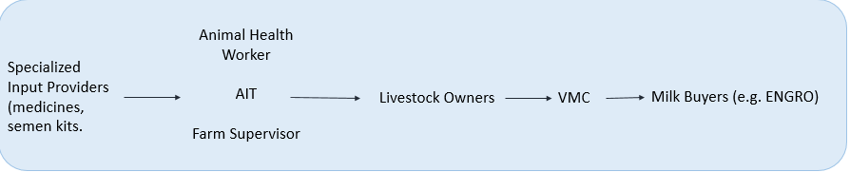
Ag Value Chain
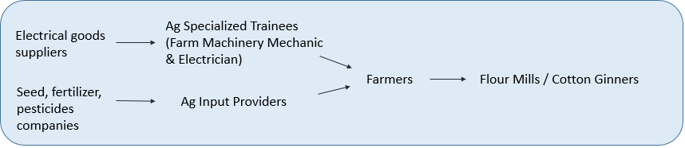
Following skills trainings, a subset of the sample villages also received a “market linkage” intervention. The market linkage component took the form of two separate melas or “fairs” per village that connected trained farmers with other players in the value chains, such as farm mechanics, animal health workers and potential buyers. One mela focused on agriculture and the other on livestock. Trainers could not mention any information about market linkage unless informed to do so.
The intervention concluded in the summer of 2018. The Center for Economic Research in Pakistan (CERP) was responsible for conducting surveys and collecting program data for program monitoring and evaluation.

Sampling & Randomization
The BPRE sample consists of 90 villages in four high-poverty Punjab districts (Bahawalnagar, Bahawalpur, Lodhran and Muzaffargarh). We first manually drew 15 grids to ensure that each grid has a group of similarly sized and geographically contiguous villages. Stratifying on the grids, we randomly assigned 30 villages to be control villages (“C” - where no program is offered) and the remaining 60 villages to one of two treatment arms – T1 and T2. The 30 “T1” villages received skills trainings only while the 30 “T2” villages received, in addition to trainings, the market linkage intervention. Within both T1 and T2 villages, all engaged households (i.e. those identified as engaged in agri-livestock production) received encouragement in the form of home visits and vouchers to enroll in the trainings, whereas non-engaged households received no encouragement but could still access the treatment.

The number of sample households in each village varied with the village size. The budget and preliminary analysis initially assumed 140 households per village on average. Given heterogeneity in village size and logistical constraints, the final sample was adjusted down in smaller villages and up in larger villages. To do so, we split the sample villages into four size quartiles by village population. A sample of 92 households were randomly drawn from the smallest villages, whereas villages in the largest size quartile got a sample of 188 households. The average was around 40% of the village sampled, though this naturally varied across village size. Our sample eventually amounts to around 12,700 households (with almost 70% engaged in either agriculture or livestock production).

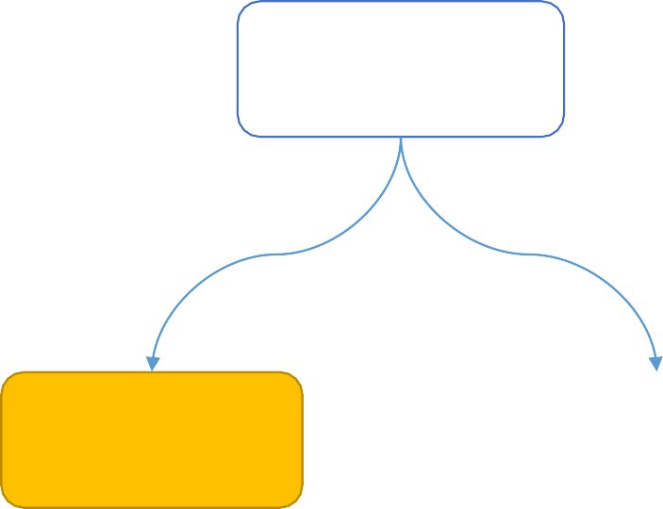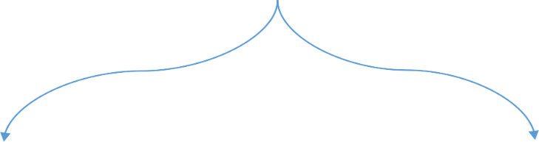
Sample
[90 Villages]
Treatment (T)
[60 Villages]
Control (C)
[30 Villages]
Training
[30 Villages]
Training + Market Linkage
[30 Villages]
Village level Randomization

Measurement
Based on our theory of change, trainees would complete the trainings, enhance their knowledge of best practice, upgrade their practice, improve their productivity, and ultimately raise their income, among other outcomes.
While we will have a wider range of economic and socio-political outcomes in our final endline survey, for the (shorter) tracker survey that motivates the current pre-analysis plan, our outcomes of interest include the following broad categories: knowledge of best practice, production practice and input, animal health and mortality, agricultural and milk production, and income from agri-livestock production. Because the BPRE intervention also trained specialized technicians such as farm mechanics and AITs to facilitate production, we would also ultimately measure village-level access to specialized service providers.
As summarized in Table 1, we plan to expand each broad category of outcomes to a list of specific variables or index scores based on survey data. We consider these variables our main outcomes of interest for the analysis related to the tracker survey. In the endline survey scheduled to start December 2018, we will expand on the tracker survey both in terms of depth and breadth of topics covered. A separate pre-analysis will be filed subsequently for that survey.

TABLE 1. Main Outcomes of Interest
Category | Outcome Variables
Crop Production | Yearly wheat & cotton output levels (maund)  Yearly wheat & cotton yields (maund per kanal)  Dummy indicators of HH engagement in wheat and cotton production  Log of yearly wheat & cotton output levels  Increase in wheat & cotton production compared to past (ratio)  Log of yearly wheat & cotton yields
Milk Production | Daily milk output level (liter)  Daily milk output per animal (liter per animal)  Dummy indicators of HH engagement in milk production  Log of daily milk output level  Increase in milk production compared to past (ratio)  Log of daily milk output per animal
Income | Yearly revenue from crop sales (level, log, & ratios)  Daily revenue from milk sales (level, log, & ratios)  Total monetary value of annual crop and milk output (level, log, & ratios)
Knowledge of Best Practices | A weighted sum of correct responses to survey questions on knowledge about water use, fertilizer and pesticide use, animal feed amount, animal health, milk storage, awareness of and response to climate change, and preservation of soil quality (for agriculture & livestock)
Input Use and Practice | A weighted sum of correct responses to survey questions on actual practice of water use, fertilizer and pesticide use, animal feed, animal health care, milk storage, and preservation of soil quality (for agriculture & livestock)
Animal Mortality | Number of animals lost from the past 12 months prior to survey time (0 if HH owns no animal)  Fraction of animals lost from the past 12 months prior to survey time (0 if HH owns no animal)

In addition to household-level analysis, we intend to examine the abovementioned outcome variables at the village level either by aggregating them or by using other sources of village-level data (e.g. administrative and/or survey data available at the village level for production, availability of specialized services, etc.)

Analysis

Balance Checks
We will test for balance along pre-treatment characteristics, which we collected in 2013 & 2016 through baseline surveys, between treatment (T1 & T2) and control groups (C). These characteristics will include agricultural and livestock knowledge and practice index scores (2016 only); wheat, cotton and milk output levels and productivity; and household-level characteristics such as land quality, access to water, wealth index score and household head literacy.
Because we randomly assigned villages to T1 and T2, we will also perform balance tests between these two sub-groups and expect balanced results.
The following regression summarizes our approach to the balance checks:
$$Y_{ij, t=1}= β_{0}+ β_{1}T_{j}+ γ+ε_{ij}$$
where we use i to index household, j village and t survey round. The left-hand-side variable, $Y_{ij, t=1}$, refers to the baseline value of a main outcome of interest or household-level characteristic. $T_{j}$ is a dummy variable indicating the village’s treatment status and will be further split into T1 and T2 to specify which treatment arm the village was assigned to. $γ$ represents grid fixed effects.
We will control for household-level characteristics that appear imbalanced in the final statistical evaluation of BPRE’s impact.

Main Regression Specifications
Because we randomly assigned BPRE treatment at the village level, we plan to measure the impact of BPRE in two forms: intent-to-treat (ITT) and local average treatment effects (LATE). We should note that both these effects are not really capturing the effect of a particular household being trained but rather the aggregate effect of a village (community) having a (fraction) of its population receiving training i.e. the impact of a “big push” in aggregate human capital.

ITT

ITT without covariates
First, we plan to run a simple linear regression model without controlling for any pre-treatment covariates, except baseline values of the outcome:

$$\begin{aligned}Y_{ij, t=2}= β_{0}+ β_{1}T_{j}+ β_{2}Y_{ij,t=0}+{β_{3}Y}_{ij,t=1}+ γ+ε_{ij} \#\left(1\right)\end{aligned}$$

In the regression above, $Y_{ij,t=2}$ represents the tracker outcome of the i^{th} household in the j^{th} village, such as wheat production level. $T_{j}$ is a dummy indicator of the j^{th} village’s treatment status and equals one if the village is in either T1 or T2. $Y_{ij,t=0}$ and $Y_{ij,t=1}$ refer to the lagged values of the left-hand-side outcome in the two baseline years, 2013 and 2016, respectively. Because some of the lagged values are missing, we plan to replace them with an arbitrary value such as zero and add dummy indicators to show their missing status. $γ$ stands for grid fixed effects. $ε_{ij}$ is a random error term.

In this specification, $β_{1}$ captures BPRE’s impact on the average household in the village, regardless of whether it was involved in agri-livestock production and/or received training. $β_{1}$ can therefore be interpreted as the analogous of an intent-to-treat (ITT) estimate in the sense that BPRE’s intention was to train individuals in the village. Alternatively, one could also consider this the causal impact of offering (and then carrying out) a range of agri-livestock trainings.

We will experiment with multiple variants of each left-hand-side outcome variable. To measure the BPRE program’s impact on crop production, for instance, we plan to use not only the output level of each crop but also its log transformation, growth, yield per kanal and a dummy variable indicating whether the household grew that crop within 12 months prior to the survey time.

In all of our specifications, we will cluster standard errors at the village level to account for the level of our randomization. This implies that these regressions are analogous to running village-level specifications (as opposed to household level). We prefer the household specifications since they allow us to examine heterogeneous effects more closely, while (through clustering) ensuring that we estimate our standard errors in a conservative manner. That said, in subsequent analyses, we also aim to estimate village-level outcomes not necessarily by aggregating the household-level data but by using data from alternative sources. For instance, we can estimate total production by focusing on large producers and/or administrative production data (where available), as well as conducting surveys that measure village-level access to services and other relevant outcomes.

ITT with pre-treatment covariates
In addition to the lagged values of the outcomes of interest, we also plan to control for a set of household- or village-level characteristics:

$$\begin{aligned}Y_{ij, t=2}= β_{0}+ β_{1}T_{j}+ β_{2}Y_{ij,t=0}+ {{β_{3}Y}_{ij,t=1}+θX'}_{ij}+ γ+ε_{i} \#\left(2\right)\end{aligned}$$

where ${X'}_{ij}$ is a matrix of pre-treatment characteristics such as family size, an asset index, household head literacy, fertilizer usage, soil quality and access to water for the i^{th} household in the j^{th} village. The composition of the covariate matrix varies by our outcomes of interest. Every other variable in (2) has the same interpretation as in specification (1). $β_{1}$ remains the ITT effect of the BPRE intervention.

Lasso regression
Next, we also intend to explore the value of using a flexible set of controls in the hope of minimizing the standard errors on our outcomes of interest. To do so, we will first generate fake treatment randomization data, use them to replace the treatment status indicators in the aforementioned specifications, and re-run these specifications using methods such as Lasso regressions to find the set of covariates and their interactions that minimize relevant standard errors. Once we find the subset of covariates that generate the least standard errors, we will run our specifications again using real treatment randomization data and only these covariates. Because this approach uses fake treatment assignment and fixes the specification prior to running the actual treatment regressions, it will help reduce variance in the data without raising data mining concerns.

Interaction between treatment status and indicator of (non-)engagement in production
Since take-up rates of skills trainings are likely to be higher for those who were already engaged in agri-livestock production, we will estimate the impact separately for engaged and non-engaged households in a village. We do so by interacting village treatment dummy with an indicator of engagement status :

$$\begin{aligned}Y_{ij, t=2}= β_{0}+ β_{1}T_{j}+ β_{2}Y_{ij,t=0}+ {β_{3}Y}_{ij,t=1}+{ β}_{4}{NonEngaged}_{ij}+β_{5}{{NonEngaged}_{ij}*T}_{j}+{θX'}_{ij}+γ+ε_{i} \#\left(3\right)\end{aligned}$$

where ${NonEngaged}_{ij}$reflects whether the i^{th} household in the j^{th} village performs agri-livestock production (at baseline). In specification (3), $β_{1}$provides the ITT effect of BPRE on the engaged population.

Heterogeneous effects
Analogous to the heterogeneity of impact by each household’s engagement status, we intend to interact the treatment status indicator with household- and village-level characteristics of interest to explore BPRE’s potential heterogeneous effects:
$$\begin{aligned}Y_{ij, t=2}= β_{0}+ β_{1}T_{j}+ β_{2}Y_{ij,t=0}+ {{β_{3}Y}_{ij,t=1}+β_{4}X_{ij}*T_{j}+ θX'}_{ij}+ γ+ε_{i} \#\left(4\right)\end{aligned}$$

where $X_{ij}$ represents a pre-treatment characteristic at either village or household level. We focus on pre-treatment characteristics that could act as complements or substitutes of the training, while acknowledging that we may not have enough statistical power to detect village-level heterogeneous effects. Table 2 summarizes some of the potential sources of heterogeneity. To avoid losing observations, we will replace missing values of these variables with some arbitrary number and then include dummy indicators to show whether the values are missing.

TABLE 2. Potential Sources of Heterogeneous Effects
Village Level | Household Level
Village size  Village development index  Overall interest in BPRE training  Quality of training (e.g. trainer turnover rates)  Access to agri-livestock market in other villages | Prior level of production/engagement  Land quality and water access  Average skill index  Labor availability  Density of social network  Wealth and production-related asset indices

Additional specifications

One natural feature of several of our outcome variables, such as production, is that a sizeable fraction of surveyed households (and hence the village) contribute zeros or missing values to the data because they do not directly produce crop or milk. While one could simply include these values as production outcomes, we intend to explore functional forms and specifications that naturally account for the presence of many zeros. If this is censored data, specifications such as tobit are effective, and we intend to use them as appropriate. In other cases such as production, however, reporting zeros could be a result of a nested choice—a household may first choose to produce or not and then, conditional on that choice, realize production. In such cases, we will apply models—such as the Heckman selection model—that explicitly account for both the selection and realized outcomes. Specifically, we would run the main specifications given previously (equations 1 to 4 above) and include the relevant selection equation. For example, in the case of equation (1), we can estimate:

$$\begin{aligned}Y_{ij, t=2}= β_{0}+ β_{1}T_{j}+ β_{2}Y_{ij,t=0}+{β_{3}Y}_{ij,t=1}+ γ+ ε_{ij}^{1}\#\left(1'\right)\end{aligned}$$

while recognizing that non-missing and non-zero values of $Y_{ij,t=2}$ are only observed when

$$\begin{aligned}βT_{j}+{γZ}_{ij}+ε_{ij}^{2}>0\#\left(S\right)\end{aligned}$$
where corr($ε_{ij}^{1}$, $ε_{ij}^{2}$)=ρ.

The above formulation acknowledges that the training treatment can influence both the selection and outcome (i.e. production) margins. To the extent that we find no impact on selection, however, we could also simply regress the outcome variables conditioning on non-zero (non-missing) values of the variables.

LATE
While our primary specification could be thought of as an ITT/reduced form estimate (i.e. the impact of offering training in a village), it is plausible that this impact works through the fact that individuals are actually trained in the village (i.e. it is not just the offer that has impact but the fact that villagers avail of it). This is analogous to saying that if an individual were (randomly) offered a training opportunity, any observed impact was due to the training itself rather than other factors (such as simply being selected).
If the observed impact indeed works through the training, however, then much in the same way that one would use an instrumental variable specification (where actual training take-up is instrumented by the randomized offer) to capture the local average treatment effect (LATE), one would want to estimate the analogous village LATE.
In our case, we can do so by replicating the specifications from Section 6.2.1 but use village treatment status as an instrument for each household’s participation status. Specification (5) provides an example:
$$\begin{aligned}Y_{ij, t=2}= β_{0}+ β_{1}{Training}_{ij}+ β_{2}Y_{ij,t=0}+ {{β_{3}Y}_{ij,t=1}+θX'}_{ij}+ γ+ε_{i} \#\left(5\right)\end{aligned}$$
where ${Training}_{ij}$, the participation status of the i^{th} household in the j^{th} village, is instrumented by $T_{j}$, the village treatment status.
We should caution that this estimate is not the impact of any one person receiving training. Since everyone in a treatment village enjoyed access to (different types of) training around the same time, we cannot isolate the impact of any one individual being trained. Rather, what the “LATE” would capture in our case is the contrast between no one being trained in the village to (at least one member of) all households in the village receiving (at least one of) the trainings. We believe this “scaling up” of the ITT estimates is useful to give a sense of how large these effects could be under the given level of program exposure and take-up.

Analysis of T1 and T2
Each treatment village in the BPRE program received either T1 (skills trainings) or T2 (skills trainings and market linkage). To measure the impact of each treatment arm, we will separate $T_{j}$—the village-level treatment status indicator—into ${T1}_{j}$ and ${T2}_{j}$ and re-run the ITT specifications in Section 6.2.1, as illustrated by Specification (6):

$$\begin{aligned}Y_{ij, t=2}= β_{0}+ β_{1}{T1}_{j}+β_{2}{T2}_{j}+ β_{3}Y_{ij,t=0}+ {{β_{4}Y}_{ij,t=1}+θX'}_{ij}+ γ+ε_{i} \#\left(6\right)\end{aligned}$$

To estimate the analogous LATE specification, we will replicate the instrumental variable model in Section 6.2.2 using ${T1}_{j}$ and ${T2}_{j}$ as instruments for participation status in the two types of villages.

For both the ITT and LATE models, we will also compare the effects of T1 and T2 by performing a test between $β_{1}$ and $β_{2}$.

PEOP’s exclusive focus was on Punjab’s four high-poverty districts located in the South: Bahawalpur, Bahawalnagar, Lodhran and Muzaffargarh (which will be referred to as the original PEOP districts in this report).
Logistical and budgetary constraints do not permit including a set of villages which are only linked to the market (i.e. no training is given). Moreover, PSDF is not interested in just evaluating the impact of market linkages since that is not its mandate.
In the end-line survey, we will inquire about topics that the tracker did not cover, such as the sampled households’ lending, borrowing and saving behaviors. We plan to investigate BPRE’s impact on these new topics once data becomes available. Similarly, we will also investigate non-economic outcomes such as political participation, which the tracker survey does not include.
To date, we have had three rounds of surveys: baseline 2013 (t=0), baseline 2016 (t=1) and the shorter 2018 tracker survey (t=2).
We will separate T into T1 and T2 in later regressions.
The training was also open to the non-engaged households, who did not take part in agri-livestock production at the time of the baseline survey in 2016.

