2 Experimental Design

In collaboration with Ireland’s largest online property sales website, daft.ie, we created a new annual energy cost label based on each property’s energy efficiency (EE), size and the price of energy. This new monetary label is motivated by assumed informational/behavioural biases which could negatively affect household demand for EE: we expect that many buyers do not understand how energy ratings affect their bills. If the monetary savings of higher efficiency levels (on our new label) are larger than household expectations, we would expect to see an increase in demand for more efficient properties (observed through higher sales prices and rents).
Since 2013, all property advertisements in Ireland are required to include a Building Energy Rating (BER) certificate. The key component of the BER is a property’s kWh/m²/annum, which is displayed on a 15-grade colour-coded scale (left panel of Figure 1). Advertisement regulations stipulate that a property’s BER category is required (only, without comparative scale) for all sale or rental advertisements (right panel of Figure 1). The BER estimates the energy used for standard occupancy for space and hot water heating, ventilation and lighting using software developed by the Sustainable Energy Authority of Ireland (SEAI). While we have no reason to expect this estimate is biased, the BER does not account for any behavioural changes associated with higher efficiency (rebound effects for example).

Figure 1: Current EE Labelling – the Building Energy Rating (BER)
BER certificate example | BER advertisement examples
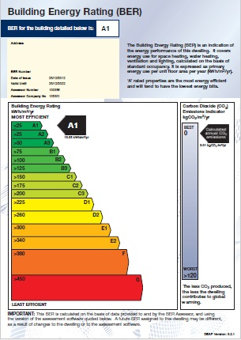
Source: www.seai.ie

The monetary label is created using three components: the property size (from advertisements), the energy consumption per year (kWh/m²/annum from the BER) and the price of energy (from Sustainable Energy Authority of Ireland (SEAI) monthly energy price tables). This follows the SEAI’s online energy cost tool “See what a difference a BER makes!” (see Figure 2). We provide an example of our calculations in Table 1.

Figure 2: SEAI Online Energy Cost Calculator (Screenshot)
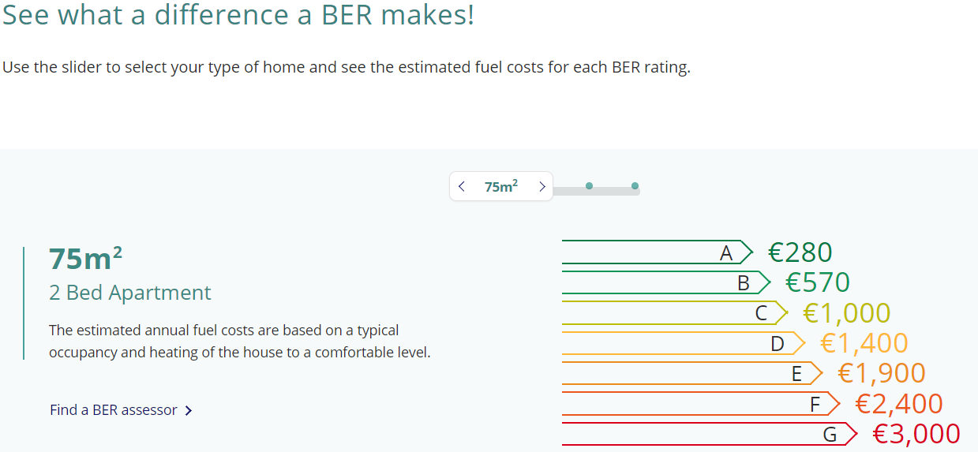
Source: www.seai.ie

Table 1: Energy Cost Calculations for Monetary Label (example) in Daft.ie-TCD Trial
Description | Values | Code | Formula
BER (kWh/m²/yr.) | 350 | a
Size (m²) | 100 | b
Cost of electricity (€) | 0.1992 | c
Cost of Gas (€) | 0.0678 | d
Cost of Oil (€) | 0.0582 | e
Energy for light and pumps (kWh/m²/yr.) | 20 | f
Delivered energy for lights and pumps (kWh/m²/yr.) | 8 | g
Cost of lights and pumps (€/m²) | €1.59 | h | g * c
Cost of heating (€/m²) | €20.79 | i | (a - f) * ((d + e)/2)
Total annual energy cost | €2,238.36 | j | (h + i) * b
Source: calculations based on the methodology used for the SEAI energy cost calculation online tool
www.seai.ie/energy-ratings/building-energy-rating-ber/
Notes: energy prices are available from www.seai.ie
The monetary label was designed by TCD and daft.ie and is displayed in Figure 3 (left panel). Relative to the pre-trial advertisement format (right panel of Figure 1), our new label contains two new and separate components that could change buyer behaviour: monetary information and a categorical and graphical scale. Therefore, to isolate the independent effects of monetary information, we included an identical categorical scale in the control group that is based on kWh/m²/annum information only (right panel of Figure 3). While this implies that there has been a change in control group information, this was carried out to remove any effects of a visual graphical scale, leaving only the effects of monetary information.

Figure 3: Label Examples from daft.ie-TCD trial
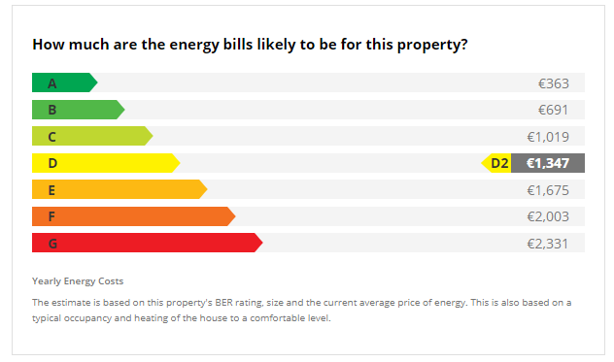 | 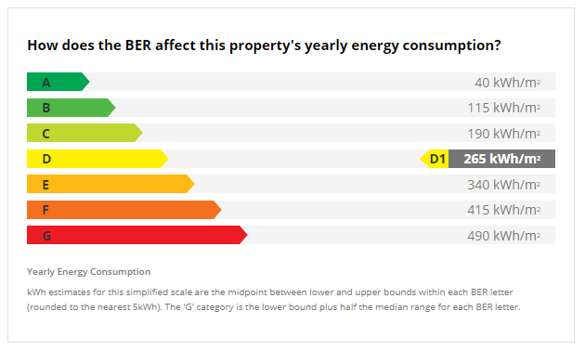
Source: designed by TCD and Daft.ie
The labels were displayed from early February 2018 in addition to existing BER advertising requirements (at the bottom of the advertisement). However, as there were a number of implementation issues during February, our analysis of treatment effects is from March 1st onwards (February is excluded from the analysis entirely, for simplicity). For treatment allocation, we split Ireland into 26 property markets, in line with the traditional administrative counties within the Republic of Ireland. While a larger number of markets would be preferable for randomisation, we were constrained by buyer search patterns which is generally within counties. This split would therefore help to reduce treatment contamination, that is, buyers learning about energy costs from a treatment county and applying this new knowledge to a control county. Each market was randomly allocated, with one exception – we combined the capital city Dublin with its surrounding counties (Meath, Kildare and Wicklow) and imposed this aggregate group to treatment. We did so as many Dublin workers reside in these counties, and we expected that such buyers would search for properties across this wider geographic area. The final county allocation is displayed in Table 2 with county numbers and shares (of total dataset). County shares generally range between 1% and 6% with two exceptions – Cork with 11% and Dublin with 34%.

Table 2: Control and Treatment County Allocation for Daft.ie-TCD trial
Control |  |  | Treatment
County | N | % | County | N | %
Cork | 29,778 | 11.25% | Carlow | 2,772 | 1.05%
Galway | 14,758 | 5.58% | Cavan | 3,743 | 1.41%
Kerry | 7,059 | 2.67% | Clare | 5,352 | 2.02%
Kilkenny | 3,628 | 1.37% | Donegal | 6,267 | 2.37%
Laois | 4,209 | 1.59% | Dublin | 91,668 | 34.65%
Leitrim | 2,343 | 0.89% | Kildare | 10,918 | 4.13%
Limerick | 10,034 | 3.79% | Louth | 7,262 | 2.74%
Longford | 2,458 | 0.93% | Mayo | 7,422 | 2.81%
Roscommon | 3,708 | 1.40% | Meath | 8,366 | 3.16%
Tipperary | 6,231 | 2.35% | Monaghan | 1,555 | 0.59%
Westmeath | 5,559 | 2.10% | Offaly | 2,805 | 1.06%
Wexford | 8,551 | 3.23% | Sligo | 3,780 | 1.43%
 |  |  | Waterford | 8,217 | 3.11%
 |  |  | Wicklow | 6,148 | 2.32%
Source: own calculations based on daft.ie dataset
Notes: data are from January 1st 2017 to January 3rd 2019 which include rental and sales. There are no data exclusions in this table.

The Dwelling Energy Assessment Procedure (DEAP).
Rebound effects refer to an increase in consumption due to the lower price of energy services resulting from energy efficiency upgrades.

