How messages of encouragement influence students’ grades on exams – pre-analysis plan of a large-scale randomized field experiment

Tamás Keller
Center for Social Sciences, Budapest
keller.tamas@tk.mta.hu

Péter Szakál
University of Szeged
Szakal.Peter@rekt.szte.hu

Abstract

We will conduct a large-scale randomized field experiment at the University of Szeged that takes the form of a message of encouragement. All students at the university will receive before their exam. We will randomize when students receive the message. A randomly selected half of all students will receive the message of encouragement before their first exam, and will not receive it before their second exam. The other random half of the sample will be treated before their second exam, and will not be treated before their first exam. By comparing students who receive the message of encouragement with those who do not, we will investigate how the message of encouragement influences students’ grades on the exam. We will explore treatment heterogeneity and test for the particular mechanism through which the potential effect might operate. Our research has particular policy relevance in terms of its search for low-cost, easily scalable interventions that can prevent students from dropping out.

Keywords

Message of encouragement; Higher education; Crossover randomized field experiment; Learning outcome; Students' exam grades

Introduction

Students’ performance in exam situations often depends on skills outside the realm of academic ability. Self-discipline (Duckworth and Seligman 2005), self-confidence (Mavis 2001; Tavani and Losh 2003), intrinsic motivation (Gottfried 1985), test-anxiety (Hembree 1988), growth mindset (Dweck 2006; Sisk et al. 2018), grit (Duckworth et al. 2007) and delay of gratification (Mischel et al. 2011) all have an independent influence on students’ performance. However, developing these soft or non-cognitive skills is not straightforward (Dev 1997), since they are resource and time intensive (Abikoff et al. 2013; Paunesku et al. 2015; Piquero, Jennings, and Farrington 2010) and might require family investment (OECD 2016). Though some of the skills are malleable at a later age (Heckman 2000; Heckman and Rubinstein 2001), little research (Behncke 2012) has focused on the question of how light-touch, low-cost, and easily scalable interventions could increase students’ academic performance through the stimulation of their non-cognitive skills.
Prior research found mixed results for the impact of financial incentives on students' cognitive test results (Borghans, Meijers, and Ter Weel 2008). However, undergraduate macroeconomics students in Switzerland were found to be responsive to encouragement messages received during a low-stakes mathematics test (Behncke 2012). Those students who received the message of encouragement obtained an average test score of 2.5 percentage points higher than those who did not. Nevertheless, further empirical evidence is required regarding to what extent this finding is context-specific, and whether we can generalize the finding across different academic disciplines, different exam-situations, and in a different institutional context. Furthermore, we need more evidence about treatment heterogeneity, especially in connection to how much the encouragement of students decreases the social status gradient in students’ exam-scores. Last, our knowledge is still limited in terms of the mechanisms underlying the effect of messages of encouragement. We know little about the whether encouragement messages exert their effects through increasing students’ motivation or self-confidence, or if they decrease test-related anxiety. The identification of the mechanisms behind the treatment may promote the development of innovative and more effective future treatments (Kraemer et al. 2002).

Institutional background

We will conduct our field experiment at the University of Szeged, which is the second-largest Hungarian university, with nearly 20,000 students in its 12 faculties.
In Hungary, like in many other countries, university students in every discipline and faculty take general courses (like statistics, anatomy, or macroeconomics) as part of their standard curriculum. General courses take two different instructional forms: theory-, and practice-oriented.
Students attend common theory-oriented lectures (1) at which all students who have subscribed to the course are grouped together. Thus, one or more instructors teach all the assigned students at the same time. Students receive in-depth explanations of the lecture-material in practice-oriented tutorial groups (2), which are taught in smaller groups (20-30 students) led by one instructor. The same instructor can conduct more than one tutorial group (with different students). Students assign themselves to tutorial groups based on their preferences and academic schedules.
Students are required to take exams concerning the lectures at the end of the semester. Exams can be either written or oral. Students have to register for the exams on the university’s online platform. They can change their registration up to 24 hours before an exam. Students who do not show up for an exam they have registered for automatically fail unless a medical doctor warrants that the student was ill on the day of the exam. If the particular lecture has a corresponding tutorial group, then a prerequisite of taking the exam is the fulfillment of the requirements of that group. Requirements in the tutorial groups can vary between tutorial groups corresponding to the same general course. The requirements of tutorial groups corresponding to different general courses might also differ.
In the fall semester of the academic year 2019/20, the first day when students can take exams from the lecture materials is December 9, 2019. This is the date when our field experiment begins.

Design

The study program was initiated by the Directorate of Education of the University of Szeged for the purpose of developing a low cost and easily scalable tool for decreasing dropout. The study program was approved by the rector and senate of the university.
Our target population is those students who are engaged in full or correspondence-based training at the university, are active in the fall semester of the academic year 2019/2020, and whose training is conducted in the Hungarian language (some students have training in English). We will treat students only in one study program. We have 16,992 different students at the university who correspond to these criteria. These students are in our target population. Students will be treated before their end-of-semester-exams on theory-oriented lectures. The exam is not a low-stakes exam, in contrast to the situation in similar earlier research (Behncke 2012).
We have designed a crossover randomized field experiment (Brown 1980) in which students function as their own control since we have repeated measurements (first and second exam) about the same students.
All students from the target population will receive the treatment for ethical reasons. We will randomize, however, the time when students receive the treatment. Based on the value of a random number, we will create two groups. Group A will receive the treatment before their first exam, and will not receive the treatment before their second exam. Group B will receive the treatment before their second exam, but not before their first exam. Students who receive the treatment (irrespective of whether they receive it before the first or the second exam) will be referred to as the treatment group. Students who do not receive the treatment (irrespective of when) will be referred to as the control group.
Our intervention takes the form of a message of encouragement that students will receive before their exam. The student will receive the message of encouragement via two channels: e-mail and text message on their mobile device.
The English translation of the Hungarian sentence that students in the treated group will receive is the following: “Dear Student! The fact that you will take your exam soon proves that you already have many successful exams behind you! I truly hope that you will succeed in the next one as well, and I wish you every success! Please follow this link and answer three simple questions before your next exam. We will distribute vouchers worth a total of HUF 100,000 that can be redeemed at the SZTE Gift Shop among the respondents. Winners will be notified via email. In the name of Head of the Directorate of Education, Péter Szakál.”
Students in the control group will receive the following e-mail: “Dear Student! Please follow this link to answer three simple questions before your next exam. We will distribute vouchers worth a total of HUF 100,000 that can be redeemed at the SZTE Gift Shop among the respondents. Winners will be notified via email. In the name of Head of the Directorate of Education .”
Students will receive the e-mail message 24 hours before the exam. In sum, in the e-mail communication the treated and control students differ only in the content of the message they will receive since every student (including those in the control condition) will receive a message from the rector which serves the aim of minimizing the Hawthorne effect, since in prior semesters students have not received any messages from the university before the exam. We will have information about whether students have received the e-mail (due to email delivery failure messages). Almost everybody (99.9% of students) has a valid e-mail address.
In addition to the e-mail message, treated students will receive an additional text message on their mobile device before their exam. The English translation of the Hungarian sentence that students in the treated group will receive as a text message on their mobile device is the following: “We wish you good luck in your next exam since, during your educational career, you have already successfully proved your aptitude! SZTE Education Directorate” Students in the control group will not receive text messages on their mobile devices.
Students gave their phone numbers to the university after matriculation. This list of phone numbers is not a supervised list. Approximately 40% of students gave their phone numbers to the university. We will have information about whether their phones have received the text message, but no information about whether the particular phone numbers still belong to the respective students.
Figure 1 summarizes the message(s) we will send out to students.
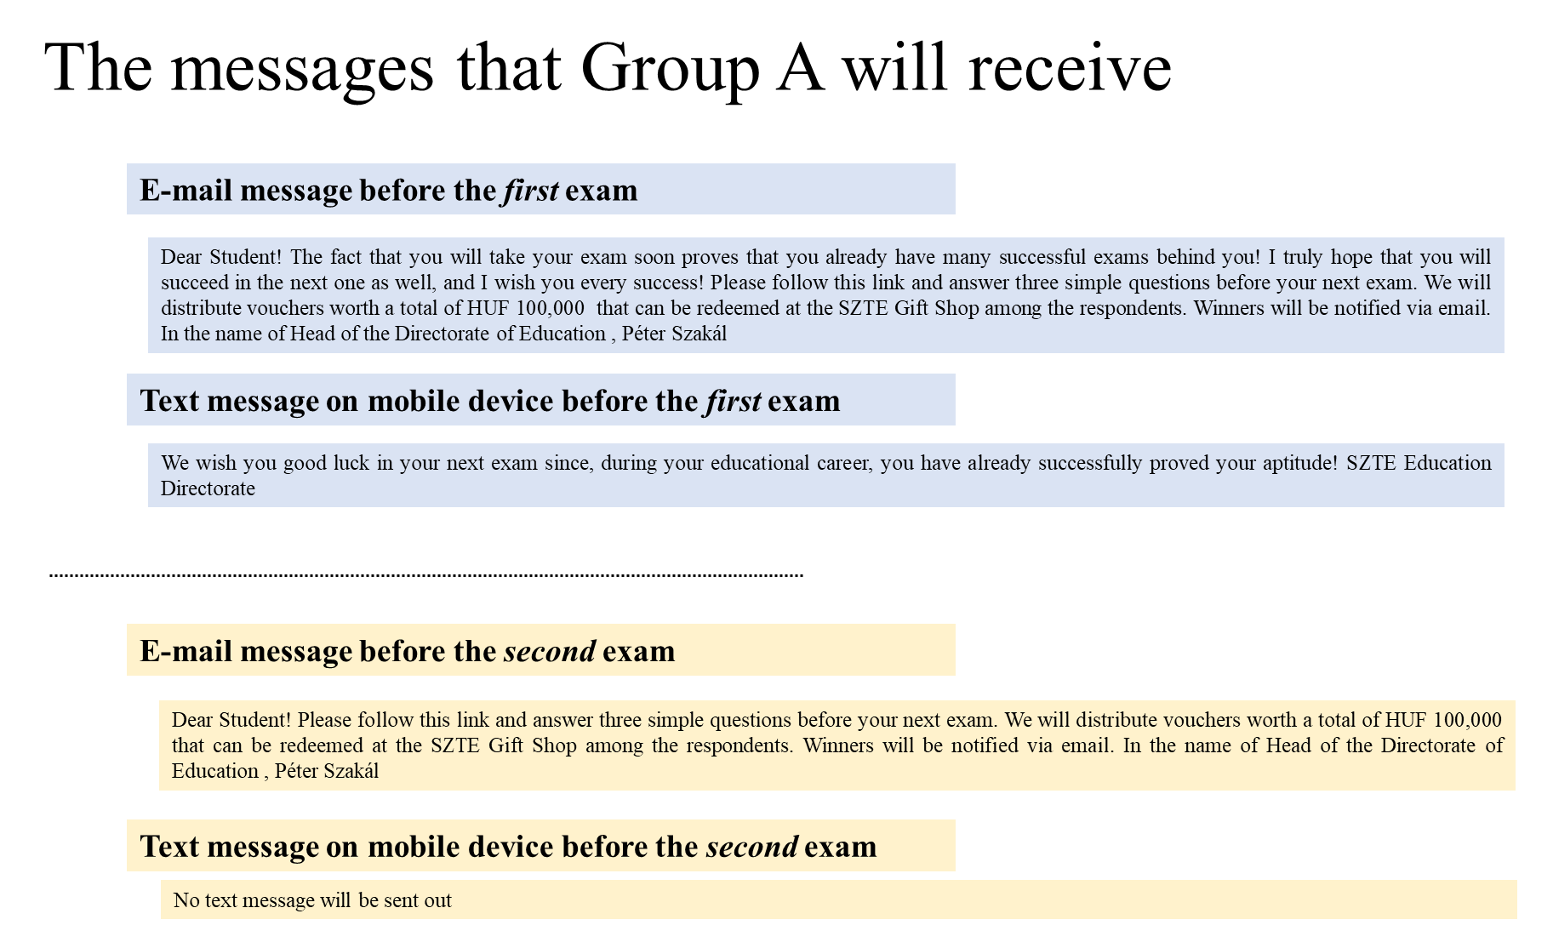
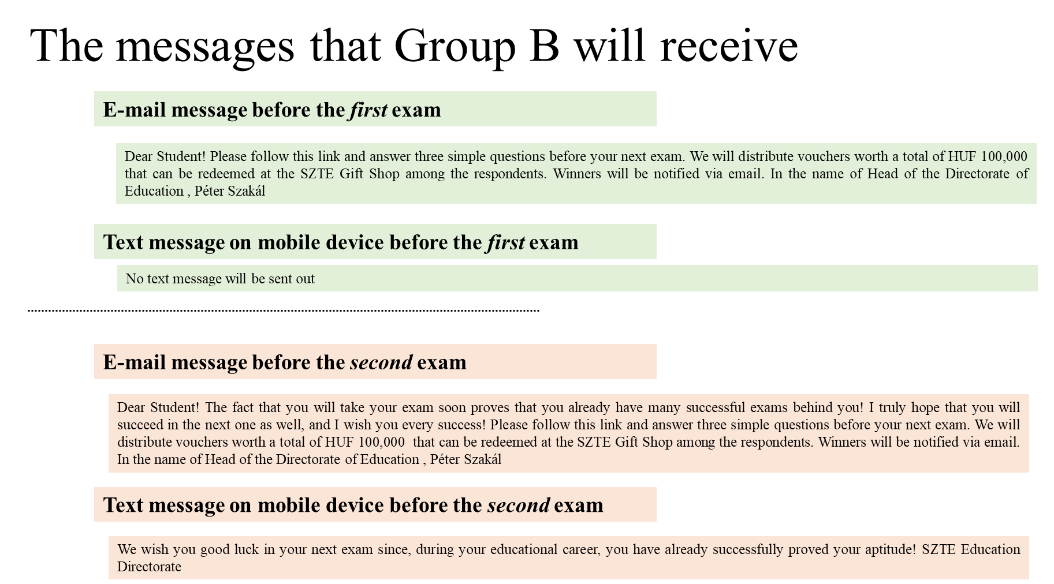
Figure 1. Messages that students randomized to Group A and Group B will receive

A similar message of encouragement was successfully employed in prior work (Behncke 2012).
The treatment may influence students’ performance on the exam through various channels: it can decrease their test-anxiety (1), it can raise their self-confidence (2), and it can raise their motivation to perform well (3) since they may seek to comply with the content of the message. We will test for these possible mechanisms in a short questionnaire, which treated and control students will receive with the e-mail message before their first and second exam (Fugure 2). The original Hungarian version of the questions is shown in the Appendix.

In the table below, you can read statements that people often use to describe how they feel. Please read each statement independently and use the scale that is provided to indicate how much you consider these statements to correspond to your current mood. Your answers will not influence the grade of your exam.

 | Not at all |  |  | => => => => => => => |  |  |  |  | Very much
I am anxious because of the exam tomorrow | 0 | 1 | 2 | 3 | 4 | 5 | 6 | 7 | 8 | 9 | 10
I am confident that I will have a successful exam tomorrow | 0 | 1 | 2 | 3 | 4 | 5 | 6 | 7 | 8 | 9 | 10
I intend to do well in the exam tomorrow | 0 | 1 | 2 | 3 | 4 | 5 | 6 | 7 | 8 | 9 | 10

Figure 2. Questions that students answer before their first and second exam

We will randomize students at the student level. We will employ pair-matched randomization (Imai, King, and Nall 2009). We will first sort the data file according to the following baseline variables: the study program on which the student is enrolled, the level of training, the type of training, the financial form of training, students’ gender, and students’ ability. In the sorted data file, we will identify the most similar pairs of students. We will randomly assign students from the same pair to Group A or Group B based on the value of a randomly generated number.
We pre-register the following criteria for the exclusion of students from the analytical sample: We will not analyze students who only have one exam in the semester and thus cannot be treated before their second exam (1). Those students who have neither e-mail addresses nor mobile phone numbers in the university’s register cannot be treated (2).
We pre-register the following decision rules: If a student takes her first and second exam on the same day, the student will be treated corresponding to her assigned status (Group A or Group B) before her third exam (1). Students will receive the treatment corresponding to their status before the second exam in the case that they do not show up to their first exam (2). Students will not receive an additional message if they do not show up on their second exam (3). Students who are enrolled in two different study programs (such as sociology and engineering) will be treated only once. We will randomly select one of the students’study programs, and we will send them messages corresponding to that program (4). Figure 3. illustrates the selection and decision rules.

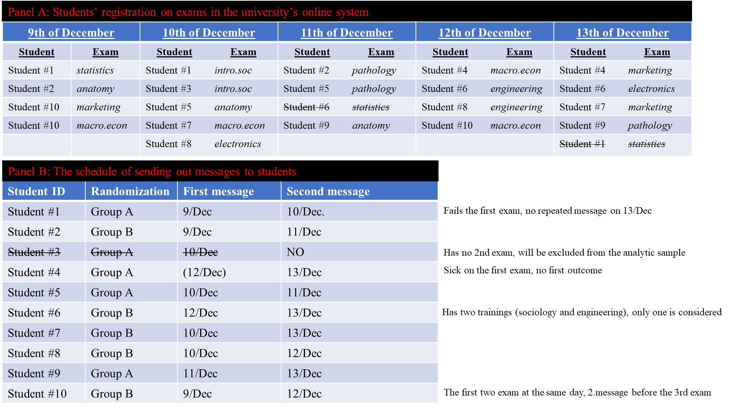
Figure 3. Illustration of selection and decision rules

Our design seeks to minimize the spillover effect and treatment contamination. First, students will receive the treatment very close to the exam. Thus, students who receive (do not receive) the message of encouragement on a given day will have limited time for exchanging this information. Second, students who have already taken the exam might inform their peers about the message they received. Thus, students who will be treated later might expect to receive a message. However, even in that case, students will not know which kind of message they will receive since this cannot be known a priori and is decided at random. Furthermore, students take their first exams in a relatively short period; in the past semesters, 80% of students took their first exam within the first two weeks.
The design makes it possible to account for the carryover effect. The carryover effect refers to whether the first treatment (message of encouragement) has an enduring effect that persists during the second treatment.
Our design is capable of handling the potential differences between the first and second exams, which may arise from the ordering of the treatment. Since half of the students will not receive the message of encouragement before their first exam, after the first exam the treatment effect thus mixes up two possible mechanisms. Treated students might be encouraged (which can boost their grades), and control students might be discouraged since not receiving the treatment might give rise to a feeling of neglect (which can lower their grades). By comparing students’ grades after the second exam, possible feelings of neglect might be ruled out since all students will receive a message in relation to that event.

Main variables and coding

The treatment variable will be a 0/1 variable indicating whether the student was randomized to the treatment group in which students will receive the message of encouragement before their exam.
The primary outcome variable is students’ grades on the exam, which are integers between 1 and 5. In the Hungarian system, grade 1 means fail; other grades are equivalent to passing the exam. The primary outcome variables will have missing value if a student has not shown up to the exam, and a medical doctor warrants that she was ill. Missing values will be not replaced.
In addition to the primary outcome variable, we pre-register secondary outcome variables such as test anxiety (1), self-confidence (2) and intention to do well on the exam (3). These variables are measured on a scale ranging from 0 to 10. The corresponding questions are asked before students' first and second exam (see Figure 2). Since we have information about the date when students have answered these questions, we pre-register to delete those answers that had been answered after the corresponding exam. The secondary outcome variables come from a voluntary student’ survey, thus we expect larger missingness than in the primary outcome. Missing values will be not replaced.
To increase the precision of the estimation, we will deploy baseline variables. The source of the baseline variables shall be the university’s administrative registry about students.
- Students’ gender can be either male or female. Females will be coded as 1.
- Students’ age is the difference between the date of the exam and their date of birth divided by 365.
- We will measure students’ abilities with the admission scores that students achieved for admittance to the university. Essentially, the admission scores are students’ test-scores for the high-school final examination. All students write the same standardized high-school final examination although different study programs at the university require different high-school final examination subjects. Thus, our measure indicates students’ baseline ability, which is specific to their particular study program and field of study. The ability variable will be z-standardized at 0 mean and 1 standard deviation.
- Type of training will be a dummy variable indicating whether a student is engaged in full-time training (=1) or either correspondence training or distance learning (=0).
- The financial form of training will be coded as state-financed (=1) or self-financed (=0).
- The level of training will be coded as bachelor level (=1), master level (=2), undivided (=3) like the training for medical doctors or lawyers, and higher-level vocational training (4). Higher-level vocational training involves two years of training taught in higher educational institutions and results in a qualification similar to the bachelor's degree, although the qualification itself is not a degree. We will use these variables as separate dummy variables. The bachelor level will be the reference category.
- A dummy variable will indicate whether students are freshmen (=1) or are more experienced students of the university (=0). Note that the first exam of the freshmen will be students’ first exam from the respective course.
- To obtain an indicator of the difficulty of the exam, we will use the proportion of those who failed the respective exam in the last semester.
- Separate dummy variables will indicate the particular study program a student is enrolled in, for example, sociology. Study programs are assigned to faculties of the university, such as the Faculty of Social Science.
In addition to the registry data, we have sent out a questionnaire to all students in the population associated with an incentive for replying. We inquired into psychological variables and parental background information in the questionnaire. Since the questions are survey questions, we will not have responses from all the students. One day before the beginning of the treatment, at 8th of December 2019, 1,531 students have answered the baseline questionnaire. These variables serve the purpose of testing hypotheses raised in prior work (Behncke 2012). The full English translation of the Hungarian questionnaire is shown in the appendix.
In the questionnaire, we inquired into students’ test anxiety by using items from the Sarason (1980) test anxiety scale. We collected data about self-confidence by applying the academic subscale items from Shrauger and Schohn's (1995) Personal Evaluation Inventory. We will measure external/internal locus of control (Rotter 1966) using the four-item version of the test Rotter-scale (Andrisani 1977; Goldsmith, Veum, and William 1996). People with an internal locus of control believe that their action determines the reward that they obtain, while those with an external locus of control believe that their own behavior doesn't matter much in terms of their rewards in life. The English translation of the original Hungarian baseline questionnaire is available in the Appendix.
We will use the following coding for the variables obtained with the student-survey.
- Test anxiety will be defined using a scale that ranges from 0 to 10. The scale sums up “Yes” answers across 10 survey items. Higher scores indicate higher test anxiety. The variable will be used in a z-standardized form with 0 as the mean and 1 standard deviation.
- Self-confidence will be defined as a scale ranging from 0 to 21. The scale adds up the values attached to particular answer categories using the following coding: 0 = strongly disagree; 1 = mainly disagree; 2 = mainly agree; 3 = strongly agree. Higher scores indicate higher self-confidence. Items marked with an * in the questionnaire will be reverse coded. The variable will be used in a z-standardized form with 0 as mean and 1 standard deviation.
- External control is the sum of external control items in the four-item Rotter questionnaire. Thus the scale ranges from 0 to 4. Higher scores indicate higher external control. The variable will be used in a z-standardized form with 0 as mean and 1 standard deviation.
- Parental education will be coded as 1 if either the father or mother has a university degree.
Missing values in the registry data will be replaced by 0, and we will include dummy variables controlling for missing status data so that we do not lose observations. We will not replace missing values in the baseline survey data.
Selective samples: We will test whether those students who have valid baseline survey data differ from those students who do not fill out the baseline survey for whom we thus have no baseline survey data. We will test the difference between them in the outcomes and also in the baseline registry data. We will only report the analysis using the baseline survey data if those who have baseline survey data can be regarded as a random sample.
Furthermore, we will test the difference between the treated and the control group regarding the answers to the questions that we collect after students have received the treatment. Since the control group will not receive the message of encouragement, they might be less likely to answer the questions, which situation serves to test the mechanism of the effect. If the difference in the numbers of valid answers between the treated and control group exceeds 20%, or those who have valid answers in the treated and control group are different at a 5% significance level in terms of the baseline registry variables, we will not report the results of the mediation analysis.

Empirical analysis and hypothesis

In our exploratory primary analysis, we hypothesize that receiving a message of encouragement will increase students’ grades on the exam.
For assessing the treatment effect, we will use the following multilevel random-effects model:

$Y_{ied}=β_{0}+β_{1}T_{ied}+β_{2}S_{ied}+β_{3}T_{ied}×S_{ied} +β_{4}X_{ied} +φ_{ied}+μ_{i}+ϵ_{ied}$ (EQ1)

where $Y_{it}$ is the i-th students’ grade in exam e on day d. Variable T is the treatment (0/1) and variable S is the exam (first=0/second=1). Variable X captures students’ baseline variables measured before the treatment and obtained from the university’s registry. We employ study-program-fixed-effect $(φ_{ied}$) and student-random-effect $\left(μ_{i}\right)$ effect. Our primary hypothesis will be justified if we receive a positive coefficient for β_{1,} which should be significant at a 5% level. The coefficient will indicate the carryover effect (i.e. that the first treatment has an enduring effect). The indication for the carryover effect is if β₃ is significant at the 5% level.
In our secondary analysis, we will use a different outcome variables; we will explore treatment heterogeneity and perform mediation analysis. We employ a method to minimize the false discovery rate (Benjamini and Hochberg 1995; Benjamini and Yekutieli 2001). Thus, we will consider results from the secondary analysis as exploratory unless, after correction for multiple testing, we identify significant results at the corresponding significance level.
First, we will substitute the primary outcome variable (grades) Y in EQ1 with test anxiety (1), self-confidence (2) and intention to do well on the exam (3). In order to avoid the false discovery arising from multiple testing on the secondary outcomes (Benjamini and Hochberg 1995; Benjamini and Yekutieli 2001), we will order p-values from low to high. We will use the following formula: p(i) = a*i/m for choosing the critical p-value of the significance test. With 3 secondary outcomes and the significance level of 0.05, the critical p-value would be 0.0167 for the coefficient with the lowest p-value (0.05* 1/3), which is the same as the Bonferroni correction. For the coefficient with the second-lowest p-value, the critical p-value will be 0.033 (0.05*2/3). For the coefficient with the highest p-value, the critical p-value will be 0.05 (0.05*3/3).

Second, we will explore treatment heterogeneity in primary and secondary outcomes by interacting $T_{ied}$ in EQ1 with the following baseline $Z_{ied}$ variables: test anxiety (1), self-confidence (2), external control (3), parental education (4), students’ ability (5), the student is a freshman (6), the student is a girl (7), the student has mobile phone number in the university’s register (8), the day (calculated from the beginning of the campaign) on which students have received the message (9), and difficulty of the exam (10). Test-anxiety, self-confidence, external control, and parental education are measured with the baseline survey; thus they are not registry data. Therefore they will not be available for all the students. We will estimate the following multilevel random-effects model:
$Y_{ied}=β_{0}+β_{1}T_{ied}+β_{2}S_{ied}+β_{3}T_{ied}×S_{ied} +β_{4}X_{ied} {+ β}_{5}Z_{ied}+β_{6}{T_{ied}×Z}_{ied}+φ_{ied}+μ_{i}+ϵ_{ied}$ (EQ2)

- We hypothesize β₆ to be negative for students’ self-confidence (1), ability (2), and parental (university) education (3), indicating that the intervention will have a greater impact on students with low self-confidence and among weaker students and those whose parents do not have a university education.
- We hypothesize β₃ to be positive for test anxiety (1), external control (2), the student is a freshman (3), the student is a girl (4), the student has mobile phone number in the university’s register (5), the day on which a particular student has received the message of encouragement calculated from the beginning of the campaign (6), and the exam is difficult (7), indicating that the intervention helps students with these attributes more.
Last, by performing a mediation analysis, we will explore the mechanism through which the message of encouragement influences exam grades. Specifically, we will test the following mechanism:
- the message of encouragement decreases students’ test anxiety, leading to higher grades on the exam;
- the message of encouragement increases students’ confidence, leading to higher grades on the exam;
- the message of encouragement increases students’ intention to do well in the exam, leading to higher grades on the exam.
To test these hypotheses, we will compare β₁ across different models. The reference β₁ (total effect) will be the β₁ coefficient obtained in the primary analysis (EQ1). We will compare the total effect to the indirect effect, more particularly to the β₁ coefficient obtained in EQ3 in which we control for test-anxiety, confidence, and intention, respectively. In EQ3 the variable $M_{ied}$ denotes the particular mechanism that we test (more specifically, test-anxiety, confidence, and intention, respectively).

$Y_{ied}=β_{0}+β_{1}T_{ied}+β_{2}S_{ied}+β_{3}T_{ied}×S_{ied} +β_{4}X_{ied} {+ β}_{5}M_{ied}+φ_{ied}+μ_{i}+ϵ_{ied}$ (EQ3)

We will test the difference between the two β₁ coefficients using seemingly unrelated estimations (e.g.: Stata’s suest routine). Regarding the three mechanisms, we hypothesize a decline between β₁ in EQ1 and β₁ in EQ3.

Power calculation

We expect a sample size of at least 10,000 students in the analytical sample. The power calculation obtained with the Optimal Design program yields an effect size of 0.05 at that sample size. Thus, our sample size is large enough to yield a small effect.

IRB approval

The ethical board at the Social Science Center has reviewed the data collection plan and plan of analysis and raised no ethical concerns (the IRB’s decision was issued on December 5, 2019). Our data collection process corresponds to the recent GDPR regulations. All the students of the university were informed about our research. They were informed that they would receive an e-mail and text message. They were also informed about the data about them that we will handle when they respond to the questionnaire. They were further informed about how and where they can seek a remedy.

Archive
The pre-analysis plan is archived before any endline data is received and before beginning the treatment. We have not seen students' baseline survey answers at the pre-registration. We archive our pre-registration plan at the registry for randomized controlled held by The American Economic Association: https://www.socialscienceregistry.org/ on 8th December 2019. We will receive the endline data at the end of February 2020.

Literature

Abikoff, Howard, Richard Gallagher, Karen C. Wells, Desiree W. Murray, Lei Huang, Feihan Lu, and Eva Petkova. 2013. “Remediating Organizational Functioning in Children with ADHD: Immediate and Long-Term Effects from a Randomized Controlled Trial.” Journal of Consulting and Clinical Psychology 81(1):113–28.
Andrisani, Paul J. 1977. “Internal-External Attitudes, Personal Initiative, and the Labor Market Experience of Black and White Men.” The Journal of Human Resources 12(3):308.
Behncke, Stefanie. 2012. “How Do Shocks to Non-Cognitive Skills Affect Test Scores?” Annals of Economics and Statistics (107/108):155.
Benjamini, Yoav and Yosef Hochberg. 1995. “Controlling the False Discovery Rate : A Practical and Powerful Approach to Multiple Testing Author.” Journal of the Royal Statistical Society. Series B 57(1):289–300.
Benjamini, Yoav and Daniel Yekutieli. 2001. “The Control of the False Discovery Rate in Multiple Testing under Dependency.” Annals of Statistics 29(4):1165–88.
Borghans, Lex, Huub Meijers, and Bas Ter Weel. 2008. “The Role of Noncognitive Skills in Explaining Cognitive Test Scores.” Economic Inquiry 46(1):2–12.
Brown, Byron Wm. 1980. “The Crossover Experiment for Clinical Trials.” Biometrics 36(1):69.
Dev, Poonam C. 1997. “Intrinsic Motivation and Academic Achievement: What Does Their Relationship Imply for the Classroom Teacher?” Remedial and Special Education 18(1):12–19.
Duckworth, Angela Lee, Christopher Peterson, Michael D. Matthews, and Dennis R. Kelly. 2007. “Grit: Perseverance and Passion for Long-Term Goals.” Journal of Personality and Social Psychology 92(6):1087–1101.
Duckworth, Angela Lee and M. E. P. Seligman. 2005. “Self-Discipline Outdoes IQ in Predicting Academic Performance of Adolescents.” Psychological Science 16(12):939–44.
Dweck, Carol S. 2006. Mindset: The New Psychology of Success. New York: Random House.
Goldsmith, Arthur H., Jonathan R. Veum, and Darity William. 1996. “The Impact of Labor Force History on Self-Esteem and Its Component Parts, Anxiety, Alienation and Depression.” Journal of Economic Psychology 17(2):183–220.
Gottfried, Adele Eskeles. 1985. “Academic Intrinsic Motivation in Elementary and Junior High School Students.” Journal of Educational Psychology 77(6):631–45.
Heckman, James J. 2000. “Policies to Foster Human Capital.” Research in Economics 54(1):3–56.
Heckman, James J. and Yona Rubinstein. 2001. “The Importance of Noncognitive Skll: Lessons from the GED Testing Program.” The American Economic Review (1976):145–49.
Hembree, Ray. 1988. “Correlates, Causes, Effects, and Treatment of Test Anxiety.” Review of Educational Research 58(1):47.
Imai, Kosuke, Gary King, and Clayton Nall. 2009. “The Essential Role of Pair Matching in Cluster-Randomized Experiments, with Application to the Mexican Universal Health Insurance Evaluation.” Statistical Science 24(1):29–53.
Kraemer, Helena Chmura, G. Terence Wilson, Christopher G. Fairburn, and W. Stewart Agras. 2002. “Mediators and Moderators of Treatment Effects in Randomized Clinical Trials.” Archives of General Psychiatry 59(10):877–83.
Mavis, Brian. 2001. “Self-Efficacy and OSCE Performance among Second Year Medical Students.” Advances in Health Sciences Education 6(2):93–102.
Mischel, Walter, Ozlem Ayduk, Marc G. Berman, B. J. Casey, Ian H. Gotlib, John Jonides, Ethan Kross, Theresa Teslovich, Nicole L. Wilson, Vivian Zayas, and Yuichi Shoda. 2011. “‘Willpower’ over the Life Span: Decomposing Self-Regulation.” Social Cognitive and Affective Neuroscience 6(2):252–56.
OECD. 2016. Low-Performing Students, Why They Fall behind and How to Help Them Succeed. OECD Publishing.
Paunesku, David, Gregory M. Walton, Carissa Romero, Eric N. Smith, David S. Yeager, and Carol S. Dweck. 2015. “Mind-Set Interventions Are a Scalable Treatment for Academic Underachievement.” Psychological Science 26(6):784–93.
Piquero, Alex R., Wesley G. Jennings, and David P. Farrington. 2010. Self-Control Interventions for Children under Age 10 for Improving Self-Control and Delinquency and Problem Behaviors.
Rotter, Julian B. 1966. “Generalized Expectancies for Internal versus External Control of Reinforcement.” Psychological Monographs: General and Applied 80(1):1–28.
Sarason, Irwin G. 1980. Test Anxiety: Theory, Research, and Applications. Hillsdale, NJ: Lawrence Erlbaum Associates.
Shrauger, J. Sidney and Mary Schohn. 1995. “Self-Confidence in College Students: Conceptualization, Measurement, and Behavioral Implications.” Assessment 2(3):255–78.
Sisk, Victoria F., Alexander P. Burgoyne, Jingze Sun, Jennifer L. Butler, and Brooke N. Macnamara. 2018. “To What Extent and Under Which Circumstances Are Growth Mind-Sets Important to Academic Achievement? Two Meta-Analyses.” Psychological Science 29(4):549–71.
Tavani, C. and S. C. Losh. 2003. “Motivation, Self-Confidence and Expectations as Predictors of the Academic Performances among Students.” Child Study Journal, 33:141–52.

Baseline questionnaire

[Test anxiety questions: Sarason (1980)]
Please indicate by ticking the corresponding answer whether the statement is "True" or "False" in your case.
 | True | False
- While taking an important exam, I find myself thinking of how much brighter the other students are than I am. | 1 | 2
- While taking an important exam, I perspire a great deal
- During class examinations, I find myself thinking of things unrelated to the actual course material | 1 | 2
- I sometimes feel my heart beating very fast during important exams. | 1 | 2
- I get to feeling very panicky when I have to take a surprise exam | 1 | 2
- During a test, I find myself thinking about the consequences of failing. | 1 | 2
- During a course examination, I frequently get so nervous that I forget facts I really know | 1 | 2
- Even when I'm well prepared for a test, I feel very anxious about it | 1 | 2
- I don't enjoy eating before an important test | 1 | 2
- Before an important examination, I find my hands or arms trembling. | 1 | 2

[Self-confidence: Shrauger and Schohn's (1995)]
The table below contains statements that express different feelings and opinions. Please, read each statement carefully and determine how much do you agree with that statement by marking the corresponding value in the table.

 | Strongly disagree | Mainly disagree | Mainly agree | Strongly agree
- Academic performance is an area in which I can show my competence and be recognized for my achievement. | 1 | 2 | 3 | 4
- * I frequently wonder whether I have the intellectual ability to successfully achieve my vocational and academic goals. | 1 | 2 | 3 | 4
- * I have recognized that I am not as good a student as most of the people with whom I am competing. | 1 | 2 | 3 | 4
- * It bothers me that I don't measure up to others intellectually. | 1 | 2 | 3 | 4
- When I take a new course, I am usually sure that I will end up in the top 25% of the class. | 1 | 2 | 3 | 4
- When I have to come through an important test or other academic assignments, I know that I can do it. | 1 | 2 | 3 | 4
- I seek out activities that are intellectually challenging, because I know I can do them better than most people. | 1 | 2 | 3 | 4
Items marked with the asterisk are reverse coded.

For the following pairs of statements, please, select which particular statement do you agree with!

A. | 1 – | What happens to me is my own doing [Internal control].
 |  | OR
 | 2 – | Sometimes I feel that I don't have enough control over the direction my life is taking [External control]  .

B. | 1 – | When I make plans, I am almost certain that I can make them work  [Internal control].
 |  | OR
 | 2 – | It is not always wise to plan too far ahead because many things turn out to be a matter of luck anyway [External control]

C. | 1 – | In my case, getting what I want has little or nothing to do with luck  [Internal control]
 |  | OR
 | 2 – | Many times we might just as well decide what to do by flipping a coin  [External control].

D. | 1 – | I can't believe that chance or luck plays an important role  in my life [Internal control]
 |  | OR
 | 2 – | Many times I feel that I have little influence over the things that happen to me [External control].

What is your mother’s highest educational level? If you are living with your stepmother, then please indicate her highest educational level!

Only one answer is possible!

a) Unfinished primary school 1
b) Completed primary school 2
c) Vocational school ([Szakiskola] new term) 3
d) Vocational school ([Szakmunkásképző] old term) 4
e) High-school final examination 5
f) BA, BSc 6
g) MA, MSc 7
h) Don’t know 8

What is your father’s highest educational level? If you are living with your stepfather, then please indicate his highest educational level!

Only one answer is possible!

a) Unfinished primary school 1
b) Completed primary school 2
c) Vocational school ([Szakiskola] new term) 3
d) Vocational school ([Szakmunkásképző] old term) 4
e) High-school final examination 5
f) BA, BSc 6
g) MA, MSc 7
h) Don’t know 8

The original Hungarian version of the questions received with the e-mail message

A következő táblázatban különböző érzéseket leíró mondatokat olvashat. Kérem, egy 0-tól 10-ig terjedő skálán jelölje be, hogy a mostani érzésit figyelembe véve Ön mennyire érzi azt, hogy az adott kijelentés megfelel annak, amit most érez.
A 0 azt jelenti, hogy Ön a jelenlegi érzései alapján egyáltalán nem így érez. A 10-es azt jelenti, hogy Ön jelenlegi érzései alapján teljes mértékben így érez. A 0 és 10 közötti számokkal árnyalhatja véleményét.

 | Egyáltalán nem érzem most ezt | > | > | > | > | > | > | > | > | > | Teljes mértékben ezt érzem
Izgulok a holnapi vizsgám miatt | 0 | 1 | 2 | 3 | 4 | 5 | 6 | 7 | 8 | 9 | 10
Biztos vagyok benne, hogy holnap sikeresen fogok vizsgázni | 0 | 1 | 2 | 3 | 4 | 5 | 6 | 7 | 8 | 9 | 10
Szeretnék jól teljesíteni a holnapi vizsgámon | 0 | 1 | 2 | 3 | 4 | 5 | 6 | 7 | 8 | 9 | 10

About 350 USD.
Kedves Hallgató! Az, hogy Ön hamarosan vizsgázik, annak bizonyítéka, hogy számtalan sikeres vizsga áll már Ön mögött. Őszintén bízom benne, hogy a soron következőt is sikeresen fogja teljesíteni. Ehhez sok sikert kívánok! Kérem, ezen a linken válaszoljon három egyszerű kérdésre. A válaszadók között összesen 100 ezer forint értékben sorsolunk ki az SZTE Ajándékboltba szóló utalványokat. A nyerteseket emailben értesítjük. Az Oktatási Igazgatóság nevében Szakál Péter
Soron következő vizsgájához sok sikert kívánunk, hiszen eddig tanulmányai során is eredményesen bizonyította rátermettségét! SZTE Oktatási Igazgatóság
“I am sure that you will solve the given problems very well. You have already taken tests in the past with success; otherwise you would not be here.”
We only know the number of those who filled in the questionnaire. We have not seen the answers, and thus we do not know wheter the answer we have is valid.
This will be a number ranging from 1 (the first they of the campaign) until the last day when we will send out a message of encouragement. This date is not yet known.

