1. Introduction

A key policy challenge facing governments across the world is how to reduce the proportion of youth not in education, employment, or training. While this challenge is particularly acute in European economies in the aftermath of the Great Recession, the transition from school to the labour market can be problematic for many youth even in a healthy macroeconomic landscape – especially for those from disadvantaged backgrounds. A large literature has shown that an early period of unemployment can have long-lasting negative impacts on a variety of future outcomes including earnings (e.g. Gregg & Tominey, 2005; Oreopoulos, von Wachter, & Heisz, 2012), crime (Bell, Bindler, & Machin, 2018) and wellbeing (Daly & Delaney, 2013), in addition to the immediate fiscal costs arising from reduced tax revenues and increased welfare expenditure.

Active Labour Market Policies (ALMP) have formed one of the primary policy responses to this challenge. Such policies typically comprise some combination of labour market training schemes, job search assistance (e.g. CV workshops), wage subsidies, and public sector work programmes. However, while ALMPs now make up a substantial fraction of public expenditure for OECD countries (Crepon & van den Berg, 2016), evidence on their effectiveness is mixed. Drawing on their meta-analysis of 207 such studies, Card, Kluve, & Weber (2015) characterise job search assistance and sanction programmes as typically having a relatively large short-run impact which fades over time; programmes which seek to raise human capital (e.g. training or wage subsidies) as having small or even negative short-run impacts which become more positive in the medium- and long-run; and public sector employment programmes as having negligible or even negative programme impacts at all time horizons. ALMPs also do not seem to work equally well for everyone. They have been found to be least effective for younger adults, those from socially disadvantaged backgrounds, and those with very low skills or motivation (Caliendo & Schmidl, 2016). This suggests that new tools and approaches may be needed to help policymakers address the challenge of inactivity among disadvantaged youth.

This study evaluates the effectiveness of a new ALMP design using a randomised controlled trial (RCT) approach. This ALMP – called NExTWORK – seeks to improve economic and educational outcomes for disconnected youth by building work experience through rotating labour market training hosted by a network of companies. The programme has a strong focus on positive youth development activated in highly facilitated peer networks and close support to both participating youth and employers.

The trial is taking place in Denmark. This is a country which continues to experience elevated levels of youth unemployment in the aftermath of the 2008 financial crisis at around double the rate of both its pre-crisis level and the current rate for the general population. Despite committing substantial public resources to ALMPs, education and training programmes, around 7-8% of each birth cohort progress through their 20s without a stable labour market affiliation or post-compulsory education. While Denmark’s extensive system of social assistance provides a consumption floor for this group, Landersø & Heckman (2016) have argued that it also weakens incentives to work and invest in education, potentially reducing the degree of social mobility. Schultz-Nielsen & Skaksen (2016) estimate that the financial benefits of integrating these disconnected youth into the labour market are large: between 12 and 15 billion DKK per year, around $2 billion at current exchange rates.

The support currently provided to disconnected youth in Denmark by the government includes CV preparation, life-skills, math and literacy courses, and company internships. A given youth will be assigned to one or more of these by their municipal case-worker and is obliged to attend them in order to continue receiving benefit payments.

NExTWORK is designed to address some of the shortcomings that have been identified in previous ALMPs and within the current Danish system. It aims to improve match quality between companies offering internships and participating youth, as well to recognise and address the barriers youth face in productive engagement in education and the labour market. The two key features that distinguish NExTWORK from the Danish government programme, as well as other programmes evaluated in the literature are: (1) ‘many-to-many’ matching of youth to internship opportunities through a network of local firms; and (2) a youth counsellor led peer-support group for the participating youth.

Internships and work placements with private sector companies have been found to have positive effects on employment prospects of young people (Card, Kluve, & Weber, 2015). The internship component of NExTWORK builds on this feature of traditional ALMPs. While within the Danish government system, youth are typically placed with firms by a municipal case-worker, in NExTWORK, young adults seeking work placements are brought together with a network of companies offering placements. This ‘many-to-many’ approach gives the youth an opportunity to meet, choose and rotate among companies in the network, and provides both youth and companies with a setting in which there may be potential to form better matches. Members of the company network are in regular contact with a company coordinator and the youth counsellors, and support is available on an on-demand basis. The network also provides opportunities for managers to meet counterparts in other firms and to share tips on how they develop the right conditions for productive internships.

The second key component of NExTWORK is peer-support networks. Participating youth attend weekly counsellor-led group meetings where the focus is on sharing work experiences, encouraging the youths to reflect on and overcome challenges together, as well as on providing the young people with insights into different workplaces and work cultures. This is motivated by the idea that an individual’s perception of their own identity, as well as that of others, can influence behaviour and actions, and so economic outcomes (Akerlof & Kranton, 2010).

The aim of this study is to conduct a RCT of NExTWORK across 5 to 6 municipalities. Currently five have agreed to participate, three of which have already started implementation. In these municipalities, eligible youth will be randomly assigned either to the standard government service or to NExTWORK. Administrative register data, along with implementation data will be used to evaluate the effectiveness of the programme. The broad aim of the study is to assess whether NExTWORK is more effective at improving the employment and education outcomes and reducing dependence on social assistance and engagement in crime of the participating youth than the status-quo government programme. In the rest of this document we start by providing further details about the NExTWORK programme, then set out the study design, as well as the full set of hypotheses that we plan to test, describe the analytical approach and present detailed power calculations; the final section discusses trial monitoring and ethics.

2. The Intervention

NExTWORK
The NExTWORK programme links youth between the ages of 18 and 29 who receive social assistance with companies willing to offer internships and participate in the NExTWORK programme requirements. Rather than determining matches directly, NExTWORK facilitates matching events at which youth and companies can select each other directly. The programme then provides ongoing support to the youth through a youth counselor and peer-support groups, and to the companies through company coordinators and company support networks. The aim is for the youth to acquire the experience and skills they need in order to progress into either education or employment.

A NExTWORK team is set up in each municipality typically with six staff; a team leader, three youth (and company) consultants, a community builder and a part-time psychologist. The intention is to serve about 45 young people and 60 companies at any point in time.

NExTWORK has grown out of the positive youth development approach and has explicitly identified three core principles, that guide all work processes and activities that the NExTWORK team is conducting with young people and companies.

Principle #1: Many-to-many
The focus is on building networks – and thus social capital - between young people and companies. In order to facilitate a productive and relevant match between the youth and companies, NExTWORK adopts a network approach which allows young people to meet and interact with many companies offering different work experience opportunities.

Principle #2: Shift of power
NExTWORK aims to empower the youth and increase their confidence in themselves. A key element of this is that it gives the participating youth a genuine choice in selecting the workplace for the internship, to ensure that it is meaningful for them. The young people are also encouraged to identify their own goals for their involvement in NExTWORK and thereby set their own direction for their route out of unemployment. Likewise, the companies are involved in developing and running the company network, and having a say in selecting the young people they would like to support and enrol as interns.

Principle #3: Work identity
NExTWORK aims to give the young people an opportunity to develop their work identity as a crucial step in finding direction towards education and work. The core focus is for the young people to be exposed to different work experiences and through sharing these experiences in their peer-support group facilitated by a NExTWORK consultant, to qualify these experiences as useful knowledge and skills - thereby strengthening their sense of "being a person capable of having a job". Work identity is primarily developed from these interactions in their peer-support group and through feedback from the company contact-person and secondly during 1:1 support with their youth-counsellor.

Participating youth are onboarded in groups through introductory activities, where they are: introduced to NExTWORK and to each other through various team building activities; given information about the companies in the NExTWORK company network; and guided in preparing a social match event with companies from the NExTWORK network, to be held by the end of the introductory period. During the introductory period, which on average lasts 1-2 weeks, youths are also assigned to a peer-support group consisting of up to eight people. These groups will constitute a key part of the youths’ support network throughout the programme period (and possibly beyond), and provide a setting for weekly meetings.

Before the end of the introductory period, a social matching event with companies is held. At this event, which is hosted by the youth and facilitated by the NExTWORK team, youths engage in highly structured speed-dating with companies to direct the focus of the interaction towards the culture of the workplace, work interest, personal preferences and concrete internship offers. There are always more companies present at the match event than youth to ensure that the youth have a genuine choice in selecting a smaller number of preferred companies for an internship placement. Following the event, youths indicate which three companies they would be most interested in interning with, their interest is matched with that of the companies and the NExTWORK teams organize internships based on these expressions of interest. Generally, internships require the youth to be present at the companies for at least 5-10 hours a week for 3-6 months. The agreed number of hours and exact length of the internship varies across youths and over time, depending on the youths’ capabilities and level of progression.

While youths are engaged in internships, they meet with their peer-support groups once a week for two hours. Here, they are given an opportunity to jointly reflect on and share their work-related experiences and challenges, in order to explore ways to overcome personal barriers and engage pro-actively in the workplace. These group meetings are facilitated by a youth counsellor. The counsellor uses a narrative approach to build work identity among the youth by asking them to share their work experiences, and, thereby, provide everyone in the group with insights into the different workplaces and work cultures. Individual conversations with the youth counsellor and a psychologist are also facilitated, though this is not intended to be the primary medium through which support is provided.

Companies must assign a contact person who supports the young person during the internship. Companies are encouraged to provide weekly feedback to their interns, and the youths themselves are encouraged to provide weekly feedback on their level of wellbeing and satisfaction with NExTWORK and the companies at which they intern.

NExTWORK supports the companies that provide internships through a company coordinator. The companies can contact him/her or the youth counsellor of their intern at any time with queries and concerns about their intern. In addition, company network meetings are facilitated every three months, at which companies can share experiences and problems with other companies in the network and receive guidance from the youth counsellors as well as the NExTWORK psychologist.

Every six weeks, youth are called in for a status conversation with their counsellor, at which they discuss progress, and fill in a progress monitoring tool. Youths can stay with a company for three to six months, after which, if they are still with the programme, they are encouraged to try out new internships to be exposed to different work settings.

There is no upper limit to the duration of participation in NExTWORK. Individuals exit the programme either when they enter employment or education or when they no longer fulfil the eligibility criteria, typically because the youth counsellor and case worker in dialogue with the youth agree that the youth needs a higher level of support than that which NExTWORK can provide (e.g. treatment for drug abuse or psychiatric problems). A service manual describing NExTWORK in detail is available in Danish and more information can be found on www.nextworks.dk.

The Government programme
Individuals allocated to the control group are enrolled in a standard government ALMP. The benefit entitlements and obligations of youth depend on the LAB (Lov om en Aktiv beskæftigelsespolitik) category they belong to, which is determined by caseworkers’ assessment of the needs and capabilities of youths. For youth without a ‘qualifying’ education – an academic qualification sufficient to enable them to progress to higher education, or a vocational qualification of direct use in the labour market – (LAB categories 2.12 and 2.13, “Ready for Education” and “Ready for Activity” respectively), the goal of participation in activation measures is enrollment in education.

In general, CV-courses, life-skills courses, math and literacy courses and company internships are typical ALMP activities for the control group. For youth classified as “Ready for Education”, the activities provided typically center around getting the youth acquainted with and ready for the educational system. This can include tailored stays at the local vocational schools to be able to make an informed choice of education, company internships, and special focus on upgrading math and Danish skills to be able to pass the education entry requirements. For the youth classified as “Ready for Activity”, the additional activities offered carry a larger element of support, such as mentoring and participation in physical and social activities.

3. Study Design

Trial design
The trial is designed as a stratified randomized trial. Within each municipality, participants are randomly assigned to either NExTWORK (the treatment group, T) or service as usual (the control group, C). The aim is to have an average of 45 individuals in the treatment group at any point in time in each municipality throughout the project period. The number of individuals randomized into the treatment and control groups will be adjusted to meet this target. Expected average programme participation duration is 6 months per person, meaning we expect to treat 90 youth per municipality per year.

Participants

Eligibility and recruitment
The trial is being conducted across 5 municipalities: Roskilde, Copenhagen, Sønderborg, Horsens and Vejle. In all municipalities, the primary target group consists of youth between the ages of 18 and 29 who receive social assistance and who do not have a ‘qualifying’ education. That corresponds to youths classified as LAB 2.12 or LAB 2.13. In Copenhagen, however, only youth classified as LAB 2.13 are eligible for randomization. In Roskilde and Copenhagen, a small number of youth from LAB categories 2.2 and 2.3 are enrolled in the NExTWORK programme as well, but they will not be included in the trial.

Across municipalities and irrespective of classification, youths are excluded from the trial if they are exempted from participating in active measures. In addition, youth who are about to start an education, go on maternity leave, go to prison, go into intensive treatment or otherwise will be unavailable for a long period will be excluded.

A final assessment of whether someone is eligible for randomization is made by their caseworker as part of their regular meetings with the youth. If the young person meets the eligibility criteria above, and is not deemed by the caseworker to have insufficient ability to participate in weekly groups or sustain regular attendance at a workplace (basic requirements of the NExTWORK programme), the caseworker uses a randomization tool to assign the youth either treatment or control status.

Randomisation
Randomisation is performed using allocation sequences with permuted blocks of randomly varying size (4 and 6). Separate allocation sequences are created for each stratum of the included LAB categories for each municipality. The allocation ratio between treatment and control groups is either 1:1 or 1:2, depending on the ratio of open spaces (in NExTWORK) to eligible youths. All sequences were generated in Stata using the ralloc module. The sequence is concealed from caseworkers who perform the random allocation when faced with an eligible young person by logging onto a website created specifically for the purpose, using personal passwords.

While recruitment and randomization are continuous in the participating municipalities, uptake in NExTWORK is designed to be periodic, with intervals of 6 weeks. Hence, while contact with the young people may be made by NExTWORK staff immediately following assignment to the treatment group, the young people may wait up to 6 weeks after having been allocated to the treatment group until they are participating in match events preceding placement in internships (see description of treatment below).

Enrolment in onboarding activities starts as soon as possible after randomization (Figure 1). For youth randomized to the treatment group participation in NExTWORK is a condition for receiving social benefit (as is participation in the government programmes for the control group).

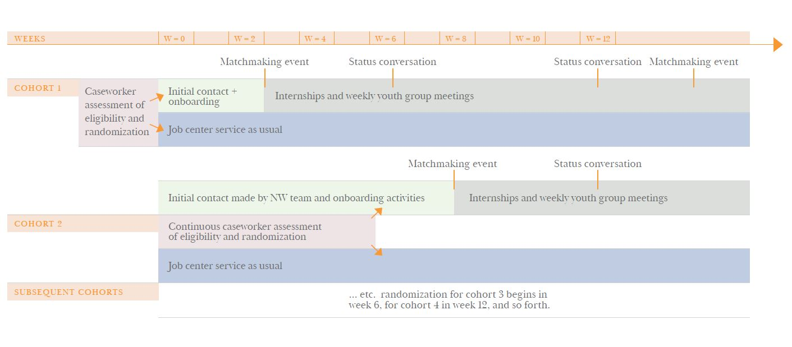Figure 1: Participant timeline. Note that in Roskilde, the trial began in January 2017, and in Copenhagen in January 2018. It is expected to begin in October 2018 in Sønderborg.

The figure illustrates the timeline for randomization and subsequent employment service offers in a given municipality. If a young person is assigned to treatment as usual in the randomization, he or she follows the standard services of the job center. If a young person is assigned to NExTWORK, he or she is contacted by a member of the NExTWORK team and onboarding activities start. These include assignment of a NExTWORK youth counsellor, introduction to NExTWORK and the list of companies on offer and gradual enrolment into the peer networks and activities until the next match event with companies take place.

Every 6 weeks, a status conversation is held between the youth and their NExTWORK youth counselor with progress as the main topic. The main conclusions of this meeting are shared with the youth’s caseworker at the job center. The rolling intake of youths is aligned with the rolling exit of youths that leave NExTWORK to enter employment or education or because they no longer fulfil the eligibility criteria.

In each municipality, the trial will run for a minimum of two years with the expectation that approximately 90 youth per year will be enrolled, giving an expected total treatment group sample of 900 youth (with at least as large a control group). The assigned treatment status holds even if youth make a fresh claim for social assistance.

Blinding
Due to the nature of the intervention neither the participants, caseworkers, counselors, nor treatment administrators can be blinded to treatment status.

Concomitant care and obligations
All youths, regardless of treatment status are required to interact periodically with the job center; the frequency depends on their LAB category. The main purpose of these interactions is for the job center to assess whether their engagement in current employment services are in fact helping them to move closer to ordinary education or work or whether new measures should be taken.

“Activity ready youth” may have complex challenges that require the coordinated effort of several different municipal departments and authorities. Any additional service for youths owing to such coordinated efforts is permitted as concomitant care for youths in the trial.

Youths who have not completed a secondary education are required to take tests for reading, writing and math skills (so-called FVU tests). If the tests reveal that a young person has inadequate skills to enroll in a secondary education, they must enroll on a course to improve these skills until they meet the requirements for passing obligatory schooling (9th grade). Enrollment in these courses is also permitted as concomitant care for youths in either the trial’s treatment or control groups.

Fidelity
Fidelity of service delivery is supported by (i) training of the NExTWORK staff prior to as well as throughout the trial; (ii) an underlying NExTWORK service description; and (iii) regular supervision of programme staff by the primary psychologist involved in the development of the service; (iv) inter-municipal network where NExTWORK staff meet bi-annually to build capacity and share learnings. In addition, the NExTWORK IT platform serves as a programme monitoring system, where elements of service delivery are recorded, including dates of completed peer-support group meetings, attendances, and internships provided. Finally, an external implementation evaluation team has been contracted to provide a primarily qualitative assessment of implementation, including fidelity.

The first part of the trial period in Roskilde served as a piloting stage and was characterized by a start-up phase to qualify work processes and setting up an automatized randomization tool to assign the youth either treatment or control status. The automatized randomization tool started functioning on the 5th of December 2017.

Compliance with assigned treatment status will be monitored periodically by research assistants associated with the trial.

4. Hypotheses and Data

The aim of NExTWORK is to improve employment or educational outcomes of disadvantaged youth, while reducing their dependence on social assistance. We will assess its effectiveness by studying impact on these outcomes. We expect the programme to have some lock-in effects and anticipate that most of the programme impacts will take at least two and a half years to set in, from randomisation. This takes into account average programme duration (6 months), and the expected length of completion of a qualifying education (2 years). Table 1 sets out the specific hypotheses we plan to test and the measures that we plan to use for each of the domains.

In addition to testing the above hypotheses using the statistical approach set out below, we plan to explore potential drivers of our main findings. We will do this in three main ways:
- We will study the impact of the intervention on potential mediators of any effects we find and conduct mediation analysis in order to test the degree to which the main effect is mediated by this factor. For example, in studying impacts on employment outcomes, we will complement analysis of impacts on final outcomes set out above with analysis of impact on and mediating power of the number and average duration of employment spells. Such analysis may help determine whether positive employment effects are driven by staying in each job longer or switching to better jobs.
- We will utilise detailed implementation data collected by the NExTWORK programme team to assess the role of compliance. For example, we will study heterogeneity of impacts by programme completion status, as well as by finer dosage measures such as the number of group sessions attended by the individual.
- We expect that the characteristics of participating youth may determine the extent to which they benefit from NExTWORK. We will, therefore, examine heterogeneity of impact along a number of different individual characteristics, including, for example, age, gender, municipality and LAB category.
We will utilise a combination of register data provided by Statistics Denmark, administrative data from the participating municipalities, a survey of youth, and implementation data collected by the NExTWORK programme team. Specific registers that we will use include DREAM, UDDA, BFL, and KRSI. Youth in the treatment and control groups will be identified through a data linkage facility provided by Statistics Denmark that ensures individuals remain anonymous to researchers.

Table 1: Main Study Hypotheses (2.5 years after randomisation) and Measures
Outcome | Hypothesis | Measure | Details of measure
- Reducing dependence on Social Assistance | 1.1) NExTWORK will on average reduce the proportions of participating youth claiming social assistance. | Whether claiming social assistance | Proportion of youth no longer claiming a social assistance or social insurance payment, defined by the recorded receipt of an applicable payment in the DREAM register.
 | 1.2) NExTWORK will on average reduce the length of time participating youth claim social assistance. |  | Cumulative length of time claiming social assistance since being assigned treatment status.
- Education | 2.1) NExTWORK will have a positive average impact on rates of completion of education among participating youth. | Whether have completed the first phase of upper-secondary education | Proportion of youth who have completed the first year of general upper-secondary education or vocational education and training, as recorded in the KOTRE register.
- Employment | 3.1) NExTWORK will have a positive average impact on uptake of paid employment among participating youth. | Whether in paid employment | Proportion in paid employment, defined as having positive earnings recorded in the BFL/BFLBRTI register
 | 3.2) NExTWORK will have a positive average impact on total amount of time spent in paid employment among participating youth. |  | The cumulative length of time in paid employment since being assigned treatment status, where being in paid employment is defined as having positive earnings recorded in the BFL/BFLBRTI registers.
 | 3.3) NExTWORK will have a positive average impact on weekly earnings of participating youth. |  | Weekly earnings, as recorded in the BFL/BFLBRTI registers. Earnings for those who have no earnings recorded for a given week will be coded as zero.
- Participation in Crime | 4.1) NExTWORK will reduce the proportion of participating youth charged with a criminal offense. | Being charged with a criminal offense | Proportion charged with a criminal offense (excluding minor traffic infractions) subsequent to randomisation, recorded in the KRSI register

5. Statistical Analysis

Evaluation Approach
In order to test the main study hypotheses, set out in Table 1, we want to causally identify the impact of the NExTWORK programme on the four groups of outcome. The challenge at the heart of causal impact identification is that ideally we would like to compare the outcomes of individuals who receive the treatment to the outcomes of the same individuals without receiving treatment. That is, for example, we would want to compare employment status of individual A at time t, where t=six months after completing NExTWORK to the employment status of individual A at time t had he/she attended the standard government programme instead. This true counterfactual is impossible to observe.

Formally, we denote treatment status as D, so that D=1 for those who receive the NExTWORK treatment and D=0 for those receiving the default government programme and become ineligible for joining NExTWORK at any future point. The outcome of interest is denoted as $Y_{t}\}_{t=0}^{T}$ where T is the most recent time period for which register data on the relevant outcome are available and t=0 is the time at which the individual is randomised into NExTWORK; $Y_{t}^{1}$ and $Y_{t}^{0}$ denote outcomes at time t if joining and not joining NExTWORK at t=0. We are interested in the average impact at each time-point $∆_{t}$ for those joining the programme versus those going into the government programme at time t=0:

$$∆_{t}=E\left(Y_{t}^{1}-Y_{t}^{0}\right|D=1)=E\left(Y_{t}^{1} | D=1\right)-E\left(Y_{t}^{0} | D=1\right)$$

for t = 1, 2, ..., T months since randomisation. Since the amount of time that an individual spends in treatment is endogenous, we start measurement of $∆_{t}$ from the time that he/she is randomised into the programme rather than from the time of programme completion. That is, whatever happens after the randomisation, including programme lock-in effects, is treated as part of the impact. $∆_{t}$ measures the intent to treat (ITT) effect rather than the Treatment on the Treated (ToT) effect, capturing outcomes of everyone eligible for the treatment rather than just those who end-up receiving the treatment. We anticipate that there will be a non-negligible level of non-compliance and therefore ITT will not equal ToT. We will therefore also perform an instrumental variable regression, using randomisation into the treatment as an instrument for treatment, in order to estimate the size of the ToT effect.

The causal inference problem is that while we can identify $E\left(Y_{t}^{1} | D=1\right)$, which is the expected value of the outcome variable in the treatment group on receiving treatment, it is not possible to identify the expected value of the outcome variable in the treatment group had the programme not existed ($E\left(Y_{t}^{0} | D=1\right)$) from the data; we can only identify $E\left(Y_{t}^{0} | D=0\right)$ i.e. expected value of the outcome variable in the control group (those who did not receive the treatment). If we can make a credible case that $E\left(Y_{t}^{0} | D=0\right)$=$E\left(Y_{t}^{0} | D=1\right)$ then we can use the former to estimate $∆_{t}$. To make this case we have to be able to believe that $Y_{t}^{0}$ is independent of the treatment status i.e. that$Y_{t}^{0} ⊥D$. In a real-life situation we would not be able to make this assumption without at least conditioning on observable characteristics since participation in any programme is a choice (bearing in mind that social assistance payments will be conditional on such choice) and individuals who make this choice are likely to differ from those who do not along characteristics that also affect $Y_{t}^{0}$. This is the reason why a key feature of our study design is random allocation of eligible individuals into the programme (as described above). The randomisation, if implemented successfully, ensures that the average of outcome variable among non-participants is a good approximation of the expected value of the outcomes among the participants had the programme not existed.

If this is the case we can say that
$∆_{t}=E\left(Y_{t}^{1}-Y_{t}^{0}\right|D=1)=E\left(Y_{t}^{1} | D=1\right)-E\left(Y_{t}^{0} | D=1\right)=E\left(Y_{t}^{1} | D=1\right)-E\left(Y_{t}^{0} | D=0\right)$

Both terms can then be identified from the data.

Estimation
Our outcomes are measured using continuous and binary measures. Programme impacts on continuous outcomes (e.g. average weekly earnings; cumulative time in paid employment) will be estimated using ordinary least squares (OLS) regression; we will use the Logit model to estimate impacts on binary outcomes (e.g. whether employed/in qualifying education).

In addition to treatment status, our main model will include controls for baseline measure of the outcome variable (where applicable), municipality indicator and controls for any core individual or background characteristics found to be imbalanced between treatment and control at baseline. We will also estimate models which include additional covariates that can help to improve precision of our estimates, such as gender, age, background characteristics (immigration history, education, medical diagnoses etc.), parental income (both contemporaneous and lifetime) and other parental characteristics (such as history of criminal convictions or psychological referrals).

Our main estimating equation is as follows:
$$y_{imt}=α+{βy}_{im0}+{γT}_{im}+{δX}_{im0}+{θM}_{m}+ϵ_{imt}$$
Where $y_{imt}$ is one of the outcomes listed in Table 2 for individual i in municipality m at time t; $y_{im0}$ is the baseline measure of the same outcome; ${γT}_{im}$ is the treatment status of individual i in municipality m; $X_{im0}$ is a vector of characteristics that are not balanced between treatment and control at baseline; ${θM}_{m}$ is a municipality indicator.

This model will be estimated at each time-point when new register data become available and the coefficients will be plotted to study the evolution of programme impacts over time.

In addition, we will assess the effect of mediators (as discussed above) through estimation of equation 2:
$$y_{imt}=α+{βy}_{im0}+{πT}_{im}+{ρZ}_{imt}+{δX}_{im0}+{θM}_{m}+ϵ_{imt}$$
Where $Z_{imt}$ is a potential mediator. Mediation power is tested by testing the hypothesis that $π=γ$. A rejection of this hypothesis is consistent with Z being a relevant mediator of the impact of T on outcome y.

The analysis will be conducted using Stata. We will not use as dependent or independent variables any indicator variable that has a prevalence rate of below 5% or above 95%. More broadly, we will not use any variables in the analysis that have the same answer for at least 95% of the sample.

We analyse several treatment effects which creates a risk of identifying spurious treatment effects by chance if we apply the standard one hypothesis at a time approach to hypothesis testing. We will explicitly account for the multiplicity of hypotheses being tested by adjusting p-values (e.g. the step-down procedure developed by Romano & Wolf, 2005, 2011) for each group of related outcomes – as grouped in Table 1.

Sample size and power calculations
The intervention has capacity to enrol 45 full-time equivalent youth per year in each municipality. Given an expected average enrolment length of six months, this means that approximately 90 youth per year are expected to participate in the programme in each municipality over the study period. This means that we currently expect an overall treatment group size of at least 900 youth across 5 municipalities. It is intended that at least one youth be enrolled in the control group for each in the treatment group, with the possibility to enrol more than this in Copenhagen.

Table 2 contains estimates of the minimum detectable effect (MDE) of the intervention on the outcomes described above, assuming a two-sided alpha of 0.05, power of 0.80 and equally sized treatment/control groups of 900 youth. These are calculated using moments derived from a pseudo-treatment group, created by drawing a random sample of 180 youth from those living in each of Copenhagen, Horsens, Roskilde, Sønderborg and Vejle in 2014 who would have met the criteria to be eligible for treatment. The columns show the outcome proportion (or mean) and MDE for the group at different horizons from the time of randomisation. For example, these show that given the trial’s design we will likely be able to detect effects of at least 21%, 16%, and 11% on the proportion of youth no longer claiming social assistance 26, 52 and 130 weeks following randomization respectively. The MDEs for almost all outcomes are much lower proportionally at longer horizons because of the greater variation in these outcomes over longer horizons.

Table 2: Baseline means/proportions & Minimum Detectable Effect (MDE) of intervention on outcomes
 | Time since randomised into pseudo-treatment group
 | 26 weeks |  |  | 52 weeks |  |  | 130 weeks
 | Baseline | MDE |  | Baseline | MDE |  | Baseline | MDE
Primary Outcomes
% no longer claiming social assistance | 0.307 | 0.063 |  | 0.409 | 0.066 |  | 0.580 | 0.064
cumulative weeks claiming social assistance | 20.855 | -1.062 |  | 37.330 | -2.338 |  | 76.352 | -6.019
% in paid employment | 0.120 | 0.046 |  | 0.156 | 0.051 |  | 0.230 | 0.058
cumulative weeks in employment | 2.563 | 0.861 |  | 6.165 | 1.759 |  | 21.497 | 4.694
average weekly earnings (DKK) | 466.074 | 222.261 |  | 631.377 | 259.003 |  | 1061.719 | 336.849
% completed qualifying education | 0.098 | 0.043 |  | 0.099 | 0.043 |  | 0.110 | 0.045
% Non-speeding criminal conviction | 0.075 | -0.031 |  | 0.130 | -0.041 |  | 0.211 | -0.051
Note: two-sided hypothesis test assuming alpha of 0.05, power of 0.80 and equally sized groups of 900 youth.
Source: Authors’ calculations using Stata’s built-in power command and register data from Statistics Denmark.

These MDEs could be further reduced if the relative size of the control group in Copenhagen can be increased. Table B1 in the Appendix shows that increasing the ratio of the control group size to treatment group size from 1:1 to 2:1 reduces the MDE for our first primary outcome (the proportion of youth no longer claiming benefits) assessed 26 weeks following randomization from 0.061 to 0.058; a reduction in the proportional effect size from 23% to 22%. These gains in power are proportionally biggest for outcomes with relatively high MDEs.

Other common strategies to boost power offer less substantial gains. Simulations suggest that including covariates in the empirical estimation of the ITT will increase power only slightly (see Appendix B1). Similarly, although our register data includes repeated (for the most part, weekly) measures of our outcome measures, exploiting these is unlikely to result in large power gains because our measures appear to be quite strongly autocorrelated.

6. Trial Monitoring & Ethics

Ethics:
The project has been approved by the Danish Data Protection Agency as is the standard procedure for randomized controlled trials conducted in Denmark within the social sciences (file number 2017-41-5108). Because the project is not related to health sciences it does not require further ethics approvals.

Consent:
To program participation: The Danish legislation on employment efforts requires all unemployed who receive some form of income replacement or welfare benefits to participate in employment programs during their unemployment. This is a requirement to uphold the right to receive benefits. While program participation is in this sense mandatory, the unemployed have some say in what program they wish to participate in – in a case where an unemployed person refuses to participate in a specific program, they will be placed under another program. Along these lines, we cannot force the youth to participate in NExTWORK, but need their informal consent to the participation.

To being surveyed and having survey answers linked to registers: Prior to filing out the survey, the youth confirm – in writing - their willingness to participate in the survey, that they have been properly informed about the project both verbally and in writing, and that they consent to having their survey answers linked to the information that we may get on them from the administrative sources.

Confidentiality:
We secure the anonymity of the participants by blinding all information that can be used for identifying them. This means that once municipal and monitoring data have been merged into the register data at Statistics Denmark, the data no longer contain names or the personal identifiers used for linking the different data sets. All identifier variables are encrypted according to the standards used by Statistics Denmark and data cannot be exported.

Dissemination:
We plan to disseminate output from the NExTWORK evaluation through both academic channels (e.g. through publishing academic papers) and popular channels (e.g. through the media and in public debates). Furthermore, we will write an evaluation note in Danish that we distribute to all involved parties in the NExTWORK program (all relevant parties in Roskilde municipalities, to the involved firms, the participating youth etc.), and to other interested parties (e.g. employment services in other municipalities, NGOs etc.). In the dissemination material it will never be possible to identify any individuals or firms.

Appendices

Appendix A. Profile of primary outcome measures over time in the absence of NExTWORK

Figure A.1. Proportion of youth no longer claiming social assistance/insurance payments
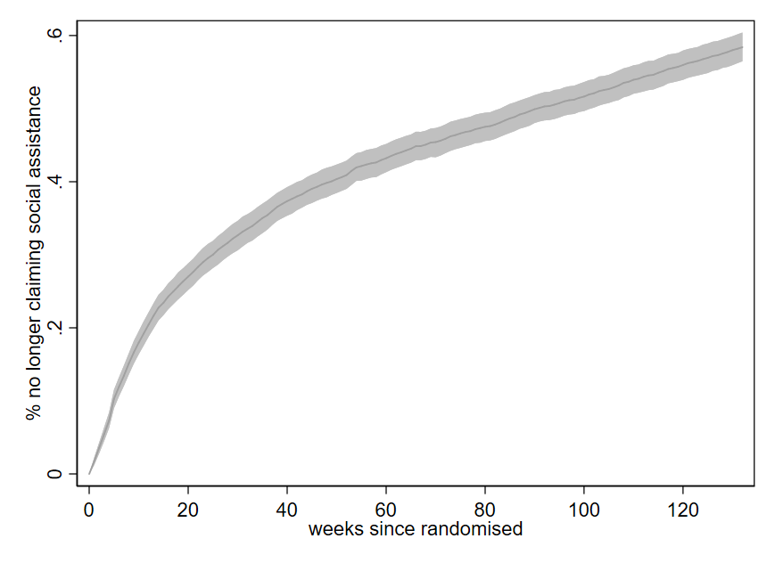

Figure A.2. Cumulative weeks claiming social assistance
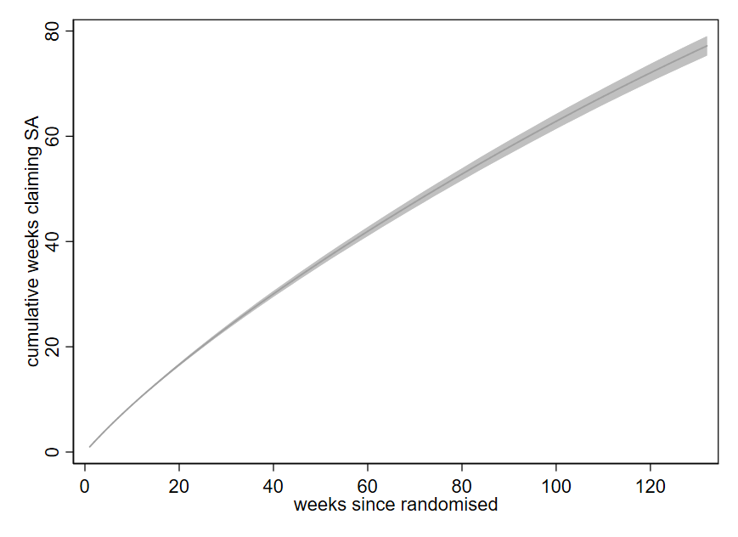
Figure A.3. Proportion of youth who have completed a qualifying education
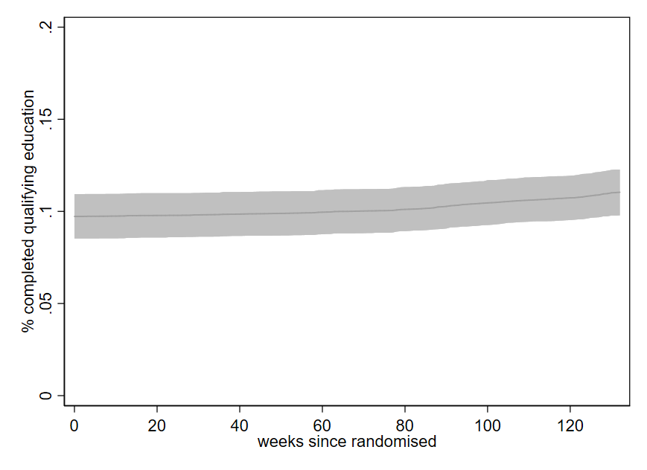

Figure A.4. Proportion of youth in paid employment
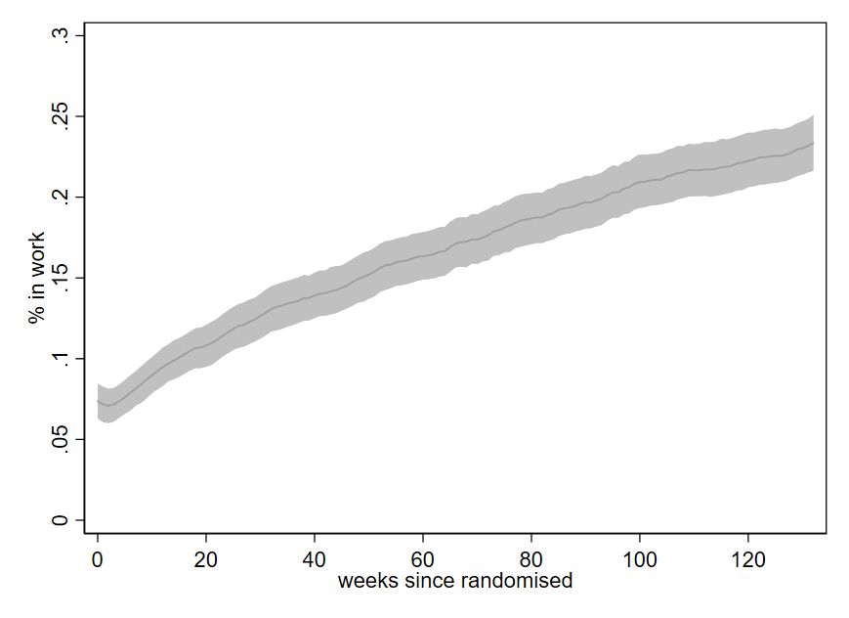
Figure A.5. Cumulative weeks in paid employment
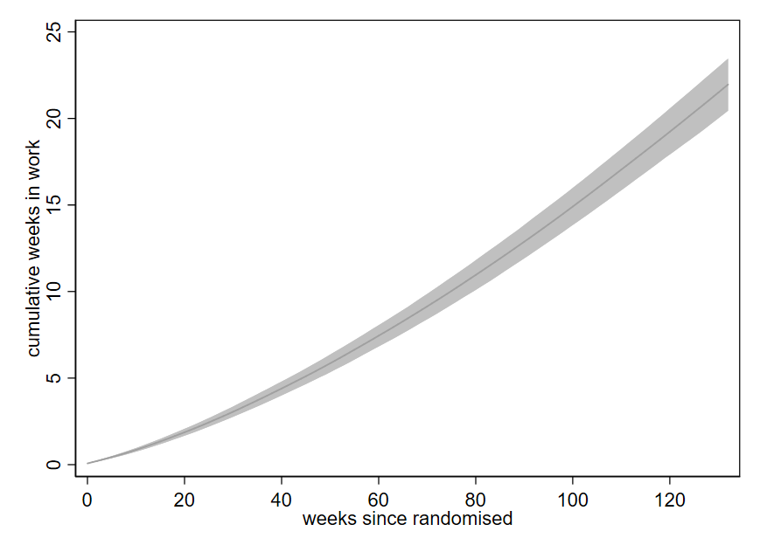
Figure A.6. Average weekly earnings for youth
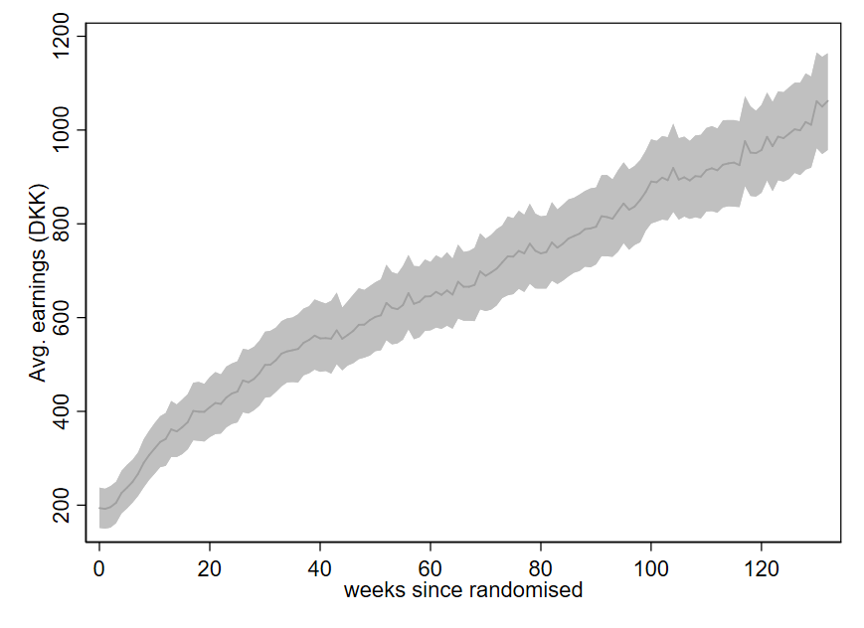

Figure A.7. Proportion of youth charged with criminal offense since being randomised
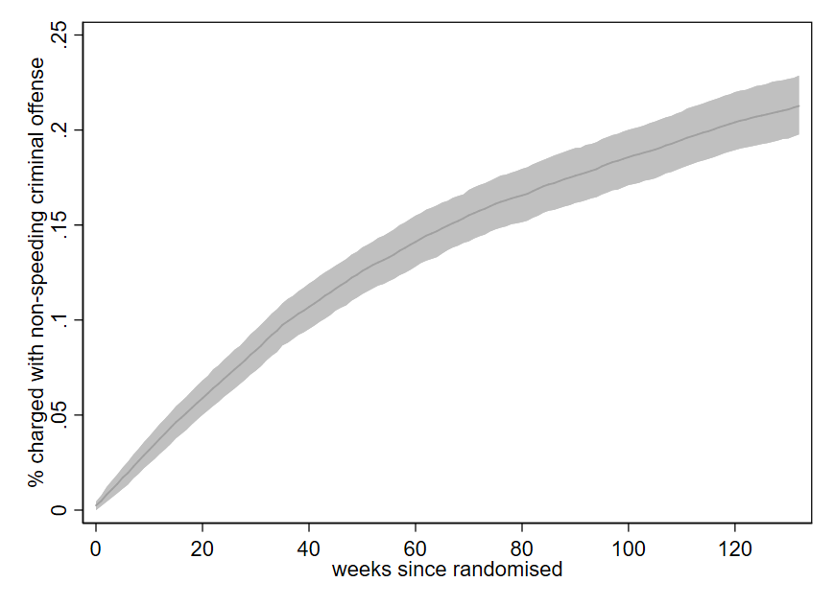

Appendix B. Additional minimum detectable effect and power calculations

Table B1 contains estimates of the minimum detectable effect (MDE) of the intervention on the outcomes described in section 4, assuming a two-sided alpha of 0.05, power of 0.80 and equally sized treatment/control groups of 900 youth. These are calculated using moments derived from a pseudo-treatment group, created using the same method as described at the end of section 5. The columns show the bootstrapped proportion (or mean) of the outcome 26 weeks following (pseudo) randomization, along with the MDE associated with a balanced and various unbalanced treatment designs. These reductions in MDEs are proportionally largest for outcomes with a relatively high MDE under a balanced design, meaning that adopting an unbalanced treatment design may be particularly beneficial in identifying effects on outcomes with more variation (e.g. weekly earnings) or assessed at shorter time horizons (e.g. 26 weeks after randomization).

Table B1: MDEs for balanced and unbalanced treatment designs, 26 weeks following randomisation
 |  |  | Minimum Detectable Effects
 |  |  | Ratio of control to treatment group size
 | Baseline mean |  | 1:1 | 1.25:1 | 1.5:1 | 2:1
Primary Outcomes
% no longer claiming social assistance | 0.307 |  | 0.063 | 0.059 | 0.057 | 0.054
cumulative weeks claiming | 20.855 |  | -1.062 | -1.007 | -0.969 | -0.919
% in paid employment | 0.120 |  | 0.046 | 0.044 | 0.042 | 0.040
cumulative weeks in employment | 2.563 |  | 0.861 | 0.817 | 0.786 | 0.746
average weekly earnings (DKK) | 466.074 |  | 222.261 | 210.739 | 202.784 | 192.378
% completed qualifying education | 0.098 |  | 0.043 | 0.041 | 0.039 | 0.037
% charged with criminal offense | 0.075 |  | -0.031 | -0.030 | -0.029 | -0.027
% psychiatric hosp. since randomisation | 0.076 |  | -0.031 | -0.030 | -0.029 | -0.027
Note: two-sided hypothesis test assuming alpha of 0.05, power of 0.80 and treatment group size of 900 youth. Control group size varied to equal either 900, 1125, 1350 or 1800. Source: Authors’ calculations using Stata’s built-in power command and register data from Statistics Denmark.

To investigate the potential gain in power from including covariates in our estimation of ITT parameters, we simulate the power at which treatment effects of various sizes ($δ$) can be detected using 1,000 bootstrap replications of our pseudo-treatment and control groups. Each replication is created by (twice) drawing a random sample of 180 eligible (in 2014) youth from each of the 5 initially participating municipalities. We then (randomly) increase the share of youth for whom outcome $Y_{i}=1$ in each replication of the treatment group to the hypothesized proportion ($P_{2}=P_{1}+δ$) and estimate the ITT by running a logit model of the form $Y_{i}=β_{0}+β_{1}*TREATED_{i}+X_{i}β$ on each the 1,000 replications (N=1800), where $X_{i}$ is a vector of covariates derived from the register data. These include demographic variables (e.g. average parental lifetime income, maternal education), how many weeks the youth had been claiming social assistance and whether the youth had ever been charged with a criminal offence before being randomised into either the treatment or control group. Our simulated measure of power is the proportion of these 1,000 replications for which the coefficient $β_{1}$is statistically different from 0 at the 95% level of confidence (i.e. $α=0.05$).

Figure B1 shows how this simulated measure of power including controls compares to that obtained estimating the logit model with only an intercept and treatment dummy, for two of our primary outcome measures: a) the proportion of youth no longer claiming social assistance, and b) the proportion of youth who have not been charged with a criminal offence. For both, including the vector of covariates increases power but only by a negligible amount.

Figure B1. Proportion of youth (52 weeks after randomization) that:
a. Are no longer claiming social assistance | b. have not been charged with a (non-speeding) criminal offence
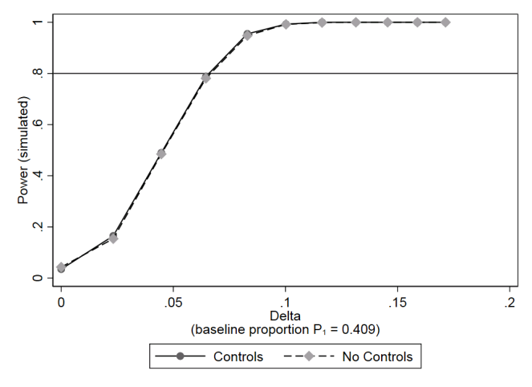 | 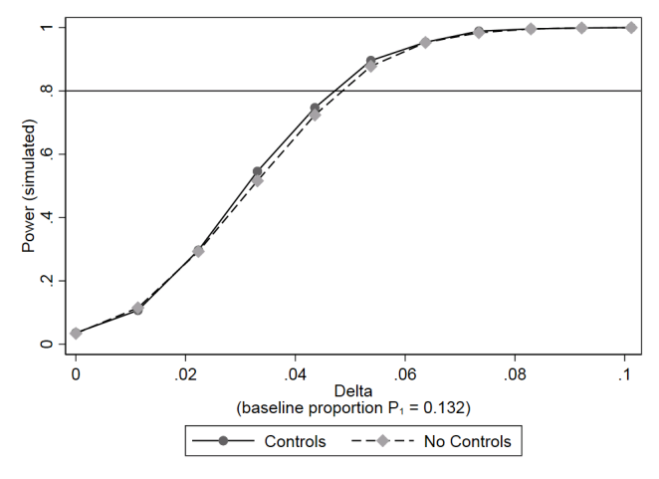
Note: two-sided hypothesis test assuming alpha of 0.05, power of 0.80 and equally sized groups of 900 youth.
Source: Authors’ calculations using Stata’s built-in power command and register data from Statistics Denmark.

Bibliography
Akerlof, G., & Kranton, R. (2010). Economics and Identity. The Quarterly Journal of Economics , pp. 715 - 753.

Bell, B., Bindler, A., & Machin, S. (2018). Crime Scars: Recessions and the Making of Career Criminals. Review of Economics and Statistics, Volume 100, Issue 3 , pp. 392 - 404.

Benson, P., Scales, P., Hamilton, S., & Sesma, A. (2007). Positive Youth Development: Theory, Research and Applications. Handbook of Child Psychology .

Bruner, J. (1993). Acts of Meaning. Harvard University Press.

Caliendo, M., & Schmidl, R. (2016). Youth Unemployment and Active Labor Market Policies in Europe. IZA Journal of Labor Policy, Volume 5, Issue 1 , pp. 1 - 30.

Card, D., Kluve, J., & Weber, A. (2015). Active Labour Market Policy Evaluations: A Meta-Analysis. NBER Working Paper Series, Working Paper 16173 , pp. 1 - 48.

Crepon, B., & van den Berg, G. (2016). Active Labour Market Policies. Annual Review of Economics, Volume 8 , pp. 521 - 546.

Daly, M., & Delaney, L. (2013). The Scarring Effect of Unemployment Throughout Adulthood on Psychological Distress at age 50. Social Science & Medicine, Volume 80 , pp. 19 - 23.

Foucault, M. (1997). Technologies of the Self. In M. Foucault, & P. Rabinow, Ethics: subjectivity and truth. New York: WW Norton.

Gregg, P., & Tominey, E. (2005). The Wage Scar From Male Youth Unemployment. Labour Economics, Volume 12, Issue 4 , pp. 487 - 509.

Landersø, R., & Heckman, J. (2016). The Scandanavian Fantasy: The Sources of Intergenerational Mobility in Denmark and the US. The Scandinavian Journal of Economics, Volume 119, Issue 1 , pp. 178 - 230.

Nissen, M. (2012). The Subjectivity of Participation: Articulating Social Work Practice with Youth in Copenhagen. Palgrave Macmillan.

Oreopoulos, P., von Wachter, T., & Heisz, A. (2012). The Short- and Long-Term Career Effects of Graduating in a Recession. American Economic Journal: Applied Economcs, Vol.4, No. 1 , pp. 1 - 29.

Romano, J., & Wolf, M. (2011). Exact and Approximate Stepdown Methods for Multiple Hypothesis Testing. Journal of the American Statistical Association , Volume 100, Issue 469, pp. 94-108.

Romano, J., & Wolf, M. (2005). Stepwise Multiple Testing as Formalized Data Snooping. Econometrica , Volume 73, Issue 4, pp. 1237-1282.

Rose, N. (1996). Iventing our Selves. Cambridge University Press.

Schultz-Nielsen, M. L., & Skaksen, J. R. (2016). Den Økonomiske gevinst Ved at Inkludere de Udsatte Unge. Rockwool Fondens Forskningsenhed Arbejdspapir nr. 39 , pp. 1 - 14.

Vygotsky, L. (1980). Mind in Society: Development of Higher Psychological Processes. Harvard University Press.

White, M. (2007). Maps of narrative practice. New York: WW Norton & Co.

White, M. (2003). Narrative Practice and Community Assignments. International Journal of Narrative Therapy & Community Work , pp. 17-55.

These entail willingness to offer internship places, participation in company network meetings and in match events with the youth as well as allocation of a company contact person for each intern.
See for instance Benson, Scales, Hamilton, & Sesma (2007), Vygotsky (1980), Bruner (1993), and Nissen (2012).
To get the more challenged youth onboarded, initial presence may sometimes be only 2 hours per week.
See for instance White (2003), White (2007), or for a theoretical background Rose (1996) or Foucault (1997)
Lov om en aktiv beskæftigelsespolitik (LAB) is a Danish law, with a primary goal of contributing to a well-functioning labour market. The target groups of LAB are people without a stable affiliation to the labour market, and it is described in the second paragraph of the law. There are 14 target groups in total and each of these are referred to by combining the paragraph number with the target group number, e.g. LAB category 2.12 is the 12th target group described. For more, see http://www.socialjura.dk/content-storage/love/love/beskaeftigelsesindsatslov/
These youth are assigned LAB categories 2.12 and 2.13. For youth with a qualifying degree (LAB categories 2.2 and 2.3), the end goal is employment. A fuller description of these categories is contained in Section 3 below.
LAB category 2.12 defines youth as “Ready for education”, meaning that they are considered ready to start an education within one year and will receive an education-help stipend.
LAB category 2.13 defines youth as “Ready for activity”, meaning that they are classified as needing extra support in order to prepare for an education, and may not be ready within 12 months. Youth in this category receive the education-help stipend and, when they participate in municipal active measures, an activity supplement.
LAB category 2.2 defines youth as “job ready”. They already have a qualifying degree (either a vocational education or higher education) and are assessed ready to start a job within 3 months. They receive social assistance, the value of which was 17 percent higher than that of the education help stipend in 2017. The value of both benefit types varies depending on age, whether one lives with parents or not, whether one has children or any mental disorders. For current rates see https://www.borger.dk/arbejde-dagpenge-ferie
LAB category 2.3 defines youth as “Ready for activity”. They have a qualifying degree (either a vocational education or higher education), but are assessed to need more than 3 months to prepare for a job due to e.g. complex social or health related problems. In this category, youth receive social assistance and, when they participate in municipal active measures, an activity supplement.
Youth can be exempted from participating in active measures if their caseworker determines they are too ill. Regulations governing this are available from: https://www.retsinformation.dk/Forms/R0710.aspx?id=184891
By actively participating in NExTWORK, the youth meet the governmental requirements for receiving social assistance. In NExTWORK, the actual demands on the individual youth will differ depending on his or her ability. Some start with a minimum attendance at the workplace of two hours per week, while others will be expected to have a regular attendance of 10 or 20 hours per week.
Unauthorised absence results in monetary sanctions through lowering the benefit payment for the month.
See http://econ.au.dk/the-national-centre-for-register-based-research/danish-registers/
Note that the frequency with which data are available varies depending on the specific outcome in question.
These figures are given by taking the MDE as a percentage of the baseline proportion e.g. for this outcome 26 weeks following the intervention 21% = 0.063/0.307. Appendix A shows the evolution of these baseline proportions for our primary outcome measures over time.
See McKenzie (2012) for discussion of when multiple measurements of outcomes at short intervals provide substantial gains in power. [ref https://ideas.repec.org/a/eee/deveco/v99y2012i2p210-221.html]

