Leisure Recovery after Covid-19 Lockdown:
Experimental Evidence from Zhengzhou

Introduction
Previous research predominantly focuses on the impacts of social distancing on disease spreading, yet the underlying decision-making mechanisms and associated social consequences has been largely understudied. Though companies usually resume work soon after the infectious disease gets relatively controlled, the reluctance for people to engage in leisure and social activities tend to continue for a long period of time after a complete lockdown, inducing significant economic and social welfare loss.

In this research, we aim to understand people’s behavioral pathways for leisure demand in the post-pandemic phase. Specifically, we wish to answer two research questions:

First, how do supply side forces shape an individuals’ leisure activity demand after the lockdown? For example, people might choose to stay at home on weekends either driven by the belief of inadequate supply of safe dining environments, such as limited amenity availability (e.g., few restaurants are opening) OR limited precautionary measures taken by restaurants to reduce infection risks (e.g., frequent disinfection, temperature testing, larger distance between tables). As supply and demand forces are usually intertwined and co-create each other, relying on observational data to disentangle how the two factors affect decision-making processes is difficult. We exogenously variate people’s attention and knowledge of safe dining supply around their neighbourhood by providing the evolving statistics and list of restaurants having the Meituan safe dining certificate. This supply side information is scripted from Dianping APP and validated through hundreds of phone interviews to local restaurants. Comparing people receiving and not receiving supply side information can help us understand the role supply plays in constraining leisure activity in the post-pandemic period.

Second, we wish to understand how people construct their leisure demand based on their perception of behaviors of peers living in their close geographic proximity. In normal conditions, an average individual will extract information from their peers’ consumption choices and tend to converge to it. For instance, when an average individual sees two restaurants side by side and one is packed with lively people and the other is relatively empty, he has a much larger tendency to choose the packed one. This reflects the intrinsic nature of human-beings to follow the choices of others to save the cognitive cost of decision-making, and to depict that they are “in-group”. Though widely accepted and taken for granted, this obvious norm-based behavioral mechanism may not hold true during the current pandemic period, when individuals act as transmission channels of a virus, and social distancing is the main public health policy measure to control the virus outbreak. Against this background, individuals might then use the expected number of people in a given place as a signal for high infection risk.

To disentangle the causal peer effect of leisure behaviors is difficult for three main reasons (Wolske et al. 2020). First, unobserved factors could be influencing both the individual and their neighbours. Second, people might self-select into their residence thus have intrinsic similarity. Third, an individual is simultaneously affecting his neighbours while being affected. To address the above identification challenges, we design a randomized controlled trial (RCT) in which we randomly select people into the treatment group and exogenously variate their perceptions of others’ behaviors through weekly information interventions. In particular, we analyze the changes in people’s belief of others’ behaviors to infer how the counteracting forces of social norm and risk avoidance are at play in their decision-making process. In total, we track the behavior of individuals in our sample for more than a month to see how the impacts of social information evolve with time (i.e., as the risk gets lower together with the drop in the number of cases in the country, or change by certain news in the media about the development of COVID-19). In addition, we will explore heterogeneity across individuals with different risk preferences and community trust, and across activities with high (i.e., dining out) and low (i.e., park visitation) social distancing needed.

Understanding the pathways of decision-making during the post-pandemic period and the differential impacts induced supply and demand factors on different types of individuals can assist the epidemiological modeling of second wave infection risk, as well as guide the policy makers to design more effective nudging policies to facilitate the post-lockdown consumption recovery.

Conceptual Framework
The behavioral responses to our supply side interventions are predictable in direction. If people find more safe amenity supply than expected, they will likely to increase the consumption of that amenity. The demand side forces, in contrast, are more unpredictable. We summarize the matrix of potential belief & behavior updating scenarios and the hypothesis conforming to the responses in Table 1.

Table 1: Summary the testable hypothesis in the experiment
 | Increase activity probability | Decrease activity probability
Posterior belief < Prior belief  (Less other people do) | Risk Avoidance | Social Norm
Posterior belief > Prior belief  (More other people do) | Social Norm | Risk Avoidance

On one hand, the decisions of social distancing need are affected by the perceived contact risk of contagion. Knowing that more people are going out could thus decrease one’s propensity to join the public life if their perception of risk increases. We call this process of inferring infection risk through the perceived objective number of people going out as “Risk Avoidance”.
On the other hand, as social animals, people are easily affected by others’ behaviors and tend to follow social norms. In this sense, knowing that more people are going out could actually increase one’s propensity to join the public life if they trust their neighbours and interpret the increase in the number of individuals joining the public life as a sign of reduced severity of infection risk. Or people can simply have the intrinsic wish to follow others without deliberately interpreting the risk information at all. We refer to these two channels of impacts for which people follow others deliberately or intuitively as “Social Norm”.

Two strategies are used to better disentangle the role of risk avoidance and social norm played in people’s decision-making process during/following the pandemic period in response to others’ behaviors.
First, as the Risk Avoidance need is directly obtained from people’s perceived contact rate with others, R0, we would expect it to be stronger for the environment with higher population density. We thus propose to test the different weights that individuals attach to these two information signals (social norm/ risk avoidance) by exploring the different behavioral responses in close and open spaces of public life: restaurants and parks. These two places have very different population density (individuals per square meter of the specific recreational area), and thus different infectious risk tied with each activity. We would expect social norms to dominate more in people’s decision-making process of going to the park.

Second, knowing all the safe precautionary measures restaurants are taking to prevent infection will reduce people’s perceived risk given the same number of people in the public space. We thus take advantage of our two-by-two treatment designs to compare the treatment effect of others’ behaviors on people receiving safety reassurance from the restaurant supply side with those who have not received. We would expect people having the safety reassurance are more likely to act towards the social norm direction.

Sample And Recruitment

The main experiment will take place in the city of Zhengzhou and will last for six weeks. We intend to recruit about 800 people to install our specially designed cell phone App. As a continuous project with the survey done in Zhengzhou this July (COUHES Exempt ID: E-1455: The Impact of Air Pollution on Green Travel Choice), the individuals of the experiment will be selected from the 3000 people participated in the survey. Sample recruiting will be conducted through text messages (script attached with the application). In the first week, participants will be instructed to familiarize with the interface of the App, and we will check the functioning of GPS trajectory documentation. The following 4 weeks will be the main experimental phase. During the four weeks individuals will be rewarded on the basis of GPS data provision and the completion of questionnaires.

Experimental Designs

Randomization
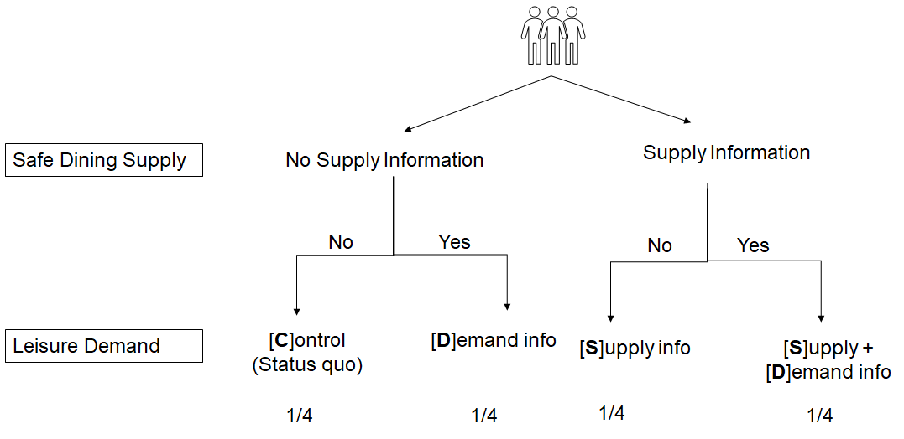
Figure 1. Structure of treatment randomization.

Groups:
Control (C)
Demand only (D)
Supply only (S)
Demand + Supply (SD)

Block randomization:
Individuals are randomized into each group, stratified by geographical area (e.g. five urban districts in municipality area of Zhengzhou) and previous frequency of going to restaurants for leisure (frequent restaurant visitor VS non-frequent restaurant visitor). We define “frequent restaurant visitor” as the ones dining out at restaurants for leisure at least once a week pre-Covid19.

Interventions

Intervention 1: Safe Dining Supply [S]

Data collection for information treatment:
We first scrape Dianping (i.e., Chinese Yelp) to collect basic information about the restaurants in Zhengzhou. The information includes the location of the restaurant, contact details, opening hours and whether a restaurant is certificated as “Meituan Safe Dining Restaurant” (As indicated by the red arrow in the figure below). Restaurants need to fulfill the “Standards for Online Disclosure of Health Service Information of Catering Merchants” published by Meituan Feb 20, 2020. Restaurants need to act according to the instruction of standards, take pictures and upload to Meituan to go through the reviewing process. After the getting approved, the certification will appear on the main page of Dianping/ Meituan APP in the format of a yellow tag, with “today infected” “all members tested temperature” and “dining in distance” labelled following the tag.
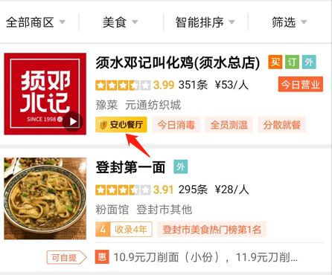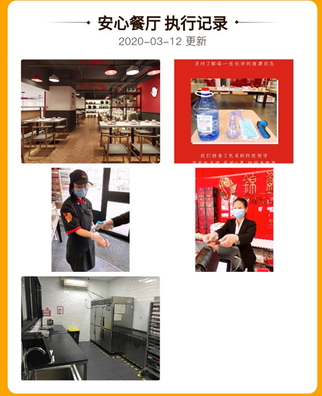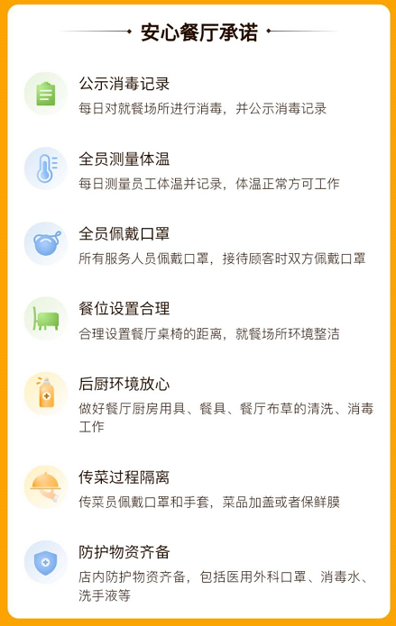

In complement to the information scripted on APP, a group of research assistants will undertake phone interviews for a random sample of the 500 restaurants with/ without the certificate to confirm the following questions:
Opening status and the availability of dining in service2. What precautionary measures they are taking to secure the safety of your guests against the COVID-19 virus / coronavirus? (randomly pick 3 items from the 7 certificate standards)

Intervention 2: Leisure Demand / Peer effects [D]

Data collection for treatment:
From Tuesday to Thursday, we launch a questionnaire on a weekly basis for a random sample of the population in Zhengzhou to collect information about people’s plans about going to a restaurant/ park in the upcoming weekend. The survey will also collect the following socio-demographic characteristics of individuals of the respondents: #1. Age group #2. Gender #3. Income #4 Education. #5. Occupation #6. Home location.
Based on this information, we will inform the experiment participants in the treatment group about the percentage of individuals planning to go to restaurants/ parks in their urban district. This information is supposed to be more informative of what the norm is in the relevant society than the average individual in the city.

Experimental Procedure
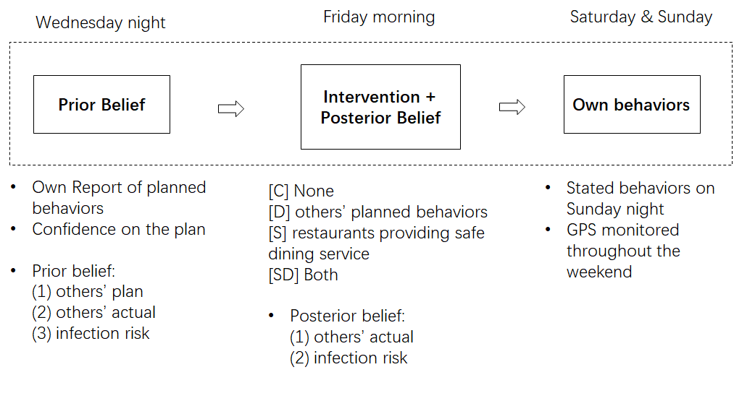

Analysis Plan

Main hypotheses
(Supply)
- Effects of safe dining supply on dining out propensity: Individuals will be more likely to dine out when they learn about precautionary measures of restaurants.
- Restaurant choice: When presented with the list of restaurants undertaking precautionary measures, individuals are more likely to go to restaurants that are Metuan certified.
- Risk Perception: Learning about precautionary measures of restaurants reduces the perceived risk of dining out.

(Demand)
- First Stage: Effects of intervention on belief on others’ demand
- Actual behaviors on the weekend (both question & GPS)

Econometric model

Supply information
Separate regression:
We apply the following specification for each intervention week, where $Y_{it}$ describes the planned and realized behaviors to go to the restaurant or park (dummy) on the weekend on date t (i.e., Wednesday/ Friday). We run 2 separate regressions for parks and restaurant activities:
$Y_{i}=ƛST_{i}+μμμμμμμμμμμμμμμμμX_{i}+ε_{it} (2)$

Where $ST_{i}$ takes the value of 1 when the individual receives the supply treatment information (dummy variable taking value one for people who receive the information about the share of restaurants being Metuan Certified in their urban district), and zero otherwise. We hypothesize that those individuals that receive the information treatment, learning that are restaurants certified in their urban district will be more likely to go to restaurants.

$Y_{it}=ƛST_{i}+μμμμμμμμμμμμμμμμμμμμST_{i}×{Low BeliefRestaurant}_{i}+μμϑ×{Low BeliefRestaurant}_{i} +X_{i}+ε_{it} (3)$

To disentangle the treatment effect by groups with higher/ lower prior belief, we add in an interaction term between treatment status and prior belief (${Low BeliefRestaurant}_{i}$takes the value of 1 when the prior belief about how many restaurants are taking precautionary measures is lower than truth) to understand the heterogeneous treatment effects by prior belief. We hypothesize that people are more likely to go out when they learn the proportion of restaurants implementing precautionary measures is higher than they expected.

Joint regression

We will use a Wald test to test which treatment has stronger effects on the probability of people to go to restaurants.
$Y_{it}=ƛST_{i}+ αT_{i}+ε_{it} (5)$

We will test:
$|ƛ|$=$|α|$

Supply Mediators
Risk perception
Since we are interested in the impact of people’s risk perception on their own decisions and behaviors, we also estimate the local average treatment effect (LATE) using the two stage least squares methodology.
The first stage estimates the effects of the information treatment about the certification information on the subject's risk perception, conditional on the set of control variables.
The second stage exploits the variation regarding other subjects’ risk perception altered by the experimental treatment to estimate the effect of beliefs about others’ behaviors on one’s own planned and realized behaviors of going to restaurants/ parks.

Social norm vs risk avoidance

First Stage:
Effects of intervention on belief about others’ going out
We run the regressions for three groups respectively: all subjects, subjects who have prior belief below the truth, subjects who have the prior belief above the truth. For the week of intervention, we get the first stage impacts of information treatment on people’s belief about others’ going out behaviors by the following formula:
${{Posterior}_{i}=δBelief}_{i}+ γT_{i}+X_{i}$

Where ${Belief}_{it}$ is individual i’s belief about the proportion of people going to the restaurants/ parks on date t (i.e., Wednesday/ Friday). $T_{i}$is dummy indicating treatment or control status for demand treatment, ${Posterior}_{i}$ is a variable describing the individual’s expected number of people going out on our Friday survey. $X_{i}$ is the set of control variables. The coefficient $γ$captures the impact of treatment (i.e., the information of others’ planned behaviors) on an individual's belief about others’ actual behaviors (proportion of people going to the restaurant and parks).

Reduced Form:

For the planned behavior, we apply the following specification for each intervention week, where $Y_{it}$ describes the planned and realized behaviors to go to the restaurant or park (dummy) on the weekend on date t (i.e., Wednesday/ Friday). In addition, we consider as outcomes the risk perception of individuals of going to parks and restaurants (measured in two separate 7-point Likert scales). We run 2 separate regressions for parks and restaurant activities:
$Y_{it}=αT_{i}+βT_{i}×{Lowprior}_{i} +ρ×Lowprior{}_{i} +X_{i}+ε_{it} (1)$

Where $T_{i}$ takes the value of 1 when the individual receives the treatment information (dummy variable taking value one for people who receive the information about the share of people planning to go to a restaurant/park in their urban district), and zero otherwise. To disentangle the treatment effect by groups with higher/ lower prior belief, we add in an interaction term between treatment status and prior belief (${Lowprior i}_{}$takes the value of 1 when the prior belief is lower than truth) to understand the heterogeneous treatment effects by prior belief. X_{i} is the set of control variables.

Our main hypothesis is that updating the beliefs will have a significant impact on individuals’ intentions ($α$). As shown in Table 1, other peer’s behavior have 2 possible effects on one’s behavior via health risk factors (social distancing) and social learning factors.
- When health risk avoidance factors are dominant, H0: $α> 0$; $(β+ α)< 0$
- When social norm factors are dominant H0: $α< 0$; ($β+ α)> 0$

The risk avoidance factors should be stronger in close spaces, where the expected population density is higher. Thus we hypothesize that:

$(βrestaurant+ αrestaurant) <(βpark+ αpark)$

Local Average Treatment Effect (LATE):
Since we are interested in the impact of people’s belief about others’ behaviors on their own decisions and behaviors, we also estimate the local average treatment effect (LATE) using the two stage least squares methodology.
The first stage estimates the effects of the experimental treatment on the subject's posterior belief regarding other subjects’ actual behaviors of going to restaurants/ parks on weekends, conditional on the corresponding prior belief and a set of control variables.
The second stage exploits the variation regarding other subjects’ participation altered by the experimental treatment to estimate the effect of beliefs about others’ behaviors on one’s own planned and realized behaviors of going to restaurants/ parks.

Interaction supply and social norm

In addition, we will test whether the supply precautionary measures will reduce the health risks associated with the increased perception of the number of people in the neighborhood going to restaurants

$Y_{it}=αT_{i}+ρLowprior{}_{i}+δT_{i}×Lowprior{}_{i}+{θ×T_{i}×Lowprior ×ST_{i} +X}_{i}+ε_{it} (5)$

We hypothesize that those individuals believe that restaurants are taking precautionary measures will encourage them significantly more to go out (or discourage them less to go out). Thus, we hypothesize that $θ$>0.

Extra treatment: Pro-social neighbors information treatment

Finally, we will test whether the precautionary measures undertaken by neighbors (See treatment scripts) will reduce the health risks associated with the increased perception of the number of people in the neighborhood going to restaurants and parks.

$Y_{it}=α{PT}_{it}+X_{it}+ʎ{}_{i}+ε_{it} (6)$

This treatment is only tested in week 5 of the experiment. We hypothesize that those individuals believe that neighbors are taking precautionary measures will encourage them significantly more to go out (or discourage them less to go out). Thus, we hypothesize that $α$>0. The regression will include individual fixed effects $ʎ{}_{i}$.

Decomposition of treatment effects:

Given that our treatments cannot be easily removed (forgotten) once implemented, we will decompose the effect of the first time individuals receive the treatment, and the later times. The expectation is that the largest effect will be the first time that individuals receive the treatment.

In addition, the demand treatment, where individuals are informed about other people’s behavior is asymmetric (some individuals correct their beliefs upwards, and some other correct beliefs downwards). Given that we follow participants over multiple weeks, we will explore how the different updating paths will reflect in individual’s behavior, and risk perceptions.

Control Variables

Age respondent
- Gender
- Week fixed effects
- Urban district fixed effects
- Baseline frequency of restaurant visitation (Prior to COVID-19)
- Having kids at home

Other Outcomes
- Destination: high/ low population density; certificate status

- Quasi-experimental variation allows us to take advantage of the events in the post pandemic period: how the trade-offs changing with time
  - Confirmed cases number
  - Event shocks
    - Government policies
    - News of imported cases to Zhengzhou
  - Social media environment (e.g., Weibo posts on covid-19)
  - End of quarantine measures
  - COVID-19 active cases in China reaching zero

We hypothesize that as time goes by, the perceived risk is lower, and social norms will be more prominent for both treatments and shift people towards going out.

Heterogeneity
We will explore heterogeneity in prior beliefs and treatment effects across the following blocks.

1. Perceived Risk: Health Belief Model
- Deliberate risk
(i) distance to a confirmed case;
(ii) geographic risk: cumulative number of historical cases of Covid-19
Though most cases are cured, people will still hold the memory of the prevalence and the severity of the disease, which will have a lasting effect on their behaviors (Chen et al. 2013; Poletti et al. 2012). We hypothesize that individual chooses what to attend to (e.g., social norm/ social distancing) as a Bayesian, given his prior beliefs of the cost of contacts and the trust within their community.
(iii) Car ownership
Owning a car can make people less susceptible to the exposure on the way to the destinations.

- Affective risk
(iv) Anxiety and fear related to coronavirus.
(Measured in survey 3 and pop-up survey)

2. Utility Function about exposure risk
- Age
- Gender
- Having kids at home
- Economic Preferences (Risk & Time)
Risk and time preferences will change people’s utility function u_{s} about the potential exposure risk. We hypothesize that economic preferences like time preference and risk preference are predictive to commuting behavior in our experiment. Specifically, we would expect the likelihood of choosing self-distancing action be higher for someone who dislikes risk immensely. And since the incubation of disease is usually 3-7 days, future oriented people will also weigh the suffering in the future larger. We would expect more future oriented people are more likely to choose a more conservative action right now to ensure the risk won’t go up in the future.

3. Uncertainty with respect to the risk
a. Education/ Income
b. Knowledge about coronavirus
Our hypothesis is that having higher knowledge about coronavirus, the more well-equipped one is to rely on his own judgement rather than crowd wisdom to determine the risk conditions.
c. Media exposure
The effect of the media is less obvious. Since media exposure increases the knowledge yet abundant with fake news. The uncertainty of the situation is higher/ lower for us as an empirical question.

4. Community trust
We hypothesize a higher level of trust for others would make people more likely to rely on others’ judgement to infer the risk situation.

Which indicates having proper virus protection measures including disinfection, temperature testing, waiter/ waitress wearing masks, safe food serving process, clean kitchen, adequate distance between tables, individually identifiable dining QR codes, etc.
In this week we will have five arms: original demand treatment, prosocial demand treatment, supply treatment and pure control group.

