IGL TRIAL PROTOCOL TEMPLATE: INNOSUP

The following is a suggested template for trial protocols to be used by trials funded by Innosup Programme. The items are based on the SPIRIT statement, that sets out the items essential for study conduct, review, reporting, and interpretation of trials. The SPIRIT checklist includes scientific items that closely mirror the latest version of the CONSORT statement.
Each section of this template contains some suggestions for required content. Further guidance and explanation is available in IGL’s guide to running RCTs or by contacting the IGL Team. In some sections comments and footnotes have been included to provide further explanation, these can be deleted as you complete those sections (1-4; 5-7; 8-9 and then the whole protocol).
The structure of the IGL template follows our approach to evaluating trial designs. Should we identify significant issues it is likely that these would need to be resolved through changes to the approach set out in that section or earlier in the protocol. Therefore, we would recommend that you complete and discuss each section in turn rather than waiting until you have completed the whole template before seeking feedback.

1. INTRODUCTION
1.1 Complete project title | Diversity Innovation Support Scheme for SMEs (DINNOS)
1.2 Trial registration | AEA
1.3 Protocol version | 01/08/2020
1.4 Roles and Responsibilities | PI:  Wladislaw Rivkin – Aston Business School  COIs:  Ioannis Kratsiotis – Aston Business School  Nicholas Theodorakopoulos – Aston Business School  Mark Hart – Aston Business School  Helen Bates – Greater Birmingham Chambers of Commerce  Stefan Diestel – Bergische University Wuppertal  Charlotte Hohnemann – Bergische University Wuppertal  Lukas Fastenroth – Kienbaum Institute@ISM

2. MOTIVATION AND SETTING
2.1 Rationale | Due to changing demographics in Germany and the UK and associated retirement policies, in organisations age diversity is expected to increase. Previous research has suggested that age diversity can impact innovation on different organisational levels. On the individual level increased age is associated with a decline of fluid cognitive abilities, which are relevant for the development of innovative ideas. On the organisational level, conflicts, and age stereotypes have a negative impact on innovation.  To prevent and even reverse the adverse impact of age diversity on innovation, an innovation support scheme for SMEs was developed and piloted in a previously conducted research project in Germany. This scheme included interventions for individuals and leaders. At the individual level, a cognitive ability training was introduced to reduce the decline of fluid cognitive abilities and in turn increase the generation of innovative ideas particularly for older employees. Moreover, a leadership training was introduced, which emphasizes on reducing age stereotypes and associated conflicts and enhance appreciation of age diversity. DINNOS, aims to conduct a Randomized-Controlled Trial (RCT) to evaluate the effectiveness of this innovation support scheme in a sample of SMEs from Germany and the UK. In both countries, we will conduct an RCT involving an experimental- and a waiting-list control group with N=300 SMEs which will be equally divided to both groups. On the individual level we will examine cognitive ability, individual creativity and innovation behaviours as outcomes. Whereas on the organisational level outcomes will consist of self-reported indicators, such as reduced age stereotypes and team innovation as well as objective outcomes such as number of submitted ideas and patents.
2.2 Main Research Question | Leadership training  For SMEs with high age diversity among their workforce does the administration of a leadership training for entrepreneurs facilitate employee innovation behaviours compared to a control group, to which the training was not administered.  Cognitive training  Does a cognitive training for individual who are at least 45 years old improves employees’ cognitive skills, creative process engagement, and innovation behaviours compared to employees to whom the training was not administered.
2.3 Setting | The study will take place in the  - West Midlands Region of the UK  - Rhine-Ruhr Region of Germany  It will involve SMEs from this region

3. PARTICIPANTS, INTERVENTIONS, AND OUTCOMES
3.1 Participants | Leadership training:  N=300 SME entrepreneurs will receive the leadership training  - N=150 from the UK  - N=150 from Germany  The evaluation of the training will be conducted on the basis of follower ratings.  - Each leader will be rated by five followers. These ratings will be aggregated to the team level.  Cognitive training:  N=1500. 5 participants from each SME.
3.2 Interventions | In essence, the ISS involves two components, which aim to facilitate leadership behaviours (leadership training component) of SME entrepreneurs and cognitive or intellectual capacities (cognitive training component) of individual employees.  Leadership training:  The leadership training component consists of an elaborated training concept for SME entrepreneurs, which is based on the servant leadership approach. The training will focus on three mechanisms, which have been previously demonstrated to underlie the relation between servant leadership and followers’ creativity and innovation. Namely, the training will expand upon how to satisfy followers’ basic psychological needs, manage task and relationship conflicts within teams, and facilitate a climate of psychological safety. During the training participants will be informed about the specific challenges of high age diversity in teams.  Due to the current Cov-19 pandemic, the leadership training will be implemented in an online version. While the training was initially planned with a face-to-face delivery, current governmental regulations (e.g. prohibition of meetings in large groups), corporate regulations (e.g. restrictions on business trips and the participation in workshops) as well as the current assessment of health risks for all participants lead to the decision about an adapted delivery based on the blended-learning approach using a University provided delivery platform (i.e., Blackboard or Moodle).  The online training intervention will unfold over a period of 8 weeks and is broken down in 7 parts. Part 1 consists of a pre-recorded video which introduces leadership styles including servant leadership. Part 2 consists of an interactive online session focused on providing feedback and introducing reflective practices. Part 3 introduces the concept of basic psychological needs and their association with Servant leadership. Part 4 introduces the concepts of implementation intentions and age diversity. Part 5 consists of an interactive online session whereby we focus on best practices and behavioural implementation intentions. Following the main body of the training intervention, Part 6 is a follow up online interactive session aimed at increasing self-efficacy to implement the training content. Part 7 is the concluding online interactive session used to revise the training content and initiate an open discussion with the trainees regarding any aspect of the training and their implementation behaviours  Cognitive training:  The cognitive training component is based upon an integrative set of cognitive exercises, which enhance primary memory and executive processes (e.g. attention) as well as fluid cognitive functioning (e.g. inductive and deductive reasoning), in order to foster individual capacities for creative and innovative performance at work. It will be administered in cooperation with CogniFit (https://www.cognifit.com/#). Participants will be asked to use the software for 30 minutes at least four times a week for a period of six weeks.
3.3 Outcomes | Leadership training  Aggregated creative and innovative behaviours and creative and innovative outcomes rated by followers are the primary and secondary outcomes respectively. Innovation behaviours will be measured by the use of the psychometric instrument “Behavioural Innovation Process model” and the overall scale score will be obtained by computing the mean score of the items. Innovation outcomes will be measured by objective measures assessing whether employees have implemented product, services, or process innovations.  Data will be collected via online surveys.  Cognitive training  The outcomes will be collected from individual employees who have signed up for the cognitive training intervention. As primary outcomes the three components executive processes, memory as well as fluid cognitive abilities will be assessed by an objective cognitive ability test developed by the University of Wuppertal. Each test provides a numerical outcome for each cognitive function. As secondary outcomes, self-reported innovation behaviours and creative process engagement will be captured. The overall scale scores will be obtained by computing the mean score of the items. The data for the secondary outcomes will be collected via online surveys.

4. LOGIC MODEL
4.1 Logic Model
Setting out the underlying logic or theory of change and a set of assumptions about how an intervention works.
Leadership training:
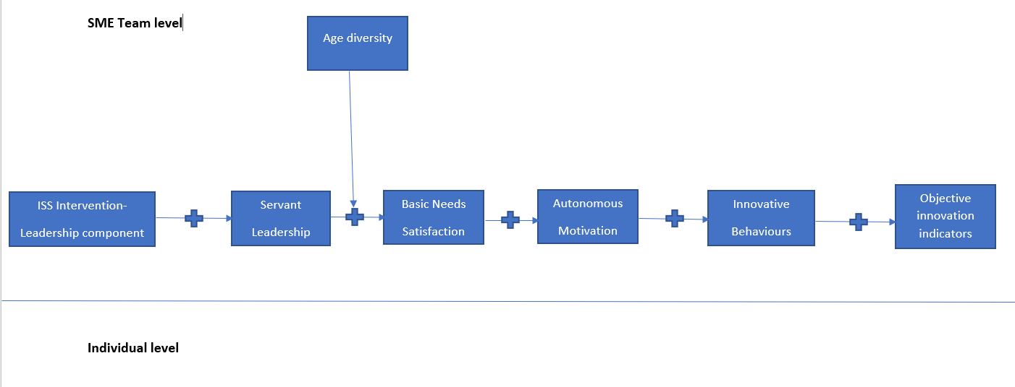
The underlying idea is that the training will have an impact on followers’
perceptions of servant leadership, which in turn will influence team-level basic needs satisfaction and in turn aggregated team-level Innovative behaviours as outcomes. Furthermore, we expect that team level innovative behaviours will have a positive impact on objective indicators of innovation. Moreover, the team-level relations between servant leadership and basic needs satisfaction will be moderated by age diversity.

Cognitive training
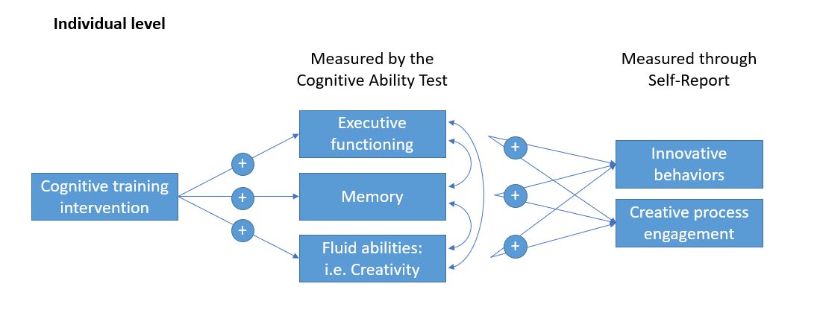
The cognitive training is expected to increase the cognitive abilities with an emphasis on executive functioning, memory capacity and fluid cognitive abilities. Divergent thinking as a form of creativity is considered to be part of fluid cognitive abilities. In turn, these abilities can foster innovative behaviours and creative process engagement.
With further additional analyses, boundary conditions for the influence of cognitive abilities on innovation indicators, such as individual characteristics and attitudes, can be identified.

5. TRIAL DESIGN
5.1 Description | The design of the trial is a waiting list-control group design. After an initial baseline data collection, SMEs will be randomly assigned to an experimental and a waiting-list control group. SME-entrepreneurs and employees in the experimental group will receive the ISS consistent of the leadership and cognitive training. Afterwards, another data collection involving both the experimental- and waiting-list control group will take place. This data collection will be used to evaluate the effectiveness of the ISS in the experimental group. Finally, the waiting-list control group will receive the ISS followed by a final data collection to assess the effectiveness of the ISS for the waiting-list control group and the long-term effectiveness for the experimental group.

5.2 Trial Diagram
Add a simple representation of the trial design. Below you can find an illustration of how this would look.
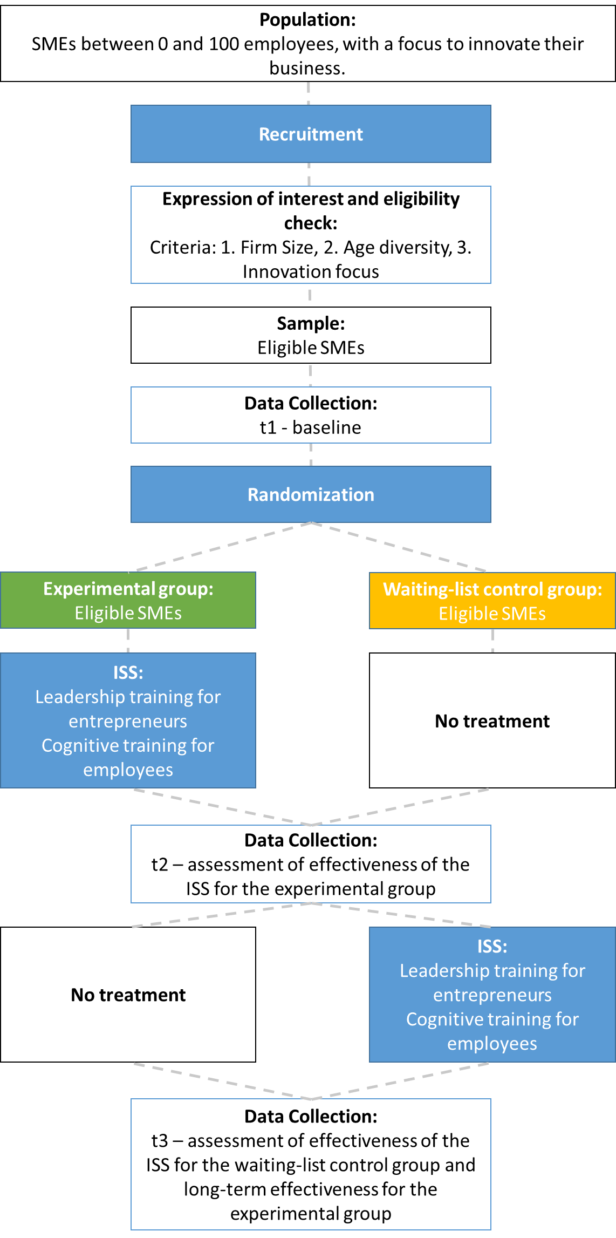
This design will be implemented simultaneously in Germany and the UK.

6. RANDOMISATION AND ASSIGNMENT
6.1 Allocation Sequence | The trial will make use of cluster randomization. The relevant clusters will be SMEs.
6.2 Allocation Mechanism and Implementation | Randomization will be implemented through the Excel Data randomized function. The PI will be involved in the process.  Randomization will occur after collection of baseline data.

7. STATISTICAL ANALYSIS
7.1 Intended comparisons | Leadership training  Follower rated innovation behaviours and innovative outcomes at t2 will be compared between the experimental- and the waiting-list control group while controlling for endogenous variables at t1. We expect a statistically significant increase in all outcomes in the experimental- as compared to the waiting-list control group.  Follower rated innovation behaviours and innovative outcomes at t3 will be compared between the experimental- and the waiting-list control group while controlling for endogenous variables at t2. We expect a statistically significant increase in all outcomes in the waiting-list control group as compared to the experimental group.  Additionally, we will conduct multivariate linear regression analyses to test for the direct effects of the leadership training intervention on the primary and secondary outcomes.  Cognitive training  Cognitive abilities (executive functioning, memory capacity, and fluid cognitive abilities including creativity) as well as self-reported innovative behaviours and creative process engagement at t2 will be compared between the experimental- and the waiting-list control group while controlling for endogenous variables at t1. We expect a statistically significant increase in all outcomes in the experimental-group as compared to the waiting-list control group.  Cognitive abilities (executive functioning, memory capacity, and fluid cognitive abilities including creativity as well as self-reported innovative behaviours and creative process engagement and creative process engagement at t3 will be compared between the experimental- and the waiting-list control group while controlling for endogenous variables at t2. We expect a statistically significant increase in all outcomes in the waiting-list control group as compared to the experimental group.  Additionally, we will conduct multivariate linear regression analyses to test for direct effects of the cognitive training intervention on the primary and secondary outcomes.
7.2 Statistical methods | Due to the hierarchical structure of the data (individuals nested in SMEs) we will use multilevel analyses with restricted maximum likelihood estimation to analyse the effects of the leadership and the cognitive training interventions.  The multivariate linear regressions will be conducted within a standard SEM framework with maximum likelihood estimation
7.3 Additional analysis | Leadership training  We will further test the model presented in 4.1 by specifying a multilevel model on the SME-team-level. In this model, participation in the leadership training predicts followers’ team- and individual level servant leadership perceptions. In turn, servant leadership predicts followers’ aggregated team-level task-, and relationship conflicts as well as psychological safety climate, and basic needs satisfaction, which in turn predict all outcomes. In addition, we will test age diversity as a moderator of the proposed relation between team-level servant leadership and team-level perceptions of task- as well- as relationship conflict.  In the form of additional analyses, we will test the same model with leader perceptions of the respective variables as outcomes. Moreover, we will explore leader-rated business ambidexterity, entrepreneurial innovation orientation as well as objective indicators of innovation as more distal outcomes.

8. POWER AND SAMPLE SIZE
8.1 Sample Size
Leadership training:
SME-team-Level N= 300
Individual-Level: 5 employees per SME providing external leadership ratings)
Analyses will be conducted on the SME-team-level.

Cognitive training:
Individual-Level N= 1500 Participants for the cognitive training.
Analyses will be conducted on the individual level.
The proposed sample sizes have accounted for a potential dropout of 15%.

Table 1: Potential assumptions relevant to sample size calculations
8.2 Assumptions to consider | Value/Details
Criterion for statistical significance (probability level; typically 0.05) | Level of significance: 0.05
Power against alternative hypothesis (conventionally 80%) | Power: 0.80
Expected effect size | Effect Cohen's d: .20.  For the leadership training intervention, the assumption of a d=.20 effect is the most conservative expected effect size and is based on the following meta-analysis: Allan Lee, Alison Legood, David Hughes, Amy Wei Tian, Alexander Newman & Caroline Knight (2020) Leadership, creativity and innovation: a meta-analytic review, European Journal of Work and Organizational Psychology, 29:1, 1-35, DOI: 10.1080/1359432X.2019.1661837  Effect Cohen's d: .40  For the cognitive training, the assumption of a d=.40 is grounded in the empirical literature that demonstrates that mental abilities is the strongest predictor of various performance indicators. Considering that the effect sizes in the literature vary we decided to assume an effect size of .40 which is again a conservative assumption and also coincides with the results of the pilot study.
Allocation ratio, i.e. proportion of randomisation units assigned to treatment (e.g. 50% of the total sample assigned to treatment in a two-arm trial) | Proportion of randomisation units assigned to treatment: 50%
Treatment compliance  - participants switching treatment groups  - participants in the treatment group deciding not to take up the offered program  - participants dropping out of the experiment entirely (such that we no longer collect their data) | Treatment compliance: 85%
Number of individuals per randomisation unit (applicable to cluster randomised trials) | Leadership training:  N=5 – will be aggregated  Cognitive training:  N=1.325 – Assumption for ICC = 0  N=1.375 – Assumption for ICC = 0.1  N=1.443 – Assumption for ICC = 0.2  Due to minor differences in the sample size calculations depending on the assumption about ICCs, we will aim to recruit N=5 employees per SME for the cognitive training, which should be sufficient even if ICCs are higher than expected.
Intra-class correlation (ICC) coefficient (rho) (applicable to cluster randomised trials) | Leadership training:  Not applicable as outcomes will be aggregated to the SME-team-level.  Cognitive training:  Calculated with  ICC = 0  ICC = 0.1  ICC = 0.2
Proportion of variance in the outcome explained by covariates (R-squared) - if applicable
Correction for multiple comparisons | Bonferoni
Software used for Minimum Detectable Effect Size calculations. | Webpower  https://webpower.psychstat.org/models/mlm01/

Note: if required sample size is unrealistically large, or minimum detectable effect size is unreasonably large (i.e. the trial is unable to detect economically meaningful effects), we recommend reducing the number of comparisons (by dropping a treatment arm, or restricting subgroup analyses) and/or reducing the noise in the outcome measure (by using stratified randomization, more precise outcome measures or repeated measurements).

9. RECRUITMENT AND DATA COLLECTION
9.1 Recruitment | Recruitment will be conducted through the networks of the project consortium in the UK and in Germany. The only eligibility criterion for recruitment will be the size of the company so as to fit the characterisation of SME. We do not specify further eligibility criteria because our recruiting advertisements will a priori focus on creativity and innovation in age diverse teams.  For the leadership training, SME leaders will be incentivised to participate to the study through the training provided and their followers’ feedback they will receive in T1, T2, T3. T1, T2, and T3 refer to the three different point in time where data collection will take place (T1: Before the introduction of the ISS to the experimental group; T2 three months after the introduction of the ISS to the experimental group; T3 three months after the ISS has been introduced to the control group). In all three times followers will be asked to answer a survey enquiring about the servant leadership behaviours of their leader. These responses will be aggregated and form the feedback that will be provided to the leader.  Regarding the cognitive training , employees will be offered a monetary compensation to participate to the study (£40).
9.2 Assessment of data collection | For t1 data means, standard deviations, reliabilities, ICCs and the factor structure of self-report data will be examined using appropriate analyses and compared to established cut-off criteria. All variables, which fall below cut-offs, will be discarded and not be further examined. The same will be done for data collected at t2 and t3.  For the time scale please see point 13. Timeline
9.3 Data collection instruments | Leadership training:  See Additional Document - Project Journal  Cognitive training:  See Additional Document - Project Journal
9.4 Business retention plan | The waiting-list control group trial design can be expected to facilitate retention of SME entrepreneurs.  For individual employees a compensation will be awarded for participation in the cognitive training and providing data for evaluation.
9.5 Cost-effectiveness analysis | Cost effectiveness analyses will be conducted at the end of the trial. The estimated costs for the leadership training programme conducted by a professional trainer and signing up for the cognitive training app will be compared to standardized effect sizes.

10. IMPLEMENTATION AND PROCESS EVALUATION
10.1 Process evaluation and implementation:  questions and purpose | Leadership training:  The trial will involve a qualitative process evaluation after delivering the leadership training intervention to the experimental group. Following Kirkpatrick’s (1975) framework for training evaluation, we will collect participants’ affective (reaction), cognitive (learning), and behavioural (behaviours) outcomes in regard to the training.  Cognitive training:  The cognitive training consists of various exercises that can be independently combined. After the implementation for the experimental group, the composition of the cognitive training will be qualitatively and quantitatively evaluated. Based on participants’ feedback and usage patterns as well as individual improvements in the different sub facets, less efficient exercises will be replaced for the following implementation.
10.2 Process evaluation: methods and data collection | Leadership training:  To assess whether trainees engaged with the online training materials, links to a brief survey and a revision quiz will be embedded at the end of each session. The brief survey will be both a quality control of the material presented, and an indication of whether trainees watched the entirety of the video. The quiz will present an opportunity for the trainees to test their understanding on the presented material and will also be an indication of their level of engagement.  An additional way of monitoring engagement will be via the online interactive sessions that will require some preparation from the trainees based on exercises presented in the pre-recorded videos.
10.3 Wider Impact evaluation | A cost-benefit analysis will be conducted.  An assessment of participants’ well-being will be conducted.

11. ETHICS
11.1 Ethical concerns | To ensure that the trial conforms to highest ethical standards. Ethical approval will be obtained from the ethics commissions of the University of Wuppertal before implementation.  Please see Deliverable D7.1 and D7.2
11.2 Consent or assent for participation in the trial | Please see Deliverable D7.1 and D7.2
11.3 Confidentiality | Please see Deliverable D7.1 and D7.2
11.4 Data Protection | Please see Deliverable D7.1 and D7.2
11.5 Declaration of interest | There are no competing interests.

12. RISKS
Description of risks to the trial and how they might be addressed.

Trial risk register with examples:
Risk | Assessment | Countermeasures and contingencies
Difficulties in target sample (SME and/or employee) acquisition | Likelihood: moderate  Impact: moderate | Two innovation agencies with well-established contacts to SMEs will be in charge of recruitment. Moreover, the Academic members of the consortium have a well-established track-record of conducting sophisticated applied studies in the work-related field. Through these studies they have established contacts to a wide network of SMEs which may also support participant recruitment.  In the case of a low initial sign-up we will implement a cohort based approach on allocating SMEs in the experimental and control groups till we meet the required sample size.  It can be expected that SME entrepreneurs participating in the leadership training will have a high compliance due to the potential beneficial impact of the training on their businesses.  To ensure continuous commitment to participate in the cognitive training the DINNOS budget includes a compensation for each participant. Participants will only receive compensation upon full participation in the trainings and accompanying surveys for evaluation. Additionally, if we observe that we have low response rates, SME leaders and employees will receive e-mail reminders and if we observe a lack of compliance we might need to make follow up phone calls.  To mitigate the risk that participants’ dropout will affect final attrition rate DINNOS will collect an addition 15% of participants.  Finally, if initial recruitment is not satisfactory DINNOS may adapt the time scale to ensure that the necessary sample is recruited.
Evaluation shows that the ISS is not effective in fostering innovation on the organisational-and individual level. | Likelihood: low  Impact: moderate | The evaluated ISS has been successfully piloted in a large-scale research project in Germany in which members of the consortium were involved. The design of the RCT involving an experimental- and a waiting-list control group does not only ensure that all participants will receive the ISS but also offers the opportunity to adapt the ISS if the evaluation of the experimental group data does not suggest its effectiveness.  To mitigate the risk of the intervention being not successfully evaluated DINNOS has implemented another potential adaptation of the ISS after the results of the waiting-list control group data are examined. Moreover, to enhance its effectiveness DINNOS will also conduct a qualitative evaluation of the ISS.
Spillovers/ contamination | Likelihood: Low  Impact: Moderate | As the recruited SMEs will most likely operate in different fields and not be part of the same business networks there is a low likelihood that the training intervention to the experimental group will contaminate the control group.
Retention of participants | Likelihood: Moderate  Impact: Moderate | To ensure a high retention of participants DINNOS has adapted a waiting-list control group trial design, which ensures that both the experimental and the waiting-list control group receives the proposed ISS. Accordingly, this makes retention more likely.

13. TIMELINE
Phase | Time period
Phase 1: Trial design and preparation (trial protocol, survey design, etc.) | October 2019 – August 2020
Phase 2: Recruitment (engagement, baseline, randomisation, etc.) | September 2020
Phase 3: Intervention Delivery (experimental group) | October 2020 – December 2020
Phase 4: Data Collection and analysis (final follow-up survey, qualitative data, etc) | March 2021 – April 2021
Phase 5: Intervention Delivery (waiting-list control group) | May 2021 – June 2021
Phase 6: Data Collection and analysis (final follow-up survey, qualitative data, etc) | September 2021 – October 2021
Phase 5: Reporting (concluding analysis and evaluation report) | October 2021 – January 2022

Standard Protocol Items: Recommendations for Interventional Trials (SPIRIT).
Consolidated Standards of Reporting Trials (CONSORT). Please visit this link for examples: http://www.consort-statement.org/examples/sample
Avoid setting too many primary questions to answer. Trials are typically powered to detect changes in a single primary outcome. Multiple primary outcomes require larger samples (or an analytical correction). Example: For SMEs (the population), does offering access to 30 hours of free businesses coaching alongside a grant (the intervention) lead to faster sales growth (the outcome) than offering the grant alone (the control)?
If some of your measurement instruments (including composite scores) will be constructed, e.g. “attitude to new technology”, please provide a description of how the outcome will be constructed from the main variables.
Whilst the objective of Innosup is to find ways to increase SME productivity it is recommended that projects also identify more proximate outcome measures that are key determinants of success - e.g. have SMEs advanced through different stages of adoption or delivered changes within their businesses that are expected to deliver positive impacts on productivity.
A logic model will help to see the intended mechanism for change for each programme or policy and should also underpin what data needs to be collected when for each evaluation. This can be helpful to identify the proximate outcome measures that can provide more timely measures than measures such as SME productivity. Logic models should also help to identify risks or contingency factors which may mean outcomes are not as envisaged.
There are a number of factors involved in estimating the sample size, including: Type and structure of the trial and research question; Effect size - ‘Minimum Detectable Effect Size (MDES); The ‘noise in the outcome variable’ (i.e. unexplained variance). Two approaches to estimation: Fixed Sample: What is the smallest true impact that I can be confident of detecting given a sample of this size? Target Impact: What sample size do I need to be confident of detecting an impact of this scale? It is important to highlight that statistical significance is not the same as policy significance. What scale of impacts would inform your policy decision? For example, how much want to increase the proportion of SMEs who adopt technology x; % change in productivity or the ratio of net economic benefit to programme cost. Ideally, want to align the Minimum Detectable Effect Size in the trial with policy significant outcome. So able to say with confidence whether impacts exceed or fall short of decision thresholds.
Please use Table 1 to provide a summary of the key assumptions you have made, detailing and fully justifying your choices in the text below - where have the assumptions come from and why decided to use these (including why something is not relevant).
Process evaluation can be crucial for understanding the effects and exploring potential causal mechanisms of complex interventions or for assessing programme fidelity.
Although this is the most common time structure for trials, not all projects follow this clear path. Feel free to change the phases if necessary.

