Online Survey of Grade XII Students

Hello! Welcome to the Online Survey of GradeXII Students.

This survey must be taken with a desktop computer in a computer room at school.
If you are in a computer room at school, please proceed.
If not, please close the browser. When you sit in the computer room, please re-click the survey link URL. The same URL will work.

The Ministry of Education is creating a career support program for higher secondary students with financial grant from the Asian Development Bank, one of the biggest international aid agencies. The data collected from this online survey will be used for the career support program.
This Survey is being administered to all grade XII students in all higher secondary schools.
Your responses to this survey will NEVER be used to assess your or anyone's academic performance. Your responses will be accessed only by the research team of the Asian Development Bank. The Ministry of Education can access only aggregated anonymized data.
Please answer all questions carefully. Your careful truthful responses are crucial.
The survey will take approximately 1-1.5 hours. Once you start, you are not allowed to stop.
If you are ready to start, please click the button below. If not, please close the browser and re-click the survey URL link when you become ready.

Important Note:
- This survey does not allow you to go back to previous pages. You can only move forwards. In other words, if you move to a next page, you cannot return to a previous page.
- Even if you leave the survey by closing a web browser and re-click the survey URL link, you will be redirected to the survey page that you left.
- Hence, please make sure that you carefully answer questions before proceeding to a next page.

A. Registration

A1. What is your name? _________________
A2. What is your Student ID code? _________________
A3. What is your gender? 1. Male 2. Female
A4. What is your date of birth? ____ (day) / _____ (month) / _________ (year)
A5. What is the name of your high school? _________________
A6. What is your academic stream? 1. Arts 2. Commerce 3. Science 4. Rigzhung
A7. What is your email address provided by the ministry of education?
__________________________________
A8. What is your private email address (e.g., Gmail, Yahoo mail)?
__________________________________
A9. What is your mobile phone number? _________________
A10. Which Dzongkhag are you originally from? _________________
A11. Do you live in a school dormitory? 1. Yes 2. No

A12. What do you think your performance in each of the following subjects is? |  | 1 = Very bad (0-20%)  2 = Bad (21-40%)  3 = Moderate (41-60%)  4 = Good (61-80%)  5 = Very Good (81-100%)  99 = Don’t know/ Not applicable
a | Math | 1 | 2 | 3 | 4 | 5 | 99
b | Dzongkha | 1 | 2 | 3 | 4 | 5 | 99
c | English | 1 | 2 | 3 | 4 | 5 | 99
d. | Science | 1 | 2 | 3 | 4 | 5 | 99
e | Social studies | 1 | 2 | 3 | 4 | 5 | 99
f | Arts | 1 | 2 | 3 | 4 | 5 | 99
g | Overall | 1 | 2 | 3 | 4 | 5 | 99

A13. How much do you agree with the following statement? |  | 1 = Strongly disagree  2 = Disagree  3 = Neither disagree or agree  4 = Agree  5 = Strongly agree  99 = Don’t know
a | “It is important for me to receive education.” | 1 | 2 | 3 | 4 | 5 | 99
b | “Education makes me a better citizen.” | 1 | 2 | 3 | 4 | 5 | 99
c | “Education helps me get a better job.” | 1 | 2 | 3 | 4 | 5 | 99

A14. How much do you agree with the following statement? |  | 1 = Strongly disagree  2 = Disagree  3 = Neither disagree or agree  4 = Agree  5 = Strongly agree  99 = Don’t know
a | “For my future education and career decision, my parents’ opinions are as important as my opinion.” | 1 | 2 | 3 | 4 | 5 | 99
b | “One of my goals in life is to make my parents proud.” | 1 | 2 | 3 | 4 | 5 | 99
c | “My parents put pressure on me to study” | 1 | 2 | 3 | 4 | 5 | 99
d | “For my future education and career decision, my friends’ opinions are as important as my opinion.” | 1 | 2 | 3 | 4 | 5 | 99

A15. In the last 30 days, how many times did you discuss with your parents about your study and your future education and career?
1. Never. 0 time
2. 1-2 times
3. 3-4 times
4. More than 5 times
99. Don’t know

A16. How important is it for you to marry with someone in your life?
1. Not at All Important
2. Slightly important
3. Moderately Important
4. Very Important
5. Extremely Important
99. Don’t know

C. Preference about employment
This section will ask about your views about employment.

C1. For your future educational and career decisions, how important is each of the following for you?
1 = Strongly disagree
2 = Disagree
3 = Neither disagree or agree
4 = Agree
5 = Strongly agree
99 = Don’t know
a | Income | 1 | 2 | 3 | 4 | 5 | 99
b | Job security | 1 | 2 | 3 | 4 | 5 | 99
c | Prestige and social status | 1 | 2 | 3 | 4 | 5 | 99
d | My genuine interest | 1 | 2 | 3 | 4 | 5 | 99
f | Whether I can contribute to the well-being of society | 1 | 2 | 3 | 4 | 5 | 99
g | Advice from parents or guardians | 1 | 2 | 3 | 4 | 5 | 99
h | What my friends think and choose | 1 | 2 | 3 | 4 | 5 | 99
i | Good balance between professional and family life | 1 | 2 | 3 | 4 | 5 | 99
j | Costs of education | 1 | 2 | 3 | 4 | 5 | 99

C2. Which sectors would you prefer to work in the future? Please select and rank your top 3 choices.
1 = 1st preferred sector
2 = 2nd preferred
3 = 3rd preferred
a | Agriculture, forestry and fishing
b | Mining
c | Manufacturing
d | Electricity, gas, water supply, waste management
e | Construction
f | Retail, wholesale, trading
g | Hotel, restaurant, food services
h | Transportation
i | Information and communication
j | Financial and insurance activities
k | Education
l | Health
m | Entertainment, arts, recreation
n | Professional, scientific and technical activities

C3. For your future career, how much do you prefer the following employment types? Please rank them.
1 = 1st preferred choice
2 = 2nd preferred
3 = 3rd choice
a | Government
b | Government-owned corporation
c | Private company
d | Running non-farming business
e | Farming

C4. Which of the following employment types do you believe your parents prefer for your future career? Please rank them.
1 = Most preferred choice
2 = 2nd most preferred
3 = 3rd choice
a | Government
b | Government-owned corporation
c | Private company
d | Running non-farming business
e | Farming

D. Belief and preference about education

Next section will ask about YOUR BELIEFS, not the accuracy of information. Although you may not know the answer to a question with certainty, please answer each question as best you can. Please do not consult any outside references (e.g., internet) or discuss with other people.

Instruction:
Some questions will ask about the PERCENT CHANCE of something happening. The percent chance must be a number between 0 and 100.
- Numbers like 2 or 5% indicate "almost no chance".
- Numbers like 19% may mean "not much chance".
- Numbers like 47 or 55% chance may be an "about half chance".
- Numbers like 82% indicates a "very good chance"
- Numbers like 95 or 98% mean "almost certain".

The percent chance can also be thought of as the number of chances out of 100. Here is an example:
- Imagine that you are playing football. As the percent chance that your team will win, you answer 70. This means that you believe your team would win 70 out of 100 games on average.

D-1. Belief about population outcomes
Instruction: We will ask you about YOUR beliefs regarding employment situations of (wo)men who are around 30 years old.

D1. Among (wo)men who are about 30 years old today, what percent of them do you believe have jobs and are working if they received each of the following degrees?
a | Bachelors: Science, Math, Computer Science, Agriculture | __________%
b | Bachelors: Engineering | __________%
c | Bachelors: Medicine, Health, and Nursing | __________%
d | Bachelors: Education | __________%
e | Bachelors: Business, Management, Economics, and Law | __________%
f | Bachelors: Arts, Humanities, and Social Studies | __________%
g | Technical Degrees (National Certificate II, III, Diploma) from Technical Training Institute (TTI) or Institute of Zorig Chusum (IZC) | __________%
h | Stop education after high school | __________%

D2. Among (wo)men who are about 30 years old today, what percent of them do you believe are currently working in the government if they received each of the following degrees?
 |  | % working in the government
a | Bachelors: Science, Math, Computer Science, Agriculture | __________%
b | Bachelors: Engineering | __________%
c | Bachelors: Medicine, Health, and Nursing | __________%
d | Bachelors: Education | __________%
e | Bachelors: Business, Management, Economics, and Law | __________%
f | Bachelors: Arts, Humanities, and Social Studies | __________%
g | Technical Degrees (National Certificate II, III, Diploma) from Technical Training Institute (TTI) or Institute of Zorig Chusum (IZC) | __________%
h | Stop education after high school | __________%

D3. Among the employed (wo)men who are about 30 years old today, what do you believe are their average monthly earnings if they received each of the following degrees?
a | Bachelors: Science, Math, Computer Science, Agriculture | Nu___________
b | Bachelors: Engineering | Nu___________
c | Bachelors: Medicine, Health, and Nursing | Nu___________
d | Bachelors: Education | Nu___________
e | Bachelors: Business, Management, Economics, and Law | Nu___________
f | Bachelors: Arts, Humanities, and Social Studies | Nu___________
g | Technical Degrees (National Certificate II, III, Diploma) from Technical Training Institute (TTI) or Institute of Zorig Chusum (IZC) | Nu___________
h | Stop education after high school | Nu___________

D4. Among (wo)men who are about 30 years old today, what percent do you believe are married if they received each of the following degrees?
a | Bachelors: Science, Math, Computer Science, Agriculture | __________%
b | Bachelors: Engineering | __________%
c | Bachelors: Medicine, Health, and Nursing | __________%
d | Bachelors: Education | __________%
e | Bachelors: Business, Management, Economics, and Law | __________%
f | Bachelors: Arts, Humanities, and Social Studies | __________%
g | Technical Degrees (National Certificate II, III, Diploma) from Technical Training Institute (TTI) or Institute of Zorig Chusum (IZC) | __________%
h | Stop education after high school | __________%

D-2. Perceptions about education
Instruction: We will ask you about how you perceive higher and technical education.

D5. Parents’ approval: Imagine that you choose to pursue each of the degrees listed below. What do you think is the percent chance that your parents would approve of your choice of study?
a | Bachelors: Science, Math, Computer Science, Agriculture | __________%
b | Bachelors: Engineering | __________%
c | Bachelors: Medicine, Health, and Nursing | __________%
d | Bachelors: Education | __________%
e | Bachelors: Business, Management, Economics, and Law | __________%
f | Bachelors: Arts, Humanities, and Social Studies | __________%
g | Technical Degrees (National Certificate II, III, Diploma) from Technical Training Institute (TTI) or Institute of Zorig Chusum (IZC) | __________%
h | Stop education after high school | __________%

D6. Peer perception: Imagine that you choose to pursue each of the degrees listed below. What percent of your friends would highly regard your choice of study?
a | Bachelors: Science, Math, Computer Science, Agriculture | __________%
b | Bachelors: Engineering | __________%
c | Bachelors: Medicine, Health, and Nursing | __________%
d | Bachelors: Education | __________%
e | Bachelors: Business, Management, Economics, and Law | __________%
f | Bachelors: Arts, Humanities, and Social Studies | __________%
g | Technical Degrees (National Certificate II, III, Diploma) from Technical Training Institute (TTI) or Institute of Zorig Chusum (IZC) | __________%
h | Stop education after high school | __________%

D7. What percent of people in general in the society do you believe highly regard each of the degrees listed below?
a | Bachelors: Science, Math, Computer Science, Agriculture | __________%
b | Bachelors: Engineering | __________%
c | Bachelors: Medicine, Health, and Nursing | __________%
d | Bachelors: Education | __________%
e | Bachelors: Business, Management, Economics, and Law | __________%
f | Bachelors: Arts, Humanities, and Social Studies | __________%
g | Technical Degrees (National Certificate II, III, Diploma) from Technical Training Institute (TTI) or Institute of Zorig Chusum (IZC) | __________%
h | Stop education after high school | __________%

D-3. School choice and belief about self-outcomes

Instruction: We will ask you about what you believe and prefer regarding your own education and employment.

D8. If you, today, decide the type of degree to pursue, what are your 1st, 2nd, 3rd, 4th, 5th, 6th, 7th, and 8th choices? Please rank the following degrees.
a | Bachelors: Science, Math, Computer Science, Agriculture
b | Bachelors: Engineering
c | Bachelors: Medicine, Health, and Nursing
d | Bachelors: Education
e | Bachelors: Business, Management, Economics, and Law
f | Bachelors: Arts, Humanities, and Social Studies
g | Technical Degrees (National Certificate II, III, Diploma) from Technical Training Institute (TTI) or Institute of Zorig Chusum (IZC)
h | Stop education after high school
D9. How sure are you about your choice rankings on degrees that you just answered?
1. Not at all sure
2. Slightly sure
3. Somewhat sure
4. Moderately sure
5. Extremely sure
99. Don’t know

D10. Compared to all students who choose each of the degrees below, what do you think about your academic performance? |  | 1 = Very bad (0-20%)  2 = Bad (21-40%)  3 = Moderate (41-60%)  4 = Good (61-80%)  5 = Very Good (81-100%)
a | Bachelors: Science, Math, Computer Science, Agriculture | 1 | 2 | 3 | 4 | 5
b | Bachelors: Engineering | 1 | 2 | 3 | 4 | 5
c | Bachelors: Medicine, Health, and Nursing | 1 | 2 | 3 | 4 | 5
d | Bachelors: Education | 1 | 2 | 3 | 4 | 5
e | Bachelors: Business, Management, Economics, and Law | 1 | 2 | 3 | 4 | 5
f | Bachelors: Arts, Humanities, and Social Studies | 1 | 2 | 3 | 4 | 5
g | Technical Degrees (National Certificate II, III, Diploma) from Technical Training Institute (TTI) or Institute of Zorig Chusum (IZC) | 1 | 2 | 3 | 4 | 5
h | Stop education after high school | 1 | 2 | 3 | 4 | 5

D11. What do you believe is the percent chance that you have a job and are working when you are 30 years old if you receive each of the following degrees?
a | Bachelors: Science, Math, Computer Science, Agriculture | __________%
b | Bachelors: Engineering | __________%
c | Bachelors: Medicine, Health, and Nursing | __________%
d | Bachelors: Education | __________%
e | Bachelors: Business, Management, Economics, and Law | __________%
f | Bachelors: Arts, Humanities, and Social Studies | __________%
g | Technical Degrees (National Certificate II, III, Diploma) from Technical Training Institute (TTI) or Institute of Zorig Chusum (IZC) | __________%
h | Stop education after high school | __________%

D12. What do you believe is the percent chance that you have a job in the government when you are 30 years old if you receive each of the following degrees?
 |  | % working in the government
a | Bachelors: Science, Math, Computer Science, Agriculture | __________%
b | Bachelors: Engineering | __________%
c | Bachelors: Medicine, Health, and Nursing | __________%
d | Bachelors: Education | __________%
e | Bachelors: Business, Management, Economics, and Law | __________%
f | Bachelors: Arts, Humanities, and Social Studies | __________%
g | Technical Degrees (National Certificate II, III, Diploma) from Technical Training Institute (TTI) or Institute of Zorig Chusum (IZC) | __________%
h | Stop education after high school | __________%

D13. Imagine that you have a job and are working when you are 30 years old. What do you believe is the average monthly amount that you would earn if you receive each of the following degrees?
a | Bachelors: Science, Math, Computer Science, Agriculture | Nu___________
b | Bachelors: Engineering | Nu___________
c | Bachelors: Medicine, Health, and Nursing | Nu___________
d | Bachelors: Education | Nu___________
e | Bachelors: Business, Management, Economics, and Law | Nu___________
f | Bachelors: Arts, Humanities, and Social Studies | Nu___________
g | Technical Degrees (National Certificate II, III, Diploma) from Technical Training Institute (TTI) or Institute of Zorig Chusum (IZC) | Nu___________
h | Stop education after high school | Nu___________

D14. What do you believe is the percent chance that you will marry by age 30 if you receive each of the following degrees?
 |  | % chance that you marry by age 30
a | Bachelors: Science, Math, Computer Science, Agriculture | __________%
b | Bachelors: Engineering | __________%
c | Bachelors: Medicine, Health, and Nursing | __________%
d | Bachelors: Education | __________%
e | Bachelors: Business, Management, Economics, and Law | __________%
f | Bachelors: Arts, Humanities, and Social Studies | __________%
g | Technical Degrees (National Certificate II, III, Diploma) from Technical Training Institute (TTI) or Institute of Zorig Chusum (IZC) | __________%
h | Stop education after high school | __________%

D15. What percentage of the other grade XII students do you believe will choose each of the following degrees as their 1st choice?
a | Bachelors: Science, Math, Computer Science, Agriculture | __________%
b | Bachelors: Engineering | __________%
c | Bachelors: Medicine, Health, and Nursing | __________%
d | Bachelors: Education | __________%
e | Bachelors: Business, Management, Economics, and Law | __________%
f | Bachelors: Arts, Humanities, and Social Studies | __________%
g | Technical Degrees (National Certificate II, III, Diploma) from Technical Training Institute (TTI) or Institute of Zorig Chusum (IZC) | __________%
h | Stop education after high school | __________%

E. Information Provision
Instruction: Now we will present some information based on actual data about people who graduated from colleges, TTI/IZC, and high schools.

They are informative and useful data. Please carefully look at it.

E1. Treatment Group: Men
What % of Men Work for What Types of Jobs
This graph illustrates what percentage of 28–34 year old men are employed, depending on the types of degrees they received.
For example, among the men who received technical degrees from TTI/IZC, 81% work for regular wage jobs; 5% work for casual wage jobs; 7% run businesses; 2% run farms. In total 94% are employed.
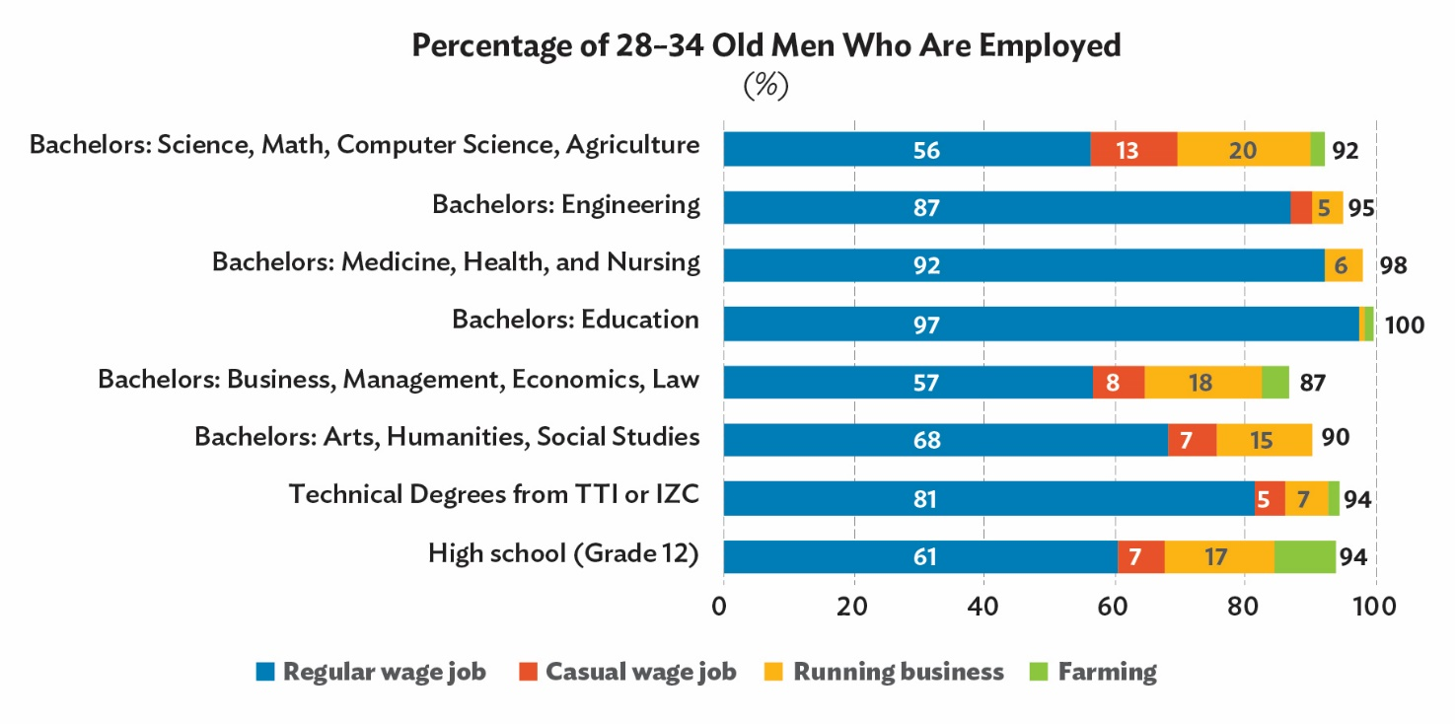
Source: Labor Force Surveys by Bhutan National Statistics Bureau

What % of Men Have Regular Wage Jobs for What Types of Employers
This graph illustrates what percentage of 28–34 year old men work for regular wage jobs in the government, government-own corporations, private firms, and non-governmental organizations (NGOs).
For example, among the men aged 28–34 who received bachelors in engineering, 21% work in the governments; 37% in government-owned corporations; 30% in private firms; and 0% in NGOs.
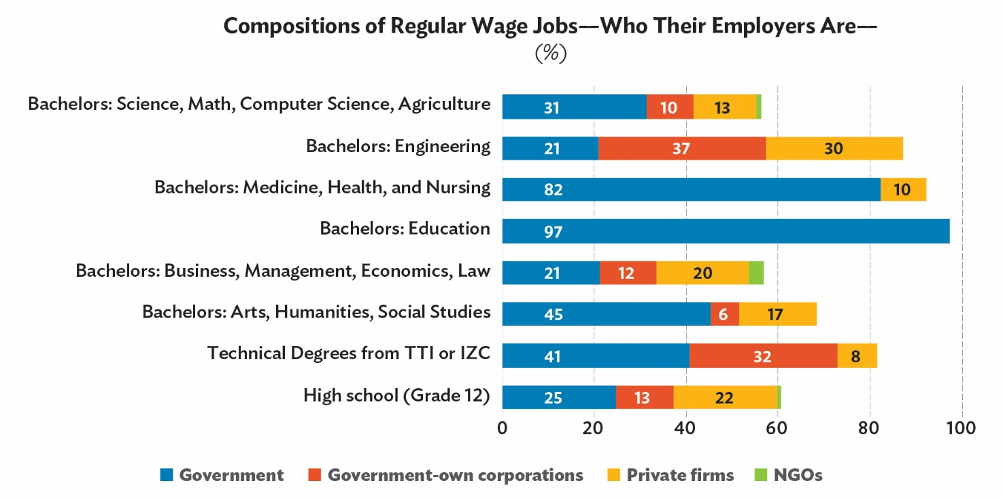
Source: Labor Force Surveys by the Bhutan National Statistics Bureau

How Much Men Earn
This graph illustrates the monthly earnings of employed men who are 28–34 years old.
For example, among the employed men aged 28–34 who received bachelors in education:
- Bottom 10-25% people earn Nu 19,500 to Nu 22,000 monthly.
- Lower middle 25-50% earn Nu 22,000 to Nu 27,000.
- Upper middle 50-75% earn Nu 27,000 to Nu 34,000.
- Top 75-90% earn Nu 34,000 to Nu 38,000.
- The average monthly earnings are Nu 28,000.
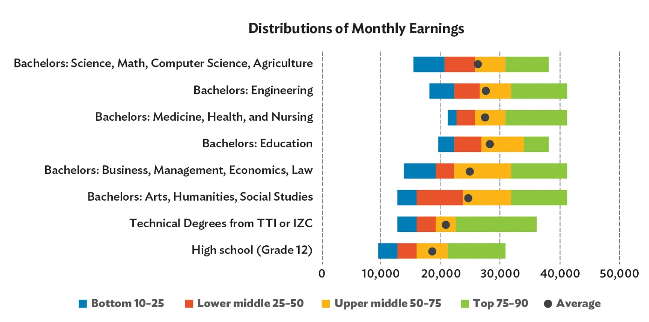
Source: Labor Force Surveys by the Bhutan National Statistics Bureau

E2. Treatment Group: Women
What % of Women Work for What Types of Jobs
This graph illustrates what percentage of 28–34 year old women are employed, depending on the types of degrees they received.
For example, among the women aged 28–34 who received technical degrees from TTI/IZC, 80% work for regular wage jobs; 2% work for casual wage jobs; 7% run businesses; 2% run farms. In total 91% are employed.
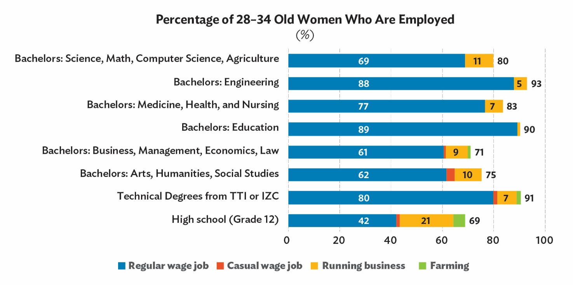
Source: Labor Force Surveys by Bhutan National Statistics Bureau

What % of Women Have Regular Wage Jobs for What Types of Employers
This graph illustrates what percentage of 28–34 year old women work for regular wage jobs in the government, government-own corporations, private firms, and non-governmental organizations (NGOs).
For example, among the women aged 28–34 who received bachelors in engineering, 41% work in the governments; 43% in government-owned corporations; 4% in private firms; and 0% in NGOs.

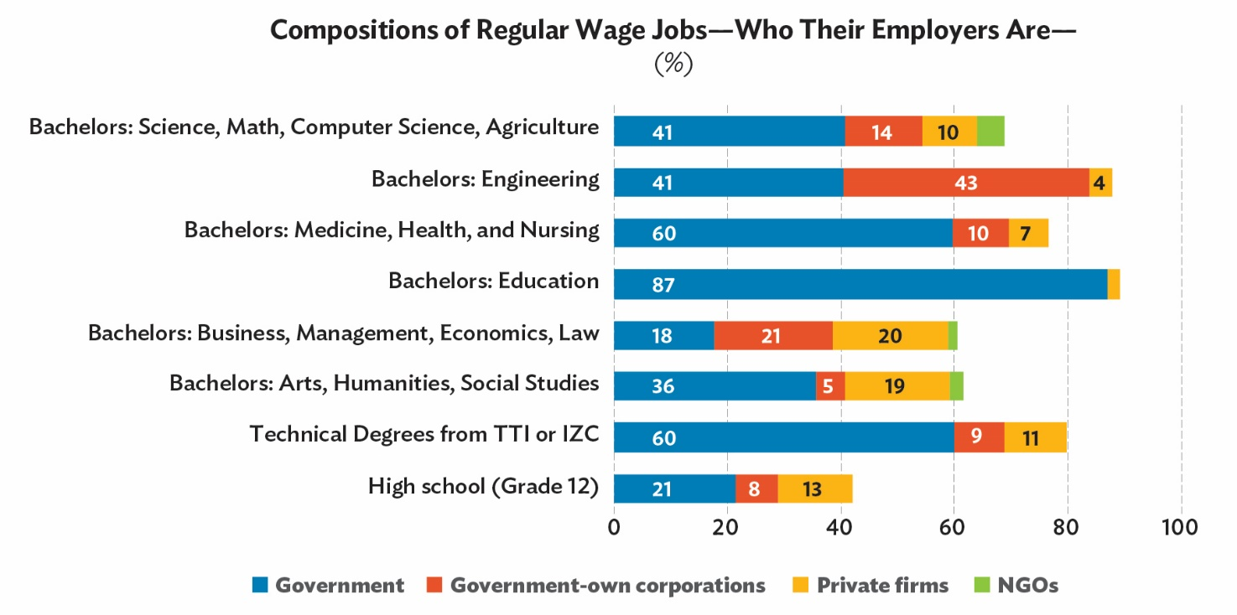
Source: Labor Force Surveys by the Bhutan National Statistics Bureau

How Much Women Earn
This graph illustrates the monthly earnings of employed women who are 28–34 years old.
For example, among the employed women aged 28–34 who received bachelors in education,
- Bottom 10-25% people earn Nu 20,000 to Nu 22,500 monthly.
- Lower middle 25-50% earn Nu 22,500 to Nu 27,000.
- Upper middle 50-75% earn Nu 27,000 to Nu 34,000.
- Top 75-90% earn Nu 34,000 to Nu 38,000.
- The average monthly earnings are Nu 28,500.
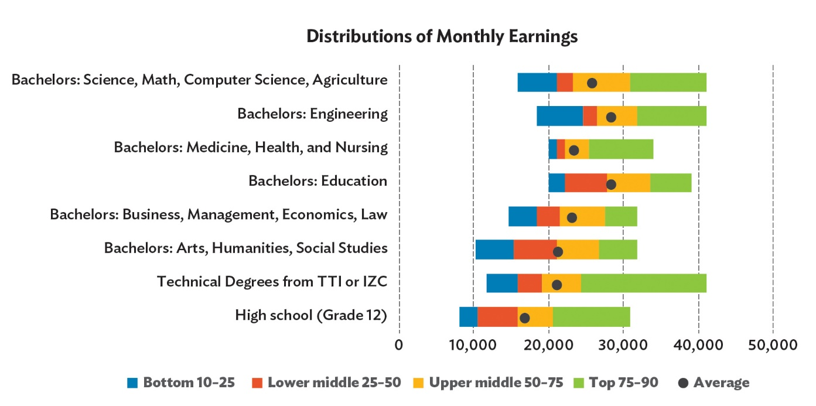
Source: Labor Force Surveys by the Bhutan National Statistics Bureau

E3. Control Group: Men

What % of Men Work for What Types of Jobs
This graph illustrates what percentage of 28–34 year old men with grade 12 or higher degrees are employed
For example, among the men who received grade 12 or bachelors’ degrees, 67% work for regular wage jobs; 7% work for casual wage jobs; 14% run businesses; 5% run farms. In total 93% are employed.
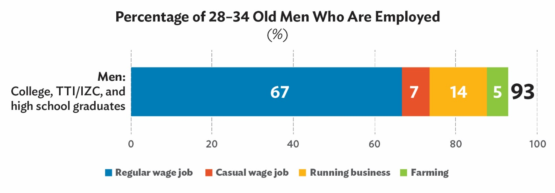
Source: Labor Force Surveys by Bhutan National Statistics Bureau

What % of Men Have Regular Wage Jobs for What Types of Employers
This graph illustrates what percentage of 28–34 year old men work for regular wage jobs in the government, government-own corporations, private firms, and non-governmental organizations (NGOs).
For example, among the men aged 28–34 who received grade 12 or bachelors’ degrees, 3% work in the governments; 14% in government-owned corporations; 18% in private firms; and 1% in NGOs.
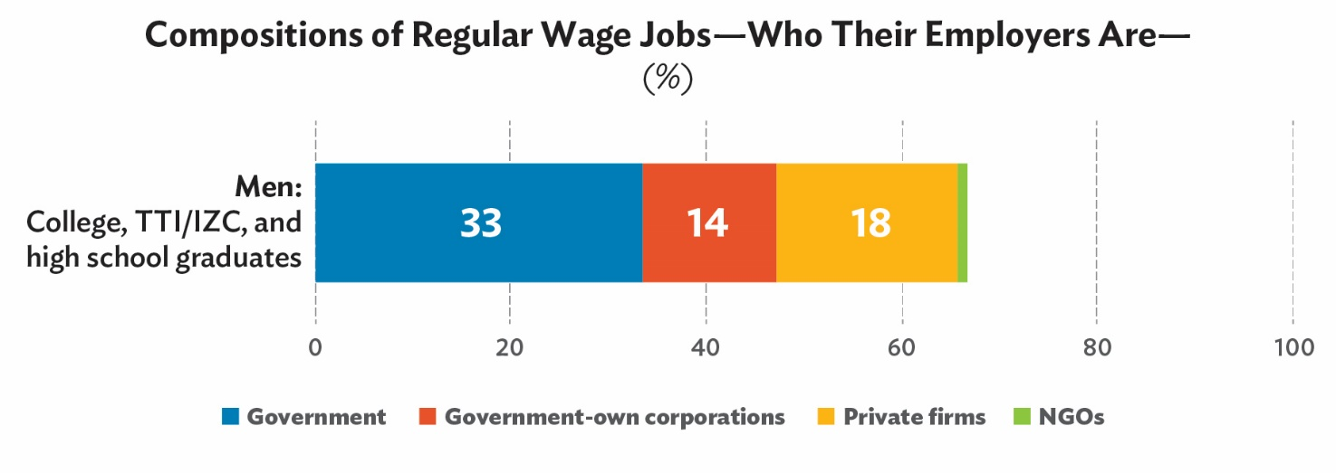
Source: Labor Force Surveys by the Bhutan National Statistics Bureau

How Much Men Earn
This graph illustrates the monthly earnings of employed men who are 28–34 years old.
For example, among the employed men aged 28–34 who received grade 12 or bachelors’ degrees:
- Bottom 10-25% people earn Nu 11,500 to Nu 15,500 monthly.
- Lower middle 25-50% earn Nu 15,500 to Nu 21,000.
- Upper middle 50-75% earn Nu 21,000 to Nu 30,000.
- Top 75-90% earn Nu 30,000 to Nu 37,000.
- The average monthly earnings are Nu 23,000.
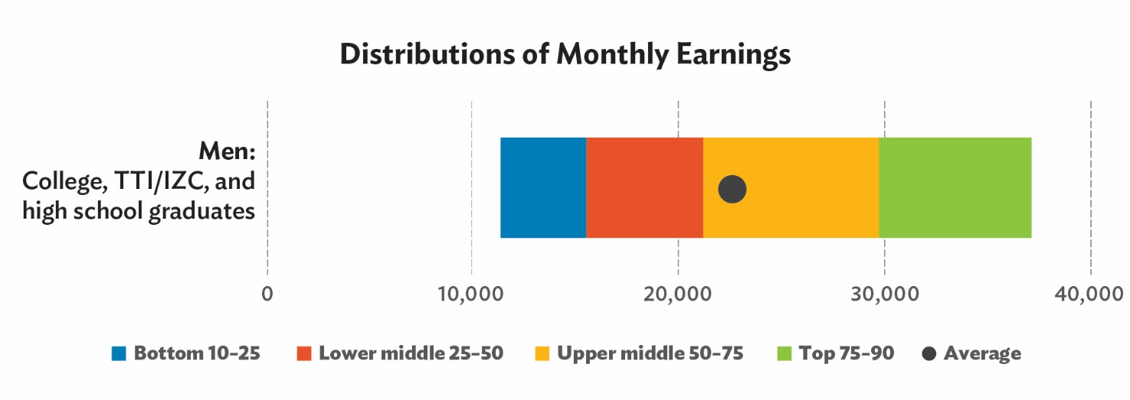
Source: Labor Force Surveys by the Bhutan National Statistics Bureau

E3. Control Group: Women
What % of women Work for What Types of Jobs
This graph illustrates what percentage of 28–34 year old women with grade 12 or higher degrees are employed
For example, among the women who received grade 12 or bachelors’ degrees, 56% work for regular wage jobs; 1% work for casual wage jobs; 14% run businesses; 3% run farms. In total 74% are employed.
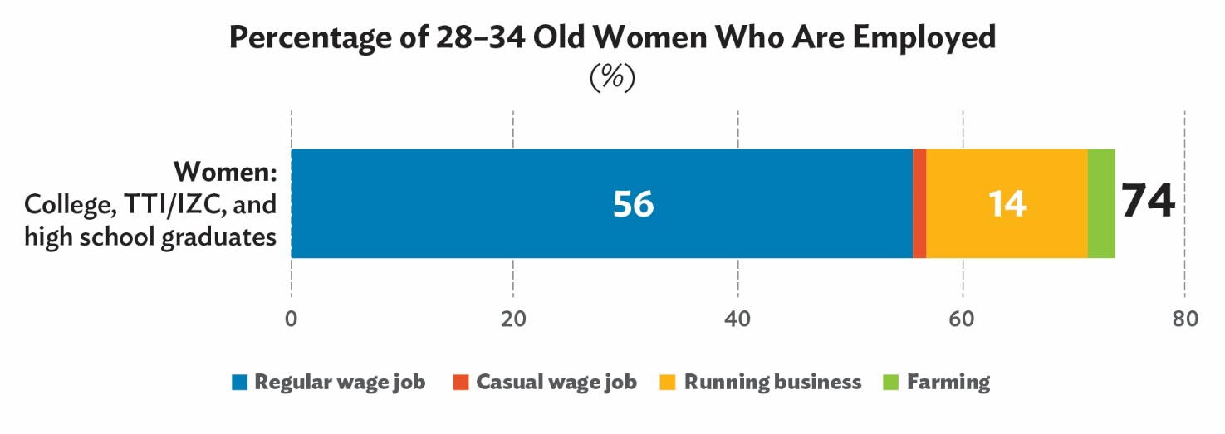
Source: Labor Force Surveys by Bhutan National Statistics Bureau

What % of Women Have Regular Wage Jobs for What Types of Employers
This graph illustrates what percentage of 28–34 year old women work for regular wage jobs in the government, government-own corporations, private firms, and non-governmental organizations (NGOs).
For example, among the women aged 28–34 who received grade 12 or bachelors’ degrees, 31% work in the governments; 11% in government-owned corporations; 14% in private firms; and 1% in NGOs.
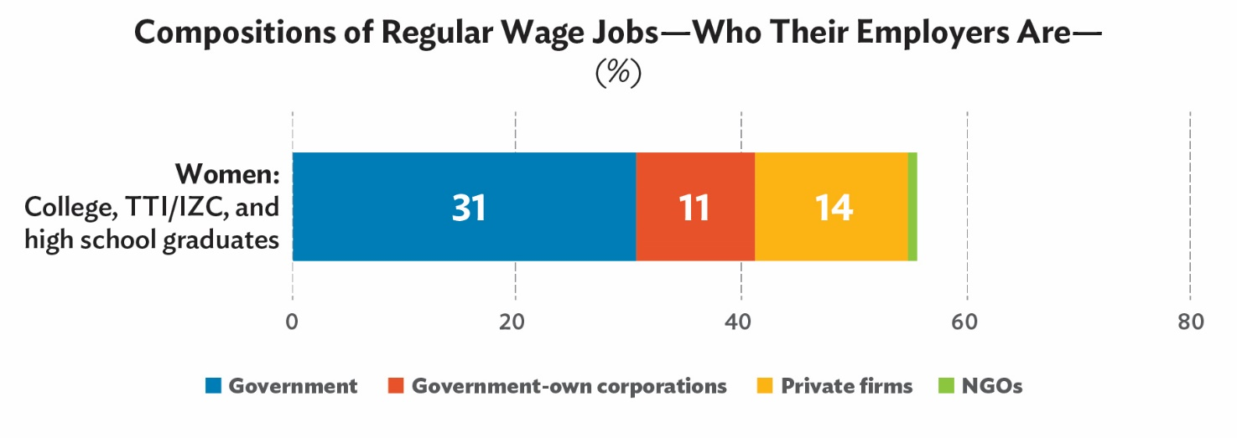
Source: Labor Force Surveys by the Bhutan National Statistics Bureau

How Much Women Earn
This graph illustrates the monthly earnings of employed women who are 28–34 years old.
For example, among the employed women aged 28–34 who received grade 12 or bachelors’ degrees:
- Bottom 10-25% people earn Nu 10,500 to Nu 15,000 monthly.
- Lower middle 25-50% earn Nu 15,000 to Nu 20,000.
- Upper middle 50-75% earn Nu 20,000 to Nu 26,500.
- Top 75-90% earn Nu 26,500 to Nu 33,000.
- The average monthly earnings are Nu 21,000.
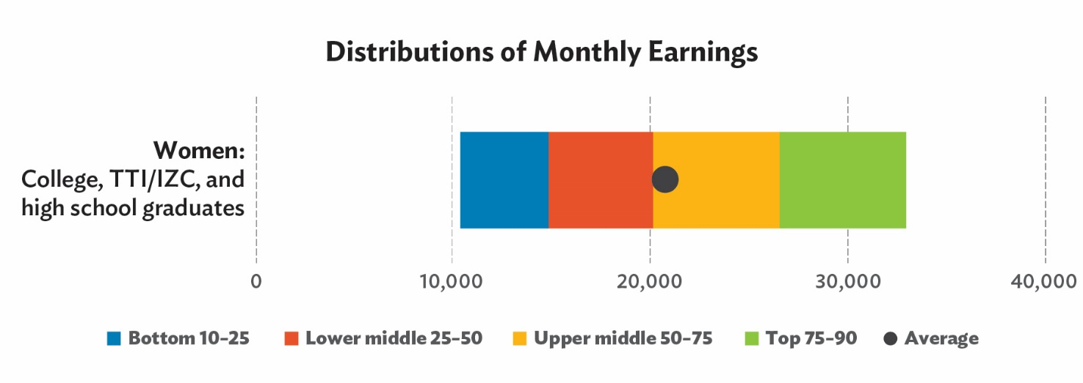
Source: Labor Force Surveys by the Bhutan National Statistics Bureau

T. Belief and preference about self-outcomes

Instruction: We will re-ask your beliefs about your own future education and employment.

T1. If you, today, decide the type of degree to pursue, what are your 1st, 2nd, 3rd, 4th, 5th, 6th, 7th, and 8th choices? Please rank the following degrees.
a | Bachelors: Science, Math, Computer Science, Agriculture | __________%
b | Bachelors: Engineering | __________%
c | Bachelors: Medicine, Health, and Nursing | __________%
d | Bachelors: Education | __________%
e | Bachelors: Business, Management, Economics, and Law | __________%
f | Bachelors: Arts, Humanities, and Social Studies | __________%
g | Technical Degrees (National Certificate II, III, Diploma) from Technical Training Institute (TTI) or Institute of Zorig Chusum (IZC) | __________%
h | Stop education after high school | __________%

T2. How sure are you about your rankings on higher education schools that you just answered?
1. Not at all sure
2. Slightly sure
3. Somewhat sure
4. Moderately sure
5. Extremely sure
99. Don’t know

T3. What do you believe is the percent chance that you have a job and are working when you are 30 years old if you receive each of the following degrees?
a | Bachelors: Science, Math, Computer Science, Agriculture | __________%
b | Bachelors: Engineering | __________%
c | Bachelors: Medicine, Health, and Nursing | __________%
d | Bachelors: Education | __________%
e | Bachelors: Business, Management, Economics, and Law | __________%
f | Bachelors: Arts, Humanities, and Social Studies | __________%
g | Technical Degrees (National Certificate II, III, Diploma) from Technical Training Institute (TTI) or Institute of Zorig Chusum (IZC) | __________%
h | Stop education after high school | __________%

T4. What do you believe is the percent chance that you are working in the government when you are 30 years old if you receive each of the following degrees?
 |  | % working in the government
a | Bachelors: Science, Math, Computer Science, Agriculture | __________%
b | Bachelors: Engineering | __________%
c | Bachelors: Medicine, Health, and Nursing | __________%
d | Bachelors: Education | __________%
e | Bachelors: Business, Management, Economics, and Law | __________%
f | Bachelors: Arts, Humanities, and Social Studies | __________%
g | Technical Degrees (National Certificate II, III, Diploma) from Technical Training Institute (TTI) or Institute of Zorig Chusum (IZC) | __________%
h | Stop education after high school | __________%

T5. Imagine that you have a job and are working when you are 30 years old. What do you believe is the average monthly amount that you would earn if you receive each of the following degrees?
a | Bachelors: Science, Math, Computer Science, Agriculture | Nu___________
b | Bachelors: Engineering | Nu___________
c | Bachelors: Medicine, Health, and Nursing | Nu___________
d | Bachelors: Education | Nu___________
e | Bachelors: Business, Management, Economics, and Law | Nu___________
f | Bachelors: Arts, Humanities, and Social Studies | Nu___________
g | Technical Degrees (National Certificate II, III, Diploma) from Technical Training Institute (TTI) or Institute of Zorig Chusum (IZC) | Nu___________
h | Stop education after high school | Nu___________

T6. Parents’ approval: Imagine that you choose to pursue each of the degrees listed below.
What do you think is the percent chance that your parents would approve of your choice of study?
a | Bachelors: Science, Math, Computer Science, Agriculture | __________%
b | Bachelors: Engineering | __________%
c | Bachelors: Medicine, Health, and Nursing | __________%
d | Bachelors: Education | __________%
e | Bachelors: Business, Management, Economics, and Law | __________%
f | Bachelors: Arts, Humanities, and Social Studies | __________%
g | Technical Degrees (National Certificate II, III, Diploma) from Technical Training Institute (TTI) or Institute of Zorig Chusum (IZC) | __________%
h | Stop education after high school | __________%

N. Networks
Instruction: We will ask you about your friendship networks at school.

Among your friends in grade XII at your school, who are the friends whom you spend the most time with? Please list at maximum five friends.
 | a. Name | b. Gender | c. Stream | d. Phone number
N1. Friend 1
N2. Friend 2
N3. Friend 3
N4. Friend 4
N5. Friend 5

W. Demographics
This is the last part of survey.
We will ask about your family (father, mother, and siblings) and a little more about yourself. We will firstly ask about your family.

Family background

Father
X1. Is your father alive?
1. Yes
2. No X3

X2. Do you currently live with your father?
1. Yes X2.1
2. No

X2a. In which Dzongkhag does your father live? _____________ (prefilled to choose)

X2.1. What is your father’s phone number? _____________

X3. What is the highest level of education that your father completed?
1. Never went to school X4
2. Went to primary school, but did not complete it X4
3. Primary X4
4. Lower secondary X4
5. Middle secondary X4
6. Higher secondary X4
7. Technical and vocational certificate X3a
8. Technical and vocational diploma X3a
9. Diploma X3a
10. Bachelor X3a
11. Master/ Ph.D. X3a
99. Don’t know X4

X3a. Which of the following best matches the field of your father’s highest degree?
1. Science, Math, Computer Science, Agriculture
2. Engineering
3. Medicine, Health, and Nursing
4. Education
5. Business, Management, Economics, and Law
6. Arts, Humanities, and Social Studies
7. Other. Describe ___
99. Don’t know

X4. Which of the following the best describes your father’s main job? [If he does not currently work or passed away, please consider the job that he engaged for the longest time]
- Farmer
- Running a non-agricultural business
- Work at government
- Work at state-owned corporation
- Work at private company
- Work at NGO
- Helping family business
- Other. Describe _____
- Never worked X6
- Don’t know

X5. In which sector does your father work? [If he does not currently work or passed away, please consider his job that he engaged in for the longest time.]
- Agriculture, forestry and fishing
- Mining
- Manufacturing
- Electricity, gas, water supply, waste management
- Construction
- Retail, wholesale, trading
- Hotel, restaurant, food services
- Transportation
- Information and communication
- Financial and insurance activities
- Education
- Health
- Entertainment, arts, recreation
- Professional, scientific and technical activities
- Other. Describe_____
- Never worked
- Don’t know

Mother
X6. Is your mother alive?
1. Yes
2. No X8

X7. Do you currently live with your mother?
1. Yes X7.1
2. No

X7a. In which Dzongkhag does your mother live? _____________ (prefilled to choose)

X7.1. What is your mother’s phone number? _____________

X8. What is the highest level of education that your mother completed?
1. Never went to school X9
2. Went to primary school, but did not complete it X9
3. Primary X9
4. Lower secondary X9
5. Middle secondary X9
6. Higher secondary X9
7. Technical and vocational certificate X8a
8. Technical and vocational diploma X8a
9. Diploma X8a
10. Bachelor X8a
11. Master/ Ph.D. X8a
99. Don’t know X9

X8a. Which of the following best matches the field of your mother’s highest degree?
1. Science, Math, Computer Science, Agriculture
2. Engineering
3. Medicine, Health, and Nursing
4. Education
5. Business, Management, Economics, and Law
6. Arts, Humanities, and Social Studies
7. Other. Describe ___
99. Don’t know

X9. Which of the following the best describes your mother’s main job? [If she does not currently work or passed away, please consider the job that she engaged for the longest time]
- Farmer
- Running a non-agricultural business
- Work at government
- Work at state-owned corporation
- Work at private company
- Work at NGO
- Helping family business
- Other. Describe _____
- Never worked X11
- Don’t know

X10. In which sector does your mother work? [If she does not currently work or passed away, please consider his job that she engaged in for the longest time.]
- Agriculture, forestry and fishing
- Mining
- Manufacturing
- Electricity, gas, water supply, waste management
- Construction
- Retail, wholesale, trading
- Hotel, restaurant, food services
- Transportation
- Information and communication
- Financial and insurance activities
- Education
- Health
- Entertainment, arts, recreation
- Professional, scientific and technical activities
- Other. Describe_____
- Never worked
- Don’t know

Wealth
X11. What is your best estimate of the total annual income of your parents in 2020?
- Less than Nu 50,000
- Nu 50,001 to Nu 100,000
- Nu 100,001 to Nu 200,000
- Nu 200,001 to Nu 300,000
- Nu 300,001 to Nu 400,000
- Nu 400,001 to Nu 500,000
- Nu 500,001 to Nu 600,000
- Nu 600,001 to Nu 700,000
- Nu 700,001 to Nu 800,000
- Nu 800,001 and above
- Don’t know

X12. Do your parents and their household members have the following?
 |  | Yes | No | Don’t know
a | Land / plot | 1 | 2 | 99
b | House / building | 1 | 2 | 99
c | Vehicle (non-commercial) | 1 | 2 | 99
d | Motorcycle | 1 | 2 | 99
e | Refrigerator | 1 | 2 | 99
f | Washing machine | 1 | 2 | 99
g | TV | 1 | 2 | 99
h | Mobile phone | 1 | 2 | 99
i | Computer (desktop or laptop) | 1 | 2 | 99

Siblings
X13. Do you have siblings?
1. Yes
2. No X15

X14. For each of your siblings (up to 4), please answer their age, gender, and education
 | Age | Gender | Highest level of education  [If s/he currently goes to school, please answer the current education.] | Field of study, if his/her education is tertiary.
Oldest sibling
2nd oldest sibling
3rd oldest sibling
4th oldest sibling

X15. Imagine that this ladder pictures how Bhutanese society is set up.
- People at the top are the best off — have the most money, the highest-level schooling, and the most respected jobs
- People at the bottom are the worst off — have the least money, little or no education, no job, or unwanted jobs

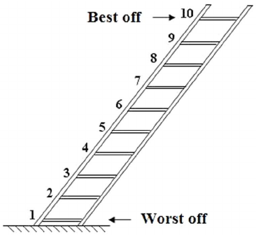

Now think about your family. Where do you think your family would be on this ladder?
Answer. 1 to 10 (selection)
1 | 2 | 3 | 4 | 5 | 6 | 7 | 8 | 9 | 10

X16. Now, assume that the ladder is picturing your school.
- At the top of the ladder are the people in your school who have the most respect, highest grades, and highest standing
- At the bottom are the people whom no one respects, whom no one wants to hang around, and who have the worst grades

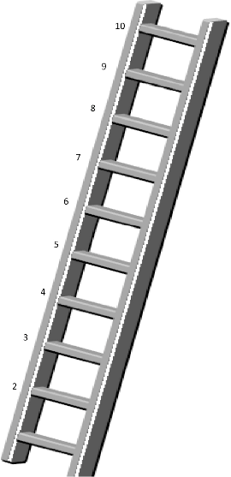

Where would you place yourself on this ladder? Answer. 1 to 10 (selection)
1 | 2 | 3 | 4 | 5 | 6 | 7 | 8 | 9 | 10

P. Personalities
This is the last part of survey. We will ask questions about what kind of person you are.

P1. How well do the following statements describe your personality?
I see myself as someone who… |  | 1 = Disagree strongly  2 = Disagree a little  3 = Neither agree nor disagree  4 = Agree a little  5 = Agree strongly
a | … is reserved | 1 | 2 | 3 | 4 | 5
b | … is generally trusting | 1 | 2 | 3 | 4 | 5
c | … tends to be lazy | 1 | 2 | 3 | 4 | 5
d | … is relaxed, handles stress well | 1 | 2 | 3 | 4 | 5
e | … has few artistic interests | 1 | 2 | 3 | 4 | 5
f | … is outgoing, sociable | 1 | 2 | 3 | 4 | 5
g | … tends to find fault with others | 1 | 2 | 3 | 4 | 5
h | … does a thorough job | 1 | 2 | 3 | 4 | 5
i | … gets nervous easily | 1 | 2 | 3 | 4 | 5
j | … has an active imagination | 1 | 2 | 3 | 4 | 5

P2. Below is a list of statements dealing with your general feelings about yourself. Please indicate how strongly you agree or disagree with each statement. |  | 1 = Strongly disagree  2 = Disagree  3 = Agree  4 = Strongly agree
a | On the whole, I am satisfied with myself. |  | 1 | 2 | 3 | 4
b | At times I think I am no good at all. |  | 1 | 2 | 3 | 4
c | I feel that I have a number of good qualities. |  | 1 | 2 | 3 | 4
d | I am able to do things as well as most other people. |  | 1 | 2 | 3 | 4
e | I feel I do not have much to be proud of. |  | 1 | 2 | 3 | 4
f | I certainly feel useless at times. |  | 1 | 2 | 3 | 4
g | I feel that I’m a person of worth, at least on an equal plane with others. |  | 1 | 2 | 3 | 4
h | I wish I could have more respect for myself. |  | 1 | 2 | 3 | 4
i | All in all, I am inclined to feel that I am a failure. |  | 1 | 2 | 3 | 4
j | I take a positive attitude toward myself. |  | 1 | 2 | 3 | 4

P3. Instructions: “Status in society” refers to how much money you and your family have, the kind of jobs you have, and how you describe your place in society (lower class, middle class, or upper class). |  | 1 = Strongly disagree  2 = Disagree  3 = Mostly disagree  4 = Neither disagree nor agree  5 = Agree  6 = Mostly agree  7 = Strongly agree
a | You have a certain status in society, and you really can’t do much to change it. | 1 | 2 | 3 | 4 | 5 | 6 | 7
b | Your status in society is something about you that you can’t really change very much. | 1 | 2 | 3 | 4 | 5 | 6 | 7
c | You can do things differently, but you can’t really change your status in society. | 1 | 2 | 3 | 4 | 5 | 6 | 7
d | No matter who you are, you can significantly change your status a lot. | 1 | 2 | 3 | 4 | 5 | 6 | 7
e | You can always greatly change your status in society. | 1 | 2 | 3 | 4 | 5 | 6 | 7
f | No matter what your status is at one point in your life, you can always change it quite a bit. | 1 | 2 | 3 | 4 | 5 | 6 | 7

Miscellaneous
Z1. This question asks what kind of images about TVET (technical and vocational education and training, such as TTI and IZC) you have. Which one of the following do you agree with the most?
1. “TVET is the last option to take.”
2. “TVET is a place for employment, but I don’t want to go to TVET.”
3. “TVET is a place for getting employment.”

=========== End of survey ===========

