Analysis Plan for ‘STOCHASTIC REWARDS AND WORK PERSISTENCE’
Outline

Our main DV is a dummy variable that takes value one if quitting happens in a given time frame or not. We are interested in this DV in the last 5, 10 and 15 minutes of the experiment.
We study the treatment effect of “Stochastic” (“Popup”) by regressing the DV with respect to a dummy taking value 1 if a participant is in a “Stochastic” (“Popup”) treatment. We use probit panel models with robust standard errors. These regressions include Cognitive Reflection Test scores as control along with summation skills and gender.
We complement this analysis with discrete-time proportional hazard models without unobserved individual heterogeneity.
To test the hypotheses in Figure 1, we also use standard analysis of variance with robust standard errors along with SEM techniques. To that end, we use our self-reported measures of stress enjoyment and attention. Interaction effects involving the Bergen Work Addiction Scale (BWAS) and Inhibitory control are also conducted using tests conducted in an independent trial.
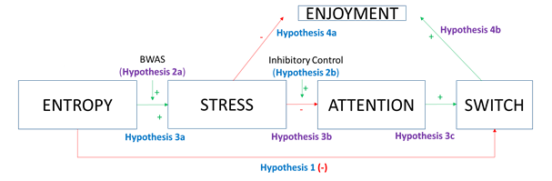
Figure 1. Hypotheses (BWAS stands for Bergen Work Addiction Scale).

